Investigating Intention by Rhythm Switching – Telluride 2026
We would like to investigate the phenomenon of switching between two alternative meters in an ambiguous rhythm. The main interest lies in the temporal dynamics of the switch, as well as factors influencing them. Most interestingly, we could observe a transitional period when switching from one imagined meter to another, which could indicate an intention influencing behavior before the switch happened.
The planned experimental paradigm is a behavioral tapping task. Participants are primed with tone sequences indicating either a douple or a triple meter. Afterwards, they listen to isochronous tone sequences containing no accents and reproduce the primed meter by accenting the imagined downbeats. There are two experimental conditions: In one condition, participants receive a cue to switch to the alternative meter. In the other condition, they are instructed to spontaneously switch the meter. Switching dynamics will be modelled by a logistic model predicting the switch time from the tapping amplitude. From this model, we can retrieve the predicted switch time, as well as the slope of the switch. Preliminary pilot data show that the model can accurately predict the switches in the cued and spontaneous conditions (see Figure 1).
Figure 1: Example pilot data and computational modeling approach

A)
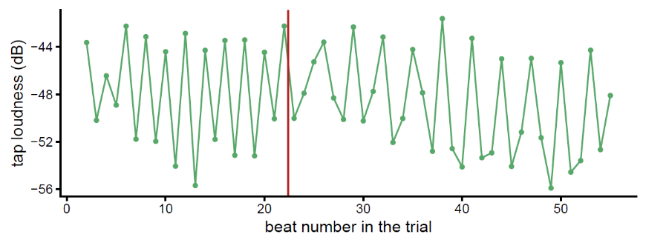

B)
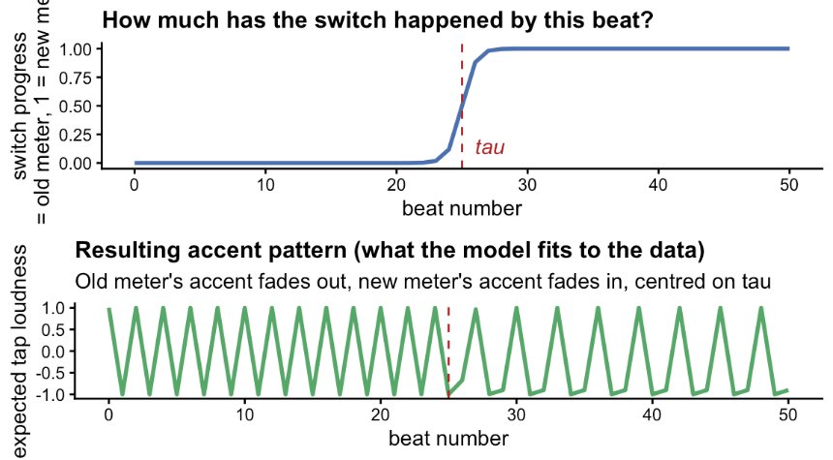
Additionally, there is a lag (~2.3 beats) between the cue and the estimated switch, suggesting that the intention to switch might be observable within this window. Future analyses are planned to investigate effects of musical training on the switching speed, as well as effects of the experimental conditions (cued versus uncued) and switch direction (switch to 2 or switch to 3). Finally, we would like to discuss potential designs for an EEG study while controlling confounds such as motor artifacts.

