Meme Team (65): Mitchell Johnson, Vivienne Qie, Arshiya Singh, Brittany Tan

**Context Diagram**

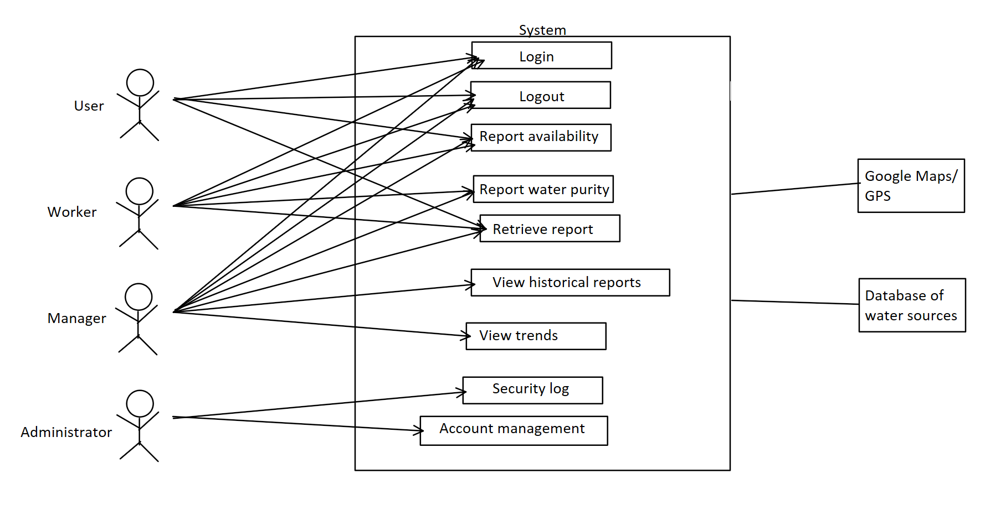

**Use Cases**

1. Login User
2. Logout User
3. Report Water Availability
4. Report Water Purity
5. Retrieve Water Report
6. View Historical Reports
7. View Trends
8. Access Security Log
9. Manage User Accounts

Vivienne Qie

CS 2340 M4 Use Case 3

**Use Case: Report Water Availability**

**Primary Actor:** User

**Stakeholders and Interests:**

**User:** Wants to report on water availability.

**Worker:** Wants to report on water availability.

**Manager:** Wants to report on water availability. Wants to delete individual Users’ reports that are deemed inaccurate.

**Pre-conditions:** User log-in has been authenticated.

**Post-conditions:** User’s water availability data is reported and saved.

**Main Success Scenario:**

1. User wants to report new water availability.
2. User log-in is successful.
3. User goes to main menu and selects “Report Water Availability.” User enters location where water is available, chooses the type of water and condition of water, and submits their report. System adds the user’s report to the database.
4. User exits system successfully.

**Extensions (Alternative Flow):**

3a. User reports inaccurate location of water availability.

1a. User deletes report and starts a new report.

1b. Manager deletes individual report that is deemed inaccurate.

1c. User is banned by administrator for submitting incorrect information.

**Special Requirements:** None

**Frequency of Occurrence:** Often

Brittany Tan

CS 2340 M4 Use Case 10

**Use Case: Manage User Accounts**

**Primary Actor:** Administrator

**Stakeholders and Interests:**

**Administrator:** Wants to manage use accounts by deleting accounts, banning a User from submitting reports, or unblocking an account that has been locked for incorrect login attempts. Want to view the security log.

**Pre-conditions:** Administrator log-in has been authenticated.

**Post-conditions:** User accounts are deleted, banned, or unblocked. Security log is viewed.

**Main Success Scenario:**

1. Administrator wants to manage user accounts.
2. Administrator log-in is successful.
3. Administrator goes to main menu and selects “View Security Log.” Administrator views log for any inaccurate submitted reports by users or any locked accounts for three incorrect login attempts.
4. Administrator sees locked user account.
5. Administrator unblocks the user from using the system.
6. User exits system successfully.

**Extensions (Alternative Flow):**

4a. Administrator sees multiple inaccurate reports submitted by a user.

1a. Administrator bans user from submitting reports.

1b. Administrator deletes user account completely.

**Special Requirements:** None

**Frequency of Occurrence:** Often

Mitchell Johnson

Use Case 8, CS2340 M4

**Use Case: View Historical Reports**

**Primary Actor:** Manager

**Stakeholders and Interests:** Manager: interested in historical reports for data and data analysis

Users: Interested in historical data for nearby water locations. (cannot view)

Workers: Interested in historical data for data analysis. (cannot view)

**Pre-Conditions:** Log-In (as Manager)

**Post-Conditions:** Historical Report is displayed

**Main Success Scenario:**

* 1. Manager queries for a report using a date, location, or report ID
  2. System returns list of resulting reports.
  3. Manager selects a report.
  4. System displays the selected report in.
  5. Manager selects to return to the main menu
  6. System returns to the main menu

**Extensions (Alternative Flow):**

2a. Query returns 0 reports.

1. System displays “No Reports Found.”
2. Manager Selects button to return to search screen
3. Continue at Step 1.

5a. Manager selects to return to search screen

1. System returns to search screen
2. Continue at Step 1.

**Special Requirements:** System must contain historical data for manager to load.

**Frequency of Occurrence:** Occasional