**Section 1: Introduction**

Cancer metastasis refers to the spread of cancer cells from a primary tumour to other parts of the body, leading to the formation of secondary tumours. The onset of metastasis often implies drastically worse 5-year survival rates for cancer patients, while it is estimated that more than 90% of deaths from cancer is due to the direct or indirect effect of metastasis [3]. Therefore, inhibiting metastasis is an active field of research, aiming to prevent the spread of cancer in order to improve patient prognosis and improve therapeutic outcomes [3,4,5].

Carcinoma cells acquire metastatic traits via epithelial-mesenchymal transition, a key process that results in epithelial cells, which are bound to the tissue surface, to become mesenchymal cells that have increased migratory capacity. Importantly, the actin cytoskeleton in cancer cells undergoes reorganisation, resulting in the loss of cell-cell adhesion [7], change in cell polarity [8] and the formation of actin-based structures such as lamellipodia and filopodia, which confers mobility to cancer cells. These actin-based motility structures enable cancer cells to undergo invasion [10], traversing through the extracellular matrix to enter the blood or lymphatic vessels [11]. Subsequently, these cells can travel through the vascular systems to distal sites in the body, eventually leading to the formation of new secondary tumours [12].

The mobility of cancer cells depends on the coordinated dynamic polymerisation and depolymerisation of actin filaments, which is regulated at localised sites by the binding of actin-associated proteins (AAPs) [14,15]. While several localisation mechanisms, such as the formation of actin waves and mRNA localisation, has been proposed to explain the spatial and temporal localisation of AAPs, the relative contribution of these mechanisms to the formation of actin-based motility structures is not fully understood.

In this paper, we will be reviewing the actin-based cellular structures involved in the invasion of cancer cells as well as currently proposed methods of AAP localisation. Thereafter, we propose several experiments to determine if inhibiting known AAP localisation mechanisms is a viable strategy to prevent the formation of various actin-based motility structures.

**Section 2: Actin-based structures involved in cell mobility**

2.1 Regulation of actin-based structures:

Cancer cells require specialized actin structures for invasion during metastasis. Each of these actin-based structures (lamellipodia, filopodia, invadopodia and actin stress fibres) serve distinct functions in cancer cell movement. Coordinated changes in these structures lead to cycles of protrusion and adhesion at the front of the cell (leading edge), followed by translocation of cell body and retraction of the back of the cell (trailing edge), allowing metastatic cancer cells to migrate [16, 18]. In these actin-based motility structures, actin filaments are arranged as either linear filament bundles or branched filament networks. The formation of linear filaments is governed by the AAP formin, which directs the addition of actin monomers to the barbed end of actin filaments. On the other hand, ARP2/3 complex binds to the side of actin filaments and nucleates the formation of new actin filaments at a 70-degree angle, resulting in dense, branched networks. The interaction between actin and various AAPs are shown in Figure 1A.

2.2.1 Structures involved in cell mobility

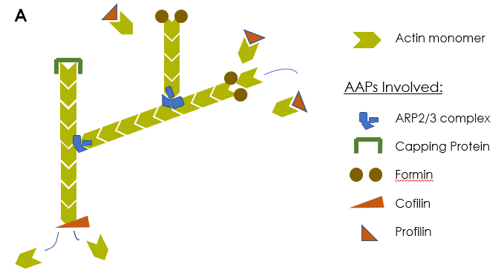

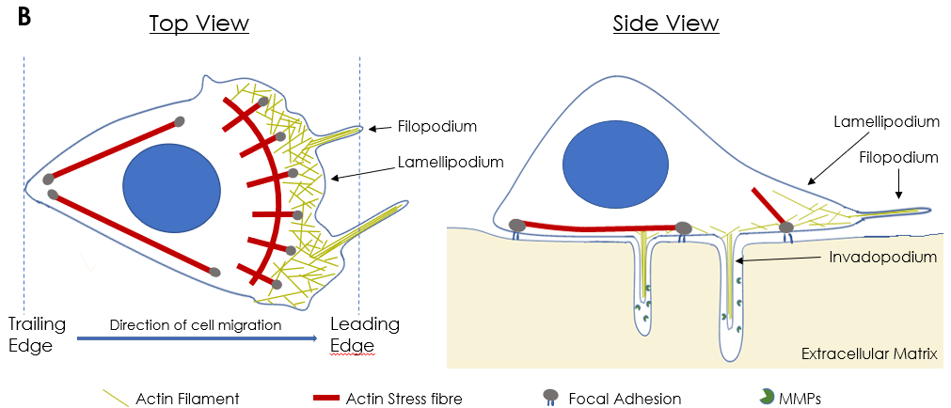

**Figure 1: Actin structures underlying metastatic cell mobility.** A: Schematic representation of the interactions between actin monomers and AAPs in the formation of actin cytoskeleton. ARP2/3 complex nucleates the formation of actin side branches at a 70o angle. Capping protein prevents actin filament elongation by inhibiting the barbed end of actin filaments. Formin elongates actin filaments by recruiting actin monomers to the barbed end of actin filaments. Cofilin depolymerises actin filaments from the pointed end. Profilin recruits actin monomers to proline-rich proteins such as formin, thus speeding up the formation of actin filaments. B: Schematic representation of mobility-enabling actin structures within metastatic cells.

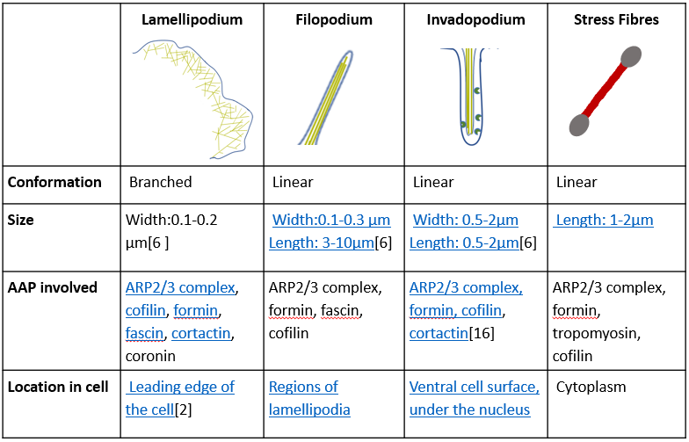

**Table 1:** General characteristics of actin structures relevant to cell migration

2.2.1 Lamellipodia

Lamellipodia are transient, flat projections found at the leading edge of metastatic cells. They comprise of dense, branched networks of actin filaments. These broad, low-pressure structures are mainly utilised by cancer cells for movement across 2-dimensional surfaces [17].

Formation of lamellipodia is stimulated by the activity of ARP2/3 complex, which is regulated by the Rac-WAVE-Arp signalling pathway [19]. Upon binding of ARP2/3 complex to the side of actin filaments, new actin filaments branch out and polymerise towards the leading edge of the cell. These branched filaments push against the cell membrane, forming lamellipodia protrusions. Directional movement is enabled by cycles of protrusion, followed by attachment to the ECM which serves as anchor for the retraction of the trailing edge, leading to cancer cell movement [20].

2.2.2 Filopodia

Beyond the leading edge of lamellipodia are slender, membrane protrusions known as filopodia. They are made up of long actin filaments bundled tightly together within the protruding membrane [18]. Filopodia allow the migrating cell to probe its surroundings and influences the direction of migration by the cell via mechanosensing [].

In contrast to lamellipodia, filopodia form via the polymerisation and elongation of linear actin filaments [24]. The binding of N-WASP to the AAPs profilin and ARP2/3 nucleates the formation of new filopodia [24]. Subsequently, the elongation of actin filaments is directed by the AAP formin. Similar to lamellipodia, these actin filaments push against the cell membrane, leading to slender membrane protrusions characteristic of filopodia.

2.2.3 Invadopodia

Like filopodia, invadopodia also comprise of linear actin filaments and occur as obtrusions from the cell membrane of an invading cell. Invadopodia have the unique ability to degrade the surrounding matrix of the cell by the secretion of matrix degradation enzymes.

The formation of invadopodia resembles that of filopodia in terms of formin-directed polymerisation and elongation of linear actin filaments. In addition, invadopodia possess adhesion molecules commonly found in normal cells such as B1 integrins and CD44 as well as proteases such as Matrix Metalloprotease (MMP) and separase. It is suggested that adhesion molecules serve as docking stations for the proteases in invadopodia, contributing to the matrix degradation property of invadopodia[[ref](https://www.ncbi.nlm.nih.gov/pmc/articles/PMC3969876/)].

The presence of invadopodia is often associated with tumour invasiveness in cell lines originating from squamous cells, bladder cells as well as colorectal cells(cite). As digestion of the ECM and cell contact with the surrounding plays an important role in cancer cell invasion, it has been shown that cancer cells which do not possess invadopodia fail to undergo metastasis (cite).

2.2.4 Stress Fibres

Stress fibres are contractile structures composed of antiparallel arrays of cross-linked actin filaments associated with myosin II bundles. Two main types of stress fibres are involved in cell motility. Dorsal stress fibres stabilise focal adhesions at the leading edge of the cell, enabling the forward movement of the cell body; ventral stress fibres are fundamental to trailing edge retraction and inhibit the formation of cell protrusions at the trailing edge, ensuring directional movement of the cell towards the cell leading edge [reviewed in XXX]. Stress fibres are assembled via actin polymerisation at focal adhesions, which are then bundled in parallel via cross-linking proteins such as α-actinin. Similar to aforementioned actin structures, actin filaments are nucleated by ARP2/3 complex and formin.

Based on our review of actin-based motility structures, it is apparent that AAPs such as ARP2/3 and formin are key players in cancer cell migration by directing actin polymerisation underlying these structures. For cancer cell migration to occur, these AAPs in the cell need to be directed to specific locations within the cell to form necessary motility structures. How do AAPs become localised in metastatic cells?

**Section 3: Mechanisms of AAP localisation**

Currently, three methods of AAP localisation has been recognised: co-migration of AAPs with actin waves, localisation of mRNA coding for AAPs, as well as passive diffusion of AAP in the cell cytoplasm. Here we discuss these mechanisms of AAP localisation as well as their contribution to cell motility.

3.1 Actin Waves:

Actin waves, the observed wave-like propagation of actin filaments along the cell membrane of motile or growing cells, has been proposed as a promising method of AAP movement in motile cells to suit AAP needs [1]. While studies of actin waves focused on the transport of actin filaments to the edges of the cell, it has been observed that various AAPs, including formin and ARP2/3 complex, co-migrate with actin waves to the edges of the cell. The formation of lamellipodia protrusions at the leading edge of fibroblasts and Dictyostelium cells have been observed via confocal microscopy to coincide with the arrival of actin waves at the leading edge [5]. Additionally, the propagation of actin waves away from the leading edge of the paralyses the cell border [9]. This suggests that actin waves maintain cell motility by ensuring that a required concentration of actin as well as AAP is present at sites of protrusion formation.

The formation of actin waves is currently explained by a model of autocatalytic positive feedback followed by a delayed negative feedback []. Based on this model, the spontaneous upstream activators of actin assembly form the activators of an excitable system, while the depletion of these actin filament promoters or accumulation of inhibitors would result in termination of the wave excitation. In neutrophils, Hem-1 initiates actin waves formation by activating AAPs such as ARP2/3 complex as well as the WAVE regulatory complex (WRC).[3] Activated AAPs leads to the polymerisation of actin filaments, producing actin waves, while WRC contributes to a positive feedback response through the recruitment and activation of additional ARP2/3 complex. Actin filaments formed inactivate and remove Hem-1 present via negative feedback [4]

The maintenance and propagation of actin waves involves a local treadmilling process [2]. As actin filaments in actin waves elongates, depolymerisation happens concurrently at its rear end. Actin monomers and AAPs are more concentrated at the rear of the filaments due to their dissociation from actin filaments. As a result, actin monomers and AAPs diffuse towards the polymerising front of the actin wave and can be reused for actin polymerisation. Similarly, clutch molecules that attaches actin filaments to the cell membrane dissociates at the rear of the actin wave and reforms at the front, providing traction for the actin wave to propagate along the cell membrane to the target cell edge.

Thus, the directed diffusion and co-migration of AAPs with polymerising filaments contribute to the emergence of actin waves, with the activation and inhibition mechanisms remaining the prevailing models behind such actin dynamics.

3.2 mRNA localisation

\/ \/(⊙﹏⊙)(⊙﹏⊙)(⊙﹏⊙)Work in Progress(⊙﹏⊙)(⊙﹏⊙)(⊙﹏⊙)\/ \/

The significance of ARP2/3 mRNA localization has been demonstrated in an experiment where the mRNA encoding for Arp2 which forms part of the ARP2/3 complex is localized to the perinuclear region of the cell by expressing it as a bicistronic mRNA with Dia1 mRNA. In this cell, even though the overall expression level of Arp2 is similar to a normal cell, the directional migration of the cell is inhibited. These findings demonstrated the importance of mRNA localization within cancer cells.

Localization of these proteins can be done by targeted transport of mRNA encoding for these proteins towards the leading edge of the cell. One of the mechanisms often utilized by cancer cells for localization of mRNA coding for AAPs is the zipcode-mediated model. In this mechanism of mRNA transport, a zipcode binding protein (ZBP) may bind to the RNA localization sequence located at its 3’UTR region AAP’s mRNA and subsequently, the zipcode binding protein will escort the mRNA towards the leading edge of the cell while suppressing its translation simultaneously. After the mRNA is delivered to its target location, the mRNA is anchored to one of the actin binding proteins attached to actin filaments. Localized activation of signalling pathways at the leading edge of the cell may then cause dissociation of the zipcode binding protein and subsequently, translation of mRNA is no longer inhibited. One of the mRNAs which utilizes this method of transport is the mRNA encoding for ARP2/3 complex which is an actin binding protein required for nucleation of branched actin filaments. After ZBP1 binds to the localisation sequence at the 3’UTR region of ARP2/3 mRNA, the mRNA is delivered to newly formed focal adhesion. Several experiments have demonstrated that inhibition of this transport causes diminishing rate of lamellipodia formation and subsequently cancer cell migration. As a matter of fact, a study which uses shRNA to inhibit expression of ZBP in cancer cell undergoing metastasis resulted in substantial drop in rate of lamellipodia formation and there are also many other studies which demonstrated the strong correlation between expression of ZBP and poor prognosis in cancer.

The localization of ARP2/3 complex mRNA is dependent on serum platelets derived growth factor and lysophosphatidic acid which serves as a ligand acting upstream on activation of Rho and activation of myosin II. As mentioned above, localized activation of Rho will cause dissociation of ZBP1 from ARP2/3 complex mRNA allowing it to be translated by the ribosomes located at the leading edge of the cell. In addition to this, localized activation of Rho is also important for phosphorylation of myosin 2 which will stimulate its contractile activity. Activation of myosin 2 will then contribute towards the formation of lamellipodia.

Although it may appear less specific than other methods of mRNA transport, diffusion may also play a significant role in mRNA transport. This protoplasmic flow can be driven by myosin activity at the leading edge of the cell which generates an intracellular force gradient within the cell. Subsequently, diffusing mRNA which encodes for protein which affect the formation of lamellipodia is carried along.

/\ /\ (⊙﹏⊙)(⊙﹏⊙)(⊙﹏⊙)Work in Progress(⊙﹏⊙)(⊙﹏⊙)(⊙﹏⊙)/\ /\

3.3 Passive Diffusion

Aside from the aforementioned mechanisms, it is important to consider the baseline scenario where AAPs are delivered to localised sites by passive diffusion alone. Owing to the large size of subunits of AAPs and the viscosity of eukaryotic cytoplasm, AAP has a much smaller diffusion coefficient (30um2/s) compared to water molecules (2000um2/s) based on the Stokes-Einstein equation[[ref](http://book.bionumbers.org/what-are-the-time-scales-for-diffusion-in-cells/)]. The diffusion rate of AAPs decreases exponentially as diffusion distance increases due to decreased. Hence, diffusion of AAPs from the cytoplasm near the nucleus of a cell to its leading edge may take a significant amount of time. However, AAPs such as ARP2/3 complex remain bound to actin filaments within the actin cell cortex. Upon actin cytoskeleton rearrangement to form motility structures, these AAPs are released and may contribute to the formation of protrusions needed for cell migration. The diffusion distance of these AAPs are significantly shorter and may be sufficient to enable some level of cell motility.

**Section 4: Proposed Experiment**

Although the above mechanisms are generally acknowledged as the mechanisms underlying AAP localisation in cells, they have been largely studied separately. Furthermore, while it has been observed that the inhibition of actin waves and mRNA localisation do lead to a decrease in the motility of metastatic cells, it is not known if inhibiting them together at the same time would be more effective at reducing cell motility. Here we propose an experimental outline in an attempt to answer these questions.

As mentioned earlier, inhibition of either actin waves or mRNA localisation alone does not completely stop cell migration. Even when one mechanism is inhibited, the cells still maintain an appreciable level of motility. We believe that this motility is preserved via the other main mechanism. Hence, we want to look into whether inhibiting more than one mechanism at a time can more effectively stop migration in cancer metastasis.

This brings us to our hypothesis that the simultaneous inhibition of actin waves and mRNA localisation will prevent the formation of motility structures, even in the presence of passive diffusion of AAP. If our experiments show this to be true, it would serve as a proof of concept that targeting AAP localisation via blockage of mRNA localisation and actin waves is a viable clinical strategy in reducing metastasis.

However, this hypothesis assumes that the inhibition of both mechanisms indeed causes significantly decreased cell motility by disrupting the localisation of AAPs. This must be verified experimentally by tagging the AAPs with fluorescent proteins to track their movements.

Since diffusion is fundamental to many cellular processes besides the transport of AAPs, it is not experimentally feasible to stop diffusion from occurring to study its role in AAP localisation. Thus, we will be using the diffusion rate of AAPs as a baseline for the movement of AAPs due to the other two mechanisms.

\/ \/(⊙﹏⊙)(⊙﹏⊙)(⊙﹏⊙)Work in Progress(⊙﹏⊙)(⊙﹏⊙)(⊙﹏⊙)\/ \/

Imaging: FRAP(to check for movement of tagged proteins) and TIRF(mainly for actin waves)

* Baseline measurement of actin wave activity and rate of AAP diffusion

Inhibit actin wave via a1b1 antibodies. Effect of inhibition checked by staining. must be specific to the actin wave process.

Stain ARP2/3 and formin in separate experiments (is the staining method compatible w live-cell imaging?)

siRNA inhibition

Nuclear targeted siRNA delivery system can be used to bind to the zipcode sequence at the 3’ UTR region of mRNA encoding for ARP2/3 and formin. This will prevent the binding of ZBP1 to mRNA encoding for ARP2/3 and formin and as a result, mRNA localization by this pathway will be prevented. To achieve nuclear targeting, a complex is formed between nuclear localization signal peptide and siRNA complementary to the zipcode binding site of ZBP . Electrophoresis can be used to make sure that proper assembly of the complex occur.

In order to verify nuclear localization of the siRNA complex, the siRNA is first labelled with a fluorescent tag and then confocal laser scanning microscopy is used to track its position within the cell

Visualisation of AAP localisation:

Actin waves can be inhibited by preventing the binding of integrins within actin waves

Look up on ARP2/3 in actin waves

References

1. Verma, S., Welch, M. D., Mitchison, T. J., Iwamatsu, A., & DePace, A. H. (2002). The Human Arp2/3 Complex Is Composed of Evolutionarily Conserved Subunits and Is Localized to Cellular Regions of Dynamic Actin Filament Assembly. *The Journal of Cell Biology*, *138*(2), 375–384. https://doi.org/10.1083/jcb.138.2.375
2. Miki, H., Yamaguchi, H., Coniglio, S., Segall, J., Symons, M., Kempiak, S., … Eddy, R. (2005). Molecular mechanisms of invadopodium formation. *The Journal of Cell Biology*, *168*(3), 441–452. https://doi.org/10.1083/jcb.200407076
3. Takenawa, T., & Miki, H. (2001). WASP and WAVE family proteins: key molecules for rapid rearrangement of cortical actin filaments and cell movement. *Journal of Cell Science*, *114*(Pt 10), 1801–1809. Retrieved from http://www.ncbi.nlm.nih.gov/pubmed/11329366
4. Weiner, O. D., Marganski, W. A., Wu, L. F., Altschuler, S. J., & Kirschner, M. W. (2007). An actin-based wave generator organizes cell motility. *PLoS Biology*, *5*(9), 2053–2063. https://doi.org/10.1371/journal.pbio.0050221
5. Vicker, M. G. (2002). Eukaryotic cell locomotion depends on the propagation of self-organized reaction-diffusion waves and oscillations of actin filament assembly. *Experimental Cell Research*, *275*(1), 54–66. https://doi.org/10.1006/excr.2001.5466
6. Graziano, B. R., & Weiner, O. D. (2014). Self-organization of protrusions and polarity during eukaryotic chemotaxis. *Current Opinion in Cell Biology*, *30*(1), 60–67. https://doi.org/10.1016/j.ceb.2014.06.007
7. Schroth-Diez, B., Anderson, K., Gerisch, G., Ishikawa-Ankerhold, H. C., Müller-Taubenberger, A., Ecke, M., & Bretschneider, T. (2009). The Three-Dimensional Dynamics of Actin Waves, a Model of Cytoskeletal Self-Organization. *Biophysical Journal*, *96*(7), 2888–2900. https://doi.org/10.1016/j.bpj.2008.12.3942
8. Gross, S. R. (2013). Actin binding proteins: Their ups and downs in metastatic life. *Cell Adhesion and Migration*, *7*(2), 199–213. https://doi.org/10.4161/cam.23176
9. Guan, X. (2015). Cancer metastases: Challenges and opportunities. *Acta Pharmaceutica Sinica B*, *5*(5), 402–418. https://doi.org/10.1016/j.apsb.2015.07.005
10. Rosel, D., Sanz-Moreno, V., Fernandes, M., Heneberg, P., Veselý, P., Brábek, J., … Gandalovičová, A. (2017). Migrastatics—Anti-metastatic and Anti-invasion Drugs: Promises and Challenges. *Trends in Cancer*, *3*(6), 391–406. https://doi.org/10.1016/j.trecan.2017.04.008
11. Sleeman, J., & Steeg, P. S. (2010). Cancer metastasis as a therapeutic target. *European Journal of Cancer*, *46*(7), 1177–1180. https://doi.org/10.1016/j.ejca.2010.02.039
12. Marrow, B., Secreted, S., & Protect, C. (2014). NIH Public Access, *71*(11), 3831–3840. https://doi.org/10.1158/0008-5472.CAN-10-4002.BONE
13. Manuscript, A. (2010). RNA Localization and Polarity: From A(PC) to Z(BP) Stavroula, *19*(4), 156–164. https://doi.org/10.1016/j.tcb.2009.02.001.RNA
14. Nelson, W. J. (2009). Front-Rear Polarity.Pdf, 1–19.
15. Kazazian, K., Go, C., Wu, H., Brashavitskaya, O., Xu, R., Dennis, J. W., … Swallow, C. J. (2017). Plk4 promotes cancer invasion and metastasis through Arp2/3 complex regulation of the actin cytoskeleton. *Cancer Research*, *77*(2), 434–447. https://doi.org/10.1158/0008-5472.CAN-16-2060
16. Murphy, D. A., & Courtneidge, S. A. (2011). The “ins” and “outs” of podosomes and invadopodia: Characteristics, formation and function. *Nature Reviews Molecular Cell Biology*, *12*(7), 413–426. https://doi.org/10.1038/nrm3141
17. Pellegrin, S., & Mellor, H. (2007). Actin stress fibres. *Journal of Cell Science*, *120*(20), 3491–3499. https://doi.org/10.1242/jcs.018473
18. Morris, H. T., & Machesky, L. M. (2015). Actin cytoskeletal control during epithelial to mesenchymal transition: Focus on the pancreas and intestinal tract. *British Journal of Cancer*, *112*(4), 613–620. https://doi.org/10.1038/bjc.2014.658
19. Fife, C. M., McCarroll, J. A., & Kavallaris, M. (2014). Movers and shakers: Cell cytoskeleton in cancer metastasis. *British Journal of Pharmacology*, *171*(24), 5507–5523. https://doi.org/10.1111/bph.12704
20. Gross, S. R. (2013). Actin binding proteins: Their ups and downs in metastatic life. *Cell Adhesion and Migration*, *7*(2), 199–213. https://doi.org/10.4161/cam.23176
21. Sahai, E. (2007). Illuminating the metastatic process. *Nature Reviews Cancer*, *7*(10), 737–749. https://doi.org/10.1038/nrc2229
22. McNiven, M. A. (2013). Breaking away: Matrix remodeling from the leading edge. *Trends in Cell Biology*, *23*(1), 16–21. https://doi.org/10.1016/j.tcb.2012.08.009
23. Mattila, P. K., & Lappalainen, P. (2008). Filopodia: Molecular architecture and cellular functions. *Nature Reviews Molecular Cell Biology*, *9*(6), 446–454. https://doi.org/10.1038/nrm2406
24. Krause, M., & Gautreau, A. (2014). Steering cell migration: Lamellipodium dynamics and the regulation of directional persistence. *Nature Reviews Molecular Cell Biology*, *15*(9), 577–590. https://doi.org/10.1038/nrm3861
25. Sibony-Benyamini, H., & Gil-Henn, H. (2012). Invadopodia: The leading force. *European Journal of Cell Biology*, *91*(11–12), 896–901. https://doi.org/10.1016/j.ejcb.2012.04.001
26. Yilmaz, M., & Christofori, G. (2009). EMT, the cytoskeleton, and cancer cell invasion. *Cancer and Metastasis Reviews*, *28*(1–2), 15–33. https://doi.org/10.1007/s10555-008-9169-0
27. Stylli, S. S., Kaye, A. H., & Lock, P. (2008). Invadopodia: At the cutting edge of tumour invasion. *Journal of Clinical Neuroscience*, *15*(7), 725–737. https://doi.org/10.1016/j.jocn.2008.03.003
28. Linder, S. (2007). The matrix corroded: podosomes and invadopodia in extracellular matrix degradation. *Trends in Cell Biology*, *17*(3), 107–117. https://doi.org/10.1016/j.tcb.2007.01.002
29. Giannone, G., Mège, R. M., & Thoumine, O. (2009). Multi-level molecular clutches in motile cell processes. *Trends in Cell Biology*, *19*(9), 475–486. https://doi.org/10.1016/j.tcb.2009.07.001
30. Petrie, R. J., Doyle, A. D., & Yamada, K. M. (2018). 5° Año 2018, *10*(8), 538–549. https://doi.org/10.1038/nrm2729.Random
31. Vallee, R. (2002). Mechanisms Of Fast And Slow Axonal Transport. *Annual Review of Neuroscience*, *14*(1), 59–92. https://doi.org/10.1146/annurev.neuro.14.1.59
32. Katsuno, H., Sakumura, Y., Toriyama, M., Ikeda, K., Mizuno, K., Inagaki, N., & Hosokawa, Y. (2015). Actin Migration Driven by Directional Assembly and Disassembly of Membrane-Anchored Actin Filaments. *Cell Reports*, *12*(4), 648–660. https://doi.org/10.1016/j.celrep.2015.06.048
33. Vallee, R. B., & Bloom, G. S. (1991). Mechanisms of Fast and Slow Axonal Transport. *Annual Review of Neuroscience*, *14*(1), 59–92. https://doi.org/10.1146/annurev.ne.14.030191.000423

To organise these structures, the actin cytoskeleton must undergo dynamic polymerisation and depolymerisation via treadmilling, which is regulated by various actin-associated proteins (AAPs). Treadmilling refers to the process where one end of the filament polymerises faster than the rate of depolymerisation of the other end. The end growing in length is termed the barbed end, while the shrinking end is called the pointed end.

In addition, some actin filament-binding proteins advance together with the cell in the direction of polymerisation. As the actin filaments form a mechanical adhesion to the plasma membrane through shootin1 and L1-CAM, the ends undergoing polymerisation exerts an outward force on the membrane. This happens alongside disassembly of the filaments at the opposite end, such that these actin filament-binding proteins travel together with the polymerising filament.