A flow chart is a graphical representation of a process. It is used to show a certain process to be easily viewed by a reader instead of putting it into sentences. To compose a flow chart only words or phrases for the description of the process and it should not be too lengthy. The words should also be inside the shapes for more organized flow chart and a corresponding arrow so that the reader will know what will be the next step. It is important to use a flow chart so that the process that you want to input will only be brief since you are going to use words or phrases only and using a flow chart the processes will be organized since there are arrows and graphic presentation that would be easily be followed by the reader.

There are several common flowchart symbols and these are; terminator, process, decision, connector, data and document. A terminator is an oval flow chart which indicates the start or end of the process. While the process is a rectangular shape which indicates that it is a normal process flow step. A decision flow chart is a diamond shaped flow chart which has branch for indication in the process flow. Moreover, a connector is a small labeled circular flowchart shape that show a jump point from one point in the process flow to another. The data is a parallelogram that shows the input or output for a process. Lastly, the document is used to indicate a document or report.

Here is an example of a flowchart:

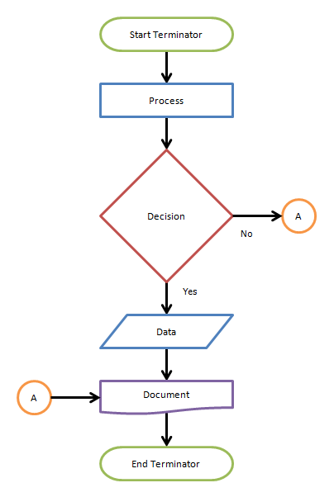

Retrieved from: <https://www.breezetree.com/articles/what-is-a-flow-chart>

A pseudo code is a term which is regularly utilized in programming and calculation based fields. It is a methodology that enables the developer to represent the usage of algorithm. An algorithm is an organized logical sequence of the activities or the methodology towards a specific issue. A programmer calculates an algorithm to solve a problem. And so, a pseudo code is important because it is the execution of the algorithm and it has no syntax like any programming language hence can't be ordered or deciphered by the PC.

Here is the example of pseudo code:

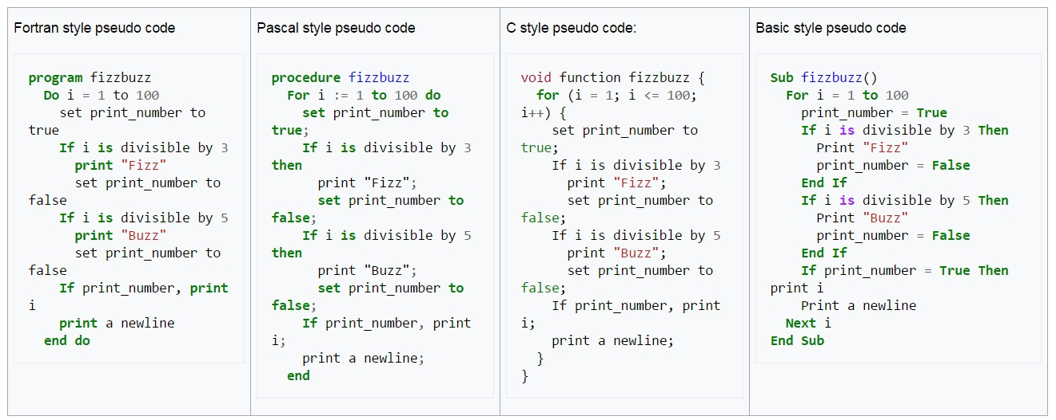

Retrieved from: <https://www.geeksforgeeks.org/how-to-write-a-pseudo-code/>

Retrieved from: <http://computersciencementor.com/pseudocode/>