Vivienne Vera V. Villaruel

TM 191

Adding two numbers

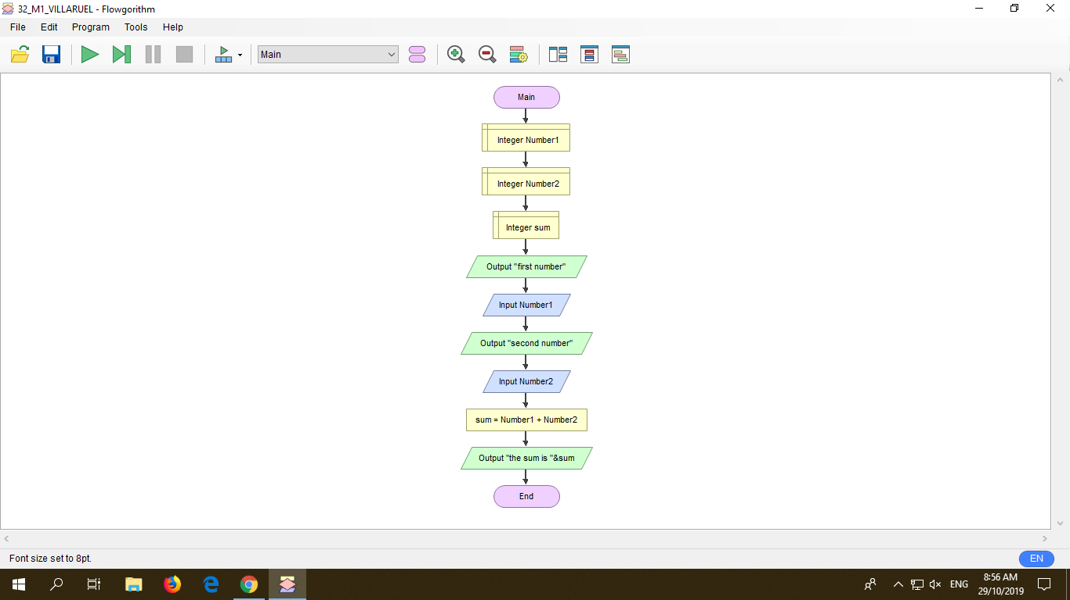

The image above shows the flowchart of adding two number using flowgorithm. Using a flowgorithm is far different from the flowchart we are doing in the word document. The symbols are more complicated and there are some additional symbols that I used in doing the flowchart in flowgorithm. Before I came up with my final flowchart I had many trial and errors since what I have said it was far different from the flowchart I am doing in a word document. In flowgorithm, when you open the application the terminators are automatically flashed in the screen. The next step is to declare your variables and choose between integer, real, string and Boolean. I chose to use integer and then I entered Number1 and then it I just repeat the step for declaring Number2 and sum. After declaring the variable, used the parallelogram symbol and then I will output the first number and it should have quotations so that it will run. After the output, I input the Number1 and it same goes with the second number and Number2. The next symbol is called the Assignment Statement, using this symbol I input the sum as my variable and then Number1 + Number2 as my expression. And lastly, with that I output it with the use of this statement “the sum is “&sum. After doing many trial and error I have finally run the program.

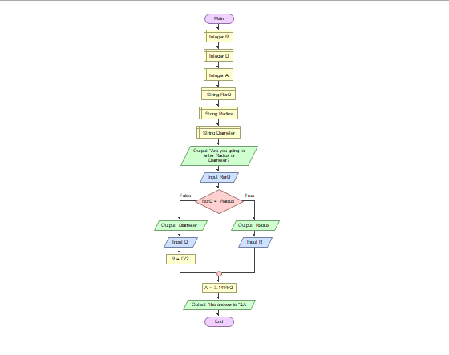

The image above is the second flowchart I made using flowgorithm. Doing this flowchart is really hard because using the decision symbol in flowgorithm is not as easy as I thought. This activity is so complicated but when I’ve finally found out the correct symbols and process I am really happy because there are a lot of trials and errors. So first just what I’ve did in the previous activity the terminator is already flashed then I declared the variables; R, D, A using the Integer. And then I used the String, since I will use the decision symbol. It is important to use string in using decision because this is when you are going to answer the yes or no question. So, I declared RorD, Radius and Diameter using String. After declaring all of the variables I put the parallelogram symbol and then output “Are you going to enter Radius or Diameter?” and then Input RorD. The next step is to input the decision symbol, inside the symbol I input RorD = Radius so if your answer is Radius it is True then I used the input and output. I put the output first then I type “Radius” then I input R. If you answer Diameter then it is false then I output first the “Diameter” then I input D and then I used the Assignment statement symbol. In this symbol I declare the R as my variable and then D/2 as my expression. Lastly, I still used the Assignment statement symbol and I declare A as my variable and 3.14\*R\*2 as my expression and then Output it with the statement “the answer is “&A. Finally, I have run my program.