Technical Report

Semester Project 2



Vivian Grosch

Word count

Summary: 250 | Main text:500

Table of Contents

1. Summary 3

2. Body 4

2.1. Introduction 4

2.2. Main section of report 4

2.3. Conclusion 4

3. References 5

4. Acknowledgements 6

5. Appendices 7

# 1. Summary

This report is about planning, designing and programing a microsite for SpaxeX. It’s a detailed description on how this project went the past five weeks. I will start of with writing about the planning process how I came up with my Target audience, going onto the design part, how I came up with the name and logo. To then continue with writing about the prosecco of programming, the ups and downs of the project. I will end up with a conclusion on this project.

# 2. Body

## 2.1. Introduction

This report is about planning, designing and programming a microsite with HTML/CSS and JavaScript known length. The microsite is supposed to focus on space technology for NASA or SpaceX. I decided on SpaceX Since I found it interesting to learn about it too.

In this report I will describe why the methods I used worked for me and why I used them. I will be ending this report with a conclusion of this assignment on how it went and what struggles I faced.

## 2.2. Main section of report

## Planing

Reading through the task I started doing some research about SpaceX and NASA since my knowledge about that was not that big. Probably not necessary to do, but I felt it would be easier for me to create a design for something I know a little bit about. I wrote down keywords of what is important for this job.

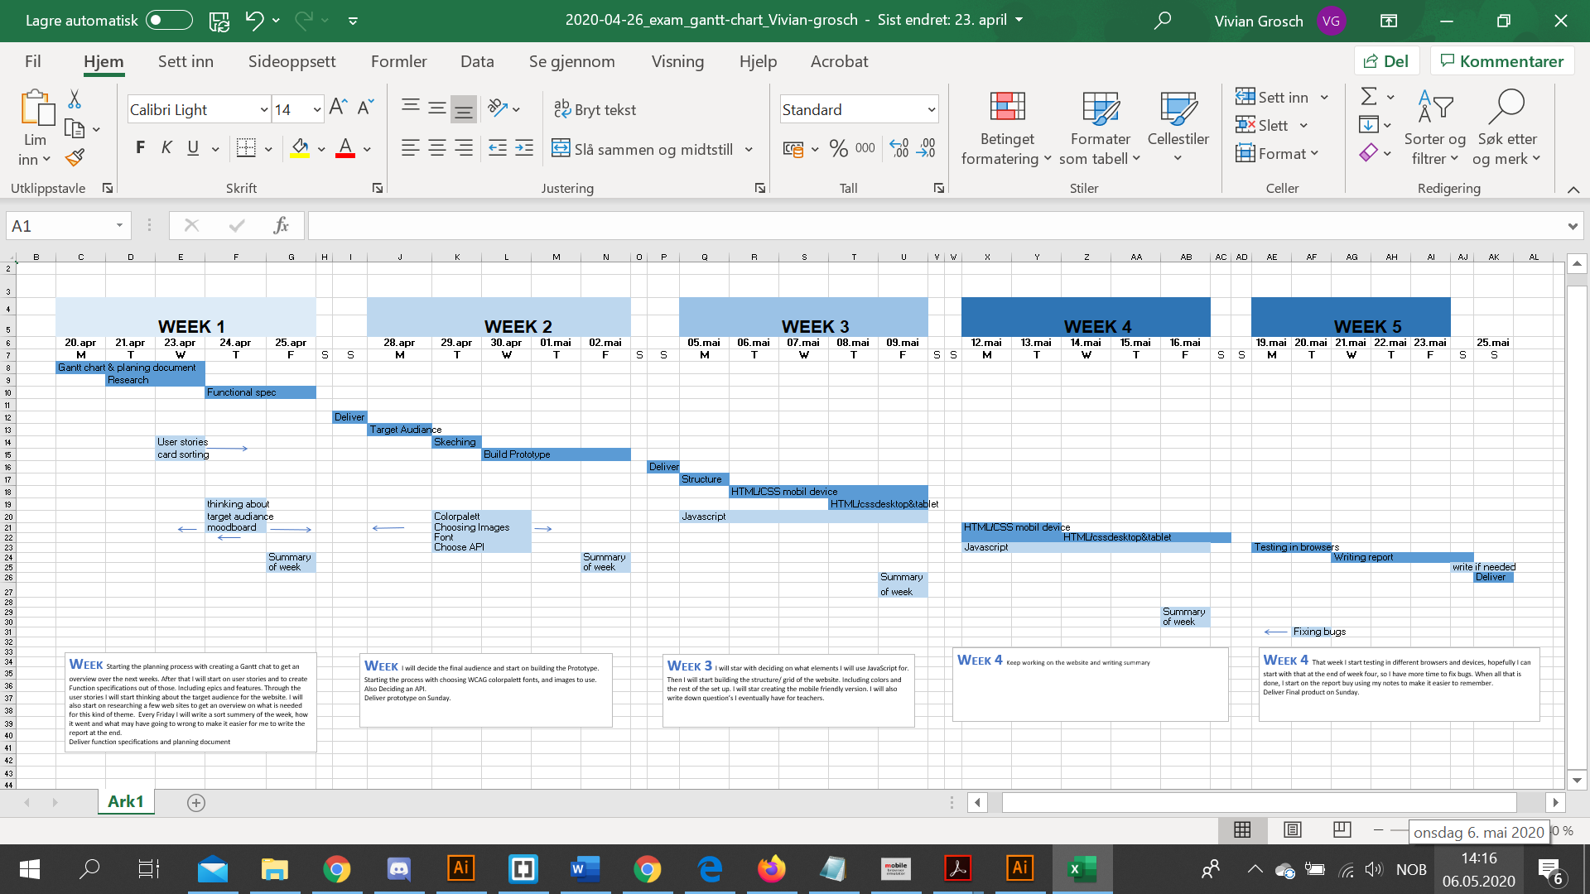When I decided to focus on a microsite for SpaceX, I started creating a Gantt Chart. I planed day by day and week for week. When that was done the may project stared.

Gantt Chart

I started with writing down the most important keywords fron the brief we got on a whiteboard to get a over few what to include.

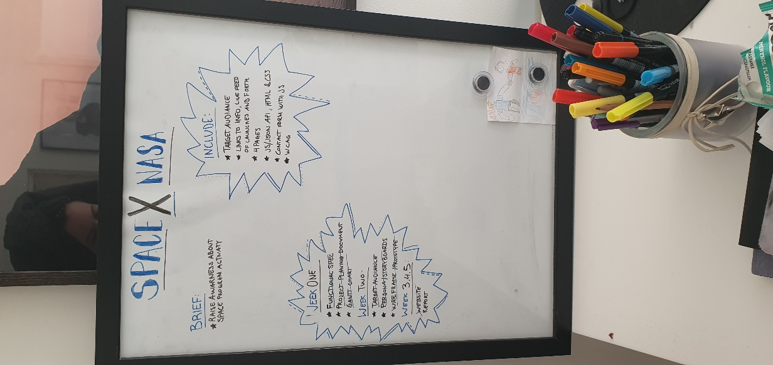

Keywords on whiteboard.

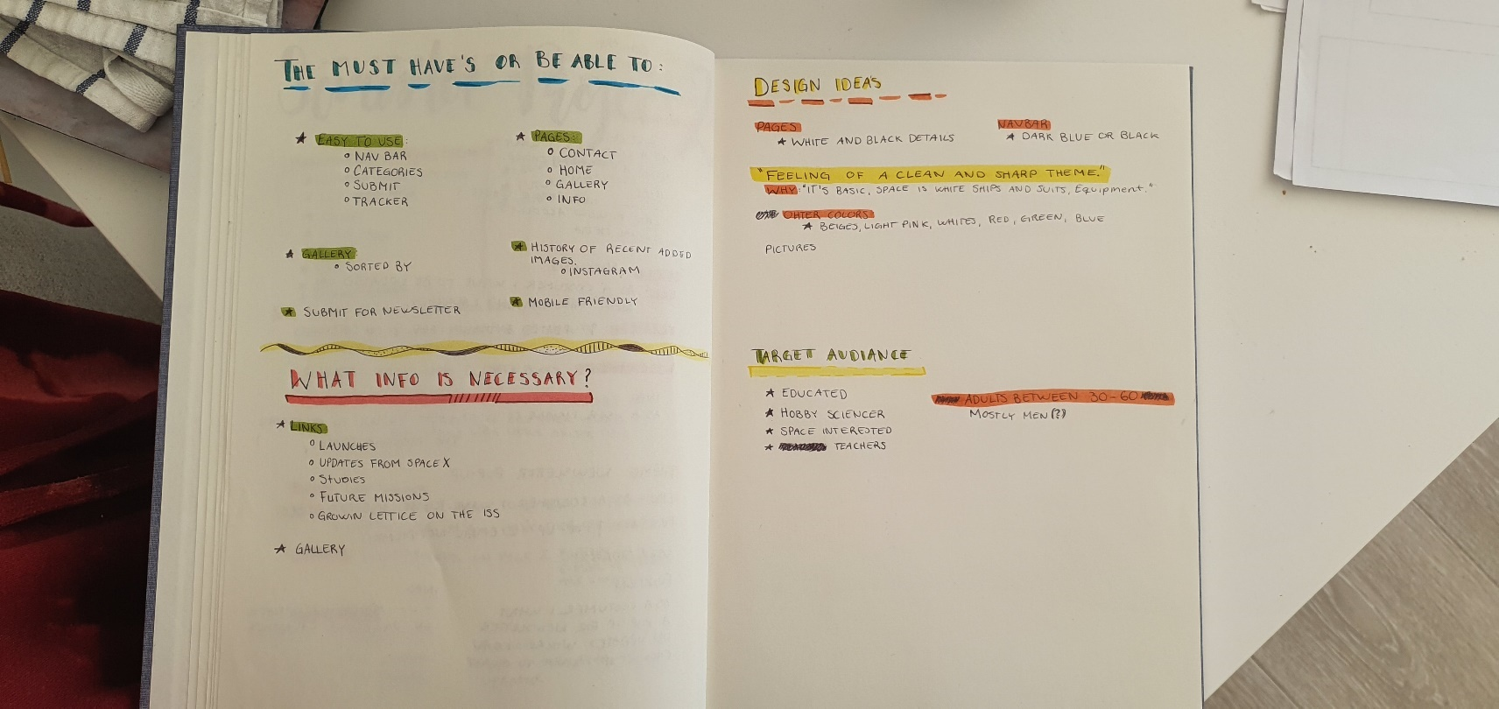

Then I started to write more detailed things about this project with pen and paper.

I started creating personas and function spesification. Asking people about space with the keywords I had and what they are looking for in a website for the kind of a topic. I asked Men and women, but I got more information and interest out of men. That made it also easier for me to choose a Target audience later on.

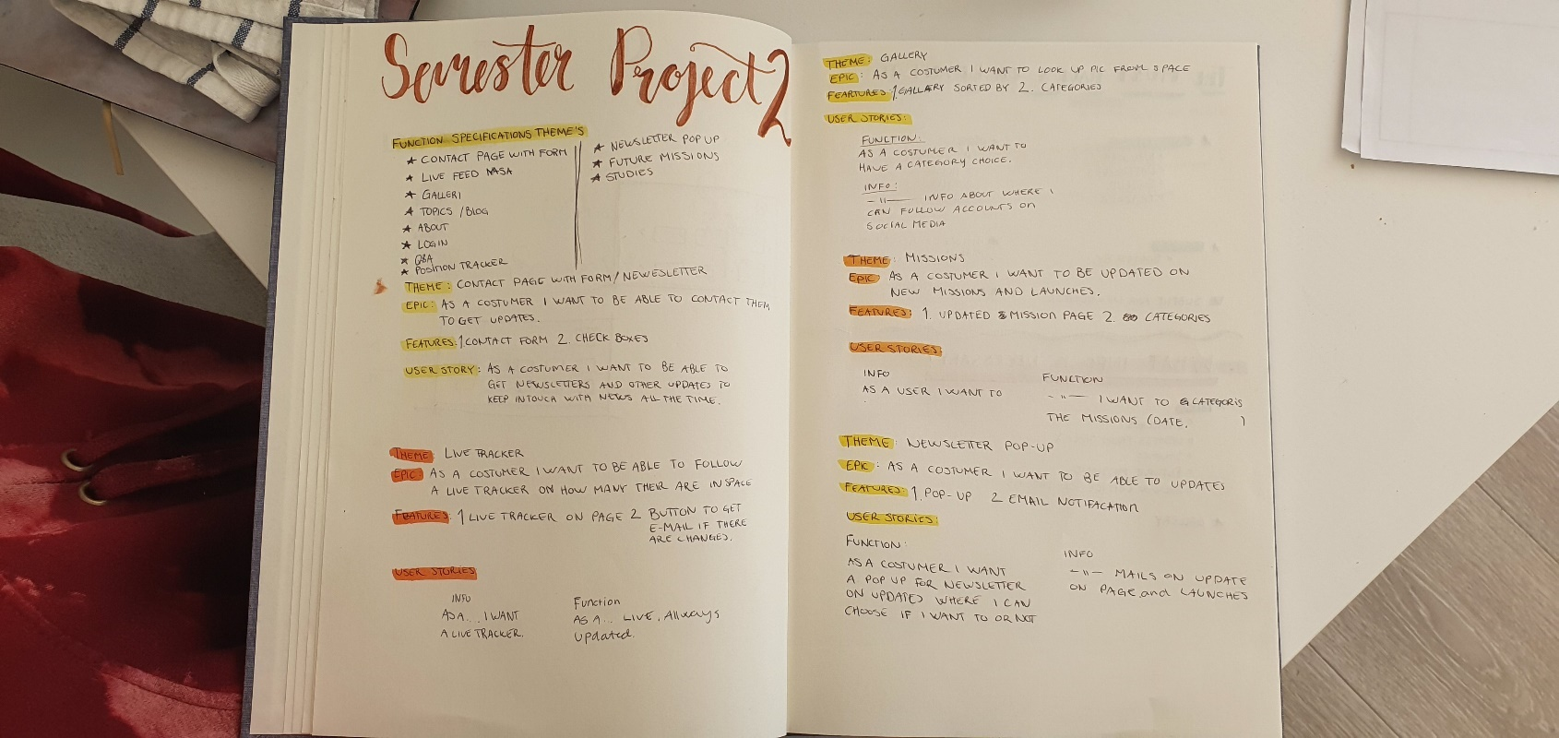

I used a few techniques we have learned about for personas. For example did I use card sorting. Writing down questions and making personas out of that.

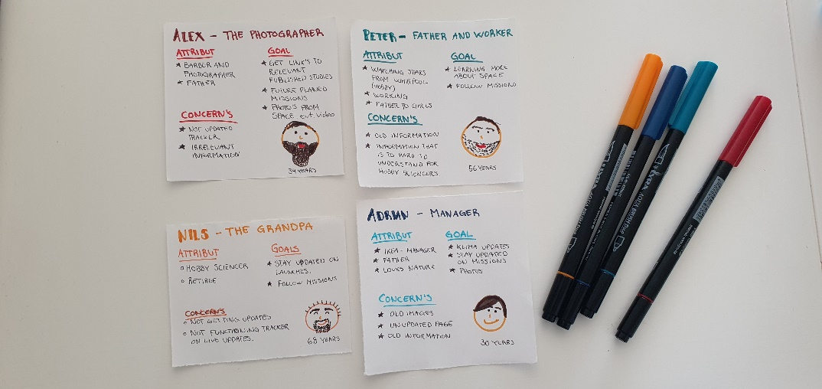

Because of time and the world situation I decided on contacting people over social media and have a conversation through that. I had quite a few people answering and telling med about there goals and concerns. I decided on focusing on 4 out of 10 personas.

The main goal was to be updated on launches. That’s something I was sure of before I even stared because that also sounded interesting for me if I was interested in space.

I started writing down elements I wanted to create on the page and if I am able to even create them with my known length in HTML, CSS and JavaScript.

I then started sketching a prototype on paper and in illustrator. To make have something to work after. I changed a few things during the process that I will write about later.

I decided on a pretty wide Target Audience 30-70 year’s old men. Space experts, teachers and retired space interested people. That’s definitely something I could worked out a little bit more.

2.2 Main Section of report

## DESIGN

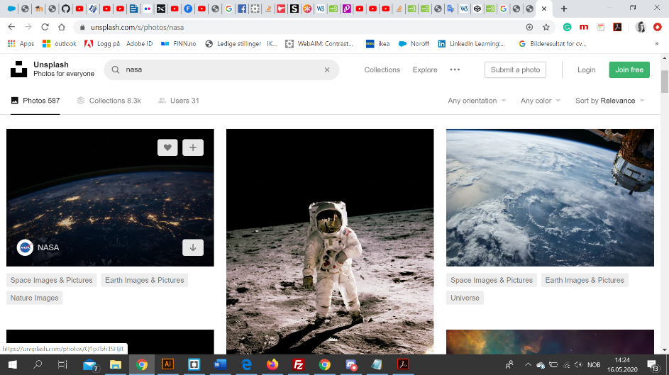

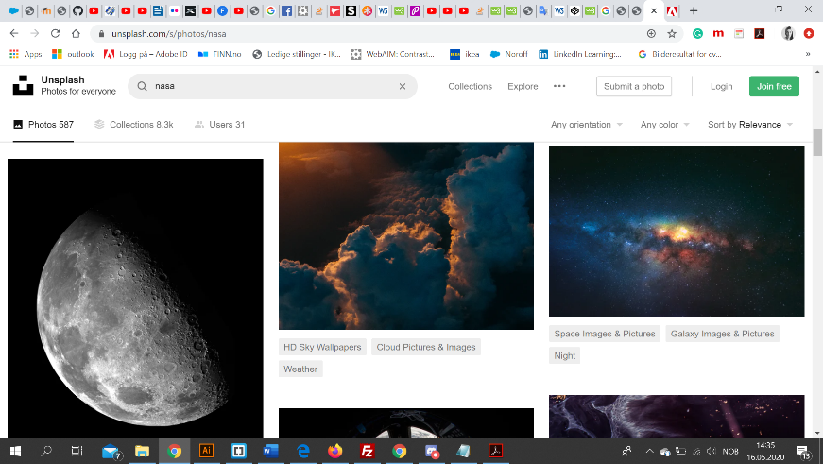

Unshapash.com color theme

I was looking up images from space to decide on a color theme. Out of that I made a few color themes In adobe color. I wanted to use “space” colors. What Is are the firsts colors that come to my head when I think about space I was asking myself. For me it was black, white, yellow, red and brown beige colors. That’s because, space suits are white, space is dark around, you have red details on the sutites, yellow because of stars and other lights. I also askes my personas to tell me what colors they thought of.

Also since it is a microsite for SpaceX I thought it was important to kind of get the same theme. So users recognize what it is for. The website is also really clean with only white and black.

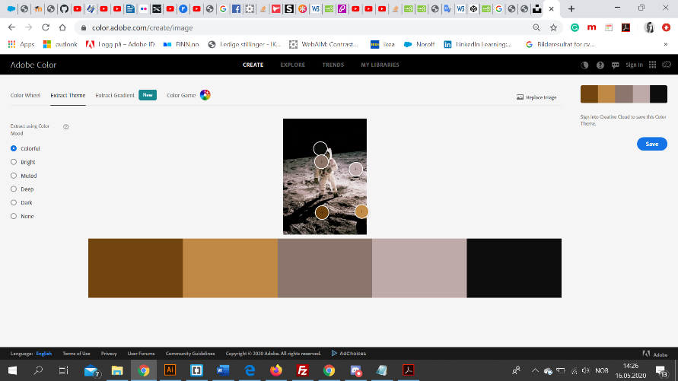

Out of this theme I created a WCAG friendly color theme for my microsite.

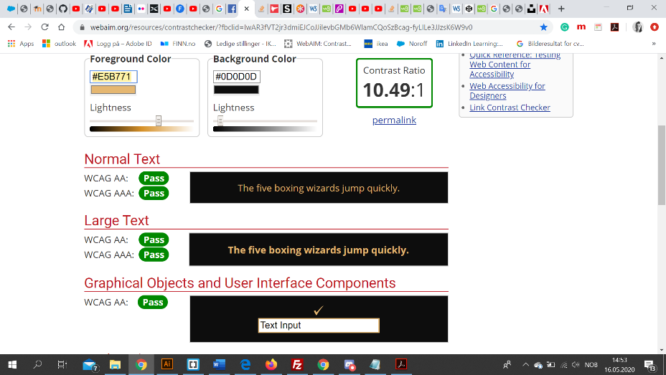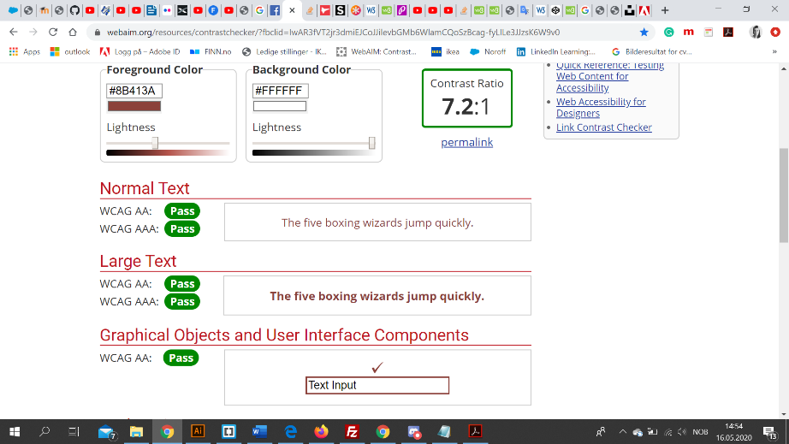

Those are the contrast colors I decides on for headings, menu or other elements. When the theme where ready I made a styletile. I had made that in earlier assignments and think it is really helpful through a process of designing.

I wanted the colors to make you feel invited to the website for kids and adults.

Colors a highly subjective. The color with the largest area is the dominant color, the background (lesson2.1, p 2). In my case it is the light matt Black it repeats on every page. The accent colors are those with a small relative area, they offer a contrast because of the vibration in hue, intensity, and saturation.

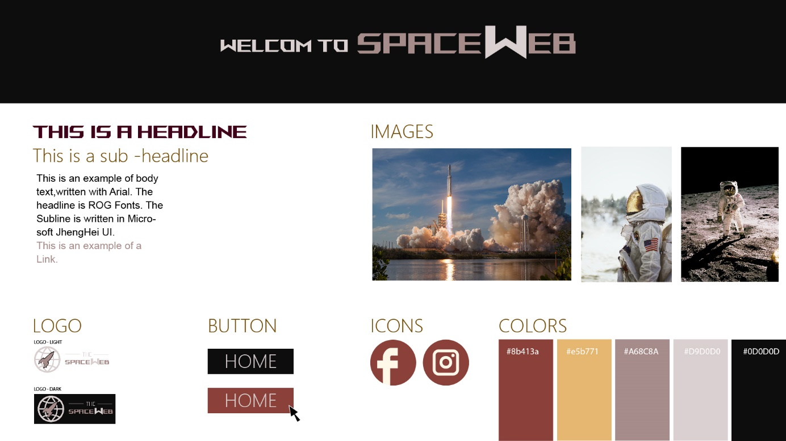

Styletile

I have to say I made a few changes though the process. I Choose some other Fonts. I also decided on creating my own logo and call my microsite for “SpaceWeb”

The name came to my head pretty quick, I didn’t want to use that much time on that eighter. I wanted to focus on the design and programming, so when the name was decided I started sketching and created the logo in Illustrator.





Logo 1 Logo 2

I created those two, but I decided on Logo 2, it fited my design much better so I choose that. Its simple and easy to understand.When it comes to the getalt theory I would say the logo has some kind of clousure, but also regualety and symmetry in it. Closure occurs when an object is incomplete or a space is not completely enclosed (Lesson 1,4, p.3) Regularity is about patterns and predictability. If the design uses regularity it creates a sense that the design is predictable and the elements follow a standard pattern (Lesson 1,4, p4).

With all those elements I made a wireframe for desktop and mobile.

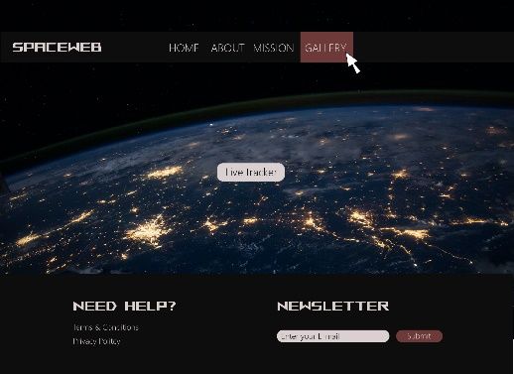

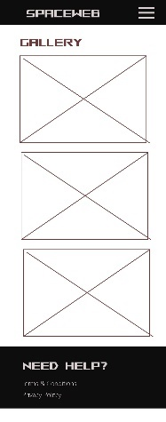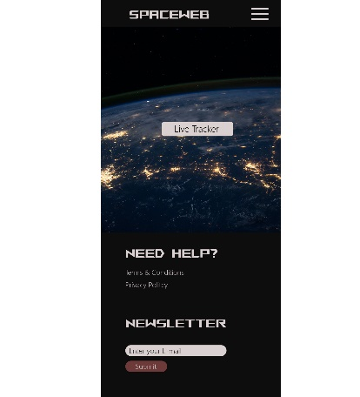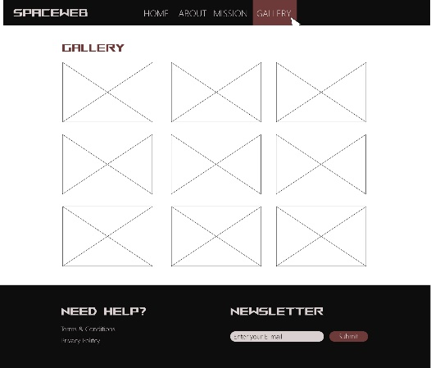

Examples on Gallery and homepage wireframe

Those two pages got pretty similar to the wireframe I made, I did change the Place of the navigation bar, to make It more balanced. I felt I got to much weight on the left site so I decided on putting it all to the right.

I will write more about the changes I made I the programming section later.

## programming

I started programming at the end of week 2 on Friday. I Like to do page by page, so I stared with the home page. I decided on to leave JavaScript elements for later. But I build everything around it for mobile and desktop device.

I started with creating the mobile version. That’s because certain elements need to be left out as a strict hierarchy is developed, but the rest of the site should be accessible in some way, so it allows the users to continue browsing (Lesson 1.3 p.3). My goal was to create a site that is easy to navigate and read. I also want the web standards to be important. People with hearing of eye disabilities should have the same experience as a person with no disabilities. Using descriptions of images and colors that function for everybody.

Users often come from links and not directly by searching the website. So, I use different meta tags on each page with descriptions that describe what you will get form that page.

Moving on to navigation I focused on primary navigation category, audience and task. And secondary navigation was a promotion, location, alphabetical order, and popularity.

I had a wireframe to work after, but decided early in the progress on some things I wanted to change. Like I wrote earlier the navbar went from center to the right site to create a better balance.

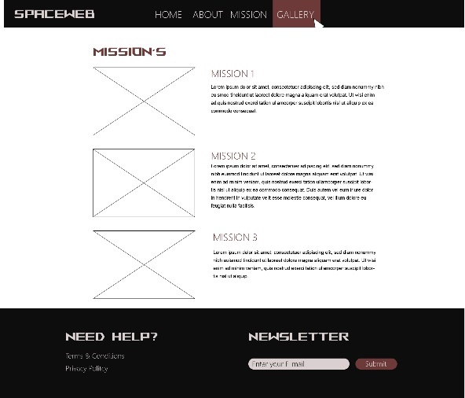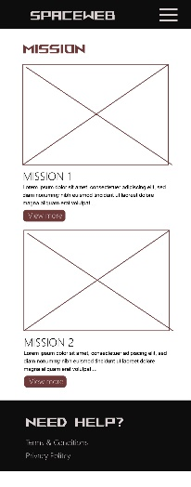

Wireframe Mission/Launches

Other changes I made was because of missing knowledge. On My launch page, I wanted images and text to different launches. I managed to create the text, year and rocket names. In that API I used there were no Images. But I didn’t know how to include a different API with images beside to the information cards.

I also tried to remove “null” from those elements that didn’t have a description.

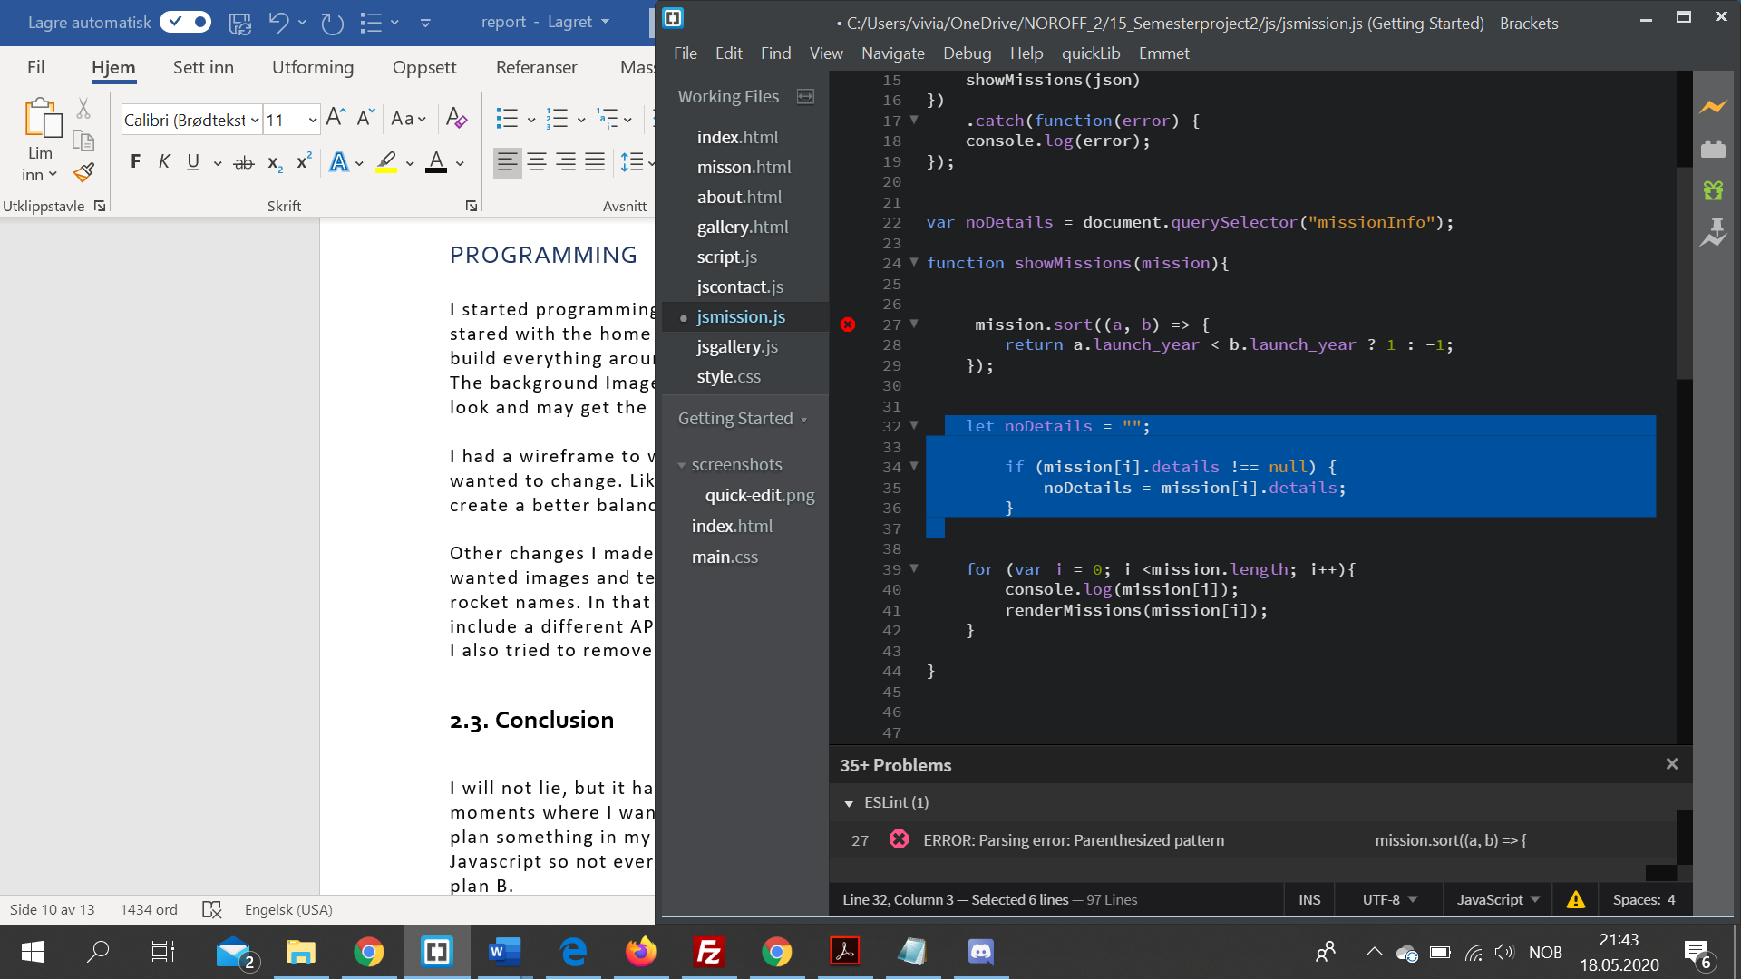

JavaScript code

At the end I want to say something about IP. If this website would go live, I would choose a secure IP it’s important to determine the location of the intellectual property assets of the company. Policies, processes, and agreements must be made to protect and enforce the IP (Lesson 1.1, p.12). You should be aware of copyright refers to the right to prevent the act of copying. It’s also important to give the owner fully attention to their values on their intellectual property and goals.

## 2.3. Conclusion

I will not lie, but it have been five stressful weeks. With a lot up’s and down’s, and moments where I wanted to give up on the project. I’m a perfectionsit and when I plan something in my head I want it to be like that. I this case I still struggle with Javascript so not everything I wanted to do I was able to create. I had to go with my plan B.

I will also say I’m proud of my work, I se the difference between earlier projects and now and I’m able to do a lot more then I did a few months ago.

I feel like the HTML and CSS part is getting easier for me and the project started good. I created a structure / grid and I implemented pictures and text. I think ist quite hard to create a responsive layout. My plan were to start with that, And I did, but ended up with making the desktop layout first. I still think I managed to create an OK responsive layout, but its also something I want to use more time on to get better at it.

In the palning fase I looked up old assignments and code eleents I used that I may wanted to use in this assignment to. That made it a lot easier for me.

I was moste afraid of starting the javaScript part. I googled a lot, and looked up a lot of videos and old lessons for the elements I wanted to create. It was the most frustrating part og the assignment. I managed to create the Countdown, but then it stopped working. Its quite hard for me to see whats wrong and it gave me a bad headche to make it work again. I also used Jquery for the pop-up element. I looked up a lot of videos for that, and I implemented a little bit of each to make it work. That was a element I wanted to include, but I didn’t find a way only using JavaScript code.

All in all I’m proud of my work. The microsite is functioning and responsive. It includes the requiered elements as using HTML, CSS and JavaScript. I Created four pages and I use API/JSON to get information.

# 3. References

Design 1 , Lesson 1,4, p.3 <https://cloudplayer-eu.bravais.com/preview?p=&lastCDSsessionCheck=1589968672839>

Design 1 , Lesson 1,4, p.4 <https://cloudplayer-eu.bravais.com/preview?p=&lastCDSsessionCheck=1589968672839>

Design 1 , Lesson2.1, p 2 <https://cloudplayer-eu.bravais.com/preview?p=&lastCDSsessionCheck=1589969397963>

Design 1, Lesson 1.3 p.3 <https://cloudplayer-eu.bravais.com/preview?p=&lastCDSsessionCheck=1589969591840>

Web and communication technology Lesson 1.1, p.12 <https://cloudplayer-eu.bravais.com/preview?p=&lastCDSsessionCheck=1589970014936>

# Images

Home background <https://unsplash.com/photos/Q1p7bh3SHj8>

About photo <https://unsplash.com/photos/OHOU-5UVIYQ>

About photo eventually <https://unsplash.com/photos/tKs_2sBoqAg>

Gallery images:

<https://www.flickr.com/photos/spacex/>

# Color

Link to check WCAG <https://webaim.org/resources/contrastchecker/?fbclid=IwAR3fVT2jr3dmiEJCoJJilevbGMb6WlamCQoSzBcag-fyLILe3JJzsK6W9v0>

Color theme inspo <https://unsplash.com/photos/0o_GEzyargo>

Color theme inspo <https://unsplash.com/photos/e5eDHbmHprg>

Color theme inspo <https://unsplash.com/photos/dBaz0xhCkPY>

Creating color themes <https://color.adobe.com/mythemes>

# Javascipt

Pop- up window help <https://www.youtube.com/watch?v=pMKO9opvdWk>

How to use JQuery CDN<https://www.w3schools.com/jquery/jquery_get_started.asp?fbclid=IwAR19UQv1mAcvopgZQ2-iYlxQvSSrUVkBq2fDcCU2_dY4ZwrZ0il46kfLg5I>

# Research

What is a microsite <https://www.bluleadz.com/blog/microsite-vs-website-what-is-the-difference>

# API

API til SpaceX<https://docs.spacexdata.com/?version=latest>

# 4. Acknowledgements

Start writing here

# 5. Appendices

Start writing here