Target Audience
Between 30-70 years, mostly men.
- Educated
- Hobby science
- Space interested
- Teachers and students

Logo design


Function specifications

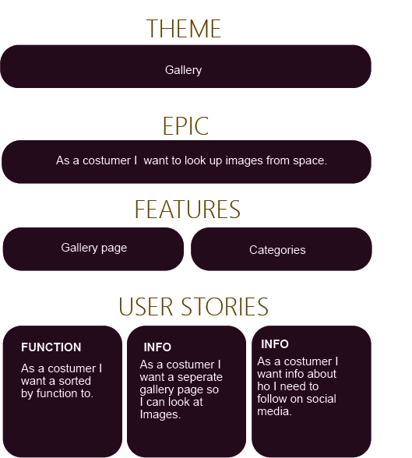

Function specifications
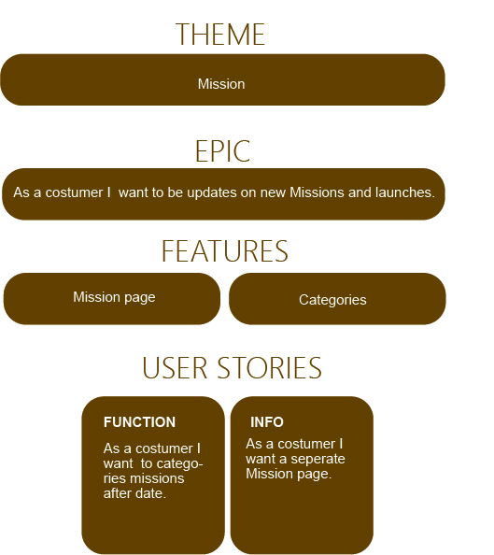

Function specifications
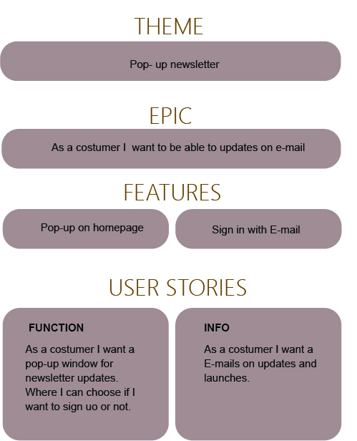

Persona

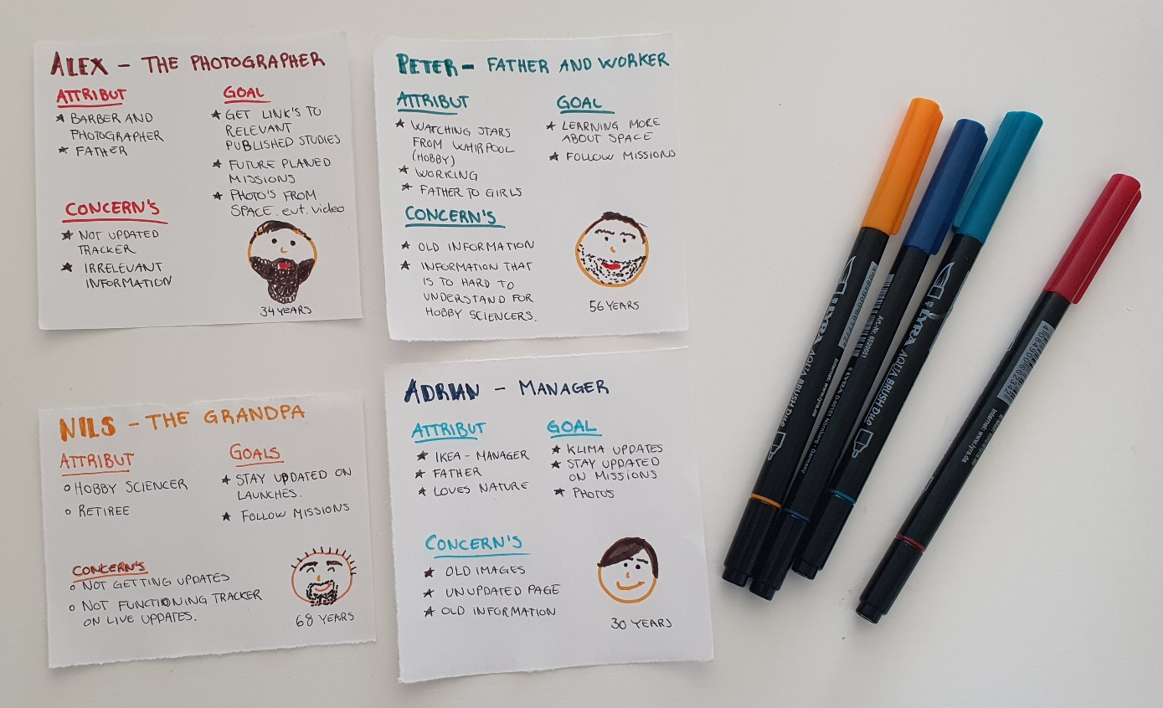
I decided to focus on those 4 personas, as I think this where the most helpful goals and concerns for my website.

Styletile

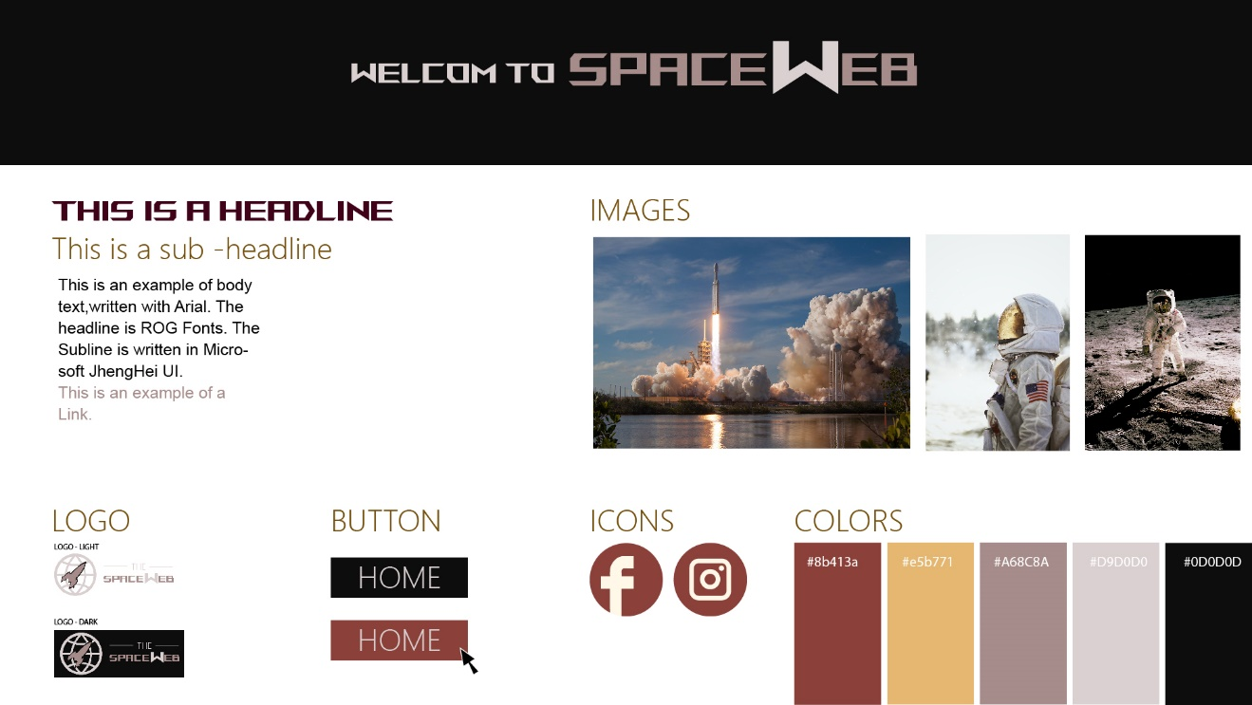

Wireframe
DESKTOP

HOME
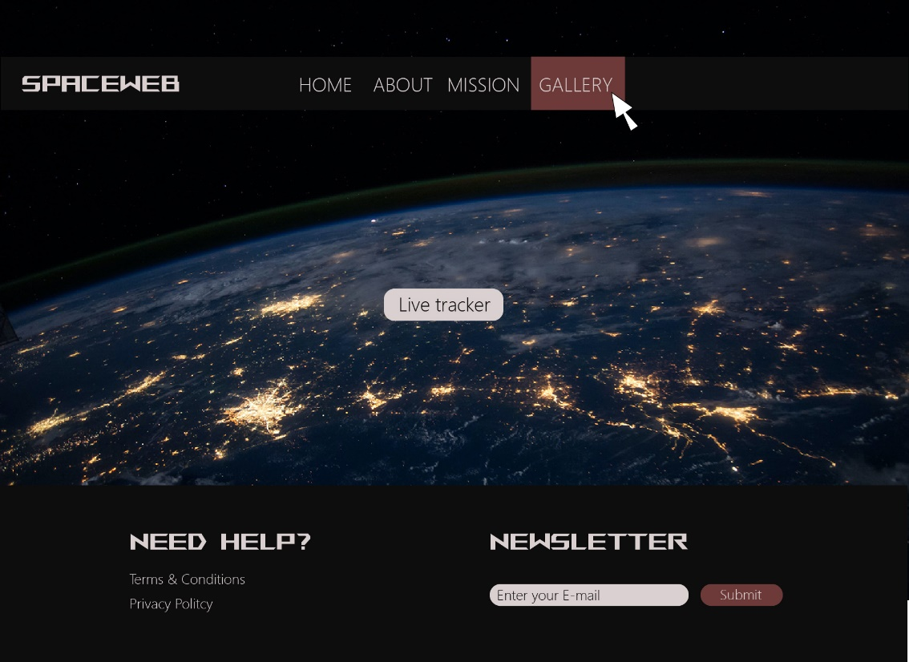

ABOUT
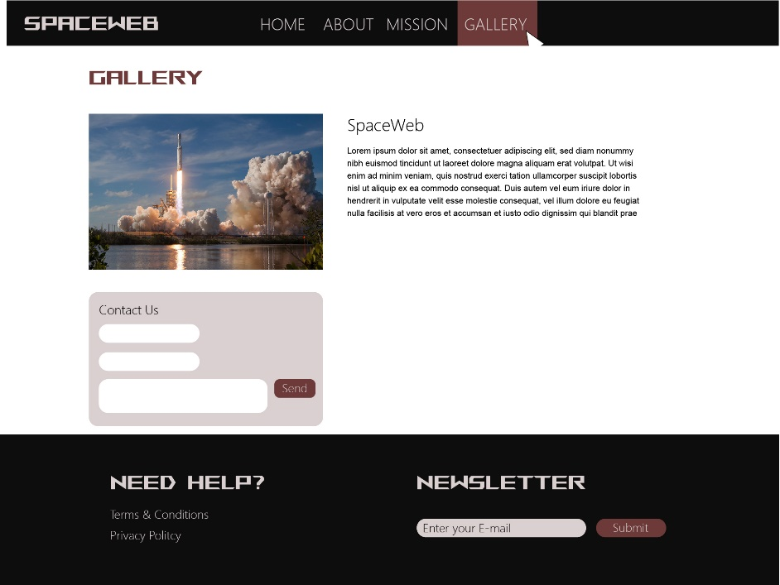

MISSION
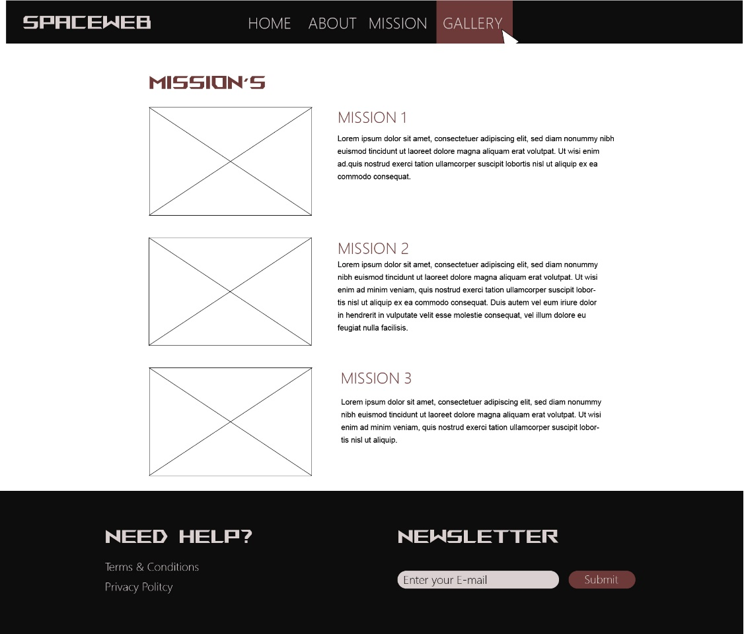

GALLERY
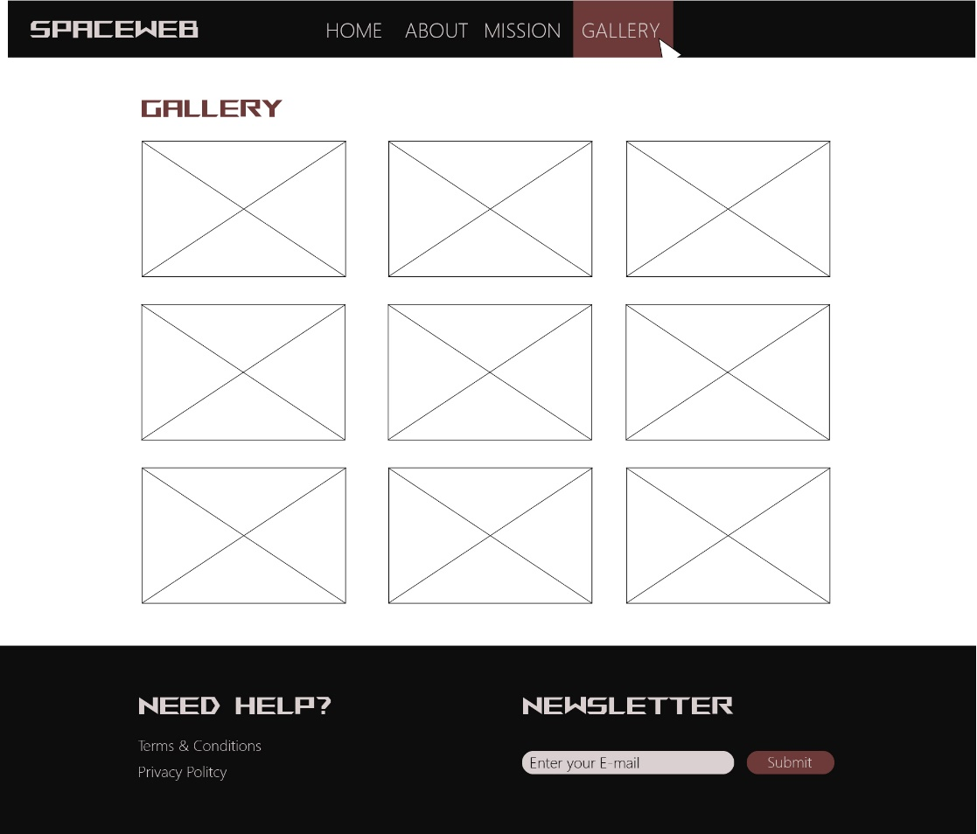
MOBILE

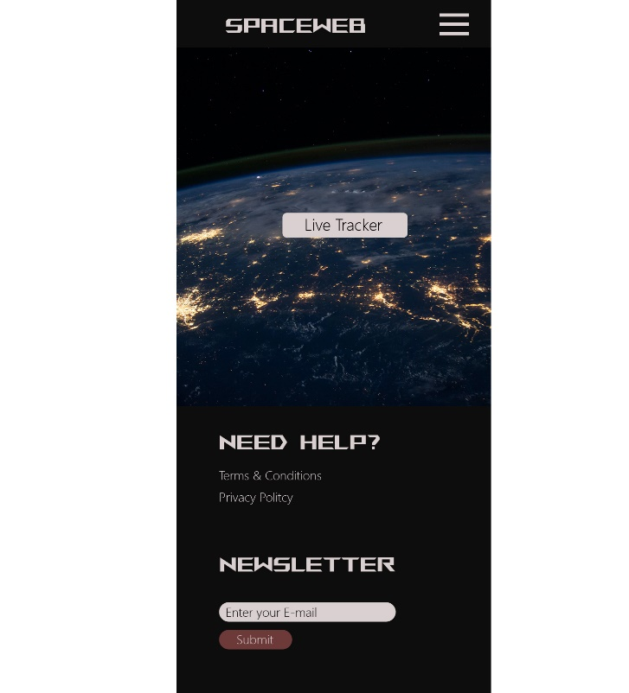
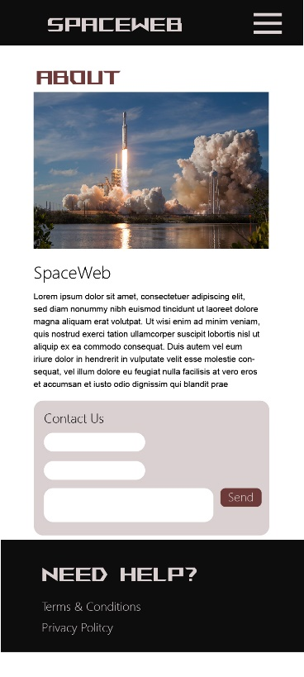
HOME ABOUT

MISSION GALLERY

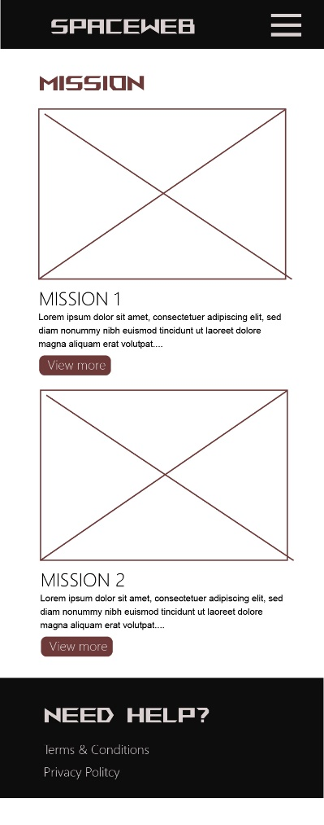
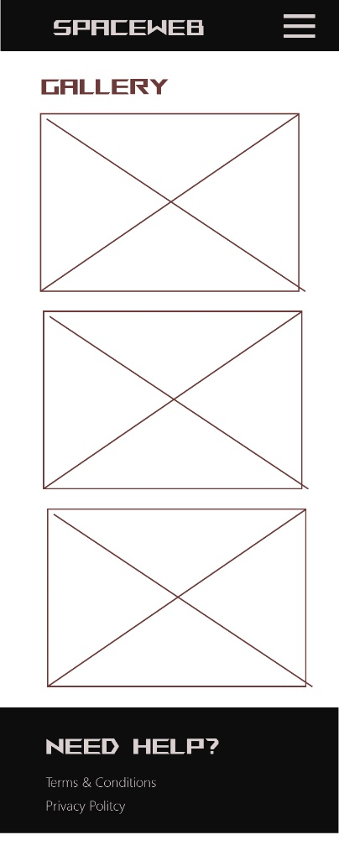

Feedback on the last delivery

The bug fix was included in the last Gantt Chart I delivered.
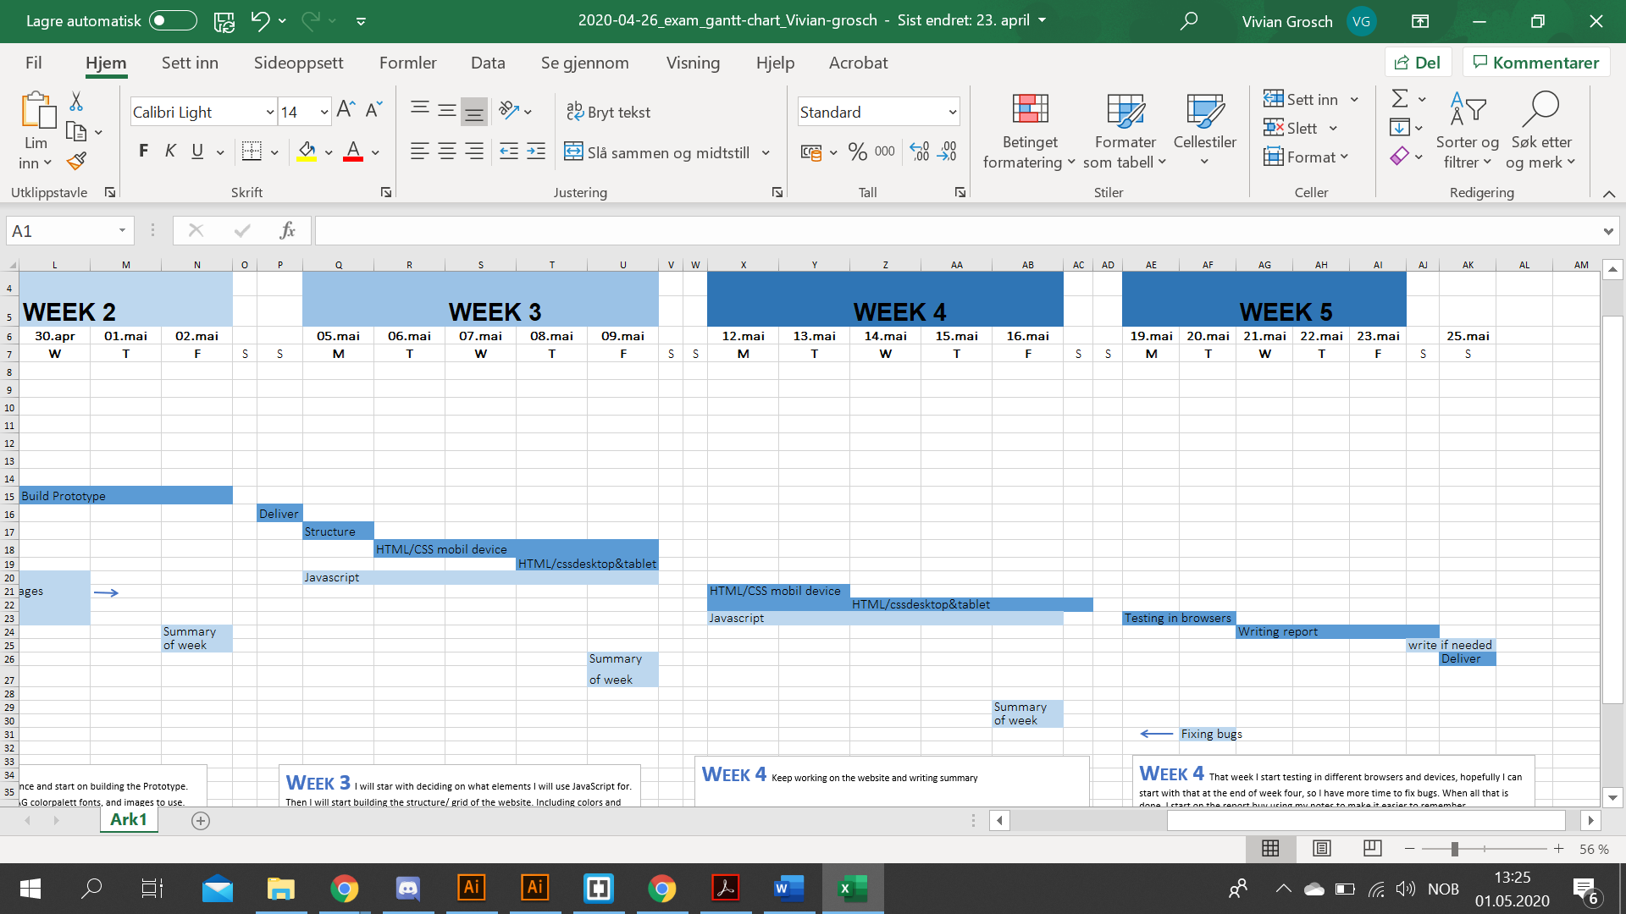

And the function specifications where ready to, but in on of the Discord groups, a teacher wrote it was ok to deliver the next week, so I guess I misunderstood that.


