Task 2 — Values Audit
Strait Compliance Pte. Ltd.
A Jurisdiction-Aware AML Transaction Monitoring Tool



1. Company Mission, Stage, Scope
Hypothetical company: Strait Compliance Pte. Ltd.
Headquarters: Singapore (with a small US presence in New York, opened to support correspondent banking clients in the New York USD-clearing market).

Mission statement

Strait Compliance helps banks running cross-border USD and SGD corridors detect financial crime that single-jurisdiction monitoring systems were never built to see, and to do so in a way the bank’s regulator can verify, not merely accept.

Core values
- Catching crime is the only durable form of compliance. A monitoring system that produces clean alerts but misses real layering will lose its client a banking license. We optimize for genuine detection first, examiner-friendliness second.
- Explainability is not the same as documentation. A SHAP plot that a bank examiner can interrogate is worth more than a 200-page policy manual nobody reads. We invest in the former and refuse to sell the latter.
- We accept that we cannot serve everyone. Tier-1 banks build in-house; Tier-4 banks cannot afford us. We sit in the middle, and we will not pretend our tool fits jurisdictions we have not properly studied.
- Jurisdictional honesty. Where US and Singapore rules contradict each other (and they sometimes do), the system must say so to a human operator, not silently pick the more permissive one.

Honest scope (strengths and weaknesses side-by-side):
What we are good at | What we are not good at
• Cross-currency transaction-flow stitching (USD/SGD/HKD/MYR). | • We do not do KYC onboarding (no biometric liveness, no document verification at origination).
• Explainable ML alerting — every alert ships with feature attributions. | • We are not a sanctions screening engine. We consume OFAC / MAS-TFS / UN feeds but do not maintain them.
• Fast core-banking integration via a thin event-bus connector. | • Our EU AMLD coverage is weak; we plan to address it in 2027, not before.

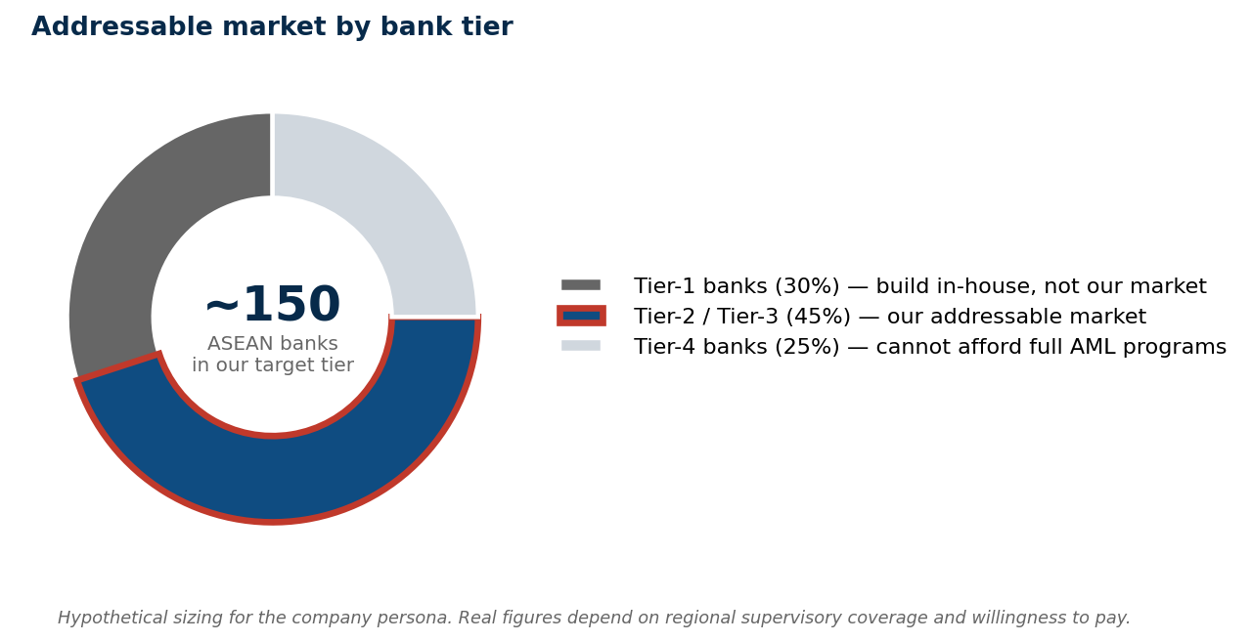
Figure 1. Addressable market by bank tier. The company persona targets Tier-2/3 ASEAN banks specifically (~150 institutions); Tier-1 build in-house, Tier-4 cannot fund a full AML program.

2. Whose Perspective Does the Tool Serve?

Primary perspective — the paying client (the bank’s MLRO and CCO)
The bank’s Money Laundering Reporting Officer signs the cheque. Without their endorsement, the product does not get bought.
Secondary perspective — the regulator, but only via the MLRO
We design the system so that an MAS examiner or an OCC examiner can pick up a typology, an alert, or a SAR/STR and trace it backward to the input data and the model’s reasoning. We do this because:
- (a) the MLRO benefits when the system survives examination, so this aligns with the primary perspective; and
- (b) It is the only operational way to make the “regulator’s perspective” influence design — we cannot sell to MAS, but we can make sure the MLRO is not embarrassed by us in front of MAS.

Tertiary perspective — the consumer (underserved, and we should be honest about that)
The consumer most affected by our tool is the small business or remittance customer who gets debanked due to a false-positive alert. Our tool, used aggressively, reproduces this harm.

The genuine tensions, with evidence
Tension | Who pulls which way | Evidence
Speed vs caution | Bank wants real-time alerting (fewer transactions blocked in flight). Regulator wants thorough investigation (which is slower). | The 2023 Singapore S$3B case: legitimate-looking accounts moved funds for years across multiple banks; near-real-time review would have caught it earlier, but no bank was incentivised to slow its onboarding.
Jurisdictional contradiction | US OFAC says block. Singapore MAS may say the same wire is fine domestically. | OFAC’s extraterritorial reach via USD clearing means a Singapore-domestic SGD transfer that touches a USD correspondent leg is suddenly a US-jurisdiction transaction — even though no Singapore rule was violated.

What drove the choice
- We chose US + Singapore as the first jurisdictional pair because (a) every USD-clearing wire from Singapore touches US jurisdiction, whether the bank likes it or not, so the pair is operationally unavoidable for our customers, and (b) the Standard Chartered case file is the obvious public reference for the failure mode, sits exactly in this corridor.
- We did not choose to build for the consumer’s perspective, and we should be honest that this is a commercial choice, not an ethical one. A consumer-protection tool would need to be paid for by a regulator or a foundation, not by a bank, and we have not raised that kind of capital.

3. Genuine Risk vs Documenting Compliance

Feature INCLUDED for substance, not required: cross-corridor alert stitching
What it is: the system links alerts that look benign in any single payment corridor but, together, form a recognizable pattern of layering or structuring. Concretely, a USD wire from a Singapore SME’s USD account through New York correspondent clearing, followed within 72 hours by an SGD transfer of similar magnitude to an apparently unrelated counterparty that nonetheless shares a beneficial owner one or two corporate hops away — none of these legs alone trips a single-corridor rule. Stitched together, they fit a layering pattern.
Why is this not required by either jurisdiction?
- US BSA SARs are filed per institution, per identified suspicious transaction or pattern. There is no rule requiring cross-corridor or cross-currency stitching.
- MAS Notice 626 likewise frames suspicion at the institutional level; correspondent-banking review is required, but cross-corridor chaining is not specified.
Why we built it anyway: Standard Chartered and the 2023 Singapore S$3B cases share a structural feature — the laundering succeeded because each leg of each transaction looked normal within its corridor. Detection failed at the seam between corridors, not within any one corridor. A rule-of-thumb truth: regulators write rules for the failure mode they last saw; layering moves to the failure mode they have not yet seen. Stitching is our attempt to detect the next mode rather than the last one.

LLM-generated SAR/STR narratives
What competitors offer: Several AML vendors now sell “GenAI drafts your SAR/STR narrative” features. The pitch is that the LLM reads the transaction history, summarises the suspicion, and produces a narrative that the MLRO can edit and file.
Why we refuse:
- OCC Bulletin 2026-13 explicitly excludes GenAI and agentic AI from its model-risk-management framework. OCC 2026-13 is supervisory guidance, not a legal prohibition on LLM-assisted SAR drafting, but its lack of clarity on GenAI creates governance ambiguity. A bank that uses LLM-drafted SARs lacks a clear prudential MRM regime, placing a heavier burden on justifying their use. We prefer not to transfer that burden onto our customers.
- A SAR/STR narrative is the regulator’s primary evidentiary entry point. The narrative is what an FBI agent or STRO investigator reads first. Outsourcing that text to an LLM produces fluent, plausible-but-shallow stories exactly the failure mode the lecture deck names: “compliant-looking” rather than “true.”
- What we do offer instead: a structured-template SAR/STR scaffold that pre-fills factual fields (account numbers, transaction IDs, counterparty data, alert reason codes from the model) but explicitly leaves the narrative free-text fields blank for the human investigator to author. The scaffold is examiner-friendly; it is not author-replacing.

4. Who Bears the Cost If the Tool Gets It Wrong?
There are three canonical failure modes for an AML monitoring tool. Each lands on a different stakeholder, and each deserves a specific name rather than a generic “stakeholders may be affected” phrasing.

(a) False positive — the tool flags a legitimate customer
- Specific harm: the customer’s account is frozen pending review, or closed outright; downstream payments to suppliers and employees fail; the customer’s relationship with their wider banking network is damaged because debanking from one bank often triggers exit from others.
- Specific stakeholder most affected: Small and medium-sized exporters in correspondent corridors face higher risks. An Indonesian textile manufacturer paying in USD through Singapore is more likely to be flagged than a Singapore-based multinational due to country-of-counterparty risk in AML rules. This has led banks to exit entire corridors, pushing legitimate flows into the informal sector.

(b) False negative — the tool misses genuine financial crime
- Specific harm: sanctioned-state actors, drug-trafficking proceeds, or human-trafficking funds pass through the bank and reach their downstream destinations.
- Specific stakeholder most affected: the victims of the underlying crime — civilians in sanctioned states whose elites are exfiltrating wealth, trafficking victims whose payments are being laundered, and communities harmed by narcotics flows. Less visible than a debanked SME, far more harmful in absolute terms.

(c) Jurisdictional misconfiguration — the tool applies the wrong rule
This is the most catastrophic failure mode for a jurisdiction-aware tool, because it is the one our value proposition is supposed to prevent.
- Failure shape A — overzealous US application to a Singapore-domestic transaction: the system applies OFAC SDN screening to a Singapore-domestic SGD transaction with no US nexus. The customer is wrongly blocked. Specific harm: acceleration of debanking in the SGD domestic market. Specific stakeholder: Singapore SME or individual customer.
- Failure shape B — under-application to a USD-clearing wire routed through Singapore: The system treats a USD wire as a Singapore-domestic flow under MAS suspicion-based STR, overlooking that its USD-clearing leg in New York subjects it to US OFAC and BSA regulations. The wire may warrant a SAR filing due to suspicion ($5,000 USD under 31 CFR 1020.320(a)(2)) and could involve a sanctioned counterparty, but it doesn’t trigger action on the US side due to the lack of US nexus recognition. This results in missed SAR filing and possible sanctions issues, putting the bank’s NY correspondent relationship at risk. The New York branch is the primary stakeholder, and, given past actions by NY DFS against Standard Chartered, repeated compliance failures could lead to severe consequences.
- Failure shape C — silent contradiction between regimes: OFAC sanctions a counterparty that MAS does not. The system must surface the contradiction to a human, not silently pick. If we silently apply the more restrictive rule (over-block), we debank a lawful Singapore customer. If we silently apply the more permissive rule (allow), we expose the bank’s NY branch.

Failure-mode summary (which stakeholder, which harm):
Failure mode | Most affected stakeholder | Specific harm
(a) False positive | SME exporters in correspondent corridors | Frozen/closed accounts; downstream payment failures; cross-bank debanking cascade.
(b) False negative | Victims of the underlying crime (sanctioned-state civilians, trafficking victims, narcotics-affected communities) | Crime proceeds reach their destination; harm is invisible in customer-satisfaction surveys.
(c) Jurisdictional misconfiguration | Bank’s NY branch; SG SME customers; lawful-but-flagged corporates | Mis-applied OFAC, missed BSA scope, or silent over/under-block in regime contradictions.

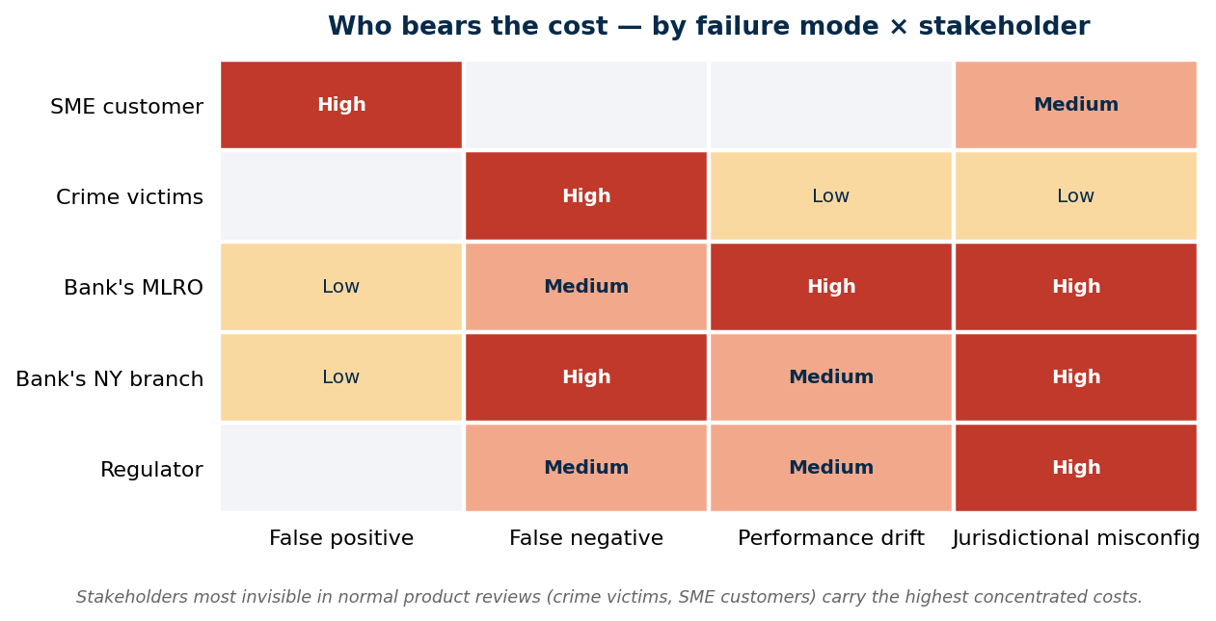
Figure 2. Stakeholder cost concentration by failure mode. Crime victims (FN) and SME customers (FP) — the parties least represented in standard product reviews — bear the most concentrated harms.

