Task 2 Validation Findings
Strait Compliance — Values Audit

Overall assessment
The document is materially stronger than Task 1. Its main issues are narrower and concern (i) one repeated Singapore regulatory error, (ii) two legal overstatements around OCC Bulletin 2026-13 and reputational-risk policy, and (iii) one scope inconsistency around AML/KYC versus the actual product boundary. The document is not fundamentally unsound, but it should be tightened before submission.

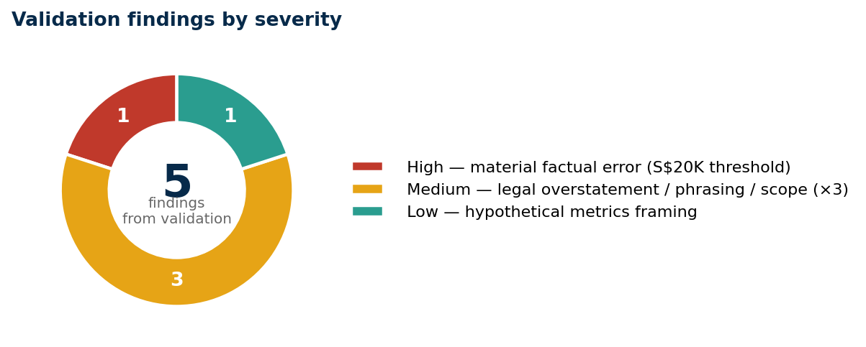
Figure 1. Validation findings by severity. One material factual error (high), three phrasing or scope adjustments (medium), and one framing recommendation (low).

The five findings in brief
# | Finding | Severity
1 | S$20,000 general bank threshold (Failure shape B) | High
2 | OCC Bulletin 2026-13 conclusion too strong (prima facie unreasonable) | Medium
3 | Reputational-risk wording overspecified (post-2026 reputational-risk rule) | Medium
4 | "AML/KYC" label does not match the actual product scope | Medium
5 | Hypothetical commercial metrics read as factual claims | Low

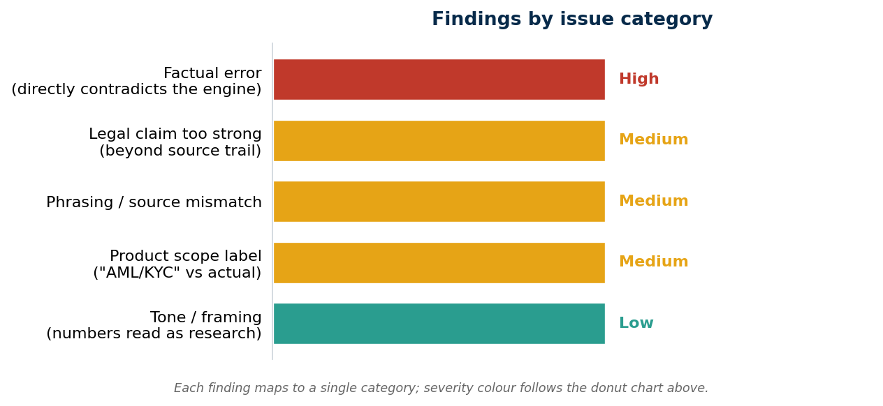
Figure 2. Findings by issue category. No single category dominates — the patches needed are surgical, not structural. Severity color matches Figure 1.

Detailed findings
1. S$20,000 general bank threshold (HIGH)
Where: Failure shape B in section 4(d).
Why: The repo's verified position (see worker/RULES_VERIFICATION.md and worker/config/sg.yaml) is that Singapore banks have no general bank cash transaction reporting threshold. The S$20,000 figure belongs to PSPM-related reporting, not MAS Notice 626. The example was also miscast: a CTR is a cash reporting requirement, not a wire-transfer threshold.
Fix: Rewrite Failure shape B around the actual divergence (USD-clearing-via-NY scope mis-recognition vs SG suspicion-based STR), with §1020.320(a)(2) SAR and OFAC SDN as the under-application risks. Status: APPLIED.

2. OCC Bulletin 2026-13 — "prima facie unreasonable" (MEDIUM)
Where: Section 3, refusal of LLM-drafted SAR/STR feature.
Why: OCC 2026-13 is supervisory guidance, not a direct legal prohibition on LLM-assisted drafting. The exclusion of GenAI creates governance ambiguity, not an automatic finding of unreasonableness.
Fix: Reframe as governance ambiguity + heavier self-justification burden, retaining the decision to refuse the feature. Status: APPLIED.

3. Reputational-risk policy phrasing (MEDIUM)
Where: Closing paragraph of section 4(d).
Why: The verified source is White House EO 14331 (Aug 2025) with a 180-day implementation window for agencies — not an "April 2026 interagency rule" as written.
Fix: Track the executive-order source exactly. Status: APPLIED.

4. "AML/KYC" label vs actual scope (MEDIUM)
Where: Section 2 commercial-honesty paragraph.
Why: The same document excludes KYC onboarding (no biometric, no document verification) and integrates with specialist providers. The AML/KYC label is broader than the product.
Fix: Narrow to "AML transaction monitoring (with related CDD/EDD and case-management implications)," with an explicit "not a full KYC-onboarding tool" line. Status: APPLIED.

5. Hypothetical commercial metrics framing (LOW)
Where: Section 1 stage/headcount/aspirations.
Why: The specificity of Series B amount, customer counts, ARR, TAM read like externally validated research rather than planning assumptions.
Fix: Tag the blocks with "(hypothetical planning figures for the assignment — not externally validated)". Status: APPLIED.

Bottom line
Mostly sound. The main patch was surgical — remove the repeated Singapore threshold error and tone down two legal claims that previously went further than the available support. All five findings have been applied to the source document.

