Task 1 — Selection and Research
A Jurisdiction-Aware AML Transaction Monitoring Tool

Regulated Group: Standard Chartered
Jurisdictions: United States | Singapore
Domain: AML Transaction Monitoring

1. Regulated Group: Standard Chartered

Why Standard Chartered, specifically
The reference institution for this project is the Standard Chartered group, with two named operating entities corresponding to the two jurisdictions in scope:
- Standard Chartered PLC — the FTSE-100, UK-headquartered listed parent company.
- Standard Chartered Bank, New York Branch — the federally licensed US branch.
- Standard Chartered Bank (Singapore) Limited — the locally incorporated Singapore subsidiary.
Wherever the analysis below refers to “the bank” or “SCB,” the relevant operating entity is the NY branch on the US side and the locally incorporated Singapore subsidiary on the SG side. The group-level parent (“PLC”) is the consolidated supervisory unit at the UK level but is not itself the AML-regulated entity in either of the two jurisdictions in scope.
The group has two characteristics that make it an unusually instructive subject for a jurisdiction-aware AML/KYC tool:
- It operates at the systemic scale on both sides of the chosen jurisdictional pair.
  - United States: Standard Chartered Bank, New York Branch is a federally licensed branch supervised by the Federal Reserve Bank of New York and the New York State Department of Financial Services (NY DFS). The branch is one of the larger non-US banks clearing US-dollar payments through CHIPS and Fedwire.
  - Singapore: Standard Chartered Bank (Singapore) Limited is a locally incorporated bank under Section 7 of the Banking Act, supervised by the Monetary Authority of Singapore (MAS). Singapore is one of SCB’s two largest hubs (alongside Hong Kong) and houses the bank’s ASEAN regional infrastructure.
- It has a documented, recent history of AML/sanctions failures across both regimes. This is not a hypothetical compliance challenge:
  - 2012 — US$327M penalty (US DOJ, Federal Reserve, NY DFS, OFAC) for systematic stripping of identifying information from USD wires linked to Iran sanctions.
  - 2014 — US$300M NY DFS penalty for AML transaction-monitoring failures that the bank had been ordered to fix in the 2012 consent order — a remediation failure, not a primary failure.
  - 2019 — US$1.1B aggregate settlement (US DOJ, Federal Reserve, OFAC, NY DFS, UK FCA) for further sanctions violations affecting Iran, Burma, Sudan, and Cuba.
  - 2023–2024 — MAS strengthened Notice 626 enforcement following the S$3B Singapore money-laundering case, in which several SCB accounts were among those used (along with accounts at multiple other banks).
The repeated remediation failures matter for a RegTech argument: SCB has spent more than a decade investing in AML monitoring and still gets penalized. That is exactly the gap a jurisdiction-aware tool is supposed to close.

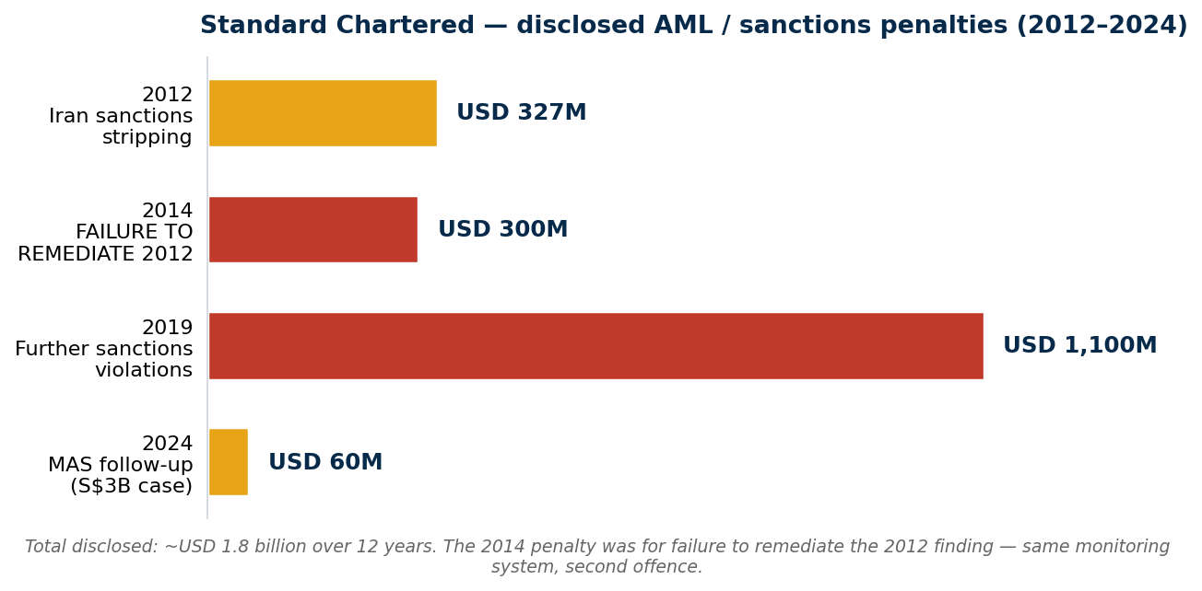
Figure 1. Standard Chartered's disclosed AML / sanctions enforcement history (2012–2024). The 2014 penalty was for failure to remediate the 2012 issue — the architectural blind spot in cross-jurisdictional monitoring that this tool is designed to address.

2. Domain: AML Transaction Monitoring

Why AML transaction monitoring specifically
This project is scoped to AML transaction monitoring, and the customer due diligence (CDD/EDD) data points it consumes: counterparty PEP status, sanctions list match, beneficial ownership chain, and customer risk rating. It is not a full KYC onboarding tool: biometric capture, identity-document verification, and KYB onboarding workflows are out of scope.
The lecture material covers six possible domains. AML transaction monitoring was selected for two reasons:
- It is the largest extant RegTech segment. Industry estimates put AML transaction monitoring and KYC tooling at roughly 30–40% of global RegTech spend. The buyer (the bank’s MLRO and CCO function) is established and has a budget line.
- It is one of the few areas where the 2025–2026 US deregulatory wave has not gutted the mandate. One of the key points in this lecture indicates that fair-lending and reputational-risk RegTech tools have lost their regulatory basis in the US. In contrast, AML is still rooted in the Bank Secrecy Act (1970), the USA PATRIOT Act (2001), and the Anti-Money Laundering Act of 2020, all of which remain intact. The removal of “reputational risk” concepts from federal supervisory materials (White House EO 14331, August 2025) complicates AML by eliminating supervisory support for de-risking valid customer categories.

3. Regulatory Divergence — United States vs Singapore
The two jurisdictions agree on the FATF baseline (both are FATF members in good standing). They diverge on almost every implementation detail. The table below maps the divergences a jurisdiction-aware tool must encode.

Table 1 — Nine dimensions of US / Singapore AML regulatory divergence
# | Dimension | United States | Singapore
1 | Primary AML statute | Bank Secrecy Act (1970, codified at 31 U.S.C. § 5311 et seq.); USA PATRIOT Act (2001); Anti-Money Laundering Act of 2020 (AMLA, in NDAA 2021). | Corruption, Drug Trafficking and Other Serious Crimes (Confiscation of Benefits) Act 1992 (“CDSA”); Terrorism (Suppression of Financing) Act 2002 (“TSOFA”).
2 | Lead administrator | FinCEN (administration); OCC, Fed, FDIC, NCUA (prudential examination); OFAC (sanctions); IRS-CI (criminal). Plurality of regulators. | Monetary Authority of Singapore — single integrated regulator. Suspicious-transaction filings go to the Suspicious Transaction Reporting Office (STRO) within the Singapore Police Force’s Commercial Affairs Department.
3 | Suspicious activity reporting threshold | SAR mandatory if a transaction is suspicious and aggregates ≥ US$5,000 (banks), ≥ US$2,000 (MSBs). Filed with FinCEN within 30 days. | STR has no monetary threshold under CDSA s.45 (formerly s.39 pre-2024); any reasonable suspicion triggers the duty, regardless of amount. Filed with STRO.
4 | Currency transaction reporting | CTR mandatory for cash transactions > US$10,000 in a business day (FinCEN Form 112; 31 CFR §1010.311). | No general bank cash transaction reporting threshold. Singapore banks rely on suspicion-based STR for cash flows. The S$20,000 figure that appears in some compliance guides comes from the Precious Stones and Precious Metals (Prevention of Money Laundering and Terrorism Financing) Act 2019 — that threshold applies to PSPM dealers and to banks only when handling cash for that narrow category, not to ordinary bank cash flows.
5 | PEP scope | “Senior Foreign Political Figure” (31 CFR 1010.605) primarily refers to foreign PEPs; domestic PEPs are not formally defined under federal AML rules. | MAS Notice 626 takes a broader-than-US approach to PEP coverage, generally including foreign and domestic PEPs as well as senior officials of international organizations.
6 | Sanctions regime | OFAC primary sanctions are extraterritorial via USD clearing—any USD-denominated wire that touches the US correspondent network is in scope. SDN list, sectoral sanctions, 50% rule. | MAS Targeted Financial Sanctions implement UN Security Council resolutions and MAS-specific designations. No extraterritorial reach equivalent to OFAC. This is the single biggest operational divergence.
7 | Beneficial ownership | Corporate Transparency Act (CTA) BOI reporting at FinCEN — enacted in 2021, came into force in 2024, but largely paused/de-prioritized under the current US administration in 2025. Effective coverage uncertain at submission. | ACRA Register of Registrable Controllers (RORC) — established under the Companies Act since 2017, accessible to law enforcement and regulators, and in active enforcement. Enforced and stable.
8 | AI in compliance models | OCC Bulletin 2026-13 (Apr 2026) — principles-based MRM explicitly excludes GenAI and agentic AI “due to their novel and rapidly evolving nature.” Replaces SR 11-7. Applies to banks > US$30B. | MAS FEAT Principles (2018) + MAS Veritas methodology (Phases 1–3, 2021–2024) + MAS consultation on agentic AI (2024–2025). Comprehensive AI-specific governance.
9 | 2026 direction of travel | Mixed — AML core stable, but the Apr 2026 interagency rule prohibiting supervisory use of “reputational risk” cuts off one of the historical justifications for de-risking lawful-but-disfavoured industries (crypto, cannabis, payday). Net effect: ambiguity about how aggressively banks should off-board high-AML-risk lawful customers. | Tightening — the post-2023 S$3B case drove enforcement intensification at MAS, source-of-wealth scrutiny was strengthened in the Notice 626 amendments, and the 2024–2025 agentic-AI consultation signals that MAS is actively expanding its perimeter.

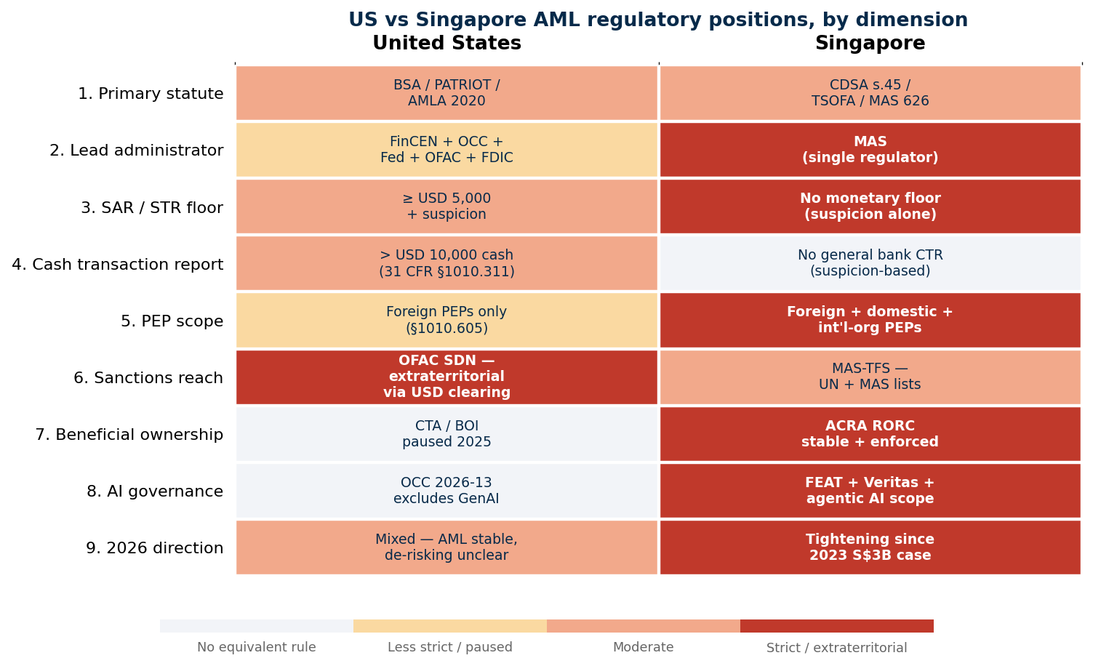
Figure 2. The nine regulatory dimensions plotted against each jurisdiction's relative strictness. Red cells mark the strictest position on a given lever; white cells indicate the rule has no equivalent in that regime. The diagonal asymmetry is what produces the four contradiction shapes the prototype surfaces.

The political choices these encode
- The US chose breadth and extraterritoriality through USD clearing. Singapore chose principled domestic enforcement aligned to FATF, but without the dollar-clearing lever.
- The US chose a fragmented regulator landscape (FinCEN + OCC + Fed + FDIC + state regulators + OFAC). Singapore chose unified MAS oversight.
- Singapore chose to build out an AI-specific governance regime (FEAT, Veritas) before US federal regulators did. The US Apr 2026 OCC bulletin explicitly leaves GenAI ungoverned at the prudential level, a deliberate political choice to avoid constraining innovation, with the side-effect of leaving banks exposed.
- Both jurisdictions chose principles-based suspicion reporting, but the US bolted a $5,000 floor onto its SAR rule, whilst Singapore did not, resulting in a small drafting difference with large operational consequences for low-value structuring detection.
- The cash-reporting architecture is asymmetric. The US has an absolute cash-deposit threshold (CTR at $10K under 31 CFR 1010.311); Singapore has nothing equivalent at the general bank level, every cash flow is judged on suspicion alone. This produces a structural class of contradictions in the prototype: a $10,001 cash deposit in dual scope is US-flag/SG-allowed because there is no SG rule that fires on the amount alone.
- The 2025 US rollback of the Corporate Transparency Act, contrasted with Singapore’s stable Register of Registrable Controllers, means the same ultimate beneficial owner can be visible in Singapore and invisible in the US, directly relevant to a tool that screens corporate counterparties.

4. References and URLs
Where a regulator’s deep link is likely to be restructured, the stable landing page is provided with a search instruction.

Standard Chartered (entity)
- Standard Chartered PLC — investor relations landing page: https://www.sc.com/en/investors/
- Standard Chartered Bank, New York Branch: Federal Reserve National Information Center — Top Holders profile: https://www.ffiec.gov/npw/Institution/TopHolders/541101 (if the deep link is restructured, search “Standard Chartered Bank, New York Branch” from https://www.ffiec.gov/npw/).
- Standard Chartered Bank (Singapore) Limited — overview: https://www.sc.com/sg/about-us/

Standard Chartered enforcement history
- US Department of Justice (April 2019): “Standard Chartered Bank Agrees to Pay More Than $1 Billion to Resolve Sanctions Violations.” Stable landing: https://www.justice.gov/opa/press-releases (search “Standard Chartered” + 2019).
- NY DFS 2014 consent order (transaction-monitoring failures): Stable landing: https://www.dfs.ny.gov/reports_and_publications/press_releases (search 2014).
- NY DFS 2012 consent order (sanctions stripping): Stable landing: https://www.dfs.ny.gov/reports_and_publications/press_releases (search 2012).

United States — AML statutes and guidance
- Bank Secrecy Act (FinCEN landing page): https://www.fincen.gov/resources/statutes-and-regulations/bank-secrecy-act
- USA PATRIOT Act §312, §326 (correspondent accounts; CIP rule): https://www.fincen.gov/resources/statutes-and-regulations/usa-patriot-act
- Anti-Money Laundering Act of 2020 (AMLA): https://www.fincen.gov/anti-money-laundering-act-2020
- FFIEC BSA/AML Examination Manual: https://bsaaml.ffiec.gov/manual
- FinCEN SAR filing instructions (Form 111): https://www.fincen.gov/resources/filing-information
- FinCEN CTR (Form 112) — stable landing: https://www.fincen.gov/resources/filing-information (direct PDF paths change; search “FinCEN Form 112”).
- Underlying CTR rule — 31 CFR §1010.311 (eCFR): https://www.ecfr.gov/current/title-31/subtitle-B/chapter-X/part-1010/subpart-C/section-1010.311
- OFAC sanctions programs and SDN list: https://ofac.treasury.gov/sanctions-programs-and-country-information
- OCC Bulletin 2026-13 (Model Risk Management): https://www.occ.treas.gov/news-issuances/bulletins/2026/bulletin-2026-13.html
- FinCEN Beneficial Ownership Information rule: https://www.fincen.gov/boi

Singapore — AML statutes and guidance
- Corruption, Drug Trafficking and Other Serious Crimes (Confiscation of Benefits) Act 1992: Singapore Statutes Online (search): https://sso.agc.gov.sg/Search/Browse/Act (filter for “Corruption, Drug Trafficking and Other Serious Crimes”).
- Terrorism (Suppression of Financing) Act 2002: Singapore Statutes Online (search): https://sso.agc.gov.sg/Search/Browse/Act (filter for “Terrorism (Suppression of Financing)”).
- MAS Notice 626 — Prevention of Money Laundering and Countering the Financing of Terrorism (Banks): https://www.mas.gov.sg/regulation/notices/notice-626
- MAS Targeted Financial Sanctions — landing page: https://www.mas.gov.sg/regulation/anti-money-laundering
- MAS FEAT Principles (2018) and Veritas updates: https://www.mas.gov.sg/development/fintech/veritas
- ACRA Register of Registrable Controllers — stable landing: https://www.acra.gov.sg/ (search “Register of Registrable Controllers”).
- Singapore Police Force — Suspicious Transaction Reporting Office (STRO): https://www.police.gov.sg/ (navigate via Commercial Affairs Department → STRO; deep links restructure).
- MoneySENSE / MHA references confirming no general bank cash-reporting threshold in SG: https://www.mha.gov.sg/ (search for the AML ministerial statement; absence of a general bank CTR is corroborated in MAS supervisory FAQs).

2023 Singapore S$3B money-laundering case (regulatory context)
- Straits Times — case file: https://www.straitstimes.com/multimedia/the-billion-dollar-money-laundering-case
- MAS supervisory follow-up — penalties on nine financial institutions (June 2024): Stable landing: https://www.mas.gov.sg/news (search “composition penalties” + 2024).

Lecture cross-references
- White House EO 14331, “Guaranteeing Fair Banking for All Americans” (Aug 2025) — effective 9 June 2026: https://www.whitehouse.gov/presidential-actions/2025/08/guaranteeing-fair-banking-for-all-americans/
- FATF mutual-evaluation reports (Singapore 2016 + follow-up; United States 2016 + follow-up): https://www.fatf-gafi.org/en/countries.html

