

School of Computer Science Engineering and Information Systems

Fall Semester 2026-2027

Department of Computer Applications

PAMCA698 - Internship I/ Dissertation I (Project)

Review -2

Date: 07.10.2026
Calibrated Uncertainty in Food Supply Chain Demand Forecasting via Deep Evidential Regression and Blockchain-Verified Provenance

Reg.No, NAME
Under the Guidance of
Dr Karthikeyan P
Professor Grade 1
SCORE

Guide Signature with date
Dr Karthikeyan P

Internal Examiner -1 Internal Examiner-2
Signature Signature

ABSTRACT:
Most food supply chain forecasts give a single number and say nothing about how far that number can be trusted. That matters most around recalls and outbreaks, which is exactly when the data behind a forecast is weakest. This project builds a deep evidential regression model, a GRU encoder with a Normal-Inverse-Gamma output head, that returns a forecast along with its aleatoric and epistemic uncertainty in one forward pass. All data is real and public: monthly US imports for 73 supply nodes (23 foods from 30 countries) from UN Comtrade, January 2016 to July 2026, plus 2,660 matched FDA recalls and 1,923 CDC NORS outbreaks. Every record sits on a SHA-256 proof-of-work ledger, and a record counts as verified when it passes five FSMA 204 traceability checks. The evidential model had the lowest error of the six models tested (MASE 0.773) and the best-calibrated intervals, with its 90% interval covering 91.8% of actual values. There was no evidence that traceability lowers epistemic uncertainty (p = 0.48). Epistemic uncertainty was higher before 57% of 245 recall events (p = 0.010), though this depends on how recalls are matched. Put simply, the model tells a buyer or lender when a forecast should not be taken at face value.

200 Words & Keywords:
Keywords: deep evidential regression; uncertainty quantification; demand forecasting; food supply chain; traceability; blockchain; calibration

- INTRODUCTION:
Food supply chains rarely fail slowly. A contamination finding, a recall or an outbreak can cut off a product line within days, and the COVID-19 pandemic showed how fast normal food flows can break on both the supply and the demand side [16]. Anyone planning purchases, stock or credit around these flows leans on demand forecasts, and those forecasts tend to be least dependable right when they are needed most.
Forecasting itself has become very accurate on average. DeepAR [8] and the Temporal Fusion Transformer [9] learn across many related series, and the M5 competition [10] showed global machine learning models beating classical methods on real retail data. But these works are judged mostly on accuracy. Few say how confident a particular forecast is, and fewer still separate two quite different reasons for doubt: demand that is naturally noisy, and a model that simply has not seen enough similar data.
The usual ways to get uncertainty out of a neural network are MC-dropout [4] and deep ensembles [5]. Both work, but MC-dropout needs many stochastic passes for every prediction and an ensemble needs several separately trained networks. Deep evidential regression [1] goes another way: the network predicts the parameters of a Normal-Inverse-Gamma distribution, and both kinds of uncertainty can be read from a single pass.
Separately, traceability and blockchain have been pushed hard as a way to make food safer and supply chains more trustworthy [12]-[15]. Most of that work is conceptual or describes pilots, and it rarely puts a number on what traceability is actually worth.
This project joins the two threads. It produces calibrated forecasts with separated uncertainty for real US food import demand, keeps every record on a tamper-evident provenance ledger, and then tests whether better traceability goes with more reliable forecasts. Sections 2 to 5 cover the problem, objectives, scope and proposed system, Section 6 reviews the literature, Section 7 gives the methodology, Sections 8 to 11 cover requirements, architecture, design and implementation, and Section 12 sums up the results.

- PROBLEM STATEMENT:
A point forecast looks exactly the same whether it rests on ten years of steady history or on a series that was just hit by a recall. Buyers, food-safety teams and lenders who use these numbers get no signal telling them when to discount one, so a weak forecast gets acted on with the same confidence as a strong one.
There is also no quantitative link between traceability and forecast reliability. Firms are asked to invest in better records and blockchain systems, yet nobody can say whether that makes their planning any more dependable, which makes the investment hard to justify or price.
The research question is therefore: does verified provenance go with lower epistemic uncertainty in demand forecasts, and does epistemic uncertainty rise in the months before a recall is initiated? The work was done under one firm constraint. Only real, publicly available data is used, and nothing is simulated.

- OBJECTIVES:
1. Build a reproducible pipeline that collects real import, recall and outbreak data and links them at supply-node and month level, with no look-ahead.
2. Implement deep evidential regression for monthly demand and split its uncertainty into aleatoric and epistemic parts.
3. Compare it with naive, seasonal naive, SARIMA, point GRU and MC-dropout baselines on both accuracy and calibration.
4. Build a SHA-256 proof-of-work provenance ledger that can verify itself and detect tampering.
5. Test H1 (traceability against epistemic uncertainty), H2 (uncertainty before recalls) and H3 (perishable against shelf-stable foods).
6. Deliver a web dashboard, built with FastAPI and React, that analysts can use to explore forecasts, reliability and the ledger.

- SCOPE OF THE PROJECT:
In scope: 23 imported food commodities and, for each one, the main origin countries, meaning those with at least a 2% share of US imports that were active in at least 85% of months. The data is monthly from January 2016 to July 2026, forecasts are one month ahead, the market is the United States, and the safety events used are FDA recalls and CDC NORS outbreaks.
Out of scope: retail or consumer demand (import volume is used as the proxy), real blockchain records from companies (these are not public), daily data, other countries, and live deployment.
Users: supply chain analysts, food-safety teams, credit and risk officers, and auditors.
Limitations: recalls are linked to commodities by keyword matching, so some will be missed or mislabelled. Few recalls name an origin country, which leaves only 5 usable events in total. And “verified” here means a recall record is complete under the FSMA 204 checks; it does not prove the firm actually used a blockchain.

- PROPOSED SYSTEM:
The system is built in five layers (Fig. 9.1). Ingestion pulls the three public sources and stores them untouched. Processing picks the supply nodes, builds a monthly series for each and links recalls and outbreaks to commodities. The features and ledger layer turns each node into model inputs and, alongside that, writes every record onto the provenance chain. The evidential model produces the forecast, and the API and dashboard put the results in front of the user.
For each node and month the model gives four outputs: γ, ν, α and β. γ is the forecast. The aleatoric uncertainty is β/(α−1) and the epistemic uncertainty is β/(ν(α−1)). What the user actually sees is the forecast, an 80% and a 95% range around it, and a one-word label: reliable, volatile or unreliable. A forecast is marked unreliable when its epistemic uncertainty falls in the top 20% of the validation year, and volatile when its aleatoric uncertainty does.
The ledger keeps one block per month. Each block holds a Merkle root over that month's records and the hash of the block before it, and is mined with proof of work at difficulty 3. Verification walks the whole chain and, if a record has been edited, points to the exact block where the chain breaks.
Existing approaches handle these jobs separately. Forecasting tools give point numbers, uncertainty methods like MC-dropout or ensembles need repeated sampling or several models, and traceability systems record provenance without ever measuring its value. The proposed system does all three together and puts a number on the last one.

- LITERATURE SURVEY: (minimum 15 papers)

S.NO | TITLE | MERITS | DEMERITS
1 | Deep Evidential Regression (Amini et al., NeurIPS 2020) | Places a Normal-Inverse-Gamma prior on the regression output so one network gives the prediction, aleatoric and epistemic uncertainty in a single forward pass; no sampling or ensembles. | Uncertainty depends on a regulariser weight that must be tuned; evaluated on vision and toy data, not on time series.
2 | The Unreasonable Effectiveness of Deep Evidential Regression (Meinert et al., AAAI 2023) | Shows that evidential uncertainty still ranks predictions usefully in practice and explains why. | Proves the method is a heuristic: the epistemic term is not an exact Bayesian quantity, so values should be read relatively, not as true variances.
3 | Evidential Deep Learning to Quantify Classification Uncertainty (Sensoy et al., NeurIPS 2018) | Introduces evidential (Dirichlet) outputs for classification and a KL regulariser against unwarranted evidence. | Classification only; does not address continuous targets such as demand.
4 | Dropout as a Bayesian Approximation (Gal and Ghahramani, ICML 2016) | Treats dropout at test time as approximate Bayesian inference; cheap to add to any network. | Needs many stochastic passes per prediction and tends to underestimate uncertainty.
5 | Simple and Scalable Predictive Uncertainty Estimation using Deep Ensembles (Lakshminarayanan et al., NeurIPS 2017) | Strong, simple baseline: several independently trained networks give well-calibrated intervals. | Training and inference cost grow with the number of members.
6 | What Uncertainties Do We Need in Bayesian Deep Learning for Computer Vision? (Kendall and Gal, NeurIPS 2017) | Separates aleatoric from epistemic uncertainty and shows both are needed in practice. | Relies on MC-dropout sampling for the epistemic part; vision tasks only.
7 | Accurate Uncertainties for Deep Learning Using Calibrated Regression (Kuleshov et al., ICML 2018) | Defines calibration for regression and gives a recalibration method for any probabilistic model. | Recalibration is a post-processing step and needs held-out data that resembles deployment.
8 | DeepAR: Probabilistic Forecasting with Autoregressive Recurrent Networks (Salinas et al., IJF 2020) | Global RNN trained across many related series gives probabilistic forecasts; widely used in retail. | Uncertainty comes from a likelihood plus sampling; it does not separate epistemic from aleatoric.
9 | Temporal Fusion Transformers for Interpretable Multi-horizon Time Series Forecasting (Lim et al., IJF 2021) | Attention-based model with quantile outputs and interpretable variable selection. | Large model needing much data; quantiles are not decomposed into uncertainty sources.
10 | M5 Accuracy Competition: Results, Findings, and Conclusions (Makridakis et al., IJF 2022) | Large real benchmark (Walmart sales) showing global ML models beat classical methods. | Point accuracy only; product identities are anonymised, so external events cannot be linked.
11 | Another Look at Measures of Forecast Accuracy (Hyndman and Koehler, IJF 2006) | Proposes MASE, a scale-free error usable across series of very different sizes. | Covers point errors only; does not assess predictive intervals.
12 | Blockchain's Roles in Meeting Key Supply Chain Management Objectives (Kshetri, IJIM 2018) | Maps blockchain to cost, speed, dependability, risk and sustainability goals with case evidence. | Qualitative; gives no measure of how much traceability improves decisions.
13 | Blockchain Technology and its Relationships to Sustainable Supply Chain Management (Saberi et al., IJPR 2019) | Structured analysis of barriers to blockchain adoption in supply chains. | Conceptual; no quantitative link between verified records and outcomes.
14 | The Rise of Blockchain Technology in Agriculture and Food Supply Chains (Kamilaris et al., Trends in Food Sci. & Tech. 2019) | Survey of food blockchain projects and their aims (traceability, safety, trust). | Finds most projects are pilots; evidence of measurable benefit is limited.
15 | An Agri-food Supply Chain Traceability System for China based on RFID and Blockchain (Tian, ICSSSM 2016) | Early design combining RFID tagging with a blockchain record for farm-to-retail traceability. | System design without large-scale evaluation; no forecasting component.

[6.1] FINDINGS IN LITERATURE SURVEY:
Evidential regression [1] gives both kinds of uncertainty from a single pass, which makes it cheap enough to run on every node every month. Meinert et al. [2], however, show that its epistemic term is a heuristic and not a true Bayesian variance. This project takes that on board: epistemic values are only compared relatively, through per-node medians and percentile thresholds, and are never read as absolute numbers.
Sampling methods [4], [5] are still strong, but they cost many passes or many models. The calibration work [7], [17] makes the point that a good forecast needs honest intervals, not just a small error, so calibration is reported next to accuracy here.
The forecasting benchmarks [8]-[11] report point accuracy almost exclusively. Since the series in this project vary widely in size, a scale-free measure like MASE [11] is needed to compare them fairly.
The blockchain and traceability papers [12]-[15] are mostly qualitative or describe pilot systems. None of them measures what verified provenance does to a downstream decision.
The gap: no existing work combines decomposed uncertainty for food demand with a measured test of whether traceability makes a difference. That is what this project sets out to do.
[7]. METHEDOLOGY:
Data collection. Monthly US import data comes from UN Comtrade [21], recall records from the openFDA food enforcement API [22] and outbreak records from CDC NORS [23]. The series start in January 2016 because Comtrade only reports weights from that year onward.
Node selection. A supply node is one commodity from one origin country. A country is kept if it has at least a 2% share of US imports of that commodity and is active in at least 85% of months, with no more than six countries per commodity. This gives 73 nodes.
Recall matching. Recalls are matched with whole-word keyword rules on the first 160 characters of the product description, leaving out finished foods such as soups or ready meals. That gives 2,660 recalls. Each is then checked against the five FSMA 204 key data elements [20]: lot code, date, quantity with unit, distribution locations and firm address. Only 13.5% pass all five.
Verification ratio. For each node this is the share of its recall records that pass, shrunk toward the commodity-wide rate with a pseudo-count of 5 so that nodes with only a handful of recalls do not end up with extreme values. Only recalls published before the training cut-off are counted.
Features. Each input is a 24-month window of standardised log imports, with the month encoded as sine and cosine and recall counts placed by report date, so the model only sees what was public at the time. The static features are the verification ratio, perishability and volume.
Model. The encoder is a two-layer GRU [18] with 64 units and no node-ID embedding, so it cannot simply memorise each node. It is trained on the Normal-Inverse-Gamma loss plus the evidence regulariser, with λ = 0.1 picked by calibration on the validation year. Training uses AdamW with early stopping and is repeated over three seeds.
Baselines. Naive, seasonal naive, SARIMA, a point GRU and an MC-dropout GRU are run on the same splits. MC-dropout is the fair comparison because it uses the same GRU and also produces uncertainty, so any gap between the two comes from how uncertainty is estimated and not from the network.
Evaluation. A rolling-origin split with two folds is used. Accuracy is measured with MASE, MAE, RMSE, WAPE and MAPE, and calibration with NLL, interval coverage (PICP) and interval width. H1 is tested with a Mann-Whitney test and an OLS regression with HC3 errors, and H2 with a Wilcoxon signed-rank test.
Ledger. Records are grouped by month, a Merkle root is computed for each block, each block is mined and linked to the previous hash, and the chain is stored in SQLite. Verification recomputes every root and hash and reports the first block that does not match.
[8].SOFTWARE REQUIREMENTS:
Functional and Non Functional Requirements
8.1 Functional Requirements
• FR1 Data acquisition: download US monthly import statistics (UN Comtrade), FDA food enforcement records (openFDA) and CDC NORS outbreak records, and resume interrupted downloads.
• FR2 Data preparation: select supply nodes (commodity × origin country), build a complete monthly series per node, and link recalls and outbreaks to commodities using documented keyword rules.
• FR3 Traceability scoring: check every recall record against five FSMA 204 key data elements (lot code, date, quantity with unit, distribution locations, firm address) and compute a verification ratio per node.
• FR4 Provenance ledger: store every record in a SHA-256 proof-of-work chain (one block per month, Merkle root per block), verify the whole chain on request and report the exact block that fails.
• FR5 Forecasting: produce, for any node and month, a demand forecast, aleatoric and epistemic uncertainty and 80%/95% prediction intervals from one forward pass.
• FR6 Baselines and evaluation: train naive, seasonal-naive, SARIMA, point-GRU and MC-dropout models on identical splits and report accuracy, calibration and the hypothesis tests.
• FR7 Dashboard: show a supply map with a reliability label per node, node detail charts with recall markers, the evaluation results and a ledger explorer with a tamper demonstration.
• FR8 API: expose all of the above as JSON endpoints.
8.2 Non-Functional Requirements
• Data integrity: only real public data is used and nothing is simulated; a month with no recorded imports for a node is taken as zero imports, and every derived table can be regenerated from the raw downloads.
• No look-ahead: model inputs at month t use only information published by month t; splits are by time.
• Reproducibility: fixed random seeds, pinned package versions, one script per pipeline step.
• Performance: full training of all models in under five minutes on a laptop GPU (RTX 3050); ledger rebuild in under ten seconds; API responses under one second.
• Portability: a single setup script installs Python, packages and the dashboard inside the project folder; runs on CPU-only machines.
• Tamper evidence: any change to a stored record must be detected by verification.
• Usability: reliability is shown as a word and an icon, never by colour alone; the dashboard works in light and dark themes and on narrow screens.
8.3 Hardware and Software Environment
Component | Used in this project
Processor / memory | x86-64 laptop, 16 GB RAM
GPU (optional) | NVIDIA RTX 3050 Laptop, 6 GB (CUDA 12.6); CPU fallback supported
Operating system | Windows 11
Language / runtime | Python 3.12, Node.js 24
Machine learning | PyTorch 2.14, statsmodels 0.15, SciPy, pandas, NumPy
Backend | FastAPI 0.142, Uvicorn, SQLite
Frontend | React 19, Vite 8, Leaflet 1.9, Recharts 3
Testing | pytest 9

[9]. SYSTEM ARCHITECTURE:
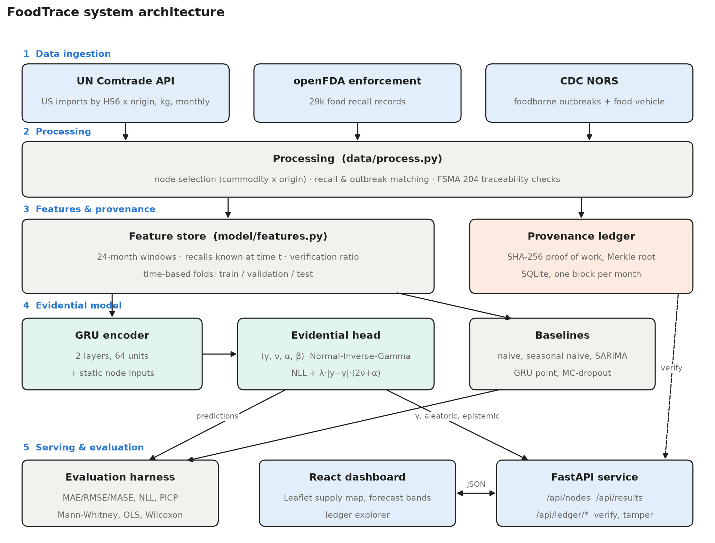

Fig. 9.1 System Architecture
The system is organised in five layers (Fig. 9.1).
• Data ingestion: three downloaders fetch the public sources into data/raw exactly as published.
• Processing: selects 73 supply nodes (23 commodities from 30 countries), builds 127 monthly values per node (2016-01 to 2026-07), matches 2,660 FDA recalls and 1,923 CDC outbreaks to commodities, and scores each recall against the FSMA 204 checks.
• Features and provenance: the feature store turns each node into 24-month input windows; in parallel, every record is written to the proof-of-work ledger.
• Evidential model: a two-layer GRU encoder with an evidential head outputs (γ, ν, α, β); the baselines are trained on the same windows.
• Serving and evaluation: the evaluation harness writes results.json; FastAPI serves forecasts, results and ledger operations to the React dashboard.

[10]. UML DIAGRAMS:

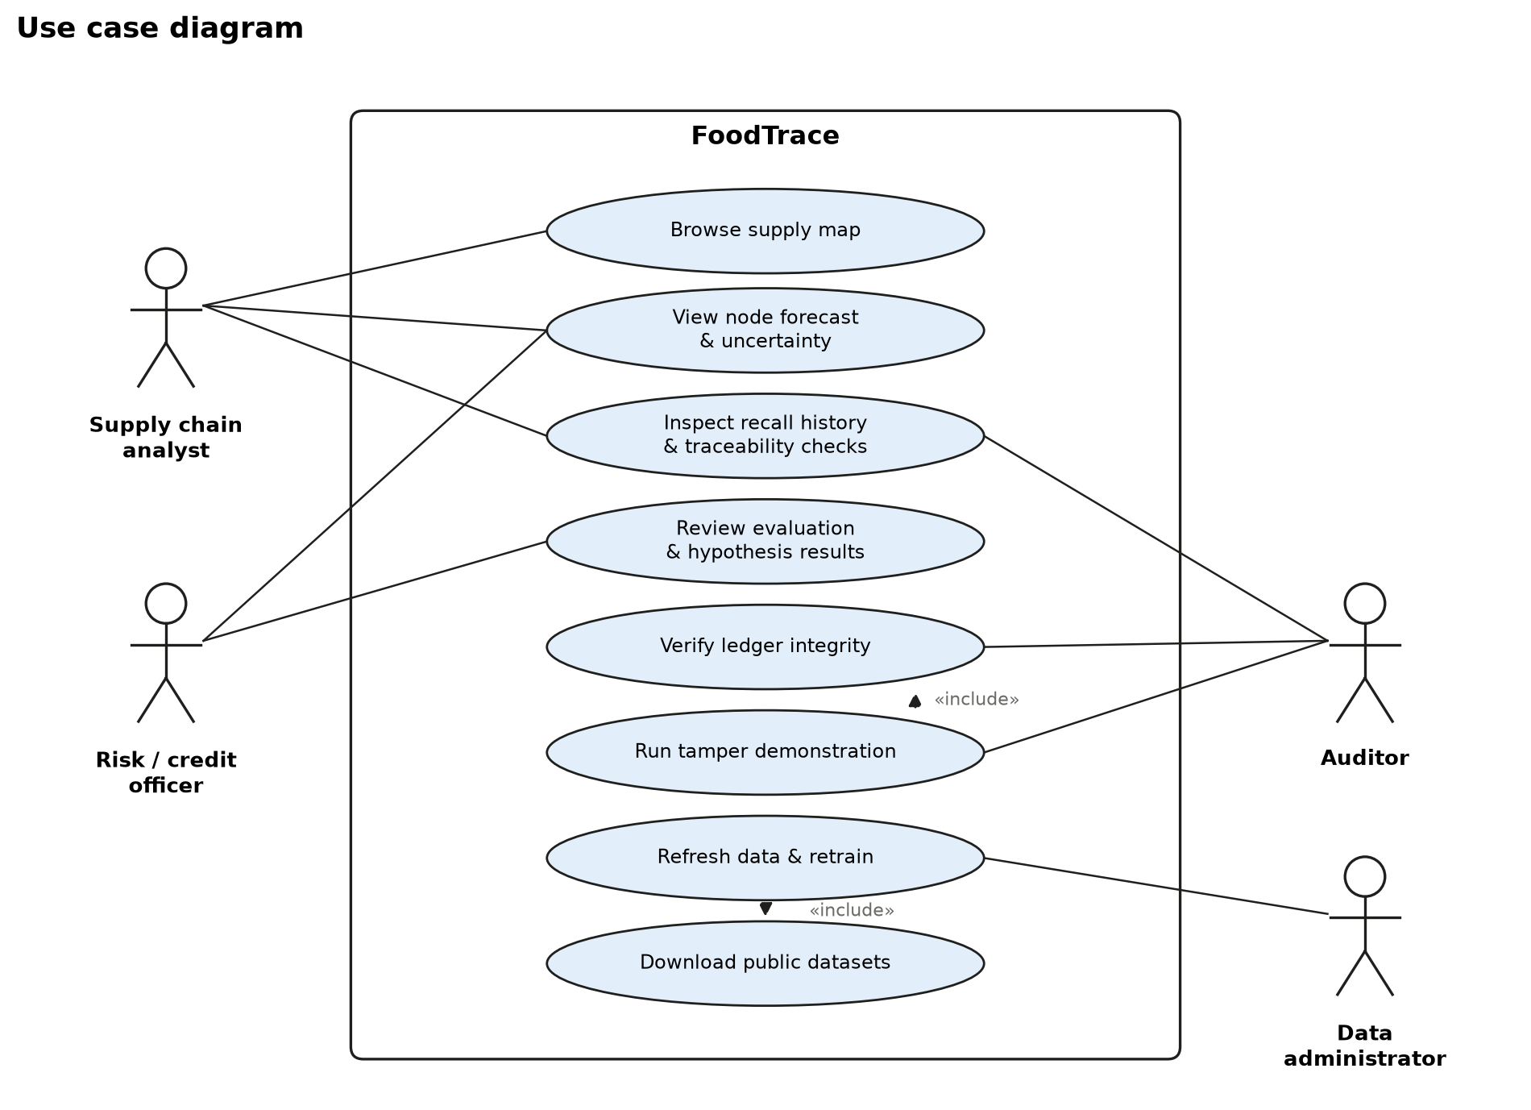
Fig. 10.1 Use Case Diagram
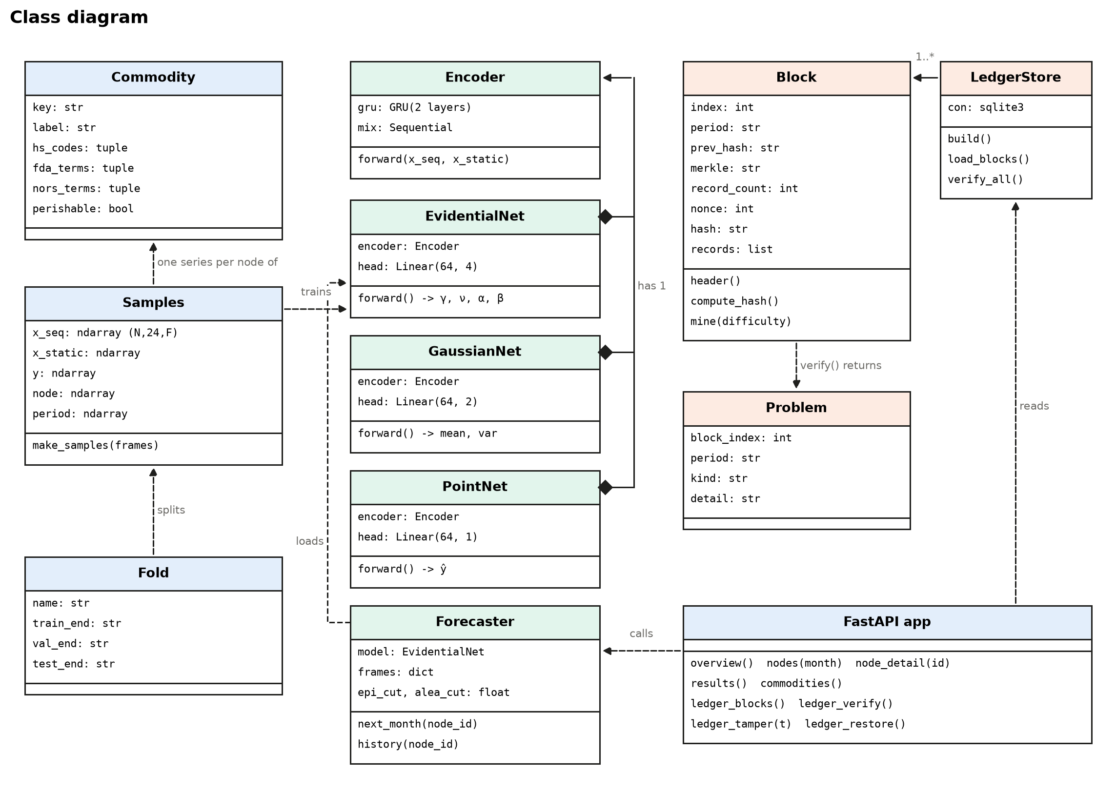
Fig. 10.2 Class Diagram

[11]. IMPLEMENTATION

11.1. PROJECT PLAN
Table 11.1 Project plan
Phase | Work | Deliverable | Status
1 Problem & literature | Problem framing, survey of uncertainty and traceability work | Proposal, literature table | Done
2 Data | Source selection, download, cleaning, node selection, recall/outbreak matching | data/processed tables | Done
3 Provenance ledger | Hash chain, Merkle roots, proof of work, verification, tamper demo | ledger module + SQLite chain | Done
4 Modelling | Evidential GRU, MC-dropout, point GRU, SARIMA, naive baselines | Trained models | Done
5 Evaluation | Accuracy, calibration, hypothesis tests on time-based folds | results.json | Done
6 Application | FastAPI service, React dashboard | Running web app | Done
7 Testing & packaging | Unit/API tests, one-command setup, documentation | Test suite, setup scripts, README | Done
8 Report & review | Review-2 document, presentation | This report, slides | In progress

11.2 SAMPLE CODE
Listing 11.1 Evidential head and loss (backend/foodtrace/model/nets.py)
class EvidentialNet(nn.Module):
def __init__(self, n_seq, n_static, hidden=64, dropout=0.1):
super().__init__()
self.encoder = Encoder(n_seq, n_static, hidden, dropout)
self.head = nn.Linear(hidden, 4)

def forward(self, x_seq, x_static):
out = self.head(self.encoder(x_seq, x_static))
gamma, lognu, logalpha, logbeta = out.unbind(-1)
nu = F.softplus(lognu) + 1e-6
alpha = F.softplus(logalpha) + 1.0 + 1e-6
beta = F.softplus(logbeta) + 1e-6
return gamma, nu, alpha, beta

def nig_nll(y, gamma, nu, alpha, beta):
omega = 2.0 * beta * (1.0 + nu)
return (0.5 * torch.log(math.pi / nu) - alpha * torch.log(omega)
+ (alpha + 0.5) * torch.log(nu * (y - gamma) ** 2 + omega)
+ torch.lgamma(alpha) - torch.lgamma(alpha + 0.5))

def evidential_loss(y, gamma, nu, alpha, beta, lam):
reg = torch.abs(y - gamma) * (2.0 * nu + alpha)
return (nig_nll(y, gamma, nu, alpha, beta) + lam * reg).mean()

Listing 11.2 Merkle root and proof of work (backend/foodtrace/ledger/chain.py)
def merkle_root(leaf_hashes):
level = list(leaf_hashes)
while len(level) > 1:
if len(level) % 2:
level.append(level[-1])
level = [sha256(level[i] + level[i + 1]) for i in range(0, len(level), 2)]
return level[0]

def mine(self, difficulty):
target = "0" * difficulty
self.nonce, h = 0, self.compute_hash()
while not h.startswith(target):
self.nonce += 1
h = self.compute_hash()
self.hash = h

Listing 11.3 FSMA 204 traceability checks (backend/foodtrace/data/process.py)
def traceability_checks(rec):
code = (rec.get("code_info") or "") + " " + (rec.get("more_code_info") or "")
dist = rec.get("distribution_pattern") or ""
return {
"chk_lot": bool(LOT_PATTERN.search(code)),
"chk_date": bool(DATE_PATTERN.search(code)),
"chk_quantity": bool(QTY_PATTERN.search(rec.get("product_quantity") or "")),
"chk_distribution": bool(PLACE_PATTERN.search(dist) or PLACE_PATTERN.search(dist.lower())),
"chk_origin": all((rec.get(k) or "").strip() for k in ("address_1", "city", "postal_code")),
}

11.3 TESTING STRATEGIES
Unit and integration tests
• Ledger: a valid chain passes; editing one record is reported in that block only; re-mining a tampered block breaks the next block's link; mined hashes meet the difficulty.
• Matching: complete FDA records pass all checks; a missing lot code fails only that check; "nationwide" is not a specific distribution; processed products (e.g. tomato soup) are excluded.
• Evidential model: outputs satisfy ν > 0, α > 1, β > 0; the moments match their closed forms; more evidence lowers epistemic uncertainty; training reduces the loss.
• API: overview and node endpoints return valid forecasts with lo80 ≤ forecast ≤ hi80; tamper breaks the chain at the edited block and restore makes it valid again.
• Result: 20 automated tests, all passing.
Model evaluation protocol
• Time-based rolling origin: main fold trains on targets 2018-01 to 2021-12, tunes on 2022, and tests on 2023-01 to 2026-07; a second fold tests on 2021-2022.
• λ is chosen on the validation year by interval calibration (selected λ = 0.1).
• Three training seeds for the neural models; SARIMA forecasts are one step ahead with fixed parameters, so every model sees the same history.
Table 11.2 Forecast accuracy on the test period (3,139 forecasts)
Model | MASE | MAE (log) | WAPE % | MAPE* %
Evidential GRU | 0.773 | 0.661 | 15.9 | 41.9
SARIMA | 0.794 | 0.668 | 15.8 | 39.6
MC-dropout GRU | 0.868 | 0.713 | 16.9 | 44.6
Naive | 0.920 | 0.727 | 21.3 | 47.8
Seasonal naive | 1.000 | 0.907 | 21.0 | 58.5
GRU (point) | 1.024 | 0.759 | 22.4 | 51.3

* MAPE excludes months below 10% of a node's usual volume.
Table 11.3 Calibration of predictive intervals (test period)
Model | NLL | PICP 50% | PICP 80% | PICP 90% | PICP 95%
Evidential GRU | 1.129 | 51.0 | 81.4 | 91.8 | 96.3
MC-dropout GRU | 1.630 | 56.6 | 80.8 | 87.6 | 91.6
SARIMA | 1.813 | 51.1 | 76.0 | 83.5 | 88.3

Table 11.4 Hypothesis tests
Test | Result
H1 verified vs unverified epistemic (Mann-Whitney, one-sided) | median 2.41 vs 2.57; p = 0.480
H1 regression with controls (HC3) | β = -0.18; p = 0.546
H2 epistemic before recall vs quiet months (Wilcoxon, evidential) | 245 events; higher before in 57%; p = 0.010
H2 same test, MC-dropout | higher before in 50%; p = 0.180

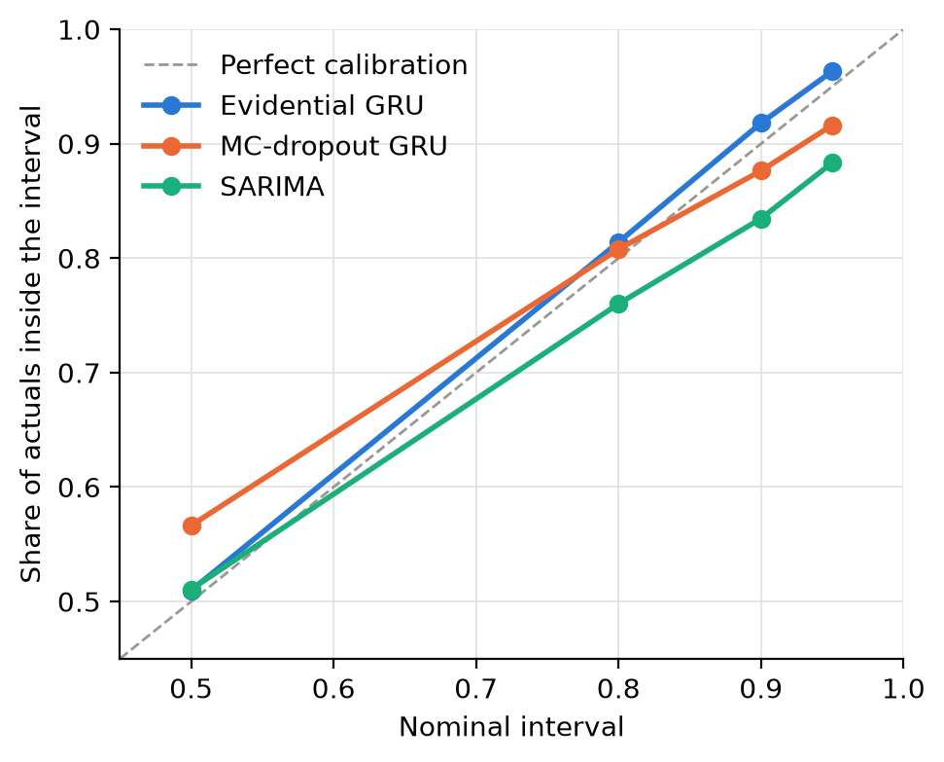
Fig. 11.1 Calibration of prediction intervals

11.3 SAMPLE SCREEN SHOTS
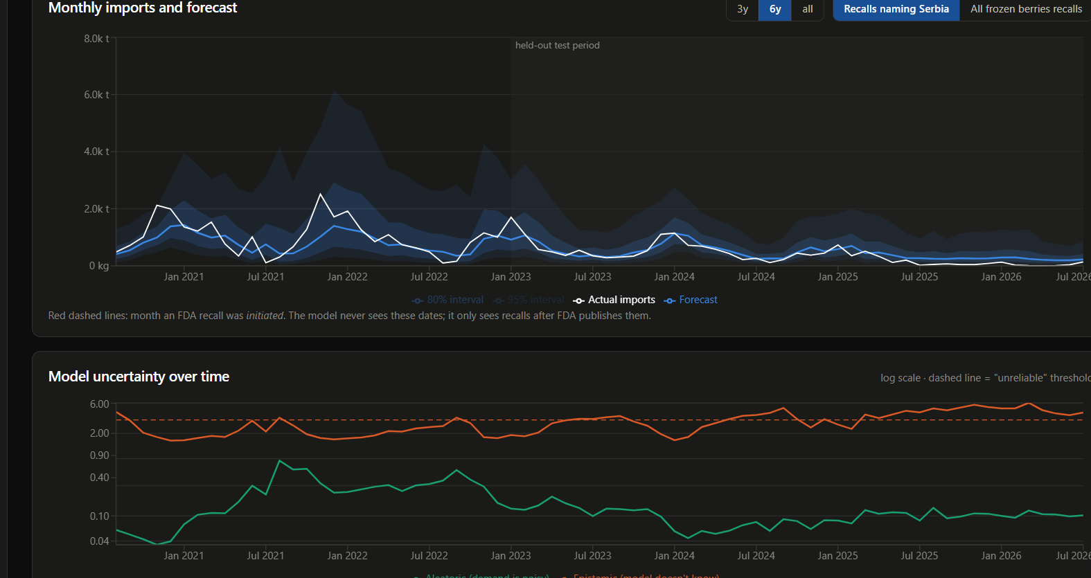

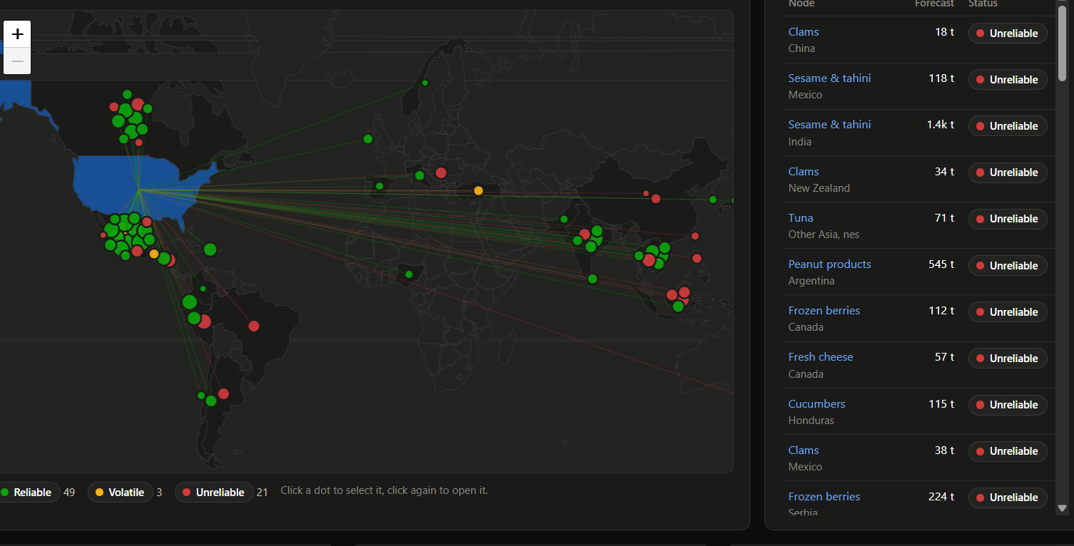

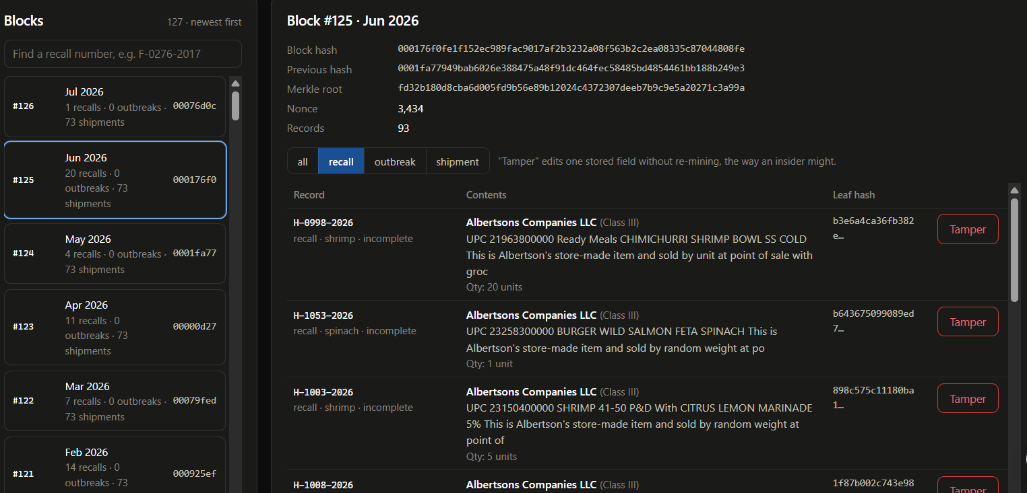

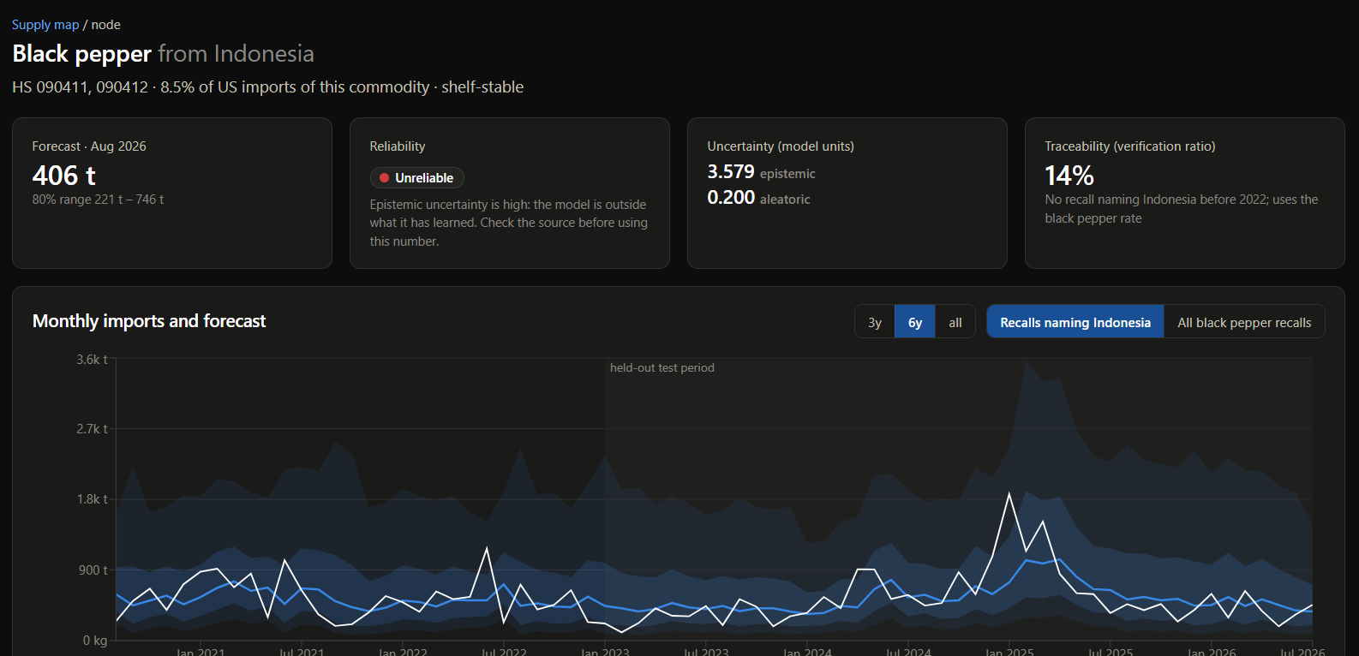

[12]. SUMMARY:
This project built a forecasting system for US food import demand that tells the user how far to trust each forecast, and separates that doubt into noise in the demand and gaps in what the model knows. It runs on real public data from UN Comtrade, the FDA and the CDC, with every record kept on a tamper-evident ledger.
The evidential GRU was the most accurate of the six models, with a MASE of 0.773. It was also the best calibrated: its 90% interval covered 91.8% of actual values, against 87.6% for MC-dropout and 83.5% for SARIMA. H1 was not supported (p = 0.48), so verified nodes were not forecast with noticeably less epistemic uncertainty. H2 was suggestive, with uncertainty higher before 57% of recall events (p = 0.010), but the result shifts with how recalls are matched and needs to be read with care. H3 showed no difference by perishability (p = 0.29 for shelf-stable and 0.63 for perishable foods).
Two things come out of this. Uncertainty-aware forecasting is practical, since one forward pass is enough and the intervals hold up. And record completeness on its own did not make the model any more certain, so if traceability does carry value, it has to be looked for in richer data than recall paperwork.
Future work includes using real supplier-level traceability data, auditing the recall matching with data/processed/recall_match_audit.csv, adding deep ensembles as a further baseline, and mapping epistemic uncertainty to a risk premium for suppliers.

REFERENCES: (minimum 15 papers)

- A. Amini, W. Schwarting, A. Soleimany and D. Rus, "Deep Evidential Regression," in Advances in Neural Information Processing Systems (NeurIPS), vol. 33, 2020.
- N. Meinert, J. Gawlikowski and A. Lavin, "The Unreasonable Effectiveness of Deep Evidential Regression," Proceedings of the AAAI Conference on Artificial Intelligence, vol. 37, no. 8, pp. 9134-9142, 2023.
- M. Sensoy, L. Kaplan and M. Kandemir, "Evidential Deep Learning to Quantify Classification Uncertainty," in Advances in Neural Information Processing Systems (NeurIPS), vol. 31, 2018.
- Y. Gal and Z. Ghahramani, "Dropout as a Bayesian Approximation: Representing Model Uncertainty in Deep Learning," in Proc. 33rd International Conference on Machine Learning (ICML), PMLR 48, pp. 1050-1059, 2016.
- B. Lakshminarayanan, A. Pritzel and C. Blundell, "Simple and Scalable Predictive Uncertainty Estimation using Deep Ensembles," in Advances in Neural Information Processing Systems (NeurIPS), vol. 30, 2017.
- A. Kendall and Y. Gal, "What Uncertainties Do We Need in Bayesian Deep Learning for Computer Vision?," in Advances in Neural Information Processing Systems (NeurIPS), vol. 30, 2017.
- V. Kuleshov, N. Fenner and S. Ermon, "Accurate Uncertainties for Deep Learning Using Calibrated Regression," in Proc. 35th International Conference on Machine Learning (ICML), PMLR 80, pp. 2796-2804, 2018.
- D. Salinas, V. Flunkert, J. Gasthaus and T. Januschowski, "DeepAR: Probabilistic Forecasting with Autoregressive Recurrent Networks," International Journal of Forecasting, vol. 36, no. 3, pp. 1181-1191, 2020.
- B. Lim, S. O. Arik, N. Loeff and T. Pfister, "Temporal Fusion Transformers for Interpretable Multi-horizon Time Series Forecasting," International Journal of Forecasting, vol. 37, no. 4, pp. 1748-1764, 2021.
- S. Makridakis, E. Spiliotis and V. Assimakopoulos, "M5 Accuracy Competition: Results, Findings, and Conclusions," International Journal of Forecasting, vol. 38, no. 4, pp. 1346-1364, 2022.
- R. J. Hyndman and A. B. Koehler, "Another Look at Measures of Forecast Accuracy," International Journal of Forecasting, vol. 22, no. 4, pp. 679-688, 2006.
- N. Kshetri, "Blockchain's Roles in Meeting Key Supply Chain Management Objectives," International Journal of Information Management, vol. 39, pp. 80-89, 2018.
- S. Saberi, M. Kouhizadeh, J. Sarkis and L. Shen, "Blockchain Technology and its Relationships to Sustainable Supply Chain Management," International Journal of Production Research, vol. 57, no. 7, pp. 2117-2135, 2019.
- A. Kamilaris, A. Fonts and F. X. Prenafeta-Boldu, "The Rise of Blockchain Technology in Agriculture and Food Supply Chains," Trends in Food Science & Technology, vol. 91, pp. 640-652, 2019.
- F. Tian, "An Agri-food Supply Chain Traceability System for China based on RFID & Blockchain Technology," in Proc. 13th International Conference on Service Systems and Service Management (ICSSSM), 2016.
- J. E. Hobbs, "Food Supply Chains during the COVID-19 Pandemic," Canadian Journal of Agricultural Economics, vol. 68, no. 2, pp. 171-176, 2020.
- T. Gneiting and A. E. Raftery, "Strictly Proper Scoring Rules, Prediction, and Estimation," Journal of the American Statistical Association, vol. 102, no. 477, pp. 359-378, 2007.
- K. Cho et al., "Learning Phrase Representations using RNN Encoder-Decoder for Statistical Machine Translation," in Proc. EMNLP, pp. 1724-1734, 2014.
- S. Nakamoto, "Bitcoin: A Peer-to-Peer Electronic Cash System," 2008.
- U.S. Food and Drug Administration, "Requirements for Additional Traceability Records for Certain Foods (Final Rule)," Federal Register, vol. 87, p. 70910, Nov. 21, 2022 (21 CFR Part 1, Subpart S).
- United Nations Statistics Division, UN Comtrade Database, https://comtradeplus.un.org (accessed Oct. 2026).
- U.S. Food and Drug Administration, openFDA Food Enforcement Reports API, https://open.fda.gov/apis/food/enforcement/ (accessed Oct. 2026).
- Centers for Disease Control and Prevention, National Outbreak Reporting System (NORS) dataset, https://data.cdc.gov (accessed Oct. 2026).

