AN AI-DRIVEN
SOFTWARE DEVELOPMENT
SYSTEM
A Theoretical Framework for the
Modern Software Engineering Lifecycle
Version 1.0
April 2026
A reference text for engineers, technical leaders, and learners

Contents
Preface
How to Read This Book
Part I — Foundations
1. Why an AI-Driven SDLC?
2. Mental Models for AI-Driven Development
3. The Federation of Lifecycles
4. The Four-Layer System Architecture
Part II — Operating Disciplines
5. Context as a Supply Chain
6. Token Economics
7. Governance
8. Prompt Engineering as an Engineering Discipline
9. The Tracker and Session Recovery
Part III — The Agents
10. Agent Design and Responsibilities
11. The Execution Loop
12. Agent Anti-Patterns
Part IV — Quality Concerns
13. Quality Assurance: Failure-First Testing
14. Security and Threat Modeling
15. Performance
16. Observability
Part V — Operating the System
17. Failure and Recovery
18. Cost Economics of Agent Systems
19. Maturity Model and Adoption Path
20. Domain Application Patterns
Part VI — Reflection
21. Advanced Capabilities
22. Limitations and Honest Disclosure
23. Final Principles
24. Glossary
Each Part opens with a short vocabulary refresher covering the terms used most often in the chapters that follow. Full definitions remain in the glossary at the back of the book.

How to Read This Book
The book is written so that a careful linear reading works for any audience, but most readers will get more out of it by following one of the paths below. Each path picks a subset of chapters and an order through them suited to a particular starting point. The full book has twenty-four chapters across six parts; the paths below assume you may not need every one of them on a first pass.
Whichever path you choose, the recommendation is to read the Preface first and the Glossary last. Everything in between is up to you.

Path 1 — First-year undergraduate
Build a working mental model of how modern software gets built before specializing. The goal at this stage is vocabulary and intuition, not depth.
- Chapter 1 (Why an AI-Driven SDLC?) — the motivation.
- Chapter 2 (Mental Models) — the lenses.
- Chapter 3 (Federation of Lifecycles) — the structure of engineering work.
- Chapter 10 (Agent Design) — read the role descriptions only; skip the contracts on first pass.
- Chapter 13 (Failure-First QA) — the most concrete chapter; helps the rest land.
- Chapter 23 (Final Principles) — to consolidate.
Skip on first pass: chapters 5–9 (operating disciplines), chapter 14 (security), chapter 18 (cost economics). Return to them after a project.

Path 2 — Senior undergraduate / capstone
You are about to ship something real, in a team, possibly for the first time. The goal is to develop the disciplines that turn a working prototype into a system you would not be embarrassed to leave running.
- Chapter 1 — motivation.
- Chapters 3 and 4 — federation and architecture.
- Chapter 5 (Context as a Supply Chain) — critical for any team using AI tools.
- Chapters 7 and 9 — governance and the tracker.
- Chapters 10–12 — agent design, execution loop, anti-patterns.
- Chapter 13 — failure-first QA.
- Chapter 16 — observability.
- Chapter 17 — failure and recovery.
- Chapter 20 — domain application patterns; use the one closest to your project as a checklist.

Path 3 — Graduate student or researcher
You are likely interested in the design choices and their alternatives, not in operational pragmatics. Pay attention to where the book is opinionated; those are the places worth pushing back on.
- Preface and Chapters 1–2 — to anchor what assumptions are being made.
- Chapters 3 and 4 — the structural commitments.
- Chapter 5 — the supply-chain framing for context.
- Chapter 6 — token economics; the closest the book gets to a quantitative model.
- Chapter 12 — anti-patterns; useful failure cases for analysis.
- Chapter 19 — the maturity model; the most empirically testable claim in the book.
- Chapter 22 — limitations; if you are looking for unanswered questions, this is where they are explicit.

Path 4 — Working engineer or technical lead
You are looking for ideas you can apply this quarter. Read for what you can take and use, and skip what does not fit your stack yet.
- Preface — to confirm the framework matches your problem shape.
- Chapter 3 — lifecycle inventory; map onto your current process.
- Chapters 5–9 — the operating disciplines; this is where most of the practical leverage lives.
- Chapters 11–12 — the execution loop and the anti-patterns; both are immediately actionable.
- Chapters 13–16 — the quality lifecycles; pick the ones that map to your current weak spots.
- Chapter 17 — failure recovery patterns.
- Chapter 19 — the maturity model; locate yourself honestly, then pick one discipline to add this quarter.
- Chapter 20 — domain patterns; read the one closest to your domain.

A note on the running case study
A learning-platform example called Atlas Learn appears in teal callout boxes throughout the book. Each appearance applies the chapter’s topic to the same fictional system, so the reader can watch one product get designed, built, tested, secured, and operated across the full book. Atlas Learn is small enough to fit in a student’s head and rich enough to host every concept in the framework. The callouts are not load-bearing — you can skip them and the rest of the book still works — but readers who want a single thread to follow should read the teal boxes in order.
Key Idea
All four paths are valid first reads. The book is written to be re-read; most readers find the chapters they skipped on a first pass become exactly the ones they want on a second.

Preface
This book offers a theoretical framework for software engineering in an era when capable AI agents can be put to work inside the development lifecycle. It is written as a textbook rather than a manual: principles come first, the mechanisms that follow from them come second, and examples are drawn from many domains because the framework is meant to be portable. Anyone looking for a tutorial on a specific tool or vendor will be disappointed; what’s here instead is a vocabulary, a structure, and a set of operating disciplines that together describe what it takes to build production-grade software with AI agents inside the loop.
The starting observation is fairly narrow. Modern language-model agents are good at producing fluent, plausible engineering output, and not very good at distinguishing correct output from confidently wrong output. Both qualities scale together. The point of an AI-Driven SDLC is to apply enough engineering discipline around the agent that the wrong outputs get caught and the right ones get used — without leaning on the agent itself to know the difference.
The book runs to twenty-four sections in six parts. Part I lays the foundations: why an AI-Driven SDLC is worth the trouble, what mental models make it intelligible, how the work federates into seven lifecycles, and how those lifecycles fit inside a four-layer architecture. Part II develops the operating disciplines that hold everything together — context as a supply chain, the economics of tokens, the mechanics of governance, prompt engineering treated as a contract discipline, and the tracker that gives the system its memory. Part III describes the agents in detail, walks through the inner execution loop, and catalogs the anti-patterns that have undone many otherwise capable systems. Part IV covers the quality concerns: failure-first QA, security and threat modeling, performance, and observability. Part V is about operating the resulting system in the real world — failure recovery, cost economics, maturity and adoption, and how the same skeleton applies across five very different domains. Part VI closes with advanced capabilities, an honest accounting of the limits, a set of final principles, and a glossary.
Each section follows a consistent shape — an opening intuition, the principles themselves, a few examples drawn from across domains, common pitfalls, a reflection prompt, and a brief takeaway. Reading linearly works the first time through. After that, sections tend to stand on their own, and most readers come back to specific ones as the operating context demands.
Three audiences in particular should find this useful. The senior engineer or technical leader who needs to design how an AI-augmented team will operate will find vocabulary and structure to organise the operation around. The student or early-career engineer building intuition for what production-grade systems look like in this era will find principles laid out before tools, on the working assumption that tools turn over much faster than principles do. And the skeptic — anyone who has watched AI tools fail in unconvincing ways and concluded the whole approach is unserious — will find a discipline that takes the failure modes seriously and converts most of them into engineering problems with engineering answers.
Examples are drawn from many places: banking and ledgers, telemedicine, logistics, multiplayer game backends, content publishing, IoT, fraud detection, ride-hailing, and others. The framework isn’t really about any one of them; the variety is meant to make a different point, which is that the structure is roughly the same across domains and the differences live mostly in the specifics. Readers from any of these domains should recognise the patterns. Readers from domains not on the list will recognise the same patterns in their own work.
The framework is opinionated, and it’s worth being upfront about that. It treats process as engineering, prompts as contracts, context as a supply chain, the tracker as memory, and governance as the cost of being able to delegate confidently. It is uncompromising about the disciplines it considers load-bearing and modest about what it can promise. It will not make a system reliable; it offers a way to build reliability into a system. It will not make development faster in any given week; it offers a way for competence to compound over months and years. Teams that adopt it consistently tend to describe a similar arc: an expensive first quarter while the disciplines get put in place, a calmer second one as they start paying back, and a year that is both more productive and more honest about what is happening inside the software being shipped.
That arc, and the operating rules that make it possible, is what the rest of this book is about.

0. A Software Engineering On-Ramp
This short section is for readers who arrive at this book without a traditional software-engineering background. If you have already shipped production software for a year or two, you can skim it; if you have written code only for school assignments or personal projects, the vocabulary here will save you confusion in the chapters that follow. The book uses a few terms — production, deployment, release, regression, observability — as if everyone reading already knows them. This section makes sure that’s true.
Read time is about fifteen minutes. The goal is not to teach you software engineering; the goal is to give you the working mental models the rest of the book assumes.

0.1 Software Engineering Is Not Coding
Coding is the act of writing instructions a computer can execute. Software engineering is the discipline of building software that other people will rely on — software that has to keep working when you are not around, when conditions change, and when the assumptions you started with turn out to be incomplete.
A useful contrast: a script you write to rename five hundred photos on your laptop is code. The same script, packaged so that ten thousand customers can run it on their own photos and complain to you when it breaks, is software. The transformation between the two is most of what software engineering is about.
Example
A student writes a Python program that scrapes weather data from a website and emails it to her every morning. It works. Six months later the website changes its layout; the script silently emails her empty messages for two weeks before she notices. Was the original script wrong? No — it did exactly what it was written to do. But it was not engineered. An engineered version would have noticed the change, recorded the failure, and reported it. The difference between code and software engineering is mostly that the engineered version anticipates a future its author will not be present for.
Most of this book is about the surrounding system that turns code into software: how teams collaborate, how changes are reviewed, how failures are detected, how the work is recorded so that someone investigating an incident next quarter can reconstruct what happened. The AI-driven part of the book — the agents, the prompts, the disciplines — only makes sense once you accept that all of this surrounding system is the actual subject.

0.2 Production: A Noun, Not a Verb
The book uses the word "production" repeatedly. In this context it does not mean making something or putting on a play. It is the name of the environment where real users encounter your software — the live system, as opposed to the development environment where engineers test their changes.
Most software runs in three environments at once:
- Development — the engineer’s laptop or shared development server. Mistakes here are private. Data is fake.
- Staging — a production-like environment used for final testing before release. Mistakes here affect engineers, not customers.
- Production — the real live system. Real customers, real money, real consequences. A mistake here is an incident.
When the book says "in production" it means "in the environment customers actually use." When it says "ship to production" it means "make a change that customers will see." The distinction matters because the cost of a mistake is roughly a thousand times higher in production than in development, and most of the disciplines in this book exist to manage that gap.
Example
A bug that loses a few minutes of fake test data in development might cost an engineer ten minutes to clean up. The same bug in production, where it loses a few minutes of real customer transactions, might cost the company a regulatory fine, a public apology, and a quarter of customer-trust repair. Same bug, very different cost. The disciplines that prevent the second kind of incident are what production-grade software engineering is about.
Key Idea
Almost everything in this book — review gates, audit trails, canary releases, rollback rehearsals — exists because production is expensive to be wrong in. The cost of being wrong is the gravity well that all the disciplines orbit around.

0.3 Version Control
Version control is the practice of recording every change to a body of source code, who made it, when, and why. The dominant tool is Git, but the discipline is older than any tool: the principle is that the history of a project is a first-class artifact, as important as the current state.
Three properties matter:
- Every change is recorded with author, timestamp, and message. Nothing is anonymous; nothing is undated.
- Any prior state can be retrieved exactly. The version of the code that shipped six months ago can be reproduced with one command.
- Two engineers can work in parallel on the same code, and the version control system reconciles their changes — or, when reconciliation is impossible, surfaces the conflict so that humans can decide.
In this book, "the codebase" refers to the version-controlled body of code that defines the system. "A commit" is one recorded change. "A branch" is a parallel line of development that can later be merged back. "A pull request" (or "merge request") is a proposed change that other engineers review before it joins the main branch.
Example
A team is investigating an incident from three weeks ago. Production was fine on Tuesday and broken by Thursday. The team uses version control to list every change between those two dates — fourteen commits, by six different engineers — and bisects: try the system at the midpoint, see if it’s broken, narrow down. Within an hour they find the specific commit that introduced the bug. Without version control, this same investigation would have been days of guessing. The history is part of what makes the system debuggable.

0.4 Testing
Testing is writing additional code whose only purpose is to verify that the main code does what it claims. A test calls the code with known inputs and checks that the output matches what it should be. Tests are run automatically before any change is merged, so a change that breaks an existing test cannot accidentally ship.
Different kinds of tests catch different kinds of failures:
- Unit tests — verify one small function in isolation. Fast, cheap, and the foundation of the testing pyramid (Chapter 13 covers this in detail).
- Integration tests — verify that two or more components work correctly together.
- End-to-end tests — verify a full user-visible flow, like signing in or making a purchase.
- Property tests — generate many random inputs and check that some property always holds (e.g., "for any list, sorting it twice equals sorting it once").
A test that passes is evidence the code does at least one specific thing right. A test that fails is evidence the code is broken. A test that does not exist is, technically, evidence of nothing at all — but in practice it is the most common reason production breaks. Most of the failures customers report were not caught because no test was written for the relevant case.
Common Pitfall
"Our tests pass, so the code works." Tests pass means tests pass. They tell you nothing about the cases nobody wrote a test for. A code change that passes all tests can still break production in a way the test suite cannot detect. This is one of the reasons Chapter 13 inverts the priority: enumerate failure modes first, then write the tests, rather than writing the happy-path tests and treating their passing as proof of correctness.

0.5 The Software Development Lifecycle
A software development lifecycle (SDLC) is a description of the stages a piece of software goes through as it is built and operated. The classic stages are roughly: someone identifies a need, the team designs a solution, engineers build it, the system is tested, the system is released, and the system is operated. Each stage has its own activities, its own outputs, and its own failure modes.
There are many SDLC frameworks. Waterfall runs the stages strictly in order, finishing each before starting the next. Agile runs the stages repeatedly in short cycles. DevOps merges the build-and-operate split into a continuous flow. Each is a response to specific problems with the previous approach, and each carries its own failure modes.
Chapter 1 of this book describes a particular kind of SDLC — one in which AI agents participate alongside humans in the lifecycle stages. Chapter 3 elaborates this into a federation of seven lifecycles operating in parallel, with explicit feedback edges between them. The terminology there assumes you already accept that some lifecycle exists; this section just made sure you know what an SDLC is in general.
You don’t need to memorize the differences between waterfall, agile, and DevOps to read this book. The framework here is its own thing, with its own structure. The book mentions the others mostly for contrast.

0.6 Vocabulary You Will See Repeatedly
A short reference for terms the book uses without re-introducing them:
Feature. A unit of user-visible functionality. "Adding a feature" means adding something a user can see or do that they couldn’t before.
Bug. A defect: behavior that diverges from what the system was supposed to do.
Regression. A bug introduced by a recent change. Specifically: something that used to work, no longer does.
Release. A specific version of the software made available to users. Software is released; users get a release.
Deploy. The act of installing a release on production servers so users can reach it. A team deploys a release; they don’t deploy a feature.
Rollback. Reverting to a previous release because the current one is causing problems. Rollback is faster than fixing forward, when it works; the book argues it should always be available.
Canary. A release made available to a small fraction of users first, to detect problems before exposing everyone. Named after the proverbial canary in a coal mine.
Incident. A production failure serious enough to require human attention. Incidents are recorded, classified by severity, and followed by a postmortem.
Postmortem. A written account of an incident: what happened, why, what was done about it, and what should change to prevent recurrence. The book uses the word frequently.
SLO. Service Level Objective — a measurable target for some property of the system, usually availability or latency, with a defined budget for how often it can be missed.
Latency. How long an operation takes. Almost always measured in milliseconds, almost always reported as a percentile (p50, p95, p99) rather than an average. Chapter 15 covers this.
p99 latency. The latency below which 99% of requests fall. The slowest 1% of requests take longer than the p99 number; the other 99% are faster. p99 is a much more honest measure than average for systems where the user notices the slow tail.
Tenant. In multi-tenant systems (where one platform serves many distinct customer organizations), each customer is a "tenant." Atlas Learn, the case study used throughout this book, is multi-tenant: each university is a tenant.

0.7 What Counts as Infrastructure
Infrastructure is the substrate the application runs on: servers, databases, networking, storage, queues, caches, observability tools. The application is the code your team wrote; infrastructure is everything else the application needs to function.
A common framing: if it has a hostname, an IP address, a credential, or a quota, it is infrastructure. If it has business logic, it is application. The distinction matters because failures of infrastructure produce a different class of incident than failures of application, and the disciplines for each are different.
Example
A team’s database runs out of disk space. The application is fine — the code did exactly what it was supposed to do — but the database refuses new writes, so users see errors. This is an infrastructure failure. The fix is not to change the code; it’s to add capacity, archive old data, or reconfigure the database. Application engineers and infrastructure engineers often work on the same incident from different angles.
In this book, the controller, the system memory, and the observability pipeline are all infrastructure. Agents are agents. Artifacts are artifacts. The distinction tracks the four-layer architecture introduced in Chapter 4.

0.8 What "Engineering Discipline" Means
Throughout the book, "discipline" is a load-bearing word. It does not mean punishment, and it does not mean rigid process. It means a repeated practice with explicit rules, measurable outputs, and named owners.
Three properties separate a discipline from a habit:
- It is written down. The rules exist outside any individual’s head.
- It produces something observable. You can tell from outside whether the discipline is being followed.
- It has an owner. When the discipline fails, someone is responsible for noticing and addressing it.
"We do code review" is a habit if it lives in social memory and varies by reviewer. It is a discipline when there is a written checklist, the review produces a recorded artifact (an approval or a finding), and a specific role owns the standard.
Most of the failure modes the book describes — the confidently wrong answer, drift across iterations, quiet erosion of standards — are habit failures dressed up as engineering. The framework in this book is a federation of disciplines that, together, produces software engineers can trust their AI agents to participate in.
Key Idea
When a process feels like ritual, it has usually decayed from a discipline into a habit. The framework offers a way to recognize this and recover the underlying discipline rather than discarding the practice.

0.9 What This Book Is and Is Not
This book is an industrial reference and a college textbook for the practice of building software where AI agents participate in the lifecycle alongside humans. It is opinionated: it argues for specific patterns and against others. The arguments are grounded in failure modes the authors have seen repeatedly, not in theoretical preference.
It is not a survey of AI tools. It does not recommend specific products. It does not promise that the framework will eliminate failure — Chapter 22 is explicit about where the framework still doesn’t help. It is not an introduction to programming, machine learning, or large language models; it assumes you have working familiarity with all three (or that you can pick them up alongside the book).
It can be read linearly, but the introduction (How to Read This Book) describes four other paths through the material, depending on what you came here for.

0.10 Onward
You should now have working definitions of: software engineering, production, version control, testing, the SDLC, the basic vocabulary of feature/bug/release/deploy/rollback, the application/infrastructure split, and what discipline means in this book. That is enough to start Chapter 1. Where the chapters introduce a term that wasn’t covered here, the introduction is on the spot; where the chapters use a term that was covered here, they assume you know it.
If you’re ever lost on vocabulary mid-chapter, Chapter 24 is a glossary. It covers everything in this section and more, organized by topic. A bookmark there is reasonable.
A note on tone. The book is written in plain prose, not jargon. When jargon is unavoidable, it is defined on first use. Where the book seems to be making a strong claim, it is usually because the underlying failure mode is well-attested. Skepticism is welcome — the book argues with itself, and Chapter 22 names where it thinks it might be wrong.

PART I
Foundations
Vocabulary for Part I — Foundations
A short refresher on the terms used most often in the chapters that follow. Full definitions remain in the glossary at the back of the book; these short forms are meant to anchor the reader before diving in.
• AI-Driven SDLC. A software development lifecycle in which specialized AI agents perform engineering work under explicit governance, with persistent memory, and inside a federated structure of concerns.
• Agent. A specialist component, typically driven by a language model, that executes a single role under a strict input/output contract.
• Lifecycle. A concern that owns its own clock and rhythm — product, design, development, QA, security, performance, release — coupled to other lifecycles only at named hand-offs.
• Federation. The set of lifecycles operating in parallel with explicit feedback edges between them, instead of a single linear pipeline.
• Invariant. A property the system must preserve under all conditions allowed by its domain.
• Memory layer. The persistent store that holds design, invariants, contracts, schemas, the tracker, and prior decisions — the surrounding system’s memory that compensates for the agent having none.

1. Why an AI-Driven SDLC?
After this chapter, you will be able to:
• LO 1.1 — Describe what an AI-Driven SDLC is and how it differs from a traditional development process or a simple coding-assistant workflow.
• LO 1.2 — Identify the three failure modes that any serious deployment of AI agents in engineering work must address.
• LO 1.3 — Explain why disciplines like governance, contracts, and invariants become more important rather than less when AI is added to the loop.
• LO 1.4 — Recognize when an engineering decision is being framed as productivity when it should be framed as reliability.
• LO 1.5 — Outline the structure of the rest of the book and decide which reading path fits your role.
A non-trivial software system has a long life. People imagine it, design it, build it, test it, secure it, operate it, and eventually replace it — usually different people at each stage, often years apart. The Software Development Life Cycle is the structure that lets these stages add up to something coherent rather than a sequence of unrelated efforts.
Adding AI agents to the loop changes the economics of every stage. Producing well-formed engineering artifacts gets dramatically cheaper. So does producing well-formed engineering artifacts that happen to be wrong in subtle ways. Both effects scale at roughly the same rate, and a system that captures only the first is rare. The point of an AI-Driven SDLC is to put the second effect under engineering control — not to eliminate it (no system does), but to make it visible, bounded, and recoverable.
Key Idea
An AI-Driven SDLC is best understood as a way of applying many specialized agents to many specialized concerns under governance, with persistent memory, and with the same accountability we would demand of human engineers. Faster code is a byproduct, not the point.

1.1 What This Book Is
This document is a framework, not a manual for any particular product. It assumes you are building something non-trivial — a payment system, a hospital records platform, a fleet-routing engine, a multiplayer game backend, an analytics pipeline — and that the cost of getting it wrong is real. Whether your domain is regulated finance or experimental gaming, the underlying concerns are the same: correctness, scalability, security, observability, governance, evolvability.
The framework is built around three commitments:
- Treat each engineering concern as its own lifecycle, not a phase of a single linear pipeline.
- Treat each AI agent as a single-purpose specialist with a strict input/output contract, not a generalist assistant.
- Treat context, prompts, decisions, and failures as first-class engineering artifacts that are versioned, audited, and reusable.

1.2 Who This Book Is For
Three audiences in particular:
- The senior engineer or technical leader designing how an AI-augmented team will operate. This book gives you a vocabulary and a structure to organize that operation.
- The student or early-career engineer building intuition for what production-grade software systems look like in the AI era. This book teaches the principles before the tools, on the assumption that tools will change.
- The skeptic who has watched AI code-generation tools fail and concluded the entire approach is unserious. This book takes your skepticism seriously and answers it with a discipline that converts the failure modes into engineering problems with engineering solutions.

1.3 The Three Failure Modes We Are Solving

1.3.1 Failure Mode One: The Confident Wrong Answer
A modern language model produces fluent, plausible, internally coherent output even when the underlying reasoning is incorrect. A human reader cannot reliably tell the difference between a correct answer and a confident wrong one by reading the answer alone. The mitigation is structural: every output must be checkable against a written rule, a contract, an invariant, or a peer artifact. This is why governance, contracts, and invariants are not optional.

1.3.2 Failure Mode Two: The Drift Across Iterations
Across many small steps, an AI agent that answers each step plausibly can produce a result that, in aggregate, is incoherent. Module A assumes a contract that Module B does not implement. Test C asserts a behavior that Code D cannot satisfy. The mitigation is structural memory: artifacts reference each other by stable identifiers, contracts are written down, and a Validator agent checks for consistency across the whole.

1.3.3 Failure Mode Three: The Quiet Erosion of Standards
Without governance, every shortcut taken by an agent becomes the new normal. Yesterday’s emergency workaround is today’s reference implementation. The mitigation is procedural: explicit approval gates, escalation rules, and an immutable audit trail.
Key Idea
AI-driven systems work because the surrounding system is built to make them reliable, not because the AI itself is reliable. Most of the engineering effort goes into that surrounding system.
Atlas Learn — How the three failure modes look in production
Atlas Learn is a multi-tenant online learning platform with around three million learners, eighty thousand peak concurrent users, and a million-plus assessment submissions per day. The three failure modes show up there in shapes anyone who has run a system at scale will recognize. A confident wrong answer: an agent generates a grading function that returns a number for every input, including malformed ones, and the wrong number is indistinguishable from the right number until a learner appeals. Drift across iterations: the enrollment service is updated four times in a sprint, and by the fourth change the seat-counter contract that the second change depended on no longer holds — but no test fails, because each change passed its own tests in isolation. Quiet erosion: a hot fix bypasses the audit trail "just this once" during an incident, and three months later nobody remembers which fix was the last one to skip the trail or why. The framework in this book is the response to all three.

1.4 What Changes, What Stays the Same
Concern | Stays the Same | Changes With AI
Correctness | Defined by invariants and contracts. | Verification can be continuous, not periodic.
Speed | Bounded by the slowest stage. | Many stages compress; coordination becomes the bottleneck.
Quality | Measured by user outcomes. | Test design becomes specification work.
Cost | Lifecycle TCO matters more than line cost. | Token economics replaces per-seat economics.
Skill | Senior judgment is irreplaceable. | Junior tasks shift; review and design grow.
Risk | Failures still cost money and trust. | Failures arrive faster and need faster recovery.

1.5 What This Book Is Not
- It is not a tutorial on any specific model, vendor, or product.
- It is not a prompt cookbook. Prompts appear, but as illustrations of a discipline, not as recipes.
- It is not a substitute for engineering judgment. It is a way to organize and apply it.
Common Pitfall
Framing an AI-Driven SDLC primarily as a productivity tool. The productivity gains are real, but they are a side effect; the actual deliverable is a reliable engineering system. When productivity is the only goal, the disciplines that make the system reliable get cut first, which usually produces a faster path to outages rather than a faster path to releases.

1.6 How to Read This Book
The book is divided into six parts. Part I (Sections 1–4) lays foundations and mental models. Part II (Sections 5–9) develops the operating disciplines: context, tokens, governance, prompts, tracker. Part III (Sections 10–12) describes the agents themselves, the execution loop, and the anti-patterns to avoid. Part IV (Sections 13–16) covers the quality lifecycles: QA, security, performance, observability. Part V (Sections 17–20) is about operating the system in the real world: failure recovery, cost economics, maturity, and domain application patterns. Part VI (Sections 21–24) closes with advanced capabilities, honest limitations, final principles, and a glossary.
Each section follows roughly the same shape: an opening intuition, the principles themselves, an example or two from across domains, common pitfalls, and a short takeaway. The first reading benefits from going through the book linearly, since later sections lean on vocabulary established earlier. Subsequent readings tend to be selective, with people coming back to specific sections as their operating context calls for them.
Exercises
Solutions appear in the companion solutions volume. Try the exercises before consulting them.
1. Restate, in your own words, the three failure modes of AI-driven engineering described in this chapter.
2. List the seven lifecycles named in the book and write a one-sentence purpose for each.
3. Define "discipline" as the term is used in this chapter, and explain how it differs from "tool" or "process."
4. For a software system you have used in the past month (a banking app, a streaming service, a course platform), identify one place where each of the three failure modes might plausibly occur, with a one-sentence scenario each.
5. Take any small recent code change you have witnessed (a colleague’s, a tutorial’s, your own) and identify which of the seven lifecycles it touched. Most touch more than one.
6. Write a one-paragraph elevator pitch for the AI-Driven SDLC framework that a non-engineer manager could understand. Aim for under 120 words.
7. Pick a software project you would like to build. Sketch how each of the three failure modes might play out in it without the framework, and what the framework would change in each case.
8. Argue for or against the claim "reliability is a property of the surrounding system, not of the agent." Use at least two concrete examples to support your argument.
9. Describe a class of software (your choice) where the framework in this book would be over-engineering. Justify your answer with reference to the cost and risk profile of that class.
Common Mistakes
Each one looks reasonable in isolation; each one produces a failure mode the chapter argues against.
1. "We just need a better model." Treats failure modes as model problems rather than system problems. Better models reduce some failure rates but not the structural ones (drift, erosion, audit gaps), and the surrounding system still does most of the reliability work.
2. "Once we have the framework, failures will stop." The framework reduces failure rates, shortens recovery, and makes incidents easier to explain. It does not promise no failures, and any team that adopts it expecting elimination will be disappointed by the first quarterly incident.
3. "We’re too small for this discipline." A team of three can adopt the framework lightly; a team of thirty cannot adopt it from scratch under deadline pressure. The investment compounds; postponing it until the team is large enough to "need" it tends to mean adopting it during a crisis instead.
Key Takeaways
AI-Driven SDLC is a discipline more than it is a toolset.
The upside and the downside of AI in engineering arrive together; the discipline is what separates them.
Reliability is a property of the surrounding system, not of the agent.

2. Mental Models for AI-Driven Development
After this chapter, you will be able to:
• LO 2.1 — Recognize the six foundational mental models the rest of the book leans on: federation, memory, supply chain, failure-first, determinism, and trust by construction.
• LO 2.2 — Apply the federation model to identify which engineering concerns own their own clock in a system you have worked on.
• LO 2.3 — Distinguish between memory that lives in artifacts and memory that lives in people, and explain why the distinction matters more in an AI-driven setup.
• LO 2.4 — Analyze a piece of context entering an agent for provenance, versioning, and risk profile.
• LO 2.5 — Evaluate whether a property in a given system is enforced by construction or merely by convention, and predict where it will fail first.
Before any structure is useful, the reader needs a small set of mental models. These are not the structure itself; they are the way of seeing that makes the structure feel inevitable. Each model is a lens that, once held, makes a class of decisions easier.

2.1 The Federation Model
A traditional engineering organization looks like a pipeline: requirements flow into design, design flows into code, code flows into tests, tests flow into release. In practice, no organization actually works this way. Real engineering is a federation of overlapping concerns, each with its own rhythm, vocabulary, and authority.
Key Idea
Software gets built by a federation of specialties working in parallel, with overlap and feedback. The pipeline mental model hides those seams; the federation model surfaces them, which is what you want when you are deciding where to put governance and where to put hand-offs.
In an AI-Driven SDLC, the federation becomes explicit. Each lifecycle (product, design, development, QA, security, performance, release) is owned by an agent or set of agents. The federation makes coordination an engineering problem, not a meeting problem.
Example
Consider a hospital records platform. The patient-record schema is owned by clinical informaticists. The encryption discipline is owned by security engineers. The query latency budget is owned by SREs. The retention policy is owned by compliance. None of these can be subsumed into "engineering." The federation acknowledges what already exists.
Atlas Learn — A single feature, six federation members
On Atlas Learn, a feature as ordinary as "let an instructor reopen a closed assessment for one student" is not a development task. It touches Product (does it match the policy we promised paying tenants?), System Design (where does the override live in the data model — on the assessment or on the submission?), Development (the implementation), QA (what concurrency edges does this open up; what if the student is already mid-attempt?), Security (does this give an instructor a path to alter another tenant’s data?), and Audit (is the override recorded with a reason, per INV-AL-10?). Six federation members, one small feature. The pipeline model would treat this as one ticket; the federation model treats it as one ticket with six contracts.

2.2 The Memory Model
A human engineering team has memory in three places: documents, code, and people. When a person leaves, their portion of the third memory leaves with them. This is the central reason for written design documents, runbooks, and post-mortems — to push memory out of people and into artifacts.
An AI agent has no memory between invocations beyond what is explicitly given to it. Every invocation is a memoryless act. The system around the agent must therefore carry all the memory the agent needs.
Key Idea
Most of the work in an AI-Driven SDLC is designing the memory system that surrounds the agent. The agent itself is stateless; whatever it needs to know on a given invocation has to be assembled and handed to it.
This single mental shift reorders priorities. The quality of your design documents matters more than the quality of any single prompt. The discipline of your decision ledger matters more than the verbosity of any single agent. The naming of your invariants matters more than the cleverness of any single test.

2.3 The Supply-Chain Model
Modern software is acutely aware of dependency supply chains: package signatures, license audits, vulnerability scans. We treat third-party dependencies as material that enters the build with a known provenance and a known risk profile.
Context to an AI agent is the same kind of material. It enters the agent with a provenance (which document, which version, which decision) and a risk profile (what damage occurs if it is wrong, stale, or forged). It must be treated with the same supply-chain discipline.
Key Idea
Context is a supply chain. Known sources, signed artifacts, minimal surface, auditable delivery.
Example
In a fraud-detection system, the rule "block transactions over a threshold from a new device" must be sourced from a single, versioned policy document. If the agent receives an outdated copy, it builds the wrong rule. If the policy document is unsigned, it can be forged. If five copies exist in different repositories, the agent will eventually use the wrong one.

2.4 The Failure-First Model
Engineers default to thinking about how a system works. The most useful question is the inverse: how does it fail? Failure-first design enumerates failure modes before features, writes tests for failures before tests for success, and budgets time for recovery before optimization.
Key Idea
A system you cannot fail safely is unfinished. Most of the production-grade engineering work goes into the failure paths; the success path tends to be the easy part once those are handled.
Example
A logistics platform must answer not "how does the route plan work" but "what does the route planner do when GPS is unavailable, when one driver’s shift ends mid-route, when a depot closes early, when the destination address is incorrect, when two routes need the same vehicle?" Designing for these is the actual work.

2.5 The Determinism Model
Production-grade systems prize determinism. Given the same inputs, they produce the same outputs. AI agents are statistically biased toward determinism but not guaranteed. The system around them must add what they lack.
- Inputs are content-addressed: the same context produces the same hash.
- Prompts are versioned: the same prompt ID resolves to the same template.
- Outputs are structured: the same agent produces the same shape.
- Replay is exact: the tracker can reproduce a prior decision under the same context and prompt.
Key Idea
Determinism in this setup comes from the system rather than the agent. Content-addressed inputs, versioned prompts, structured outputs, and a replayable tracker are what produce repeatable behavior; the underlying model only has to be consistent enough to ride on top.

2.6 The Trust-by-Construction Model
Trust in software comes from two sources: testing (we tried it and it worked) and construction (we built it so it cannot fail this way). Testing scales linearly; construction scales exponentially. An AI-Driven SDLC leans heavily on construction-level trust: invariants enforced at storage, contracts enforced at compile, transitions enforced by state machines, authorization enforced server-side.
Example
A banking ledger does not test that balances never go negative. It declares "balance >= 0" as a database constraint. An order-fulfillment system does not test that an order cannot move from "delivered" back to "pending." It encodes the state machine and rejects illegal transitions at write time.
Key Idea
When you can express a property as "cannot happen" — a constraint at the storage layer, a transition rejected by the state machine, an authorization check that runs server-side — you should. "Should not happen" is a wish; "cannot happen" is a property.

2.7 Putting the Models Together
These six models — federation, memory, supply chain, failure-first, determinism, trust-by-construction — are the lenses through which the rest of this book is written. When a later section recommends an apparently bureaucratic discipline (versioned prompts, signed events, append-only ledgers), the recommendation traces back to one of these models.
Common Pitfall
Reading later sections as a checklist without holding the mental models. The discipline becomes ritual, the rituals get pruned for speed, and the system collapses into a fast unreliable thing.
Reflection
Pick a non-trivial system you have worked on. Identify which of the six models was missing or weakly held. Identify the production incident that resulted. The match is almost always exact.
Exercises
Solutions appear in the companion solutions volume. Try the exercises before consulting them.
1. Name the six mental models introduced in this chapter and give a one-sentence definition of each.
2. Explain what is meant by "memory in three places" in the Memory Model, and identify which place is most fragile.
3. Describe the Supply-Chain Model and list two properties it borrows from physical supply chains.
4. For a system you know, identify which two of the six models are most often skipped in practice. Explain why.
5. The Federation Model claims that real engineering is not a pipeline. Pick a project where the pipeline framing was used and explain what the federation framing would have changed.
6. Apply the Failure-First Model to a feature you recently shipped or used. List the top three failure modes that the feature’s design should have considered first.
7. Argue that the Determinism Model and the Trust-by-Construction Model are independent (one can hold without the other) and provide a worked example illustrating each combination.
8. A team adopts only the Federation Model and ignores the other five. Predict three failure modes this team will encounter within a year, justified by which model is missing.
9. Design a one-page "lens check" that a team could run in 15 minutes on any in-flight project to verify each of the six models is being honored.
Common Mistakes
Each one looks reasonable in isolation; each one produces a failure mode the chapter argues against.
1. Picking the favorite lens. Treating one of the six models as the lens through which everything is seen, and skipping the others. Each lens reveals failure modes the others miss; using only one is the engineering equivalent of having a single tool for every problem.
2. Treating the lenses as a checklist. Mechanically running through "federation, memory, supply chain, failure-first, determinism, trust by construction" without genuinely thinking with each one. The lenses are aids to judgment; treating them as ceremony reduces them to rote.
3. Conflating two adjacent models. Memory and Supply Chain look similar (both are about durable artifacts); Determinism and Trust-by-Construction look similar (both are about predictability). They are not the same. A team that conflates them will discover later that the failure modes the conflated model would have caught are now in production.
Key Takeaways
The six lenses are: federation, memory, supply chain, failure-first, determinism, trust-by-construction.
Without the lenses, the disciplines later in the book read as bureaucracy; with the lenses, they read as engineering responses to specific failure modes.
When something in the framework starts to feel like ritual, returning to the lens that motivates it usually reveals which part has decayed.

Bridge — Requirements Engineering
This chapter sits between Mental Models and the Federation of Lifecycles for a reason: the federation only makes sense once a reader has a working sense of what requirements are, where they come from, and how they connect to the contracts and invariants the rest of the book treats as already given. A federated SDLC without an explicit requirements discipline tends to drift; the engineers feel they’re building the right thing because they’re busy, while the actual purpose of the work decays in the gap between what stakeholders said they needed and what the system is actually doing.
This is a bridge rather than a numbered chapter because the rest of the book’s numbering is preserved — Chapter 3 still follows directly after Chapter 2 in the spine. Read the bridge if you don’t already have a software-engineering background that covers requirements; skim it if you do.
After this chapter, you will be able to:
• LO B.1 — Distinguish functional, non-functional, and quality-attribute requirements, and explain why all three matter at the same time.
• LO B.2 — Identify the recurring causes of requirements failure (ambiguity, stakeholder disagreement, drift over time) and recognize them in a real project.
• LO B.3 — Apply the elicitation → analysis → specification → validation → evolution discipline to a feature you would actually ship.
• LO B.4 — Trace a requirement from its stakeholder source through to the invariants and contracts it produces, and to the tests that guard it.
• LO B.5 — Evaluate a requirements register for staleness, traceability gaps, and missing acceptance criteria; propose corrections.
Before reading this chapter
You will get more out of what follows if you are already comfortable with:
• Section 0 (Software Engineering On-Ramp) for the basic vocabulary of feature, release, and SDLC.
• Chapter 1 (Why an AI-Driven SDLC?) for the framing of what the system is responding to.
• Chapter 2 (Mental Models) for the federation framing and the supply-chain framing of context. Requirements are themselves a context input, and the analysis here borrows that supply-chain vocabulary.
• A working sense of "stakeholder" — anyone with a legitimate interest in what the system does. Customers, users, operators, regulators, and the engineering team itself are all stakeholders. Any introductory software-engineering text covers this in one chapter.

B.1 What Requirements Are
A requirement is a statement of what a system must do or be, written precisely enough that someone can later check whether the system honors it. The precision matters more than the form. A requirement that reads "the system should be fast" is not a requirement; it is a hope. A requirement that reads "the catalog browse endpoint returns within 400 ms at the 99th percentile under a load of 80,000 concurrent users" is a requirement, because someone can measure it.
Requirements split into three overlapping categories:
Functional requirements. What the system does. "An instructor can reopen a closed assessment for a single learner." "A grade, once published, is immutable." Functional requirements describe behavior; they answer "what happens when this user does this thing."
Non-functional requirements. How well the system does it. Latency budgets, availability targets, throughput, resource limits, security properties, accessibility conformance. Non-functional requirements often have the largest blast radius when violated; they are also the ones most likely to be skipped during elicitation.
Quality attributes. Cross-cutting properties of the system as a whole. Maintainability, evolvability, observability, auditability, recoverability. Quality attributes rarely show up in user-facing tickets but are usually the difference between a system that survives five years and one that does not.
Example
Atlas Learn’s "submit an assessment" feature has functional requirements ("the learner can submit before the deadline; submissions after the deadline are accepted into a grace window if the policy allows it"), non-functional requirements ("submission write completes within 700 ms p99"), and quality attributes ("submission events appear in the tracker within five seconds for every submission, observable to instructors with the right permissions"). All three exist for the same feature; missing any one of them produces a different class of failure when the feature ships.
In practice the three categories are not separable in the user’s mind. A learner who experiences a 30-second submission delay does not say "your non-functional requirements are unsatisfied"; they say "your system is broken." Engineering treats them as separate categories because the disciplines that produce each one are different. Functional requirements come from product conversations; non-functional requirements come from operational realities; quality attributes come from a system’s long-run health.

B.1.1 User Stories and Acceptance Criteria
A user story is a short statement of a requirement from the user’s perspective, conventionally in the form "as a [role], I want [capability], so that [benefit]." User stories are useful for elicitation because they keep the conversation grounded in what someone actually wants to do, rather than in implementation choices. The "so that" clause is the part most often skipped and most often essential: it captures the why, which is what lets a team push back when the requested capability would not actually produce the stated benefit.
Acceptance criteria are the conditions a user story must satisfy to be considered done. They are written before implementation, and they are testable. A user story without acceptance criteria is a feature request; a user story with acceptance criteria is a requirement.
Example
User story: "As an instructor, I want to reopen a closed assessment for a single learner, so that I can grant a documented extension without having to reopen it for the whole class." Acceptance criteria: (1) the reopen action is available only to users with instructor privileges on the course; (2) the action requires a recorded reason; (3) only the named learner’s submission window reopens; (4) the rest of the class’s closed status is unaffected; (5) the reopen event is recorded in the tracker with the actor, target learner, reason, and timestamp; (6) the reopen window has an explicit expiry. Six criteria, six tests.

B.2 Why Requirements Are Hard
Requirements engineering looks easy from the outside: ask the stakeholders what they want, write it down, build it. The reality is that almost every step in that sentence has well-attested failure modes.

B.2.1 Stakeholders Don’t Know What They Want
More precisely: stakeholders know what they want at a high level, but they have not worked out the consequences of that high-level want against the constraints they would also impose if asked. A stakeholder who says "I want learners to be able to retake assessments freely" usually does not mean "infinite retakes that would let a learner brute-force the answer." The interesting requirements engineering work is in the gap between what was said and what was meant; the engineering team has to elicit the gap, not assume it.

B.2.2 Stakeholders Disagree With Each Other
A product manager wants flexibility; a security engineer wants constraint; a regulator wants traceability; a salesperson wants the feature shipped before next quarter. All four are legitimate stakeholders. Their requirements pull in different directions. The requirements engineer’s job is not to pick a winner; it is to surface the disagreement explicitly so the trade-off can be made by someone with the authority to make it.

B.2.3 Requirements Drift
The right requirements at the start of a project are rarely the right requirements at the end. Markets shift, regulations change, the team learns things during implementation that change what should be built. A requirements document that does not change is almost always wrong; it just does not know it yet.
Common Pitfall
"Requirements should be locked at the start of the project so we can deliver on time." This is the single most common requirements-process failure mode. Locked requirements survive only when reality cooperates; when reality changes, the team either ships the wrong thing or ignores the lock and ships off-spec. A discipline of evolution is more honest and produces fewer surprises than a discipline of stability.

B.2.4 The Tacit Knowledge Problem
Some requirements are so obvious to stakeholders that they don’t mention them. "Of course the system should not lose data." "Of course the price displayed to the customer should be the price they’re charged." "Of course the new feature should not break the old features." These are real requirements; they’re just invisible until they’re violated. The requirements engineer’s job includes surfacing the tacit assumptions and writing them down before they become incidents.

B.3 The Requirements Engineering Discipline
The discipline has five activities. They overlap and recur; the linear ordering below is a teaching simplification.
Elicitation. Talking to stakeholders, observing users, reading the regulatory environment, learning the domain. The output is a raw set of statements about what the system needs to do or be. Elicitation is not transcription — it requires the engineer to ask follow-up questions, identify gaps, and surface tacit assumptions.
Analysis. Examining the raw statements for ambiguity, conflict, completeness, and feasibility. The output is a refined set of candidate requirements with the disagreements made explicit. This is where the requirements engineer earns most of their value: by not pretending the disagreements have been resolved when they haven’t.
Specification. Writing the requirements down in a precise, testable form, with traceability to their sources. The output is the requirements register, the durable artifact that every other lifecycle consumes.
Validation. Confirming with stakeholders that the specified requirements actually capture what they meant. This is its own activity because what you wrote down is rarely identical to what the stakeholder said, and even more rarely identical to what they meant.
Evolution. Managing changes to the requirements over time as reality shifts. New change requests are evaluated; affected requirements are updated; downstream artifacts (designs, contracts, tests) are flagged for review.
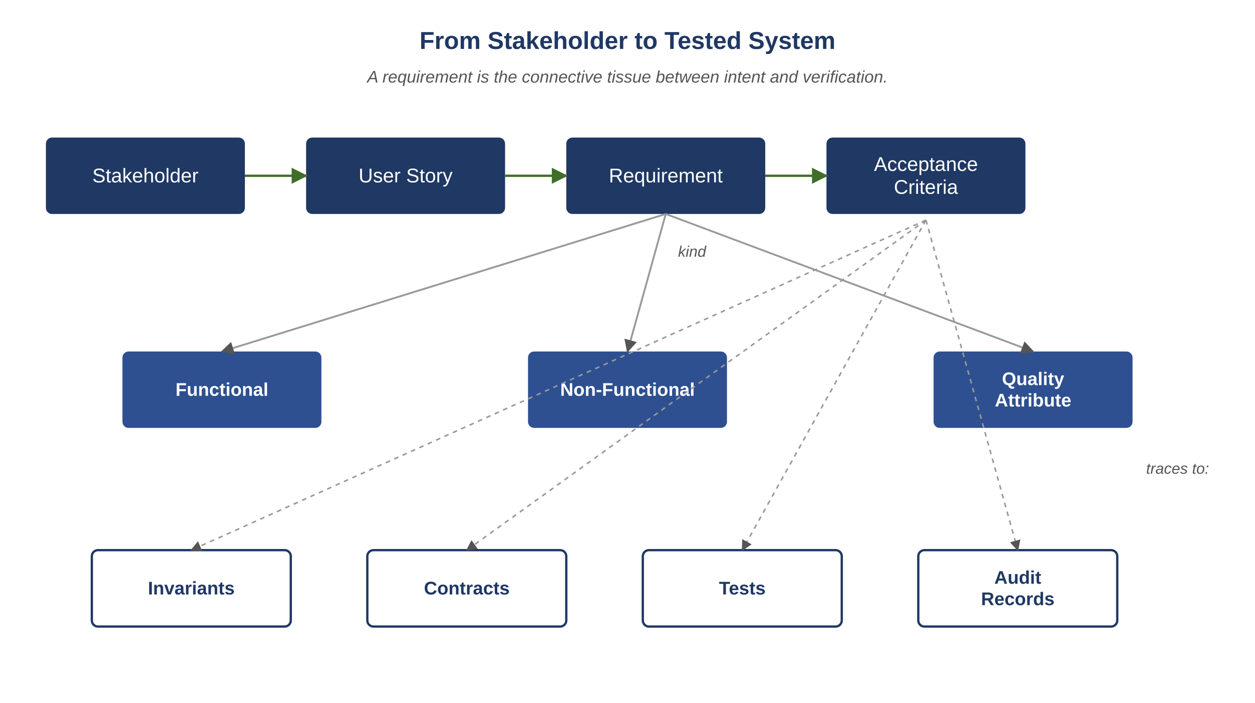
Figure B.1 — From stakeholder to tested system: the requirements pipeline.
In an AI-driven system, each of these activities can involve agents. Elicitation can be supported by agents that summarize stakeholder interviews; analysis by agents that surface contradictions; validation by agents that prototype acceptance criteria into runnable tests. The discipline does not change; the participants do.

B.4 Requirements in an AI-Driven System
The framework in this book consumes requirements in three places. Knowing where they go is what makes the discipline concrete rather than ceremonial.

B.4.1 Requirements as Inputs to Design
The Architect agent receives requirements as part of its context. A design proposal is, in effect, a structured response to a set of requirements: this design satisfies these functional requirements, respects these non-functional budgets, and preserves these quality attributes. A design that does not cite the requirements it satisfies is incomplete; the Auditor should reject it.

B.4.2 Requirements as Inputs to Invariants
Many invariants in the system descend from non-functional requirements. "A grade, once published, is immutable" began as a stakeholder requirement (regulatory, in Atlas Learn’s case); it became INV-AL-04 because the engineering team needed an enforceable substrate, not a wish. Tracing every invariant back to the requirement that motivated it is part of how the requirements register stays meaningful: a requirement that produces no invariant, no contract, and no test was probably not really a requirement.

B.4.3 Requirements as Inputs to Tests
Acceptance criteria become tests. Functional requirements produce example tests; non-functional requirements produce property tests, load tests, or chaos tests; quality attributes produce structural checks (e.g., "every public action records an audit event with the canonical fields"). The QA agent’s test plan should include at least one test per acceptance criterion; the Validator should refuse to ship a release whose acceptance criteria lack tests.
Key Idea
A requirement that does not produce an invariant, a contract, or a test is functionally invisible to the system. The requirements engineer’s discipline includes refusing to ship requirements that have nowhere to go.

B.5 Capturing Requirements: The Canonical Artifact Shape
Each requirement, in the requirements register, is a structured record. The fields below are the minimum useful set; teams add more as their needs become clear.
{
"id": "REQ-AL-0214",
"statement": "An instructor can reopen a closed assessment for a single learner.",
"kind": "functional", // functional | non_functional | quality_attribute
"rationale": "Documented extensions are a frequent legitimate need; reopening for the whole class is too coarse.",
"source": ["interview:instructor-cohort-2025-Q1", "ticket:ATLAS-1184"],
"stakeholders": ["instructors", "compliance", "learners"],
"priority": "must", // must | should | could | won't (MoSCoW)
"status": "approved", // proposed | analyzing | approved | implemented | superseded
"acceptance_criteria": [
"AC-1: action available only to users with instructor privileges on the course",
"AC-2: action requires recorded reason",
"AC-3: only the named learner’s window reopens",
"AC-4: rest of class’s closed status is unaffected",
"AC-5: tracker event recorded with actor, target, reason, timestamp",
"AC-6: reopen window has explicit expiry"
],
"traces_to": {
"designs": ["DSG-AL-0091"],
"invariants": ["INV-AL-08"],
"contracts": ["API-AL-INSTRUCTOR-04"],
"tests": ["QAS-AL-1130", "QAS-AL-1131"]
},
"introduced": "2025-Q1",
"last_reviewed": "2025-Q4"
}
The fields earn their keep in different ways. Stable identifiers ("REQ-AL-0214") let every other artifact in the system reference the requirement by ID rather than by name; the statement can be revised without breaking the references. Source citations make the requirement traceable to its origin, which matters when a stakeholder later challenges what was promised. Priority makes trade-off conversations explicit; status tracks the requirement’s journey through the discipline. Traces are the connective tissue: every design, invariant, contract, and test that the requirement touches is enumerated, so an investigator months later can answer "what depends on this?" in seconds.
Common Pitfall
A requirements register that lacks a "traces_to" structure is a list, not a register. Lists are easy to maintain and impossible to evolve safely; without traces, a change to a requirement cannot be propagated reliably to the artifacts that depend on it. This is one of the more common silent failures in real teams.

B.6 Validating Requirements
Validation answers the question: did we capture what they meant? It is its own activity because the requirements engineer’s draft and the stakeholder’s mental model rarely match on the first pass.
Three validation techniques cover most cases:
Review. Stakeholders read the specified requirements and confirm or correct them. Sounds simple; in practice the stakeholder needs help, because they are reading a structured artifact in vocabulary they did not invent. The reviewer’s discipline is to translate the artifact back into stakeholder language during the review and confirm the round-trip preserves meaning.
Prototyping. Build a thin slice that shows the requirement satisfied, before committing to the full implementation. A prototype that the stakeholder can interact with surfaces ambiguity that no document review will catch. In an AI-driven system, the Architect can produce design-level prototypes (mock data flows, schema sketches, interaction diagrams) cheaply enough that this becomes routine.
Acceptance testing. The acceptance criteria, as tests, are run against the implementation. Passing the criteria is necessary but not sufficient; criteria can be passed by an implementation that violates the spirit of the requirement. The QA agent’s test plan should include adversarial tests that try to satisfy the criteria while breaking the intent.
In the framework, validation is also where the Auditor agent earns its keep on the requirements artifact itself. The Auditor checks each requirement for: testability (does it have at least one acceptance criterion that can be turned into a test?), completeness (are the priority, source, and traces all populated?), and consistency (does the requirement contradict another requirement in the register?). A requirement that fails any of these checks is returned to the requirements engineer with a structured finding, just as a design-time finding is returned to the Architect.

B.7 Evolving Requirements
Requirements evolve. The discipline is not "lock the requirements" but "manage the evolution explicitly." Three mechanisms make evolution survivable.

B.7.1 Change Requests
A change request is a structured proposal to modify a requirement. It includes: the requirement ID being changed, the proposed change, the rationale, the requesting stakeholder, the impact estimate (which downstream artifacts are affected), and the priority of the change. Change requests go through the same elicitation → analysis → specification → validation cycle as new requirements; they do not bypass the discipline because they are "just changes."

B.7.2 Versioning the Register
The requirements register itself lives in version control. Every change to a requirement is a recorded edit, with author, timestamp, and rationale. The current state is computable from the change history; a snapshot of the register as it stood three months ago is recoverable exactly. This is the same discipline applied to source code, applied here to the artifact that drives the source code.

B.7.3 Stale-Requirement Detection
A requirement that has not been reviewed in a long time, or whose downstream artifacts have changed without a corresponding requirement update, is suspicious. The Validator agent runs a periodic sweep: any requirement with last_reviewed older than the policy threshold, or whose traced invariants/contracts/tests have changed since the requirement’s last edit, is flagged for human review. Most flagged requirements turn out to be fine on inspection; the small percentage that turn out to be stale are exactly the ones that would otherwise have produced "but we said this was a requirement!" arguments months later.
Reflection
Pick a requirement document or backlog you have seen in real life. For each requirement, identify whether it has: a stable ID, a source citation, an acceptance criterion, a priority, traces to design/invariants/tests, and a last-reviewed date. Most real requirement documents are missing at least three of the six. The missing fields are the gaps where requirements drift quietly out of sync with the actual system.

B.8 Atlas Learn: An Enrollment-Feature Evolution
Atlas Learn — A requirement traced from initial draft to shipping behavior
On Atlas Learn, the requirement that became "an instructor can reopen a closed assessment for a single learner" did not arrive in its final form. The first draft, from a stakeholder interview, was simply: "instructors should be able to extend deadlines for learners with documented reasons." The requirements engineer’s analysis surfaced four ambiguities. (1) Is the extension before the deadline, or after the assessment is already closed? Both, said compliance, but the latter needs an audit trail the former does not. (2) Who counts as an instructor? The course owner only, or also TAs? Course owner and named TAs, said the product team. (3) Can an extension be revoked? Yes, said legal, but only with a recorded reason. (4) Does the reopened window have a maximum duration? Yes, said compliance: 14 days. The four ambiguities became four acceptance criteria, two new invariants (INV-AL-08 on the audit trail; INV-AL-10 on privileged-action recording), and one update to an existing contract. By the time the feature was implementation-ready, the original one-line requirement had become a 12-criterion record with traces to two designs, two invariants, three contracts, and seven tests. This is what requirements engineering produces when it is done honestly: not bureaucracy, but the connective tissue that lets the rest of the framework do its job.
The example illustrates two general points. First, an honest elicitation catches more than a hasty one; the four ambiguities would all have produced incidents if shipped. Second, a single requirement legitimately produces many downstream artifacts; the traces are not overhead but the substance. A team that skips the requirements discipline does not avoid these artifacts; it produces them tacitly, which is much worse.
Exercises
Solutions appear in the companion solutions volume. Try the exercises before consulting them.
1. Distinguish functional, non-functional, and quality-attribute requirements. Give one example of each from a system you know.
2. Name the five activities of the requirements engineering discipline (elicitation, analysis, specification, validation, evolution) and the output of each.
3. List the recurring causes of requirements failure named in this chapter (stakeholder unknowns, stakeholder disagreement, drift, tacit knowledge) and a single failure mode each one produces.
4. Take the user story "as an instructor, I want to reopen a closed assessment for a single learner." Write at least six acceptance criteria for it, in the style of the chapter’s example.
5. For Atlas Learn’s "submit an assessment" feature, list one functional, one non-functional, and one quality-attribute requirement that the feature must satisfy.
6. Take a requirement from a project you know and evaluate it against the canonical artifact shape (id, statement, kind, rationale, source, stakeholders, priority, status, acceptance_criteria, traces_to, introduced, last_reviewed). Identify which fields are missing.
7. Argue against the claim "requirements should be locked at the start of a project." Identify two failure modes the locked-requirements discipline produces and propose a discipline of evolution that preserves predictability without producing the same failures.
8. Design the requirements review process for an AI-driven team. Specify who reviews, what the review produces, how disagreements are recorded, and how the review record connects to the rest of the framework’s audit trail.
9. A team’s requirements register has 800 entries, none with last_reviewed dates. Design a remediation plan: how to bring the register to a healthy state without halting development, and how to prevent the staleness from recurring.
Key Takeaways
Requirements are statements of what the system must do or be, written precisely enough to test.
The five activities — elicitation, analysis, specification, validation, evolution — are recurring, not linear; a requirement returns through them many times over its life.
The canonical artifact shape (ID, statement, source, priority, status, traces) is what makes the requirements register usable as connective tissue rather than as a static document.
In an AI-driven system, requirements feed into designs, invariants, contracts, and tests; a requirement that produces none of these is functionally invisible.

3. The Federation of Lifecycles
After this chapter, you will be able to:
• LO 3.1 — Identify the seven lifecycles in the federated SDLC and the owner, inputs, outputs, and exit criteria of each.
• LO 3.2 — Diagram the forward and backward edges between lifecycles for a representative engineering change.
• LO 3.3 — Explain why a single linear pipeline understates how real engineering work actually happens, with specific reference to where it breaks down.
• LO 3.4 — Apply the federation to a system you know, identifying which lifecycle is currently weakest and what production risk that creates.
• LO 3.5 — Justify, with examples, why skipping a lifecycle does not save time but moves cost from before production to after.
We now move from intuition to structure. The first structural commitment of the framework is that the SDLC is not a single lifecycle but a federation of seven, each with its own owner, inputs, outputs, exit criteria, and feedback edges.

3.1 Why Seven Lifecycles, Not One
A single linear "design → build → test" pipeline forces every concern into a sequence. In practice, security cannot wait for tests, performance cannot wait for security, and observability cannot wait for release. Concerns must operate in parallel, with explicit hand-offs and explicit feedback.
Key Idea
Lifecycles are concerns that own their own clock. They couple at the seams through hand-offs and feedback edges rather than collapsing into a single timeline, which is what allows them to operate at different rhythms without blocking each other.

3.2 The Seven Lifecycles

3.2.1 Product Lifecycle
Owner: Product agent or human product owner.
Inputs: User research, business goals, regulatory constraints, competitive landscape.
Outputs: Problem statement, target users, success metrics, feature specifications, acceptance criteria, declared non-goals.
Exit gate: Specification is unambiguous, testable, prioritized; non-goals are written down.
Example
In a streaming service, the Product lifecycle decides whether "continue watching" appears on a child profile, what the success metric is for content discovery, and explicitly that algorithmic ranking by personal data is a non-goal in regulated markets.

3.2.2 System Design Lifecycle
Owner: Architect agent.
Inputs: Approved product spec, non-functional requirements (latency, throughput, availability, durability), prior architectural decisions, infrastructure constraints.
Outputs: System design documents, API contracts, schemas, invariants, sequence diagrams, technology choices with explicit tradeoffs.
Exit gate: Auditor sign-off; every invariant phrased as "under condition X, property Y must hold"; failure modes enumerated.

3.2.3 Development Lifecycle
Owner: Developer agent.
Inputs: Approved design, scoped task context, current tracker state, coding standards.
Outputs: Source code, unit tests, inline documentation, migration scripts, feature flags, structured change summaries.
Exit gate: Code compiles; unit tests pass; conforms to contracts and schemas; static analysis clean; scope respected.

3.2.4 Quality Assurance Lifecycle
Owner: QA agent.
Inputs: Code delta, design, invariants, historical defect ledger, concurrency profile, load profile.
Outputs: Failure-first test plan, regression tests, concurrency tests, edge-case assertions, classified defect reports.
Exit gate: No P0 defects open; P1 defects either fixed or carry written, time-bounded exceptions.

3.2.5 Security Lifecycle
Owner: Security agent.
Inputs: Code delta, data-flow diagrams, threat model, dependency manifest, authentication context.
Outputs: Threat model update, vulnerability findings, attack-simulation results, hardening recommendations.
Exit gate: No unresolved critical or high findings; threat model current; residual risks documented.

3.2.6 Performance Lifecycle
Owner: Performance agent.
Inputs: Code delta, critical-path inventory, SLOs, query plans, cache configuration.
Outputs: Latency budgets per endpoint, load-test results, query-plan reviews, before/after benchmarks, concurrency analysis.
Exit gate: No regression on critical-path latency; no query exceeds its budget; cache hit ratios within band.

3.2.7 Release and Observability Lifecycle
Owner: Release Governor agent.
Inputs: All approved artifacts, change log, blast-radius analysis, on-call status, SLO budget history.
Outputs: Release package, canary plan, dashboards, alert rules, runbooks, rollback plan.
Exit gate: Canary cohort shows no regression in observation window; on-call has acknowledged the runbook; rollback rehearsed.

3.3 Relationships Among Lifecycles
The lifecycles are not strictly sequential. They form a directed graph with mandatory feedback edges. A QA finding can push work back to Development. A Performance finding can push back to System Design. A Security finding can invalidate a Product assumption. These backward edges are not failures of the process — they are the process.

3.3.1 The Federated SDLC Flow
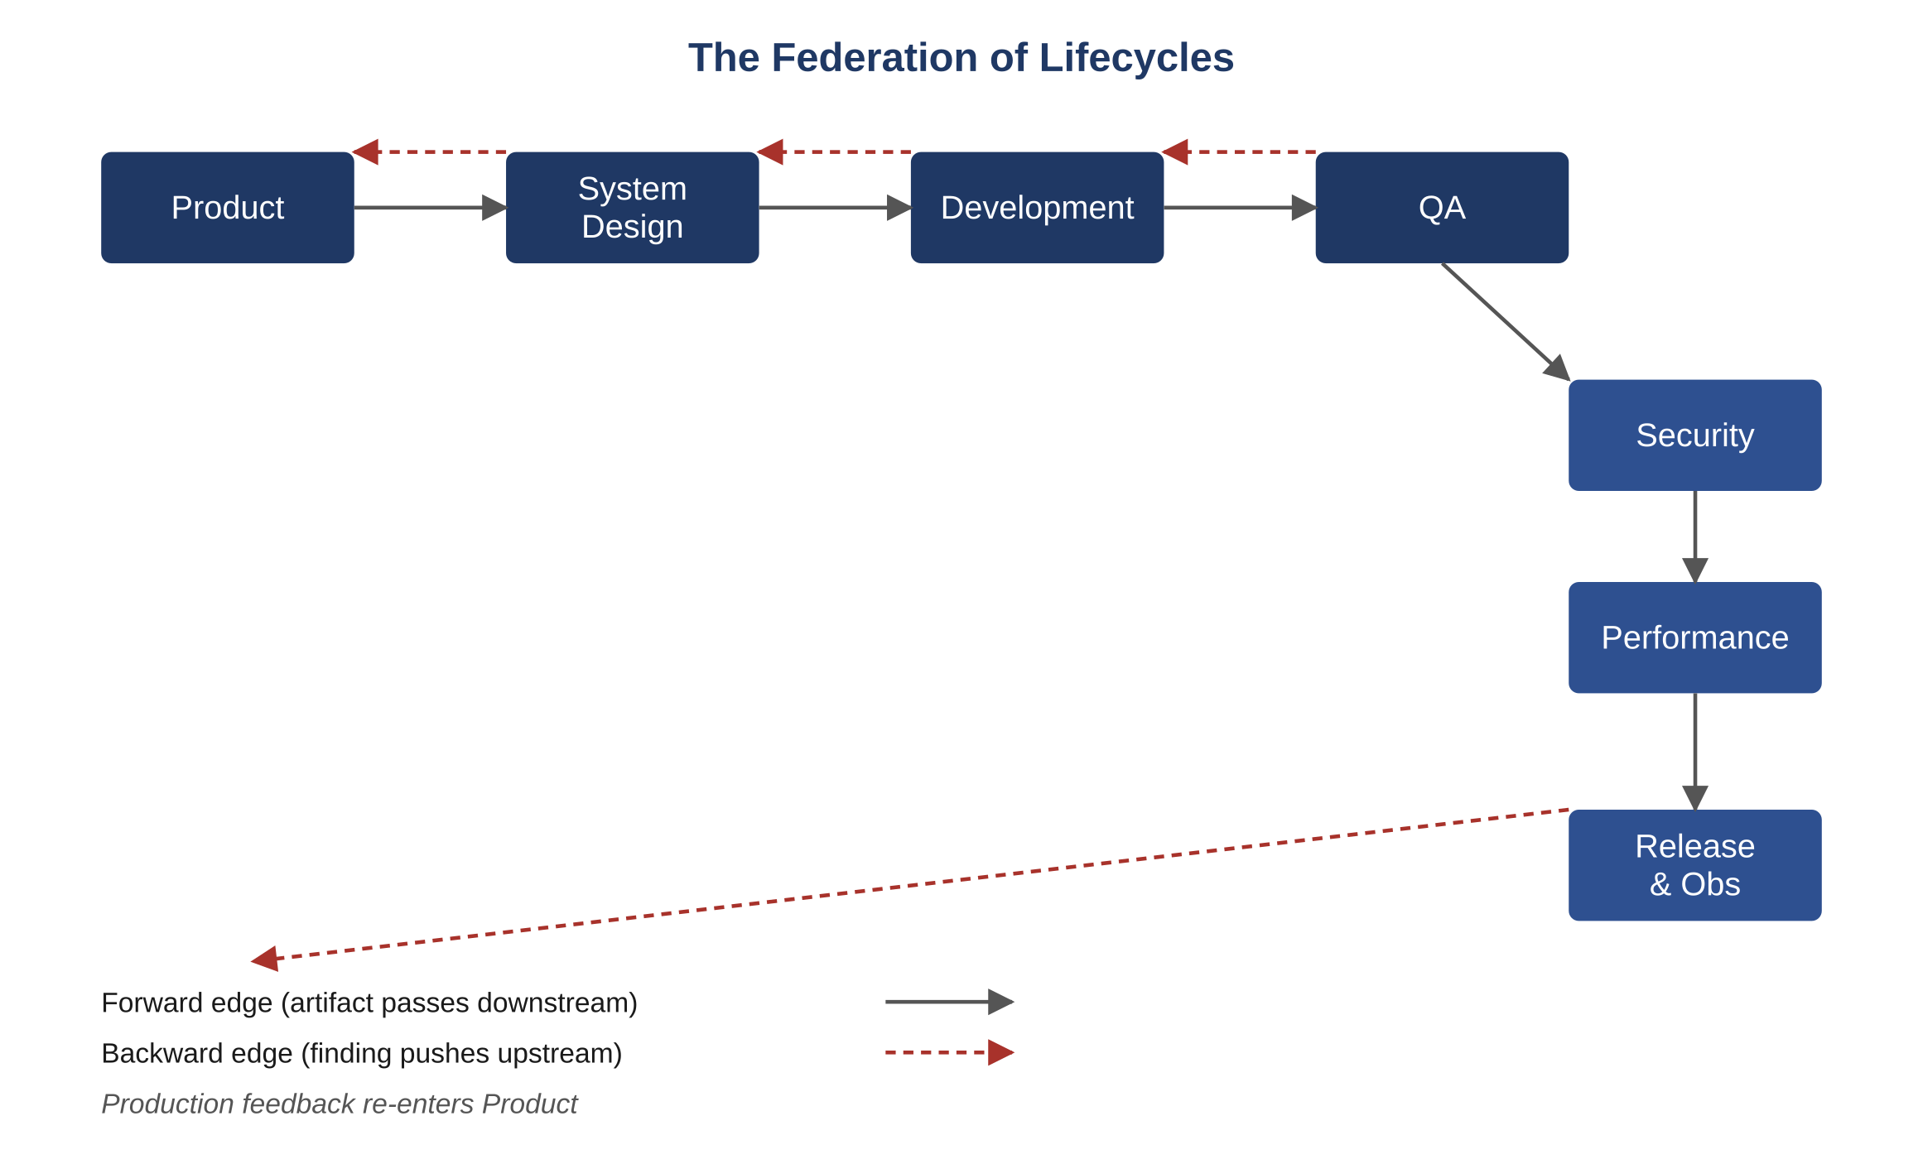
Figure 3.1 — The federation of lifecycles.

3.4 Why Development Alone Is Insufficient
A common misconception is that an AI coding agent constitutes an AI development system. It does not. A coding agent without a product lifecycle builds the wrong thing correctly. Without a design lifecycle it produces inconsistent components. Without QA it ships untested edge cases. Without security it exposes admin paths. Without performance it regresses critical paths. Without release governance it deploys changes that cannot be rolled back.
The Development lifecycle is the engine. The other six are the brakes, the steering, the instruments, and the traffic laws.
Key Idea
Skipping a lifecycle does not save time. It moves the cost of that lifecycle from "before production" to "after production," where it is paid in incidents, customer trust, and regulatory exposure.

3.5 Cross-Lifecycle Feedback Edges
Forward edges propagate a successful artifact downstream. Backward edges propagate findings upstream. Both are first-class.
From -> To | Trigger | What Travels
QA -> Development | Defect found | Defect record + repro + invariant cited
Performance -> System Design | Budget breach | Bench data + plan analysis + suggestion
Security -> Product | Risk to assumption | Threat scenario + mitigation cost
Release -> Product | Production signal | Metric delta + user impact + decision request
Validator -> any | Inconsistency | Mismatch report + offending artifact
Common Pitfall
Treating backward edges as exceptions. They are routine. A lifecycle without measurable backward edges is one not doing its job; the defects are simply being deferred to production.
Atlas Learn — A backward edge from production back to product
Atlas Learn ships a small change: the deadline for assessment submission is rendered with the learner’s timezone instead of the section’s. A week after release, the Release & Observability lifecycle picks up a metric: late submissions are up roughly 12% in the first time zone where the change reached the canary. The Performance and QA agents had no signal — the system was performing within budget and tests were passing. The signal travels backward from Release into Product, not into Development. Product re-examines the assumption: "everyone wants their own timezone" turns out to mean "everyone wants the assessment timezone clearly labeled, in their own timezone, with a countdown." The fix is a product change, not a code fix. The framework treats this loop as ordinary; ad-hoc teams often misroute production signals into bug-fix queues, which is how features keep regressing.
Reflection
In a recent project, count the number of times a finding from QA, Security, or Performance pushed work back upstream. If the count is near zero, you are likely shipping defects, not finding them.
Exercises
Solutions appear in the companion solutions volume. Try the exercises before consulting them.
1. List the seven lifecycles and identify which is the engine and which are the brakes, steering, and instruments.
2. Define "forward edge" and "backward edge" between lifecycles and give one example of each.
3. Explain why running Development without the other six lifecycles produces deferred cost rather than savings.
4. For Atlas Learn’s enrollment-confirm critical path, identify which lifecycle owns each of: the contract, the schema, the latency budget, the audit record, and the rollback plan.
5. Pick any recent feature you have read about in a technology blog. Map which of the seven lifecycles were active in delivering it. Most blogs only describe one.
6. Take a backward edge from QA to Development and write the structured payload it should carry (defect record, repro, invariant cited, blast radius). Use a real or plausible example.
7. Argue that Performance and Security are themselves federation members and not "concerns to be added at the end." Use a specific failure mode to support each.
8. Design the cross-lifecycle handoff for a security finding that affects the data model. Identify which lifecycles see it, in what order, and what artifact each produces.
9. A startup founder claims they will skip QA and Security as separate lifecycles to ship faster. Predict the three production incidents that will result, and identify which lifecycle each one originated in.
Common Mistakes
Each one looks reasonable in isolation; each one produces a failure mode the chapter argues against.
1. Treating the seven lifecycles as one pipeline. The instinct is to draw an arrow from Product to Release and call it the workflow. The federation framing exists because the actual work bounces among the lifecycles many times; the pipeline framing hides the backward edges that prevent most production incidents.
2. Skipping a lifecycle because "we don’t need it yet." Every skipped lifecycle’s work still has to happen — just later, more expensively, often as an incident. A team that skips Performance until something is slow has chosen to discover the budget by exceeding it.
3. Not recording the backward edges. When QA bounces a finding back to Development, the backward edge is structurally part of the workflow. A team that handles the bounce by chat or in person, rather than as a recorded backward edge with the invariant cited and the artifact updated, will find that future investigations cannot reconstruct what happened.
Key Takeaways
There are seven lifecycles, each with its own inputs, outputs, and exit criteria.
Feedback edges are part of normal operation; a backward edge is not an exception.
Development is the engine, but the other six are what keep the engine pointed at the road.

4. The Four-Layer System Architecture
After this chapter, you will be able to:
• LO 4.1 — Describe the four architectural layers — Memory, Controller, Agents, Artifacts — and the contract each one keeps with its neighbors.
• LO 4.2 — Identify which cross-layer interactions are allowed, which are forbidden, and explain the reasoning behind each rule.
• LO 4.3 — Trace a single engineering task as it flows through the four layers and produces a signed artifact.
• LO 4.4 — Analyze a proposed shortcut between layers (for example, an agent reading memory directly) and predict the operational cost it will create.
• LO 4.5 — Evaluate where humans fit into the architecture and how their actions are recorded with the same discipline as an agent’s.
Before reading this chapter
You will get more out of what follows if you are already comfortable with:
• The federation idea from Chapter 3 — the chapter assumes you already accept that engineering work splits across overlapping concerns.
• Layered architecture in general (presentation/application/domain/infrastructure or similar). If the term is new, the Wikipedia entry on multilayered architecture is a fifteen-minute read that suffices.
• The notion of a software contract — a written interface specification one component honors so another can rely on it. Any introductory software-engineering text covers this in one chapter.
• A working sense of what an audit trail is and why systems keep them. No formal background needed; just the intuition that "who did what, when, on what input" must be reconstructable.
We turn now from process to structure. The system that hosts AI-driven engineering work is organized as four horizontal layers. Each has strict contracts with the layers above and below it. Layers do not reach across; an agent does not read raw memory directly, and one agent does not invoke another. This separation is what makes the system auditable, debuggable, and replaceable.
Key Idea
The architecture is layered for replaceability. Because the contracts between layers are written down, any one layer can be rewritten without rewriting the others — which matters in a domain where individual components (models, controllers, memory backends) get replaced more often than the overall structure.

4.1 The Four Layers at a Glance

4.1.1 The System Memory Layer
Purpose: Holds all persistent state the agents need: design documents, invariants, contracts, schemas, the tracker, prior decisions, prompt library, defect ledger.
Components: Versioned document store, structured knowledge base, event-sourced tracker, decision ledger, prompt library, defect ledger, observability map.
Contract: Every read is logged. Every write is versioned. Nothing is deleted; it is superseded with a deprecation note.

4.1.2 The Controller Layer
Purpose: The orchestrator. Decides which agent to invoke next, assembles context, enforces budgets, handles retries, routes escalations.
Components: Workflow engine, context assembler, budget controller, escalation router, audit emitter, retry manager.
Contract: The controller is the only component that invokes agents. Agents do not invoke each other.

4.1.3 The Agent Layer
Purpose: The specialists. Each agent has a single responsibility and a strict input/output contract.
Components: Architect, Auditor, Developer, QA, Security, Performance, Validator, Release Governor.
Contract: Every agent receives a sealed context (role, inputs, objective, constraints, output format) and returns a sealed artifact. No hidden state. No side channels.

4.1.4 The Artifact Layer
Purpose: The deliverables. Code, tests, reports, release packages, dashboards, runbooks.
Components: Source repository, test suites, vulnerability reports, performance reports, release manifests, observability configurations.
Contract: Every artifact is signed by the agent that produced it and references the input artifacts it consumed.
Atlas Learn — One Atlas Learn task through all four layers
Task TSK-AL-201 is a fix for the seat-overrun bug: under heavy load, two learners can briefly claim the same last seat in a section, breaking INV-AL-01. The Memory layer holds the offending invariant, the contract for the enrollment service, the existing schema, and the prior decision record about why the seat counter is denormalized. The Controller pulls just the relevant slices of memory into a context pack and invokes the Architect agent. The Architect proposes a small redesign: an atomic decrement guarded by a unique-per-section idempotency key. The Controller passes the proposal to the Auditor agent, which checks the proposal against INV-AL-01 and INV-AL-06; on approval, the Developer implements the change against the existing contract. Each step writes signed artifacts: the Architect writes a design delta, the Auditor writes an approval record, the Developer writes code and a test. The Artifact layer holds them; the Memory layer indexes them; the Controller is the only thing that crosses layer boundaries. No agent ever reads memory directly, and no agent invokes another. That single discipline is what makes the system replayable for an audit later.

4.2 Component Diagram
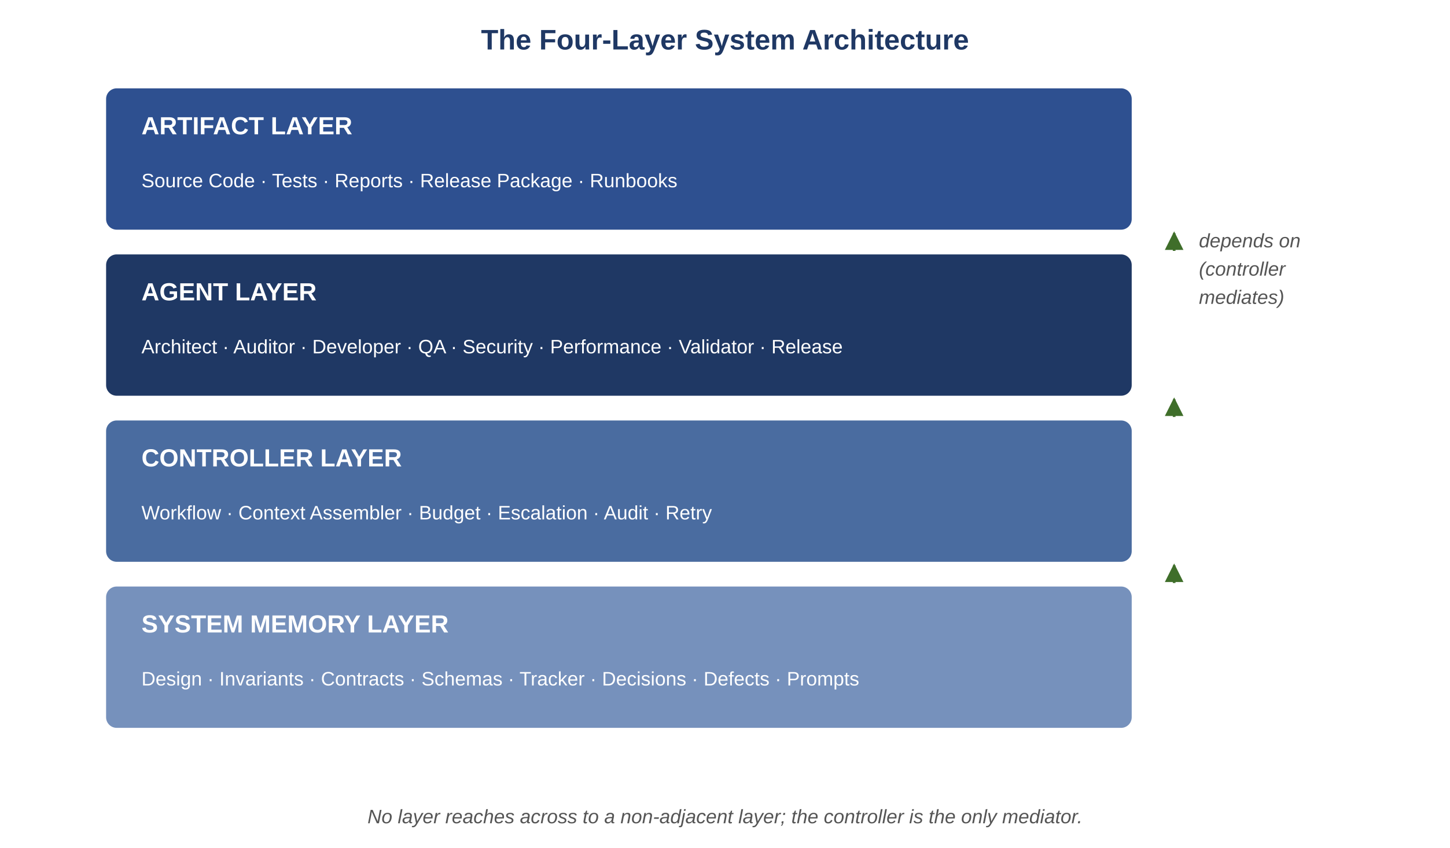
Figure 4.1 — The four-layer system architecture.

4.3 Allowed and Forbidden Cross-Layer Traffic
From -> To | Allowed? | Reason
Agent -> Memory (direct) | No | All memory access goes through the controller for auditing.
Agent -> Agent (direct) | No | Workflow is controller-mediated; prevents hidden coupling.
Controller -> Memory | Yes | Controller is the memory gatekeeper.
Controller -> Agent | Yes | Standard invocation pattern.
Agent -> Artifact | Yes | Agents produce signed artifacts.
Artifact -> Memory | Yes (via controller) | Artifacts are persisted and referenced.
Human -> Controller | Yes | Approval, override, and escalation entry points.
Human -> Memory (direct) | Discouraged | Allowed for governed edits to invariants or schemas, fully audited.

4.4 Why This Layering Matters
Layering is not architectural elegance for its own sake. It produces concrete properties:
- Auditability. Every memory access and agent invocation passes through the controller, which logs it. There is no off-record path for an agent to read or write state.
- Replaceability. The controller can be rewritten without touching agents. An agent can be replaced by a better one without touching the controller.
- Testability. Each layer is testable in isolation. Memory is fixtures; controller is unit-tested with mocked agents; agents are tested with sealed contexts.
- Failure isolation. A bad agent output does not corrupt memory; it is rejected at the controller boundary.
Example
Imagine a content-moderation platform where a Security agent and a QA agent disagree about a finding. In a layered system, the disagreement is visible: each agent’s output is independently logged with its inputs and reasoning. The controller routes the conflict to a Validator. In an unlayered system where agents talk to each other directly, the disagreement is resolved in private — if at all — and the audit trail is silent.
Common Pitfall
Allowing "convenience shortcuts" that let an agent reach into another layer directly. This is how systems ossify into untestable monoliths within months. Every shortcut taken is a future audit failure.

4.5 The Human Layer
Humans are not a fifth layer; they are entry points into the controller and the memory layer. The framework treats humans as a privileged actor with two responsibilities: approval at named gates and authorship of governed edits. Both are audited like any other event.
Key Idea
Humans participate in this system through specific entry points — approvals at named gates and authored edits to memory. They are not external supervisors; their actions go through the same audit and tracker that agents do, which is what makes joint human-AI operation reproducible after the fact.
Reflection
For a system you operate, draw the four layers. Identify every place where one layer reaches into a non-adjacent one. Each such crossing is a candidate refactor or a candidate incident.
Exercises
Solutions appear in the companion solutions volume. Try the exercises before consulting them.
1. Name the four layers of the architecture and the contract that each one keeps with its neighbors.
2. List two interactions between layers that are explicitly forbidden, and the operational reason for each prohibition.
3. Explain why agents cannot invoke other agents directly. What property of the system would be lost?
4. For Atlas Learn’s seat-fix task (TSK-AL-201), identify what each of the four layers contributed. Be specific about which artifact lives where.
5. Take a system you know that does NOT use this architecture. Identify three places where a non-adjacent cross-layer call exists and predict the operational cost each one creates.
6. A new agent is being added to handle accessibility audits. Specify its inputs, outputs, and the layer interactions it is allowed to make.
7. Critique the constraint "no agent may read raw memory directly." Build the strongest case against it, then rebut it. Whose argument is more persuasive?
8. Design what a "self-service shortcut" between the Agent layer and the Memory layer would look like, then enumerate the three kinds of incident it would eventually produce.
9. Argue for or against this claim: "the human is just another agent, with the same contract obligations and the same audit record." Use at least two examples to support your position.
Common Mistakes
Each one looks reasonable in isolation; each one produces a failure mode the chapter argues against.
1. "Just this once" cross-layer reads. An agent reads memory directly to skip a controller round-trip. The controller no longer has the audit record; the operation is invisible to subsequent investigation. "Just this once" tends to become routine within a quarter.
2. Treating the controller as just a router. The controller is not a passing-through layer; it is the chokepoint where retries are bounded, transitions are decided, and audit is written. A controller implementation that "just forwards" has lost the discipline that justified having it.
3. Adding a fifth layer for a special case. When something doesn’t fit the four layers, the temptation is to invent a fifth. The honest answer is usually that the special case belongs inside one of the existing four; the new layer is a workaround, not a refinement.
Key Takeaways
The four layers are Memory, Controller, Agents, and Artifacts.
The controller mediates every cross-layer interaction; agents do not reach into memory or call each other directly.
The value of this constraint shows up in audit, in debugging, and in the ease of replacing one layer at a time as the technology underneath evolves.

Bridge — Architecture Patterns
Chapter 4 introduced the four-layer architecture this book argues for: System Memory, Controller, Agents, and Artifacts. That architecture is opinionated about the meta-system — the system that hosts AI agents — but it is silent on the architecture of the application the agents are building. Real applications run as monoliths, microservices, event-driven systems, hexagonal architectures, and CQRS systems. A textbook on engineering needs to give a reader the vocabulary to recognize these patterns, the criteria to choose between them, and the framework’s answer for how each pattern interacts with the disciplines this book argues for.
This is a bridge chapter for the same reason as the previous one: it sits between two existing chapters without displacing them. The chapters that follow continue to assume the four-layer architecture for the meta-system; the patterns surveyed here describe the application architecture the meta-system orchestrates work on.
After this chapter, you will be able to:
• LO C.1 — Recognize the six dominant application-architecture patterns (monolith, layered, microservices, event-driven, hexagonal, CQRS) and articulate the trade-off each one optimizes.
• LO C.2 — Apply the right pattern to a problem given its concurrency profile, deployment cadence, team structure, and operational maturity.
• LO C.3 — Identify how the framework’s four-layer meta-architecture adapts to each application pattern, and where the integration points sit.
• LO C.4 — Evaluate an architectural choice for an unstated coupling, an unbudgeted operational cost, or a mismatch with the team’s actual capabilities.
• LO C.5 — Construct a defensible argument for or against a pattern in a real proposal, citing the specific failure modes the pattern tends to produce or prevent.
Before reading this chapter
You will get more out of what follows if you are already comfortable with:
• Chapter 4 (The Four-Layer System Architecture) for the meta-system architecture this chapter’s patterns interact with.
• Chapter 2 (Mental Models), particularly the Federation Model and the Failure-First Model. Most pattern choices are bets about which failure modes you would rather have.
• A working sense of what a "service" is in software — a process that exposes an interface other processes call. Any introductory software architecture text covers this.
• Section 0’s definitions of latency, deployment, and infrastructure. Pattern conversations are mostly about latency budgets, deployment cadence, and infrastructure shapes.

C.1 Why Architecture Patterns Exist
A pattern is a named, recurring solution to a class of problem. Architecture patterns are named ways of organizing a system’s components, the boundaries between them, and the way they communicate. They exist because the same structural problems recur across domains, and naming a solution makes it cheaper to discuss, evaluate, and replace later.
Three claims about patterns are worth holding in mind throughout this chapter:
- Patterns are bets, not truths. Each one optimizes some properties at the cost of others. A team adopting a pattern is buying its strengths and inheriting its weaknesses; the question is whether the trade is right for them, not whether the pattern is right in general.
- Patterns compose. Real systems usually combine several patterns at different scales: a microservices application where each service is internally layered; a monolith with one event-driven subsystem; a hexagonal core with a CQRS read side. The discrete labels in this chapter are pedagogical conveniences.
- Patterns evolve. A system that starts as a monolith often evolves toward microservices; a CQRS read side often grows out of a layered system whose read load eventually justified the split. Pattern choice is a snapshot of a moving target; revisiting the choice as the system grows is itself a discipline.
Key Idea
A pattern is a bet. The right question is never "which pattern is correct" but "which failure modes is this team ready to inherit, and which would break them."

C.2 The Monolith
A monolith is a single deployable unit that contains all of the application’s functionality. One process, one codebase, one database (usually). The name carries cultural baggage — in some quarters "monolith" is a slur — but the pattern remains the dominant choice for new applications, and for good reasons.
What it optimizes: Internal communication latency (function calls, not network calls), transactional consistency (one database transaction can span the whole feature), simple deployment (one artifact, one rollout), and small-team velocity (no cross-service coordination overhead).
What it costs: Independent deployability (a small change requires re-deploying everything), independent scaling (the whole monolith scales together), and clean ownership (any team can edit any module unless conventions enforce otherwise).
When it fits: Small teams, single-domain applications, teams that have not yet earned the operational maturity to run distributed systems, and the early life of almost every successful product. Most successful microservices systems started as monoliths.
Example
A small fintech startup runs the entire product as a monolith for two years. Every customer-facing feature, every internal admin tool, and every reporting endpoint live in one codebase and deploy together. The team is six engineers. They ship every business day. When the user base grows past a million, the monolith starts hurting in two specific places: the reports endpoint runs heavy queries that interfere with transactional latency, and the admin tools have a different deploy cadence than the customer site. They split those two pieces out as separate services. The rest stays a monolith for another three years. The lesson is not that monoliths are right; it is that the boundary between a healthy monolith and a too-large monolith is a specific operational threshold, not a code-size threshold.
Common Pitfall
"We chose microservices because monoliths don’t scale." Monoliths scale. They scale until specific bottlenecks (deploy contention, query interference, team coordination) exceed the team’s tolerance. Adopting microservices to "fix scaling" without naming the specific bottleneck usually trades known monolith pain for unfamiliar distributed-systems pain at a worse exchange rate.

C.3 The Layered Architecture
Layered architecture organizes the application into horizontal layers, each one with a defined responsibility, where each layer can call the layer directly below it but not the other way around. The classic three layers are presentation, business logic, and data access. Larger systems add layers for cross-cutting concerns like API gateway, integration, and policy.
What it optimizes: Separation of concerns within a single deployable unit, independent reasoning about each layer’s logic, and replaceability of a layer’s implementation without changing the layers above or below.
What it costs: Performance overhead from layer-to-layer translation (each crossing usually costs a serialization and a function call), and the temptation for engineers to bypass layers when convenient ("just this once") which gradually erodes the discipline that justified the layers.
When it fits: Almost any monolith benefits from internal layering. The layered pattern is more about how to organize a codebase than how to deploy a system; it composes cleanly with other patterns.
The framework’s four-layer meta-architecture is itself an instance of layered design — Memory → Controller → Agents → Artifacts. The inheritance is intentional: the layered pattern’s discipline (calls go down only; cross-layer calls are forbidden) is the same property that makes the framework auditable. When the chapters argued that no agent may call another agent or read raw memory, that is the layered pattern showing up at the meta-level.

C.4 Microservices
A microservices architecture decomposes the application into a set of independently deployable services, each owning a bounded portion of the domain, communicating over the network. Each service has its own codebase, its own deploy cadence, often its own database, and one team responsible for its operation.
What it optimizes: Independent deployability (a service can ship without other services changing), independent scaling (each service scales to its own load), team autonomy (one team owns the full stack of one service), and technological diversity (each service can choose its own runtime, language, or database).
What it costs: Network latency between services, transactional weakness (cross-service transactions are hard), operational complexity (now there are dozens of moving parts), and deployment-coordination overhead for changes that span services.
When it fits: Large systems with multiple bounded domains, multiple teams that need to deploy independently, and an operational maturity that includes service discovery, distributed tracing, and resilience patterns (circuit breakers, retries, fallbacks). Microservices without operational maturity are usually worse than the monolith they replaced.
Example
Atlas Learn runs as a microservices architecture: enrollment, grading, live-session, content delivery, and discussion are each their own service, each with its own team. The decomposition followed the bounded contexts of the domain: enrollment’s data and rules are mostly independent of grading’s, so each can evolve without the other. The cross-service interactions are intentionally narrow — enrollment publishes events that grading and discussion subscribe to, but grading does not call enrollment synchronously. The narrowness is what makes the architecture survivable; a wider coupling would have produced a distributed monolith.
Common Pitfall
The distributed monolith. A microservices architecture where every change requires every service to deploy together. The decomposition gave the team the costs of distribution without the benefit of independent deployability. The fix is rarely "split further" — it is usually to fix the synchronous couplings that turned independent services into one logical unit.

C.5 Event-Driven Architecture
In an event-driven architecture, components communicate primarily by emitting and consuming events rather than by calling each other. A service publishes "an enrollment was confirmed"; other services that care subscribe to it. The publisher does not know who consumes; the consumers do not know who else consumes.
What it optimizes: Loose coupling (publisher and subscribers are independent), responsiveness (subscribers react asynchronously without blocking), and extensibility (a new subscriber can join without modifying the publisher).
What it costs: Eventual consistency (a state change reaches different consumers at different times), debuggability (the causal path runs through a broker that may obscure it), and the discipline to design events as a stable contract.
When it fits: Domains where many components react to the same state change, where strict consistency is not required, and where the publisher genuinely does not need to know about consumers. Notification fan-out, audit trails, and downstream analytics are classic candidates.
Event-driven architectures are increasingly common in AI-driven systems because the agentic federation maps cleanly to it. The controller emits stage-transition events; agents subscribe to the stages they handle; the tracker records every event. The pattern’s loose coupling is what lets the controller add or replace an agent role without touching the rest of the system.

C.6 Hexagonal Architecture
Hexagonal architecture (also called ports-and-adapters) inverts the usual dependency direction: the application core does not depend on the outside world; the outside world depends on the application core through adapters. The core defines ports — interfaces the core needs — and the outside world (databases, queues, HTTP, message brokers) implements those ports. The core is, in principle, runnable in isolation, with the adapters substituted for tests.
What it optimizes: Testability (the core has no infrastructure dependencies; all infrastructure is mocked through adapters), portability (swapping a database is replacing one adapter), and conceptual clarity (the domain logic is uncontaminated by infrastructure concerns).
What it costs: Indirection at every infrastructure call, conceptual overhead (engineers must internalize the inversion), and the discipline to keep the core pure (any infrastructure leak into the core silently nullifies the architecture’s benefits).
When it fits: Domains with rich business logic that the team wants to evolve over years, where the infrastructure is expected to change (databases swapped, queue technology replaced, network protocols upgraded), and where testability is a first-class concern.
The framework’s discipline of separating agents (which embody domain reasoning) from controllers (which talk to infrastructure) and from memory (which persists state) is conceptually similar to hexagonal architecture: the agents are the core; the controller and memory together act as the adapters; the application architecture beyond is the outside world. The inheritance is not coincidental — hexagonal architecture solves the same conceptual problem the framework solves at the meta-level.

C.7 CQRS
CQRS — Command Query Responsibility Segregation — separates the path that mutates state from the path that reads it. Commands (writes) go through one model; queries (reads) go through another. The two paths can have different schemas, different scaling profiles, even different storage backends.
What it optimizes: Read performance at scale (reads use a denormalized projection optimized for the query pattern; writes are not slowed by read-side considerations), and complex domains where the write model and the read model genuinely have different shapes.
What it costs: Eventual consistency between the write and read sides (a write may not appear in a query for some bounded delay), conceptual overhead, and the work of maintaining a separate projection.
When it fits: Read-heavy domains where the read load justifies a separate path; domains where the write model is normalized for invariants and the read model is denormalized for views; and CQRS pairs naturally with event-driven architecture, where events feed the projection.
Example
Atlas Learn’s grade-publishing system uses CQRS. Writes go through a strongly consistent path that enforces INV-AL-04 (a published grade is immutable; corrections flow as amendments) against the canonical grade store. Reads come from a denormalized projection that joins grades with assessment metadata for fast instructor-dashboard queries. The two sides are kept consistent through events. A naive non-CQRS design would have either slow dashboards (because the strongly consistent store is normalized for invariants, not for queries) or weakened invariants (because the denormalized store could not enforce INV-AL-04 cleanly). The split is what lets both properties hold.

C.8 Choosing Well
No pattern dominates the others. The right choice depends on properties of the team and the system that the patterns themselves do not see. Five questions reliably surface the relevant properties.
What is the team’s operational maturity? A team without distributed-tracing, service discovery, and circuit breakers should not adopt microservices. The pattern’s benefits assume operational capabilities the team has not yet built; without them, the team inherits the costs and forgoes most of the benefits.
What is the system’s concurrency profile? Read-heavy systems with very different write and read shapes are CQRS candidates. Notification-heavy systems with many independent consumers are event-driven candidates. Strongly transactional systems with cross-feature consistency requirements are monolith or layered candidates.
What is the deployment cadence? Independent deployability is the strongest argument for microservices; if the team deploys once a week and is happy with that cadence, the argument loses most of its weight.
What is the domain shape? Domains with rich, evolving business logic benefit from hexagonal’s testability; domains where the business logic is mostly CRUD do not benefit enough to justify the indirection.
What does the team already know? The cost of adopting an unfamiliar pattern is rarely budgeted accurately. A team that already operates a microservices system competently will have an easier time scaling that pattern than one that is learning it for the first time.
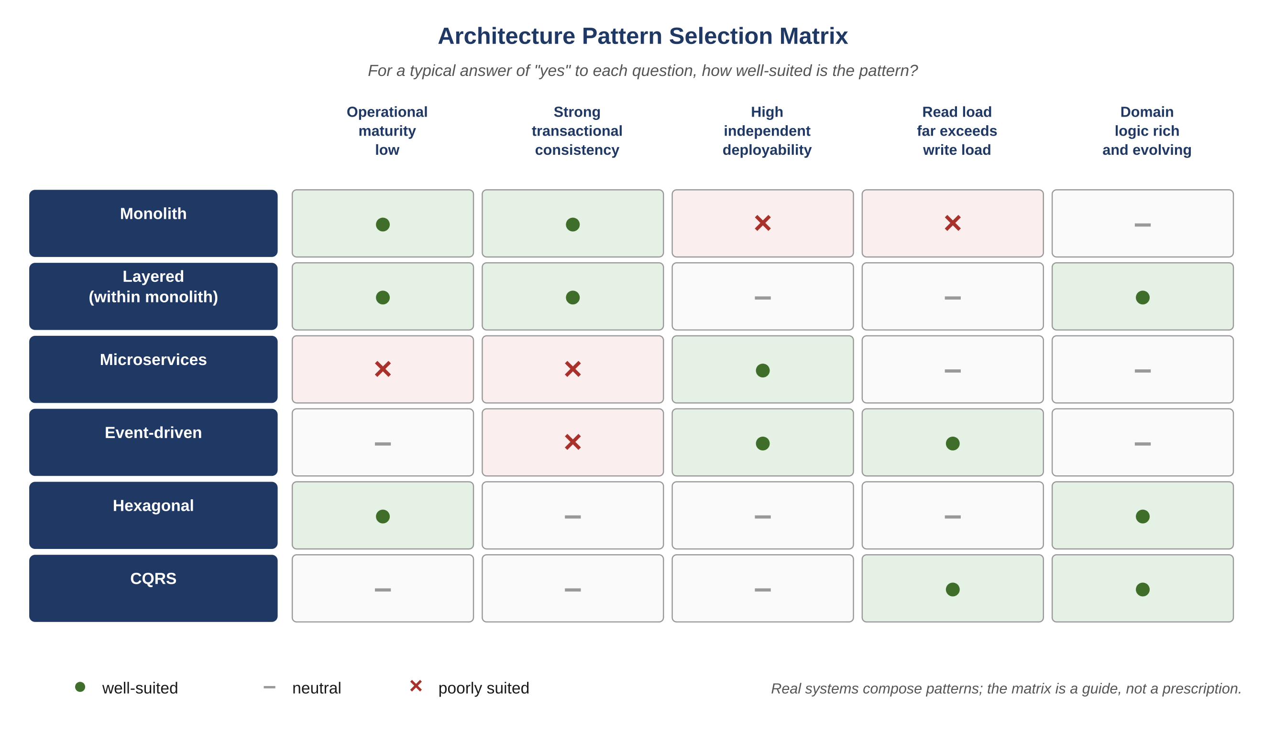
Figure C.1 — Architecture pattern selection matrix.
A defensible architectural choice answers all five questions explicitly. A choice that answers only one of them — most often "what is fashionable" — is a bet placed without seeing the other side of the table.
Atlas Learn — Why Atlas Learn ended up where it did
Atlas Learn’s architecture is the result of choices made over several years, not a single design decision. The platform began as a monolith. The first split was the live-session subsystem, because real-time video has a very different scaling profile and operational rhythm from the transactional core. The second was grading, because INV-AL-04 (grade immutability) demanded a write path the rest of the system did not need. CQRS landed at the grade-publish boundary because dashboard queries were getting expensive against the canonical store. Event-driven landed because enrollment’s state changes had four different downstream consumers (notifications, search index, analytics, audit) and synchronous calls would have been a mess. Hexagonal-style adapters wrap the database calls inside the grading service because the team wanted the freedom to swap the underlying database without rewriting the domain logic. None of this was decided at design time; each split was a response to a specific operational pressure. The lesson is the one this chapter argues for: pattern choice is iterative, situated, and bets-driven, not categorical.
Exercises
Solutions appear in the companion solutions volume. Try the exercises before consulting them.
1. Name the six architecture patterns introduced in this chapter and write a one-sentence trade-off summary for each (what it optimizes vs. what it costs).
2. Distinguish between hexagonal architecture and CQRS. Both involve a separation between two parts of the system; explain what each one separates and why.
3. List the five questions the chapter offers for choosing between patterns and explain what each one is meant to surface.
4. For Atlas Learn, identify which pattern was chosen at each split (live-session, grading, enrollment events, grade-publish boundary) and explain the operational pressure that motivated each choice.
5. A team running a monolith reports that "the database is the bottleneck." Identify three patterns that could plausibly help, what each one would cost the team, and what additional information you would need to choose between them.
6. Take a small system you have used (a personal blog, a class project, a side application) and identify which patterns it implicitly uses. Most are layered without naming it; some are event-driven through email or webhooks.
7. Argue against this claim: "microservices are best practice for any system above ten developers." Identify two specific operational capabilities a team must have before microservices pays back its costs, and explain what happens to teams that adopt the pattern without them.
8. Design the architecture for a hypothetical small online retail platform. Pick one pattern as the primary structure and at most one additional pattern for a specific subsystem. Justify each choice against the five questions in C.8.
9. A senior engineer argues that "every system should be hexagonal because it improves testability." Construct the strongest case for adopting hexagonal everywhere, then identify three classes of system where the indirection costs more than the testability gains.
Key Takeaways
Six dominant patterns: monolith, layered, microservices, event-driven, hexagonal, CQRS. Each is a bet that optimizes some properties at the cost of others.
Real systems compose patterns; the discrete labels are pedagogical conveniences, not deployment choices.
Pattern choice is iterative — the right answer for a system today is rarely the right answer two years later, and revisiting the choice is itself a discipline.
The four-layer meta-architecture this book argues for is independent of the application architecture; the framework adapts to whichever patterns the application uses.

PART II
Operating Disciplines
Vocabulary for Part II — Operating Disciplines
A short refresher on the terms used most often in the chapters that follow. Full definitions remain in the glossary at the back of the book; these short forms are meant to anchor the reader before diving in.
• Context. The structured input given to an agent for one invocation; layered as global, module, and task; assembled by the controller.
• Provenance. The traceable origin of a piece of context — which document, which version, which decision — used to decide whether the context can be trusted.
• Token economics. The discipline of treating tokens as a measurable cost driver and a quality driver, and applying patterns (deltas, identifier referencing, output compression, adaptive verbosity, pruning) to control both.
• Governance. The combination of role isolation, approval gates, and audit trails that makes delegation possible without losing accountability.
• Approval gate. A point at which an artifact cannot progress without a recorded signature — by another agent, the controller, or a human.
• Tracker. The append-only event log of every task and every stage; the system’s memory of work in progress and the substrate for resumption, audit, and postmortem.
• Prompt library. The versioned, reviewed store of canonical prompts; one or more per agent role; rolled out and rolled back like code.

5. Context as a Supply Chain
After this chapter, you will be able to:
• LO 5.1 — Distinguish the three concentric layers of context — global, module, task — and explain what belongs at each layer.
• LO 5.2 — List the canonical memory artifacts a mature system maintains and identify the owner and update cadence of each.
• LO 5.3 — Apply the four provenance questions (where from, when verified, what claim, what blast radius) to a piece of context before consuming it.
• LO 5.4 — Analyze a context pack for opportunities to minimize, identify, or compress, and estimate the token cost saved.
• LO 5.5 — Evaluate a current workflow for context anti-patterns (over-inlining, treating context as documentation, no invalidation) and propose a corrected version.
Before reading this chapter
You will get more out of what follows if you are already comfortable with:
• Cryptographic hashing at an intuitive level — you do not need the math, but you need the property: the same input always produces the same fixed-length string, and a different input almost certainly produces a different one. Git’s commit hashes are the everyday example.
• Content-addressed storage. The idea is that a piece of data is identified by the hash of its contents rather than by a name or path. Anything stored this way is automatically tamper-evident.
• The general idea of a software supply chain — third-party packages, signatures, vulnerability scanning. If the SolarWinds incident is a familiar reference, you have enough.
• A token, in the sense the chapter uses it: the unit a language model bills and reasons in. Roughly four characters of English text per token; precise definition is not required.
An AI agent has no memory between invocations beyond what is given to it. The quality of an agent’s output is therefore bounded by the quality of its context. This section develops the discipline of context engineering: what is included, what is omitted, where it comes from, how it is layered, and how it is invalidated.
Key Idea
"Garbage in, garbage out" understates the problem. Context that arrives without provenance produces output that may look correct but cannot be trusted, because there is no way to trace which input was responsible for which conclusion. Provenance is what turns context from raw text into something an engineer can audit.

5.1 The Anatomy of Context
Context for an AI agent has three concentric layers. The innermost layer is task-specific; the middle layer is module-specific; the outermost layer is global.
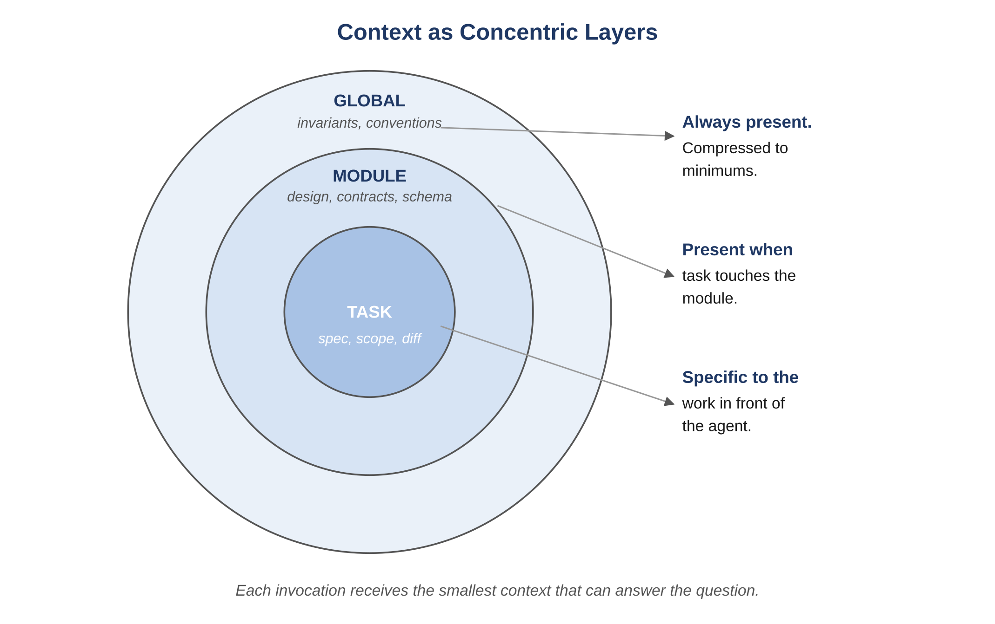
Figure 5.1 — Context as concentric layers.

5.1.1 Global Layer
Always present, always compressed. Includes inviolable invariants, the table of contents of the system design, coding and naming conventions, and the runtime specification. The global layer is small by construction — if it grows, the system has eroded its discipline.

5.1.2 Module Layer
Present when the task touches a specific module. Includes the relevant section of the system design, the contracts the module exposes and consumes, the schema of the module’s data, and the module-specific extracts of the global invariants.

5.1.3 Task Layer
Specific to the work in front of the agent. Includes the task description, acceptance criteria, blast-radius analysis, the tracker entry for prior stages of this same task, any prior defects or decisions referenced by the task, and the exact files and symbols the change is scoped to.
Atlas Learn — A real context pack for one task
For TSK-AL-201 — the enrollment seat-fix — the actual context that reaches the Developer is small. Global layer: the invariants INV-AL-01 (seats_taken ≤ seats_total) and INV-AL-06 (idempotency on retries), plus the convention that mutating endpoints take an idempotency key. Module layer: the enrollment service’s public contract, its current schema for the Section and Enrollment entities, and the prior decision record explaining why the seat counter is denormalized for read-time speed. Task layer: the task description, the failure case ("two learners claim the last seat under contention"), and the exact two files in scope. The total context pack is on the order of two thousand tokens. A naive context that simply inlined the entire enrollment service would be ten times that, and most of it would be code the agent has no business modifying.

5.2 The Required Context Documents
A mature system maintains a small canonical set of memory artifacts. Each has a clear owner, a clear update cadence, and a clear retention policy.
Artifact | Purpose | Owner / Update Cadence
System Design | Canonical architecture: services, flows, storage, failure domains. | Architect; per approved design change.
Invariants | Immutable properties the system must preserve. | Architect with human veto; append-only with deprecation.
API Contracts | Public and internal interfaces with versioning. | Architect; per contract change with deprecation windows.
Schemas | Persistence definitions, indexes, constraints, migration history. | Architect; per migration.
Test Plan | Failure-first catalog with edge cases and concurrency scenarios. | QA; per defect or new scenario.
Tracker | Event-sourced log of every task and stage. | Controller; appended per agent step.
Decision Ledger | Architectural decisions with rationale and consequences. | Architect; append-only.
Defect Ledger | All defects with classification, root cause, and fix. | QA + Release Governor; append-only.
Prompt Library | Versioned prompt templates per agent. | System owner; semver.
Observability Map | Per-service metrics, logs, traces, dashboards, alerts. | Release Governor; per service change.

5.3 The Provenance Discipline
A piece of context entering an agent should answer four questions before it is consumed:
- Where did this come from? (Document, version, owner.)
- When was it last verified? (Timestamp, last reviewer.)
- What does it claim? (Single source of truth, or one of many?)
- What happens if it is wrong? (Blast radius if the agent acts on stale or forged context.)
Example
In a clinical decision-support system, a dosing rule that arrives in context without provenance is not a usable rule. The agent must know that the rule came from version 14 of the formulary, was last reviewed by the chief pharmacist on a particular date, and is the canonical source. Otherwise, "dose this drug at X" becomes a liability without a lineage.

5.4 The Minimization Discipline
Context is the largest cost driver in agent execution and the largest source of reasoning errors. Irrelevant context misleads models. Minimization is enforced by these rules:
- Include only the layers required for the agent role. A QA agent does not need coding standards. An Architect agent does not need per-test assertions.
- Replace bodies with identifiers when bodies are not needed. Reference an invariant by ID rather than inlining its prose.
- Reference code by file path and symbol; do not paste entire files unless the agent will modify them.
- Compress prior tracker entries into structured summaries when they are older than a few stages.
- Never include unrelated modules. Never include the entire repository.
Key Idea
Every token spent on irrelevant context costs three things at once: latency, dollars, and reasoning capacity. Models do not silently ignore noise — they degrade across it. The smallest correct context tends to produce the best output, not the largest available one.

5.5 The Persistence and Invalidation Disciplines
- Every context pack assembled by the controller is hashed and stored. If an agent’s output needs to be reproduced, the same context can be replayed.
- Context edits are versioned; the tracker stores the context hash per agent invocation.
- Agents never mutate context. They produce artifacts; artifacts update memory through the controller.
- Stale context is invalidated automatically when an underlying canonical artifact (invariants, contracts, schemas) changes; affected tasks are re-queued for the Validator.
Example
A ride-hailing platform updates its surge-pricing algorithm. The invariants document changes. Every in-flight task that was assembled with the old context is invalidated; the controller reassembles their contexts and re-queues them at the Validator stage. No agent is left holding the previous version.

5.6 Context Anti-Patterns
Common Pitfall
"More is safer." Adding context "in case the agent needs it" reliably degrades output. Models reason worse over bloated context, not better.
Common Pitfall
"Just paste the file." When agents see whole files, they are more likely to rewrite unrelated parts. Pass the symbol and the relevant lines.
Common Pitfall
"Context is documentation." Context is engineering input. If your only documentation is what you happen to feed to an agent, you have no documentation — you have artifacts of past invocations.
Reflection
Take a recent agent invocation. Strip its context to the minimum the agent actually used. Compare token counts and output quality. The minimum is almost always smaller and the output almost always sharper.
Exercises
Solutions appear in the companion solutions volume. Try the exercises before consulting them.
1. Name the three concentric layers of context and identify what belongs in each.
2. List the four provenance questions that should be applied to every piece of context before consuming it.
3. State the three context anti-patterns named in this chapter and the failure each one produces.
4. For Atlas Learn’s seat-fix task, list the items that belong in the global, module, and task layers, with rough token counts for each.
5. A teammate proposes inlining the entire 2,800-line grading service into the prompt because "the model needs context." Refute their proposal in three sentences using the disciplines from this chapter.
6. Take a memory artifact you maintain (a README, a design doc, a runbook). Apply the four provenance questions to it. Identify which fields are missing and what to add.
7. Argue that "context is a supply chain" is more than a metaphor. Identify three operational properties that supply-chain analysis would predict and that pure document-management would miss.
8. Design a context invalidation discipline for a domain you know. Specify the trigger conditions, the propagation rules, and the verification step.
9. A stakeholder asks: "If small context is better, why include any global layer at all?" Construct the strongest case for retaining the global layer, then identify a small set of conditions under which the answer would actually be "drop it for this task."
Common Mistakes
Each one looks reasonable in isolation; each one produces a failure mode the chapter argues against.
1. "More context = better outputs." The opposite is closer to the truth. Models reason worse over noise, and most "more context" ends up being noise. The discipline is minimization, not accumulation.
2. Inlining whole files when an ID would suffice. A 2,800-line file pasted into the prompt is a token-cost incident waiting to happen. The file already lives in memory with a stable ID; the agent’s prompt should reference the ID and let the controller resolve it.
3. Not invalidating context when upstream changes. A schema change ships, the contract is updated, but the cached context still references the old shape. Subsequent agent invocations operate on stale context for hours or days before someone notices. The invalidation discipline is part of the supply chain, not an optional polish.
Key Takeaways
Context behaves like a supply chain: it has provenance, it gets layered, it needs minimization, and it requires invalidation when upstream artifacts change.
More context is not safer; in practice it tends to be slower, more expensive, and less accurate, because models reason worse over noise.
The quality of the memory artifacts upstream sets a ceiling on the quality of any agent output downstream.

6. Token Economics
After this chapter, you will be able to:
• LO 6.1 — Explain why token discipline correlates with output quality rather than trading against it.
• LO 6.2 — Apply the five disciplines — delta processing, identifier referencing, output compression, adaptive verbosity, context pruning — to a representative agent invocation.
• LO 6.3 — Classify a given task into the appropriate verbosity tier (terse, standard, deep, critical) and justify the choice.
• LO 6.4 — Estimate the cost reduction expected from converting an inlined-context workflow into a delta-and-identifier workflow.
• LO 6.5 — Evaluate token-cost telemetry from a real or simulated system and identify the next discipline to invest in.
Tokens are the unit of cost, the unit of latency, and indirectly the unit of quality in an AI-driven system. A system that uses 100,000 tokens for a task that could be done in 12,000 is not "more thorough." It is slower, more expensive, and — because models reason worse over bloated input — frequently less correct.
Key Idea
Token discipline is usually framed as cost optimization, but the more interesting effect is on accuracy: the same disciplines that shrink the prompt — minimal context, structured output, deltas instead of whole-file pastes — also reduce error rates. Cost and quality are correlated here, which is unusual.

6.1 The Five Disciplines
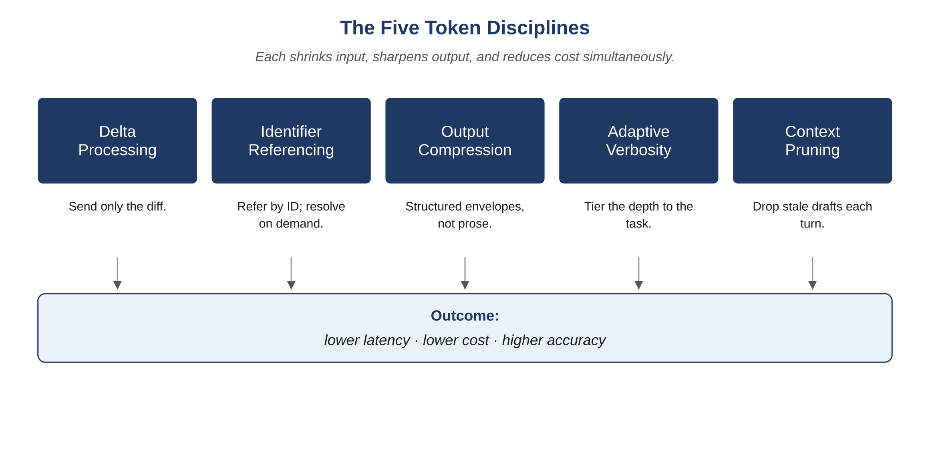
Figure 6.1 — The five token disciplines.

6.1.1 Delta Processing
Problem: Re-sending the entire module on every iteration wastes tokens and tempts the model to regenerate code that was already correct.
Discipline: Send only the diff plus a small structural frame: the file path, the unchanged surrounding signature, and the intended change.

Without delta processing (~2,400 tokens):
[Entire 380-line module with imports, unrelated methods, and the target method receiving a small fix.]

With delta processing (~210 tokens):
File: billing/invoice_service.py
Symbol: InvoiceService.recompute_total
Intent: ensure suspended discounts evaluate to zero (INV-031)

Current method:
def recompute_total(self, invoice_id: UUID) -> Money:
inv = self._load(invoice_id)
subtotal = sum(li.amount for li in inv.lines)
discount = self._discount.apply(inv) if inv.discount_id else Money(0)
return subtotal - discount + self._tax.compute(inv)

Expected change:
- if inv.discount_status == SUSPENDED: treat discount as Money(0)
- emit metric "billing.discount.suspended_applied"

6.1.2 Identifier Referencing
Problem: Inlining the body of every prior artifact (prior QA report, prior design) on every step burns tokens linearly with task age.
Discipline: Assign stable identifiers to every artifact and reference them by ID. Bodies are resolved on demand, not pre-included.
Example
"Task TSK-1184 violates INV-031 (subtotal integrity). Prior attempt DEF-0907 was root-caused to the missing SUSPENDED branch; see ADR-117 for the decision to keep the recompute idempotent." A reader — human or agent — knows which references matter and can request bodies only as needed.

6.1.3 Output Compression
Problem: Agents default to verbose prose. Downstream agents do not read prose; they read structured data.
Discipline: Every agent returns a structured envelope. Explanations are optional and enabled only by an explicit flag.

Example output envelope (QA agent):
{
"agent": "QA",
"task_id": "TSK-1184",
"status": "DEFECTS_FOUND",
"defects": [
{ "id": "DEF-0907", "severity": "P0",
"invariant": "INV-031", "repro": "QAS-2210",
"observed": "discount not zeroed on SUSPENDED",
"expected": "discount=0; metric +1" }
],
"tests_added": ["QAS-2210", "QAS-2211"],
"coverage_delta": "+1.7% on billing module"
}

6.1.4 Adaptive Verbosity
Problem: Uniform verbosity is wrong in both directions — too terse for complex tasks, too verbose for simple ones.
Discipline: The controller selects a verbosity tier per invocation, based on task complexity, historical failure rate, and agent role.
Tier | When Used | Reasoning Style | Output Budget
Tier 1 — Terse | Trivial single-file change | No chain-of-thought; direct diff | <= 600 tokens
Tier 2 — Standard | Routine feature work | Short plan, then output | <= 2,500 tokens
Tier 3 — Deep | Cross-module, invariant impact | Explicit plan, alternatives, risks | <= 8,000 tokens
Tier 4 — Critical | Schema migration, security flow | Full ADR draft + exhaustive checks | <= 16,000 tokens

6.1.5 Context Pruning
Problem: After several iterations the context window accumulates stale drafts, rejected artifacts, and historical chatter.
Discipline: The controller runs a pruning pass before each invocation, retaining only the latest approved artifacts, the current diff, and the minimum set of referenced identifiers. Pruned material remains in memory and is retrievable by ID.

6.2 Why Each Discipline Matters
- Delta processing reduces median prompt size by 70–90% on iterative work and prevents accidental rewrites of unrelated code.
- Identifier referencing reduces context size while increasing traceability; postmortems become tractable.
- Output compression makes downstream agents fast, cheap, and reliable; structured payloads are parseable.
- Adaptive verbosity spends budget where it matters and saves it where it does not.
- Context pruning prevents drift and anchoring; each agent sees a clean current view.
Atlas Learn — What the disciplines saved on Atlas Learn’s grading service
Before the disciplines were applied, an iteration on the grading service averaged about 14,000 input tokens because the entire 2,800-line module was being re-sent on every step. Output verbosity averaged ~3,500 tokens, mostly explanation prose. After applying the disciplines: delta processing dropped average input to ~2,100 tokens (the diff plus a small structural frame); identifier referencing replaced inlined invariants and contracts with their IDs (INV-AL-04, the grade-immutability invariant, instead of three paragraphs of prose about it); output compression replaced explanation prose with a structured JSON envelope of about 600 tokens; adaptive verbosity dropped routine grading-fix invocations to a low-verbosity tier. End-to-end cost per iteration fell roughly 80% and accuracy improved, because the agent stopped accidentally rewriting unrelated grading code. The discipline that mattered most was the simplest: send only the diff.

6.3 Setting Reasonable Targets
A mature system tracks token cost per task type and per agent. Suggested initial targets, to be tuned with telemetry:
- Median Developer invocation: under 6,000 input tokens.
- Median QA invocation: under 4,000 input tokens.
- P99 across all agents: under 24,000 input tokens.
- If routine tasks regularly exceed these, the system design is at fault, not the agent.
Common Pitfall
Treating token cost as a vendor concern. The same disciplines that reduce token cost also reduce error rate. Skipping them produces a slower, more expensive, less accurate system.
Reflection
Audit your three most expensive tasks last week. For each, ask: which of the five disciplines, if applied, would have reduced cost most? The answer is rarely "model choice."
Exercises
Solutions appear in the companion solutions volume. Try the exercises before consulting them.
1. Name the five token disciplines and give a one-sentence summary of each.
2. Define delta processing and explain why it usually saves more tokens than identifier referencing.
3. Identify which discipline addresses each of: stale drafts in the conversation, prose explanations replacing structured output, and re-sending unchanged code.
4. Estimate the token saving on Atlas Learn’s grading service if delta processing alone is applied to a typical iteration (start from the numbers given in the case-study vignette).
5. Pick a recent prompt you ran. Rewrite it to apply (a) identifier referencing and (b) output compression. Compare token counts before and after.
6. A teammate proposes setting verbosity tier 4 (highest) as the default for safety. Refute the proposal using the adaptive-verbosity discipline.
7. Design token telemetry for a small team: which numbers to capture per invocation, which dashboards to maintain, and which thresholds should trigger investigation.
8. Argue for or against the claim "token discipline and quality discipline correlate." Use a counter-example where they appear to diverge, and resolve the apparent contradiction.
9. A team is planning to switch to a cheaper model to save money. Without using the case-study vignette directly, design an evaluation that would tell the team whether the switch will save total cost or move cost into another component.
Common Mistakes
Each one looks reasonable in isolation; each one produces a failure mode the chapter argues against.
1. Optimizing model cost in isolation. A team that watches only the model line in their cost telemetry will trade visible savings for invisible failure-cost growth. The discipline is to track all four cost components together; the model is rarely the binding constraint that the dashboard suggests.
2. Default verbosity tier 4 "for safety." Verbosity is not rigor. A simple task at tier 2 produces a sharper output than the same task at tier 4; raising the tier "to be safe" is a tax on every routine invocation.
3. Sending whole files instead of deltas. The most common single source of token waste. The file rarely needs to be re-sent; the agent already saw it on the prior turn. Delta processing typically saves an order of magnitude in input tokens with no loss of correctness.
Key Takeaways
Five disciplines: deltas, IDs, compression, adaptive verbosity, pruning.
Token discipline and quality discipline correlate; both improve when context shrinks.
Measure tokens per task type; use the data to target the next discipline to add.

7. Governance
After this chapter, you will be able to:
• LO 7.1 — Describe the three pillars of governance — role isolation, approval gates, audit trails — and the failure mode each one prevents.
• LO 7.2 — Classify defects and risks at three levels (P0, P1, P2) and explain how the classification drives gating and escalation.
• LO 7.3 — Map approval gates onto the federated execution loop and identify where a human signature is required.
• LO 7.4 — Analyze a recent production incident in a system you know and locate the gate or pillar that should have caught it.
• LO 7.5 — Evaluate a proposed exception to a P0 ship-block and decide whether the exception is principled or expedient.
Governance is the mechanism that prevents a federation of well-meaning agents from producing a runaway change. Without governance, an eager Developer agent can propose an acceptable change, an eager QA agent can approve an acceptable test, a Release agent can ship an acceptable package — and the sum of these acceptable steps can still violate an invariant the system never explicitly checked. Governance is the explicit, enforced set of checks that prevent this class of failure.
Key Idea
Governance is what makes delegation possible without giving up accountability. Without it, a chain of individually reasonable decisions can produce a collectively unreasonable outcome, and you discover that fact only after deploying it.

7.1 The Three Pillars of Governance

7.1.1 Role Isolation
Each agent has one job and cannot perform another’s. Developers do not approve their own code. QA does not sign release packages. Architects do not unilaterally edit invariants. The controller rejects outputs that step outside the agent’s declared role.

7.1.2 Approval Gates
Approval gates are the points at which an artifact cannot progress without a signature — either by another agent or by a human.
Gate | Required Approver | Failure Action | Human Required?
Design -> Build | Auditor | Architect revision | If invariants touched
Build -> Test | Controller (static checks) | Developer revision | No
Test -> Secure | QA (no P0 open) | Developer revision | If P0 accepted
Secure -> Perf | Security (no critical) | Developer revision | If high accepted
Perf -> Validate | Performance (budgets met) | Developer or Architect | No
Validate -> Release | Validator (consistency) | Back to offending stage | No
Canary -> Fleet | Release Governor + human | Rollback | Always

7.1.3 Audit Trails
Every agent invocation emits an immutable audit record. The tracker is the index; the decision ledger is the body. Records are hash-chained: any retroactive edit is detectable.
- Fields: timestamp, task ID, agent, role, context hash, prompt ID, input IDs, output IDs, duration, tokens, verdict, escalations.
- Retention: minimum two years; longer for regulated flows.
- Access: read-only to agents; append-only to the controller; human-readable export for compliance.

7.2 Issue Classification
Defects and risks are classified at three levels. The classification drives both the gating behavior and the escalation path.

7.2.1 P0 — Ship Blocker
- Violates an invariant; loses or corrupts data; exposes sensitive data; enables unauthorized action.
- Examples across domains: balance can go negative; medical record served to wrong patient; chat message visible across tenants; vehicle assigned to two drivers; account compromised by parameter tampering.
- Treatment: blocks release. Requires fix or a documented, time-bounded exception signed by a human owner.

7.2.2 P1 — Must Fix Near-Term
- Degrades a critical metric beyond SLO budget; creates operational toil; materially impacts experience.
- Examples: search p95 regresses by 150 ms; refund flow needs two manual confirmations; dashboard widget loads slowly during peak.
- Treatment: may ship with a fix committed within one release cycle; tracked in the defect ledger.

7.2.3 P2 — Track and Plan
- Non-critical, cosmetic, or optimization opportunities.
- Examples: admin label inconsistency; verbose logs in a non-critical service; cache TTL can be tuned.
- Treatment: tracked with a planned window; re-prioritized as the cohort grows.

7.3 Release Gating
A release package cannot progress without a uniform set of clearances:
- Clean Auditor, QA, Security, Performance, and Validator verdicts.
- Rollback plan: exact commands or flags, recovery time objective, data-loss bound.
- Blast-radius analysis: services, tenants, and user cohorts affected.
- Observability readiness: dashboards updated, alerts configured, runbook linked.
- Human approval for canary promotion and full-fleet rollout.

7.4 Governance Flow Diagram
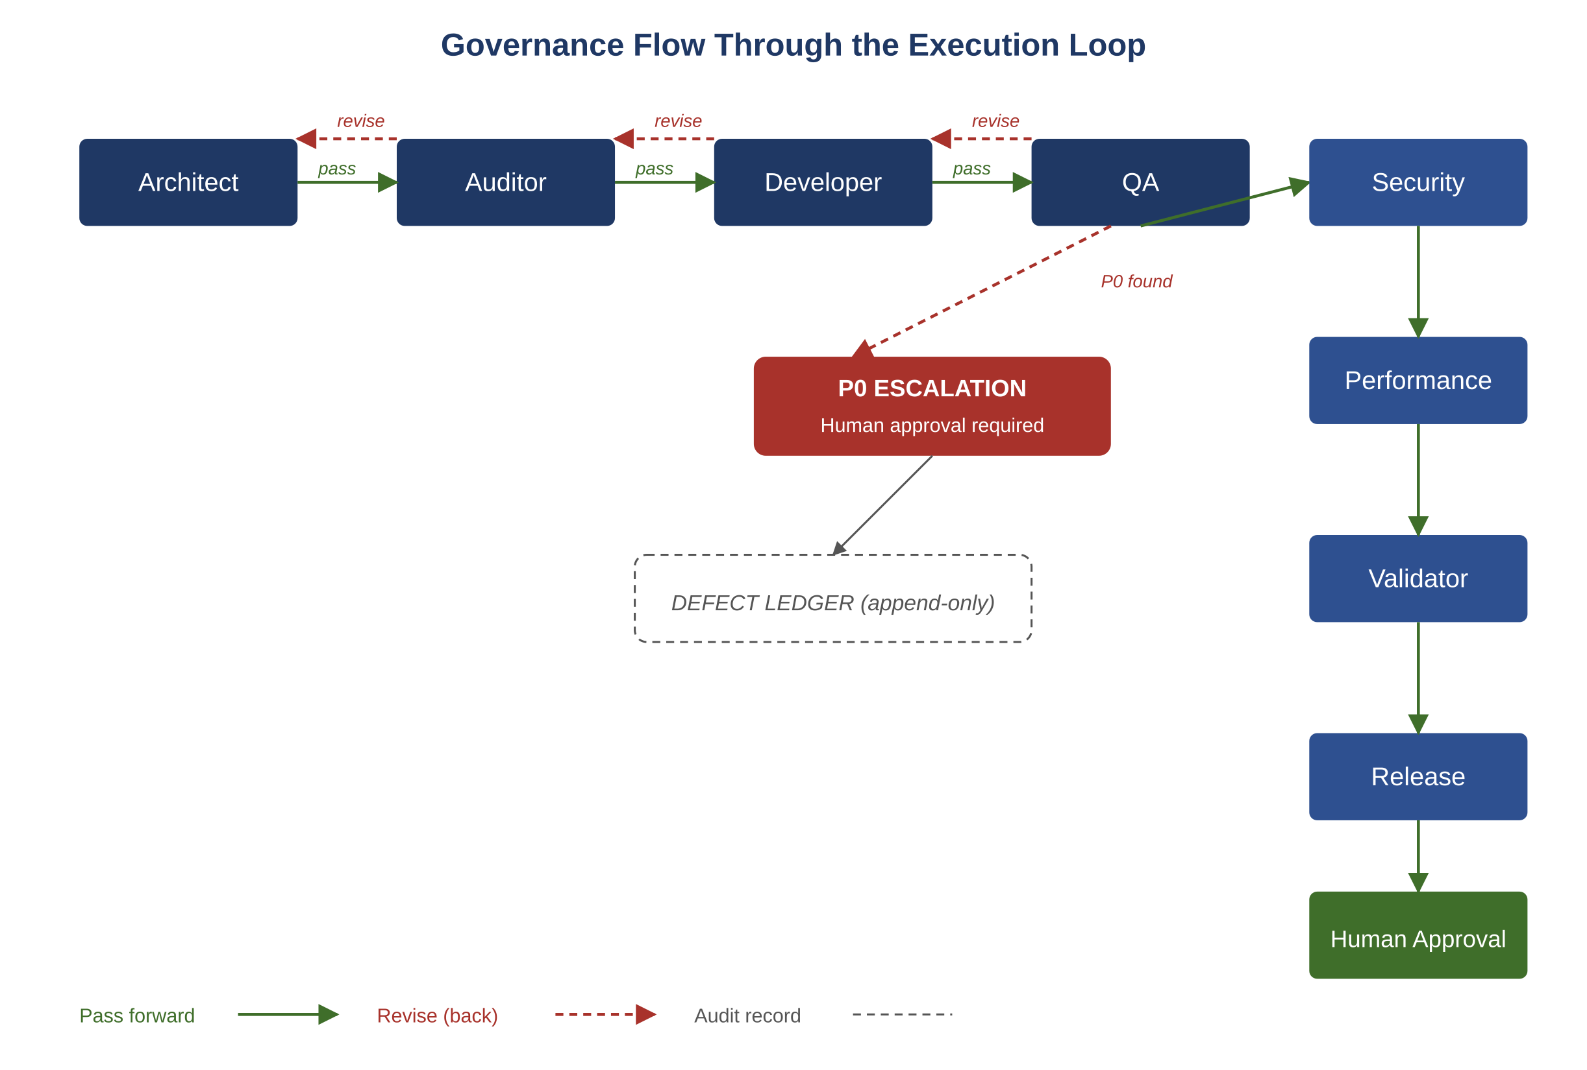
Figure 7.1 — Governance flow through the execution loop.

7.5 Governance Anti-Patterns
Common Pitfall
"Approve to unblock." Approving a P0 because a deadline is near corrupts the entire scheme. Either the rule is wrong (and should be revised explicitly) or the approval is wrong.
Common Pitfall
"Audit fatigue." Humans rubber-stamping canary promotions because the dashboard always looks fine. Mitigate by surfacing the specific risks of this change, not the generic dashboard.
Common Pitfall
"Shadow channels." Agents or humans communicating outside the tracker because it is faster. Once shadow channels exist, the audit trail is fiction.
Atlas Learn — A P0 escalation: the duplicate grade
On Atlas Learn, the QA agent reports a defect during the canary stage of a grading-service release: under specific retry conditions, a single submission can produce two grade records, each valid in isolation but jointly violating INV-AL-04 (a published grade is immutable; corrections flow as amendments). The defect is classified P0 because it touches a named invariant and the canary tenant is large. Governance flow: QA produces a defect record citing INV-AL-04 and the failure-mode name "submission retry creates duplicate grade" (linked to INV-AL-06). The release is blocked. The Architect proposes a fix using the existing idempotency-key contract; the Auditor verifies the fix preserves both INV-AL-04 and INV-AL-06; the Developer implements; QA re-tests with the original failure scenario; Security signs off; Performance confirms no budget regression on the grade-publish critical path. The release is then re-canaried. The audit trail records every transition, including the original defect detection, the proposed fix, and the human approval to resume canary. None of this is unusual — it is the system working as designed.
Reflection
Take any past production incident and trace it backward. Identify the gate that should have caught it, why it did not, and which of the three pillars (role isolation, approval gates, audit trails) was weak.
Exercises
Solutions appear in the companion solutions volume. Try the exercises before consulting them.
1. Name the three pillars of governance and a single failure each one prevents.
2. Define P0, P1, and P2 issue classifications and identify which class blocks a release.
3. List the three governance anti-patterns named in this chapter.
4. Classify each of the following Atlas Learn defects as P0, P1, or P2: (a) a typo in the enrollment confirmation, (b) an INV-AL-04 violation that allowed a published grade to be edited, (c) a 5% latency regression on the discussion-post path that is still under budget. Justify each.
5. Walk the duplicate-grade case-study vignette through the three pillars: what role isolation enforced, what approval gate triggered, what audit record was produced.
6. A team has approval gates and audit trails but weak role isolation: the same engineer designs and reviews their own changes. Predict the class of failure that will result and explain why the other two pillars do not catch it.
7. Design a P0 escalation workflow for a system you know. Specify the detection signal, the automatic action, the human escalation path, and the rollback rehearsal cadence.
8. Argue against this claim: "humans should approve every change because they are accountable." Identify two ways audit fatigue undermines the claim, and propose a tuning that preserves accountability while reducing fatigue.
9. A regulator asks "show me every privileged action by an admin in the last quarter, with reason and approval chain." For a system you know, identify exactly which artifacts you would need to assemble that report, and which gaps in the current discipline would prevent you.
Common Mistakes
Each one looks reasonable in isolation; each one produces a failure mode the chapter argues against.
1. Approving everything to avoid friction. The approver who "rubber-stamps" reviews has converted approval into ceremony; the gate exists in form but not in function. The first incident that should have been blocked at the gate will reveal that nothing was actually checked.
2. Auto-promotion because QA passed. The QA agent’s pass is one signal among several; the controller promotes, not the agent. A workflow where any single agent’s verdict moves the stage forward has lost the discipline of structural cross-checks.
3. Letting shadow channels grow. Side conversations, out-of-band approvals, "quick fixes" that bypass the recorded path. Each one is convenient; together they make the audit trail fictional. The discipline is to refuse the convenience; the cost compounds against you when the auditor or the regulator finally asks.
Key Takeaways
The three pillars are role isolation, approval gates, and audit trails.
Governance often gets framed as friction, but in practice it is what enables a team to delegate confidently rather than constantly second-guessing the system.
Issue classification (P0/P1/P2) is what wires governance into action: it determines what blocks a release and what merely gets tracked.

8. Prompt Engineering as an Engineering Discipline
After this chapter, you will be able to:
• LO 8.1 — Identify the six fields of the canonical prompt template — role, input, objective, constraints, output format, self-review — and explain what each one prevents.
• LO 8.2 — Apply the canonical template by writing a prompt for a Developer, QA, or Security agent on a small task of your own choosing.
• LO 8.3 — Distinguish a friendly conversational prompt from a contractual one, and predict where each will produce inconsistent output.
• LO 8.4 — Justify, with examples, why prompt edits should travel through review and version control rather than be made in place.
• LO 8.5 — Evaluate an existing prompt against the template and propose specific revisions that would improve consistency or reduce token cost.
In an AI-Driven SDLC, prompts are not natural-language requests. They are versioned engineering artifacts with a fixed schema. A prompt has the same lifecycle as code: review, version, deploy, and roll back. The Prompt Library is the canonical store; the controller selects a prompt by ID and verbosity tier.
Key Idea
It helps to think of a prompt as a contract with a specialist. Like any contract, it spells out who is doing what, on what inputs, with what constraints, and what the deliverable looks like. Conversational phrasing is one of the more reliable ways to get inconsistent results back.

8.1 The Canonical Template
ROLE:
<single, narrow agent role>
INPUT:
<list of structured inputs by ID; references resolve from memory>
OBJECTIVE:
<one sentence; testable; bound by an exit condition>
CONSTRAINTS:
<hard limits: scope, schema, invariants, budget, forbidden actions>
OUTPUT FORMAT:
<strict schema or strict structural template>
SELF-REVIEW:
<a short list of checks the agent must run before returning>
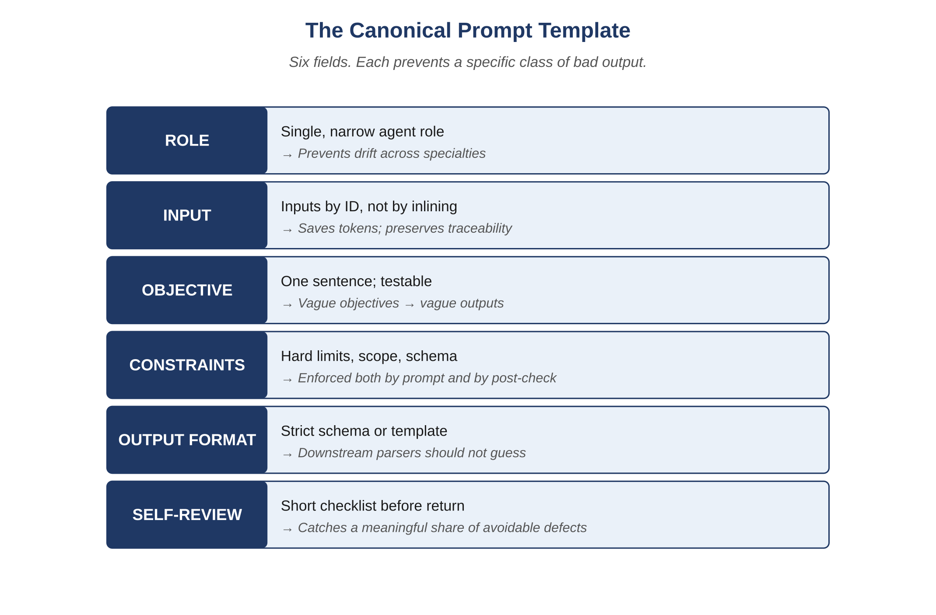
Figure 8.1 — The canonical prompt template.

8.2 Why Each Field Exists
- ROLE narrows the agent to one specialty; prevents drift.
- INPUT is by ID, not by inlining; preserves token budget and traceability.
- OBJECTIVE is testable; vague objectives produce vague outputs.
- CONSTRAINTS are hard limits enforced both in the prompt and in post-processing.
- OUTPUT FORMAT is strict; downstream parsers must not need to guess.
- SELF-REVIEW catches a meaningful share of avoidable defects without an extra invocation.

8.3 Worked Example: Developer Prompt
ROLE:
Developer agent. Implement a single, scoped change.
INPUT:
task: TSK-1184
design: DSN-0411
invariants: [INV-031]
contracts: [API-INVOICE-04]
schema: DB.invoice, DB.invoice_line
scope_files: [billing/invoice_service.py,
billing/discount_evaluator.py,
tests/billing/test_recompute.py]
OBJECTIVE:
Implement recompute handling for invoice.discount_status=SUSPENDED such that
discount=0 is applied and metric billing.discount.suspended_applied is emitted.
CONSTRAINTS:
- Do not modify any file outside scope_files.
- Do not change DB schema or API contracts.
- Add unit tests for the SUSPENDED branch and idempotent re-entry.
- No new external dependencies.
- Output budget: 2,500 tokens (verbosity tier 2).
OUTPUT FORMAT:
{
"summary": "<short>",
"diff": "<unified diff>",
"tests_added": ["<test_id>", ...],
"references": { "invariants": [...], "contracts": [...] }
}
SELF-REVIEW:
- Diff touches only scope_files.
- Each new branch has a test.
- INV-031 is referenced in at least one assertion.
- Metric name matches the observability map.
Atlas Learn — The same prompt template, an Atlas Learn task
For TSK-AL-201 — the seat-fix — the Developer prompt has the same six fields, populated with concrete identifiers. Role: Developer agent, scoped to the enrollment service. Input: task TSK-AL-201, the diff envelope DIFF-AL-3c4a, invariants [INV-AL-01, INV-AL-06], prior defect [DEF-AL-0418], concurrency profile enrollment.high_contention. Objective: implement the atomic seat-decrement with idempotency, preserving both invariants. Constraints: do not modify the section schema; do not change the public contract; output budget 4,500 tokens. Output format: a JSON envelope with agent, task_id, status, summary, files_changed, tests_added_ids. Self-review: every change cites at least one invariant; the test that previously reproduced DEF-AL-0418 now passes; no edits outside scope. The structure is identical to the generic example above; only the proper nouns change.

8.4 Worked Example: QA Prompt
ROLE:
QA agent. Failure-first test design and execution.
INPUT:
task: TSK-1184
diff: DIFF-3a92
invariants: [INV-031]
prior_defects: [DEF-0907]
concurrency_profile: invoice.high_contention
OBJECTIVE:
Find any remaining defect on the recompute path with priority on
invariant violations, concurrency, idempotency, and edge cases.
CONSTRAINTS:
- Tests must be deterministic and reproducible by seed.
- Every test cites the invariant or contract it guards.
- Do not relax acceptance criteria.
- Output budget: 4,000 tokens (verbosity tier 2).
OUTPUT FORMAT:
{ "agent": "QA", "task_id": "...", "status": "...",
"summary": {...}, "defects": [...], "tests_added_ids": [...] }
SELF-REVIEW:
- INV-031 has at least one negative test.
- At least one concurrency scenario exercised.
- At least one idempotency scenario exercised.
- Coverage on the recompute path >= 95%.

8.5 Worked Example: Security Prompt
ROLE:
Security agent. Threat-model this change and find vulnerabilities.
INPUT:
task: TSK-1184
diff: DIFF-3a92
data_flows: [DF-INV-RECOMPUTE]
prior_findings: [SEC-0290]
threat_model_version: TM-2026.04
OBJECTIVE:
Identify any tampering, replay, authorization, or information-disclosure
risk introduced by the recompute path and the SUSPENDED branch.
CONSTRAINTS:
- Verify mitigations by inspection or test, not by claim.
- No critical/high finding may be ignored.
- Output budget: 3,500 tokens.
OUTPUT FORMAT:
{ "agent": "Security", "task_id": "...", "status": "...",
"findings": [...], "threat_model_changes": [...],
"blocking_release": true|false }

8.6 Library Governance
- Every prompt has an ID and a semantic version.
- Prompt edits are reviewed and pass an evaluation suite before merge.
- Critical-path prompts require a human approver.
- Bad prompts roll back exactly like bad code: by version pin and a tracker event.

8.7 Prompt Anti-Patterns
Common Pitfall
"Friendly" prompts. Conversational phrasing reads warmer but tends to produce inconsistent output, because the agent treats it as a softer constraint. Declarative, structured phrasing — closer to a contract than a chat — gives more reliable results, even when it sounds blunt.
Common Pitfall
Inlining the world. A prompt carrying five thousand tokens of background documentation has stopped being a prompt and become a documentation dump addressed to a model. The signal-to-noise ratio drops, the model anchors on irrelevant material, and the cost goes up while the quality goes down.
Common Pitfall
"Just one tweak." Untracked edits to live prompts are like untracked production hotfixes. Treat prompt changes as deployments.
Reflection
Take a prompt currently in use. Rewrite it in the canonical template. Compare the outputs over a small evaluation set. The structured form usually wins on consistency and cost.
Exercises
Solutions appear in the companion solutions volume. Try the exercises before consulting them.
1. Name the six fields of the canonical prompt template and the failure each one prevents.
2. Distinguish between OBJECTIVE and CONSTRAINTS. Why are they separate fields rather than one?
3. Explain what a prompt library is and why prompts deserve the same treatment as code (versioning, review, rollback).
4. Take the developer prompt for TSK-AL-201 in the case-study vignette. Identify the role, input, objective, constraints, and output-format fields, and check whether each is fully specified.
5. Rewrite a generic instruction like "summarize this document" using all six template fields. Be specific about the role, the constraints, and the output format.
6. A prompt produces good outputs in 80% of runs and low-quality outputs in 20%. Use the SELF-REVIEW field to design a check that would either prevent the 20% from being returned or escalate them.
7. Design a versioning and review pipeline for prompts: where they live, how a change is reviewed, how a regression is detected, how rollback works.
8. Argue against this claim: "prompts should be free-form because models are flexible." Identify three failure modes that the canonical template prevents.
9. A team has 200 prompts in production. Specify how to govern this library so that no one prompt drifts undetected: the metrics, the review cadence, and the rollback budget.
Common Mistakes
Each one looks reasonable in isolation; each one produces a failure mode the chapter argues against.
1. Editing prompts in place without versioning. The prompt that produced last week’s good outputs is not the prompt that’s producing this week’s drift, but without versioning nobody can tell. Prompts deserve the same treatment as code; rolling back a prompt change is exactly as routine as rolling back a code change, when the discipline allows it.
2. Mixing OBJECTIVE and CONSTRAINTS into one field. "Do X without doing Y" feels economical to write but produces ambiguous outputs. The fields are separate because the agent reasons about them separately; collapsing them costs more in output quality than it saves in prompt length.
3. Friendly prose instead of structured fields. "Hi, please review this code carefully and let me know what you think" gets followed less reliably than the canonical six-field template. The prompt is not a conversation; it is a contract with the agent, and a contract reads in fields.
Key Takeaways
Prompts deserve the same treatment as code: versioned, reviewed, evaluated, and rolled back when they regress.
The canonical template — role, input, objective, constraints, output format, self-review — gives the agent a shape it can satisfy reliably.
The library, the review process, and the rollback mechanism mirror what you would do for any other production artifact.

9. The Tracker and Session Recovery
After this chapter, you will be able to:
• LO 9.1 — Describe the structure of an event-sourced tracker: streams, events, projections, and append-only semantics.
• LO 9.2 — Trace how the tracker enables session recovery after a controller restart, including the four properties that make resumption safe.
• LO 9.3 — Apply tracker discipline to design an audit-ready record of a multi-stage agent workflow on a system you know.
• LO 9.4 — Analyze the difference between a tracker projection and the underlying event stream, and explain when each one is the right thing to read.
• LO 9.5 — Evaluate a workflow for shadow channels (out-of-band changes) and propose how to bring them inside the tracker without slowing the team down.
Before reading this chapter
You will get more out of what follows if you are already comfortable with:
• Event sourcing as a storage pattern. The idea: instead of storing the current state, store the sequence of events that produced it; the current state is computed from the events. Greg Young’s talks are the standard introduction.
• Append-only data structures — a log you can write to but never edit. Any introductory database text covers this; the write-ahead log is the everyday example.
• Idempotency: a property by which repeating an operation produces the same result as doing it once. The HTTP semantics of PUT versus POST give a concrete grounding.
• A general sense of what a projection is in event-sourced systems: a derived view, computed from the event log, that answers a specific query cheaply.
Memoryless agents inside a memoryful system require an external memory of work-in-progress. The tracker is that memory. It is event-sourced, append-only, and the single source of truth for what every agent has done on every task. Without a tracker, an interrupted session cannot be resumed, an audit cannot be reconstructed, and a postmortem cannot be written.
Key Idea
The tracker is where the system’s memory actually lives. Anything not recorded there is unrecoverable after the fact — even if everyone involved remembers it differently. For audits and postmortems this matters more than it sounds; reconstruction is only possible from what was written down at the time.
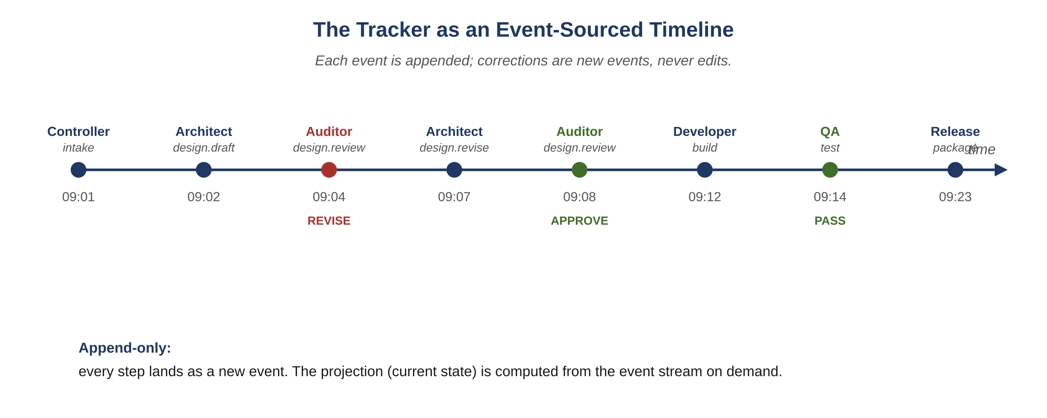
Figure 9.1 — The tracker as an event-sourced timeline.

9.1 Structure
- One logical stream per task. Tasks have a stable identifier.
- Each stream is a sequence of events. An event records: timestamp, agent, role, stage, input IDs, output IDs, context hash, prompt ID, verdict, escalations, tokens, duration.
- Events are append-only. A correction is a new event that supersedes a prior one with an explicit reason.
- A summary projection is maintained per task: current stage, last verdict, open defects, blocking items, next required action.

9.2 Usage
- The controller reads the tracker to decide the next agent to invoke.
- Agents read the tracker projection (not raw events) to understand the task’s current state.
- Auditors read the tracker to verify no required stage was skipped.
- Humans read the tracker to triage escalations and authorize releases.
Atlas Learn — The seat-fix as a stream of tracker events
TSK-AL-201 lands in the tracker as the first event: stage=intake, actor=Controller, input=defect_record DEF-AL-0418, context_hash=h0. The next event is the Architect’s design draft (stage=design.draft); after the Auditor returns REVISE on the first proposal, the tracker grows a fourth event (design.revise from the Architect) and a fifth (design.review with verdict=APPROVE from the Auditor). Six more events follow through Build, QA, Security, Performance, Validate, and Release. Twelve events total. None of them edits the previous ones; every correction is a fresh event referencing the prior one. Three weeks later, when an auditor wants to know who approved the seat-fix and on what evidence, the answer is reachable in seconds: the projection points at the Auditor’s approval event, which references INV-AL-01 and DEF-AL-0418 by ID. This is the property that distinguishes a tracker from a chat log: chat answers what people said, the tracker answers what the system did.

9.3 Session Recovery
When the controller restarts — because of a deployment, a crash, or a deliberate pause — it does not re-run completed work. It reads the tracker, finds the last committed stage for each in-flight task, and resumes from the next stage. The properties that make this safe are:
- Every stage commits its output to memory before the next stage begins.
- Stage execution is idempotent: replaying a committed stage produces the same artifact.
- Context assembly is deterministic given the tracker state and the context hash.
- Escalations and human approvals are tracker events too; resuming honors prior approvals without re-prompting humans.

9.4 Example Tracker Snapshot
task_id: TSK-1184
title: Suspended-discount handling on invoice recompute
status: IN_PROGRESS
events:
- 2026-04-27T09:01:00Z Controller intake inputs=[PRD-061]
- 2026-04-27T09:02:14Z Architect design.draft output=DRAFT-DSN-0411
- 2026-04-27T09:04:08Z Auditor design.review verdict=REVISE
finding=missing SUSPENDED branch
- 2026-04-27T09:06:55Z Architect design.revise output=DSN-0411
- 2026-04-27T09:07:30Z Auditor design.review verdict=APPROVE
- 2026-04-27T09:11:42Z Developer build output=DIFF-3a92, tests=[T1..T6]
- 2026-04-27T09:14:01Z QA test verdict=DEFECTS_FOUND
defect=DEF-0907 (P0, INV-031)
- 2026-04-27T09:18:18Z Developer build.revise output=DIFF-3a93
- 2026-04-27T09:21:09Z QA test verdict=PASS
- 2026-04-27T09:23:30Z Security scan verdict=PASS
- 2026-04-27T09:26:12Z Performance bench verdict=PASS, p99=81ms
- 2026-04-27T09:28:00Z Validator verify verdict=PASS
- 2026-04-27T09:28:40Z Release package output=REL-2026.04.27
- 2026-04-27T09:30:00Z Human approve canary approver=osr@team
projection:
current_stage: canary
blocking: none
next_action: await canary observation window

9.5 The Tracker as Postmortem Substrate
Postmortems normally begin with reconstruction: what happened, in what order, decided by whom, on what input. The tracker provides this for free. A postmortem becomes annotation rather than archaeology.
Example
A media platform finds that a recommendation feature is suddenly degrading user retention. The tracker for the relevant task shows the change was approved with a P1 defect deferred for a follow-up release. The root-cause discussion takes minutes, not days, because the trail of decisions is unbroken.

9.6 Tracker Anti-Patterns
Common Pitfall
Out-of-band changes. Editing memory directly without a tracker event — even with the best intent — corrupts the audit trail. If you must, the override is itself an event.
Common Pitfall
Pruning "for cleanliness." Old tracker entries are evidence. Compress projections; keep events.
Common Pitfall
Treating the tracker as a UI. The tracker is a data structure with views; if your only access is a dashboard, you cannot reproduce decisions programmatically.
Reflection
Pick a recent decision from your team. Could you reconstruct it from written artifacts alone? If yes, you have a working tracker discipline. If no, you have a memory at risk.
Exercises
Solutions appear in the companion solutions volume. Try the exercises before consulting them.
1. Define event sourcing and explain how the tracker uses it.
2. List the canonical fields of a tracker event and identify which two are essential for session recovery.
3. Describe the difference between the tracker’s event stream and its projection. When does each get read?
4. Walk through the seat-fix vignette: list the twelve tracker events with timestamps, actors, and decisions in order.
5. A tracker projection shows a task is at stage=qa.review with verdict=APPROVE. The next event records stage=release.canary. Identify which tracker properties make this transition safe to resume after a controller crash mid-transition.
6. Design a tracker event for a security finding: which fields it carries, who emits it, what decision is recorded, and what audit retention applies.
7. Argue for or against allowing tracker events to be edited under tightly controlled circumstances. Identify two scenarios where edits seem helpful and explain why each one undermines the audit property.
8. Design a tracker for a small team adopting the framework for the first time. Specify the minimum event schema, the storage backend, and the projection-rebuild policy.
9. A team’s tracker has gaps: some agent invocations are not recorded because shadow channels exist. Describe a migration plan to close the gaps without re-running historical work.
Common Mistakes
Each one looks reasonable in isolation; each one produces a failure mode the chapter argues against.
1. Editing tracker events to fix typos. A tracker event is append-only; corrections flow as new amendment events. A team that allows in-place edits "for small things" has lost the audit property; the question "what did the system know at this time" no longer has a reliable answer.
2. Treating the projection as authoritative. The projection is a fast read; the event stream is the source of truth. When they disagree (and over time, in any system, they will at some point), the projection rebuilds from the stream, not the other way around.
3. Skipping the tracker for "small" decisions. The decisions a team is most tempted to skip recording are the ones that turn out to matter most in the postmortem six months later. The discipline is uniform; the cost of a tracker entry is small enough that the threshold for skipping should be very high.
Key Takeaways
The tracker is event-sourced and append-only, which is what makes session recovery deterministic and replays exact.
Resumption after a crash, deploy, or pause is a property of the tracker, not of the agent — the agent has no memory to resume from.
A well-kept tracker reduces postmortem and audit cost more than almost any other single discipline.

Bridge — Data Engineering for Agent Systems
Software systems are increasingly defined as much by the shape of their data as by the shape of their code. Schemas, migrations, lineage, retention, and quality are operating disciplines in their own right — the kind of work that happens continuously alongside development, security, and performance. The book has so far treated data implicitly: invariants reference the data they constrain, contracts describe the data flowing across boundaries, the tracker stores data about its own operation. This bridge makes the data discipline explicit.
It sits at the boundary between Part II (Operating Disciplines) and Part III (The Agents). The placement is deliberate: by the end of Part II a reader has the disciplines (context, tokens, governance, prompts, tracker) that operate over data; in Part III the agents that consume and produce data are introduced. A working sense of how data is engineered makes both the disciplines and the agents land more concretely.
After this chapter, you will be able to:
• LO D.1 — Distinguish schema, contract, and invariant as data-engineering concepts; identify which one each tool in the team’s pipeline owns.
• LO D.2 — Apply versioned-schema discipline to a real change: backward-compatible additions, breaking changes, and the migration plan that makes both safe.
• LO D.3 — Identify lineage gaps in a data flow and propose specific instrumentation to close them.
• LO D.4 — Evaluate a data-quality regime against drift, dropout, and duplication; propose detections for each.
• LO D.5 — Construct a defensible argument for a retention policy on a particular data class, citing both regulatory and operational constraints.
Before reading this chapter
You will get more out of what follows if you are already comfortable with:
• Section 0’s definitions of "production" and "infrastructure," because data engineering happens at the production layer.
• Chapter 5 (Context as a Supply Chain), because much of data engineering uses the same supply-chain vocabulary applied to application data rather than agent context.
• Chapter 9 (The Tracker), because the tracker is itself a data system and many of this chapter’s examples reference its discipline.
• A working sense of what a database schema is and what a migration is. Any introductory database textbook covers this in two chapters.

D.1 Why Data Engineering Is Its Own Discipline
In a small team it is tempting to treat data as something the application "just stores" — a side effect of writing code that runs. The temptation survives until the first real data incident: a column that meant one thing in 2024 means another thing in 2026; a migration ran on staging but not on production; an analytics dashboard quietly diverged from the reality it was meant to reflect; a regulator asks "where did this user’s data go in the last six months" and the team realizes they cannot reconstruct the answer.
Each of these is a failure of data engineering, not a failure of code. They share a property: the system’s code was correct under the assumptions it made, but the data violated those assumptions in ways the code did not check. Data engineering is the discipline of making those assumptions explicit, enforceable, and observable.
Three claims warrant holding throughout this chapter:
- Data has its own lifecycle, distinct from the code that operates on it. A column that is created today may be consumed by code that has not been written yet; a column that is no longer written by any code may still be read by reports that nobody has retired. The data’s lifespan and the code’s lifespan diverge, and treating them as one thing produces silent inconsistencies.
- Data has its own failure modes that do not show up in code review. Drift (the data’s shape changes gradually), dropout (some records simply do not arrive), duplication (records arrive twice), and contradiction (the same fact is recorded with different values in different places) are first-class failure classes that the application’s tests will not catch.
- Data is governed externally as well as internally. Privacy regulations, retention policies, audit obligations, and contractual commitments to customers all impose constraints on data that no test can verify in isolation. Data engineering carries the discipline that makes those constraints survivable.
Key Idea
Code without data engineering is a system that works correctly until the data violates the assumptions the code did not check. The discipline exists because data outlives the code that created it.

D.2 Schemas, Contracts, and Invariants
Three terms recur in data conversations and are easy to conflate. They are distinct.
Schema. The structure of the data — columns, types, nullability, indexes. A schema describes how data is laid out at rest. A schema can be enforced by a database, by a type system in code, or by a runtime validator at the boundary.
Contract. The agreement between a producer and a consumer of data. A contract includes the schema but adds semantics: which columns are populated for which event types, what nullable means in practice, what the producer guarantees about the data’s arrival. A schema can be valid and a contract can still be violated.
Invariant. A property the data must always satisfy across the system. Invariants are usually stronger than schemas: a schema may say "balance is a numeric column" while the invariant says "the sum of all balances equals the sum of all initial deposits plus interest." Invariants are checked, not declared.
Example
On Atlas Learn, the enrollments table has a schema (columns include learner_id, section_id, status, enrolled_at, with status as a constrained enum). It also has a contract: the enrollment service guarantees that enrollment events arrive in causal order per learner-section pair, and that status transitions follow the documented state machine. And it has invariants: INV-AL-01 (a section’s seats_taken never exceeds seats_total) is a property over many rows of this table together. A schema-conformant write can still violate the contract (out-of-order events) or the invariant (an enrollment that pushes seats over the cap). Each is checked in a different place: the schema by the database, the contract by the producing service, the invariant by the QA agent and Auditor.

D.3 Schema Evolution
A schema rarely stays still. New columns get added; old columns get removed; semantics get refined; constraints tighten. Each change is a migration, and each migration is a discipline.
The basic taxonomy of schema changes:
Backward-compatible additions. Adding a nullable column, adding a new enum value, adding a new index. Old code continues to work; new code can use the addition. These are the cheapest changes and the ones a team can do confidently.
Backward-compatible removals. Removing a column or table that nothing reads from. Done in two phases: first stop writing to it, then (after all readers have caught up) drop it. The two-phase pattern protects against forgotten consumers; a single-phase removal is a recipe for an incident.
Breaking changes. Changing a column’s type, tightening a constraint, renaming a column, splitting one column into two. Old code that referenced the original schema breaks the moment the migration runs. Breaking changes need a coordinated rollout: prepare both producers and consumers to handle either schema, do the migration, then retire the old shape.

D.3.1 The Expand-Migrate-Contract Pattern
Most non-trivial schema changes follow a three-step pattern. First, expand: add the new shape alongside the old, so both coexist. Second, migrate: move existing data to the new shape, and switch readers/writers over. Third, contract: remove the old shape once nothing references it. The pattern is what makes breaking changes survivable; it converts a single risky operation into three smaller ones, each of which can be paused or rolled back.
Example
On Atlas Learn, splitting the assessments.due_at column into due_at_local and due_at_utc (to fix the timezone-of-deadline bug from the case-study vignette) followed expand-migrate-contract. Expand: added the two new columns nullable, alongside due_at. Migrate: backfill the new columns from due_at and the section’s timezone; switch the application to read and write the new columns; verify all paths use the new shape. Contract: drop due_at after a grace period in which nothing referenced it. The whole sequence took two months for one column. The team’s judgment was that this was the correct duration: a one-week version would have been faster but would have broken something.
Common Pitfall
"This migration will only take an hour, so we don’t need expand-migrate-contract." The migration takes an hour; the recovery from the surprise consumer that you forgot about takes a week. Expand-migrate-contract is a discipline against the unknown reader, not against the known timing.

D.4 Lineage
Data lineage is the record of where each piece of data came from and what produced it. A row in a reporting table might originate as a row in a transactional table, transformed by a pipeline, joined with a reference table, aggregated, and projected into the final shape. Lineage is the chain that makes this traceable.
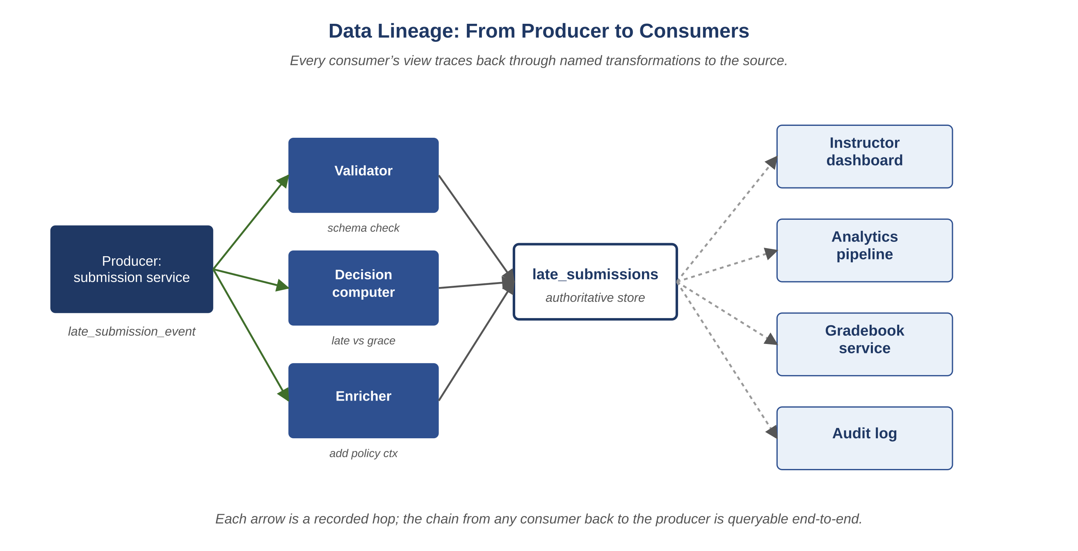
Figure D.1 — Data lineage from producer to consumers.
Lineage matters operationally for three reasons:
- Debugging. When a number in a dashboard looks wrong, the path from the source data to the dashboard is the path the investigator must follow. Without lineage, that path is reconstructed by guess.
- Compliance. When a regulator asks "is this user’s deleted data really deleted everywhere," lineage answers the question. Without it, the team has to enumerate every place data could have flowed and check each one manually.
- Change management. When a source column changes meaning, lineage tells the team which downstream artifacts need to be reviewed. Without it, the change ships and the downstream artifacts silently misrepresent the new meaning.
In an AI-driven system, lineage extends beyond data: every artifact in the system has a provenance chain. The decision-log fields the framework requires (input_ids, output_ids, context_hash) are the agent-system equivalent of data lineage. The same discipline that makes data systems debuggable makes agent systems debuggable, for the same reasons.

D.5 Quality: Drift, Dropout, Duplication
Three failure modes recur in data pipelines. Each one needs its own detection.
Drift. The data’s shape or distribution changes gradually. A field that was always populated is suddenly blank for 15% of records; a numeric range that used to fit a known distribution now has a new tail; the meaning of an enum value shifts because a producer started using it differently. Drift is detected by monitoring distributions over time and alerting on significant changes from a baseline.
Dropout. Records that should arrive do not. A producer is failing silently; a network partition is dropping events; a queue is overflowing. Dropout is detected by reconciling expected counts against observed counts — either through a side channel that gives an authoritative count, or by comparing successive aggregates for unexplained gaps.
Duplication. A record arrives more than once. A retry mechanism without idempotency keys; a producer that emits twice on commit; a consumer that processes the same message twice. Duplication is detected by deduplication at consumption time, idempotency keys at production time, and exactness checks against expected counts.
Each detection has its own cost and its own false-positive profile. A team adopting these detections progressively almost always discovers that one of the three has been happening silently for some time — the detections are also a kind of audit on the system’s past quality.

D.6 Retention and Privacy
Retention policy answers the question "how long is this data kept, and what happens at the end?" It is partly a regulatory matter (some classes of data have legal retention floors and ceilings), partly an operational matter (long-retained data is expensive to store and risky to lose), and partly an ethical matter (data kept indefinitely is data that may eventually be misused).
A defensible retention policy specifies, per data class:
- The minimum retention period (often regulatory). Financial transactions, audit logs, and certain personal data have legal floors.
- The maximum retention period (often ethical or operational). Personal data should not be kept beyond the purpose that justified collecting it.
- The action at end-of-retention. Deletion (permanent removal), archival (moved to cheaper storage with restricted access), or anonymization (kept but with personal identifiers stripped).
- The verification mechanism. The policy is a property; the team needs evidence the property holds. A discipline of periodic audits against the policy is the standard answer.
Example
Atlas Learn’s retention policy for live-session recordings: 90 days for default tenants, 365 days for tenants with a "compliance" plan tier, deletion at end of retention with a 7-day soft-delete grace period for accidental deletion recovery. The policy has a verification mechanism: a weekly job sweeps recordings older than the policy and confirms they have been deleted, and the result is a tracker event. Twice in the platform’s history the sweep has found stragglers — recordings that the deletion path missed because of an edge case in the storage backend. Both findings produced fixes; both fixes were tested by re-running the sweep on synthetic stragglers. Without the verification mechanism, neither edge case would have been found until a regulator or a customer asked.

D.7 Data Engineering in an AI-Driven System
The framework consumes data engineering in three places.

D.7.1 Memory Artifacts as Data
System Memory — the durable artifacts the framework relies on — is itself data with all of the disciplines of this chapter. Decision records have a schema; the contract between memory writers and memory readers covers field semantics; invariants govern what makes memory consistent; lineage tracks which memory artifact informed which agent decision; retention applies (some memory is permanent, some has a window). A team that takes the framework seriously but skips data engineering will discover, in their first audit, that their memory layer is data without the discipline.

D.7.2 Agent Output as Data
Every agent invocation produces an artifact: a design delta, a code diff, an audit record, a finding, a plan. These artifacts are data. They have schemas (each artifact type has a structure), contracts (consuming agents expect specific fields), invariants (an audit record must reference at least one invariant ID), lineage (every artifact lists the artifacts it consumed), drift detection (an artifact whose shape changes silently is a regression in the prompt), and retention (some artifacts are permanent; others can be aged out). Treating agent outputs as a data engineering problem is what lets the framework be debuggable later.

D.7.3 Domain Data the System Operates On
Most obviously, the application’s own data — the customer records, the transactions, the events — is data with all of the disciplines. The framework’s contribution here is mostly to make existing data engineering practice integrate cleanly with agent-driven changes: when an agent proposes a schema migration, the same expand-migrate-contract discipline applies; when an agent reads from a data source, lineage extends through the agent the same way it extends through any other consumer. The discipline does not change because agents are involved; the discipline gets an additional kind of consumer to track.

D.8 The Atlas Learn Late-Submission Pipeline
Atlas Learn — Six months in the life of one data class
On Atlas Learn, late-submission events are a data class with all the disciplines of this chapter. The schema (assessment_id, learner_id, submitted_at, deadline_at, grace_window, decision) is small. The contract is interesting: the producer (the assessment service) guarantees that decision is computed deterministically from submitted_at, deadline_at, and the section’s policy. The invariant is INV-AL-09: late-submission decisions, once recorded, are immutable; corrections flow as new events. The lineage runs from the submission service through the late-submission record into three downstream consumers (instructor dashboards, analytics, gradebooks). Six months ago the team noticed a drift signal: the rate of late_accepted decisions had increased 4% week-over-week for three consecutive weeks. The drift detection had been quiet for years; this was the first alert. Investigation traced the drift to a producer change — a refactor had inadvertently shifted the timezone basis of the submitted_at field by an hour for one tenant. Without drift detection, the change would have shipped silently, and ten thousand late submissions would have been recorded with the wrong decision; the discovery would have come from a regulator or a stakeholder, much later, with a much larger blast radius. With drift detection, the producer change was rolled back within four hours, and the late submissions from the affected window were re-evaluated against the correct timezone and re-recorded as amendments under INV-AL-09. The data engineering discipline did its job.
Exercises
Solutions appear in the companion solutions volume. Try the exercises before consulting them.
1. Distinguish schema, contract, and invariant as data-engineering concepts. For a system you know, give one example of each.
2. Define drift, dropout, and duplication as data-quality failure modes, and give a one-sentence detection for each.
3. Explain the expand-migrate-contract pattern in your own words and identify the failure mode the three-step structure protects against.
4. Walk through the Atlas Learn due-at split (D.3.1 example) and identify what could have gone wrong at each step if the team had skipped the corresponding discipline.
5. For a data class you know (a transactional record, a log event, an analytics row), specify the four properties of a defensible retention policy: minimum, maximum, end-of-retention action, verification mechanism.
6. Take one agent role from earlier chapters (Architect, Auditor, Developer, QA) and apply the data-engineering disciplines to its output. Identify the schema of its artifacts, the contract with consumers, the invariants, the lineage, and the retention.
7. Argue against this claim: "drift, dropout, and duplication are paranoia for systems that don’t actually have them." Identify three classes of system that look immune but are not, and explain how each one’s drift, dropout, or duplication usually first becomes visible.
8. Design the lineage instrumentation for a small data pipeline (say, the late-submission pipeline in D.8). Specify what gets logged at each hop, how the chain is queryable end-to-end, and what the cost of the instrumentation is.
9. A regulator asks: "show me, for any user who requested deletion in the last quarter, that their data is gone from every place it ever was." Design the response: which artifacts you would assemble, which gaps in the current discipline would prevent you from answering completely, and what the team would have to invest to make the answer trivially producible next time.
Key Takeaways
Data engineering is the discipline of making data-related assumptions explicit, enforceable, and observable.
Schema, contract, and invariant are distinct; each one is checked in a different place by a different mechanism.
Schema evolution follows expand-migrate-contract for any non-trivial change; the three-step structure is what makes breaking changes survivable.
Drift, dropout, and duplication are first-class failure modes that the application’s tests do not catch; each one needs its own detection.
In an AI-driven system, agent outputs and memory artifacts are themselves data and inherit the same disciplines.

PART III
The Agents
Vocabulary for Part III — The Agents
A short refresher on the terms used most often in the chapters that follow. Full definitions remain in the glossary at the back of the book; these short forms are meant to anchor the reader before diving in.
• Architect. The agent that designs systems, contracts, schemas, and invariants; owns the System Design lifecycle.
• Auditor. The agent that reviews any artifact for consistency and compliance; approves or sends back for revision.
• Developer. The agent that produces code within a declared scope and adds tests for new branches.
• QA, Security, Performance, Validator, Release Governor. The five remaining specialist agents in the canonical federation, each with one job and an explicit halt-on condition.
• Halt-on condition. A signal that should stop an agent rather than provoke a guess — ambiguity, missing context, contradiction with an invariant.
• Execution loop. The inner cycle through which every change passes: design → audit → build → test → secure → perf → validate → release.
• Anti-pattern. A design or workflow that looks reasonable, fails predictably, and is replaced by a named discipline.

10. Agent Design and Responsibilities
After this chapter, you will be able to:
• LO 10.1 — List the eight agents in the canonical federation — Architect, Auditor, Developer, QA, Security, Performance, Validator, Release Governor — and the one job each owns.
• LO 10.2 — Identify the inputs, outputs, constraints, and halt-on conditions for any given agent role.
• LO 10.3 — Apply the agent contract template to design a new specialist agent for a domain-specific concern not covered in the canonical eight.
• LO 10.4 — Distinguish a halt-on condition from a refusal, and justify why halting on ambiguity is a feature rather than a failure.
• LO 10.5 — Evaluate an existing automation that always produces output, and identify which halt-on conditions, if added, would improve correctness.
The agent layer is the most visible part of the system but also the most easily misunderstood. The temptation is to imagine each agent as a small expert. The accurate image is narrower: each agent is a contract executor with one job, a strict input shape, a strict output shape, and explicit conditions under which it must halt rather than guess.
Key Idea
It is more accurate to model an agent as a function with a typed signature than as a junior engineer with judgment. The output may resemble judgment, but the things you can rely on are the inputs you supplied and the schema you required back; everything else is best-effort. Designing around the signature instead of around the apparent intelligence is what makes the system predictable.

10.1 The Common Contract
Every agent in the federation is described by the same shape:
- Purpose: a one-sentence statement of what this agent exists to do.
- Inputs: structured data the agent must receive to do its job.
- Outputs: structured data the agent must return.
- Constraints: hard limits the agent must respect.
- Halt-on conditions: signals that should stop the agent rather than provoke a guess.
The remainder of this section describes the eight agents that constitute the canonical federation. Real systems may add domain-specific agents, but these eight are the minimum viable set for a serious engineering operation.

10.2 Architect Agent
Purpose: Translate an approved product specification into a complete, internally consistent system design with explicit invariants, contracts, schemas, and decision records.
Inputs: Product specification, non-functional requirements, prior design and invariants, prior decisions, infrastructure constraints.
Outputs: Updated design sections, draft decision records, updated contracts and schemas, draft invariants, sequence diagrams for new critical flows.
Constraints: May not change existing invariants without a decision record proposal. Must enumerate failure modes. Must declare blast radius.
Halt-on: Product specification ambiguous; new requirement contradicts an existing invariant; required non-functional requirement missing.
Example
In a logistics platform, the Architect designs the route-replanning service. It declares an invariant ("a vehicle is never assigned to two routes at the same time"), specifies the contract for accepting external traffic data, and enumerates the failure modes (data feed lag, sensor outage, depot closure). It does not guess about driver preferences when the specification is silent; it halts.

10.3 Auditor Agent
Purpose: Reject any artifact that is internally inconsistent, contradicts an approved artifact, or omits a mandatory element.
Inputs: Candidate artifact (design, code diff, QA report), the approved artifacts it must conform to, the relevant invariants.
Outputs: Verdict (approve, revise, escalate) with a structured list of findings: type, severity, citation, suggested fix.
Constraints: May not author code, tests, or designs. May not approve its own prior verdicts. Must cite specific lines or identifiers.
Halt-on: Cannot determine compliance because of missing context; the Auditor requests the missing context rather than guessing.
Atlas Learn — The Auditor catching a near-miss
On Atlas Learn, an Architect proposes adding a "regrade" endpoint that lets an instructor change a published grade. The proposed contract reads: "the endpoint updates the grade in place and returns the new value." The Auditor reads this against INV-AL-04 (a published grade is immutable; corrections flow as separate amendments referencing the original) and returns verdict=REVISE with one finding: severity=high, citation=INV-AL-04, suggested fix="model regrade as a new amendment record linked to the original grade; do not update in place." The Auditor does not write the fix — that is the Architect’s job — but the verdict is enough to redirect the design before any code is written. The single Auditor turn caught a class of audit problem that would have been visible only after a regulator asked, six months later, "show me every change ever made to this published grade."

10.4 Developer Agent
Purpose: Produce code that satisfies an approved design within an explicit scope.
Inputs: Approved design section, scoped file paths, current code, contracts, schemas, invariants, coding standards.
Outputs: Source diff, unit tests for added or changed behavior, inline documentation, change summary by ID.
Constraints: May not modify files outside scope. May not propose schema or contract changes — must escalate. Must add tests for every new branch and edge.
Halt-on: Required design detail missing; existing code conflicts with stated invariant; test would require modifying production schema.
Example
A Developer agent assigned to implement two-factor authentication for admin sign-in receives the scope: identity service login path, MFA challenge service, audit log writer. It refuses to modify the user-facing sign-up flow even if the change appears related, because it is out of scope; that becomes a separate task.

10.5 QA Agent
Purpose: Find defects before users do, with explicit emphasis on failure modes, edge cases, and concurrency.
Inputs: Code diff, design section, invariants, prior defect ledger entries on the affected module, concurrency profile, load profile.
Outputs: QA report with structured defects, new or modified tests, coverage delta.
Constraints: May not relax acceptance criteria. Must execute generated tests, not just declare them. Must cite the invariant each test guards.
Halt-on: P0 defect found; cannot construct a deterministic repro for an observed failure.

10.6 Security Agent
Purpose: Identify vulnerabilities and threat-model changes before release.
Inputs: Code diff, data-flow updates, dependency manifest, threat model, prior findings, authentication and authorization context.
Outputs: Updated threat model, vulnerability findings, attack-simulation results, hardening recommendations.
Constraints: May not approve release with unresolved critical or high findings without a written human exception. Must verify mitigations rather than accept claims.
Halt-on: Critical finding; secret detected in repo; new external network access without justification.

10.7 Performance Agent
Purpose: Detect performance regressions and enforce critical-path budgets.
Inputs: Code diff, critical-path inventory, SLOs, query plans, cache configuration, prior load-test results, current production metrics.
Outputs: Latency and throughput report, cache analysis, concurrency analysis, before/after benchmarks, recommended index or query changes.
Constraints: No feature change may regress a critical-path SLO without an explicit, time-bounded waiver. Must benchmark on a representative dataset.
Halt-on: Critical-path budget breach; query plan regression; cache hit ratio drop beyond band.

10.8 Validator Agent
Purpose: Cross-artifact consistency check before release. The last technical gate.
Inputs: All artifacts produced for the task: design, code, tests, security, performance, runbook, dashboards.
Outputs: Consistency report: contracts vs code, schema vs code, design vs code, tests vs invariants, dashboards vs metrics, runbook vs failure modes.
Constraints: May not author content. May only verify. Must cite mismatches with file and line.
Halt-on: Any mismatch — escalate to the originating agent.

10.9 Release Governor Agent
Purpose: Package, canary, monitor, and roll back changes safely.
Inputs: Validated artifact set, blast-radius analysis, on-call status, SLO budget history, feature-flag inventory, observability readiness.
Outputs: Release package, canary plan with cohorts and metrics, dashboard and alert updates, runbook, rollback plan with recovery time objective.
Constraints: No promotion without canary success across the observation window. No release without a rehearsed rollback path. Human approval required for full-fleet promotion.
Halt-on: Canary metric regression; on-call unavailable; rollback would require irreversible data migration.

10.10 Halt-on Conditions Are Features, Not Failures
The most important property of a well-designed agent is the willingness to halt. An agent that always produces output is an agent that produces output even when it should not. The halt-on condition is what distinguishes a contract executor from an over-confident generalist.
Key Idea
An agent that halts on ambiguous input is doing the right thing. Best-effort answers on bad inputs tend to be wrong in exactly the cases where wrongness is most expensive, and a fluent answer is harder to challenge than a halt. Designing the halt conditions is part of designing the agent.
Common Pitfall
"The agent should always try its best." This phrasing produces agents that try their best in conditions where their best is harmful. Halt-on conditions are the system’s way of saying: in these conditions, your best is worse than nothing.
Reflection
For each of the eight agents, write down two halt-on conditions specific to your domain. The exercise reveals where your specification is ambiguous and where you have over-trusted automation.
Exercises
Solutions appear in the companion solutions volume. Try the exercises before consulting them.
1. Name the eight canonical agents and give a one-sentence summary of each role.
2. Define halt-on. Why is halting treated as a valid verdict rather than a failure?
3. List the four elements of the common contract that every agent obeys regardless of role.
4. For Atlas Learn’s seat-fix task (TSK-AL-201), identify which agents are invoked, in what order, and what each one consumes and produces.
5. A team proposes merging the Auditor and Validator roles into a single "reviewer" agent to save cost. Refute the proposal using the role distinctions in this chapter.
6. For a system you know, write a concrete halt-on condition for the Security agent and explain what would have happened in a recent incident if that condition had been in place.
7. Argue against this claim: "the Architect should also be allowed to write code, since they understand the design best." Identify three failure modes that role isolation between Architect and Developer prevents.
8. Design a ninth agent for a domain not yet covered (accessibility, localization, regulatory compliance). Specify its purpose, inputs, outputs, constraints, and halt-on conditions. Argue why it is a separate role rather than a function added to an existing one.
9. A federation of narrow agents tends to outperform a single broad one. Identify a small number of conditions under which the opposite would be true, and design a transition plan a team could use to move from broad to narrow as those conditions change.
Common Mistakes
Each one looks reasonable in isolation; each one produces a failure mode the chapter argues against.
1. Merging Auditor and Validator into one role. The Auditor reviews each artifact against invariants; the Validator checks for cross-artifact mismatch. They look at different things. A single "reviewer" agent that tries to do both will either lose the per-artifact rigor or lose the cross-artifact dimension; specialization is what gives the framework its catching power.
2. Not specifying halt-on conditions explicitly. An agent without halt-ons will guess when it should refuse. The guesses are inconsistent across invocations; the same input pattern that halts today will produce a confident wrong answer tomorrow. Halt-on is a property of the role specification, not of the agent’s judgment.
3. Allowing agents to call other agents directly. An agent that invokes another agent has bypassed the controller, which means the workflow transition is now invisible to the audit trail and to bounded retries. The controller is the only entity that decides what runs next; agents that ignore this rule fragment the chokepoint that makes the framework auditable.
Key Takeaways
Eight agents make up the canonical federation, each with one job, a fixed input shape, a fixed output shape, and explicit halt-on conditions.
Halting is treated as a valid verdict, not a failure.
A federation of narrow agents tends to outperform a single broad one because the narrow ones can be evaluated, versioned, and replaced independently.

11. The Execution Loop
After this chapter, you will be able to:
• LO 11.1 — Describe the seven stages of the inner execution loop and the contract each stage carries between entering and exiting.
• LO 11.2 — Distinguish a local fix (handled inside the current iteration) from a non-local fix (forces a restart at Design) and route a given defect correctly.
• LO 11.3 — Trace a single change — small or critical — through every stage of the loop and identify which agent owns each transition.
• LO 11.4 — Apply the loop discipline to a "trivial" change, and explain why running the full path is precisely where the loop earns its value.
• LO 11.5 — Evaluate a workflow that allows fast-lane bypasses for "obvious" changes, and predict the class of incident such bypasses produce.
Before reading this chapter
You will get more out of what follows if you are already comfortable with:
• Chapter 3 and Chapter 10. The execution loop is the inner cycle that lives inside those two structures; reading them first will save backtracking.
• A working idea of a state machine — a set of states with rules about which transitions are allowed. Any data-structures or compilers text covers this. The Atlas Learn enrollment lifecycle (invited → enrolled → in_progress → completed | withdrawn | revoked) is a concrete example used elsewhere in this book.
• The concept of a "diff" or change set — the difference between two versions of code, expressed as added, removed, or modified lines. Any version-control tutorial covers this.
If Chapter 3 described the federation of lifecycles and Chapter 10 described the agents that work within it, this chapter zooms in to the smallest unit of useful work: the loop a single change runs through, from design to release. Most of what feels like productivity in an AI-driven team — and most of what feels like rigor — happens at this scale.
The loop is also the level at which engineering decisions become accountable. A change that bypasses the loop is a change without an audit trail, without a checked invariant, without a deliberate trade-off. The point of formalising the loop is not to slow work down; it is to ensure that work, however fast, leaves a record someone can read later.
Within the larger federated SDLC, the inner Execution Loop is the unit of work that delivers a single change. Its shape is: Design → Audit → Build → QA → Security → Performance → Validate. Failures at any stage feed backward to the originating agent. The loop is governed by the controller; agents do not advance themselves.
Key Idea
The loop is the smallest unit through which a change becomes accountable. Whether the change is a one-line fix or a major redesign, the same path applies. The most common cause of preventable production incidents in agentic systems is a stage that someone decided to skip because the change "looked safe."

11.1 Loop Diagram
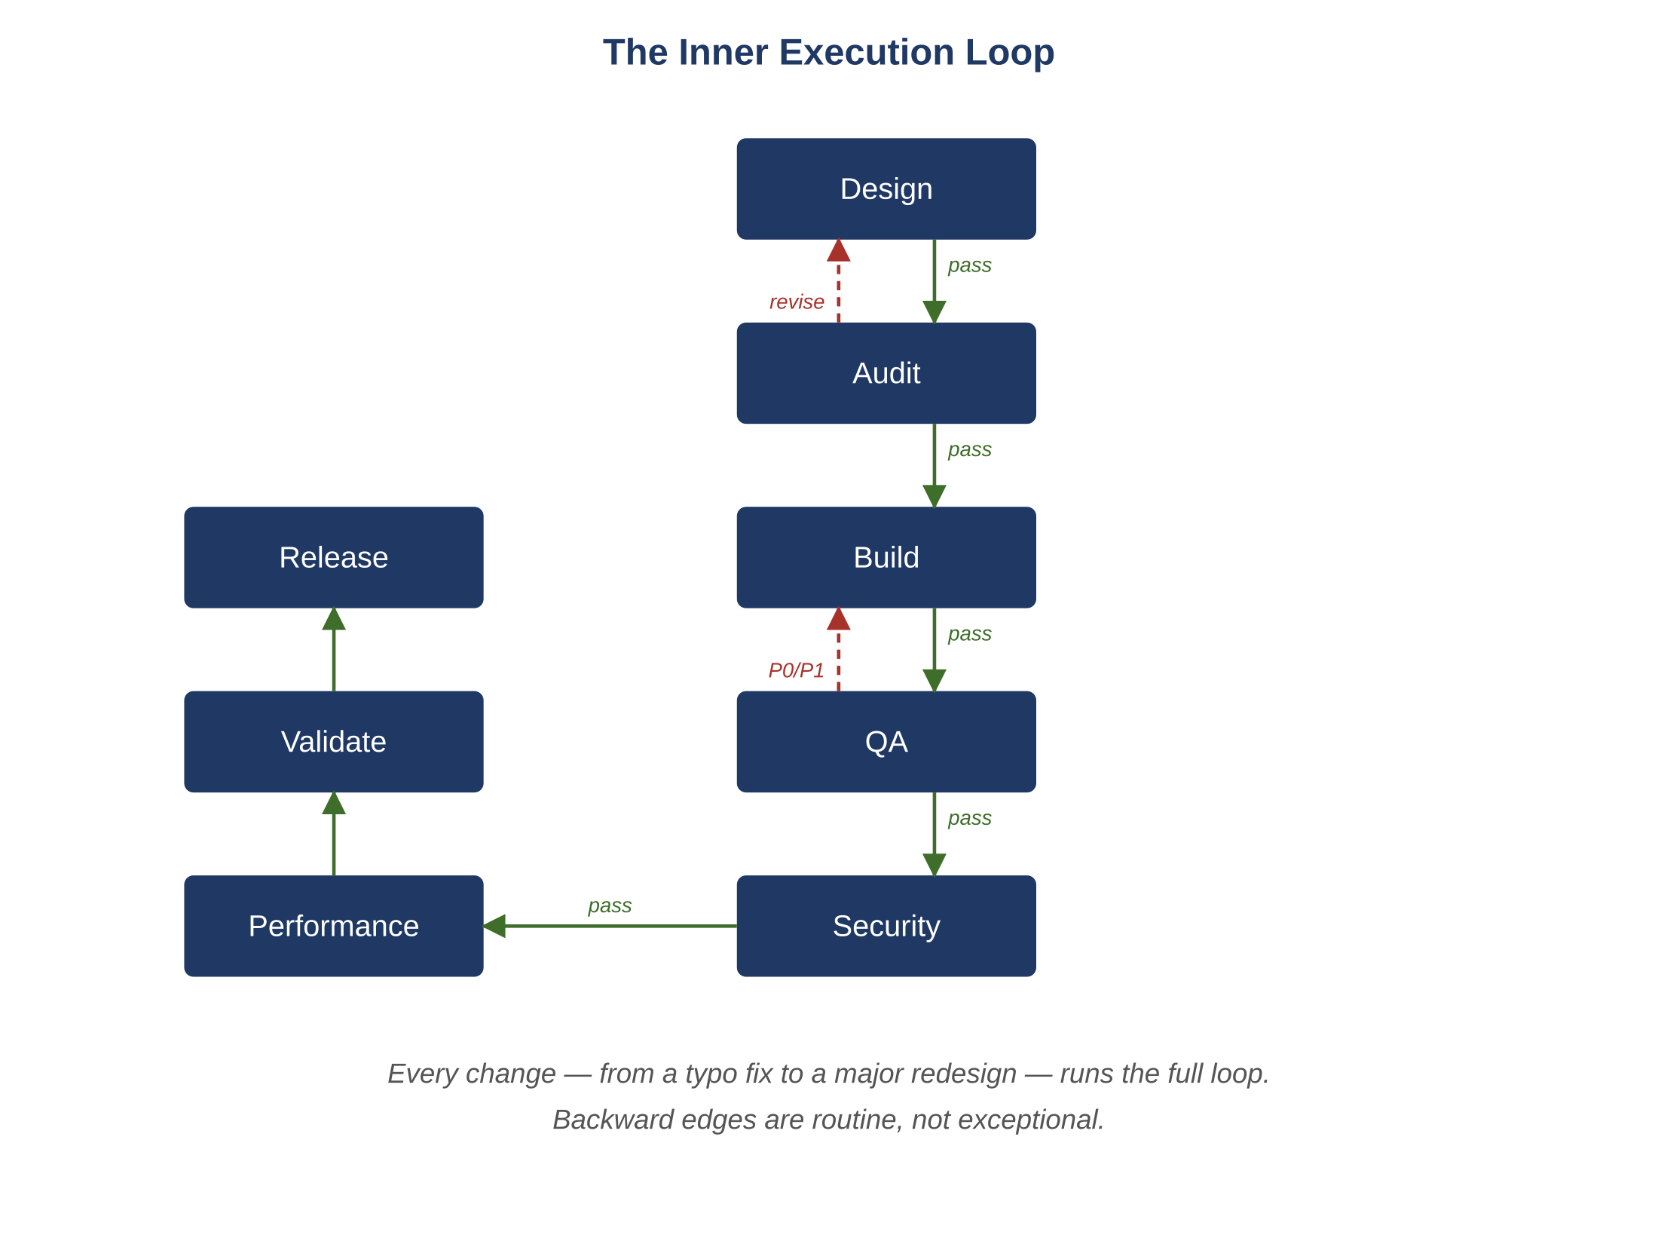
Figure 11.1 — The inner execution loop.

11.2 Stage Contracts
Stage | Enters With | Exits With | Backward Edge On
Design | Task spec + context | Approved design + decisions | Auditor revise
Audit | Candidate design or code | Verdict + findings | (forces revise)
Build | Approved design | Diff + unit tests | Static check failure
QA | Diff + design + invariants | QA report + new tests | P0 or P1 defect
Security | Diff + threat model | Findings + threat update | Critical or high finding
Performance | Diff + budgets | Bench report + plan review | Budget breach
Validate | Full artifact set | Consistency report | Any mismatch

11.3 Local Fix vs Backward Edge
Some defects are local — within the scope of the current diff. Others are non-local — require a design or contract change. The controller routes accordingly:
- Local defects (typo, missing branch, off-by-one): Developer revises within the same loop iteration.
- Non-local defects (contract change, schema change, invariant change): escalate to Architect; loop restarts at Design.
- Cross-module defects: Validator opens a sibling task; current loop holds until both converge.
Example
A QA agent finds a defect in a healthcare scheduling system: appointments can be double-booked when two providers share the same room. If the diff merely missed a branch, the Developer fixes it in place. If the schema does not represent rooms as bookable resources, the Architect must redesign — the loop restarts at Design.

11.4 Loop Iteration Discipline
A loop iteration that exceeds three Audit revises is automatically escalated to a human. Repeated revises usually mean the underlying design is ambiguous, not that the agent is poor.

11.5 Why the Loop Is Mandatory for Trivial Changes Too
It is tempting to skip stages for "obvious" changes. The temptation is the leading cause of regression. A typo fix runs through the loop because:
- The Audit catches contract or naming inconsistencies the typo introduces.
- The QA stage exercises tests that were unaffected by the change but pass cheaply.
- The Security stage confirms no secret was accidentally committed.
- The Performance stage confirms no compile-time effect on hot paths.
- The Validator confirms the change does not silently invalidate a downstream artifact.
Common Pitfall
"Fast lane for trivial changes." Once it exists, every change is trivial in the eyes of its author. The lane becomes a bypass; the bypass becomes the norm; the discipline collapses.
Atlas Learn — A trivial label change that ran the full loop and earned its keep
On Atlas Learn an instructor reports that the enrollment confirmation says "You are enrolled" even when the seat is held but unconfirmed because of a pending payment. The proposed fix is one line: change the label to "Enrollment held — awaiting payment" when the corresponding tenant’s plan is paid and the payment is pending. Looks like a five-minute change. The full loop runs anyway. The Auditor flags that the new label string introduces a translation key and the localization contract requires every key to ship with translations for the four supported languages — caught at design time, not at release. The QA stage adds a test that the original "You are enrolled" path is still reachable when the tenant’s plan is free (otherwise the change would have silently broken the free-tier flow). Performance confirms the conditional adds no measurable latency to the enrollment-confirm path. Validator confirms the new translation key is registered in the localization service. The change ships safely; without the loop, two of those four findings would have shipped with it.
Reflection
Trace a recent emergency hotfix back through the seven stages. Identify which were skipped. Identify whether each skip was justified or expedient. The honest count is usually more skips than you remembered.
Exercises
Solutions appear in the companion solutions volume. Try the exercises before consulting them.
1. List the seven stages of the execution loop in order and the contract each one carries from entering to exiting.
2. Define a local fix and a non-local fix. Identify which one stays inside the current loop iteration and which one bounces back to Design.
3. Explain why the loop is mandatory for trivial changes. Name the class of failure that fast-lane shortcuts produce.
4. Walk the trivial-label-change vignette through the seven stages. Identify what each stage caught or confirmed, and which findings would have shipped without the loop.
5. A bug fix changes the return type of a public function. Classify it as a local or non-local fix and identify which stage owns the routing decision.
6. A team’s loop is taking too long: each iteration averages 40 minutes. For a system you know, propose three specific reductions, each one identifying which stage shortens and what the trade-off is.
7. Argue for or against allowing a "fast lane" for changes that touch only documentation. Identify two failure modes the fast lane would create and propose a discipline that captures the speed without the cost.
8. Design the contract for a new stage you might add to the loop (e.g., accessibility review, localization review). Specify its predecessor, its input artifact, its output artifact, its halt-on conditions, and its place in the loop.
9. A loop iteration that exceeds three Audit revises automatically escalates to a human. Identify two conditions under which this rule should be tightened (fewer revises) and two under which it should be loosened, with justifications.
Common Mistakes
Each one looks reasonable in isolation; each one produces a failure mode the chapter argues against.
1. Fast-laning trivial changes. A two-line label change "doesn’t need" the loop, until the day a label change accidentally collapses two enum values and breaks the analytics pipeline. The loop earns most of its value on the changes the team is most tempted to skip it for.
2. Treating contract-touching bug fixes as local. If the fix changes a return type, a parameter, a schema, or an invariant, the change is non-local and must bounce back to Design. A team that classifies these as local will ship contract-breaking fixes that look correct in isolation but break consumers downstream.
3. Skipping a stage because the team trusts it. "Security is fine, no need to review this one." The trust is usually earned over time, but the review caught the rare case that mattered, and skipping it makes the rare cases the ones the team finds in production. Trust is preserved by exercising the discipline, not by retiring it.
Key Takeaways
Every change runs the full loop, including the changes that feel too small to bother with.
Local fixes stay inside the current iteration; non-local fixes (contract, schema, invariant) bounce back to Design.
Counter-intuitively, the loop earns most of its value on the changes that look trivial — those are the ones most likely to slip something past a less rigorous process.

12. Agent Anti-Patterns
After this chapter, you will be able to:
• LO 12.1 — Recognize the twelve named anti-patterns by symptom and predict the failure mode each one produces.
• LO 12.2 — Identify which anti-patterns currently exist in a workflow you operate and rate their severity honestly.
• LO 12.3 — Map each anti-pattern to the discipline that replaces it, and explain why the replacement is more reliable than the convenience it removes.
• LO 12.4 — Apply the catalog as a code-review checklist when evaluating an AI-driven workflow proposed by another team.
• LO 12.5 — Justify, with concrete examples, why the instinct to "simplify" a process is often the instinct to remove the discipline keeping a specific failure mode under control.
A short catalog of agent designs that look reasonable and fail predictably. Each is followed by the lesson it teaches and the pattern that replaces it. Anti-patterns are not theoretical; every one of them has been encountered in production systems.
Key Idea
Most teams running an AI-driven workflow exhibit at least three of these anti-patterns at any given time. The first step is recognizing them; "we don’t do that here" is almost always wrong on closer inspection.
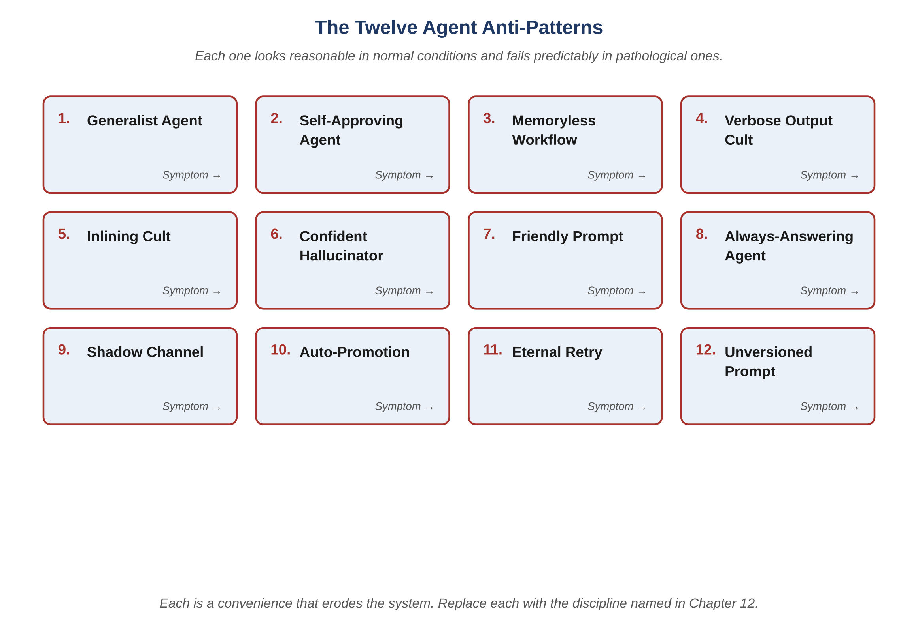
Figure 12.1 — The twelve agent anti-patterns.

12.1 The Generalist Agent
Symptom: A single "engineering agent" handles design, code, tests, and review. The prompts grow over time as concerns accumulate.
Failure: The agent cannot be evaluated against any one objective; quality regresses on the concern that received the least recent attention.
Replacement: Split by concern. The federation pattern of this book.

12.2 The Self-Approving Agent
Symptom: The same agent that proposes a change also approves it.
Failure: The audit trail is fiction. A bad change can be merged with no second pair of eyes.
Replacement: Role isolation. An Auditor (or different Developer) reviews. Hard rule: producer cannot approve.

12.3 The Memoryless Workflow
Symptom: Each agent invocation begins with no record of prior invocations on the task.
Failure: Drift between iterations; the same defect is reintroduced; fixes regress.
Replacement: The tracker. Stage-by-stage event sourcing.

12.4 The Verbose Output Cult
Symptom: Every output is a long prose explanation; downstream agents must parse natural language.
Failure: High token cost, high error rate, untestable outputs, unparseable downstream.
Replacement: Structured envelopes; explanations are an opt-in flag.

12.5 The Inlining Cult
Symptom: Every prompt contains the entire design document, the entire code file, and the entire prior conversation.
Failure: Tokens balloon; the model anchors on irrelevant context; the model rewrites code that should not be touched.
Replacement: Identifier referencing; delta processing; minimization.

12.6 The Confident Hallucinator
Symptom: The agent invents APIs, identifiers, or invariants that do not exist.
Failure: Outputs reference non-existent contracts; downstream stages fail or, worse, succeed with the wrong thing.
Replacement: Validate every reference against memory before consumption. The controller is the validator.

12.7 The Friendly Prompt
Symptom: Prompts are written in a chatty, encouraging tone.
Failure: Outputs drift conversationally; constraints feel like suggestions rather than rules.
Replacement: The canonical template: declarative, contractual, structurally enforced.

12.8 The Always-Answering Agent
Symptom: The agent never halts. Every input produces an output, no matter how ambiguous.
Failure: Best-effort output on ambiguous input is statistically wrong on the cases that matter.
Replacement: Explicit halt-on conditions. Halt is a verdict.

12.9 The Shadow Channel
Symptom: Agents (or humans) communicate or persist state outside the controller and the tracker because it feels faster.
Failure: The audit trail is incomplete; postmortems reach a wall.
Replacement: All traffic through the controller; all events through the tracker; period.

12.10 The Auto-Promotion
Symptom: Agents move stages forward on their own when they decide they are done.
Failure: The audit trail loses the gate that should have evaluated the transition; the controller is bypassed.
Replacement: The controller is the only entity that promotes stages. Agents return verdicts, not transitions.
Atlas Learn — What auto-promotion looked like when it slipped in
Early in the build of Atlas Learn the team had a "convenience": when a Developer agent finished, it would emit an event marking the task ready for QA. The team reasoned that the controller was just a forwarder for that transition; cutting it out saved a round-trip. Three months later, a regression slipped through where a Developer marked itself done despite a halt-on condition that should have triggered an Architect re-consult. The original event log showed the transition; the controller’s audit emitter, which would have stamped the transition with the active context hash and prompt ID, never ran. The team recovered by rebuilding the missing audit metadata from secondary sources, but the postmortem ran days longer than it should have. The replacement was simple: agents return verdicts, the controller decides on transitions. Throughput dropped briefly while the round-trip was restored, then recovered as soon as the audit-driven debugging on the next regression took minutes instead of days.

12.11 The Eternal Retry
Symptom: Agents that fail are retried indefinitely with no escalation.
Failure: Cost runaway; loops on systemic ambiguity; humans never see the problem.
Replacement: Bounded retries with explicit escalation. Two attempts, then a human.

12.12 The Unversioned Prompt
Symptom: Prompts are edited in place; no history; no rollback.
Failure: Performance regressions cannot be traced to a prompt change; rollback is impossible.
Replacement: Prompts are versioned artifacts; edits go through review; rollback by version pin.

12.13 Recognizing the Pattern
Every anti-pattern in this catalog shares a single underlying error: removing or skipping a discipline because it appears unnecessary in normal conditions. The discipline’s value is in abnormal conditions — which is when it is missing that incidents happen.
Common Pitfall
"This works fine for now." Anti-patterns are tolerated until they meet a pathological case. The case is when, not if.
Reflection
For each anti-pattern, rate your own system on a 1–5 scale. The lowest three are your highest-leverage improvements.
Exercises
Solutions appear in the companion solutions volume. Try the exercises before consulting them.
1. Name any six of the twelve anti-patterns and identify the discipline that prevents each.
2. Distinguish between the Generalist Agent and the Self-Approving Agent. Which one violates role isolation and which one violates approval gating?
3. Define the Shadow Channel anti-pattern and identify the property of the audit trail that it destroys.
4. For Atlas Learn’s auto-promotion vignette, identify which two anti-patterns were active simultaneously and the specific incident pattern they enabled.
5. A team’s prompt library is edited in place without versioning. Identify which anti-pattern this is, predict the failure mode, and propose the minimum discipline to fix it.
6. For each of three anti-patterns of your choice, write a one-sentence "early warning sign" that a team would see before the failure becomes acute.
7. Argue that the Friendly Prompt anti-pattern is harder to detect than the Verbose Output Cult, even though both produce token waste. Identify what makes the former invisible and propose a detection.
8. Design a quarterly "anti-pattern audit" for a team running the framework. Specify which patterns to check, which signals to look at, and what action a finding triggers.
9. A teammate insists "we don’t do any of these on our team." Construct three diagnostic questions whose honest answers usually reveal which anti-patterns are present, and explain why teams often miss them in self-assessment.
Common Mistakes
Each one looks reasonable in isolation; each one produces a failure mode the chapter argues against.
1. Believing "we don’t do any of these." Self-assessment misses anti-patterns reliably; the team sees outcomes (we ship) and not the discipline that should have produced them. Three diagnostic questions almost always reveal at least one anti-pattern present that the team did not name.
2. Adding a new agent role to handle the symptoms. When a workflow keeps producing escapes, the temptation is to add a "reviewer-of-reviewers" or a "double-check-agent." The honest fix is usually to repair the discipline that the existing roles already cover; new roles paper over the gap rather than closing it.
3. Treating recurring escapes as one-off bugs. Three similar incidents in a quarter is a pattern, not a coincidence. A team that closes each ticket individually has lost the structural thread; the discipline is to escalate the pattern to engineering rather than to absorb it ticket-by-ticket.
Key Takeaways
Twelve common failure modes, each with the discipline that prevents it.
Most of them get adopted as conveniences during normal operation and only reveal their cost during pathological cases.
The instinct to "simplify" the process is often, on inspection, the instinct to remove the part that was keeping a specific failure mode under control.

PART IV
Quality Concerns
Vocabulary for Part IV — Quality Concerns
A short refresher on the terms used most often in the chapters that follow. Full definitions remain in the glossary at the back of the book; these short forms are meant to anchor the reader before diving in.
• Failure-first testing. A testing strategy that enumerates failure modes first and confirms the success path as a byproduct of failure-mode coverage.
• Idempotency. A property by which a repeated action has the same effect as a single one; enforced via idempotency keys at storage.
• STRIDE. A threat-modeling vocabulary (Spoofing, Tampering, Repudiation, Information disclosure, Denial of service, Elevation of privilege) applied to every new or modified data flow.
• Critical path. The set of operations whose latency or availability defines the user’s experience of the product. Each has a written budget.
• Service Level Objective. A measurable target for a service property, with an explicit budget for deviation and an alerting policy when the budget burns down.
• Decision log. A structured record of an agent invocation: prompt ID, context hash, inputs, outputs, decision, reason; the fourth axis of observability.

13. Quality Assurance: Failure-First Testing
After this chapter, you will be able to:
• LO 13.1 — Describe the failure-first strategy and explain why it inverts the conventional priority of writing happy-path tests first.
• LO 13.2 — Identify the recurring categories of edge cases — concurrency, idempotency, boundary, failure injection, time — and recognize them in any new feature.
• LO 13.3 — Apply the test pyramid for an AI-driven system, distinguishing which level (unit, property, integration, concurrency, end-to-end, load, chaos) covers which class of risk.
• LO 13.4 — Construct a negative test for any stated invariant — the assertion that fails when the invariant is violated.
• LO 13.5 — Evaluate a test suite for whether it counts passing tests or guards named invariants, and propose how to convert it from the first to the second.
Before reading this chapter
You will get more out of what follows if you are already comfortable with:
• The classical test pyramid: many unit tests, fewer integration tests, fewest end-to-end tests. Mike Cohn’s "Succeeding with Agile" introduces it; any QA text covers it.
• Concurrency basics: race conditions, lost updates, the lost-update example where two readers update the same value and one wins. Any operating-systems or databases textbook covers this in its section on transactions.
• Property-based testing as an idea, not a specific tool. The notion that a test asserts a property over many generated inputs rather than checking one example.
• The notion of an "invariant" in the sense used throughout the book — a property the system must always preserve. Chapter 2 introduces this if it is unfamiliar.
Conventional QA writes tests for the happy path and adds edge cases as time permits. Failure-first QA inverts the priority: enumerate failure modes first, write tests for them first, and ensure the happy path works as a byproduct of failure-mode coverage.
Key Idea
A test that confirms the success path mostly confirms that the success path can succeed under the conditions of the test. A test that asserts a specific failure cannot occur — under concurrent access, under a partial dependency, under retry, under boundary input — is doing more useful work, because it is the failure cases that production actually exposes.

13.1 The Failure-First Strategy
- Begin from invariants: every invariant produces at least one negative test — the test that fails if the invariant is violated.
- Add concurrency tests for every shared resource.
- Add idempotency tests for every action that can be retried.
- Add boundary tests for every numeric or string field (zero, negative, max, empty, very long, unicode).
- Add failure-injection tests: dependency timeouts, partial responses, connection resets, clock skew.
- Add time-related tests: TTL expiry mid-transaction, overlapping scheduled jobs, daylight-saving transitions.
- Only after all the above pass, confirm the happy path.

13.2 The Test Pyramid for an AI-Driven System
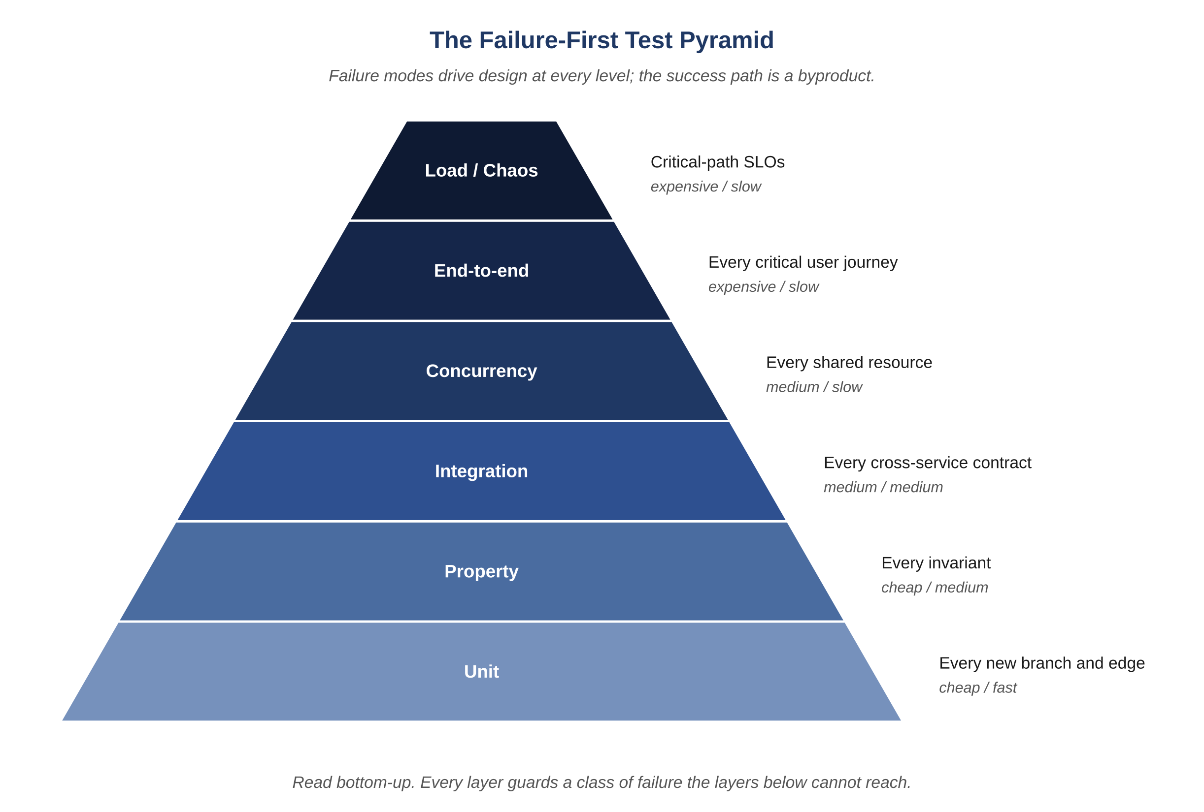
Figure 13.1 — The failure-first test pyramid.
Level | Owner | Cost / Speed | Required Coverage
Unit | Developer | Cheap / fast | Every new branch and edge
Property | QA | Cheap / medium | Every invariant
Integration | QA | Medium / medium | Every cross-service contract
Concurrency | QA | Medium / slow | Every shared resource
End-to-end | QA | Expensive / slow | Every critical user journey
Load / soak | Performance | Expensive / slow | Critical-path SLOs
Chaos | Security + QA | Expensive / slow | Every external dependency

13.3 Edge Cases Across Domains
Edge cases are not arbitrary. They are predictable consequences of the data model, the concurrency model, and the operational environment. The following examples illustrate edge-case categories that recur across domains.

13.3.1 Concurrency on Shared Resources
- Banking: two simultaneous withdrawals from the same account; exactly one succeeds when the balance can support only one.
- Inventory or stock: two customers checking out the last unit; deterministic outcome, no oversell.
- Booking: two patients booking the last available appointment; exactly one confirmed.
- Multiplayer games: two players claiming the same in-game resource; the system arbitrates with a deterministic rule, not by latency.
- IoT: two controllers commanding the same actuator; the device chooses by precedence, not by message order.

13.3.2 Idempotency on Retries
- A retried payment must not charge twice.
- A retried order must not create two orders.
- A retried publish must not produce two posts.
- A retried message-send must not deliver twice.
- A retried sensor read must not double-count an event.

13.3.3 Boundary Conditions
- Zero, one, and "many" are different cases. Test all three.
- Empty, one-character, and very long strings are different cases. Test all three.
- Currency at zero minor units, one minor unit, and the maximum representable amount are different cases.
- Time at "now," "epoch," and "end of representable range" are different cases.
- Collections at empty, near-cache-size, and very large are different cases.

13.3.4 Failure Injection
- Dependency timeout: the service the agent calls returns nothing within budget.
- Partial response: the dependency returns a body but truncated.
- Connection reset mid-stream: half the response is processed before the failure.
- Clock skew: the agent’s clock disagrees with the dependency’s by minutes.
- Dependency returns success with a body that fails schema validation.

13.3.5 Time and Schedule
- A reservation expires precisely as the user submits.
- Two scheduled jobs overlap because one ran late.
- A user crosses a daylight-saving boundary mid-session.
- A countdown reaches zero while a server is in a long garbage-collection pause.
- A token expires between authentication and authorization.

13.4 Concurrency Tests in Practice
Concurrency tests run with deterministic interleaving where possible (a test scheduler) and randomized stress where not. Every test must be reproducible from a recorded seed.
Example
A reservation system runs a concurrency test with two threads attempting to reserve the same resource at the same instant. The test scheduler interleaves their operations across all observable orderings; the test passes only if every ordering produces exactly one success and one deterministic conflict.
Atlas Learn — The two-learners-last-seat concurrency test
On Atlas Learn, INV-AL-01 (a section’s seats_taken never exceeds seats_total) is the canonical concurrency invariant. The QA agent treats it as a property test, not an example: for any section with one seat remaining, any number of concurrent enrollment attempts must produce exactly one success and the rest must fail with a stable, retryable error. The test scheduler interleaves two enrollment threads across every observable ordering of the seat-decrement and the writes that follow; on a fixed random seed it also generates ten-thousand-attempt stress runs. A failure of any ordering pins the run to a recorded seed, so the developer can replay the exact interleaving locally. The first version of the seat-fix passed the example case but failed under one specific reordering of the decrement and the membership write; that failure produced TSK-AL-201’s second design iteration. Without the property formulation, the example test would have passed and the regression would have shipped.

13.5 Retry Scenarios
- Network blip during a critical action: idempotency key prevents duplicate; user retries safely.
- Provider timeout: state polled by reconciliation; client receives a retry-friendly response with a stable identifier.
- Notification service outage: queued for retry with backoff and dead-letter; the primary action is unaffected.
- Index-write failure: best-effort indexing; missing index repaired by periodic backfill, not by failing the write path.

13.6 The QA Output Format
{
"agent": "QA",
"task_id": "TSK-1184",
"status": "DEFECTS_FOUND",
"summary": {
"tests_added": 14,
"tests_passed": 13,
"tests_failed": 1,
"coverage_delta_pct": 1.4
},
"defects": [
{
"id": "DEF-0907",
"severity": "P0",
"invariant": "INV-031",
"repro": "QAS-2210",
"observed": "discount not zeroed on SUSPENDED",
"expected": "discount=0; metric +1"
}
],
"tests_added_ids": ["QAS-2210", "QAS-2211"]
}
Common Pitfall
Counting passing tests rather than guarded invariants. A thousand happy-path tests are less useful than a hundred tests, each of which guards a named invariant.
Reflection
Pick three invariants of your current system. For each, write the negative test — the assertion that fails if the invariant is violated. Invariants you can’t turn into a test usually aren’t yet engineered properties; they are stated intentions, and intentions tend not to hold under load.
Exercises
Solutions appear in the companion solutions volume. Try the exercises before consulting them.
1. Name the six tiers of the failure-first test pyramid and the class of failure each tier guards against.
2. List the five recurring categories of edge cases (concurrency, idempotency, boundary, failure injection, time) and give one example of each.
3. Define a property test and explain how it differs from an example test.
4. Write a property test for INV-AL-01 (seats_taken ≤ seats_total). Specify the property, the input space, and the expected behavior under N concurrent enrollment attempts.
5. For Atlas Learn’s submission-write critical path, enumerate the time-related edge cases that QA should guard. Cover deadline windows, time zones, clock skew, and grace periods.
6. A team’s test suite has 4,000 tests, all green. Construct three diagnostic questions that reveal whether the suite actually guards invariants or merely covers happy paths.
7. Argue that test count is a misleading metric and invariant coverage is a better one. Identify a class of system where they would diverge and explain why.
8. Design the failure-first test plan for a new feature in a domain you know. Enumerate failure modes first, write the negative tests for each, and identify which tier of the pyramid each test belongs to.
9. A teammate proposes skipping concurrency tests for "low-traffic" endpoints. Construct three scenarios in which a "low-traffic" endpoint is exactly where concurrency bugs are most likely to hide undetected, and propose a test budget that accounts for them.
Common Mistakes
Each one looks reasonable in isolation; each one produces a failure mode the chapter argues against.
1. Counting tests instead of measuring invariant coverage. "We have 4,000 tests" is not the same as "every invariant has a guarding test." The first measures effort; the second measures protection. Most large test suites cover the happy path well and the failure modes thinly; coverage by count hides the imbalance.
2. Skipping concurrency tests on low-traffic endpoints. Low traffic is not the absence of contention; admin endpoints, periodic jobs, and rare operations cluster in unexpected ways. A team that tests concurrency only where it expects contention will be surprised by it where it didn’t.
3. Treating "all tests pass" as proof of correctness. Tests pass means tests pass. They tell you nothing about the cases nobody wrote a test for. The discipline is to invert the question: not "what do my tests verify" but "what failure mode would slip through if my test suite were the only line of defense."
Key Takeaways
Failure-first QA starts with the ways the system can fail and only afterward confirms that the success path still works.
Every invariant has at least one negative test that fails when the invariant is violated.
The categories that recur in production are concurrency, idempotency, boundaries, failure injection, and time-related cases — most teams miss at least one until it bites.

14. Security and Threat Modeling
After this chapter, you will be able to:
• LO 14.1 — Apply the STRIDE vocabulary — spoofing, tampering, repudiation, information disclosure, denial of service, elevation of privilege — to threat-model any new or modified data flow.
• LO 14.2 — Identify the application-surface concerns and the meta-surface concerns (agents, controller, memory) and explain why both must be modeled.
• LO 14.3 — Distinguish vulnerabilities that are mitigated by construction (storage constraints, server-side authorization) from those mitigated only by testing.
• LO 14.4 — Construct a hardened design for a privileged action (recorded reason, dual control, time-boxed session) for a system you know.
• LO 14.5 — Evaluate a webhook or external callback flow for replay, signature, and deduplication discipline, and propose specific corrections.
Before reading this chapter
You will get more out of what follows if you are already comfortable with:
• Authentication versus authorization — who you are versus what you may do. Any web-security primer distinguishes these.
• TLS at an intuitive level: the fact that web traffic is normally encrypted in transit and that a certificate verifies a server’s identity. The mathematics is not required.
• Common attack categories at a vocabulary level: SQL injection, cross-site scripting, replay attacks, parameter tampering. The OWASP Top Ten is the standard reference.
• Digital signatures as a property: a sender signs a message with their private key and any recipient with the public key can verify the signature. No implementation knowledge needed.
• A general sense of role-based access control: users have roles, roles have permissions, the system checks the permissions before allowing an action.
Security in an AI-Driven SDLC has two surfaces: the application surface (the system being built) and the meta-surface (the agents, controller, and memory). Both must be modeled. The Security agent owns the application surface; the Release Governor and human owners own the meta-surface. This section covers the application surface and notes the meta-surface where relevant.
Key Idea
Security needs to run as a thread through every stage rather than as a stage at the end. A correct, fast system can still be exploitable, and the typical reason is that security review happened after architectural decisions that already foreclosed safer options.

14.1 Threat Modeling: STRIDE Across Domains
Threat models are produced per change and stored in a long-lived register. The model template is STRIDE — Spoofing, Tampering, Repudiation, Information disclosure, Denial of service, Elevation of privilege — applied to every new or modified data flow.
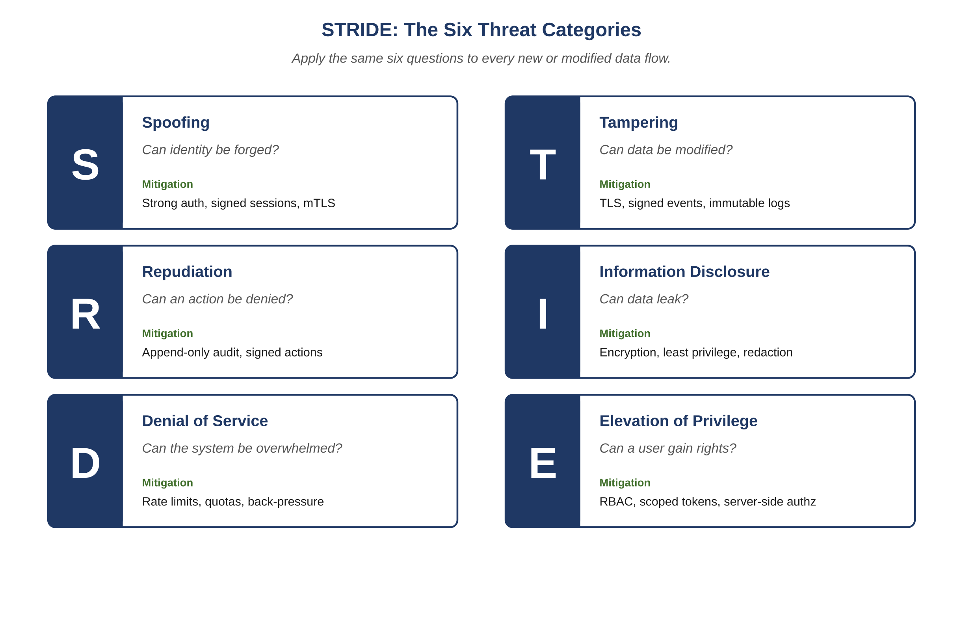
Figure 14.1 — STRIDE: the six threat categories.
Category | Question | Mitigation | Cross-Domain Examples
Spoofing | Can identity be forged? | Strong auth, signed sessions, mutual TLS internally. | Forged user token; forged sensor identity; forged service account.
Tampering | Can data be modified? | TLS, signed events, immutable logs, integrity checks. | Modified amount on a callback; tampered firmware update; altered audit log.
Repudiation | Can an action be denied? | Append-only audit, signed actions, decision ledger. | Admin denies issuing a refund; user denies sending a message; operator denies a setpoint change.
Information disclosure | Can data leak? | Encryption, least privilege, redaction in logs. | Sensitive fields in logs; misrouted email; tenant bleed in shared cache.
Denial of service | Can the system be overwhelmed? | Rate limits, quotas, circuit breakers, queue back-pressure. | Search flood; report-generation flood; sensor-event burst.
Elevation of privilege | Can a user gain rights? | RBAC, scoped tokens, server-side authorization. | User reaches admin function via parameter tampering; tenant reaches another tenant’s data; sensor reaches control plane.

14.2 Vulnerability Detection
- Static analysis on every diff with rules tuned to the language and framework.
- Dependency scanning: known vulnerabilities block at the pull-request gate; high or critical block release.
- Secret scanning: any private key, token, or credential blocks the build.
- Schema drift detection: production schema versus code-declared schema mismatch is a security finding.
- Authorization coverage: every endpoint must have an authorization assertion in tests or be tagged public.

14.3 Attack Simulation
- Authorization fuzzing: systematically request resources owned by other principals; expect denial.
- Replay attacks: replay actions with same and altered idempotency keys; expect deterministic safe behavior.
- Input fuzzing: malformed payloads, oversized inputs, deeply nested objects, unicode tricks, injection vectors.
- Webhook or signal forgery: attempt unsigned and incorrectly signed events; expect rejection with audit.
- Rate-limit evasion: rotate identifiers; expect rate-limit policies to compose correctly.

14.4 Hardening: Cross-Domain Patterns

14.4.1 Sensitive Data Minimization
- Tokenize at the edge; never persist plaintext sensitive data.
- Redact at the logger; redaction failures are themselves logged events.
- Bound retention to legal and operational requirements; longer is not safer.

14.4.2 Authentication and Authorization
- Short-lived access tokens with rotation; bound to device fingerprint where allowed.
- Server-side authorization on every action; never rely on client state.
- Multi-factor for privileged roles; step-up MFA for sensitive operations.
- Account-recovery rate limited and anomaly aware, with explicit user-visible audit.

14.4.3 Privileged Action Discipline
- Privileged actions require a recorded reason and a link to a ticket or case identifier.
- High-impact actions require dual control above thresholds.
- Privileged sessions are time-boxed; idle timeout shorter than user sessions.
- Read-only privileged views are the default; write privileges granted just-in-time.

14.4.4 Event Authenticity
- External callbacks (webhooks, sensor events) are signature-verified before any state change.
- Replay windows are enforced.
- Event ID deduplication is at storage, not service code.
Example
A telemedicine platform receives results from external lab providers via webhooks. Each provider signs its callbacks. The platform verifies the signature, deduplicates by event ID, and rejects events older than the replay window. A spoofed result cannot be inserted; a duplicated result cannot create a duplicate record; a delayed result is logged but not silently dropped.
Atlas Learn — Hardening tenant isolation by construction
INV-AL-05 (no read or write originating from tenant A reaches data owned by tenant B) is the most consequential single invariant on Atlas Learn. Hardening it by construction means: every database query carries the tenant_id implicitly, derived from the session, and a query that does not constrain on tenant_id is rejected at the data-access layer. The Security agent threat-models every new endpoint against five questions — can the tenant_id be spoofed; can a parameter override it; can a join leak across it; can an error message reveal a foreign tenant’s identifier; can a cache key collide across tenants. Task TSK-AL-224 (a tenant-isolation audit) traced one near-miss to its source: a discussion-search endpoint that derived tenant_id from a query parameter rather than the session. The fix removed the parameter entirely. The lesson generalizes: every cross-tenant boundary that is checked only at request time is a future incident. Boundaries enforced at the storage layer are not.

14.5 The Security Output Format
{
"agent": "Security",
"task_id": "TSK-1184",
"status": "FINDINGS",
"findings": [
{
"id": "SEC-0290",
"severity": "HIGH",
"category": "Tampering",
"cwe": "CWE-345",
"location": "billing/webhook_handler.py:142",
"observed": "signature verification skipped on retry path",
"fix": "Verify on every entry; do not branch on retry attempt"
}
],
"threat_model_changes": ["Updated billing callback flow"],
"blocking_release": true
}

14.6 Meta-Surface Considerations
The agents, controller, and memory must themselves be secured. Items worth attending to:
- Prompt injection: untrusted inputs can attempt to override agent instructions. Treat any user-supplied string in an agent input as untrusted; do not concatenate into the prompt without delimiters and instructions.
- Memory tampering: edits to design, contracts, or invariants must be authenticated and audited like any other privileged action.
- Token theft: model API credentials are first-class secrets; rotation, scoping, and rate limiting apply.
- Output exfiltration: agent outputs may inadvertently include sensitive data from inputs; redaction at the boundary is mandatory.
Common Pitfall
"The agent saw the secret only briefly." A secret in a prompt is a logged secret. Once it is in your trace, it is in your trace.
Reflection
For your highest-risk data flow, run the STRIDE checklist explicitly. Note which categories are mitigated by construction and which by testing alone. The latter are your weakest links.
Exercises
Solutions appear in the companion solutions volume. Try the exercises before consulting them.
1. Name the six STRIDE categories and give a one-question diagnostic for each.
2. Distinguish between mitigation by construction and mitigation by testing. Which is more robust and why?
3. Define the meta-surface and identify three of its components that deserve threat modeling distinct from the application surface.
4. Apply STRIDE to Atlas Learn’s live-session join endpoint. Identify one specific threat and one specific mitigation per category.
5. For INV-AL-05 (tenant isolation), classify each of the following as construction-mitigated or testing-mitigated: cache-key derivation from session, parameter-based tenant_id, query-layer enforcement, code-review checks. Identify the weakest of the four.
6. A new agent is being added to handle accessibility audits. Threat-model the agent itself: what spoofing, tampering, and elevation-of-privilege risks does the meta-surface introduce?
7. Argue against this claim: "if all six STRIDE categories are addressed by tests, the system is secure." Identify three failure modes that test-only mitigation does not catch.
8. Design a hardening plan for a privileged action in a system you know. Specify recorded reason, dual control thresholds, time-boxed sessions, and just-in-time write privilege. Justify each choice.
9. A regulator asks: "show me how you prevent a tenant from reading another tenant’s data, with evidence that the prevention is structural rather than policy-based." Outline the evidence package you would assemble for a system you know.
Common Mistakes
Each one looks reasonable in isolation; each one produces a failure mode the chapter argues against.
1. Mitigating with tests rather than with construction. A test that confirms cross-tenant data is rejected is useful; a database constraint that prevents cross-tenant queries from compiling is better. Test-mitigated security depends on the test’s correctness, the test’s coverage, and the test running in every relevant environment. Construction-mitigated security depends on none of those things.
2. Skipping STRIDE because "the system is internal." Internal systems get attacked by insiders, by compromised credentials, and by misconfigurations that expose them externally. The threat model is different but not absent; a team that skips the analysis on internal systems will be surprised when one of the three above conditions occurs.
3. Treating the meta-surface as outside scope. Agents, the controller, and the memory layer are themselves attack surface: prompt injection, controller-bypass attacks, memory-poisoning attacks. A security review that covers only the application is a review of part of the system; the meta-surface deserves the same discipline.
Key Takeaways
Security runs as a thread across stages rather than as a single late stage.
STRIDE — spoofing, tampering, repudiation, information disclosure, denial of service, elevation of privilege — gives a domain-independent vocabulary, and the same six categories show up almost everywhere.
The meta-surface (agents, controller, memory) is itself a security surface and deserves the same discipline applied to the application.

15. Performance
After this chapter, you will be able to:
• LO 15.1 — Define the critical path for a system you know and write a p99 budget for each operation on it.
• LO 15.2 — Identify the four levers — latency, persistence, caching, concurrency — and apply them in order to a real performance regression.
• LO 15.3 — Distinguish a hot-row pattern from a normal write pattern, and propose the appropriate concurrency control (optimistic, sharded, queue-coalesced) for each.
• LO 15.4 — Analyze a query for index usage, plan stability, and lock profile before allowing it to run on the critical path.
• LO 15.5 — Evaluate a proposed change for whether it regresses any critical-path budget, and decide whether a written waiver is warranted or whether the change must be revised.
Performance is the silent contract. A system that returns correct answers in four seconds when four hundred milliseconds is expected has shipped a defect — just one no test caught. The Performance agent enforces this contract with explicit budgets, instrumented benchmarks, and a no-regression rule on the critical path.
Key Idea
A correct response that arrives well after the user expected it tends to be experienced as a broken product, even when the underlying logic is right. Performance budgets work when they are written down, measured against, and enforced at release time — aspirational budgets get rounded up to "fast enough" until an incident forces them to be re-examined.

15.1 Defining the Critical Path
The critical path is the set of operations whose latency or availability directly affects user trust or business outcome. It varies by domain, but the discipline is universal: enumerate it, document it, defend it.
Example
In a banking app the critical path includes balance read, transfer initiation, and transaction confirmation. In a streaming service it includes catalog browse, search, playback start, and playback resilience. In a telehealth platform it includes login, appointment join, and live signal continuity. Every domain has its own — but the operations that, if slow, define the user’s impression of the product.
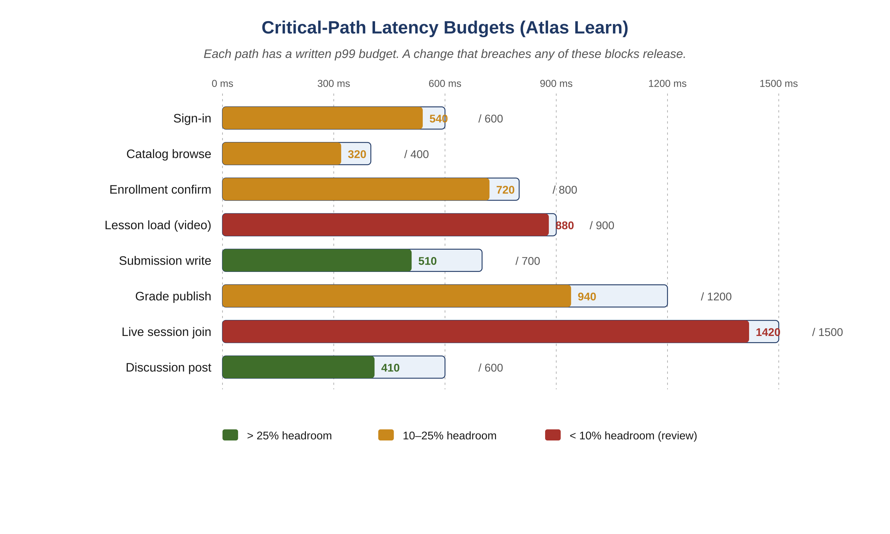
Figure 15.1 — Critical-path latency budgets (Atlas Learn).
Each critical-path operation has documented p50, p95, p99 budgets and an availability target. No change may regress any of these without a written, time-bounded waiver.

15.2 Latency Optimization Patterns
- Reduce external calls on the critical path: aggregate, denormalize for read, push computation to write time.
- Bound work per request: timeouts, max payload sizes, fan-out caps.
- Serve hot paths from caches; design cold-path fallbacks that are still bounded.
- Avoid synchronous waits on best-effort dependencies; fire-and-forget with back-pressure.
- Prefer streaming for large payloads; bound head-of-line latency.

15.3 Persistence Optimization
- Every new query is reviewed: estimated rows, index usage, plan stability, lock profile.
- Indexes are added with written justification; unused indexes are removed.
- Long-running queries are forbidden on the critical path; they go to read replicas or offline jobs.
- Schema migrations follow expand-then-contract patterns; never destructive changes inline with deploys.
- Hot rows are special-cased: sharded counters, optimistic concurrency, or queue-coalesced writes.

15.4 Caching Strategy
Cache Type | Use | TTL Range | Invalidation
Edge / CDN | Static assets, anonymous views | minutes to hours | Versioned URLs, purge on deploy
Application read-through | Hot per-request data | seconds to minutes | Event-driven on writes
Per-request memo | Repeated reads in one request | request lifetime | Automatic
Computed projection | Aggregates, summaries | until next event | Event-driven recompute
Cache hit ratio is observed per cache and per consumer. A drop beyond the agreed band is a release blocker.
Atlas Learn — Caching the catalog without breaking tenant isolation
The Atlas Learn course catalog is one of the most-read endpoints on the platform; the critical-path budget for catalog browse is 400 ms p99. The cache strategy is layered: an edge cache for the anonymous landing pages, an application read-through cache for authenticated browse keyed on (tenant_id, learner_locale, plan_tier), and per-request memoization for repeated reads inside a single request. The constraint that shaped this design is INV-AL-05: a cache key that omits tenant_id is a tenant-isolation violation waiting to happen. Per-tenant keys mean a hit ratio of about 70% rather than the 95% a single global cache would yield, but the higher hit ratio is unsafe at any speed. When the Performance agent reviewed the design, its first finding was that the cache key on the search endpoint had silently dropped tenant_id during a refactor; the budget would have been kept and the invariant would have been broken. Performance and Security review the same artifact for a reason.

15.5 Concurrency Handling
- Hot resources use optimistic concurrency control; conflict responses are deterministic and retry-friendly.
- Long transactions are forbidden on hot rows; coalesce updates via async workers where safe.
- Idempotency keys are required on every mutating endpoint; uniqueness enforced at storage.
- Back-pressure is preferred to dropping; queues bound their depth and shed at well-defined points.

15.6 The Performance Output Format
{
"agent": "Performance",
"task_id": "TSK-1184",
"status": "PASS",
"endpoints": [
{
"name": "POST /invoice/{id}/recompute",
"p50_ms_before": 18, "p50_ms_after": 19,
"p95_ms_before": 42, "p95_ms_after": 44,
"p99_ms_before": 78, "p99_ms_after": 81,
"budget_p99_ms": 120,
"verdict": "WITHIN_BUDGET"
}
],
"queries": [
{ "id": "Q-INV-7", "plan_changed": false, "rows_estimated": 1, "verdict": "OK" }
],
"cache_hit_ratio_delta_pct": -0.2,
"concurrency": { "max_observed_qps": 8400, "errors_pct": 0.0 }
}
Common Pitfall
"We will optimize later." Later does not arrive. Performance debt compounds and is paid in incidents, not refactors.
Reflection
List your critical-path operations. For each, write the p99 budget. If the budget is unwritten, the operation is unbudgeted; if it is unbudgeted, it is uncontrolled.
Exercises
Solutions appear in the companion solutions volume. Try the exercises before consulting them.
1. Define the critical path and explain why it must be enumerated explicitly.
2. Name the four main performance levers (latency, persistence, caching, concurrency) and identify the order in which they typically repay attention.
3. Distinguish p50, p95, and p99 latency. Why does the framework default to p99 budgets rather than averages?
4. For Atlas Learn, identify which two critical paths from Figure 15.1 have the least headroom and explain what would change if a release added 50 ms to each.
5. A team caches catalog browse results to meet a 400 ms p99 budget. The cache key omits tenant_id. Identify the failure that follows and propose a fix that keeps the budget while restoring INV-AL-05.
6. For a system you know, write down the top three critical paths with proposed p99 budgets. If you cannot write the budgets confidently, identify why — the answer reveals a documentation gap, not a performance gap.
7. Argue for or against this claim: "performance is a function of architecture, not of code." Use a worked example where code-level optimization could not have rescued a poor architectural choice.
8. Design a release-blocking rule for performance regressions. Specify the threshold, the exception process, and the audit record that captures any waiver.
9. A new feature requires a synchronous network call inside a critical path that currently completes in 200 ms p99 with 100 ms of headroom. Construct three architectural alternatives that preserve the budget, and identify the trade-off each one carries.
Common Mistakes
Each one looks reasonable in isolation; each one produces a failure mode the chapter argues against.
1. Optimizing average latency rather than tail. A 200ms p50 with a 5-second p99 looks fine in a dashboard that shows the median; the 1% of users hitting the tail experience something close to a broken site. The default is p99 because user-perceived performance lives in the tail.
2. Treating the critical path as everything. If every endpoint is critical, none of them are; the budget gets diluted across operations that don’t actually need it, and operations that do are competing with everything else. Enumerate the critical path explicitly and short.
3. Letting waivers accumulate. A documented waiver for a single regression is a tool. Five waivers on the same path within a quarter is a signal that the budget is wrong, the path is broken, or both — and continuing to issue waivers makes the situation worse, not better.
Key Takeaways
The critical path needs to be enumerated and defended explicitly; if it isn’t written down, it isn’t controlled.
A regression on the critical path should never ship without a written, time-bounded waiver — and the existence of repeated waivers is itself a signal worth investigating.
Latency, persistence, caching, and concurrency are the four main levers, and they generally repay attention in roughly that order.

16. Observability
After this chapter, you will be able to:
• LO 16.1 — Describe the four axes of observability — logs, traces, metrics, agent decision logs — and explain what each one is good for and what it cannot answer alone.
• LO 16.2 — Apply structured logging discipline (mandatory fields, levels, redaction, size budgets) to a service you have written or read.
• LO 16.3 — Identify the canonical fields of an agent decision log and justify why each one is required for postmortem reconstruction.
• LO 16.4 — Distinguish RED metrics (rate, errors, duration) from USE metrics (utilization, saturation, errors) and apply each to the right kind of resource.
• LO 16.5 — Evaluate a release for whether it preserves or improves observability, and decide whether the observability readiness checklist is actually satisfied.
Before reading this chapter
You will get more out of what follows if you are already comfortable with:
• The general idea of structured logging — a log line is a JSON object with named fields rather than a free-form string. Any modern logging library (zap, logrus, structlog, etc.) follows this pattern.
• Distributed tracing as a concept: a request that crosses several services is reconstructed end-to-end through a trace ID that propagates with it. The OpenTelemetry overview is a good thirty-minute introduction.
• Service-level objectives (SLOs) and error budgets — a measurable target plus a budget for falling short. The Google SRE book’s opening chapters are the canonical source; a brief blog-post-length summary is enough.
• A working sense of "p50, p95, p99" latency percentiles. The fact that an average is misleading when the distribution has a long tail is the key intuition.
• Cardinality in metrics — the number of distinct label combinations. The intuition that "log everything" produces an unaffordable cardinality explosion is enough.
A system you cannot observe is a system you cannot operate. Observability has three classical axes — logs, traces, metrics — and a fourth axis specific to AI-driven systems: agent decision logs. Each is mandatory.
Key Idea
Observability ought to ship with the code that produces it. A release that degrades observability — adds endpoints without dashboards, adds metrics without alerts, adds agent invocations without decision logs — is harder to operate even when it is functionally correct, and the cost shows up the first time something behaves unexpectedly in production.

16.1 The Four Axes
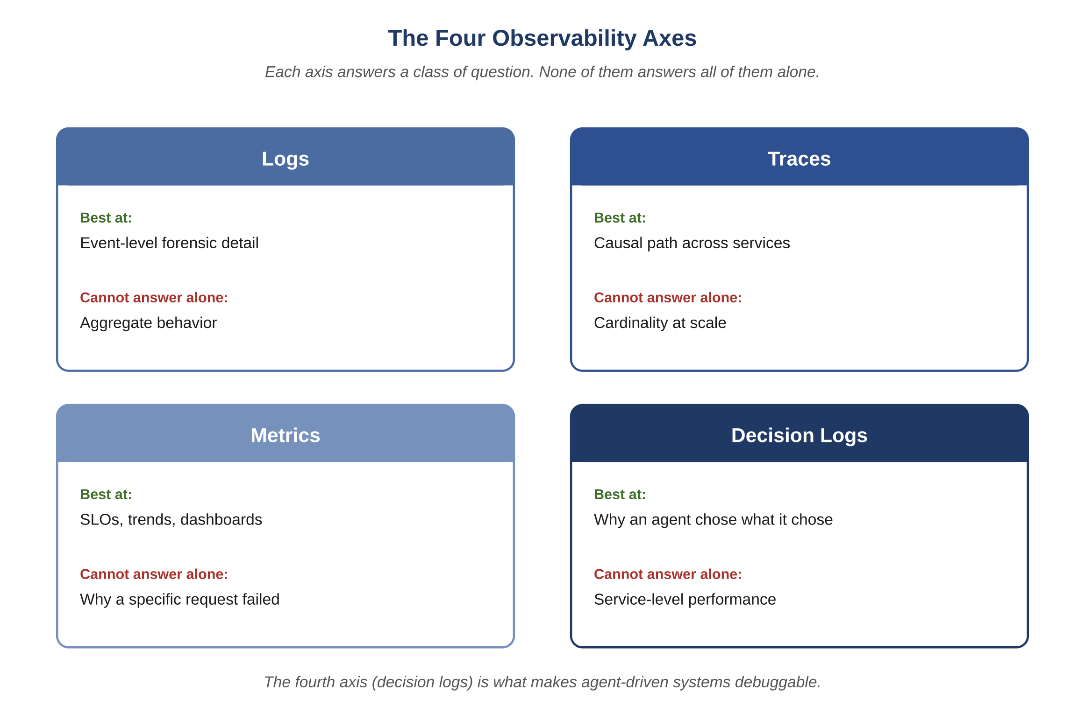
Figure 16.1 — The four observability axes.
Axis | Purpose | Required Per Service / Agent
Logs | Event-level forensic detail. | Structured JSON; correlation IDs; sensitive data redacted; level discipline.
Traces | Causal path across services and queues. | Spans across HTTP, RPC, queue, persistence; baggage carries task ID.
Metrics | Aggregate behavior and SLOs. | Rate / errors / duration per endpoint; utilization / saturation / errors per resource.
Agent decision logs | Why an agent did what it did. | Per invocation: agent, role, prompt ID, context hash, input IDs, output IDs, decision, reason.

16.2 Logging Discipline
- Every log line is structured (JSON) with mandatory fields: timestamp, level, service, environment, request ID, hashed user identifier, correlation ID, message.
- Sensitive data is redacted at the logger; redaction failures are themselves logged.
- Levels are disciplined: ERROR for actionable failures, WARN for degraded behavior, INFO for state transitions, DEBUG only in non-production.
- No log line on the critical path may exceed a documented size or count budget per request.

16.3 Tracing Discipline
- Every external call (HTTP, RPC, queue, persistence) is wrapped in a span with status, duration, and key attributes.
- Trace baggage carries the task ID and correlation ID end-to-end.
- Sample at full rate for errors and high-percentile latency; one to five percent otherwise.
- Spans for AI invocations capture: agent, prompt ID, context hash, tokens in, tokens out, model identifier, verbosity tier.

16.4 The Canonical Agent Decision Log
{
"ts": "2026-04-27T10:14:22.481Z",
"task_id": "TSK-1184",
"agent": "QA",
"role": "qa",
"stage": "test",
"prompt_id": "qa-failure-first-v3",
"context_hash": "sha256:7c6a...",
"input_ids": ["TSK-1184", "INV-031", "DEF-0907", "API-INVOICE-04"],
"output_ids": ["QAS-2210", "QAS-2211", "DEF-0907"],
"decision": "DEFECTS_FOUND",
"reason": "discount not zeroed on SUSPENDED",
"tokens_in": 3812, "tokens_out": 1402,
"duration_ms": 4180,
"model": "<vendor-and-version>",
"verbosity_tier": 3
}
Atlas Learn — What the seat-fix decision log carries
The Auditor’s decision log entry for TSK-AL-201 has the same shape as the example above, populated with Atlas Learn identifiers. task_id is TSK-AL-201; agent is Auditor; stage is design.review; input_ids include the design draft DSG-AL-3a, the prior defect DEF-AL-0418, and the invariant IDs INV-AL-01 and INV-AL-06; output_ids include the approval record APR-AL-3a; decision is APPROVE; reason is "atomic decrement guarded by per-section idempotency key satisfies INV-AL-01 and preserves INV-AL-06." The context_hash is the cryptographic hash of the assembled context pack, so a future investigator can confirm the agent saw exactly what we think it saw — even years later, even after the underlying memory artifacts have moved through several schema versions. Reproducibility of past decisions is what the fourth observability axis buys; the other three cannot answer "why did the agent decide this" at all.

16.5 Metrics
- RED per endpoint: rate, errors, duration percentiles.
- USE per resource: utilization, saturation, errors (CPU, memory, disk, network, connection pool).
- Business metrics: domain-specific outcomes that humans care about.
- Agent metrics: invocations per agent, tokens per agent, defect-find rate per QA invocation, audit revise rate per Architect invocation.
- SLO dashboards: budget remaining, burn rate, exhaustion ETA.

16.6 Observability Readiness Checklist
- Dashboards updated for any new endpoint or metric.
- Alerts configured at SLO burn-rate thresholds (fast and slow).
- Runbook linked from each alert with owner, severity, mitigation, and verification steps.
- Synthetic checks for the canary cohort.
- Trace coverage on every external call introduced.
- Sensitive-data redaction verified in logs.

16.7 Why the Fourth Axis Matters
In a traditional system, "why did this happen" is answered from logs and traces. In an AI-Driven SDLC, an additional question arises: "why did the agent decide this?" The decision log answers it. Without the decision log, postmortems on agent decisions become guesswork.
Example
A content moderation system silently changes its tolerance for borderline cases. Users notice; complaints rise. The traditional logs show the same code path executing the same way. The decision logs reveal that a prompt update changed the agent’s reasoning style; the rollback is a one-line version pin, identified within minutes.
Common Pitfall
Trusting "the model probably did the right thing" because the surface metrics look fine. Without decision logs, you have surface metrics and faith. Faith is not an operational strategy.
Reflection
For a recent agent-driven change, ask: could you reconstruct, from records alone, the prompt, context, and reasoning that produced the change? If no, your fourth axis is not yet in place.
Exercises
Solutions appear in the companion solutions volume. Try the exercises before consulting them.
1. Name the four observability axes and identify what each one is best at and what it cannot answer alone.
2. List the canonical fields of an agent decision log and explain why context_hash is essential for replay.
3. Distinguish RED metrics (rate, errors, duration) from USE metrics (utilization, saturation, errors). For which kinds of resources does each apply?
4. Walk through a postmortem for the duplicate-grade vignette using only the four axes. Identify which axis answered which question.
5. For Atlas Learn’s seat-fix decision log entry, identify what would be lost if the context_hash field were dropped, and what would be lost if input_ids were dropped.
6. A team’s metrics dashboards look healthy but specific incidents take days to debug. Identify which axis is likely under-developed and propose three concrete additions.
7. Argue that a system without the fourth axis (decision logs) cannot be honestly called debuggable when agents are involved. Identify two failure modes that the first three axes alone cannot diagnose.
8. Design an observability readiness checklist for a release. Cover all four axes, plus PII redaction, log retention, and trace sampling. State what blocks release if missing.
9. A teammate proposes "log everything" to be safe. Identify three operational costs of this strategy (cardinality, storage, signal-to-noise) and propose a discipline that captures the safety without the costs.
Common Mistakes
Each one looks reasonable in isolation; each one produces a failure mode the chapter argues against.
1. Treating decision logs as ordinary application logs. Decision logs have their own schema, their own retention, and their own query path. Mixing them into application log streams produces data that exists but is operationally unreachable; the question "why did the agent decide this" remains unanswerable.
2. Logging everything for safety. High-cardinality fields (user IDs, request IDs as part of metric labels) explode dashboard cost; verbose logs drown the signal in noise; full traces sampled at 100% are unaffordable at scale. The discipline is high signal, not high volume.
3. Adding observability after the incident. Observability instrumented during postmortem is observability that wasn’t there when it was needed. Each new endpoint, each new agent, each new memory artifact gets its observability instrumented at design time, not in the panic of the next investigation.
Key Takeaways
The four axes of observability are logs, traces, metrics, and agent decision logs.
Each release should preserve or improve them; treating observability as follow-up work is one of the more common ways operability quietly degrades.
The fourth axis — agent decision logs — is what separates a debuggable agentic system from one where production behavior is reconstructed by guesswork.

PART V
Operating the System
Vocabulary for Part V — Operating the System
A short refresher on the terms used most often in the chapters that follow. Full definitions remain in the glossary at the back of the book; these short forms are meant to anchor the reader before diving in.
• Failure class. One of the five recurring failure categories: agent, output, context, dependency, operational; each with its own detection and escalation.
• Bounded retry. A retry policy capped in count and budget, with explicit escalation when the cap is reached.
• Cost components. The four moving parts of operating cost in an AI-driven system: model, infrastructure, human oversight, and the cost of failures that reach production.
• Maturity level. One of five stages — ad hoc, shared practice, codified, federated, adaptive — describing how disciplined a team’s use of the framework has become.
• Adoption path. The recommended sequence for landing the disciplines, ordered so each step unlocks the next without trying to land the whole framework at once.
• Domain skeleton. The structure that recurs across domains — invariants, concurrency profile, failure modes, federated flow — with the specifics filled in per domain.

17. Failure and Recovery
After this chapter, you will be able to:
• LO 17.1 — Identify the five recurring classes of failure (agent, output, context, dependency, operational) and the detection mechanism appropriate to each.
• LO 17.2 — Apply bounded-retry discipline with explicit escalation, distinguishing it from indefinite retry and from immediate human escalation.
• LO 17.3 — Trace a partial-execution recovery scenario through the tracker and explain why idempotent stages make resumption safe.
• LO 17.4 — Construct a failure-handling table for a real workflow, mapping each detected condition to its automatic action and escalation rule.
• LO 17.5 — Evaluate a past incident in your organization and identify which failure class went unhandled and which discipline would have detected or recovered from it.
Failures are not exceptions; they are the steady state of distributed systems. The system is designed to fail in well-known ways and recover deterministically.
Key Idea
Asking how a system fails is a different exercise from describing how it works, and skipping it produces software that operates fine until it doesn’t. The places where the failure-mode question wasn’t asked tend to map closely to the places where outages eventually originate.

17.1 Classes of Failure
- Agent failure: model error, timeout, malformed output, refusal.
- Output failure: agent returned a result that violates a constraint.
- Context failure: required context missing, stale, or corrupted.
- External dependency failure: an upstream provider is unavailable, slow, or wrong.
- Operational failure: deployment failed, canary regressed, rollback required.

17.2 Agent Failure Handling
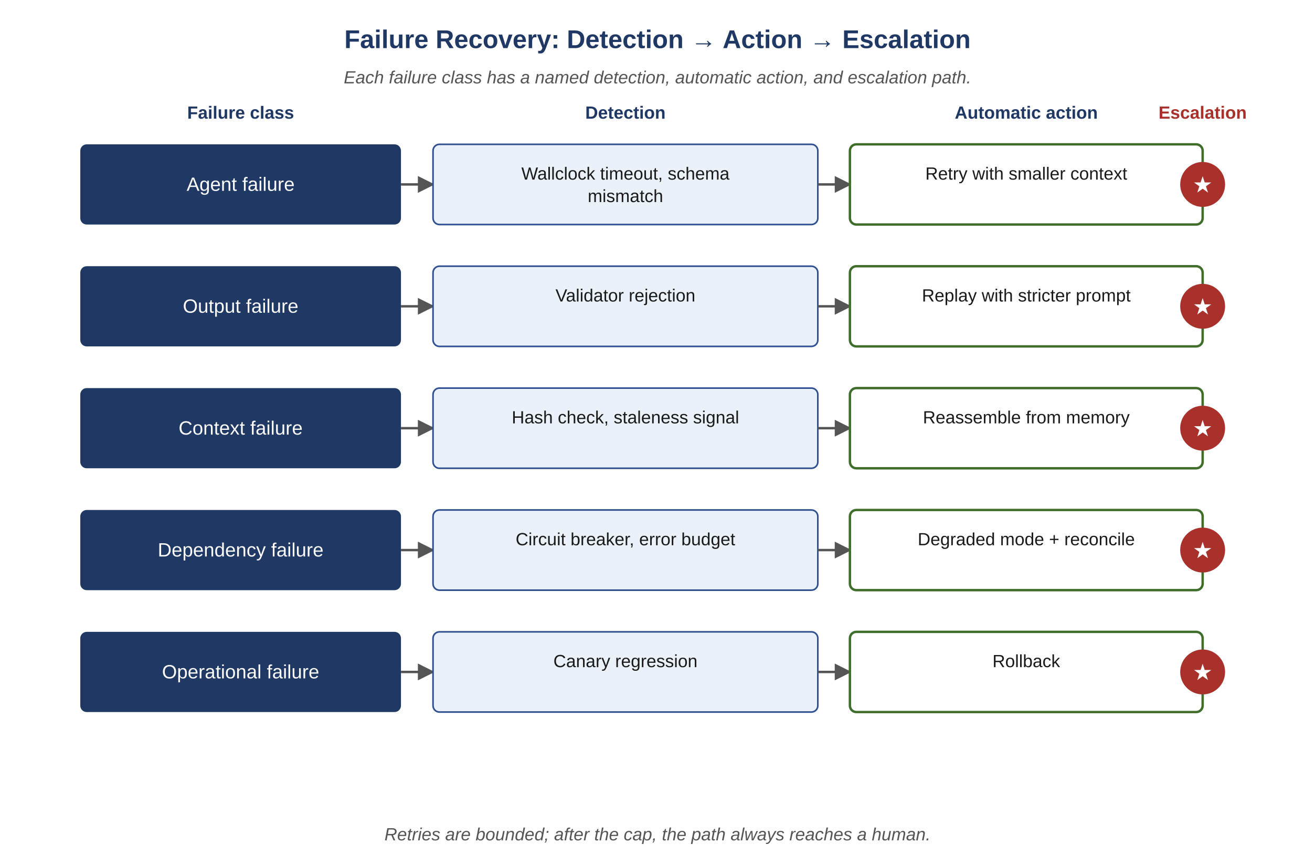
Figure 17.1 — Failure recovery: detection, action, escalation.
Failure | Detection | Action | Escalation
Timeout | Hard wallclock per invocation | Retry with smaller context (Tier-1 verbosity) | After two retries -> human
Malformed output | Schema validation | Reject; replay with stricter prompt | After two replays -> human
Refusal / safety stop | Refusal classifier | Halt; route to human | Always
Repeated revise loop | Counter on Auditor verdicts | Escalate to human after three revises | Always

17.3 Bad Output Rejection
- Every agent output is validated against a structural schema before consumption.
- Outputs that pass structure but fail semantic checks (a Developer diff that touches files outside scope) are rejected with a precise error and replayed.
- Replay is bounded: maximum two attempts. Beyond that, the controller escalates.

17.4 Retry Strategy
- Retries are idempotent at the controller: a replayed invocation does not create a duplicate tracker entry; it appends a retry event.
- Backoff is exponential with jitter, capped at the budget for the task.
- Retries narrow the problem: smaller context, stricter prompt, explicit guidance from the prior failure.

17.5 Context Recovery
- Context is content-addressed by hash; corruption is detectable.
- On any context-corruption signal, the controller halts the affected task and reassembles from the System Memory Layer.
- Stale context is invalidated automatically when a referenced identifier has been superseded; affected tasks re-enter the loop at Validate or earlier.

17.6 Partial Execution Continuation
Tasks are event-sourced. If the controller restarts mid-task, the next invocation is computed from the tracker state — not from scratch.
- Stage outputs are committed to memory before the next stage starts.
- Restart logic reads the tracker, finds the last-committed stage, resumes from the next.
- Idempotent stage execution: re-running a committed stage is a no-op.

17.7 Operational Failures
- Canary regression: the Release Governor halts promotion; rollback triggers automatically based on declared rules.
- Deployment failure: the previous version is held; release is marked failed in the tracker; postmortem auto-opened.
- External dependency outage: circuit breakers open; degraded mode is announced via runbook; metrics drive auto-recovery.

17.8 Worked Failure Scenarios

17.8.1 Out-of-Scope Edit
- Validator detects an edit outside declared scope.
- Output rejected with a code (OUT_OF_SCOPE_EDIT).
- Controller replays Developer with explicit scope reminder and the offending paths to exclude.
- A second failure escalates to a human with full context.

17.8.2 Provider Storm
- Rate-limit triggers; queue back-pressure absorbs spikes.
- Duplicate events deduplicated by event ID; signature-failed events logged and dropped.
- Reconciliation reduces drift on the next cycle.
- On-call notified only if drift exceeds threshold beyond the SLO window.

17.8.3 Unreproducible Defect
- QA halts and emits an UNREPRODUCIBLE finding with seed, environment, and observed timing.
- Controller routes to human triage; the defect is not silently closed.
- If reproduced manually, the seed and environment become a permanent test case.
Atlas Learn — A live session over-admits at peak
On Atlas Learn, INV-AL-07 holds that a live session never accepts more concurrent participants than its declared capacity. During a peak study hour the failure mode "live session over-admits at peak" fires: a popular section’s live session admits 304 participants against a declared cap of 300, briefly. The detection is a metric-derived signal: live_session.participant_count exceeds capacity within an SLO window. The automatic action is a graceful admission halt: the session’s join endpoint returns a stable retry-after response while the participant count drains naturally; meanwhile the reconciliation reduces the count to capacity by treating the four most-recently-admitted as held in a waiting state. No participant is ejected mid-session. The escalation: if the admission halt does not reduce the count below capacity within the next minute, the on-call instructor and the platform on-call are paged. The postmortem traces the over-admission to a missed cache invalidation on the capacity check; the fix is a smaller invalidation window plus a pessimistic count check that confirms capacity at storage rather than at cache. The pattern is the framework operating as designed: detection, automatic action, escalation, recovery, fix.

17.9 Recovery Is Engineered, Not Improvised
Every failure mode has a named class, a detection mechanism, an automatic action, and an escalation path. Improvisation in recovery is the source of secondary incidents — the situation where the cure is worse than the disease. The discipline of pre-planned recovery is what keeps incident timelines short.
Common Pitfall
Treating retries as the recovery strategy. Retries are a tactic; recovery is a strategy. A system whose entire response to failure is retry will retry past the moment when retrying is harmful.
Reflection
For a past incident, sketch the failure tree: what failed, what detected it, what was the automatic response, what triggered escalation, what was the human action, what was the verification. Empty cells in the tree are your highest-priority improvements.
Exercises
Solutions appear in the companion solutions volume. Try the exercises before consulting them.
1. Name the five classes of failure (agent, output, context, dependency, operational) and give a one-line example of each.
2. List the four properties that make session resumption safe after a controller restart.
3. Define bounded retry and explain why "two attempts then a human" is preferable to indefinite retries.
4. For Atlas Learn’s live-session over-admit scenario, identify which class of failure it is, what the detection signal was, and what the automatic action accomplished.
5. A teammate proposes setting the retry count to ten "to give the system more chances to recover." Refute the proposal in three sentences using the framework’s discipline on bounded retries.
6. For a system you know, list the top three operational failures you have seen in the last year. For each, identify whether the framework’s detection / action / escalation pattern would have changed the outcome.
7. Argue that recovery should be designed in advance rather than improvised during an incident. Identify two classes of secondary incident that improvisation typically produces.
8. Design the failure tree for a critical-path operation in a system you know. Specify each cell: failure, detection, automatic response, escalation trigger, human action, verification.
9. A team’s incident response is fast but its postmortems consistently fail to identify root cause. Identify which property of the framework is missing and propose the minimum addition that would fix it.
Common Mistakes
Each one looks reasonable in isolation; each one produces a failure mode the chapter argues against.
1. Improvising recovery during an incident. Incidents are the worst possible time to design recovery: incomplete information, time pressure, partial state, ad hoc decisions. Improvised recovery typically produces a secondary incident; recovery designed in advance, even imperfectly, holds up better.
2. Treating bounded retries as a bug to be removed. "Why does the system give up after only two retries? It should keep trying!" The bound is not a bug; it is the discipline that surfaces real failures rather than absorbing them as cost runaways. A team that "fixes" the bound has chosen to make every transient failure invisible.
3. Closing tickets without a postmortem when retries fix them. Three tickets in a week with the pattern "retries make it work" is the seat-overrun bug’s exact early signature. A team that closes each individually has chosen not to investigate the structural cause; the discipline is to escalate the pattern when the count exceeds a threshold.
Key Takeaways
There are five recurring classes of failure — agent, output, context, dependency, operational — and each needs its own detection, automatic action, and escalation rule.
Recovery works best when it is designed in advance; improvising during an incident tends to produce secondary incidents.
The tracker is what makes resumption possible; the controller bounds retries before they become a cost runaway; the Validator catches the cross-artifact problems no single agent would notice.

18. Cost Economics of Agent Systems
After this chapter, you will be able to:
• LO 18.1 — Identify the four cost components — model, infrastructure, human, failure — and explain how each one rises or falls in response to specific operational decisions.
• LO 18.2 — Compute end-to-end cost per task type rather than unit cost per token, and distinguish optimization that lowers total cost from optimization that simply moves cost between components.
• LO 18.3 — Recognize the three common cost anti-patterns (cheaper model to save money, more context to reduce errors, fewer humans to scale) and predict the indirect cost each one creates.
• LO 18.4 — Apply cost telemetry to identify which agent or stage is the largest contributor to runaway cost and design a budget enforcement strategy.
• LO 18.5 — Evaluate the long-run cost curve of a team that adopts the disciplines versus one that skips them, and explain the shape of each curve.
Traditional engineering cost models center on people: salaries, benefits, overhead per engineer. AI-driven systems shift the cost surface. Some costs disappear; new costs appear; old costs change shape. Understanding the new economics is necessary to operate the system without surprises.
Key Idea
There are four cost components in play: the model itself, the supporting infrastructure, the humans approving and reviewing, and the cost of failures that reach production. They interact, sometimes adversarially. Driving down one without watching the others — for example, switching to a cheaper model and absorbing more retries — usually produces no net saving and sometimes raises the bill.

18.1 The Four Cost Components
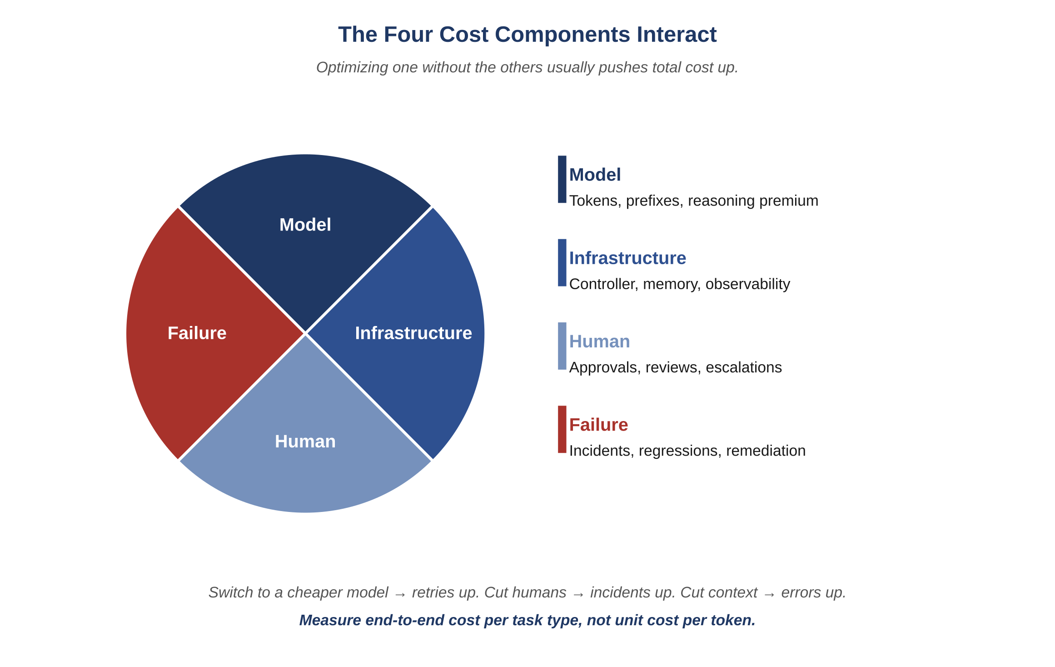
Figure 18.1 — The four cost components.

18.1.1 Model Cost
The direct cost of agent invocations: tokens in, tokens out, cached prefixes, and any reasoning-time premium. This is the most visible cost and the easiest to track per task.

18.1.2 Infrastructure Cost
The cost of the controller, memory, observability, and supporting services. Often modest per task but with steep ramps as throughput grows.

18.1.3 Human Cost
The cost of human approvals, reviews, escalations, and oversight. In a well-designed system this is the smallest direct cost. In a poorly designed system it is the largest because every failure becomes a human escalation.

18.1.4 Failure Cost
The cost of incidents, regressions, customer trust loss, and remediation. Often invisible until it dominates. The leading indicator is escalation frequency; the lagging indicator is incident count.

18.2 The Cost Equation
Total cost per task =
model_cost(tokens_in, tokens_out, cached, reasoning)
+ infra_cost(controller, memory, observability)
+ human_cost(approvals + escalations + reviews)
+ failure_cost(probability_of_incident * incident_cost)
Each term reduces in different ways:
Term | Reduces When | Increases When
Model | Context shrinks; prompts compress; deltas replace inlining. | Context bloats; verbose prose; whole-file pasting.
Infrastructure | Memory artifacts are clean; observability is in place; budgets enforced. | Memory rots; observability is reactive; budgets unenforced.
Human | Governance is well-tuned; escalations are rare; approvals are batched. | Audit fatigue; constant human approvals; ad hoc decisions.
Failure | Failure-first QA; engineered recovery; canary discipline. | Skipped stages; happy-path-only tests; manual recoveries.
Atlas Learn — Cost components measured for one Atlas Learn release cycle
A representative two-week release cycle on Atlas Learn looks roughly like this when the four components are tracked end-to-end. Model cost runs about 38% of total: agent invocations across the eight roles, with the Architect and Auditor being the largest individual contributors because they reason over more context. Infrastructure runs about 22%: controller, memory store, observability pipeline. Human cost runs about 28%: instructor reviews, security sign-offs on the meta-surface, and the approvals required by INV-AL-10. Failure cost runs about 12%: the cycle had two minor canary regressions that triggered rollback rehearsals, plus the cleanup from an INV-AL-09 near-miss (PII almost reached a non-production environment). The interesting observation is what happened the previous quarter: the team experimented with a cheaper model for the Auditor role, dropped model cost by 9 percentage points, and the failure cost rose by 11 because the cheaper Auditor missed a class of contract inconsistency. Net cost per release went up. They reverted. The lesson is in the equation, not in any one term.

18.3 Cost Anti-Patterns
Common Pitfall
"Switch to a cheaper model to save money." The cheaper model can produce more retries, more revises, more escalations, and more failure-induced cost than the savings on tokens. Measure end-to-end cost, not unit cost.
Common Pitfall
"Increase context to reduce errors." More context is more expensive and often less accurate. Measure both errors and cost; the optimum is rarely "as much context as fits."
Common Pitfall
"Eliminate human approvals to scale." Removing humans does not remove the work; it moves it to cleanup after incidents. Tune human approvals; do not eliminate them.

18.4 Cost Telemetry
A mature system tracks at least:
- Tokens in, tokens out, and cost per task type and per agent.
- Median and p99 cost per stage.
- Retry rate per agent.
- Escalation rate per stage.
- Time-to-completion distribution per task type.
- Cost per defect found in QA versus cost per defect found in production. (The first is far cheaper. The ratio is the value of the QA stage.)

18.5 Setting Budgets That Stick
Budgets work when they are visible and enforced, not when they are aspirational.
- Set per-task budgets at the controller. The controller refuses invocations that would exceed.
- Set per-day or per-week budgets at the agent role. Track burn rate.
- Alert on burn-rate anomalies, not absolute thresholds. A spike that does not deplete the budget is signal worth investigating.
- Review budget breaches in postmortems. The breach is itself a defect.

18.6 The Long-Run Cost Curve
A well-operated AI-Driven SDLC exhibits a particular cost shape: high initial investment to build the disciplines, declining cost per task as the disciplines mature, and a long flat tail. A poorly operated one has the opposite shape: low initial investment, growing cost per task as anti-patterns accumulate, and a sharp upward curve when failures begin to dominate.
Example
Consider two teams. Team A invests in a tracker, prompt library, and validator from day one. Their first month is expensive in setup but their per-task cost drops by half by month three and stabilizes. Team B starts shipping immediately without those disciplines. Their first month is cheap; their fourth month is consumed entirely by incident response.
Reflection
Compute, for one week of agent activity, the four cost components. The exercise is uncomfortable on first attempt because the failure-cost component is hard to estimate. The discomfort is itself a finding.
Exercises
Solutions appear in the companion solutions volume. Try the exercises before consulting them.
1. Name the four cost components (model, infrastructure, human, failure) and give one example of each.
2. State the cost equation in your own words and identify why end-to-end cost matters more than unit cost per token.
3. List three cost anti-patterns named in this chapter.
4. Walk through the Atlas Learn release-cycle vignette: report the percentage breakdown of the four components and identify which substitution attempt failed and why.
5. A team reports model cost at 60% of total and proposes switching to a cheaper model. Identify two specific cost-component shifts you would expect and how to measure them before committing.
6. For one week of work in a system you know (or can imagine concretely), estimate the four components qualitatively (high / medium / low). Identify which component is hardest to estimate and why.
7. Argue that the failure-cost component is the most important to track even though it is the hardest to estimate. Use a worked example where ignoring it produced a misleading total.
8. Design a cost-telemetry dashboard for a small team. Specify which numbers to capture per invocation, which per agent, and which per release. Identify one threshold per metric that should trigger investigation.
9. A leadership team is shown only model cost in monthly reviews. Predict three classes of decisions this team will make incorrectly because of the missing components, and propose what to add.
Common Mistakes
Each one looks reasonable in isolation; each one produces a failure mode the chapter argues against.
1. Switching to a cheaper model based on unit cost alone. A 30% drop in unit cost can be wiped out twice over by an increase in retries, escalations, and failures the cheaper model produces. The discipline is to measure end-to-end cost per task, not unit cost per token.
2. Hiding failure cost in the on-call rotation budget. When the cost of incidents shows up only as engineer time, leadership sees model and infrastructure costs falling and concludes the team is doing well. Failure cost belongs in the cost dashboard alongside the other three components; absorbing it elsewhere produces decisions that look right and aren’t.
3. Treating model cost as the whole cost story. The model line is the one that comes with a vendor invoice, so it’s the easiest to see. The other three (infrastructure, human, failure) are usually larger combined and almost always more strategic. A team that optimizes only the line on the invoice is optimizing the wrong number.
Key Takeaways
Four cost components — model, infrastructure, human oversight, and failure — together set the actual operating cost.
Optimizing one of them in isolation tends to push the others up; the right unit of measurement is end-to-end cost per task, not unit cost.
The disciplines in this book front-load investment and pay back across the long tail; teams that skip them get a cheap first quarter and an expensive fourth.

19. Maturity Model and Adoption Path
After this chapter, you will be able to:
• LO 19.1 — Describe the five maturity levels — ad hoc, shared practice, codified, federated, adaptive — and the symptoms typical of each.
• LO 19.2 — Locate a team you know on the maturity ladder honestly, citing the disciplines they can and cannot yet skip.
• LO 19.3 — Apply the suggested adoption path to plan the next single discipline a Level-2 or Level-3 team should adopt to move up.
• LO 19.4 — Distinguish the signs of healthy maturation from the signs of ritualized maturation, and recognize when a discipline has decayed into ceremony.
• LO 19.5 — Evaluate three common adoption anti-patterns (everything at once, tools first, lift-and-shift) and propose mitigations for each.
A team adopting this framework will not get to the end state in a single quarter, and it should not try. The five-level model in this chapter is the recognition that adoption is a sequence: each level builds on the last, and skipping levels produces the kind of theatre where teams have the artefacts of discipline without the practice. The honest read is that most teams who try to adopt the entire framework at once arrive at a worse place than teams that adopt it slowly.
The chapter's other purpose is to give a team a map of where it currently is. The five levels are diagnostic, not aspirational; the question "what level are we at?" is meant to be answered by looking at what the team actually does under stress, not at what it intends to do when the schedule clears.
A team does not arrive at a fully-disciplined AI-Driven SDLC in a single quarter. The framework is too large to adopt at once and too valuable to skip. This section defines a five-level maturity model and a recommended adoption path. It is a roadmap, not a prescription — paths vary, but the destination is the same.
Key Idea
Counting the tools a team has adopted is a poor measure of maturity. A more useful one is the set of disciplines that have become non-negotiable — the things the team would not skip even under deadline pressure, because they have been bitten by skipping them before.

19.1 The Five Levels
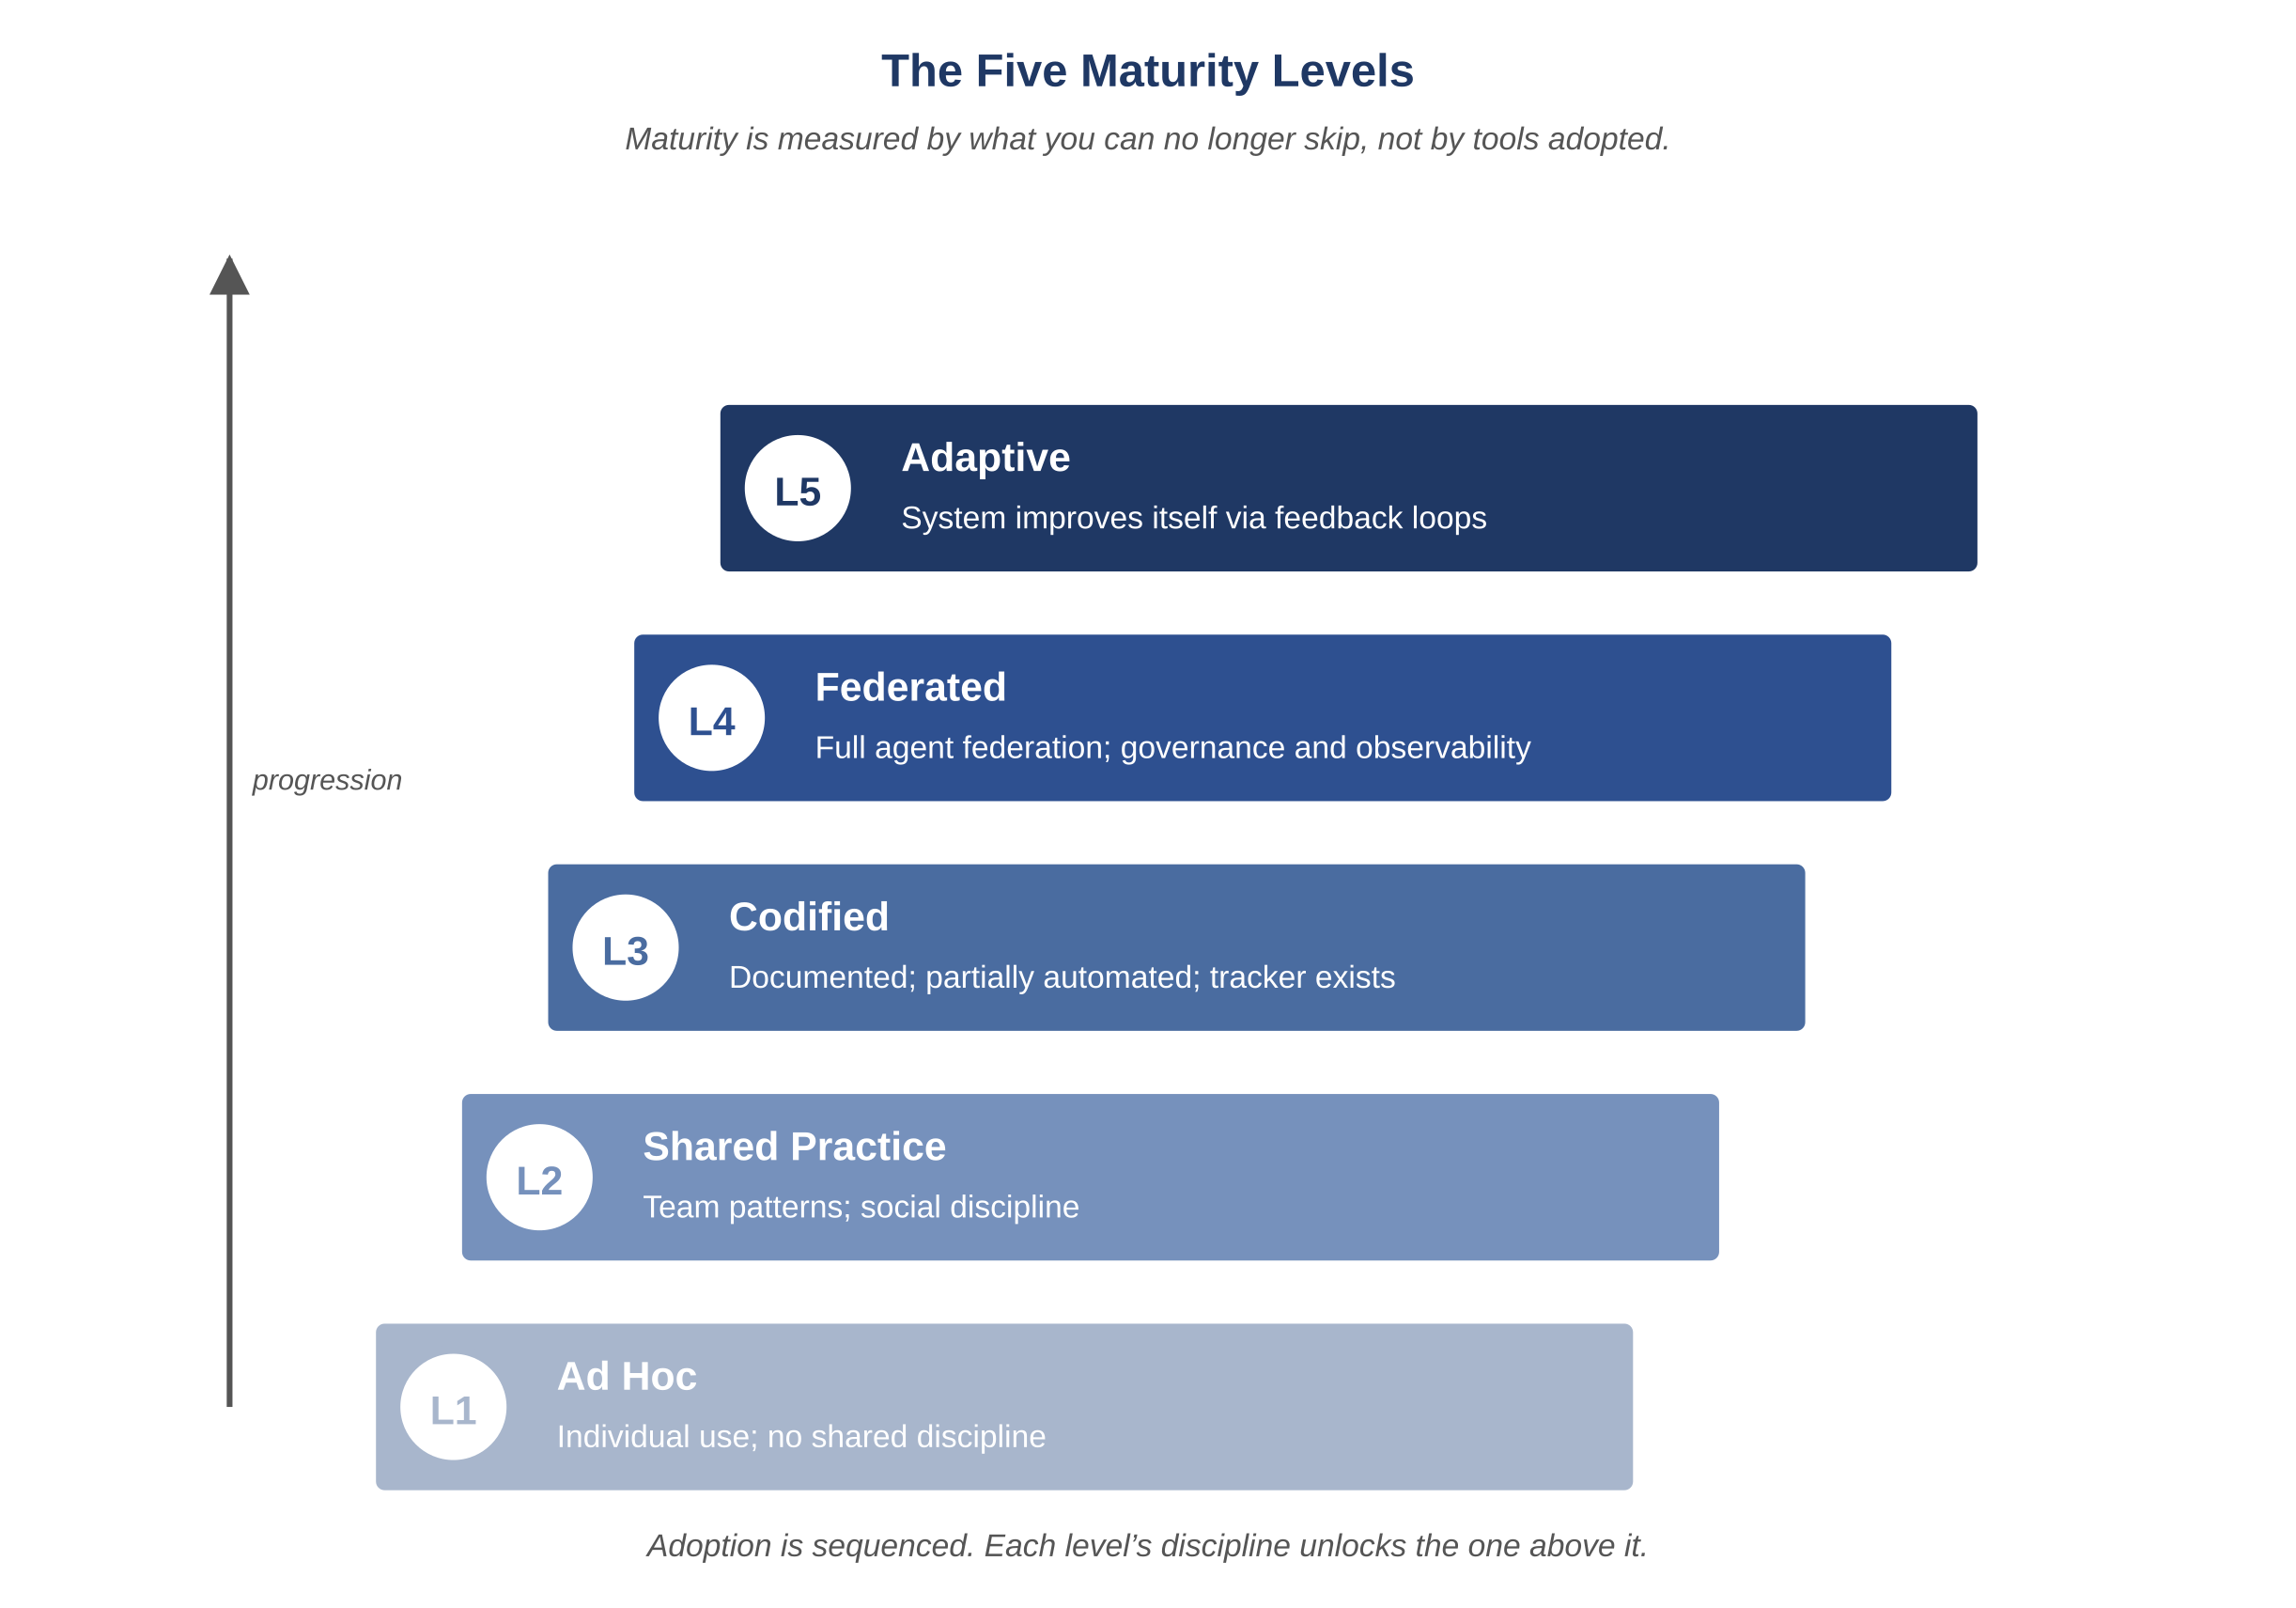
Figure 19.1 — The five maturity levels.

19.1.1 Level 1: Ad Hoc
Description: AI agents are used opportunistically by individual engineers; no shared discipline, no shared memory.
Symptoms: Inconsistent quality; prompts pasted from chat windows; outputs lost when sessions close; no audit trail.
Risk: High variance; correctness depends on the engineer using the tool; non-reproducible outcomes.

19.1.2 Level 2: Shared Practice
Description: A team agrees on a small set of patterns: a prompt template, a code-review checklist, a place to record decisions.
Symptoms: Quality is more uniform; some artifacts are reused; the team starts noticing recurrent failure modes.
Risk: Discipline is social, not enforced; under deadline pressure it erodes.

19.1.3 Level 3: Codified
Description: Disciplines are documented and partially automated. A tracker exists. A prompt library exists. Approval gates exist.
Symptoms: Audit becomes possible; postmortems become tractable; per-task cost is visible.
Risk: Discipline is uneven across the team; some agents are well-instrumented and others are not.

19.1.4 Level 4: Federated
Description: The full federation is in place: specialist agents, controller-mediated workflow, governance gates, observability across four axes.
Symptoms: Most defects are caught before release; incidents are short and well-reconstructed; per-task cost is stable.
Risk: Process complexity outpaces team understanding; new joiners need orientation; tooling drift is a real concern.

19.1.5 Level 5: Adaptive
Description: The system improves itself. Defects feed back into prompts. Performance regressions feed back into tests. Failure patterns feed back into governance rules. Maturity becomes self-reinforcing.
Symptoms: Year-over-year defect rate declines; cost per task declines; time-to-recovery declines.
Risk: Complacency. The system feels reliable; disciplines start to be questioned. The remedy is the same: read the principles again.

19.2 A Suggested Adoption Path
Most teams should adopt the disciplines roughly in this order. Earlier items unlock later ones; skipping early items makes later ones unstable.
- Establish the canonical memory artifacts: design, invariants, contracts, schema. Without these, no agent can be evaluated.
- Establish a prompt template and a small prompt library. Use it for one agent role first — typically the Developer or QA role.
- Add the tracker. Even a simple append-only log of agent invocations is enough to begin.
- Add the Auditor role. Pass every Developer output through it before merge.
- Add explicit approval gates for releases. Even one gate — human approval before promotion — changes the discipline.
- Add observability axes one at a time: metrics, then traces, then decision logs.
- Add the Validator role. Use it to catch cross-artifact mismatches before release.
- Add the remaining specialist agents (Security, Performance, Release Governor) as the volume of work justifies.
- Establish budgets and cost telemetry. Make the four cost components visible.
- Begin failure-first QA: every invariant has a guarding test.
- Move to canary discipline: every release rolls out gradually with rollback rehearsed.
- Begin the adaptive loop: defects, regressions, and incidents feed back into prompts, tests, and governance.
Atlas Learn — Where Atlas Learn sits, and what blocks the next step
A snapshot of Atlas Learn against the maturity ladder: it is solidly at Level 4 (Federated). All eight agent roles exist; the controller is in place; the memory artifacts are versioned; the tracker captures every invocation; six observability axes are operational; the four cost components are tracked per release. What blocks Level 5 is not tooling — it is the adaptive loop itself. Defects do not yet feed back into the prompt library automatically; each correction is manual. Performance regressions do not yet propose new tests automatically. The team is consciously holding at Level 4 because the adaptive loop introduces a new failure mode (the system optimizing itself toward the wrong objective) that they are not yet ready to govern. The honest assessment is the right call: Level 5 is unlocked by infrastructure plus a governance pattern for self-modification, and the latter is harder than it sounds.

19.3 Adoption Anti-Patterns
Common Pitfall
"Adopt everything in the first quarter." The framework is large; adopting it all at once produces a system nobody understands. Take the steps in order; let each settle.
Common Pitfall
"Tools first, discipline later." A tracker without a discipline is a database. A discipline without a tracker is a meeting. Both must be present.
Common Pitfall
"Lift-and-shift from another team’s setup." The tools transfer; the disciplines do not. A copied prompt library that nobody owns rots within a quarter.

19.4 Signs of Healthy Maturation
- New joiners can read the tracker and understand a task without asking anyone.
- Defects are increasingly found before release rather than after.
- Postmortems take hours rather than weeks.
- Cost per task is flat or declining despite growing scope.
- When a discipline is questioned, the answer is not "because that’s how we do it" but "because this past incident showed us why."
Reflection
Place your team on the five-level scale honestly. Identify the next single discipline you would adopt to move up. Resist the temptation to identify three; one well-adopted is worth three half-adopted.
Exercises
Solutions appear in the companion solutions volume. Try the exercises before consulting them.
1. Name the five maturity levels in order and give a one-sentence definition of each.
2. Identify the discipline that distinguishes Level 3 (Codified) from Level 2 (Shared Practice).
3. List three adoption anti-patterns named in this chapter.
4. For Atlas Learn as described in the case-study vignette, identify the level it occupies and the specific concern that blocks the next level.
5. A team has a tracker and a prompt library but no role isolation between Architect and Developer. Identify which level it is at and which discipline it lacks for the next.
6. Take a software team you know (your own or one from a published case study). Place it on the ladder honestly and identify what it would have to stop tolerating to advance.
7. Argue against this claim: "we should aim straight for Level 5 because the foundations are obvious." Identify three failure modes that skipping levels produces.
8. Design a six-month adoption plan for a team currently at Level 1. Specify which disciplines land in months 1–2, 3–4, and 5–6, and justify the sequencing.
9. A team reports being "Level 4 across all disciplines." Construct three diagnostic questions whose honest answers usually reveal that the team is mixing levels (e.g., Level 4 on tracker discipline but Level 2 on cost telemetry). Explain why mixed-level teams are common.
Common Mistakes
Each one looks reasonable in isolation; each one produces a failure mode the chapter argues against.
1. Adopting all five levels in one quarter. Big-bang adoption produces partial completion of every discipline, none of them fully landed. The phases exist because each one’s output is the next one’s input; trying to do them in parallel produces a process nobody owns.
2. Buying the tooling before doing the discipline. A dashboard, a tracker product, a prompt-management tool — each one is helpful when the discipline underneath is solid. Adopting the tooling first produces shelves of products that the team has not yet learned to use; the discipline arrives later, if at all.
3. Calling yourself Level 4 because the artifacts exist. A team that has a tracker, a prompt library, an Auditor role, and observability is structurally at Level 3 or Level 4 — but only if the disciplines are practiced reflexively. Mixed-level teams are common: Level 4 on tracker, Level 2 on cost telemetry, Level 1 on failure simulation. Self-assessment that picks the highest discipline and calls it the team’s level overstates maturity.
Key Takeaways
The five maturity levels — ad hoc, shared practice, codified, federated, adaptive — describe a path most teams travel in roughly that order.
Adoption needs to be sequenced; trying to land the whole framework at once produces a process nobody owns.
The most reliable indicator of progress is what the team has stopped being willing to skip, not what new tools have been added to the stack.

Bridge — Project Planning and Estimation
Most software engineering textbooks treat estimation and planning as topics in their own right, with chapters on cone-of-uncertainty curves, three-point estimates, story points, and the planning fallacy. The earlier parts of this book have not. The framework so far is mostly about what happens during the work, not about how the work is scheduled and committed to. This bridge fills that gap. It is short because the scheduling discipline does not change much because of AI agents — most of what software engineers know about planning still applies — but it is included because students are asked about it in their first job, and the framework has specific things to add to the standard treatment.
The chapter sits in Part V (Operating the System), between Maturity (Ch 19) and Domain Application Patterns (Ch 20). The placement is intentional: a reader who has the team-level maturity frame can think honestly about how planning happens in their actual team, before generalizing to other domains.
After this chapter, you will be able to:
• LO F.1 — Distinguish estimation, planning, and tracking, and identify which question each one answers.
• LO F.2 — Apply analogous, parametric, and three-point estimation techniques to a real change, and recognize when each is appropriate.
• LO F.3 — Identify how an AI-driven federation changes what gets estimated and what does not, and adjust planning artifacts accordingly.
• LO F.4 — Evaluate a plan for missing buffer, hidden dependencies, and unstated risks; propose corrections.
• LO F.5 — Construct an honest progress communication upward that uses the language of probability rather than false precision.
Before reading this chapter
You will get more out of what follows if you are already comfortable with:
• Chapter 19 (Maturity Model) for the team-level vocabulary; planning behaves differently at each maturity level.
• Chapter 18 (Cost Economics), particularly the four cost components, because planning has to budget the human-cost component honestly.
• A working sense of what a sprint or iteration is in modern software development. Any introductory text on agile methods covers this.
• The seat-overrun and grading-service case studies (Appendices A and B) are referenced as worked examples; reading them first makes F.5 and F.8 land harder.

F.1 Why Estimation Is Hard
Estimation is the act of forecasting how long a piece of work will take, before the work is done. It is hard because the future contains information that is not yet available at the moment of the estimate. The discipline is not about achieving accuracy that the underlying physics does not allow; it is about being calibrated about uncertainty rather than confidently wrong.
Three structural facts about estimation are worth holding in mind throughout this chapter:
The cone of uncertainty narrows over time. An estimate at the start of a project (when the work is least understood) has the widest realistic range; an estimate near the end (when most of the work is done) has the narrowest. Plotting "estimated remaining work" over time produces a cone that narrows as the work progresses. Treating the early estimate as a commitment ignores the cone’s shape; honest planning treats early estimates as ranges and tightens them as the work reveals itself.
The planning fallacy is real and asymmetric. People systematically underestimate how long their own work will take, even when they have explicit evidence that previous work took longer than they estimated. The bias is asymmetric: optimistic estimates are common; pessimistic ones are rare. The discipline is to use historical data on past similar work as the prior, rather than starting fresh from "how long should this take."
Tail risk dominates the schedule. Most tasks finish near their median estimate; a small number finish very late. The schedule is dominated by the tail, not by the median. A team that schedules to median estimates will be late on most projects; a team that schedules to a higher percentile (p70, p80) will be on time more often, at the cost of conservatism on the projects where the tail did not materialize.
Key Idea
Estimation is not a forecast that you got right or wrong; it is a calibration of uncertainty that you got close to or far from. The discipline is to track which is which over time.

F.2 Estimation Techniques
Several techniques recur across estimation traditions. Each one suits a different stage of the work and a different level of available evidence.
Analogous estimation. Compare the new work to a previous similar piece of work. "This feature looks like the enrollment refactor, which took three weeks." Useful when there is a usable analog and the differences can be enumerated. Fails when the analog is forced or the differences are large.
Parametric estimation. Apply a quantitative relationship between an input parameter and the work duration. "Migrations take roughly one engineer-day per ten million rows of historical data." Useful when the relationship is stable and the parameter is known. Fails when the relationship is assumed rather than measured.
Three-point estimation. Provide an optimistic, pessimistic, and most-likely estimate; combine into a range. The pessimistic value is usually what people most want to avoid stating, and is therefore the most informative. Useful for any work whose uncertainty is asymmetric. Fails when the three points are guessed rather than reasoned.
Story points and team-calibrated baselines. A team estimates relative size in points, then calibrates against historical velocity. Useful for ongoing work where the team has accumulated calibration data. Fails when teams change composition or when the points are mistaken for time estimates.
Example
On Atlas Learn, the team estimated the grading-service redesign (Appendix B) using a hybrid approach. Analogous estimation gave a baseline (the read-replica migration earlier had taken six weeks, so a CQRS migration of similar shape would take longer). Parametric estimation refined it (the migration script’s throughput against staging gave a per-row time; the production data volume gave a total). Three-point estimation produced the final range (8 weeks optimistic, 12 weeks pessimistic, 10 weeks most likely; the team committed to "by end of October" which was the pessimistic end). The actual was 12 weeks. The team’s calibration was honest — the pessimistic estimate matched reality — even though the most-likely estimate was off by 20%.

F.3 Estimation in an AI-Driven Team
The framework changes what gets estimated, in two specific ways.

F.3.1 The Loop’s Overhead Is Itself Estimable
Each change runs the seven-stage execution loop (Chapter 11). A team that has been running the framework for a while accumulates calibration data on how long each stage typically takes — Architect time, Auditor revise rate, Developer implementation time, QA test plan time, Security review time, Performance review time, Validator cross-check time, Release Governor canary duration. The loop’s overhead is not a constant tax; it varies with the change’s shape. A team that has measured this can estimate the loop’s contribution to a change’s duration directly, rather than treating "process overhead" as a fudge factor.

F.3.2 Agent Time Is Cheap; Human Approval Time Is Not
Most agent invocations cost seconds; most human approvals cost hours or days, especially when the approver is busy with other work. A team’s schedule is therefore dominated by the human-in-the-loop steps: Auditor revisions that bounce work back, Architect approvals that require senior-engineer time, Release Governor sign-offs that wait for a release window. The framework’s discipline is to make these steps explicit in the plan rather than hiding them in "review time." A change that requires three Architect approvals over its life has three blocking points, each potentially adding a day; budgeting for them is honest planning.

F.3.3 The Tracker Is the Calibration Substrate
Every previous change in the team’s history is recorded in the tracker, with the duration of each stage and the verdicts produced. A team that has run the framework for a quarter has hundreds of data points on its own velocity. Estimating a new change becomes a query: find similar changes, look at their duration distributions, use those distributions as the prior. This is parametric estimation enabled by the tracker; teams without the tracker have to estimate from memory, which the planning fallacy section warned against.

F.4 Planning Artifacts
A plan is a structured artifact, not a Gantt chart. The Gantt chart is a presentation; the underlying artifact has more structure and less false precision.
Three components recur in any defensible plan:
Work breakdown. The work decomposed into pieces small enough to estimate confidently. The breakdown is hierarchical (project → milestone → deliverable → task), and each level has its own estimation rigor. Tasks at the lowest level should be small enough that their three-point estimate has a reasonable spread; tasks too large for that need further decomposition.
Dependencies. Explicit relationships between pieces of work, so that downstream work cannot start until upstream is complete. Dependencies are most important when they cross team boundaries, because cross-team dependencies are the ones most often missed and most often slip.
Milestones with explicit completion criteria. Each milestone names a specific observable state ("the canary tenant is on the new code; latency p99 has held at the budget for one week"). Milestones without observable criteria collapse into vague claims of "we’re close"; milestones with them have a clear pass/fail status.
In the framework, each of these is a tracker artifact. The work breakdown lives in the tracker as a hierarchy of task IDs; dependencies are recorded as references between IDs; milestones are recorded events whose completion criteria are explicit. The plan is queryable, not just viewable; "what depends on TSK-AL-201" returns a list, not a wall-staring exercise.
Common Pitfall
Plans that look more precise than the underlying knowledge supports. A Gantt chart with task durations to the nearest hour, when the underlying estimate has a 30% range, communicates false confidence. The discipline is to show the uncertainty in the plan: ranges rather than points, percentile bands rather than single dates, explicit assumptions that the plan depends on. A plan with visible uncertainty produces better decisions than a plan with hidden uncertainty.

F.5 Tracking and Replanning
Plans go out of date. A plan that has not been revised in a month is almost certainly wrong; the question is whether the team has noticed. The discipline of tracking is the discipline of comparing current state to the plan and deciding what to do about the divergence.

F.5.1 When to Replan
Replanning is not free — it costs the team’s attention, it produces churn, and it can erode confidence if done too often. Three triggers reliably justify a replan:
- A scope change. New requirements arrived; old requirements were dropped; the work is different from what was estimated. The plan should be revised to reflect the new shape.
- A learning that invalidates the estimate. The work turned out to be harder or easier than expected; the parametric assumption was wrong; an analog turned out not to apply. The plan should be revised to reflect the new evidence.
- A schedule slippage that can no longer be absorbed by buffer. The slippage is now visible to stakeholders or threatens a downstream commitment. The plan should be revised — either by re-budgeting buffer, descoping, or changing the deadline.

F.5.2 How to Replan Honestly
A replan should not produce a new plan that meets the old commitments by force. The temptation is real: the old commitment is what stakeholders are expecting, so the replan compresses downstream work to make the dates fit. The compressed work then slips again, and the next replan compresses further. The pattern is called the death march; teams that recognize it early can avoid it.
Honest replanning starts from current state and asks: given what we now know, what is the realistic forecast? If the forecast is later than the commitment, the conversation is about which of three things gives — scope, schedule, or quality. The framework’s discipline is that quality is not on the table; the loop runs in full regardless of pressure. So the conversation is about scope or schedule, recorded explicitly, with the recipient of the commitment named.

F.5.3 Schedule Slippage vs. Scope Drift
Two distinct phenomena often get conflated. Schedule slippage is the work taking longer than estimated. Scope drift is the work being more than was originally specified. Both produce missed deadlines, but they have different causes and different fixes. A team that diagnoses the wrong one will apply the wrong remedy: adding people to a slipping project (which usually slows it further — Brooks’s law) when the actual cause is scope drift, or descoping a project that is on the original scope but taking longer because of an underestimated parametric.
Example
On Atlas Learn, the grading-service redesign mid-project had a two-week deviation from plan in week six. The team’s first instinct was to attribute it to estimation error and add a developer. On investigation, the deviation was scope drift: the migration script had grown to handle three additional historical edge cases that had not been in the original spec. The remedy was to push the edge cases into a separate cleanup project, not to add capacity. The two-week deviation closed within ten days. Misdiagnosis would have produced a slower project at higher cost.

F.6 Buffer Management
Buffer is the time set aside to absorb the difference between the estimate and the actual. Every plan needs buffer; planning without buffer is planning without uncertainty, which is impossible.
Three properties of useful buffer:
It is named. The buffer is a line item in the plan, not a hidden assumption inside the task estimates. A plan that says "this task takes two weeks and we’ll probably finish in two weeks" is hiding the buffer in the task estimate; honest planning says "this task takes ten working days; the schedule allows fifteen days; the buffer is five days."
It is defended. The buffer exists to absorb realized uncertainty, not to absorb optimism. If a task starts using buffer before its end-of-window, it is a signal to investigate, not a license to consume the buffer cheerfully. A team that consumes buffer at the start of every task arrives at the project’s end with no buffer when it most needs one.
It is at the right level of aggregation. Buffer per-task tends to be either inadequate (uncertainty pools at higher levels) or wasteful (buffer per-task is summed across tasks even though the actual variance pools statistically). Buffer at the milestone or project level is better-sized; the central limit theorem implies that the variance of the sum is less than the sum of variances, so milestone-level buffer can be smaller than the sum of task-level buffers and still cover the actual risk.
What makes buffer disappear silently: schedule pressure that pushes work into the buffer without naming it; replans that re-incorporate the buffer into the apparent commitment; new commitments made before the buffer of existing commitments has been protected. A discipline of explicit buffer in the plan, with a budget that cannot be silently consumed, is what keeps the buffer doing the work it was budgeted to do.

F.7 Communicating Estimates Upward
Estimates communicated upward to stakeholders, customers, or executives have a different shape than estimates inside the team. The framing matters as much as the number; a precise number with no range produces overconfidence in the recipient, while a range with no point estimate produces frustration.
Three disciplines for honest upward communication:
Use the language of probability. "We expect to deliver in late October, with 80% confidence; 95% confidence is by mid-November." This is more useful than "we will deliver in late October," which sets up a binary success/failure that hides the uncertainty.
Say "I don’t know yet" when you don’t. A senior engineer’s "I don’t know yet, but I will know more by Friday after the design review" is more credible than a confident estimate produced under pressure. The first sentence shapes future trust; the second one trades it.
Avoid false precision. A duration to the nearest hour is almost always misleading at the start of a project. Round to the nearest week, or the nearest sprint, or the nearest month — whichever is honest given the cone’s width at that point. False precision is one of the more common ways teams lose stakeholder trust over multiple projects.

F.8 Atlas Learn: A Planning Lesson from the Grading Redesign
Atlas Learn — How the team estimated, replanned, and shipped
The grading-service redesign in Appendix B was estimated initially at ten weeks. The actual was twelve. The two-week deviation looks like a 20% overrun, which is roughly average for a project of that size at that team’s maturity level. What is interesting is the texture of the planning, not the numbers. The original estimate (ten weeks) was a most-likely from a three-point estimate of 8 / 10 / 12. The team committed externally to "by end of October," which was the pessimistic value, not the most-likely — the team had learned, from prior projects, to commit at p80 rather than p50. When week six showed two weeks of slippage, the team’s honest assessment was that the slippage came from scope drift (three historical edge cases the migration script needed to handle), not from estimation error. The team pushed the edge cases into a separate cleanup project, recovered the schedule, and finished at week twelve — right at the pessimistic value, exactly where the commitment had been set. Stakeholders saw an on-time delivery. The team saw an honestly-managed plan that survived a real surprise. The lesson the team named in their retrospective: commit at p80, not at p50, and protect the buffer between them with discipline. Three projects since have used the same pattern; two of three have shipped at or before the committed date.
Exercises
Solutions appear in the companion solutions volume. Try the exercises before consulting them.
1. Distinguish estimation, planning, and tracking. Identify the question each one answers, and explain why a team that does only one of them is operating partially.
2. Name the four estimation techniques discussed in F.2 and identify which is appropriate for each of: a brand-new feature in a domain the team has never worked in; a routine refactor of a familiar service; a migration whose duration depends on a known parameter (data volume); a quarter’s worth of small features whose composition is similar to last quarter’s.
3. Distinguish schedule slippage from scope drift, and explain why the standard remedy for one (adding capacity) often makes the other worse.
4. For Atlas Learn’s grading-service redesign (Appendix B), identify which of the four estimation techniques the team used, when each was applied, and what the resulting estimate was.
5. A team has estimated a migration at six weeks (most-likely) using parametric estimation. Halfway through, they realize the parameter (data volume) was off by 30%. Identify which of the three replan-triggers fits this case, and outline what the honest replan looks like.
6. For a project you have observed, identify whether its plan included visible buffer, hidden buffer, or no buffer. If buffer was present but invisible, identify what would have made it visible; if buffer was absent, identify when the project first encountered uncertainty it could not absorb.
7. Argue against the claim "story points are superior to time estimates because they remove the bias of human optimism." Identify two ways story points reintroduce the same biases under different names, and propose a discipline that captures the relative-sizing benefit while acknowledging the bias.
8. Design a project-status dashboard for an AI-driven team that conveys the cone of uncertainty honestly. Specify which numbers it shows, how it represents ranges and confidence levels, and what triggers cause it to highlight items requiring stakeholder attention.
9. A senior engineer reading this chapter argues that "estimation is fundamentally guesswork; the discipline of detailed planning is therefore wasted effort." Construct the strongest case for the claim, then identify what it gets wrong about the value of calibration even when individual estimates are imprecise.
Common Mistakes
Each one looks reasonable in isolation; each one produces a failure mode the chapter argues against.
1. Committing at the most-likely estimate. P50 estimates miss roughly half the time. A team that commits at p50 will be late on roughly half its projects; a team that commits at p80 will be late on roughly one in five. The difference is the buffer between the most-likely and the pessimistic value, and how the team chooses to use it.
2. Hiding buffer inside task estimates. "This task takes two weeks" usually means "I think it takes ten days but I’m padding to fourteen." The padding is buffer; hiding it inside the task estimate produces a plan whose buffer is invisible and therefore consumable. Honest planning names the buffer separately.
3. Adding capacity to a slipping project. Brooks’s law: adding people to a late project makes it later. The new people need ramp-up time, the existing people need to spend time onboarding them, and the coordination cost rises. The remedy for a slipping project is usually scope reduction or schedule extension, not capacity expansion.
Key Takeaways
Estimation is calibration of uncertainty, not prediction; the discipline is to be calibrated rather than confidently wrong.
The framework’s loop overhead is itself estimable, and the tracker is the calibration substrate.
A plan should show its uncertainty rather than hide it; visible buffer, percentile commitments, and explicit assumptions produce better stakeholder decisions than false precision.
Replanning is honest when it starts from current state; the death-march pattern starts when replans force fit current state into the old commitment.
The distinction between schedule slippage and scope drift matters because the remedies differ; a team that conflates them applies the wrong fix.

20. Domain Application Patterns
After this chapter, you will be able to:
• LO 20.1 — Identify the recurring skeleton that applies across domains — invariants, concurrency profile, failure modes, federated flow — and recognize which elements transfer and which are domain-specific.
• LO 20.2 — Apply the federated flow to a representative change in any of the five domains covered (financial ledger, telemedicine, logistics, multiplayer game, content publishing).
• LO 20.3 — Compare two domains side by side and identify which invariants and failure modes are analogous and which are genuinely different.
• LO 20.4 — Construct the domain-specific portion (invariants, concurrency profile, hardening priorities) for a domain not covered in the chapter.
• LO 20.5 — Evaluate why a team that has mastered the framework in one domain typically reaches working competence in another faster than a team starting from scratch.
The framework is domain-agnostic. The disciplines apply equally to a banking ledger, a telemedicine platform, a logistics fleet, a multiplayer game, and a content publishing platform. What differs is the specifics: which invariants matter most, which concurrency profiles are worst, which failure modes are most dangerous.
This section walks through five domains, applying the same federated flow each time, to demonstrate that the discipline is the constant and the domain knowledge is the variable.
Key Idea
The disciplines in this framework recur with similar shape across very different domains. A team that internalises them in one domain — banking, healthcare, logistics, gaming, content — picks them up much faster in the next, because most of the muscle memory is in the structure, not the specifics.

20.1 Domain: Financial Ledger
Representative invariants: Account balance is non-negative under all conditions allowed by policy. Every debit has a matching credit. Transactions cleared today match the end-of-day reconciliation.
Critical concurrency: Two transfers from the same account; same-payee duplicate transfers; reconciliation overlapping with intraday posting.
High-stakes failure modes: Lost transaction; double-posted transaction; balance temporarily negative even briefly; unauthorized access to another account.
Federated flow specifics: The Architect designs every state transition explicitly. The Auditor verifies that no transition can produce a debit without a credit. The Developer implements with storage-level constraints, not service-level checks. The QA focuses on the worst three concurrency interleavings. The Security agent verifies authorization on every read and write. The Performance agent enforces sub-100ms p99 on balance read. The Validator confirms reconciliation reports cover every committed transaction. The Release Governor canaries to a single branch before fleet rollout.

20.2 Domain: Telemedicine Platform
Representative invariants: A patient record is visible only to clinicians authorized for that patient’s case. A prescription cannot be issued without a recorded clinical encounter. A signal interruption during a consultation is logged and recoverable.
Critical concurrency: Two clinicians editing the same record; appointment join from two devices; lab result arriving during an active consultation.
High-stakes failure modes: Wrong patient record served to a clinician; prescription issued without the required check; consultation transcript lost; sensitive data leaking into logs.
Federated flow specifics: The Architect designs an explicit access-control model that ties every read to an authorized clinical relationship. The Security agent verifies the model with attack simulations. The QA agent runs concurrency tests on shared records. The Performance agent enforces low jitter on live consultation streams. The Validator confirms audit trails cover every PHI access. Release goes per-region to align with regulatory requirements.

20.3 Domain: Logistics Fleet
Representative invariants: A vehicle is never assigned to two routes at the same time. A driver does not exceed regulated working hours. A package arrives or is explicitly accounted for.
Critical concurrency: Two dispatchers re-routing the same vehicle; sensor data conflicting with manual updates; depot closure announced mid-route.
High-stakes failure modes: A vehicle double-assigned; a driver pushed past regulated hours; a package marked delivered without proof; a route plan ignoring a depot outage.
Federated flow specifics: The Architect designs the assignment model with explicit conflict resolution. The Auditor verifies that conflicts are deterministically resolved by a written rule, not by latency. The Developer implements with optimistic concurrency on assignments. The QA agent runs simulations across many fleet topologies. The Performance agent ensures replanning completes within budget on the largest fleet. The Validator confirms that hours-of-service rules are enforced at the model layer, not just at the UI. Release is staged per region.

20.4 Domain: Multiplayer Game Backend
Representative invariants: A player’s inventory does not duplicate; an in-game economy preserves currency conservation; a match outcome is final and verifiable.
Critical concurrency: Two players claiming the same item; trade execution under network instability; match-end state writes from multiple servers.
High-stakes failure modes: Item duplication; currency inflation from dropped updates; match outcome reversed silently; cheat or exploit goes undetected.
Federated flow specifics: The Architect designs an authoritative state model: the server, not the client, decides truth. The Auditor verifies that no client message can change protected state. The QA agent simulates adversarial clients and laggy networks. The Security agent runs attack simulations specific to gaming (replay, manipulation, exploitation). The Performance agent enforces tight latency on player-visible actions. The Validator confirms that anti-cheat audit is in place. Release Governor canaries a small player cohort before global rollout.

20.5 Domain: Content Publishing Platform
Representative invariants: A piece of content has exactly one canonical version visible at any time. Content tagged for moderation does not appear in any feed. Authors retain rights to delete their content; deletion propagates to caches and search indexes.
Critical concurrency: An author edit during simultaneous moderation review; deletion during read-replica replication; cache fill during a takedown.
High-stakes failure modes: A moderated piece reappears in a feed; a deleted piece is served from cache; a draft is published prematurely; an unrelated user sees another user’s draft.
Federated flow specifics: The Architect designs explicit visibility states with deterministic transitions. The Auditor verifies that no path from "moderated" to "visible" exists without a recorded approval. The QA agent tests concurrent edits, deletions, and cache fills. The Performance agent ensures search updates lag by less than the SLO. The Security agent confirms tenant isolation. The Validator confirms cache invalidation rules cover every write. Release goes per region to manage policy variation.
Atlas Learn — Atlas Learn as a populated instance of the skeleton
The five domains above describe what to put in the skeleton; Atlas Learn is what one fully-populated instance looks like. Representative invariants: ten of them, INV-AL-01 through INV-AL-10, covering enrollment integrity, assessment integrity, multi-tenancy, idempotency, live ops, completion, privacy, and audit. Critical concurrency: the seat-counter at peak enrollment, the live-session capacity check at peak study hours, the submission idempotency on a retry storm. High-stakes failure modes: the eight named in the case-study spec, each tied to one of the invariants. Federated flow specifics: an Architect that owns data-model evolution; an Auditor that reviews any change touching INV-AL-01..10; a Release Governor that canaries lowest-tier tenants first and the largest tenants last. The skeleton does not need to be filled in differently per domain — it needs to be filled in carefully per domain. The framework portability is not theoretical; it is the property that lets a team trained on Atlas Learn move to a logistics fleet without re-learning how to think about engineering work.

20.6 The Common Skeleton
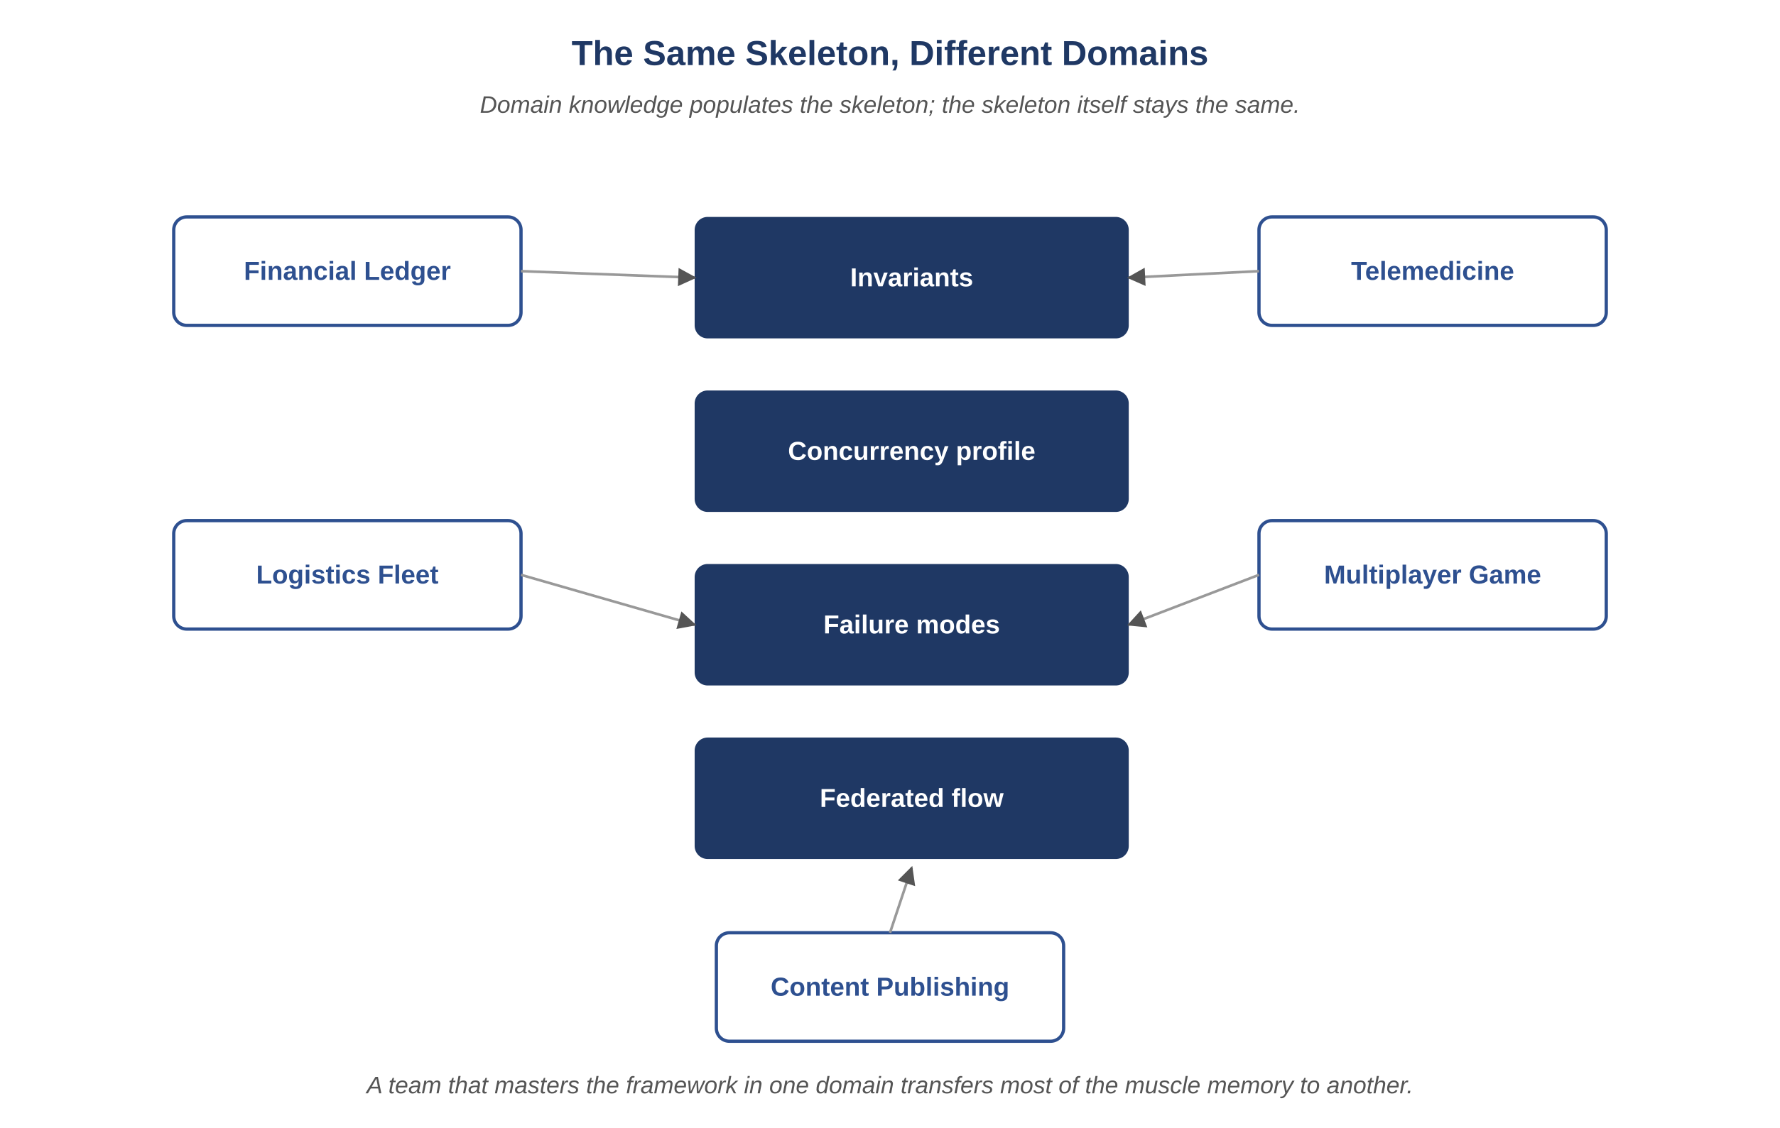
Figure 20.1 — The same skeleton, different domains.
Across all five domains, the same skeleton applies:
- Identify the invariants that must hold under all conditions allowed by the domain.
- Identify the concurrency profile and the contention hot spots.
- Enumerate the high-stakes failure modes.
- Pass each task through the same federated flow: design, audit, build, test, secure, perf, validate, release.
- Tune the verbosity tier and budgets to the criticality of the change.
Key Idea
Domain knowledge fills in the specifics — which invariants matter, which concurrency profiles are dangerous, which failure modes are unacceptable — but the underlying structure stays the same. That separation is what makes the framework portable across domains rather than locked to any one of them.

20.7 What Travels and What Does Not
Element | Transfers Across Domains? | Why
The four-layer architecture | Yes | Domain-independent.
The federated lifecycles | Yes | Same concerns recur across domains.
The agent contracts | Yes | Roles are universal.
Specific invariants | No | Domain-specific by definition.
Specific failure modes | Partly | Categories transfer; specifics are local.
Performance budgets | No | Domain-specific SLOs.
Prompt templates | Mostly | Skeleton transfers; bodies are domain-tuned.
Reflection
Pick a domain you know well. Walk through the federated flow for a representative change in that domain. The exercise is illuminating: the framework slides in cleanly almost everywhere, and the places where it does not are usually the places where your existing process has gaps.
Exercises
Solutions appear in the companion solutions volume. Try the exercises before consulting them.
1. Name the five domains discussed in this chapter and the most consequential invariant each one named.
2. List the four parts of the common skeleton (invariants, concurrency profile, failure modes, federated flow).
3. Identify which parts of the framework travel between domains unchanged and which parts have to be re-populated each time.
4. Populate the common skeleton for Atlas Learn: list its representative invariants, its critical concurrency profile, three high-stakes failure modes, and the agent role assignments.
5. For a domain not covered in this chapter (your choice — IoT fleet, fraud detection, scientific computing), populate the same four-part skeleton with at least three items each.
6. A team that mastered the framework on a content-publishing platform is moving to a banking platform. Identify which parts of their muscle memory transfers and which parts they need to re-learn from scratch.
7. Argue that the skeleton itself is more valuable than any of the five worked domains. Identify two operational benefits that come from the skeleton being domain-independent.
8. Design a "domain-readiness checklist" a team could run before starting work in a new domain. Cover the four skeleton parts plus the five recurring categories of edge cases from Chapter 13.
9. A claim sometimes heard: "every domain is special, the framework cannot just transfer." Construct the strongest case for this claim, then rebut it. Identify which parts of the claim are true and which are false.
Common Mistakes
Each one looks reasonable in isolation; each one produces a failure mode the chapter argues against.
1. Skipping the skeleton because "our domain is special." Every domain feels special from inside; the skeleton is what stays the same across special domains. A team that skips it because their domain is "different" usually rediscovers the skeleton later, by trial and error, at higher cost.
2. Copying another domain’s invariants without re-deriving them. "Atlas Learn has ten invariants, so we should have ten too." Invariants are domain-specific by definition; copying them produces a list that looks like rigor and isn’t. Each invariant has to be derived from the actual properties the system must preserve.
3. Treating tooling as the transferable part. The tracker, the prompt library, the controller — these are domain-independent and amortize across products. The judgment of what to record, what to prompt for, and what to validate is domain-specific and does not transfer. A team that ports the tooling without re-developing the judgment will have working tools and broken outputs.
Key Takeaways
The framework recurs with similar shape across domains as varied as banking, healthcare, logistics, gaming, and content publishing.
What changes domain to domain is the specifics — invariants, concurrency profiles, failure modes — not the structure that surrounds them.
A team that has worked through it in one domain typically gets to working competence in the next much faster than a team starting from scratch.

PART VI
Reflection
Vocabulary for Part VI — Reflection
A short refresher on the terms used most often in the chapters that follow. Full definitions remain in the glossary at the back of the book; these short forms are meant to anchor the reader before diving in.
• Observability-driven debugging. Investigating an incident by replaying the exact prompt, context, and decisions that produced the responsible artifact, rather than reconstructing them from memory.
• Failure simulation. A periodic exercise that injects a known failure into a critical path to confirm fallbacks, recovery paths, and observability still work.
• Final principles. The ten operating constraints that sit underneath every recommendation in the book: determinism, traceability, modularity, performance-first, failure-first, governance, context as supply chain, trust by construction, discipline over tooling, and honesty.

21. Advanced Capabilities
After this chapter, you will be able to:
• LO 21.1 — Describe the four advanced capabilities — observability-driven debugging, failure simulation, invariant-driven enforcement, plugin extensibility — and the foundational discipline each one depends on.
• LO 21.2 — Explain why none of the advanced capabilities is reachable without the foundations, and identify common attempts to skip ahead.
• LO 21.3 — Apply the plugin extension pattern to design a new domain-specific agent without modifying the core controller or memory layer.
• LO 21.4 — Trace how a defect found in production feeds back through observability-driven debugging into a prompt-library or test-suite improvement.
• LO 21.5 — Evaluate which advanced capability would have most reduced cost on a recent serious incident in your organization.
Beyond the base lifecycle, the framework supports four advanced capabilities that compound its value over time. Each is engineered, not aspirational. None of them is reachable without the foundational disciplines in place.

21.1 Observability-Driven Debugging
When a defect surfaces in production, the controller can replay the exact agent decisions that produced the responsible artifact. A debugging session begins with a trace, jumps to the decision-log entries that touched the affected code path, and ends with the precise prompt, context, and output that produced the defect.
- Root-cause analysis becomes a deterministic walk through the tracker, not a guesswork exercise.
- Defects flagged this way are appended to the defect ledger with the prompt and context that produced them.
- The next prompt-library iteration includes guards informed by the ledger.
Key Idea
Once the system can explain its own decisions — what prompt ran, on what context, with what input artifacts and what reasoning — debugging shifts from a forensic exercise to a directed search. Most of the time spent investigating an agent-driven incident comes from reconstructing what happened; if that reconstruction is already in the tracker, the investigation is much shorter.

21.2 Failure Simulation Loops
A periodic job picks a critical path and runs an injected-failure simulation: dependency timeouts, partial responses, malformed payloads, clock skew. Findings flow through the QA lifecycle; new tests are added to the regression suite.
Example
A streaming service runs a weekly chaos exercise: induce a 30-second latency on the recommendation service. The system must continue to play content, fall back gracefully, and log the degraded mode. The exercise reveals a missing fallback in a feature added last quarter — found in a controlled simulation rather than during a peak-traffic incident.

21.3 Invariant-Driven Enforcement
Invariants are not a document — they are an enforcement substrate. Every Auditor review checks the design against every invariant referenced in scope. Every QA test cites the invariant it guards. Every Validator pass cross-checks code, contracts, schema, and tests for invariant alignment. A new invariant is a major event: it triggers a sweep that re-validates affected modules.
Atlas Learn — Adding INV-AL-11 triggers a sweep
Imagine a new Atlas Learn invariant introduced after the case study spec was written: INV-AL-11, a learner’s active enrollments across all tenants do not exceed a per-learner concurrency cap (a constraint motivated by completion-rate research). Adding it is not a one-line policy change — it is a trigger. The Auditor agent re-reviews every endpoint that creates or modifies an enrollment to confirm it consults the cap. The QA agent generates property tests that try to violate the cap from every direction (creation across tenants, undelete after withdrawal, instructor override). The Validator confirms that the cap is enforced at storage, not at request time, so a race between two enrollment endpoints cannot exceed it. Performance reviews whether the cap check adds latency to the enrollment-confirm critical path; if so, a denormalized counter is proposed. Each of these is a tracker entry in its own right; the new invariant is fully integrated only when every entry is closed. This is what "invariants as substrate" means in practice.

21.4 Extensibility Through Plugins
The framework is extensible without rewriting the core. New agents, new lifecycle stages, and new domains arrive as plugins.
- New agents declare role, input schema, output schema, prompt ID, budget tier.
- New stages declare predecessor stage, gate condition, output schema, halt rules.
- New domains declare invariants, contracts, schemas; the federated flow is unchanged.
- Plugins ship behind feature flags and pass through the Release Governor like any other change.

21.5 What Becomes Possible
When the foundational disciplines are mature and the advanced capabilities are in place, several operational properties become available:
- Mean time to recovery is measured in minutes, not days.
- Defects discovered in production drop year over year.
- New domains are onboarded in weeks, not quarters.
- Prompt and agent improvements roll out under the same canary discipline as code, with measurable evaluation.
- Postmortems become tractable; the question "why did this happen" is answerable from records, not memory.
Common Pitfall
Reaching for advanced capabilities before the foundations are solid. Observability-driven debugging requires complete observability; failure simulation requires a stable critical path; invariant-driven enforcement requires invariants. Build the floor before adding the ceiling.
Reflection
Identify which advanced capability would have most reduced cost on your last serious incident. Trace what foundational discipline was missing for that capability to have been available. The answer points to your next investment.
Exercises
Solutions appear in the companion solutions volume. Try the exercises before consulting them.
1. Name the four advanced capabilities (observability-driven debugging, failure simulation, invariant-driven enforcement, plugin extensibility) and the foundational discipline each one depends on.
2. Distinguish between an invariant as a stated intention and an invariant as an enforcement substrate. What changes when the latter is in place?
3. Define plugin extensibility in the context of the framework and identify which kinds of additions can ship as plugins.
4. For Atlas Learn’s INV-AL-11 sweep vignette, identify what each of the affected agents (Auditor, QA, Validator, Performance) actually had to do, and how the work would differ in a system without invariant-driven enforcement.
5. Design a failure-simulation campaign for a system you know. Specify three failure modes to inject, the recovery paths to verify, and the success criteria for each.
6. A team has solid logs and metrics but no decision logs for agents. Identify which two of the four advanced capabilities are still out of reach for them, and what they need to add to unlock them.
7. Argue that "advanced capabilities first" is one of the most expensive mistakes in adoption. Identify three concrete failures that result when foundational disciplines are skipped in favor of capability ambition.
8. Design a sequencing plan for adopting the four advanced capabilities. Specify which one comes first, why, and what evidence indicates the team is ready for the next.
9. A vendor claims their tool offers all four advanced capabilities "out of the box." Construct the diagnostic questions that reveal whether the foundations underneath are present or whether the capabilities are theatre.
Common Mistakes
Each one looks reasonable in isolation; each one produces a failure mode the chapter argues against.
1. Building failure simulation before engineered recovery. Failure simulation against an undesigned recovery path produces real outages disguised as drills. The simulator hits a failure mode the team has not prepared for, the system breaks for real, and the postmortem reads "we caused our own incident."
2. Adopting plugin extensibility before contract discipline. Plugins assume stable contracts between the core and the extensions. A team without contract discipline finds that every plugin becomes a private kingdom, every change is unsafe, and the integration surface sprawls until rolling back any plugin breaks something unexpected.
3. Treating advanced capabilities as the goal. Observability-driven debugging, failure simulation, invariant-driven enforcement, plugin extensibility — these are the rewards of the foundational disciplines, not substitutes for them. A team that reaches for the advanced capabilities first usually ends up with expensive theatre and less reliability than they started with.
Key Takeaways
Four advanced capabilities — observability-driven debugging, failure simulation, invariant-driven enforcement, plugin extensibility — compound on top of the foundational disciplines.
Each one earns most of its value when the foundations underneath it are already solid; without them they tend to be expensive theatre.
The usual mistake is reaching for the advanced capabilities first because they sound impressive, rather than landing the foundations they depend on.

22. Limitations and Honest Disclosure
After this chapter, you will be able to:
• LO 22.1 — Identify the failure modes that the framework mitigates but does not eliminate, and articulate the difference between reduction and elimination accurately to stakeholders.
• LO 22.2 — Recognize the operational risks that come with adopting the framework (cost runaway, latency creep, model drift, vendor outages, audit fatigue, process ossification) and the discipline that addresses each.
• LO 22.3 — Describe the categories of work that remain mandatorily human — invariant changes, schema migrations, full-fleet promotion, P0 waivers — and explain why each remains so.
• LO 22.4 — Distinguish problems the framework can address from problems it cannot (organizational misalignment, regulatory ambiguity, cultural resistance) and respond appropriately to each.
• LO 22.5 — Evaluate a vendor pitch or a team’s adoption claim for honest scoping versus over-promise, citing specific limitation categories.
Every chapter of this book has, in some quiet way, been about what the framework does. This one is about what it does not do. The discipline that follows from the rest of the book is real, but it is not unbounded; the team that adopts it is still going to encounter failure modes the framework does not catch. A textbook that does not name those modes is selling something.
The posture this chapter takes is that limits are the easiest part of an engineering system to forget about and the most expensive to discover late. A reader who finishes this book without an honest accounting of where the framework helps and where it cannot is in worse shape than a reader who started skeptical, because the unbounded confidence will accumulate decisions that the framework was never going to support.
This framework is powerful but not infallible. Honest engineering requires naming where it falls short and where human judgment remains irreplaceable.

22.1 Where AI Agents Fail
- Novel domains: agents perform best where similar patterns exist in their training. Truly novel domains expose gaps that no prompt can paper over.
- Long-horizon reasoning: complex multi-step reasoning over deep state can drift. Structured tracker state mitigates but does not eliminate this.
- Ambiguous specifications: agents will produce a confident answer to an ambiguous question. The system must halt at ambiguity, not infer.
- Adversarial inputs: prompt-injection attacks can corrupt outputs. Defense in depth (output validation, role isolation, audit trail) reduces blast radius but does not zero it.
- Hallucinated references: invented APIs, invariants, or identifiers are a real risk. The controller validates references against memory before consumption.
- Hidden assumptions: agents may rely on unstated assumptions that do not match production. Citing inputs reduces this risk.

22.2 Where Human Oversight Is Mandatory
- Invariant changes: always require a human owner.
- Schema migrations that are not backward-compatible: always require a human owner.
- Releases to the full fleet: always require a human approver.
- P0 defect waivers: always require a written exception signed by a human.
- Postmortems are written by humans, with the tracker as the source of truth.
Key Idea
The realistic claim is that this framework reduces how often humans need to intervene and gives them better information when they do. It does not eliminate human judgment from the loop, and a system that promises elimination is overstating what current technology can do.

22.3 Operational Risks
- Cost runaway: an agent that loops on itself can burn budget; the controller enforces hard per-task budgets.
- Latency creep: as context grows, latency grows; pruning and adaptive verbosity counter this with ongoing tuning.
- Model drift: a new model version may change behavior; pinning, evaluation suites, and canaried prompt rollouts mitigate.
- Vendor outages: a model provider outage halts the system; degraded mode is a manual workflow, not no workflow.
- Skill atrophy: as more work shifts to agents, engineers can lose hands-on familiarity with the codebase; rotations and review duties counter this.
- Audit fatigue: humans approving canary promotions can rubber-stamp; the system surfaces the specific risks of this change to keep approvals informed.
- Process ossification: disciplines designed for past failure modes can outlive their usefulness; periodic review of the discipline itself is part of the discipline.

22.4 What This Framework Does Not Solve
- It does not solve organizational misalignment. If product, engineering, and security report through different incentives, the framework cannot fix it.
- It does not solve poor product specification. An agent cannot infer what the product team has not decided.
- It does not solve cultural resistance. A team that resents process will route around it.
- It does not solve regulatory ambiguity. Compliance requires human judgment, not just audit trails.
- It does not solve the fundamental epistemic problem of language models. It contains it.

22.5 Honest Failure Modes
Even with the framework fully adopted, a system can fail in the following ways:
- Multiple compensating defects can mask each other across stages, allowing a flawed change to pass.
- A correct artifact can be deployed against an incorrect deployment target, and no stage will catch it.
- A change correct in isolation can interact pathologically with another change in flight; the Validator catches some but not all of these.
- A subtle data corruption introduced months ago can surface only after a related change today; the system attributes the surface fault to the wrong cause.
Common Pitfall
Promising customers or executives that the framework eliminates failure. The honest claim is narrower and more credible: it makes failures rarer, more recoverable, and better explained.
Atlas Learn — Where the framework still costs more than it pays on Atlas Learn
Honest disclosure is part of the discipline, so here is one place where the framework continues to cost more than it pays. Atlas Learn has a small team that maintains the marketing site — unauthenticated, low traffic, mostly static. The team is two people; the change cadence is a few edits a week; the highest-stakes failure is a typo. Running every marketing-site change through the full federated flow (Architect, Auditor, Developer, QA, Security, Performance, Validator, Release) is theatre; it adds days of latency to a half-hour change. The team negotiated and got a documented exception: marketing-site changes use a lightweight Developer-plus-human-review path, with the eight invariants that could matter (mostly accessibility and tenant-isolation in inbound links) checked once a quarter rather than per-change. The exception is itself recorded — in the same tracker, with the same audit shape — so the choice to skip discipline is itself disciplined. The honest framing is that the framework is right-sized for high-stakes work; for genuinely low-stakes work it can over-engineer, and pretending otherwise erodes the discipline that holds it up everywhere else.
Reflection
Identify two failure modes from this section that have actually occurred in your operation. Identify which discipline would have most reduced their probability or impact. Note that the answer is rarely "another tool" — it is more often "more rigor in a discipline already in place."
Exercises
Solutions appear in the companion solutions volume. Try the exercises before consulting them.
1. List three categories of work where AI agents currently fail and explain the structural reason for each.
2. Name two situations where human oversight is mandatory regardless of the framework’s maturity, and the property that makes them mandatory.
3. Restate the four honest failure modes the framework still permits even when fully adopted.
4. Walk through the marketing-site exception in the case-study vignette: identify why the framework over-engineered for that team and what the documented exception preserves.
5. A team is told "the framework eliminates failure." Identify three specific harms that this overclaim produces (in trust, in operations, in incident response).
6. For a system you know, identify one workflow where the framework currently costs more than it pays. Justify the assessment and propose what would have to change for the trade-off to flip.
7. Argue that "documented limits" is itself a discipline of the framework, not an admission of weakness. Identify two operational benefits that come from publishing constraints honestly.
8. Design an exception process: when can a team document an exemption from a discipline, who approves, what review cadence applies, and how does the exception itself get recorded.
9. A regulator asks for a list of conditions under which the framework cannot guarantee a property. Construct the response — be specific, be honest, identify the structural conditions rather than the convenient ones.
Common Mistakes
Each one looks reasonable in isolation; each one produces a failure mode the chapter argues against.
1. Promising "the framework eliminates failure." It does not, and any honest framing should say so. Customers and stakeholders who hear "no failures" lose trust faster when the inevitable failure happens, and the team’s investment in failure recovery often atrophies because it has been told it isn’t needed.
2. Refusing to document the framework’s limits. Documenting limits feels like admitting weakness; it is closer to calibrating trust. A team that publishes its constraints — honestly, specifically, with the structural conditions named — gets more accurate trust than a team that doesn’t.
3. Skipping ethical review because "the framework is correct." Correctness is one criterion among several. A system that meets every functional and non-functional requirement can still be ethically problematic in ways the framework does not catch; the discipline of ethical review extends the framework rather than competing with it.
Key Takeaways
The framework reduces failure rates, shortens recovery, and makes incidents easier to explain. It does not promise no failures, and any honest framing should say so.
Documenting the limits is part of the discipline; teams that publish their constraints get more accurate trust than teams that don’t.
When the framework genuinely can’t help with something — organizational misalignment, ambiguous regulation, cultural resistance — it is more useful to say so directly than to imply otherwise.

Bridge — Ethics and Responsible AI in the SDLC
Most engineering decisions are also ethical decisions, even when they don’t feel that way. Choosing what to build, what to log, who can see what, when to escalate to a human, what to retain and for how long, and how to design for a user under stress — these are technical choices, but their consequences land on people who do not have a seat at the design meeting. Chapter 22 was honest about where the framework cannot help with such things; this chapter is honest about where the framework’s choices themselves carry ethical weight, and what disciplines are needed for the team to take those choices seriously.
The chapter sits between Limitations (Ch 22) and Final Principles (Ch 23). The placement is intentional: a reader who has just been told "the framework does not eliminate failure" is in the right frame of mind to also hear "and the framework’s correctness is not the only thing that matters." Final Principles then closes the book with the operating discipline that ties everything together.
After this chapter, you will be able to:
• LO E.1 — Distinguish ethical concerns that arise from the system’s behavior, from the team’s process, and from the broader regulatory environment.
• LO E.2 — Apply a structured analysis (stakeholder mapping, harm enumeration, mitigation design) to a real engineering decision before it ships.
• LO E.3 — Identify common patterns of harm in AI-driven systems (bias amplification, accountability dilution, surveillance creep, autonomy erosion) and recognize them in a real system.
• LO E.4 — Evaluate a proposed change against accountability, transparency, fairness, and human-oversight criteria; produce a structured ethical review record.
• LO E.5 — Construct a defensible position on a contested ethical question (e.g., when to use AI for high-stakes decisions) that names the trade-offs honestly rather than choosing a side rhetorically.
Before reading this chapter
You will get more out of what follows if you are already comfortable with:
• Chapter 22 (Limitations and Honest Disclosure) for the framing of where the framework cannot help; ethical concerns often live in the same gap.
• Chapter 7 (Governance), particularly the three pillars of role isolation, approval gates, and audit trails. Ethical disciplines extend governance to a wider set of stakeholders.
• Section 0’s definition of "stakeholder" — anyone with a legitimate interest in what the system does. Ethics is partly the discipline of expanding the stakeholder set beyond those in the room.
• A working sense of what a regulatory regime is. The chapter references EU AI Act, GDPR, HIPAA, and accessibility law in passing; readers without this background can follow the argument but should consult an introductory text on technology regulation alongside.

E.1 Three Sources of Ethical Concern
Ethical concerns in AI-driven engineering arise from three distinct sources. Confusing them produces conversations that talk past each other; distinguishing them is most of the work.
System behavior. What the system does, observed externally. A grading agent that systematically gives lower scores to certain demographic groups has a system-behavior concern, regardless of why it does so. System-behavior concerns are detected by audit and observation; they do not depend on the team’s intentions.
Team process. How the team reaches decisions about the system. A team that ships features without consulting the people most affected by them has a process concern, even if the resulting features turn out fine. Process concerns are detected by examining who was at which meeting, whose objections were recorded, whose were ignored.
Regulatory environment. The legal and political constraints the system operates under. The EU AI Act, GDPR, HIPAA, accessibility law, and sector-specific regulations all impose constraints that the system and the team must satisfy. Regulatory concerns are detected by counsel and compliance review; they survive disagreements about whether the regulation is well-designed.
A concern can sit in more than one category. Bias in a hiring screen is a system-behavior concern (the model gives different scores to similar candidates), a team-process concern (whose perspectives shaped the evaluation criteria), and a regulatory concern (most jurisdictions have employment-discrimination law). Treating it as only one of the three produces inadequate response.

E.2 Stakeholder Mapping
A stakeholder, in the ethical sense, is any party whose interests are affected by the system. The set is usually larger than the set of customers. For a learning platform like Atlas Learn, the stakeholders include: learners, instructors, parents of underage learners, the institutions paying for access, employers who later evaluate the credentials, regulators who oversee the platform’s claims, the engineering team itself, and the society that decides how learning credentials should be valued. Each has interests; not all of them have a representative in the design meeting.
A stakeholder map for a feature includes:
- Each affected stakeholder, named and grouped if there are many.
- Their interest in the feature — what they need it to do, what they need it not to do.
- Their power over the feature — can they refuse it, complain, escalate, sue, regulate.
- Their representation in the design conversation — are they at the meeting, are they represented by someone who advocates for them honestly, or are they absent.
The exercise is uncomfortable. Most stakeholder maps reveal that several affected parties have no representation. The discipline is not to fix that on the spot; it is to record the asymmetry so the design choices made in their absence are at least made knowingly.
Example
Atlas Learn introduces a feature that uses an AI agent to flag submissions suspected of plagiarism. The customer (the institution) is in the design meeting; the operator (the instructor) is represented by a product manager who has interviewed instructors. The learner who will be flagged is not in the meeting and has no representative. The team’s stakeholder map records this gap explicitly, and the design responds: the agent’s flag is shown to the instructor with the specific evidence, the learner is notified that their submission has been reviewed, the learner has a path to challenge the flag with the institution, and a randomly-sampled audit of flags is reviewed against actual outcomes to detect bias. None of this would have been built into the feature if the gap had not been recorded.

E.3 Patterns of Harm in AI-Driven Systems
Four patterns recur frequently enough to deserve names.

E.3.1 Bias Amplification
A system trained or tuned on data that reflects past inequities can encode and propagate those inequities, often more efficiently than the human processes it replaced. The system does not need to be designed badly; it needs only to fit its training data faithfully. Bias amplification is the default outcome of naive deployment, not an exception.
Mitigation requires explicit work: representative training data; tested-for-bias outcomes (run the system against synthetic and real cases that probe the boundaries); ongoing monitoring (a system that started fair can drift unfair as the world changes around it); and a structural review path that has authority to halt deployment when bias is detected.

E.3.2 Accountability Dilution
When humans and agents share authority over a decision, accountability tends to dilute. The agent recommended; the human approved; the institution shipped. If the decision turns out wrong, no single party is responsible enough to be held to account. Accountability dilution is what happens when "the AI did it" becomes a defense.
The framework’s discipline of recorded decisions, named approvals, and reasons-with-citations is itself a partial response. A decision with a recorded approver and a recorded reason cannot be retroactively claimed to be the AI’s decision; it is the approver’s decision, informed by the AI. Accountability is preserved by who signed, not by who proposed.

E.3.3 Surveillance Creep
Every observability axis the framework adds is also a potential surveillance surface. Decision logs that help debugging also reveal what individuals were doing when. Tracker events that enable audit also enable monitoring. The same data that makes the system trustworthy can be turned against the people the system is meant to serve.
Mitigation: explicit retention limits per data class; access controls that are themselves audited; redaction of personal identifiers from logs that don’t need them; periodic review of who can see what; and a discipline of asking, for each new piece of telemetry, "if a hostile party gained access to this, what would they learn that they should not." The four observability axes become safer when this question is asked early rather than after a breach.

E.3.4 Autonomy Erosion
Systems that make decisions on behalf of users without meaningful consent or override gradually erode the user’s sense that they are in charge of their own outcomes. A learning platform that recommends the next lesson is helpful; one that decides which courses a learner is allowed to attempt is not, even if the recommendation engine is technically very good. Autonomy erosion is harder to detect than the other patterns because each individual loss of autonomy looks small; the cumulative effect is what changes the shape of the user’s relationship with the system.
Mitigation: meaningful override paths (not buried, not punished); transparency about what the system is deciding and why; user-visible records of decisions made on their behalf; and a periodic asking of the question "what could the user no longer do for themselves that they could a year ago, and was that change made deliberately."
Key Idea
The four patterns — bias amplification, accountability dilution, surveillance creep, autonomy erosion — are default outcomes of naive deployment. Avoiding them is not the absence of harm; it is the result of specific disciplines applied deliberately.
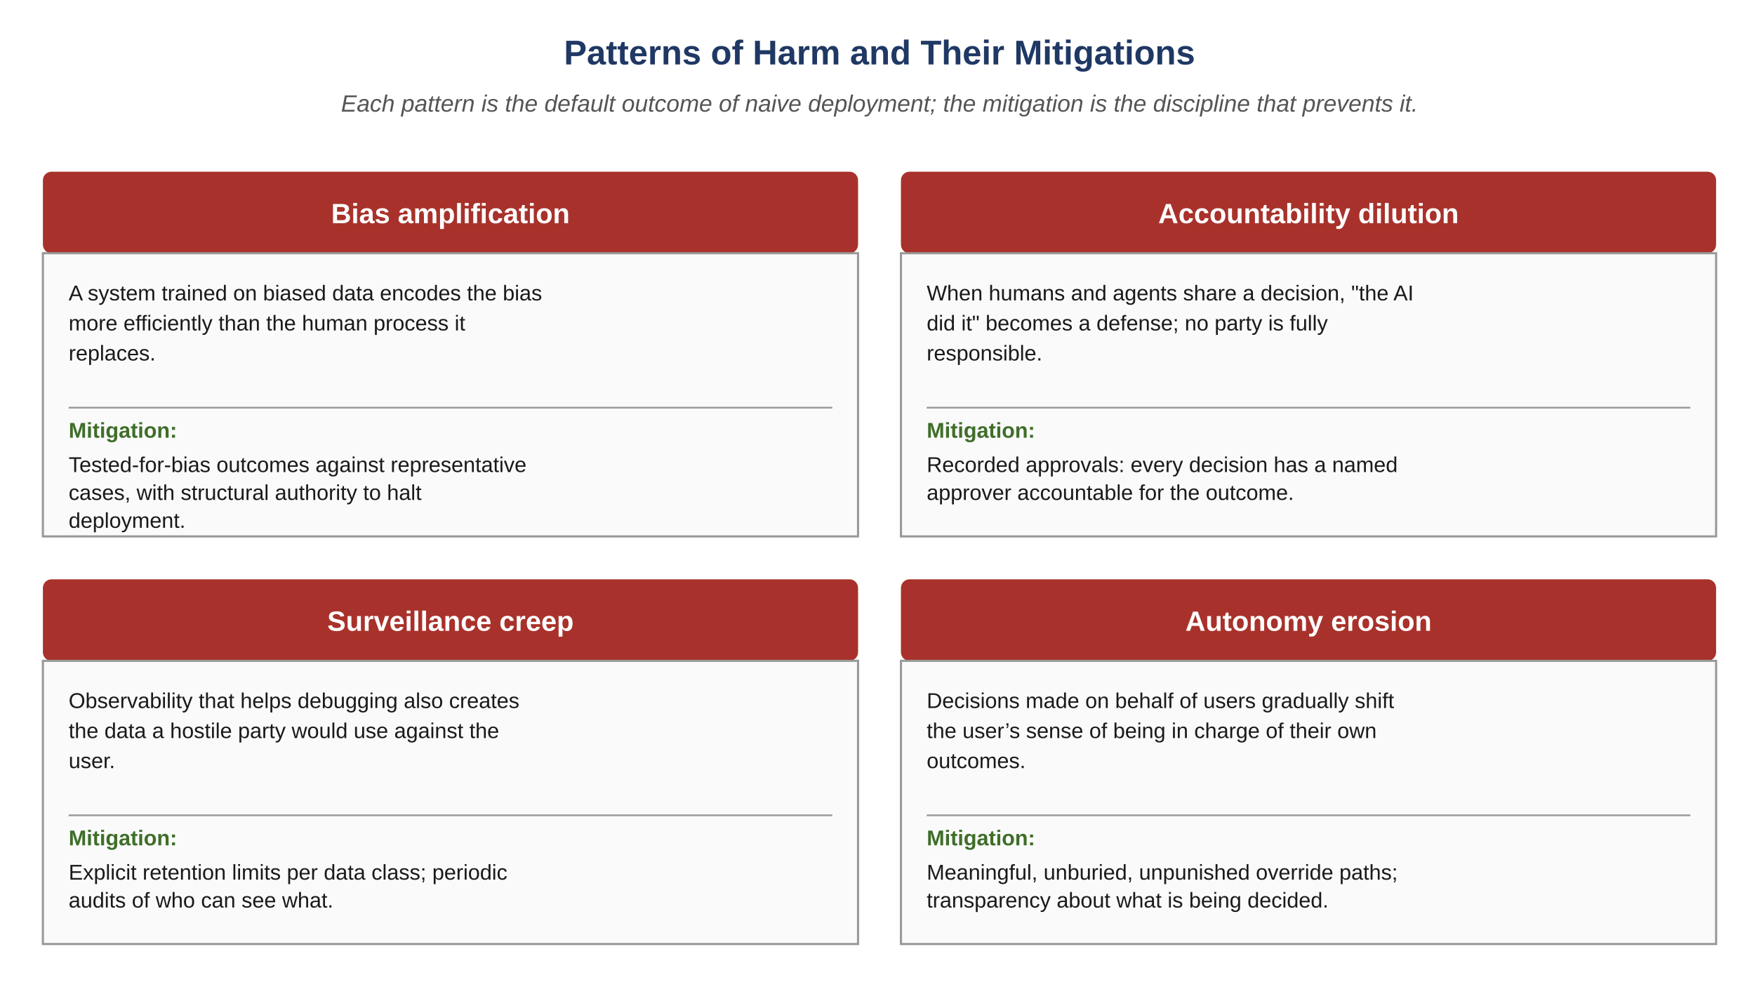
Figure E.1 — Patterns of harm and their mitigations.

E.4 The Regulatory Environment, Briefly
A complete treatment of the regulatory environment for AI is beyond this chapter’s scope and beyond most engineers’ needs. What every engineer should know:
GDPR (EU; many global followers). Personal data is governed by purpose limitation, data minimization, transparency, user rights of access and erasure, and accountability through documentation. Most agent-driven systems handle personal data in some form; the obligations are operational, not optional.
EU AI Act. Classifies AI systems by risk tier; "high-risk" systems (employment, education, credit, health, law enforcement) face heightened obligations including risk management, data governance, transparency, human oversight, and post-market monitoring. The Act is in force; an engineer working on a high-risk system has a regulatory inventory to maintain.
Sector-specific regulation. Healthcare (HIPAA in the US, equivalents elsewhere), finance (model risk management; SR 11-7 in the US), employment (anti-discrimination law), and accessibility (ADA, WCAG) each impose constraints that a working engineer encounters in practice. The framework does not exempt any system from these; the disciplines this book argues for can satisfy parts of the regulatory burden, but the obligation lives outside the framework.
Voluntary frameworks. NIST AI RMF in the US; ISO/IEC 42001; IEEE 7000-series. These are not laws but they are the vocabulary regulators borrow when writing laws, so a team familiar with them is better prepared for the regulatory environment to evolve.
The regulatory landscape changes faster than this book can. The discipline is not "memorize the regulations" but "establish a relationship with someone whose job is to track them" — in-house counsel, external counsel, a compliance officer, or a published framework the team commits to follow. A team that does not know which regulations govern its system is operating one regulator question away from a problem.

E.5 Ethical Review as a Process
Ethical review, like the other reviews in the framework, deserves to be a structured artifact, not a feeling. A defensible review of a proposed change asks five questions and records the answers.
- Stakeholder map. Who is affected by this change, what is their interest, what is their power, and who represents them in this conversation? Identify the absences explicitly.
- Harm enumeration. What could go wrong for each stakeholder? Cover the four patterns (bias, accountability, surveillance, autonomy) and any domain-specific concerns. Severity and likelihood are part of the answer.
- Mitigation design. For each named harm, what specific mitigation is in place? "We will be careful" is not a mitigation; "the agent’s recommendation is shown to the human with the evidence, and the audit trail records both" is.
- Acceptable residual risk. What harms remain even after mitigation? Acknowledge them honestly. A change with no residual risk has either solved a hard problem or has not enumerated honestly.
- Review and revisit. Who reviews this analysis, by what authority, with what cadence? The review is a living artifact; the questions it asked at design time may need to be asked again as the system evolves.
In the framework, the ethical review fits as another role, conceptually similar to the Auditor or Validator: it consumes proposed changes, applies a structured discipline, and produces a verdict (approve, revise, escalate). Unlike the Auditor, which checks against invariants, the ethical reviewer checks against the named harms and the defensible-mitigations register. The role can be staffed by humans, by an agent prompted with the review framework, or by a hybrid, but the discipline is the same regardless of who enacts it.
Common Pitfall
"We discussed it." Ethical review that does not produce a structured artifact is functionally invisible to anyone who was not in the discussion. The artifact is what makes the review reviewable, the disagreements traceable, and the residual risks acknowledged at scale. A team that does ethical review but does not record it is a team that will rediscover the same concerns repeatedly without remembering the answers it had reached.

E.6 Contested Questions
Some ethical questions in AI-driven engineering do not have settled answers. The discipline here is not to pretend the answers are obvious; it is to argue them honestly, name the trade-offs, and let the reader form their own position.

E.6.1 When Should AI Make High-Stakes Decisions?
A high-stakes decision is one whose consequences are large and not easily reversed: hiring, sentencing, medical triage, credit, immigration, child welfare. The case for AI involvement is real — humans are also biased, also inconsistent, also slow, and the alternative is not a panel of saints making perfect decisions. The case against is also real — AI bias is more efficient, AI accountability is more diluted, AI errors at scale touch more people. Both cases are correct. The discipline is to take both seriously, to design for human oversight where the consequences warrant it, to monitor for bias in the actual outcomes (not in the model in isolation), and to retain the structural ability to reverse course as evidence accumulates. The honest position is rarely "AI should" or "AI should not"; it is "AI may, under these specific conditions, with these specific safeguards, with these specific reversal paths."

E.6.2 What Do We Owe the People Whose Data Trained the Model?
Most large models are trained on data created by people who did not specifically consent to that use. Some of that data was public; some was not; some was public but used in ways the people who created it did not anticipate. The legal answer varies by jurisdiction and is contested. The ethical answer is more uncertain. The honest position is to acknowledge the gap between what is legally permitted and what is ethically defensible, to engage with the disagreement rather than dismissing it, and to let the design choices reflect the seriousness of the question — attribution where attribution is feasible, opt-out paths where they make sense, and a willingness to revise practices as norms evolve.

E.6.3 Who Bears the Cost of AI Mistakes?
When an AI-driven system is wrong, someone bears the cost. It might be the customer (a wrongly-rejected loan), the operator (a flagged submission that is correct), or the institution (a regulatory fine for systemic bias). It is usually not the engineering team, and almost never the AI. A discipline of accountability says that the people deploying the system carry responsibility for its outcomes, not the agents themselves. This is not a popular position with operators who would rather not bear the cost, but it is the position the framework is built to support: every decision has a recorded approver, every approver has accountability for what they approved.

E.7 The Tracker as Ethical Substrate
Most of the disciplines this chapter recommends rely on the tracker, perhaps surprisingly. A stakeholder map that lives in a document nobody re-reads is functionally absent. An ethical review that produces a discussion but not an artifact is a courtesy. A harm enumeration that nobody can find when an incident occurs may as well not exist.
The tracker, as introduced in Chapter 9, is the right substrate for ethical artifacts. Each ethical review produces a tracker event with the structured fields the framework already supports: actor, target artifact, decision, reason, citations, residual risks. Each decision the framework is critical of — a privileged action, a high-stakes recommendation, a deployment to a sensitive population — already has a tracker entry; extending that entry with the ethical-review record adds the dimension this chapter argues for at low operational cost.
The framework’s discipline thus extends naturally to the ethical layer. The same audit trail that lets a team answer "why did the agent do that" also lets them answer "what did we know about the harms when we shipped." Both questions become harder with time; both are answerable only if the evidence is in the same durable artifact.

E.8 Atlas Learn: A Plagiarism Flag, Reconsidered
Atlas Learn — When the discipline caught what the design missed
Atlas Learn shipped its plagiarism-flag agent (the example in E.2) eight months ago. The structured ethical review caught what the initial design had missed: that the learner whose submission was flagged was not in the design meeting, and that the burden of contesting a flag had been allocated to the party with the least power. The mitigations — instructor sees evidence, learner is notified, learner can challenge with the institution, sample-audit for bias — are all in place. They were not enough. Three months after launch, the bias audit detected that learners whose primary language was not the institution’s default language were being flagged at 2.3x the rate of native-language learners. The agent’s training data had reflected the population of submissions the institution had previously reviewed manually, and that prior review had carried the same bias the agent now reproduced more efficiently. The fix landed in two parts: a calibration adjustment to bring the flag rates closer in line, and an explicit decision that any flag near the boundary would default to "no flag" rather than "flag," because the cost of a false flag was higher than the cost of a missed flag in this context. Both decisions were tracker events with full ethical-review records. The audit-detected drift, six months after launch, also became a tracker event. None of these would have been recorded as artifacts a year earlier; the discipline in this chapter is what made the residual risks survivable.
Exercises
Solutions appear in the companion solutions volume. Try the exercises before consulting them.
1. Distinguish the three sources of ethical concern (system behavior, team process, regulatory environment) and identify which one is detected by which kind of evidence.
2. Name the four recurring patterns of harm (bias amplification, accountability dilution, surveillance creep, autonomy erosion) and state the single mitigation discipline that most directly addresses each.
3. List the five questions a defensible ethical review answers, and identify which one most teams skip in practice.
4. For Atlas Learn’s plagiarism-flag vignette, identify which of the four harm patterns each mitigation addresses, and which residual risk the bias-audit findings later revealed.
5. Take a feature you have shipped or studied. Do a stakeholder map: name the stakeholders, their interests, their power, and their representation. Identify at least one stakeholder who was not represented and what change in the design would have followed if they had been.
6. For a hypothetical change in a system you know, enumerate three plausible harms across at least two of the four patterns. For each harm, propose one structural mitigation (not "we will be careful").
7. Argue against the claim "ethical review slows the team down without producing measurable benefit." Identify three specific incidents that ethical review can plausibly prevent, and explain why their absence in the historical record does not prove the discipline was unnecessary.
8. Design an ethical-review workflow for a small team that does not yet have a dedicated reviewer role. Specify who reviews, how the review is recorded, how disagreements are escalated, and how the review record is connected to the rest of the audit trail.
9. A senior engineer argues that "regulation is a problem for compliance, not for engineers." Construct the strongest case for this position, then rebut it. Identify which parts are true and which are not, and propose a working relationship between engineering and compliance that respects the legitimate concerns on both sides.
Key Takeaways
Ethical concerns arise from system behavior, team process, and the regulatory environment; treating them as one thing produces inadequate response.
Four recurring patterns of harm — bias amplification, accountability dilution, surveillance creep, autonomy erosion — are default outcomes of naive deployment.
A defensible ethical review is a structured artifact, not a discussion: stakeholder map, harm enumeration, mitigation design, residual risk, review cadence.
The tracker is the right substrate for ethical artifacts; the same audit trail that supports debugging also supports asking "what did we know."
Most ethical disciplines extend the framework rather than competing with it; the disagreement, where it exists, is usually about the cost of doing the work, not about whether the work matters.

23. Final Principles
After this chapter, you will be able to:
• LO 23.1 — Recall the ten final principles — determinism, traceability, modularity, performance-first, failure-first, governance, context as supply chain, trust by construction, discipline over tooling, honesty — and the constraint each one represents.
• LO 23.2 — Apply the principles as a tie-breaker when an engineering decision feels ambiguous, and explain which principle resolved the call.
• LO 23.3 — Distinguish principles that are operational constraints from principles that are aspirational, and identify when a principle in your organization has slipped from the first into the second.
• LO 23.4 — Justify why "cannot happen" beats "should not happen" wherever the choice is available, with concrete examples from your own work.
• LO 23.5 — Evaluate a recent engineering decision against the ten principles and identify which one was honored and which was traded against.
What follows is a short list of operating principles that sit underneath every recommendation in this book. They aren’t slogans; each one represents a constraint that has been arrived at by watching specific failure modes occur and then designing against them. When a decision in practice feels ambiguous, returning to these tends to clarify which way to lean.
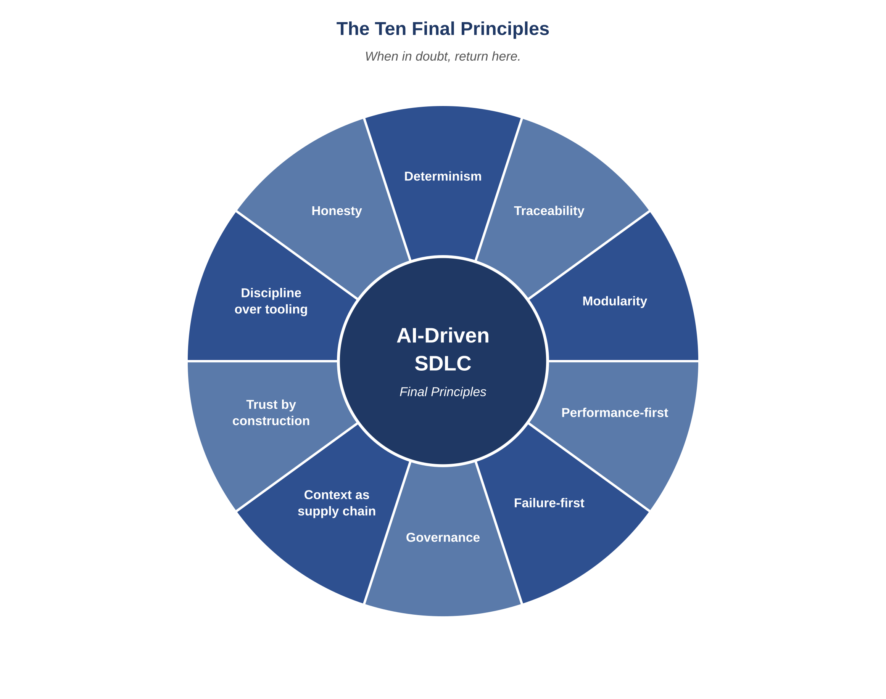
Figure 23.1 — The ten final principles.

23.1 Determinism
Given the same inputs, the system should produce the same artifacts. Content-addressed context, versioned prompts, structured outputs, and exact replay through the tracker are how that property gets built. It matters because audits, postmortems, and any meaningful trust in the system’s behavior all depend on being able to reproduce what happened.

23.2 Traceability
Every artifact should answer four questions on demand: who produced it, on what input, under what prompt, and for what reason. The tracker holds the index, the decision ledger holds the rationale. When a question about an artifact can’t be answered from those two stores, the right response is to close the gap rather than rely on memory.

23.3 Modularity
Agents do one job each. Layers don’t reach across. New capabilities ship as plugins rather than edits to the core. The reason isn’t aesthetic — it’s that production systems get evolved over years, and the only systems that survive that evolution intact are the ones whose seams are explicit enough to allow individual parts to be replaced.

23.4 Performance-First Design
The critical path is named, budgeted, and defended. A correct response that arrives too slowly tends to be experienced as a broken product, even when the logic is right. Budgets that are written down and enforced at release time hold up; aspirational ones get rounded up to "fast enough" until an incident forces the conversation.

23.5 Failure-First Mindset
Tests start from failure modes. Designs enumerate them. Releases include rollback plans. Recovery paths are engineered, not improvised during incidents. A system whose failure modes haven’t been thought through is one whose first serious operational test is also its first time encountering them.

23.6 Governance
Role isolation, approval gates, audit trails, and human escalation on ambiguity together make the difference between a system that operates autonomously and one that operates without supervision. The intent isn’t to slow things down; it’s to make delegation possible without giving up accountability.

23.7 Context as Supply Chain
An agent’s output quality is bounded by the quality of its context. Context arrives with provenance, gets minimized to what’s actually needed, and is invalidated when its underlying sources change. The mental model that works best in practice is to treat context the way you already treat third-party dependencies — as material entering the build with known provenance and a known risk profile.

23.8 Trust by Construction
Where you can express a property as "cannot happen" rather than "should not happen," it’s usually worth doing. A constraint enforced at the storage layer is more reliable than one checked in service code; a state machine catches transitions that conventions and comments will eventually let through. The ratio of "cannot" to "should not" in a system is a reasonable proxy for how much of its safety is built-in versus aspirational.

23.9 Discipline Over Tooling
Tools turn over much faster than disciplines do. A team with strong disciplines and middling tools improves faster than the reverse, because the disciplines transfer to whatever tooling shows up next year. Investment in the discipline side of the ledger has a longer half-life than investment in any particular tool.

23.10 Honesty
The system should be honest about what it can and can’t do. Agents halt on ambiguity instead of guessing. Releases include rollback plans. Limitations are documented. Postmortems are blameless and complete. Honesty isn’t a moral position here; it’s the practical condition under which trust in an automated system can scale beyond the people who originally built it.

23.11 Closing
This framework isn’t a substitute for engineering judgment. What it does is provide a way to apply that judgment at scale, with consistency across people and over time, and with a memory longer than any single team. The value compounds: every defect found becomes a test, every decision becomes a record, every prompt becomes a versioned asset, every postmortem becomes a guard against the same thing happening again.
In practice, teams that adopt this seriously report a similar pattern. The first months feel slower and more expensive. By the second or third quarter, the per-task cost has come down, the incident rate has come down, and the people involved are less anxious about what’s happening inside the software they ship. That second outcome — calmer operation rather than just cheaper operation — is harder to quantify but tends to be what people mention first when asked whether the investment was worth it.
That is the trade. The rules in this book are the ones under which the trade pays off.
Atlas Learn — What changed at Atlas Learn
A useful way to ground the principles is to look at one team that has lived with them. Atlas Learn ran for four quarters before the framework was fully adopted, and four quarters after. The numbers are not the headline; the texture of the work is. Before: regressions arrived in clusters around release weekends; on-call rotations were dreaded; postmortems were partial because the audit trail had gaps; new engineers spent weeks figuring out which parts of the codebase they were allowed to change without breaking something. After: regressions are rare and almost always caught at canary; on-call has become a quiet rotation more often than a noisy one; postmortems reach root cause within a day because the tracker preserves the decision chain; new engineers contribute meaningful changes in their first week because the contracts and invariants tell them what is safe to touch. The change is not that the framework made things faster (it did not, much), or cheaper (it did, eventually). The change is that the team’s relationship with their own software became calmer. That is the outcome the framework is built to produce, and the principles in this chapter are the ones that produce it.
Exercises
Solutions appear in the companion solutions volume. Try the exercises before consulting them.
1. List the ten final principles and pair each with a single chapter elsewhere in the book that develops it.
2. Distinguish between determinism and trust by construction. Why are they listed as separate principles?
3. Explain in your own words what "performance-first design" means as a principle, and how it differs from "optimize for speed."
4. For each of three principles of your choice, identify a recent decision (yours or one you have observed) where applying the principle would have changed the outcome.
5. For Atlas Learn, identify which principle most directly motivated the seat-fix’s use of an idempotency key, and explain the connection.
6. Take one principle (your choice) and apply it to a workflow outside software engineering — academic peer review, medical record-keeping, legal contracts. Identify what travels and what does not.
7. Argue for or against this claim: "if a team only had time to internalize three of these ten principles, the most leverage comes from determinism, traceability, and failure-first mindset." Use specific failure modes to support your position.
8. Design a "principle health check" that a team could run quarterly: for each principle, identify one observable signal that indicates whether the principle is being honored. Aim for signals that cannot be faked.
9. A principle that the chapter does not list is "kindness" — the discipline of not blaming individuals for failures that the system invited. Argue for or against adding it as the eleventh principle. If for, identify what it requires of the framework; if against, identify why it belongs elsewhere.
Common Mistakes
Each one looks reasonable in isolation; each one produces a failure mode the chapter argues against.
1. Picking a favorite principle and ignoring the rest. Every team I’ve seen develops affection for two or three of the ten principles and lets the others fade. The principles are a minimum set, not a menu. A team that excels at determinism and traceability while neglecting failure-first thinking has a system that is debuggable but does not survive its own incidents.
2. Treating principles as a quality stamp. A page on the wall titled "We Believe In These Ten Principles" is not the principles in operation; it is a poster. The discipline is whether the principles surface in actual decisions: which design is approved, which trade-off is accepted, which release is blocked.
3. Not revisiting principles when the team grows. Principles that worked at fifteen engineers may not work at fifty without adjustment. The honest move is to re-read them annually and ask whether the team’s actual operation reflects them; the team that grows without that audit usually finds the principles drifting silently.
Key Idea
A system tends to fail at its weakest stage, and the most reliable way to improve it is to identify which stage that currently is and address it. Then identify the new weakest stage and address that. The framework is more elaborate than this in detail, but most of its long-run value comes from doing this one thing repeatedly.

24. Glossary
After this chapter, you will be able to:
• LO 24.1 — Use the glossary as a reference companion while reading the rest of the book, returning to it whenever a term feels unfamiliar.
• LO 24.2 — Distinguish closely-related terms within each thematic group (for example, "tracker" vs "decision ledger", or "approval gate" vs "release gate") and explain why both are needed.
• LO 24.3 — Recognize a vocabulary gap in your team’s shared language as a likely source of recurring miscommunication, and address it by adopting a small set of canonical terms.
Terms used throughout this book, briefly defined. Definitions are operational — what the term means inside the framework, not what it might mean elsewhere.

24.1 Core Concepts
Agent. A specialist component, typically driven by a language model, that executes a single role under a strict input/output contract.
Anti-pattern. A pattern that looks reasonable, fails predictably, and is replaced by a named discipline.
Approval gate. A point at which an artifact cannot progress without a signature from another agent or human.
Artifact. A signed deliverable produced by an agent: code, test, report, package, runbook.
Audit trail. The immutable, hash-chained record of every agent invocation and every memory write.
Budget. A written limit on a measurable resource: tokens, latency, cost, retries.

24.2 Lifecycles and Stages
Lifecycle. A concern that owns its own clock: product, system design, development, QA, security, performance, release and observability.
Stage. A single position in the inner execution loop: design, audit, build, test, secure, perf, validate, release.
Federation. The set of lifecycles operating in parallel with explicit hand-offs and feedback edges.
Backward edge. A feedback path from a downstream lifecycle to an upstream one when a finding requires upstream change.

24.3 Memory and Context
Context. The structured input given to an agent for a specific invocation; layered as global, module, task.
Context hash. A content address for an assembled context pack; enables replay and invalidation.
Decision ledger. The append-only record of architectural decisions with rationale and consequences.
Defect ledger. The append-only record of every defect, its classification, root cause, and fix.
Invariant. A property the system must preserve under all conditions allowed by the domain.
Prompt library. The versioned store of canonical prompts, one or more per agent role.
Tracker. The event-sourced record of every task and every stage. The system’s diary.

24.4 Roles
Architect agent. Designs systems, contracts, schemas, invariants. Owns the System Design lifecycle.
Auditor agent. Reviews artifacts for consistency and compliance. Approves or revises.
Developer agent. Produces code within scope. Adds tests for new branches.
QA agent. Designs and executes failure-first tests. Classifies defects.
Security agent. Threat-models changes; finds vulnerabilities; verifies mitigations.
Performance agent. Enforces critical-path budgets; reviews queries; benchmarks changes.
Validator agent. Cross-artifact consistency check before release.
Release Governor agent. Packages, canaries, monitors, and rolls back releases.
Controller. The orchestrator. The only entity that invokes agents and the only entity that mediates memory access.

24.5 Quality and Operations
Critical path. The set of operations whose latency or availability directly affects user trust.
Failure-first testing. Testing strategy that enumerates failure modes before features.
Halt-on condition. An explicit condition under which an agent stops rather than guesses.
Idempotency. A property by which a repeated action has the same effect as a single one.
Issue classification. P0 (ship blocker), P1 (must fix near-term), P2 (track and plan).
Release gate. A point at which a release package cannot progress without explicit clearance.
Rollback plan. A pre-rehearsed path to revert a change with a named recovery time objective.
Runbook. Operational documentation for handling a specific alert or condition.

24.6 Observability
Decision log. A structured record of an agent invocation: prompt, context hash, inputs, outputs, decision, reason.
Logs. Structured event records. The forensic axis.
Metrics. Aggregate measures: rate, errors, duration; utilization, saturation, errors.
Service Level Objective. A measurable target for a service property, with a budget for deviation.
Traces. Causal records of work as it flows across services and queues.

24.7 Economics
Adaptive verbosity. A discipline of selecting verbosity tier per invocation based on complexity.
Context pruning. A discipline of removing stale or unused context before each invocation.
Delta processing. A discipline of sending only the change, not the whole, on each invocation.
Identifier referencing. A discipline of referring to artifacts by ID rather than inlining bodies.
Output compression. A discipline of returning structured envelopes rather than prose.

24.8 Maturity
Level 1: Ad hoc. Individual use of agents, no shared discipline.
Level 2: Shared practice. Team-level patterns, social discipline.
Level 3: Codified. Documented, partially automated disciplines.
Level 4: Federated. Full agent federation with governance and observability.
Level 5: Adaptive. The system improves itself through feedback loops.
Exercises
Solutions appear in the companion solutions volume. Try the exercises before consulting them.
1. Distinguish in your own words: invariant, constraint, contract. Give one example of each from any system you know.
2. Distinguish: tracker, decision log, audit log. Identify which one answers "what stages did this task pass through," which answers "why did this agent decide what it decided," and which answers "what privileged actions occurred in the last quarter."
3. For each of the eight agents, give one example halt-on condition that the chapter’s definition allows but does not require. Your halt-ons should be plausibly drawn from a real system.
4. Place each of these terms on the right axis of observability: error budget, p99 latency, retry count, prompt id, span, structured field, context hash. Some terms belong to more than one axis; identify which.
5. Write a one-paragraph glossary entry, in the style of this chapter, for a term that the chapter does not currently define but uses in earlier chapters. Identify the term first, then write the entry.
6. Pick five terms from this glossary and arrange them in dependency order: term A presupposes term B if you cannot understand A without first understanding B. Justify your ordering.
Common Mistakes
Each one looks reasonable in isolation; each one produces a failure mode the chapter argues against.
1. Using terms loosely rather than to the glossary’s definitions. "We have a tracker" can mean very different things depending on whether the team uses the term as defined here. Vocabulary drift is silent until two engineers discover, mid-conversation, that they have been talking about different things.
2. Inventing new terms when the glossary already has one. Every new term added to a team’s vocabulary is one more thing for new hires to learn and one more thing that can drift in meaning. If the glossary covers what you mean, use the glossary’s term; reserve invention for genuinely new concepts.
3. Skipping the glossary because "we’re past that." The glossary is most useful precisely when a team thinks they’re past it. Three months into a rollout, when the team is using the framework’s terms confidently, is when the small mistranslations start to accumulate. Returning to the glossary periodically is a discipline, not a regression.
Key Idea
Shared vocabulary is part of how the framework actually transfers between people. A team that uses the same words for the same things spends less of every conversation re-establishing what it’s talking about, which is most of what makes the structure feel obvious in retrospect.

Bridge — Career and Industry Context
A book about engineering disciplines should say something about the careers that practice them. The framework in this book is something a working engineer adopts; the question of what kind of working engineer you become, and what the industry around you looks like, is part of what the framework is for. This last bridge addresses the question directly. It is not a placement guide; the book’s author cannot know your local market, your interests, or the trajectory you would actually want. It is a structural treatment of the roles, paths, and skills that recur across the industry, with explicit advice on which of them the framework prepares you for and which it does not.
The bridge sits at the end of Part VI, after Ch 24’s glossary, before the appendices. The placement is intentional: a reader who has finished the substantive content (through Ch 23’s principles) and the reference (Ch 24’s glossary) is in the right frame of mind to consider the career frame. The appendices then offer long-form study material for those who want to deepen their understanding of specific incidents and decisions.
After this chapter, you will be able to:
• LO G.1 — Distinguish the major roles in modern software engineering by the responsibilities each one owns, the failure modes each one prevents, and the artifacts each one produces.
• LO G.2 — Identify which framework disciplines transfer between roles and which are role-specific; recognize which transferable skills compound over a career and which are local to a specific job.
• LO G.3 — Apply the framework’s vocabulary to evaluate a job posting, a job offer, or a project opportunity; identify what the role is really asking for beyond the job-description language.
• LO G.4 — Evaluate your own current skill profile against the framework’s disciplines; identify the gaps and propose a targeted skill-building plan.
• LO G.5 — Construct a defensible answer to the questions a hiring manager is most likely to ask about your AI-driven engineering experience, in a way that shows the framework’s discipline rather than reciting buzzwords.
Before reading this chapter
You will get more out of what follows if you are already comfortable with:
• The book through Ch 23 (Final Principles); the career frame makes most sense once the principles are in hand.
• Section 0’s definition of "discipline" — the recurring contrast in this chapter is between roles defined by tasks and roles defined by disciplines.
• Chapter 19 (Maturity Model) for the team-level frame; career conversations are partly about the maturity level of the teams you choose to join.
• A working sense of what "the software industry" means in your local context. The chapter generalizes across markets but lands harder when you can match the abstractions to specific companies and roles you have seen.

G.1 Roles and What Each Role Owns
The software industry uses many job titles for similar roles, and similar titles for different roles. The titles drift between companies; the underlying responsibilities are more stable. Five role-archetypes recur across the industry; almost every job title maps to one of them or to a hybrid of two.
Software Engineer (Generalist). Owns the implementation of features and fixes; works inside the codebase; produces code, tests, and the routine artifacts of the development lifecycle. The most common entry-level role and the largest population. The role’s scope is set by the team; mature teams hand a generalist increasingly large pieces over time.
Specialist Engineer. Owns a specific dimension of the system: security, performance, reliability, accessibility, data, infrastructure. Specialist roles produce the same kinds of artifacts as generalists but along a specific axis; the specialist’s value is the depth in their dimension, not breadth across the system.
Engineering Manager / Tech Lead. Owns the team’s output, not the code. The role produces planning artifacts, coordination artifacts, and people-development artifacts; the title varies (manager vs. tech lead vs. staff engineer with management responsibilities) but the work is similar. The role’s impact is mediated through the team rather than direct.
Architect / Principal Engineer. Owns the system’s design and the team’s technical direction. The role produces design documents, decision records, and technical strategy artifacts; the title varies more than the work does. The role’s value is in the load-bearing decisions that other engineers then implement against.
Engineering Leader (Director, VP). Owns the engineering organization’s shape and capacity. The role produces hiring plans, organizational decisions, and the long-term commitments to investments like the framework rollout in Appendix C. The role is increasingly removed from individual code changes and increasingly close to organizational and business decisions.
Example
Atlas Learn at the time of the seat-overrun incident (Appendix A) had all five archetypes active. The defect was found and reported by a generalist (Priya, the on-call engineer); the structural cause was diagnosed by a specialist (the database/concurrency engineer); the response was coordinated by the enrollment team’s tech lead; the redesign’s second proposal came from the system architect who reviewed the Auditor’s findings; the decision to invest in the careful six-day rollout came from the engineering director, who carried the political weight needed to slow a P0 fix when the slowness produced a better outcome. Almost every non-trivial incident is a small organism with all five roles operating. Recognizing which role you’re playing in each moment is what makes the system work; missing the role you’re actually playing is what produces the patterns this book’s chapters argue against.

G.2 The Skill Profile Each Role Asks For
Each role asks for a different mix of skills. The framework gives a vocabulary for talking about the mix.

G.2.1 The Generalist’s Profile
A generalist is asked for breadth across the seven lifecycles and depth in development. They produce code that runs, tests that catch failures, and changes that respect contracts and invariants. The framework prepares a generalist by teaching the supply chain of context (which sources to trust, which to invalidate), the canonical prompt template (how to prompt agents reliably), the inner execution loop (how their changes flow through review), and the failure-first mindset (what their tests should be designed against).

G.2.2 The Specialist’s Profile
A specialist is asked for depth in their dimension and enough breadth to integrate with the rest of the team’s work. The framework prepares a specialist by teaching the named invariants in their dimension (security has its STRIDE categories; performance has its critical-path budgets; accessibility has its WCAG conformance), the relevant agent role (the specialist often plays a specific framework role: Security agent, Performance agent), and the discipline of producing structured findings rather than informal opinions.

G.2.3 The Manager / Tech Lead’s Profile
A manager is asked for the ability to maintain throughput, quality, and team health simultaneously, with each in tension with the others. The framework prepares a manager by teaching the maturity model (so the manager knows where the team sits and what to invest in next), the cost components (so the manager can defend the engineering budget against pressure to optimize the wrong line), and the planning discipline from the previous bridge (so the manager can commit honestly upward without compressing the team into a death march).

G.2.4 The Architect’s Profile
An architect is asked for the ability to make load-bearing decisions about system structure that the rest of the team will then implement. The framework prepares an architect by teaching the four-layer architecture (the meta-system structure), the architecture patterns survey (so they can choose well), the federation of lifecycles (so they can design with the cross-cutting concerns in mind), and the discipline of recording decisions as artifacts rather than relying on memory.

G.2.5 The Leader’s Profile
A leader is asked for organizational design, hiring strategy, and long-term technical investment. The framework prepares a leader by teaching the maturity model at the organizational level (Appendix C), the cost economics chapter (so they can think about the long-tail benefits of front-loaded discipline investment), and the Ethics bridge (so they can lead an organization whose work has consequences beyond the team using the framework).

G.3 The Skills That Travel Between Roles
Many engineers will hold more than one of these roles over a career. The skills that travel between roles are more valuable than the role-specific skills, because they compound over the career rather than depreciating with each role change.
Three skills travel reliably:
Disciplined writing. A specification, a design document, a postmortem, a code-review comment, a planning artifact, a decision record — all of these are forms of writing. A career spent writing them well produces compounding value: the engineer who writes clearly is trusted with bigger decisions, the manager who writes clearly is trusted with bigger budgets, the architect who writes clearly is trusted with the load-bearing choices. The framework’s emphasis on artifacts is, in part, a teaching artifact for the discipline of writing.
Failure-first thinking. A generalist asked "what could go wrong here?" before "what should this do?" produces better tests; a specialist applies the same instinct to their dimension; a manager applies it to project planning; an architect applies it to system design; a leader applies it to organizational structure. The instinct itself is what travels; the specifics differ per role.
Calibrated communication. The discipline of saying "I don’t know yet" honestly, of distinguishing "this is my opinion" from "this is what the data shows," of stating uncertainty when it exists rather than projecting false confidence. This is a meta-skill that affects every artifact every role produces; the engineer with this skill in their first job will be the leader with it in their last.
Key Idea
The skills that compound across a career are not the role-specific skills; they are the framework-shaped skills that travel between roles. A career spent learning each role’s tasks ends at retirement with five sets of role-specific knowledge; a career spent learning the disciplines that span roles ends with capabilities that exceed any single role.

G.4 Reading a Job Posting
A job posting is a structured artifact, much like a tracker entry. The discipline is to read what is being asked rather than what the words say.
Three observations apply to almost any posting:
Buzzwords describe trends; specifics describe the work. A posting that mentions "AI-driven development" with no specific responsibilities is signaling that the company is thinking about the topic; a posting that mentions specific responsibilities ("you will own the prompt library; you will write the canonical templates for our agent invocations") is describing actual work. The first is aspirational; the second is concrete.
The "must have" list is often shorter than it appears. Most "must have" lists include items that are nice-to-have or signaling preferences. The genuine must-haves are usually two or three items that connect to the role’s primary responsibility. A candidate who matches the genuine must-haves is competitive even if they don’t match every line.
The team description tells you the maturity. A team that describes itself in terms of artifacts ("we have a tracker, a prompt library, a discipline of postmortems") is at Level 3 or higher; a team that describes itself in terms of attitudes ("we move fast, we like ownership, we believe in autonomy") is below Level 3, regardless of what attitudes it claims. The maturity of the team you join shapes which framework disciplines you will be able to practice in the role.
Example
A representative job posting: "Senior Software Engineer — AI Platform. You will own the prompt library for our agent infrastructure, including versioning, evaluation, and rollback. You will work with the system architect to define which agent roles ship and how their outputs are validated. You will participate in the team’s postmortem rotation. Required: 5+ years of engineering experience including at least 1 year in an AI-adjacent role. Strong written communication. A bias toward measurable artifacts." Reading this through the framework: the role is generalist with prompt-engineering specialization; the team is at Level 3 or higher (prompt library, named architect role, postmortem rotation are all Level 3 markers); the genuine must-haves are senior experience and disciplined writing; the AI-adjacent year is a signaling preference. A candidate who can demonstrate the framework’s prompt template, prompt versioning, and structured-postmortem disciplines is competitive even without the exact "AI-adjacent" line on their resume.

G.5 Communicating Your Experience
A candidate’s job is to communicate, in a hiring conversation, what they can actually do. The framework gives a vocabulary for doing this without buzzwords.
Three patterns for communicating effectively:
Lead with the artifact. "I owned the prompt library at my previous job" is more concrete than "I have prompt engineering experience." The artifact is verifiable; the experience claim is not. A candidate who can describe specific artifacts they produced — with the discipline behind them — communicates more in three sentences than a candidate who recites buzzwords for ten.
Name the discipline, not the tool. "We versioned our prompts and evaluated changes against a held-out set" describes a discipline; "we used PromptVendor 2.1" describes a tool. Tools change; disciplines transfer. A hiring manager who hears the discipline knows the candidate can apply it in a different toolchain; a hiring manager who hears only the tool wonders whether the candidate knows what the tool was doing.
Be honest about what you don’t know. The discipline of "I don’t know yet" applies in interviews too. A candidate who admits the limits of their knowledge while showing how they would investigate — by reading the existing artifacts, by asking the team, by running a small experiment — communicates more than a candidate who confabulates an answer. Most hiring managers value the honesty over the confabulation.

G.6 The Industry Context
The software industry is a moving target. Specific trends, specific companies, specific frameworks come and go faster than any textbook can keep up with. What the chapter can offer is the structural framing through which to read the trends as they evolve.
AI-driven development is currently a major trend. It is also genuinely transformative for engineering practice, in the ways the rest of this book has argued. A career started during this transition has a window to develop disciplines that will be valuable for decades; engineers who treat the trend as a tool-of-the-month and don’t internalize the disciplines will be passed by those who do. This is not unique to AI — it has been true of every major engineering transition (the move to web, the move to cloud, the move to mobile) — but the magnitude of the current shift is comparable to those.
The industry rewards specialization more than generalists expect. Early-career engineers are often advised to "stay broad" so as not to limit their options. The advice is partial; specialists tend to earn more, have more leverage, and have shorter job searches than equivalent-experience generalists. The discipline is to acquire breadth early (so you understand how systems work) and then choose a specialty in which to develop depth, while keeping the breadth current enough to function in cross-functional contexts.
The market values working artifacts more than years of experience. A junior engineer with three meaningful artifacts they can talk about in detail is often competitive with a senior engineer who has only a long resume. The artifacts are the evidence; the years are a proxy for evidence. The framework’s emphasis on artifacts is, in part, an artifact-building discipline; engineers who finish a project with named artifacts to point to are better-positioned than engineers who finish with vague claims of "shipped a major feature."

G.7 The Long Arc
A career spans decades. Most engineers will work for several companies, in several roles, on several technology stacks. The framework’s value is the discipline that travels between all of those.
Three observations about the long arc:
The first job teaches the disciplines you missed in school. School teaches algorithms, data structures, and the foundations; the workplace teaches the disciplines this book is about. A first job at a team operating at Level 3 or higher gives the engineer a head start that compounds for the rest of their career; a first job at a team at Level 1 forces the engineer to learn the disciplines from scratch later, often at higher cost. Choose the first job partly on the maturity of the team, not just on the prestige of the company.
The middle career is when the disciplines get tested. A senior engineer who internalized the disciplines in their first job will, by their fifth or seventh year, find themselves the most disciplined person on a team that is failing. The choice at that point — whether to compromise to fit the team or to advocate for the disciplines that produce better outcomes — shapes the next decade. Both paths are defensible; neither is free.
The late career is when the disciplines pay back fully. An engineer who has practiced the disciplines for twenty years has accumulated a set of capabilities that exceed any specific role: they can write a postmortem that travels, they can argue for a structural decision against schedule pressure, they can mentor a junior engineer through their first design review. These capabilities are what the late career is for; they are also what the framework is built to produce.

G.8 The Reader’s Move
Atlas Learn — From this book to your career
You have finished a textbook on a discipline that the industry is currently learning, in a moment when the industry is changing faster than most textbooks can describe. Your move is not to memorize the framework. It is to find a place where you can practice it. If you are a student, look for an internship at a team that talks about its work in artifacts; if you are early-career, look for a senior engineer who can mentor you through a real postmortem; if you are mid-career and the framework is new to you, find a project where you can adopt one discipline at a time and notice what changes. The disciplines compound: the engineer who writes one good postmortem learns more than the engineer who reads ten of them. The framework is what you do, not what you read about. Atlas Learn’s engineering team — fictional in this book, but representative of real teams that operate this way — reaches Level 4 not because they read about it but because they practice it for two years through a mid-rollout crisis. Your version of that arc is yours to live; this book is a substrate.
Exercises
Solutions appear in the companion solutions volume. Try the exercises before consulting them.
1. Name the five role-archetypes (Generalist, Specialist, Manager/Tech Lead, Architect, Leader) and identify the primary artifact each one produces.
2. Distinguish role-specific skills from skills that travel between roles. Name three of each.
3. List the three observations the chapter offers about reading a job posting, and explain what each one is trying to surface.
4. Take a job posting you have seen (or one you can find on the open web). Apply the chapter’s reading framework: identify the genuine must-haves, the signaling preferences, and the team’s implied maturity level. Identify what the role is really asking for.
5. For Atlas Learn’s seat-overrun incident, identify which role-archetype each named participant was playing and what artifact they each produced. Some participants played more than one role over the course of the incident; identify the transitions.
6. For your own current skill profile, evaluate yourself honestly against the framework’s disciplines (the ones from each of the chapters). Identify your three strongest and your three weakest, and propose a six-month skill-building plan that targets one of the weakest while reinforcing one of the strongest.
7. Argue against the claim "specialization is risky because it limits your options." Identify two specific ways specialization opens options that generalists don’t have, and explain the conditions under which the standard generalist advice is genuinely worse counsel.
8. Design the structure of a portfolio that communicates a candidate’s framework-aligned experience to a hiring manager who has not read this book. Specify what artifacts to include, how to describe them without buzzwords, and what the portfolio should not include.
9. A senior engineer reading this chapter argues that "career advice in textbooks is always wrong because the industry changes faster than books can keep up." Construct the strongest case for the claim, then identify which parts of this chapter would still be useful to a reader in ten years even if the specific examples have aged.
Common Mistakes
Each one looks reasonable in isolation; each one produces a failure mode the chapter argues against.
1. Choosing the first job for prestige rather than for team maturity. A prestigious company at Level 1 teaches different disciplines than a less-prestigious company at Level 3. The disciplines compound for the rest of the career; the prestige decays much faster. Choose the first job partly on what you will learn, not just on what looks good on the resume.
2. Treating "stay broad" as advice that lasts forever. Breadth early is valuable; breadth-only late is a career limit. Most early-career advice on breadth comes from a time when the industry was smaller and specialization was riskier; the modern industry rewards depth. The discipline is to acquire breadth early so you can choose a specialty informed by it, not to stay broad as the default forever.
3. Confusing tools with disciplines on a resume. "Worked with PromptVendor 2.1" depreciates as the tool depreciates; "established versioned prompt library with held-out evaluation set" travels to any future toolchain. The discipline is the durable skill; the tool is its current expression. A resume that names disciplines reads as more senior than a resume that names tools, even when the years of experience are the same.
Key Takeaways
Five role-archetypes recur across the industry; almost every job title maps to one of them or a hybrid of two.
The skills that travel between roles — disciplined writing, failure-first thinking, calibrated communication — compound across a career and outweigh role-specific skills.
A job posting reads as a structured artifact; the genuine must-haves are usually shorter than the list, and the team description tells you the team’s maturity.
The framework’s value over a career is that it gives you a vocabulary that travels between roles, between companies, between technology stacks.
The last move from the book to a career is to find a place where the disciplines can be practiced, not just read about.

APPENDICES
Long-Form Case Studies

Appendix A — Atlas Learn: The Seat-Overrun Incident
This appendix is a long-form account of one incident at Atlas Learn, traced from the first symptom to the structural fix and its follow-ups. The vignettes throughout the main chapters reference this incident in compressed form — TSK-AL-201, the seat-fix, INV-AL-01. This is the long version: what actually happened, what the team noticed, what they tried, what they got wrong, and what they learned.
The point of the long version is not that the framework worked perfectly. It is that the framework gave the team the substrate to recover honestly when one of its most-tested invariants started silently breaking. A different team, on a different system, would have seen different details. The shape of the incident — surprise, investigation, false starts, structural fix, follow-up rigor — generalizes.
Read time: About 25 minutes. The pacing is closer to an extended postmortem than to a chapter; the goal is to show texture, not to introduce concepts.

A.1 Background
Atlas Learn at the time of the incident: roughly two and a half million active learners across some four thousand institutional tenants, eighty thousand peak concurrent users during the busiest registration windows, and around a million assessment submissions per day. The platform had been running on the federated framework for three quarters; it was a Level 4 (Federated) team in Chapter 19’s vocabulary, with all eight agent roles in place, the tracker capturing every invocation, the four observability axes operational. The engineering team was forty engineers across seven product domains, with each domain owned by a sub-team but the framework discipline operating across the whole.
The enrollment service, the part of the system this incident lives in, was one of the more mature subsystems. It had been carved out of the original monolith eighteen months earlier as part of the Logistics-style scaling pressure described in Chapter 20. By the time of the incident the service was on its fourth major iteration, with the data model that had survived through all four: a Section entity that held seats_total and seats_taken, an Enrollment entity that referenced both Section and Learner, and a small state machine on Enrollment that tracked the lifecycle (pending → confirmed → withdrawn or completed).
The seats_taken field was denormalized for read-time performance. Queries about "is this section full" had been hot enough that joining against the Enrollment table to count had been measurably slow during enrollment surges. The team had chosen denormalization with a documented decision record (DEC-AL-0091) explaining the trade-off: faster reads at the cost of write-time complexity to keep seats_taken consistent with the actual count. The decision had stood for a year.
INV-AL-01 was the load-bearing invariant: seats_taken ≤ seats_total, always. The invariant had a property test (QAS-AL-1102) that ran in CI and a runtime monitor that compared the denormalized count against an authoritative recomputed count once per hour for a sample of sections. Both had been green for the entire history of the service. The invariant was, the team thought, well-defended.

A.2 The First Signal
The signal that something was wrong arrived on a Tuesday afternoon. It did not look like an incident. The first observation was a customer-support ticket: a learner at one of the larger tenants had been told their enrollment in a section was confirmed, but when they tried to access course materials, the system told them they were not enrolled. The support engineer working the ticket assumed it was a session-staleness bug — a class of issue the team had seen before, where the UI lagged the actual state by a few seconds during enrollment. They told the learner to try again; the second attempt worked; the ticket was closed as resolved.
A second similar ticket arrived on Wednesday morning, from a different tenant. A third on Wednesday afternoon. By Thursday a pattern was visible: tickets clustered around the start of registration windows, all from large tenants, all with the same shape (confirmed enrollment, then not enrolled, then enrolled again on retry). The support team flagged it to the enrollment team’s on-call.
The on-call engineer, Priya, looked at the tracker for the affected enrollments. Each one showed a clean confirmed event, then a small gap, then a clean confirmed event again. The two confirmed events had different idempotency keys but the same learner_id and section_id. That was the first clue — the system was, on retries, treating the second attempt as a fresh enrollment rather than a duplicate of the first. That should not have been possible. The contract for enrollment writes was that the (learner_id, section_id) pair was unique; only one enrollment could exist per learner per section. Either the contract had been violated or the constraint had been bypassed.
Common Pitfall
The first signal looked like a UX bug: stale UI, confused learners, retry succeeds. Several engineers, in retrospect, said they had seen variants of this pattern before and assumed it was the same class. The lesson is not that the engineers were careless; it is that early signals from a structural failure look exactly like routine ones, and the discipline of treating each one as worth investigating is what makes the difference between catching it on Tuesday and catching it on Friday.

A.3 The Detection
Priya pulled the constraint check directly. The (learner_id, section_id) uniqueness was enforced at the application layer, not at the database. The check ran inside the enrollment write path, just before the insert: query for an existing enrollment, if none exists, insert. The check was correct in isolation. It was not correct under contention.
Under contention — two concurrent enrollment attempts for the same learner and section — both could run the existence check, both could see no existing enrollment, both could insert. The database had no unique constraint on (learner_id, section_id), so both inserts succeeded. The application-level check assumed sequential execution; the database had not been told to enforce the same property.
That was the first half of the picture. The second half was about the seats counter. Each successful insert ran a separate update to seats_taken (incrementing by one). Two inserts produced two increments. For a section with one seat remaining, two concurrent attempts could both succeed, both increment, and seats_taken would now exceed seats_total by one. INV-AL-01 was being violated, silently, during contention.
The hourly monitor had not caught it because the monitor sampled sections at random and computed the authoritative count by joining against the Enrollment table. The Enrollment table now had two rows where it should have had one; the join produced two; the monitor compared seats_taken (which was 16) against the recomputed count (which was 16, because the join saw both rows) and reported a match. The monitor had been measuring two consistent broken values rather than detecting that one of them was wrong.
Key Idea
A monitor that computes the same answer two ways and confirms they agree only catches a class of bug where the two computations diverge. If both computations consume the same broken data, both produce the same broken answer, and the monitor reports green. The lesson is that monitors need to compare against an external source of truth, not against another internal computation.
Priya filed the defect at 14:23 on Thursday afternoon: DEF-AL-0418, P0 because INV-AL-01 was being violated. The release pipeline blocked. The on-call rotation paged the enrollment lead and the system architect. By 14:40 a working group of five engineers was on a call.

A.4 The Investigation
The first hour of the investigation was spent confirming the failure mode. The team wrote a load test that fired two concurrent enrollment requests for the same learner and section, and ran it against staging. On the first run it produced two enrollments roughly 8% of the time; on a hundred runs the rate was steady at 7–9%. The bug was reproducible. The blast radius across production was harder to characterize — the only authoritative way to find every double-enrollment was to scan every (learner_id, section_id) pair for duplicates, which on Atlas Learn’s scale meant a multi-hour read against the enrollment table. The team scheduled the scan to run overnight.
The investigation surfaced one false lead. The team’s first hypothesis was that the recent 4.2 release of the enrollment service had introduced the bug — it had been the most recent meaningful change. The release diff had touched the enrollment confirmation path. They rolled back the release on a canary tenant; the bug still reproduced. So the bug was older than 4.2. Bisecting backwards through the tracker showed that the existence-check pattern dated to release 1.0, eighteen months earlier. The bug had been in production the entire life of the service. The recent change had not introduced it; the recent change had merely been the first to be suspected.
The overnight scan produced its number: 312 double-enrollments across the production database, against roughly forty million total enrollments. A rate of 7.8 per million, almost exactly matching the load-test rate. Of the 312 doubles, 28 had eventually caused customer-visible problems (the support tickets that started this whole investigation); the other 284 were silent and would have remained so until something else used the data. Some of the silent doubles were from a year earlier. The bug had been quietly producing data quality issues at a low rate for the entire history of the service, undetected.
Example
Several of the silent doubles produced subtler downstream issues that nobody had connected to enrollment until the scan made them visible. One tenant’s analytics dashboard had been reporting a slightly inflated section-fill rate for months — the inflation was small enough that nobody had noticed, but it was directly traceable to the doubled rows. Another tenant’s gradebook had occasionally shown a learner enrolled in a section twice with different progress numbers, which the instructors had assumed was a UI quirk. The pattern is: structural bugs produce many small downstream symptoms whose connection is invisible until someone names the structural cause.

A.5 The First Fix (and Why It Wasn’t Enough)
The Architect’s first proposal was to add a unique constraint on (learner_id, section_id) at the database level. This would prevent the double insert from succeeding; the second concurrent attempt would fail at the constraint check, the application could catch the constraint violation and return a clean "already enrolled" response, and INV-AL-01 would be preserved by structure rather than by hope.
The proposal was elegant and went to the Auditor. The Auditor returned REVISE within an hour with three findings.
Finding 1 — Idempotency. A unique constraint solves the duplicate-row problem but does not solve the seats_taken problem cleanly. Under contention, both increments could still run before the database catches the second insert; the rollback of the second insert would happen, but the second increment might already have committed to seats_taken. The proposal preserves INV-AL-01 by accident, not by structure.
Finding 2 — INV-AL-06 (idempotency on retries). The framework had a separate invariant covering retry semantics: a write that retries with the same idempotency key should produce the same result, not a duplicate effect. The proposal did not address this; a retried enrollment would now hit the unique constraint, fail, and the client might interpret the failure as "your enrollment did not work" when in fact the original had succeeded. The fix would create a new class of false-failure.
Finding 3 — Backfill plan. The 312 existing double-enrollments would still exist; the unique constraint would prevent new ones, but the historical data needed a separate cleanup pass. The Architect’s proposal had not specified the cleanup, and adding the constraint without cleaning up the existing duplicates would cause the migration itself to fail.
The Auditor’s findings were the kind of structural feedback that keeps the framework honest. The first proposal was not wrong, it was incomplete; it would have shipped and produced two new follow-up incidents within a quarter, almost certainly traced back to exactly the pattern the Auditor had named. The discipline of returning REVISE rather than waving the proposal through was what kept the team’s actual fix at one iteration of work rather than three.

A.6 The Redesign
The Architect’s second proposal addressed all three findings together. Two structural changes, one operational change.

A.6.1 The Atomic Decrement
The seats counter and the enrollment insert needed to be a single atomic operation, not two operations that happened to commit close together. The proposal: a stored procedure (or, in the team’s eventual implementation, an explicit transaction with proper isolation level) that performed three steps as one unit. First, check the current value of seats_taken against seats_total; if the increment would push it over, abort. Second, increment seats_taken. Third, insert the enrollment row with the unique constraint that the first proposal had introduced. Either all three succeeded together or none did.
Under contention, two concurrent attempts now serialized on the seats_taken row. The first attempt acquired the row, did the check, did the increment, did the insert, and committed. The second attempt waited; when it finally got the row, the seats_taken value had already been updated, so the check would fire correctly. INV-AL-01 was now preserved by the database’s isolation guarantees, not by application-level reasoning that contention had been ignoring.

A.6.2 Idempotency by Key
The retry semantics needed to be explicit. The proposal: every enrollment write would carry an idempotency key, derived from (learner_id, section_id, registration_window_id). A retry with the same key would not attempt a fresh insert; it would look up whether an enrollment had already been recorded under that key and return the same result. This satisfied INV-AL-06 — a retry produces the same observable result as the original — without creating false-failure cases for legitimate retries.

A.6.3 The Backfill
The 312 existing double-enrollments needed to be reconciled before the unique constraint could be added. The proposal: a one-time backfill script that walked the duplicates, identified the canonical row for each pair (the earlier-created one was authoritative), marked the duplicate as superseded, and reconciled any downstream artifacts (gradebook entries, analytics rows, attendance records). The script was itself an Architect-Auditor-Developer-QA loop; the team did not skip discipline because the work was data cleanup rather than feature development.
All three changes went through the standard loop. The Auditor approved the second proposal; the Developer implemented; QA wrote the failure-first test plan that included the original load-test pattern and several variations on it (bursts, partial failures, retries during the burst); Security reviewed (no new attack surface, but the idempotency-key scheme needed to handle malicious-key-collision attempts gracefully); Performance reviewed (the atomic operation added measurable but acceptable latency to the enrollment-confirm path; the new p99 budget was 720ms vs. the old 540ms; the headroom against the contract was still acceptable). The Validator confirmed that the schema change, the application change, the migration script, and the test suite were all internally consistent. The Release Governor planned a canary rollout.

A.7 The Rollout
The rollout took six days, longer than usual. The Release Governor’s plan was paranoid because the underlying invariant was load-bearing and the failure was already in production.
Day 1 — Backfill. Run the backfill against production. The 312 duplicates were reconciled; downstream artifacts were updated; verification scans confirmed zero remaining (learner_id, section_id) pairs with multiple rows. The unique constraint was then added with the database’s strict enforcement.
Day 2 — Canary on smallest tier. The new code went to the smallest-tenant tier first, with the load test running continuously against a synthetic section. The atomic decrement held; INV-AL-01 stayed green; the false-failure rate was zero. Latency on the enrollment-confirm critical path moved from 540ms p99 to 695ms, within the new contract budget but visibly slower.
Day 3 — Mid-tier rollout. The mid-tier tenants were brought in. Enrollment volume rose by an order of magnitude; the atomic decrement held under realistic contention. Latency stayed at 695–720ms p99. The team paid attention to the seats_taken counter’s correctness using a new external monitor (described in A.8 below) that compared the denormalized count against an independently-computed count from event-stream playback. The two numbers matched on every check.
Days 4–5 — Largest-tier rollout. The largest tenants are also the most contentious; the team chose to spread the rollout across two days to give themselves more recovery time per increment. Each day brought roughly half of the largest tenants in. Both days passed without findings.
Day 6 — Full deployment + observation window. All tenants were on the new code. The team kept the load test running against synthetic sections for another week; the new external monitor stayed in place permanently. Customer-support tickets in the original pattern dropped to zero within twenty-four hours.
The rollout was, in the team’s later assessment, the part of the response they were proudest of. The structural fix had been clear once the Auditor surfaced the gaps; the slow, observably-correct rollout was discipline, and discipline is what protects the team from having to do this again because of an oversight in the deployment.

A.8 Follow-ups
A real incident response includes the work that prevents the next incident in the same family. For Atlas Learn the seat-overrun produced six follow-up changes, in roughly descending order of impact.

A.8.1 INV-AL-06 Strengthened
The original idempotency invariant had been more aspirational than enforced. The seat-fix made it specific: every mutating endpoint takes an idempotency key derived from a domain-meaningful tuple, the key is enforced at the storage layer (not just at the application boundary), and a retry with the same key returns the prior result rather than re-attempting. The strengthening triggered a sweep across other services to confirm the same property held; two other services were found to be at the application-only level and were upgraded.

A.8.2 The External Monitor
The hourly invariant monitor was rewritten to compare against an external source of truth rather than another internal computation. The new monitor reconstructed seats_taken from the enrollment-event stream (which is authoritative because it is the source of truth for what happened) and compared against the denormalized counter. A divergence is now an alert; the previous monitor would not have surfaced the seat-overrun bug at any point in its history.

A.8.3 Property Test Coverage
QAS-AL-1102 (the original property test for INV-AL-01) was not wrong, it was insufficient. It tested that seats_taken ≤ seats_total under sequential operations. The new test, QAS-AL-1130, tests the property under N concurrent enrollment attempts for varying values of N, with the test scheduler deterministically interleaving the steps across all observable orderings. The test runs as part of every release and caught two regressions in the following six months — both unrelated proposed changes that would have weakened the atomic decrement.

A.8.4 The Tracker Pattern for Postmortems
The team had been writing postmortems in a wiki. The seat-overrun incident’s postmortem was the first to live entirely in the tracker, with each finding as a structured event referencing the original defect, the proposed fix, the Auditor’s findings, the actual fix, and the verification. The pattern stuck; subsequent postmortems followed the same shape. Six months later the postmortem trail for any P0 incident could be reconstructed in minutes by anyone with read access to the tracker.

A.8.5 The "Look Like a UX Bug" Discipline
The team added a discipline to the support-engineering process: any pattern of retries-make-it-work tickets where the count exceeds three within a week is escalated to engineering rather than closed individually. The discipline does not assume that the pattern is structural; it assumes that distinguishing structural from cosmetic is engineering’s job, and the cost of one engineer-hour of investigation is small compared to the cost of letting the pattern persist. In the year since, the discipline has triggered eight escalations; one of them was structural.

A.8.6 The Decision Record
DEC-AL-0091 (the original decision to denormalize seats_taken) was updated to record the new invariant-preservation requirements. The decision itself was not reversed; denormalization is still the right choice for the read pattern. But the constraints on how to maintain the denormalization correctly were now explicit, with the seat-overrun incident as the citation for why those constraints exist. A future engineer reviewing the decision now sees the question that motivated the constraints, not just the constraints themselves.

A.9 Lessons
The seat-overrun incident is unremarkable in many ways: a concurrency bug, an under-defended invariant, a structural fix, a careful rollout. Almost every team that has run a non-trivial system has had something like it. The unremarkable parts are the parts that travel.
Three lessons that the team identified explicitly:
Application-level invariant checks are insufficient under contention. The seat-fix eventually relied on database-level isolation guarantees, not on careful sequencing in code. Code-level reasoning about contention is fragile; the discipline is to push the invariant down to the layer that can enforce it structurally.
Monitors that compute the same answer two ways are weaker than monitors against an external source of truth. The original hourly monitor agreed with itself for a year while the data was wrong. The lesson is not that monitors are useless; it is that the source-of-truth question matters more than the comparison logic.
Early signals from structural failures look like routine bugs. The first three support tickets did not look like an incident. The discipline of investigating the third occurrence — not the first, not the tenth, but the third in a pattern — is what made the difference between catching this on Thursday and catching it months later.
Three lessons that are quieter, but at least as important:
The framework’s discipline is what made the recovery survivable, not the framework’s correctness. The framework did not prevent the bug — the bug had been in production for the framework’s entire life on this team. What the framework did was make the recovery efficient: the audit trail surfaced the timeline immediately; the Auditor’s findings caught the incomplete first proposal; the canary discipline produced a slow safe rollout. A team without the framework would have eventually fixed the same bug, but the recovery would have cost more, taken longer, and produced more secondary incidents.
The longest-running bugs are the ones that look like routine variance. The 312 silent doubles had been accumulating for eighteen months. Nobody had reported them because the symptoms (a slightly inflated section-fill rate, occasional UI quirks) were below the noise floor of the team’s attention. The lesson: the absence of reported incidents is not the same as the absence of incidents.
Honest postmortems travel. The team’s postmortem for this incident was widely shared internally and contributed to two later improvements in unrelated services. The texture of the failure — the false lead, the Auditor’s revision, the careful rollout — was what made the postmortem useful. A postmortem that had simply said "we found a concurrency bug and fixed it" would have produced no learning.
Key Idea
The framework does not prevent failures; it makes failures recoverable, traceable, and instructive. The seat-overrun incident is what that claim looks like in practice.

Appendix A — Exercises
Exercises
Solutions appear in the companion solutions volume. Try the exercises before consulting them.
1. Identify the structural cause of the seat-overrun bug in your own words. The answer is not "concurrency" — concurrency is the trigger; the structural cause is more specific.
2. List the three findings the Auditor returned on the Architect’s first proposal, and explain how each one would have produced a follow-up incident if the proposal had shipped.
3. Explain why the original hourly monitor reported green for the entire history of the bug.
4. For a system you know, identify one invariant that is currently checked at the application layer but could be enforced at the storage layer. Specify the schema or constraint change that would push the enforcement down, and the migration path the change would require.
5. Take an incident from a system you have observed. Walk it through the framework’s pattern: first signal, detection, investigation (with at least one false lead), first fix and its critique, redesign, rollout, follow-ups. Where the steps don’t match exactly, identify whether the difference is in the system or in the framework.
6. Design a pattern of escalation for "tickets that retries fix" — a pattern that handles the case where the symptom looks like a UX bug but might be structural. Specify the threshold, the escalation path, and the artifacts produced.
7. Argue against this claim: "the original property test (sequential, not concurrent) was wrong; a competent team would have written QAS-AL-1130 from the start." Identify what the team in the case study would have needed to know in order to have written the concurrent test eighteen months earlier, and explain why most teams do not.
8. Design a postmortem template that produces an artifact like Appendix A. Specify the required sections, the level of detail expected at each, and the discipline that ensures the postmortem ships rather than disappearing into a wiki.
9. A senior engineer reading this case study argues that "the framework should have prevented this earlier." Construct the strongest case for the claim, then rebut it. Identify which parts are true and which conflate prevention with detection-plus-recovery.

Appendix B — Atlas Learn: The Grading-Service Redesign
This appendix traces a different kind of change at Atlas Learn: not an incident response, but a deliberate architectural evolution. The grading service moved from a monolithic implementation that shared a database with several other services to a CQRS architecture with separate write and read paths. The change took six months from the first design discussion to the last legacy code being retired. The interesting part is not the destination; almost any thoughtful team would arrive at something CQRS-shaped given the same constraints. The interesting part is the false start in the middle, what it cost, and what the team learned by paying attention to it.
Read time: About 22 minutes. The pacing is closer to a design retrospective than to a postmortem; the goal is to show how decisions evolve under operational pressure.

B.1 The Pressure
The grading service had been part of the main Atlas Learn monolith for the platform’s first three years. Its data lived in the same database as enrollment, content, and discussion; its code was a module in the main repository. When the platform was small this was fine. As Atlas Learn grew — past two million learners and into the territory where individual instructors had thousands of submissions to review — the grading paths started showing strain in two specific places.
The first place was the instructor dashboard. An instructor opening their grading queue triggered a query that joined grades, submissions, learner profiles, assessment metadata, and the section roster. At small scale this query returned in 80ms. At Atlas Learn scale it returned in 2.5 seconds at p99, and during peak grading windows (Sunday evenings, before-Monday-deadline) it spiked to 8 seconds. Instructors complained; the team tried indexing aggressively and got the median down, but the tail stayed bad because the tail was about the worst-case join pattern, not the typical one.
The second place was contention with the rest of the system. Grading writes — a published grade, an amendment, a regrade — ran against the same database that handled enrollment confirmations and content delivery. During peak windows the database’s write throughput became the limit, and grading writes (which are bursty: a teaching assistant publishes a hundred grades in two minutes) interfered with enrollment confirmations (which need to be fast and predictable). The interference was visible as p99 latency spikes on the enrollment path during heavy grading periods.
Both pressures were structural. Adding more capacity — a bigger database, a read replica, more application servers — would have postponed the pain but would not have addressed the underlying coupling. The team knew this for a year before they did anything about it, because addressing it required a real architecture change and they did not yet have the political capital or the engineering bandwidth.

B.2 The First Design Conversation
The conversation started in a quarterly architecture review. The grading lead presented the latency numbers and the contention numbers; the system architect proposed splitting grading into its own service with its own database. There was rough consensus that something needed to happen. There was no consensus on what.
Three proposals emerged. The first was the simplest: split the grading service out as a separate microservice with its own copy of the data, but keep the architecture inside the new service the same as the old one. This was the team’s default; it was the smallest change that would isolate the contention. The second proposal went further: introduce a read replica for the grading-related tables and route dashboard queries to the replica. This addressed the dashboard latency without splitting services. The third proposal was the largest: implement a full CQRS architecture, with the grading service’s write path strongly consistent and a separate read-side projection optimized for dashboard queries.
The team’s instinct was the second proposal. Read replicas were a known pattern, the team had operated them on other services, and it would deliver visible improvement quickly. The largest proposal felt too ambitious; the team had not run CQRS in production before, and the stakes (a release-blocking grade-publishing flow during finals weeks) were high.
The Auditor agent reviewed the proposals. It returned APPROVE on the second proposal with two findings.
Finding 1. The read replica addresses dashboard latency but does not address the contention with non-grading writes. Grading writes still hit the same primary database; the enrollment-path interference does not improve.
Finding 2. INV-AL-04 (a published grade is immutable; corrections flow as amendments) is currently enforced by code in the grading module. A read replica that lags the primary creates a window during which dashboard reads can show inconsistencies between the grade record and the amendment record. The current enforcement assumes synchronous reads from the primary; the proposal would change the assumption silently.
The team accepted the second finding’s implication — INV-AL-04 needed explicit reasoning — and shipped the read replica with a clarification: dashboards can show stale data within a documented bound (5 seconds), but writes always go to the primary, so the invariant’s authoritative state is unaffected. They did not address the first finding because the contention was tolerable, in the team’s estimation, given the cost of the larger redesign.

B.3 The False Start
The read replica went live in late January. Dashboard latency improved as expected: 2.5s p99 dropped to 700ms. Instructors stopped complaining. The team felt vindicated. The contention concern faded into background.
In March, the contention concern came back as a P1. A finals-week grading surge collided with a registration surge for the upcoming term, and enrollment-confirm latency spiked above its budget for forty minutes. Customer support absorbed the impact; no SLO was formally breached because the spike was just under the budget, but the on-call rotation was visibly stressed and the on-call engineer noted in the postmortem that the system was operating at the edge.
The team’s response, again, was to add capacity rather than to redesign. They moved the read replica to dedicated hardware and increased the connection pool on the primary. This bought them three months. In June, during a different peak event — an end-of-semester grading bulk where one large tenant ran a coordinated grading sweep across thirty thousand submissions — the contention came back. This time it crossed the SLO. Enrollment confirmations were rejected for fourteen minutes; about eight thousand learners experienced visible failures.
The team’s instinct, in retrospect, had been right but at the wrong scale. The read replica had been the right next step at the time — it was deployable in three weeks, addressed the visible pain, and gave the team confidence with a simpler change. The mistake was treating it as the whole solution. Six months of incremental capacity additions had postponed the redesign that the architecture review had identified as eventually necessary, and during those six months the dependency on the underlying coupling had grown rather than shrunk. By the June incident the team was operating closer to the limit than they had been in January.
Common Pitfall
"It’s working now, we can revisit later." Six months of "later" turned a planned redesign into an emergency one. The lesson is not that the read replica was wrong; it is that the team did not commit to a follow-up timeline at the moment of accepting the smaller fix. A discipline of recording the larger redesign as a tracked dependency, with a quarterly review and a hard deadline tied to a measurable threshold, would have surfaced the issue before it surfaced as an outage.

B.4 The Real Redesign Starts
The June incident produced political will. By July the team had a budget for the CQRS redesign and an executive sponsor who wanted it done before the next finals week. The architecture review reconvened; the third proposal from January, dormant for six months, became the working plan.
The proposal’s shape:
Write side. Grading writes flow to a strongly consistent grade store, normalized for invariant enforcement. INV-AL-04 (immutability of published grades) is enforced at the storage layer with table-level constraints. The write API accepts grade publishes, amendments, and regrades; the storage schema models each as a separate record type with referential integrity between grades and their amendments.
Read side. A separate denormalized read store, optimized for dashboard queries. The read store joins grades, amendments, learner profile data, and assessment metadata into a flat structure that the dashboard can query in a single round trip. The read store is updated by an event consumer that listens to grade-write events.
Eventing. The grading service emits a `grade_changed` event on every write. The read-store updater consumes the event and updates the corresponding projection record. The eventing latency is bounded; dashboards can show data up to N seconds stale, where N is part of the documented contract.
Migration. The existing grade data needs to be moved to the new write store and projected to the new read store. The migration runs in two passes: first the bulk historical data, then a tail-catch pass that picks up writes that landed during the bulk pass.
The Auditor reviewed the proposal and returned APPROVE with one finding: the eventual-consistency window between writes and reads needed explicit handling for the case where a teaching assistant publishes a grade and then immediately navigates to the dashboard expecting to see it. The proposed N seconds (the team had drafted 3 seconds) might be tolerable for most flows but would feel broken for the publisher who expected to see their own write immediately.
The team accepted the finding and added a complication: write-author dashboard reads use a session-scoped cache that holds the just-written record locally for the duration of the eventual-consistency window, with a fallback to the primary if the cache is missed. The write-then-read latency from the publisher’s perspective is now bounded by the network round-trip rather than by the eventing pipeline.

B.5 The Build
The build took ten weeks across four engineers. The team chose to do it in parallel with continued maintenance of the existing grading service rather than doing it as a freeze-and-switchover. This was, in retrospect, the right call but for the wrong reason — they thought the parallel approach would give them learning time, but what it actually gave them was the ability to keep customers running on the old code while a series of subtle integration issues with the new code were ironed out.
The phases:
Weeks 1–3. Build the new write-side schema and the migration script. Run the migration against staging with snapshots of production data. The migration was the most fragile piece because the historical data had several edge cases (orphaned amendments, regrades that referenced deleted submissions, a small number of records with malformed foreign keys from the platform’s early years). Each edge case became a tracker entry; some required Architect-level decisions about how to interpret malformed historical data without losing it.
Weeks 4–6. Build the read-side projection, the event consumer, and the session-scoped cache for write-author reads. The projection is straightforward; the event consumer needs to handle out-of-order events and bounded retries; the session cache adds API surface that needed test coverage at concurrency.
Weeks 7–8. Integration testing under load. The team simulated the finals-week grading-surge pattern with synthetic data; the new architecture held. They also simulated several failure scenarios: the event consumer falling behind, the read store being unavailable, the write store being unavailable. Each scenario revealed at least one rough edge that needed addressing before production.
Weeks 9–10. Migration rehearsal and rollback drills. The team ran the full migration twice against staging with full production data volumes; both runs took ten and a half hours. The rollback drill verified that the team could revert to the legacy architecture within an hour if the cutover went badly.

B.6 The Cutover
The cutover happened over a weekend in early October. The team chose a weekend that was not adjacent to any major academic deadline anywhere in the platform’s tenant base. The plan was sequential: migrate the historical data Friday evening through Saturday morning; route writes through the new code Saturday afternoon; route reads through the new projection Saturday evening; verify everything for thirty-six hours before retiring the legacy code on Monday afternoon.
Two issues surfaced during the cutover.
The first was during the migration. The bulk migration ran longer than the staging rehearsals had predicted — thirteen hours instead of ten and a half. The discrepancy turned out to be production data having more variance in its row sizes than the staging snapshot did; the throughput of the migration was constrained by the largest rows, not by the average row. The team had budgeted six hours of slack and used most of it.
The second was during the read-cutover. The first hour of dashboard traffic against the new projection produced a higher-than-expected error rate — about 0.2% of dashboard queries failed. The errors all came from the session-scoped cache: the cache key derivation included a session-version field that the team had assumed was always populated, but for a small set of legacy clients (instructors using older browsers without the latest auth-token shape) the field was empty. The cache lookups failed, the fallback path activated correctly, but the errors were noisy in the logs and the team paused to confirm the fallback was actually delivering correct data. After ninety minutes of investigation the team confirmed the fallback was correct, added handling for the empty session-version case, and proceeded.
Apart from those two issues, the cutover was uneventful. By Monday morning the new architecture was live for all tenants; by Monday afternoon the legacy code paths were retired. The system had a noticeable improvement immediately: dashboard latency dropped from 700ms p99 to 90ms p99; the contention with non-grading writes effectively disappeared because grading was now in its own database.

B.7 The Surprises
The team kept a list of things that surprised them after the cutover. Some were good surprises; some were not.
Good surprise: the eventual-consistency window was barely noticed. The team had budgeted significant communication for "your dashboard may show data up to 3 seconds stale," expecting instructor pushback. They got essentially none. The session-scoped cache for write-authors handled the case where it would have mattered most; the few seconds of staleness for other readers turned out to be invisible compared to the previous 2.5-second latency.
Bad surprise: the read store needed more capacity than projected. The team had sized the read store based on an estimate of dashboard query patterns derived from the legacy logs. The actual pattern post-cutover was different: instructors used the dashboard more aggressively now that it was fast, and the read store saw 1.4x the projected query volume in the first month. The team scaled the read store; it was a routine adjustment but had not been planned.
Good surprise: the migration revealed several historical bugs. The edge cases in the migration script (orphaned amendments, malformed FKs) were themselves findings. Several of them traced to bugs that had been in production for years but had been below the noise floor of the team’s attention. The team filed defect tickets for each one and fixed them in the new schema.
Bad surprise: the team’s confidence with CQRS did not transfer easily. The team had assumed that, having built a CQRS service successfully, they would be able to apply the pattern to other services where the same pressure was building. The next attempt (a similar split for the discussion service, six months later) ran into different edge cases and took its own ten-week build. The pattern transferred; the specific implementation choices did not.

B.8 The Quiet Year After
The CQRS architecture has now been in production for fifteen months. The metrics that motivated the redesign have stayed at their post-cutover levels: dashboard latency under 100ms p99, no measurable contention between grading and other workloads. The eventual-consistency window has been a non-issue in production; in the year of operation, exactly two customer reports referenced staleness, and both turned out to be misunderstandings about the visible behavior rather than actual problems.
More interesting than the metrics is what has not happened. There has not been a P0 incident in the grading service. The team’s on-call rotation for grading has become a quiet rotation. The discipline that the team built during the redesign — the tracker entries documenting every migration edge case, the rollback drills, the session-cache complication — carries through into how the team handles ongoing changes. Small grading changes still go through the full federation flow; the difference is that the federation now operates on a service that does what it was designed to do, rather than on a service that the team is fighting against.
The redesign’s honest summary, by the team’s own assessment: it cost more than they had planned (twelve weeks of engineering time vs. the original ten-week budget), it landed later than they had hoped (October vs. the August target), and it required more political work than the engineering work itself. It paid back within a year on the metrics they cared about. It would have paid back faster if they had committed to the redesign in January rather than postponing it through six months of incremental capacity additions. The case study is, in part, about the cost of that postponement.
Key Idea
Architecture choices are bets about which failure modes you would rather have. The team’s January bet was that the read replica would be enough; the bet was wrong, but the wrongness was visible only at scale and over time. Better to record the bet explicitly, with a tracked review point and a measurable threshold, than to treat the smaller fix as the whole solution.

Appendix B — Exercises
Exercises
Solutions appear in the companion solutions volume. Try the exercises before consulting them.
1. Identify the structural pressure that motivated the grading-service redesign. The answer is not "the dashboard was slow" — dashboard slowness is a symptom; the structural pressure is the underlying cause.
2. Distinguish the three proposals from the January architecture review (microservice split, read replica, full CQRS) and identify what each one would have addressed and what each one would have missed.
3. Explain why the read-replica approach worked for six months and then failed in June.
4. For a system you know that is showing strain, identify whether the pressure is contention, capacity, or coupling. The choice of remediation differs per category; specify which remediation pattern fits.
5. Take the team’s decision to ship the read replica in January as a bet. Specify what the team should have recorded at the time (the bet, the review point, the threshold) so that the postponement of the larger redesign would have surfaced before the June incident.
6. A team is considering a CQRS split for a workload they have. Construct a checklist of conditions the team should verify before committing, drawn from this case study’s false start and from the operational realities the redesign exposed.
7. Argue against the claim "the team should have skipped the read replica and gone straight to CQRS in January." Identify two specific costs the larger January redesign would have incurred that the read-replica approach avoided, and explain why those costs were legitimate to weigh.
8. Design the rollback plan the grading team needed for their cutover weekend. Specify the conditions that would trigger rollback, the maximum tolerable downtime during rollback, the data-integrity guarantees that must hold post-rollback, and the verification steps that confirm rollback succeeded.
9. A senior engineer reviewing this case argues that "the lesson is that redesigns should be done early, when there’s no operational pressure." Construct the strongest case for the claim, then identify what it gets wrong about how political will and engineering bandwidth actually accumulate in a real organization.

Appendix C — Atlas Learn: The Framework Rollout
This appendix traces something larger than an incident or a single redesign: the multi-quarter rollout of the federated framework across Atlas Learn’s engineering organization. The rollout took roughly two years, from the first explicit conversation to the team’s honest self-assessment as Level 4 (Federated). The interesting part is not whether the rollout succeeded — the metrics in Appendix A and Appendix B already imply that it did. The interesting part is the order in which things happened, the disciplines that landed easily versus the ones that fought back, and the year of consolidation that the team did not initially plan for but turned out to need.
Read time: About 28 minutes. The pacing is closer to an organizational history than to either previous appendix; the goal is to show how a framework actually arrives in a working team, with the texture of the politics, fatigue, and learning that the deployment requires.

C.1 The Starting Point
Atlas Learn at the start of the rollout: roughly fifteen engineers, organized into three loosely-defined product teams, working out of a single monolithic codebase. The platform served around half a million learners. The engineering culture was capable but ad hoc — in Chapter 19’s vocabulary, Level 1 (Ad Hoc) bordering on Level 2 (Shared Practice). Code review was widely practiced but with no consistent rubric. Tests existed but were patchy in coverage. There was no shared architectural vocabulary; "the architecture" was whatever a senior engineer had argued for last and remembered most clearly.
The CTO had been through enough engineering organizations to know what came next. As headcount grew — the company had funded plans to triple in the following year — the gap between what the team could ship and what the team could ship without producing incidents would widen unless a discipline arrived to keep the gap closed. Several discussions over the prior six months had circled the same problem; the discussions had not produced action because nobody had written the action down with an owner and a deadline.
The trigger came in February. A release introduced a regression in the assessment-grading path. The regression was small — a wrong calculation that affected scores on one assessment type — and shipped because the test suite for that path covered the path narrowly enough that the regression slipped through. A teaching assistant reported the issue; the team rolled the change back; the postmortem identified three structural gaps. None of the three were specific to grading; all three were patterns the team had been tolerating for years.
The CTO scheduled a working session for the senior engineers and the engineering managers. The session’s explicit goal was to land a decision: would the team adopt a structured framework for engineering work, or would they continue with the current approach and accept the failure modes that came with it. Two hours of debate produced a yes; a second working session a week later produced a written charter; the rollout began.

C.2 The Charter and the Phased Plan
The charter was deliberately small — one page — because the team had learned from prior change attempts that a long charter was a sign that the team was trying to design the entire end state in advance. The charter named: the goal (move to Level 3, Codified, within twelve months; reach Level 4, Federated, within twenty-four), the phases (each three to six months long), the success metrics for each phase (specific things that would be measurably true at the phase boundaries), and the explicit non-goals (the rollout would not introduce new tooling or dependencies until the discipline was solid; tooling would follow discipline, not lead it).
The phased plan, in summary:
Phase 1 (Q2): Memory artifacts. The team would establish canonical memory artifacts: an architecture document, an invariants register, a contracts directory, a schema-evolution policy. None of these existed in any consistent form at the start. Each was assigned an owner; each had a documented review cadence.
Phase 2 (Q3): Tracker and prompt library. A tracker for engineering decisions and a prompt library for the agent invocations the team had been doing ad hoc would land in the same quarter. The two go together because the tracker captures what happened and the prompt library captures the structured input that produced it.
Phase 3 (Q4): Auditor role. An explicit Auditor role on Developer outputs would be added. The team would not initially staff a dedicated agent for this; senior engineers would rotate the role as a portion of their time.
Phase 4 (Q5): Approval gates and observability. Explicit approval gates for releases plus observability axes one at a time. Metrics first, then traces, then decision logs (the framework’s fourth axis).
Phase 5 (Q6): Specialist agents and cost telemetry. The remaining specialist roles — Security, Performance, Validator, Release Governor — added as volume justified. Cost telemetry brought the four cost components into visible review.
Phase 6 (Q7–8): Failure-first QA and canary discipline. Failure-first QA — every invariant has a guarding test — and canary discipline for releases. This phase took two quarters because the test-suite work was substantial.
The plan was deliberately sequenced; each phase’s output became the next phase’s input. The team’s prior experience with attempted process changes had been that parallel adoption produced partial completion of all changes, none of them fully landed. The sequenced approach traded calendar time for actual completion.

C.3 What Landed Easily
Three disciplines landed easily because the team had been informally doing parts of them already. The rollout mostly added structure to existing practice rather than introducing new behavior.

C.3.1 The Architecture Document
The architecture document landed in three weeks. Senior engineers had each been carrying a private mental model of the system; writing them down and reconciling the conflicts surfaced two genuine disagreements (about whether the user-profile service should be a separate service — the document’s answer was "not yet, but plan the boundary") and dozens of small details that nobody had bothered to align on. The document’s first review revealed that several recent changes had made decisions inconsistent with the architecture nobody had written down, but the inconsistencies were minor and remediable.

C.3.2 The Tracker
The tracker landed faster than the team expected. The team had been writing decision records sporadically in a wiki; codifying the structure and committing to writing one per significant decision was a small step from where they had been. The hardest part was deciding the scope: every change was too granular and produced noise; every architectural change was too coarse and missed real decisions. The team settled on "every change with cross-team impact, every release-blocking decision, and every change touching an invariant," which produced about fifteen tracker entries per week initially.

C.3.3 The Prompt Library
The prompt library landed in a month. The team had been using AI agents for code review, design exploration, and test generation, but each engineer had been crafting their own prompts. Centralizing the prompts — a shared directory with versioned files, one per agent role — surfaced surprising variation. The same task ("review this code change for invariant violations") had been getting prompted six different ways, with measurably different output quality. Picking the best version of each prompt and committing to it as the team standard produced an immediate quality improvement; the library has continued to evolve, but the initial consolidation was the largest single win.

C.4 What Fought Back
Three disciplines fought back. Each one revealed something about the team’s prior practice that nobody had named explicitly until the new discipline made the gap visible.

C.4.1 The Auditor Role
The Auditor role was the first contested change. The team’s instinct was that adding a structural review on top of code review was redundant. Code review caught problems; the Auditor would just be another reviewer producing the same findings.
The first six weeks of the Auditor role proved both right and wrong. Right, in that the Auditor and the code reviewer often surfaced the same issues, and there was real overlap. Wrong, in that the Auditor was structurally different in two ways: the Auditor cited specific invariants and contracts (which code reviewers, focused on the change in front of them, often did not), and the Auditor caught a class of issue (cross-artifact inconsistency, where the code was correct but inconsistent with the design or with an unrelated contract) that code reviewers did not look for. The team’s data after a quarter was unambiguous: about 30% of Auditor findings were not also caught by code review, and that 30% included most of the findings that would later have caused production issues.
The political work was harder than the engineering work. Senior engineers initially resented spending time on Auditor reviews when they "could be writing code." The CTO held the line by being explicit: the Auditor role was not negotiable; if the team wanted to keep the rollout on track, the role had to be staffed. After two quarters the resentment faded — partly because the findings the role caught were visibly valuable, partly because the team had a year of incidents fresh enough to remember and the Auditor was preventing several classes of them.

C.4.2 Decision Logs as the Fourth Observability Axis
Metrics and traces landed easily; decision logs fought back. The framework’s fourth observability axis — a structured record of every agent invocation including prompt, context, and decision — was conceptually new for the team. The team’s instinct was that logging the agent’s decision was the same as logging the application’s output, and the existing log infrastructure could absorb it.
The team tried that approach for three months. The result was logs that were technically present but operationally useless: no consistent shape, no easy query path, no link between the log line and the artifact the agent had produced. The first time someone tried to answer the question "why did the agent recommend this change to the enrollment service in March" the team realized they could not. The data was somewhere in the log streams but it could not be reconstructed reliably.
The fix was to treat decision logs as a first-class data type with its own schema, its own retention policy, its own query path, and its own validation. The framework’s canonical fields (ts, task_id, agent, role, stage, prompt_id, context_hash, input_ids, output_ids, decision, reason, tokens_in, tokens_out, duration_ms, model, verbosity_tier) became the team’s schema. Once decision logs were a typed artifact, the questions the framework promised they would answer became answerable. Most of the questions the team has asked since are reachable in seconds; before the schema discipline, they were unreachable at any cost.

C.4.3 Failure-First QA
Failure-first QA was the longest-running fight. The team’s test culture had been heavily example-driven — a test was something you wrote that exercised the happy path and a few obvious edge cases. Inverting the priority to "enumerate failure modes first, then write the test for each" required teaching, repeated practice, and explicit rejection of test plans that did not include the inversion.
The cultural change took two quarters. The mechanical change — adding negative tests for every named invariant — took six weeks. The harder part was getting engineers to think about failure first by reflex. The way the team eventually internalized the practice was through the seat-overrun incident (Appendix A), which happened in the middle of the failure-first rollout. The incident’s clear postmortem traced directly to a property test that had been written in the example-driven style; everyone on the team saw the cost of not having written the failure-first version. The discipline became visceral after that, in a way that no amount of training had previously achieved. The seat-fix was, in a sense, the moment failure-first QA became real for this team.

C.5 The Mid-Rollout Crisis
In Q5 — about fifteen months in — the rollout hit a crisis. Three things converged. First, the engineering team had grown from fifteen to thirty-two engineers; the new hires were learning the framework while the established engineers were practicing it, and the gap between the two groups had become visible. Second, the framework’s overhead — the time spent on Auditor reviews, on tracker entries, on writing prompts to a standard — was now substantial enough to be measured, and the velocity numbers were down compared to the same quarter a year prior. Third, a competing initiative within the company — a major customer-driven feature — was running behind schedule, and the framework’s overhead was being blamed.
The CTO faced the question explicitly: pause the rollout to ship the customer feature, slow the rollout to reduce overhead, or hold the line. The team debated for a week. The honest argument for pausing was real: the feature was contractually committed and the framework was demonstrably costing engineering time. The honest argument for holding the line was also real: every prior process change in the team’s history that had been "paused" had not subsequently resumed, and pausing now would leave the rollout permanently incomplete with most of its costs already paid.
The CTO chose to hold the line on the framework but renegotiate the feature deadline with the customer. The customer, when presented with the structural reasoning ("the engineering capacity to ship this feature on time exists, but only by abandoning a process improvement that will reduce future incidents") agreed to a six-week extension. The renegotiation was difficult but successful; the framework rollout continued without compromise; the feature shipped six weeks late but with measurably lower defect rate than equivalent features in the prior year.
The crisis was, in retrospect, the moment the rollout could have failed. A different decision — even a reasonable-sounding "compromise" of slowing the rollout to ease the velocity pressure — would likely have produced exactly the partial-adoption outcome the team had been trying to avoid.
Common Pitfall
"Let’s pause the discipline rollout temporarily." Almost every "temporary pause" in process discipline becomes permanent. The team that pauses has, by the time the pause expires, forgotten exactly what they were doing and why; the priorities that displaced the rollout do not retreat; the political momentum is lost. A discipline rollout that cannot be held under deadline pressure is one that will never have been adopted.

C.6 The Year of Consolidation
Q7 and Q8 were initially planned as the final phase — failure-first QA and canary discipline. They turned into a year of consolidation that the original charter had not budgeted for. The original plan assumed that once each phase’s discipline was technically in place, it was done. In practice, each discipline needed a year of consistent practice before it stopped feeling like an effort and started feeling like the way work was done.
What the consolidation looked like:
Practice without exception. The team had to consistently apply the disciplines for a full year before the practice was reliable. Several engineers, on several occasions, proposed exceptions — "this change is too small for the full loop," "this defect is too urgent for the Auditor review." Each exception was debated, almost all were rejected, and a small number that were accepted produced visible negative results that reinforced the no-exceptions discipline.
Tooling that grew to fit the practice. The first year had been disciplined without much tooling; the prompt library was a directory of files, the tracker was a database table, the Auditor was a senior engineer playing a part-time role. Year two saw the team build tooling that fit the actual practice rather than tooling chosen in advance. The tracker grew a query interface; the Auditor role got a dedicated agent that handled the routine cases (with senior engineers reviewing escalations); the prompt library got a CI check that verified prompts conformed to the canonical template.
Recovery from the few process failures. A handful of failures of the framework itself happened — a tracker entry that was missed, a prompt that was edited without versioning, an Auditor finding that was overruled inappropriately. Each one was treated as a postmortem-worthy event and produced explicit corrections. The discipline survived the failures because they were named and addressed, not because the team was perfect.
By the end of Q8 the team was operating consistently at Level 3 (Codified) and starting to display Level 4 properties. By the end of Q12 — a full year past the original two-year target — the team had landed at Level 4 honestly. The honest assessment was important: the team had spent enough time operating below Level 4 that they could distinguish between "doing the disciplines" and "the disciplines being how work happens." The latter had taken three years.

C.7 The Hardest Surprises
The team kept a list of surprises. A few of them are worth naming because they generalize.
The new hires absorbed the framework faster than the established engineers. New engineers, joining a team that practiced the framework, treated it as the way work was done. Established engineers, who had practiced the framework as a change from prior habits, often reverted under pressure. By Q6 the team realized that some of the least-disciplined practitioners were the most senior engineers, whose long careers had built habits that the framework explicitly counter-indicated.
The discipline value compounded later than expected. The first quarter of any new discipline produced visible cost (slower velocity, more meetings) and modest benefit (a few caught issues). The benefits compounded over a year. By Q5, the cost had dropped (the team was practiced) and the benefit had risen (the framework was preventing classes of issue that would otherwise have shipped). The investment curve looked like a standard J-curve, more so than the team had been told to expect.
Customer-facing benefit was visible before internal benefit. The disciplines were intended primarily to make engineering work better, but the first beneficiaries were customers: fewer regressions, faster incident resolution, more reliable rollouts. The team saw "the customer-facing reliability has improved" before they saw "the engineering work feels different." The internal benefit followed by about two quarters.
The framework changed which engineers thrived. A small number of engineers who had been productive in the prior environment became less productive under the framework. They were engineers whose habits had relied on shortcuts that the framework explicitly prevented. Some adapted; two left the team within a year. The lesson is honest: the framework changes the shape of what engineering work looks like, and not every engineer who succeeded under the prior shape succeeds under the new one.

C.8 The Steady State
Atlas Learn has now operated under the framework for approximately three years. The metrics that matter are stable. Production incidents are roughly half what they were pre-framework; postmortems complete in roughly a third of the time; new engineer onboarding is faster (new hires are productive in their second week, where the prior baseline was the sixth or seventh); audit responses to regulatory questions are reachable in minutes rather than days.
More interesting is what is not happening. The team is not currently fighting against the framework; new disciplines (the most recent one was the data-engineering rigor described in the Data Engineering bridge chapter) are landing as small additions rather than large transformations. The team’s political capital for further changes is high because the prior rollout produced visible benefits without producing the disasters that critics had predicted. The Level 5 question (the adaptive loop, where the system improves itself) is open and is consciously being held open while the team builds out the governance for self-modification.
The team’s honest summary, three years in: the framework is what they wish they had had on day one. The rollout was harder than they expected, took longer than they planned, and required more political work than they had budgeted for. None of those make them regret the work. Several of the engineers from the original rollout team have since moved on to other companies; in conversations with them since, all have said that the framework discipline is the most transferable skill they took with them, and that it has changed how they work in subsequent jobs that did not have the framework formally.

C.9 What Generalizes
The Atlas Learn rollout is not a template. Other organizations will have different starting points, different political dynamics, different failure histories, different paths through the phases. What generalizes is not the schedule, but the structure of the work.
Three things that generalize:
Discipline before tooling. Atlas Learn invested in the practice before they invested in the tools. The team that buys the dashboard before adopting the discipline tends to end up with a dashboard nobody uses; the team that adopts the discipline first tends to build tools that fit the actual work.
Sequenced phases beat parallel adoption. Each phase’s output was the next phase’s input. Memory artifacts before the tracker; the tracker before the Auditor; the Auditor before the approval gates; the gates before the specialist agents. The sequencing came from the dependency graph, not from arbitrary preference.
Holding the line under pressure is the test. The mid-rollout crisis was the moment the rollout could have failed. The team that holds the discipline under deadline pressure has a chance of arriving at Level 4; the team that compromises returns to Level 1 with more meetings.
Three things that do not generalize:
The schedule. Two years was right for this team at this scale. A smaller team would move faster; a larger team would move slower; a team in regulated industry would have different starting constraints. The phase order is more durable than the phase length.
The crisis. Atlas Learn’s mid-rollout crisis was a customer-deadline crisis. Other organizations will have different crises — funding cycles, leadership turnover, competitive pressure. The shape of the crisis is unpredictable; the existence of a crisis somewhere in the middle of any multi-quarter discipline rollout is reliable.
The cultural fit. Atlas Learn’s engineering culture, before the rollout, was capable but ad hoc. A team starting from a culture of bureaucracy would face different obstacles; a team starting from a culture of cowboy individualism would face still others. The framework can land in either, but the political work is different in each case.
Key Idea
A multi-quarter discipline rollout is not a project; it is a sustained organizational change with at least one mid-rollout crisis and a year of consolidation that nobody plans for. The teams that succeed are not the ones who plan perfectly; they are the ones who hold the line on the disciplines that matter and recover honestly from the failures of the disciplines themselves.

Appendix C — Exercises
Exercises
Solutions appear in the companion solutions volume. Try the exercises before consulting them.
1. Identify the three disciplines that landed easily at Atlas Learn and the three that fought back. For each of the latter, name the property of the team’s prior practice that made the new discipline contested.
2. Distinguish "doing the disciplines" from "the disciplines being how work happens" in your own words. The chapter argues these are different states; explain what evidence would show a team is in the second state rather than the first.
3. Restate the three things the chapter claims generalize from the Atlas Learn rollout, and the three that do not.
4. For an engineering team you know (yours, or one from a published case study), assess where it sits on the maturity ladder honestly. Identify which of the disciplines from Atlas Learn’s six-phase plan are present in form, which are present in practice, and which are missing entirely.
5. A team is considering a similar rollout. They have eight engineers, three years of operating history, no tracker, no consistent code review rubric, and one engineer who has been advocating for the framework for six months. Identify three specific risks the team should plan for, and one specific risk the chapter’s account suggests they will face that they probably are not anticipating.
6. Take the mid-rollout crisis and design the negotiation the CTO had with the customer. Specify what information the CTO needs to assemble before the conversation, what the CTO is asking for, and what concessions the CTO can offer that do not compromise the rollout.
7. Argue against the claim "the rollout could have been done in twelve months instead of twenty-four." Identify which phases would have been compressed and what would have been lost, and explain why the consolidation year was necessary rather than merely conservative.
8. Design a discipline that handles the "new hires absorb faster than established engineers" pattern. Specify what the team should do at hire-in, at six weeks, and at six months, and how the discipline should detect when an established engineer is reverting under pressure.
9. A senior engineer reading this case argues that "the right way to roll out a framework is to wait for a major incident that forces the issue." Construct the strongest case for the claim, then identify what it gets wrong about the relationship between incidents and political will.

