Here we are going to analyse the COVID 19 CASES dataset. In analysing the datasets there are these main procedures like preprocessing the data, cleaning the data and visualization of the data .

Here we are using the covid 19 cases dataset

Step 1: Data Preprocessing:

Data Collection:

Start by gathering the data you want to analyze. Ensure that your dataset is in a suitable format for analysis, such as CSV, Excel, or a supported database.Here we are using the COVID 19 cases dataset which is in .csv format.

Firstly we have to upload the dataset.

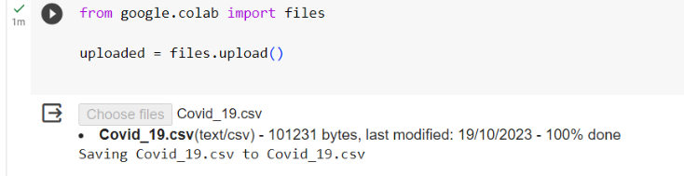

One of the key steps in the data analysis process is data preprocessing. This involves cleaning, transforming, and preparing the data for analysis. Here's an example of data preprocessing in Python using a sample dataset and some common libraries like Pandas and NumPy:

python

Copy code

# Import necessary libraries

import pandas as pd

import numpy as np

# Load your dataset (replace 'your_dataset.csv' with your data file)

data = pd.read_csv('your_dataset.csv')

# Explore the first few rows of the dataset

print(data.head())

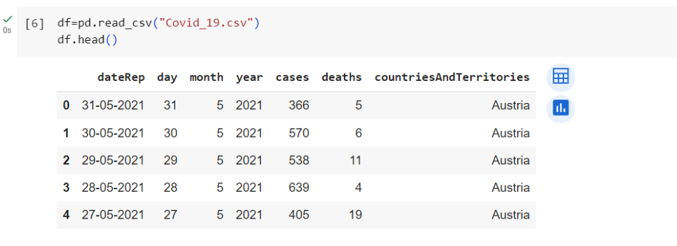

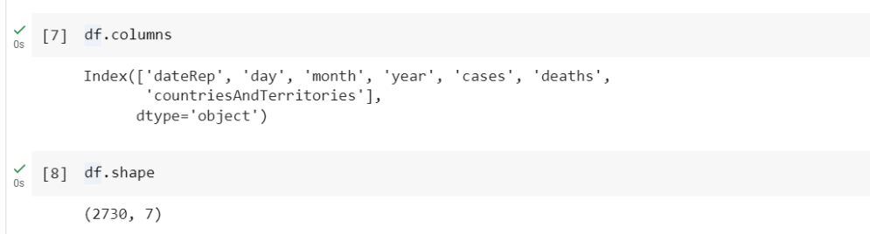

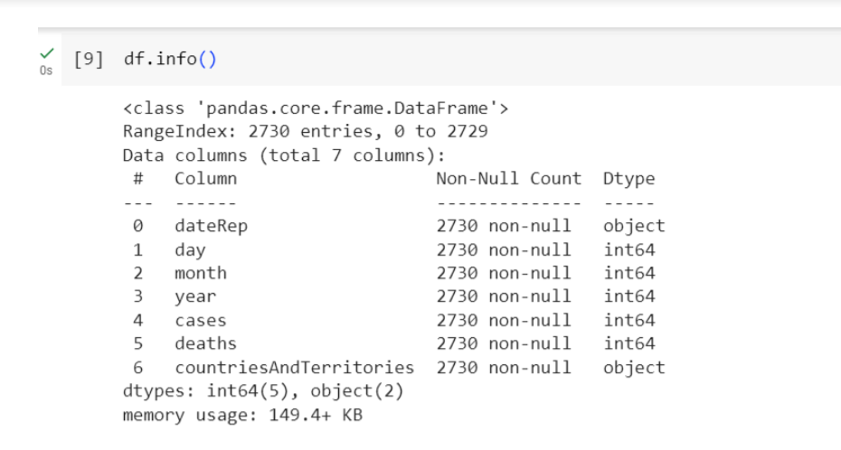

# Check for missing values

print(data.isnull().sum())

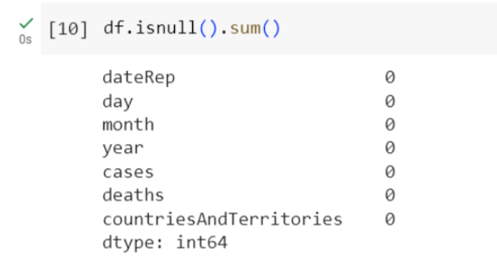

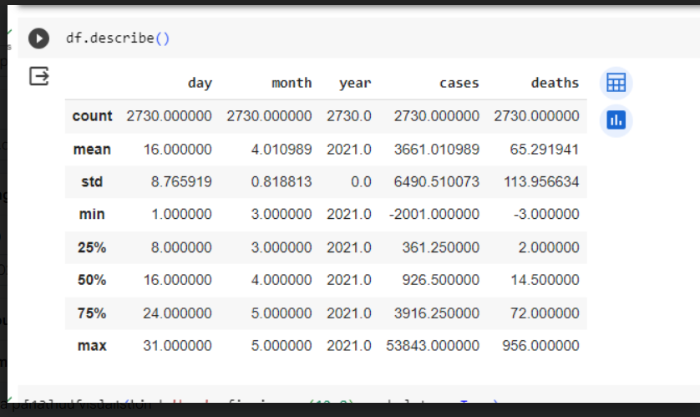

STEP 2: Data Cleaning

Perform data cleaning to handle missing values, remove duplicates, and address any inconsistencies or errors in the data. This can be done using data preparation tools in Cognos or external tools like Excel or Python.

# Handle missing values (if any)

# Example: Replace missing values in a column with the mean of that column

data['column_name_with_missing_values'].fillna(data['column_name_with_missing_values'].mean(), inplace=True)

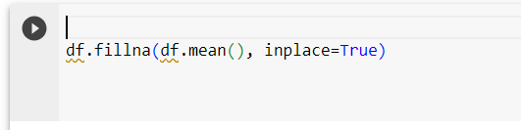

# Remove duplicates (if any)

data.drop_duplicates(inplace=True)

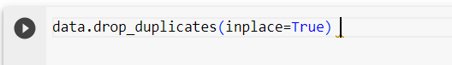

Step 3: Data Visualization:

VISUALIZATION BY USING IBM COGNOS ANALYTICS:

Create Dashboards: In Cognos, you can design interactive dashboards that allow users to interact with data. Dashboards often include various visualizations, such as charts, graphs, and maps.

Here by using IBM COGNOS ANALYTICS we can visualize the map of COVID 19 death cases in the Europian countries.

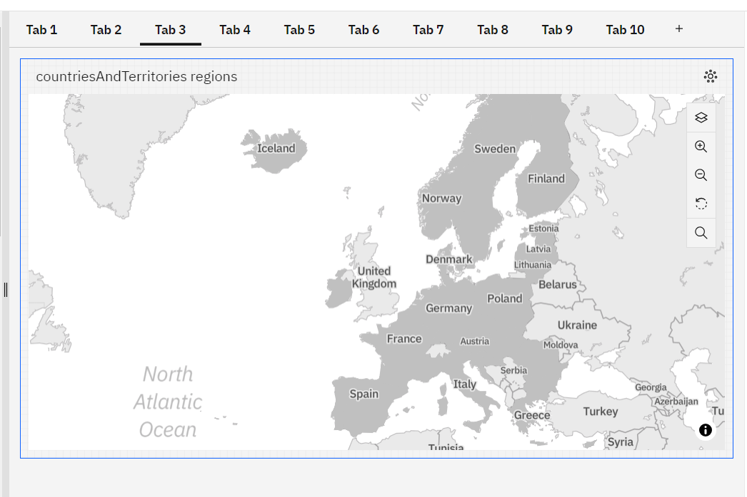

Apply Filters and Interactivity: Add filters and parameters to make your dashboards more interactive. Users should be able to drill down into the data and customize their views. We can even customize the visualization in the ibm cognos analytics.

Here we are using the decision tree to identify the death rates in the europian country;

DECISION TREE

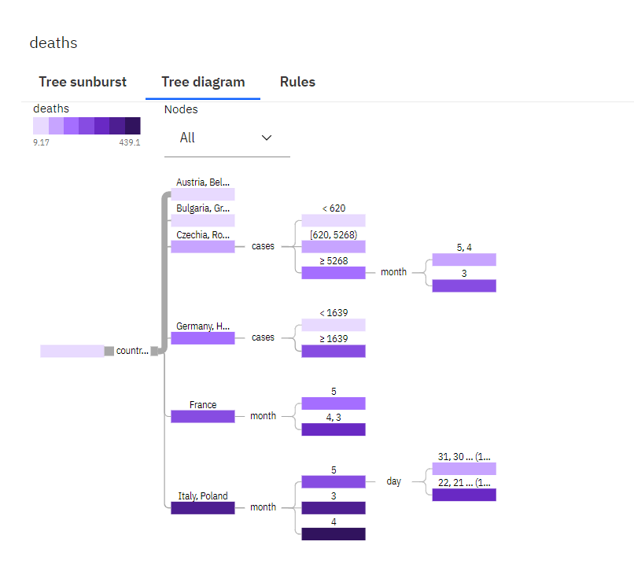

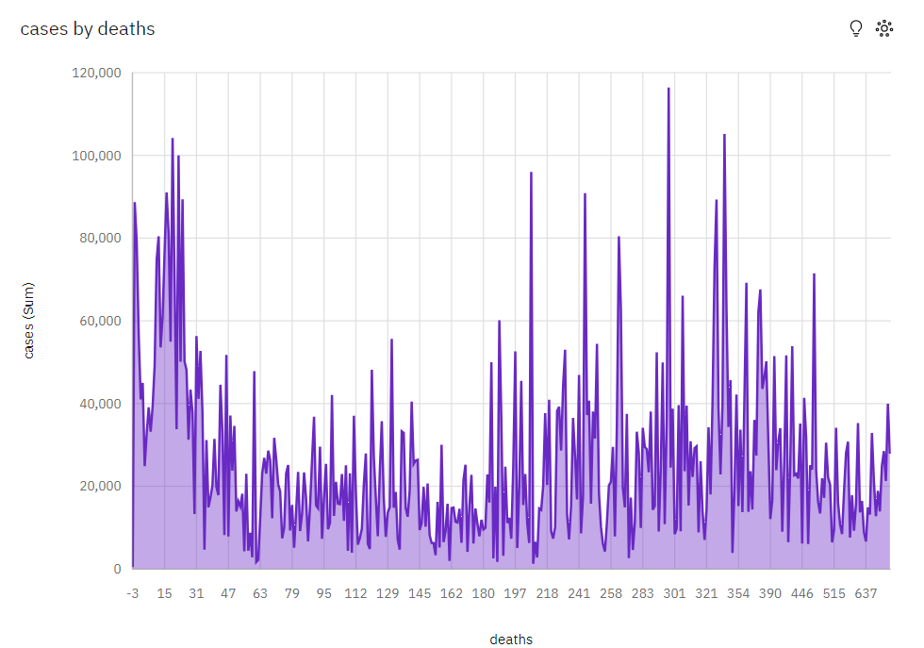

PIE CHART FOR CASES BY DEATHS:

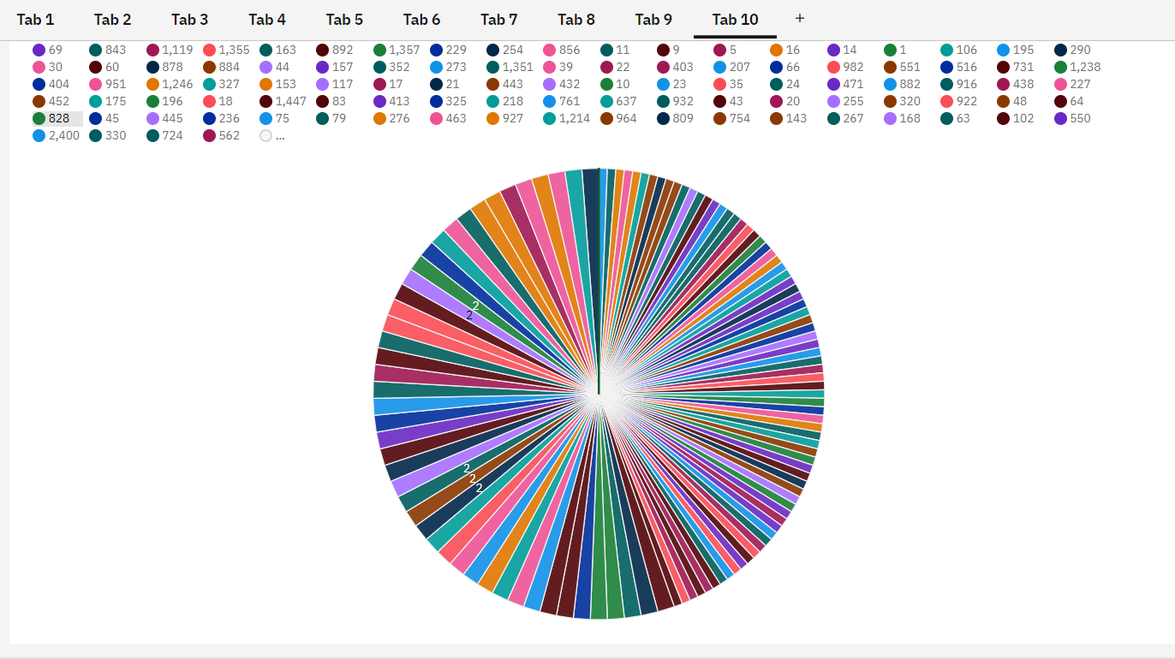

BAR CHART FOR CASES BY MONTH:

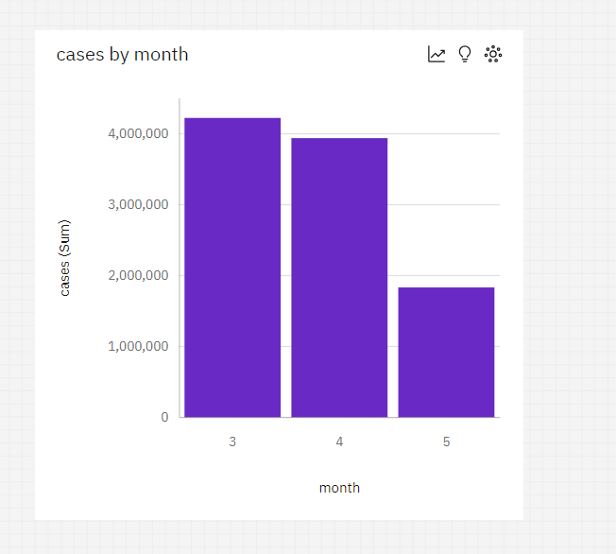

Customize Visualizations:

Customize the appearance and behaviour of your visualizations. Cognos offers a variety of options for fine-tuning chart styles and formatting. We can even customize the visualization in the IBM COGNOS analytics.

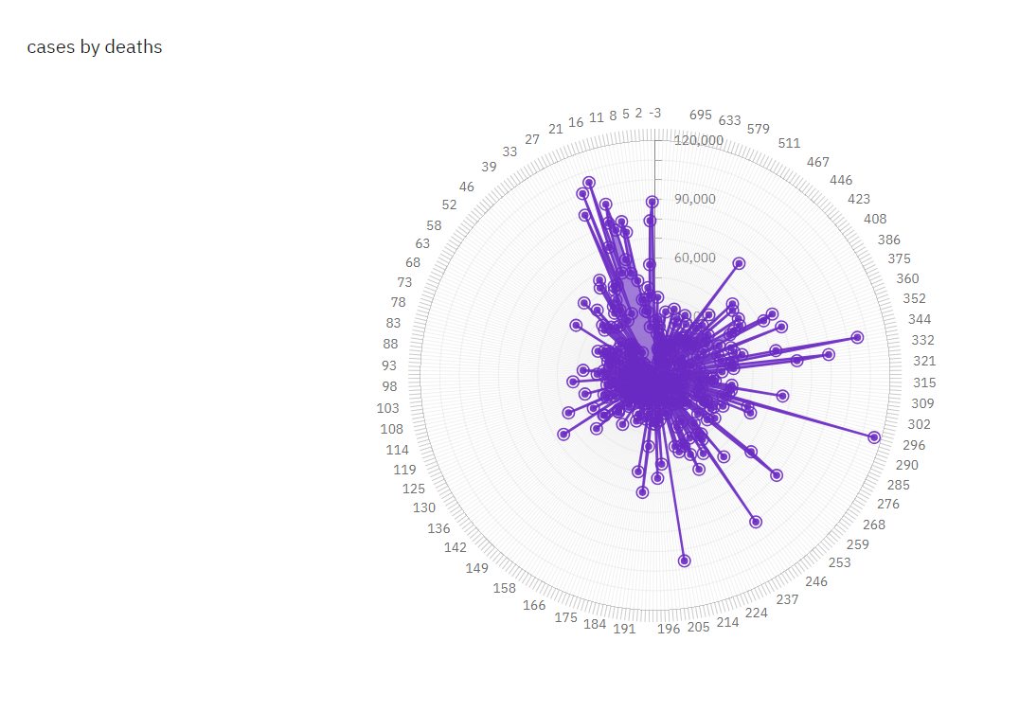

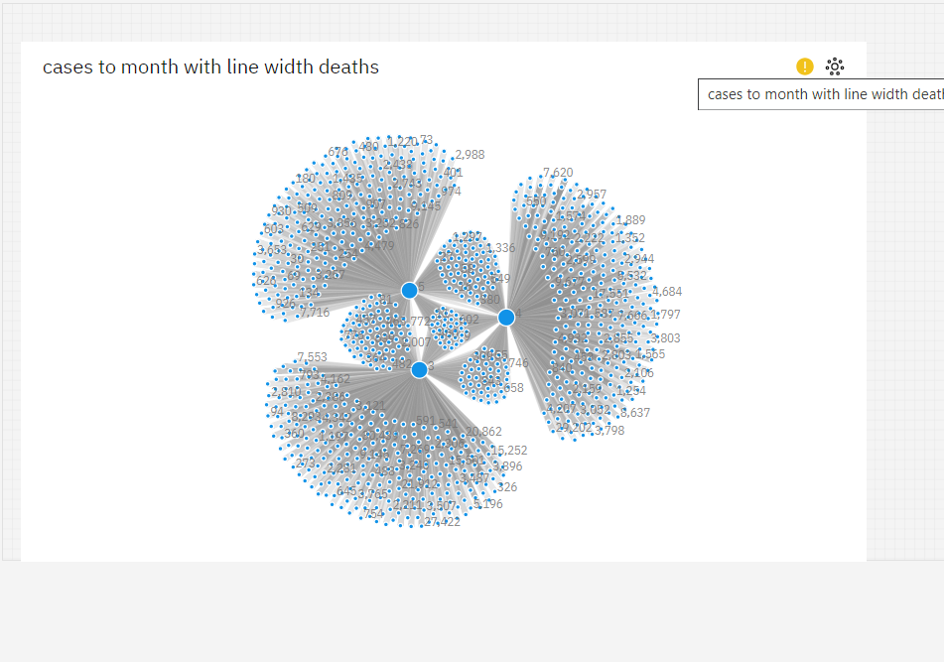

This were the basic visualization techniques used in the visualization of dataset.

BY USING PYTHON:

We can also visualize the dataset using the python

For example here we are using the box plot to visualize the given dataset.

#box plot using python

df.plot(kind='box', figsize = (12,8), subplots = True)

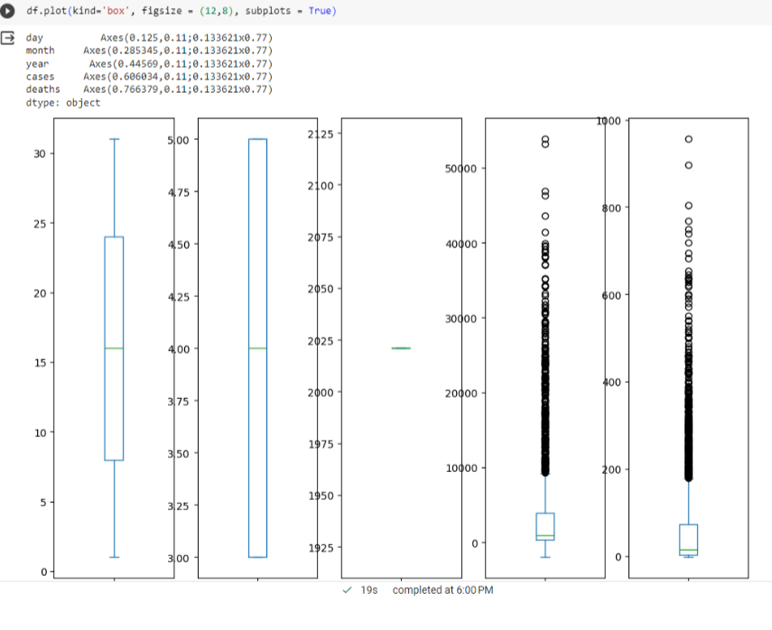

Here we are using the bar plot to visualize the confirmed covid 19 cases.

#BAR PLOT USING PYTHON

Region = df.groupby(by='WHO Region').sum()

Region

Region['Confirmed'].plot(kind='bar', )

plt.title(' Confirmed Cases')

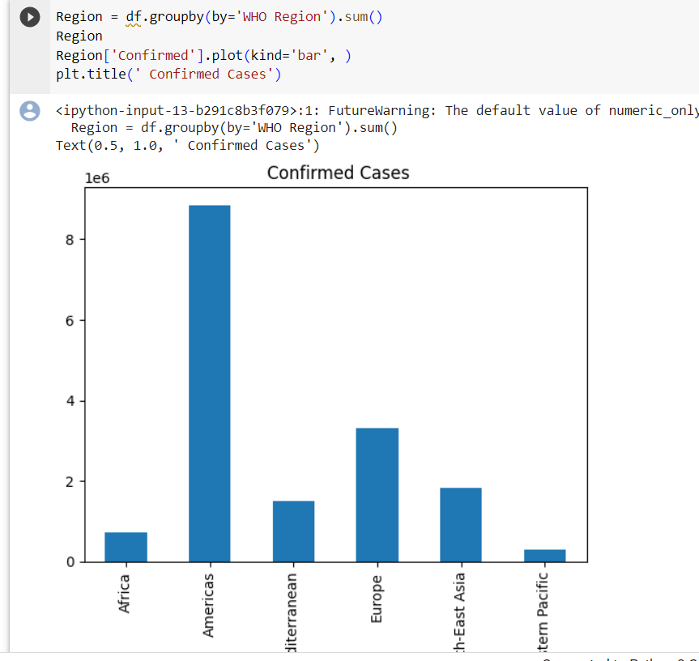

Thus we can use the IBM COGNOS ANALYTICS and PYTHON to preprocessing ,analysing and visualizing the datas.