Drought and Vegetation Stress Mapping in Kenya Using CHIRPS Rainfall and Sentinel-2 NDVI
Prepared by: Vivian Mbachi
Project 6 GIS Portfolio
Year: 2026

1. Introduction
Drought and vegetation stress are major climate-related challenges that can affect food security, water availability, livestock health, agriculture, and community livelihoods. In Kenya, rainfall patterns vary across regions, and some areas are more exposed to dry conditions than others. Monitoring rainfall and vegetation condition is therefore important for understanding where drought stress may be developing.

This project uses free geospatial climate and remote sensing data to map drought and vegetation stress across Kenya for the year 2023. The analysis combines CHIRPS rainfall data and Sentinel-2 satellite imagery to assess rainfall conditions, vegetation health, and combined drought stress priority areas.

The project was designed as part of a GIS portfolio to build practical skills in remote sensing, climate data analysis, raster classification, Google Earth Engine, and ArcMap map production. The final outputs are intended to look like NGO-style decision-support maps that can support drought monitoring, early warning, environmental planning, and food security discussions.

2. Project Goal
The goal of this project is to use free satellite and climate data to identify areas in Kenya where low rainfall and weak vegetation condition may indicate drought stress or environmental vulnerability.
The project specifically aims to:
1. Map rainfall conditions across Kenya using CHIRPS precipitation data.
2. Assess vegetation condition using Sentinel-2 NDVI.
3. Classify rainfall and vegetation data into simple interpretation classes.
4. Combine rainfall and NDVI classes to produce a drought stress priority layer.
5. Create professional GIS map outputs that can support NGO-style climate monitoring, food security planning, and early warning discussions.
The project does not aim to provide final ground-truth drought declarations. Instead, it provides a screening and decision-support output that can help identify areas that may require further monitoring, field verification, or additional data analysis.

3. Study Area
The study area for this project is Kenya. Kenya was selected because it has strong regional differences in rainfall, vegetation condition, land cover, and drought exposure. Some areas receive higher rainfall and support dense vegetation, while other areas are drier and more vulnerable to drought stress.

The analysis was carried out at national scale using the Kenya boundary from the FAO GAUL administrative boundary dataset. Kenya internal administrative boundaries were also used for visual reference in the map outputs.

This national-scale approach is useful for identifying broad rainfall and vegetation stress patterns across the country. However, the results should be interpreted as a general screening analysis, not a detailed local-level drought assessment.

4. Data Used
The project used free geospatial climate and remote sensing datasets accessed mainly through Google Earth Engine.

The main datasets used were:

1. CHIRPS Daily Precipitation

CHIRPS rainfall data was used to analyze rainfall conditions across Kenya for 2023. Daily rainfall images were summed to create an annual rainfall raster, which was then classified into rainfall condition classes.

Dataset ID:
UCSB-CHG/CHIRPS/DAILY

Purpose in the project:
To map rainfall distribution and identify areas with very low, low, moderate, high, and very high rainfall.

2. Sentinel-2 Surface Reflectance Harmonized

Sentinel-2 satellite imagery was used to calculate NDVI for Kenya in 2023. NDVI helped assess vegetation condition and vegetation stress.

Dataset ID:
COPERNICUS/S2_SR_HARMONIZED

Purpose in the project:
To map vegetation condition using NDVI and classify areas into vegetation stress classes.

3. FAO GAUL Administrative Boundaries

FAO GAUL boundaries were used to define the Kenya study area and provide internal administrative boundary reference lines on the maps.

Dataset IDs:
FAO/GAUL/2015/level0
FAO/GAUL/2015/level1

Purpose in the project:
To clip raster outputs to Kenya and display national and internal boundaries for map context.

All datasets were free to access and suitable for noncommercial GIS portfolio learning and climate-risk mapping.

5. Methodology
The project methodology followed a raster-based climate and remote sensing workflow. The analysis was first carried out in Google Earth Engine, and the processed raster outputs were later exported to ArcMap for final map styling and layout production.

The main methodology steps were:

1. Study Area Preparation

The Kenya national boundary was loaded from the FAO GAUL 2015 Level 0 dataset. The boundary was used to define the study area and clip the final raster outputs to Kenya. FAO GAUL Level 1 administrative boundaries were also loaded to provide internal reference boundaries on the maps.

2. CHIRPS Rainfall Processing

CHIRPS daily precipitation data was filtered for the period from 1 January 2023 to 31 December 2023. The daily rainfall images were summed to create an annual rainfall raster for Kenya. The rainfall raster was then clipped to the Kenya boundary and classified into five rainfall classes: very low rainfall, low rainfall, moderate rainfall, high rainfall, and very high rainfall.

3. Sentinel-2 NDVI Processing

Sentinel-2 Surface Reflectance imagery was filtered to Kenya for the year 2023. Images with cloud cover below 20 percent were selected to reduce cloud-related errors. A median composite image was created, and NDVI was calculated using Sentinel-2 Band 8, which represents near infrared, and Band 4, which represents red reflectance.

4. NDVI Classification

The NDVI raster was reclassified into five vegetation condition classes: very low vegetation, low vegetation, moderate vegetation, healthy vegetation, and very healthy vegetation. This made the NDVI output easier to interpret for non-technical users.

5. Combined Drought Stress Priority Layer

The rainfall class raster and NDVI vegetation stress class raster were combined to create a drought stress priority layer. Areas with lower rainfall and weaker vegetation condition were assigned higher drought stress priority. The final drought stress layer was classified into five priority classes: very high, high, moderate, low, and very low.

6. Export and ArcMap Styling

The processed raster outputs were exported from Google Earth Engine as GeoTIFF files. The exported rasters were opened in ArcMap 10.8, styled using meaningful colors and labels, and used to produce final map layouts. Value 0 was treated as background outside Kenya and hidden during map styling.

7. Final Map Production

Four final PNG maps were exported at 300 dpi: a drought stress priority map, a CHIRPS rainfall classes map, an NDVI vegetation stress map, and a three-panel comparison map showing rainfall, vegetation, and drought stress together.

6. Results and Map Outputs
The project produced four final map outputs. Each map was exported from ArcMap as a PNG file at 300 dpi and saved in the 5_Maps folder.

1. Map 1: Drought Stress Priority in Kenya, 2023

File name:
Map_1_Drought_Stress_Priority_Kenya_2023.png

This map shows the combined drought stress priority layer created from CHIRPS rainfall classes and Sentinel-2 NDVI vegetation stress classes. Areas shown in red and orange represent higher drought stress priority, while green areas represent lower drought stress priority.

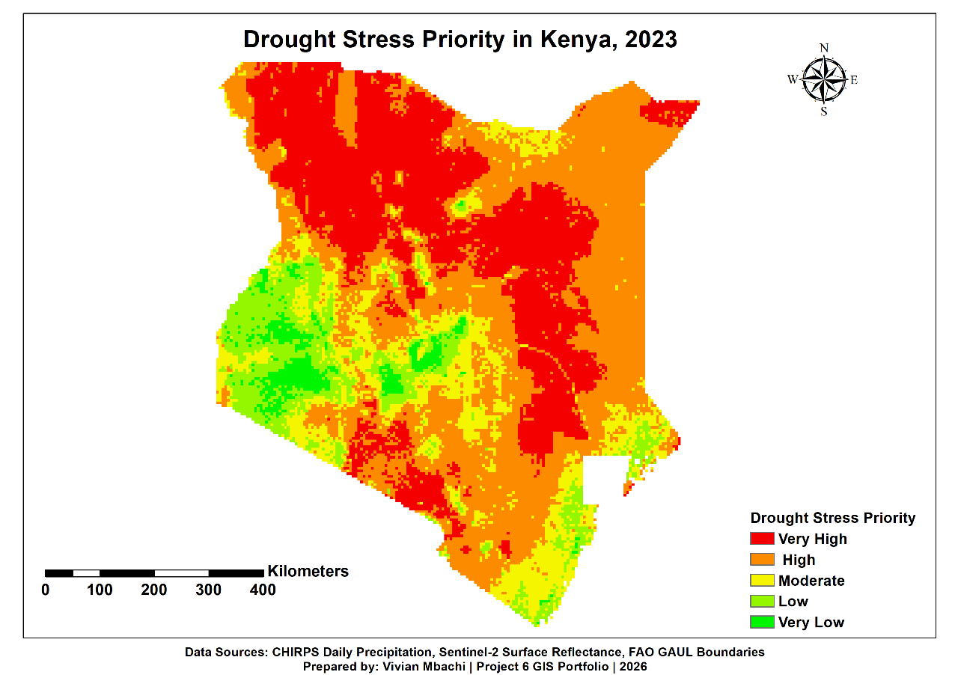

Figure 1: Drought Stress Priority in Kenya, 2023

2. Map 2: CHIRPS Rainfall Classes in Kenya, 2023

File name:
Map_2_CHIRPS_Rainfall_Classes_Kenya_2023.png

This map shows rainfall classes across Kenya for 2023. The rainfall classes range from very low rainfall to very high rainfall. The map helps identify areas that received lower rainfall and may require closer drought monitoring.

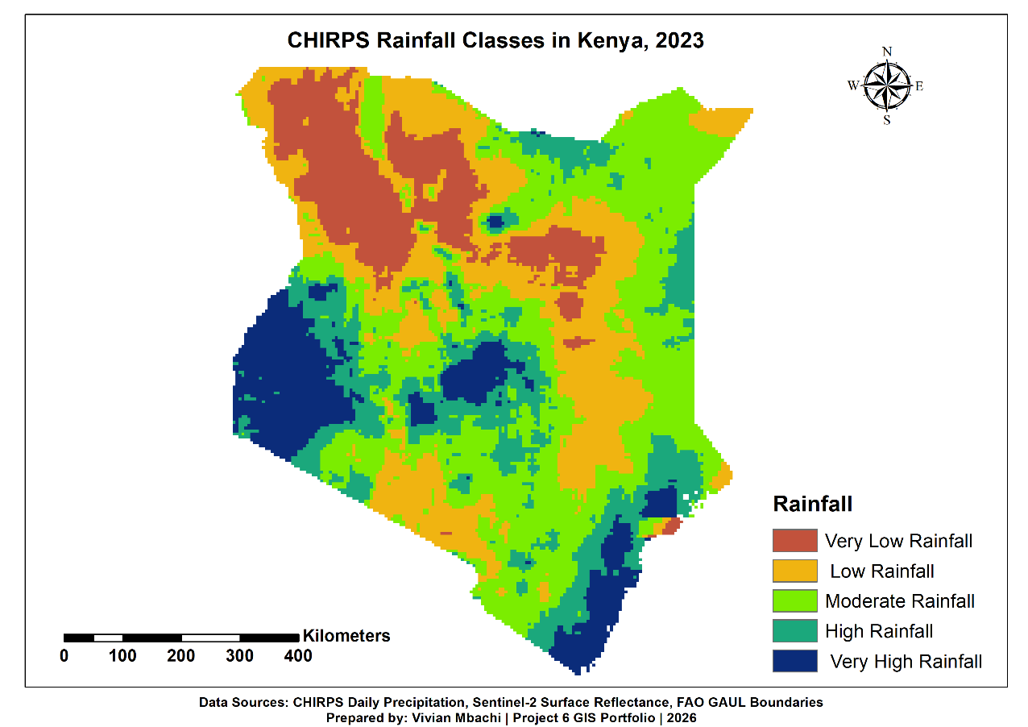

Figure 2: CHIRPS Rainfall Classes in Kenya, 2023

3. Map 3: NDVI Vegetation Stress in Kenya, 2023

File name:
Map_3_NDVI_Vegetation_Stress_Kenya_2023.png

This map shows vegetation condition across Kenya using Sentinel-2 NDVI. Brown and orange areas represent weaker vegetation condition, while green areas represent healthier vegetation. The map helps show where vegetation may be more stressed.

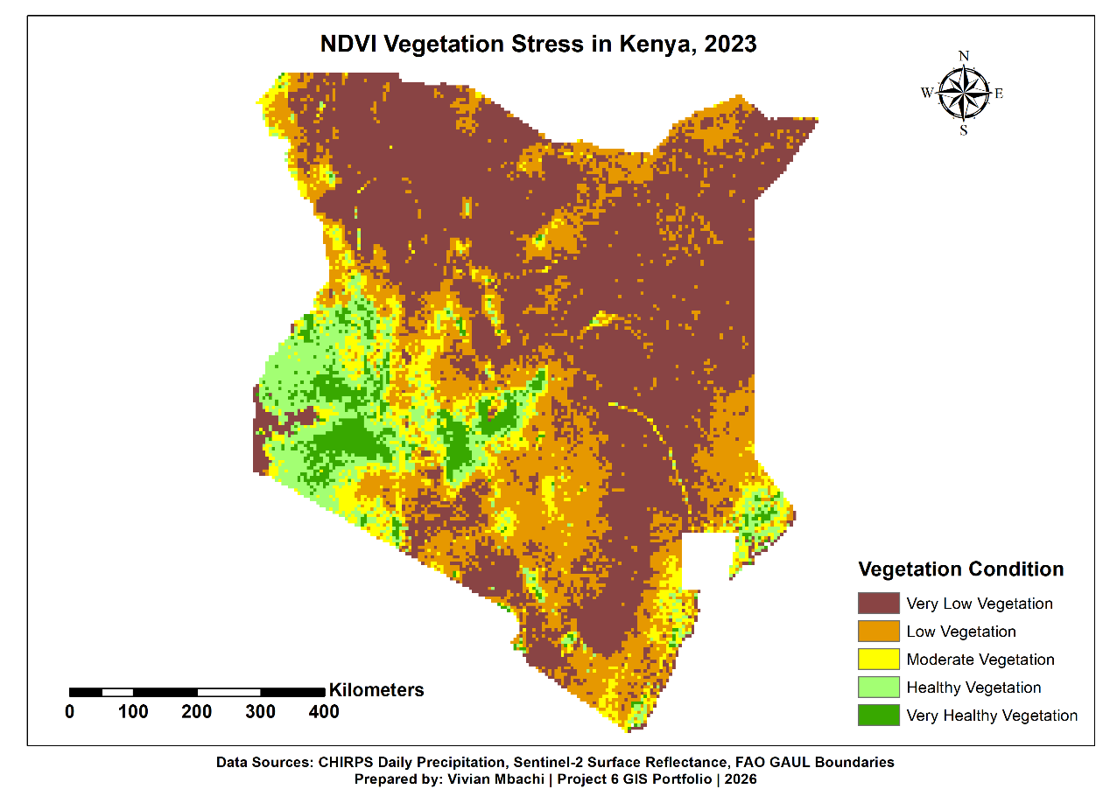

Figure 3: NDVI Vegetation Stress in Kenya, 2023

4. Map 4: Rainfall, Vegetation, and Drought Stress Comparison in Kenya, 2023

File name:
Map_4_Rainfall_NDVI_Drought_Comparison_Kenya_2023.png

This comparison map shows rainfall classes, NDVI vegetation condition, and drought stress priority side by side. It helps explain how areas with low rainfall and weak vegetation generally correspond to higher drought stress priority.

Overall, the outputs show how climate data and satellite imagery can be combined to produce simple, useful decision-support maps for drought monitoring and environmental risk interpretation.

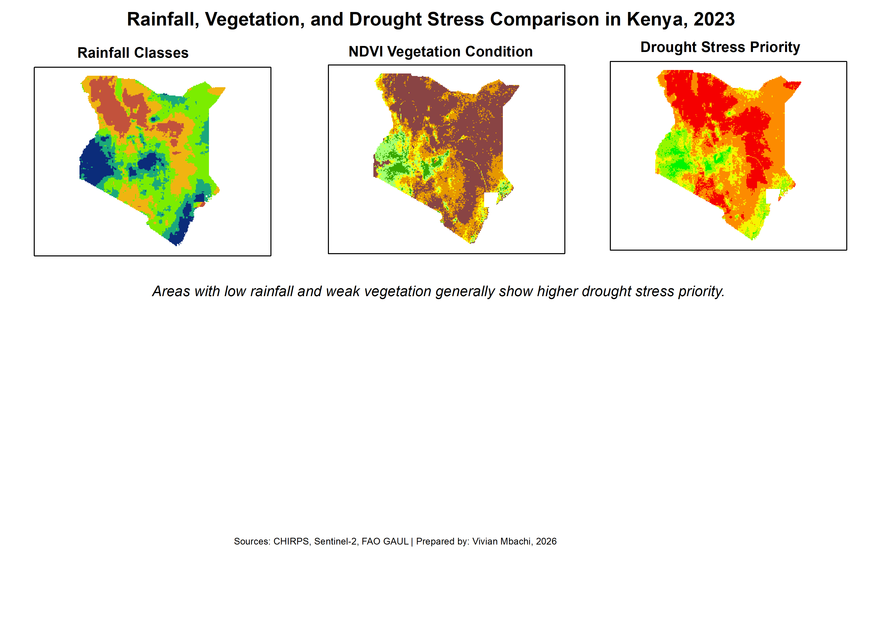

Figure 4: Rainfall, Vegetation, and Drought Stress Comparison in Kenya, 2023

7. Key Findings
The analysis showed that rainfall and vegetation condition vary across Kenya. Some areas displayed lower rainfall classes and weaker vegetation condition, while other areas showed higher rainfall and healthier vegetation.

The CHIRPS rainfall class map showed broad differences in rainfall distribution across the country. Areas with very low and low rainfall are important for drought monitoring because rainfall shortage can affect water availability, pasture condition, crop performance, and community livelihoods.

The Sentinel-2 NDVI vegetation stress map showed differences in vegetation condition across Kenya. Areas with very low or low vegetation may indicate sparse vegetation, dry conditions, bare land, land degradation, or seasonal vegetation stress.

The combined drought stress priority map showed areas where low rainfall and weak vegetation condition overlap. These areas were classified as higher drought stress priority. This does not mean they are officially declared drought areas, but it suggests they may require closer monitoring, field verification, and additional data analysis.

The comparison map helped show the relationship between rainfall, vegetation condition, and drought stress priority. In general, areas with low rainfall and weak vegetation were more likely to appear as higher drought stress priority areas.

8. Limitations
This project provides a useful national-level drought and vegetation stress screening output, but it has several limitations.

First, the analysis uses CHIRPS rainfall estimates rather than direct rainfall station measurements everywhere. CHIRPS is suitable for broad rainfall analysis, but it may contain uncertainty, especially in areas with fewer ground stations.

Second, NDVI shows vegetation greenness, but it does not directly measure food insecurity, crop yield, livestock condition, soil moisture, or household vulnerability. Low NDVI may be caused by drought, but it may also be caused by bare land, urban areas, seasonal vegetation changes, soil brightness, or land cover differences.

Third, the drought stress priority layer is simplified because it combines only rainfall and NDVI classes. A more complete drought vulnerability assessment would also include population exposure, livestock data, crop production, soil moisture, water access, poverty indicators, market prices, and field observations.

Fourth, the analysis was carried out at national scale. This means the maps are useful for broad screening and portfolio learning, but they should not be used alone for detailed local-level planning or operational humanitarian decisions.

Finally, the classification thresholds used in the project are general. They help make the maps easier to understand, but they may not perfectly represent conditions in every ecological zone of Kenya.

9. NGO and Climate Relevance
This project is relevant to NGO and climate-related work because it shows how free geospatial data can be used to support drought monitoring, environmental assessment, and early warning analysis.

The CHIRPS rainfall map can help identify areas that experienced lower rainfall during the year. This information is useful for climate monitoring, water planning, food security discussions, and drought preparedness.

The Sentinel-2 NDVI vegetation stress map can help show areas where vegetation condition appears weak or stressed. This is useful for understanding possible impacts on grazing areas, vegetation cover, land degradation, and environmental vulnerability.

The combined drought stress priority map is especially relevant for NGO decision-support because it brings rainfall and vegetation condition together into one simple priority layer. This can help organizations identify areas that may require closer monitoring, field verification, or further vulnerability assessment.

The project also demonstrates a low-cost workflow that can be repeated by students, GIS analysts, NGOs, and community-based organizations using free datasets and accessible GIS tools. This makes the approach useful for climate resilience, disaster risk reduction, food security mapping, and environmental planning.

10. Skills Learned
This project helped build several new GIS, climate, and remote sensing skills.

The main skills learned include:

1. Google Earth Engine basics

I learned how to open the Google Earth Engine Code Editor, create a script, load datasets, filter data by date and study area, display map layers, and export processed outputs to Google Drive.

2. Remote sensing with Sentinel-2 imagery

I learned how Sentinel-2 satellite imagery can be used to analyze land and vegetation conditions. I also learned that different satellite bands can be combined to calculate vegetation indices.

3. NDVI analysis

I learned how NDVI is calculated using near infrared and red bands. In this project, Sentinel-2 Band 8 and Band 4 were used to calculate NDVI and assess vegetation condition across Kenya.

4. Raster clipping and masking

I learned how raster layers can be clipped and masked to a study area boundary so that analysis only appears inside Kenya.

5. Climate raster analysis using CHIRPS

I learned how daily rainfall raster data can be filtered, summed into annual rainfall, and classified into rainfall condition classes.

6. Raster reclassification

I learned how continuous rainfall and NDVI values can be converted into simple classes that are easier for non-technical users to understand.

7. Multi-criteria raster overlay

I learned how rainfall classes and NDVI vegetation stress classes can be combined to create a new drought stress priority layer.

8. GeoTIFF export and desktop GIS workflow

I learned how to export processed raster outputs from Google Earth Engine as GeoTIFF files and open them in ArcMap for final styling and map layout production.

9. Professional map production in ArcMap

I improved my skills in raster symbology, legend editing, layout design, map export, and creating comparison maps.

10. GIS documentation and metadata writing

I practiced writing metadata READMEs, quality logs, processing notes, map output documentation, and report sections for a complete professional GIS project.

11. Conclusion
This project demonstrated how free climate and remote sensing data can be used to map drought and vegetation stress in Kenya. By combining CHIRPS rainfall data and Sentinel-2 NDVI, the project produced useful maps showing rainfall classes, vegetation condition, and combined drought stress priority areas for 2023.

The results show that Google Earth Engine and ArcMap can be used together in a practical workflow. Google Earth Engine was useful for accessing and processing large satellite and climate datasets, while ArcMap was used to style the outputs and create final professional map layouts.

The project also showed that drought analysis should not rely on one dataset alone. Rainfall data provides climate context, while NDVI provides vegetation condition information. When combined, these datasets can support early screening of areas that may require closer monitoring, field verification, or further vulnerability assessment.

Although the project has limitations, it is a strong portfolio example because it demonstrates remote sensing, climate data analysis, raster classification, raster overlay, cloud-based GIS processing, map production, and professional documentation. The workflow can be improved in future by adding population data, livestock data, crop production, soil moisture, water access, and field observations.

Overall, Project 6 strengthened my ability to create GIS outputs that are relevant to climate resilience, drought monitoring, food security, environmental planning, and NGO decision-support.

