Manifest

This file would give some guidance to the different files and folder structure within my project. Under my github page, there are currently two repositories, which is shown in the following figure.

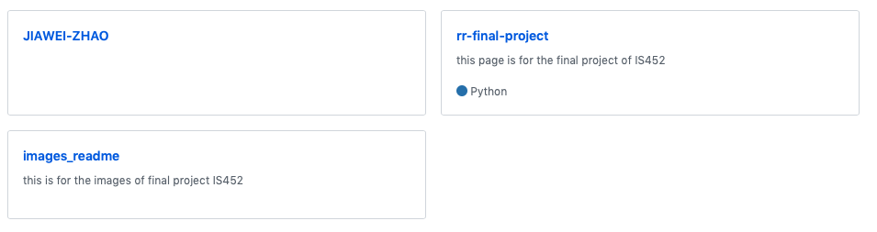

The rr-final-project contains all the files related to my final project. The images_readme contains all the images I used in my readme.md file and manifest file.

In the rr-final-project repository (figure below), there are several files, which is described as follows:

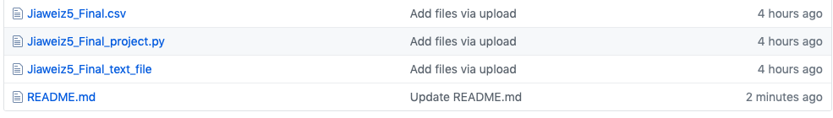

1. Jiaweiz5_Final_text_file: the text file to be converted.
2. [Jiaweiz5_Final.csv](https://github.com/vivizhao95/rr-final-project/blob/master/Jiaweiz5_Final.csv): the csv converted.
3. [Jiaweiz5_Final_Narratives.docx](https://github.com/vivizhao95/rr-final-project/blob/master/Jiaweiz5_Final_Narratives.docx): narrative file of this final project.
4. [Jiaweiz5_Final_project.py](https://github.com/vivizhao95/rr-final-project/blob/master/Jiaweiz5_Final_project.py): py file contains codes and comments of this project.
5. [README.md](https://github.com/vivizhao95/rr-final-project/blob/master/README.md): a readme file to guide you through my whole project.