VisualHAZOP lets a HAZOP performed allowing participants to keep reviewing the drawing while discussions are being recorded by the scribe. The app opens a PDF drawing and let flow lines i.e. nodes be marked on it with different colors and thickness (Figure 1). Deviations probable on the node are captured and shown in the spreadsheet view (Figure 2).
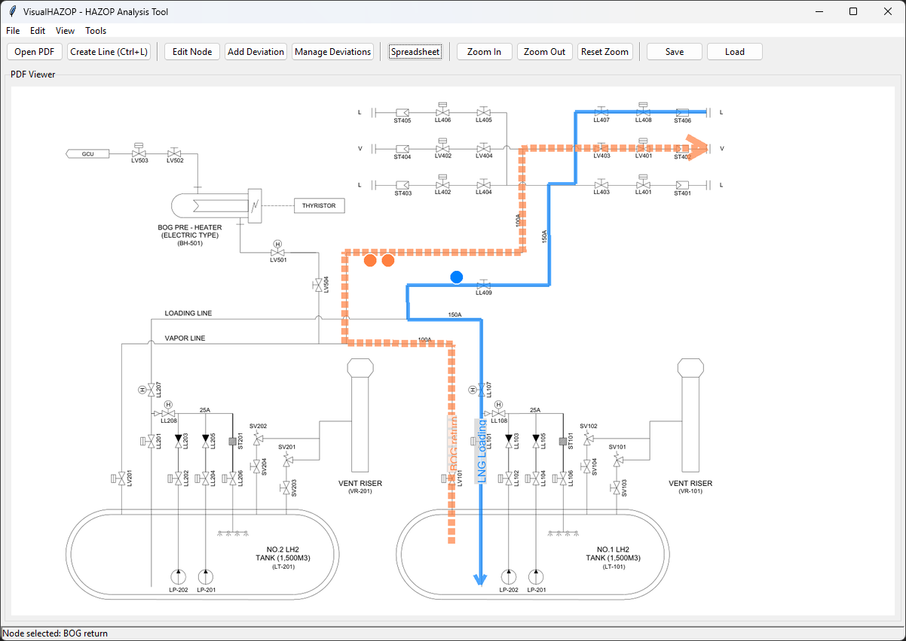
Figure 1 VisualHAZOP having loaded a PFD with two nodes and three deviations
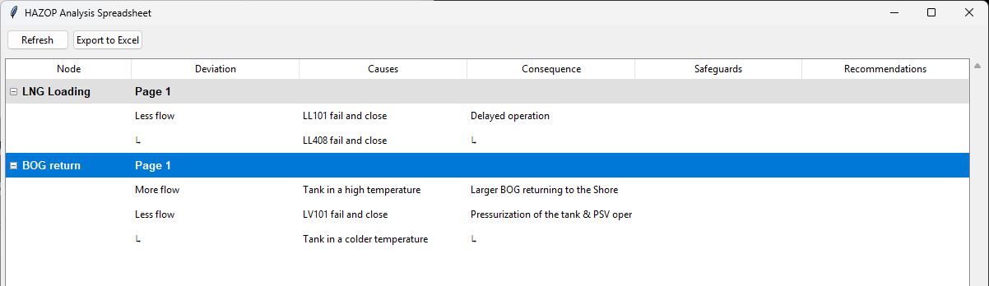
Figure 2 VisualHAZOP spreadsheet view
Figure 3 shows a list of deviations per a node and one of them is being edited. A deviation may have a few causes but one consequence. There can be multiple safeguards and recommendations associated with the deviation. A comment can be added to the deviation.
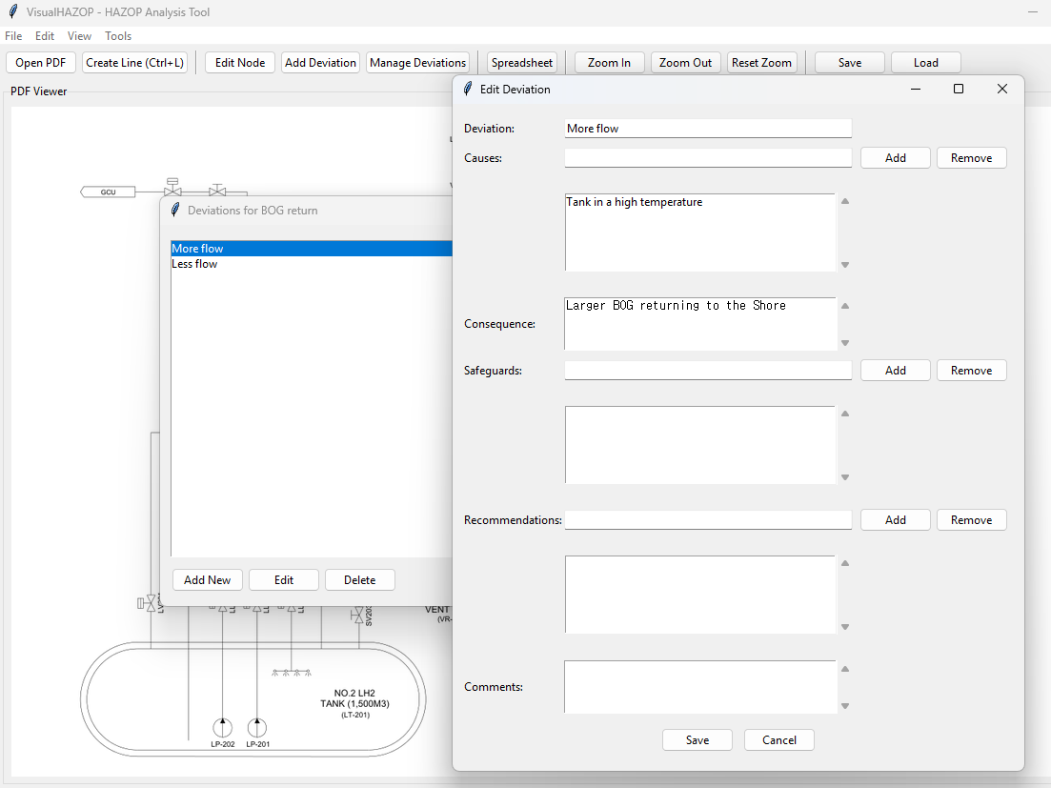
Figure 3 VisualHAZOP Adding a deviation
The analysis is saved in a JSON format. It has the absolute path to the PDF file and information on the nodes with deviations (Figure 4). And the spreadsheet can be exported as an Excel file (Figure 5).
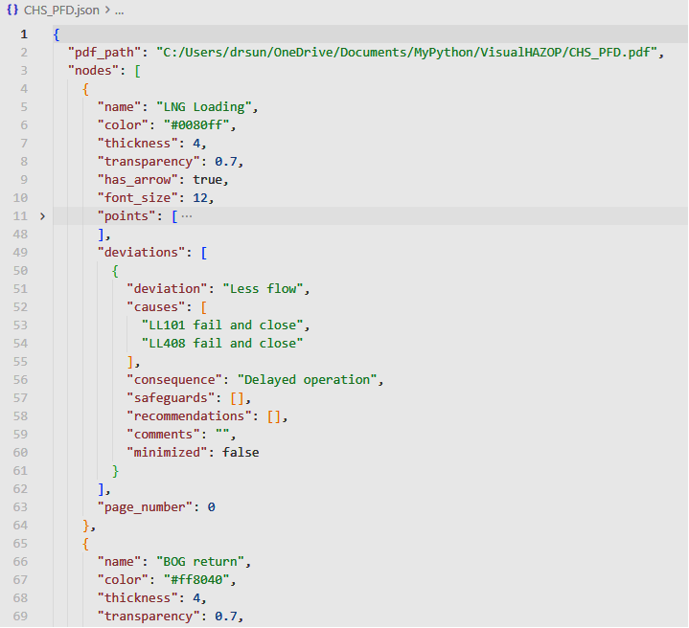
Figure 4 VisualHAZOP JSON format

Figure 5 VisualHAZOP Worksheet exported into an Excel file

