School: Engineering And Technology.
Dept: Computer Science & Engineering.
Subject: ELECTIVE -2(CRYPTOGRAPHY AND CYBER SECURITY ) LAB….
((( Assignment )))
Name: Abir Paul
Course: B.Tech
Roll No: UG/02/BTCSE/2018/061
Enrolment No: AU/2018/02/0002552
Sec: B
Year: 3rd
Semester: 6th

ASSIGMNENT : 1
1.
Program Code:

//1
#include <math.h>
#include <stdio.h>

int main() {
double base, exp, result;
printf("Enter a base number: ");
scanf("%lf", &base);
printf("Enter an exponent: ");
scanf("%lf", &exp);

// calculates the power
result = pow(base, exp);

printf("%.1lf^%.1lf = %.2lf", base, exp, result);
return 0;
}

Output:
Enter a base number: 2.3
Enter an exponent: 4.5
2.3^4.5 = 42.44
Screenshot of Output:

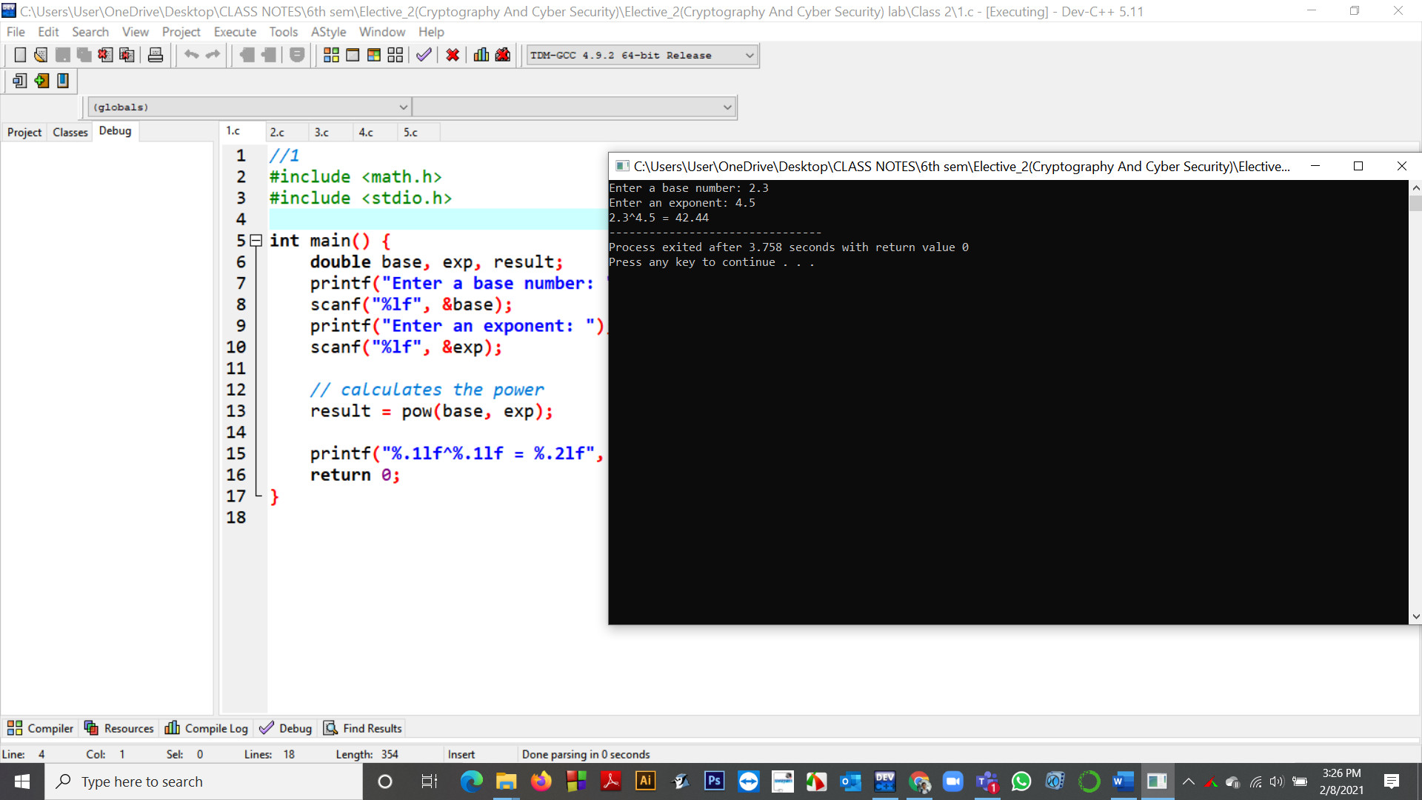

2.
Program Code:
//2
#include <stdio.h>
#include <math.h>
int main()
{
double num = 5.6, result;

result = log(num);
printf("log(%.1f) = %.2f", num, result);

return 0;
}
Output:
log(5.6) = 1.72
Screenshot of Output:
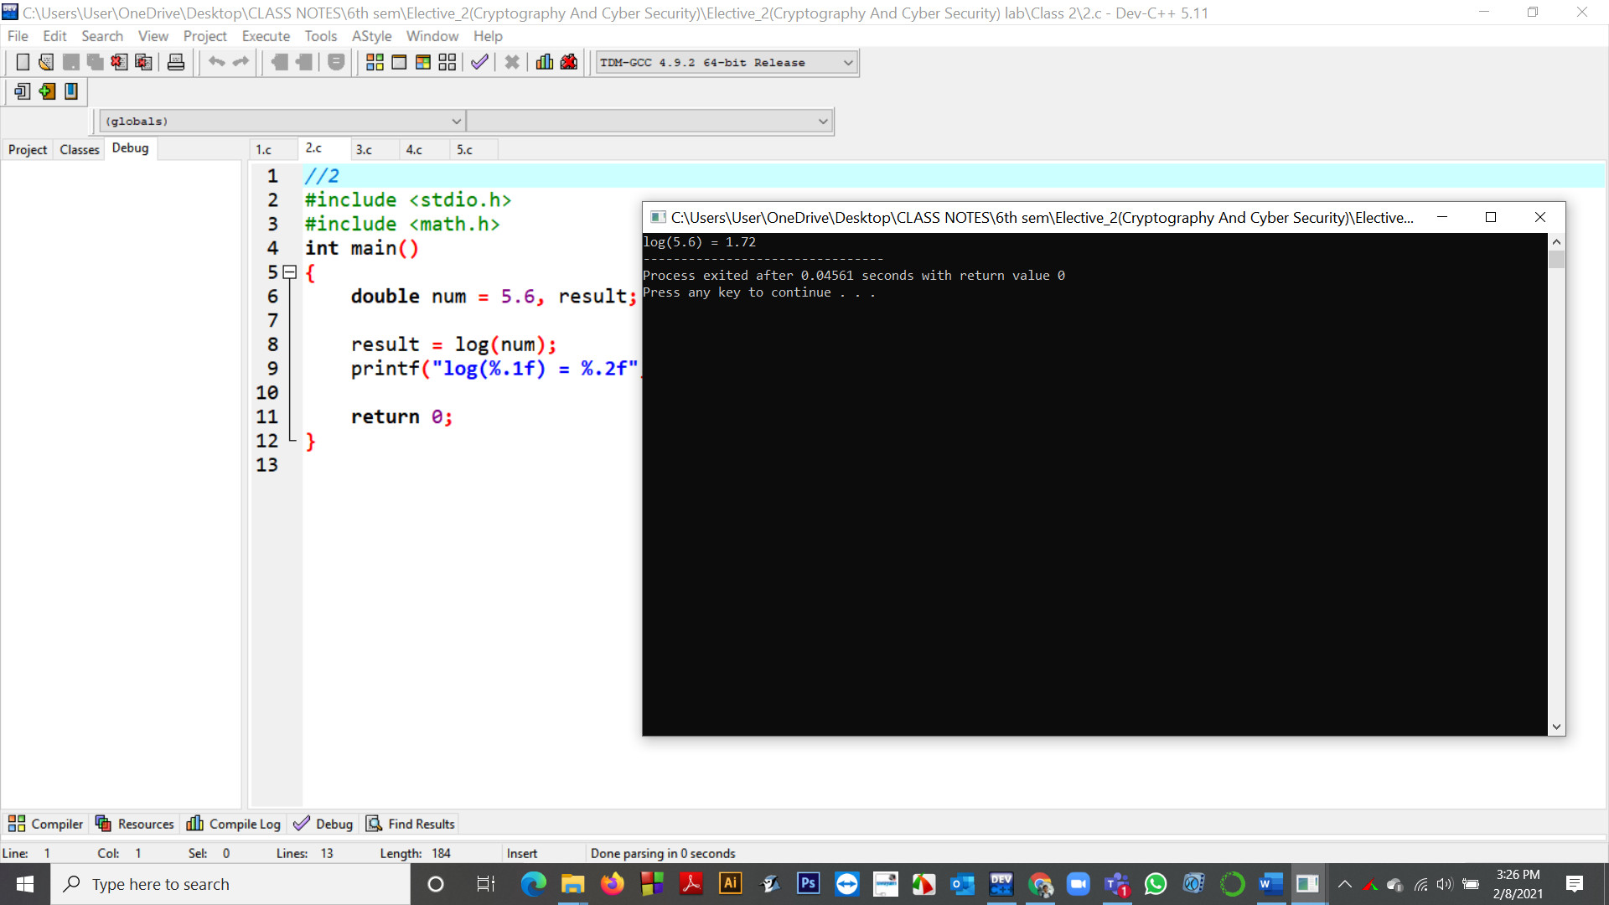

3.
Program Code:
//3
#include <stdio.h>
#include <math.h>

int main()
{
double x;
double result;

x = 2.3;
result = sin(x);
printf("sin(%.2lf) = %.2lf\n", x, result);

x = -2.3;
result = sin(x);
printf("sin(%.2lf) = %.2lf\n", x, result);

x = 0;
result = sin(x);
printf("sin(%.2lf) = %.2lf\n", x, result);

return 0;
}
Output:
sin(2.30) = 0.75
sin(-2.30) = -0.75
sin(0.00) = 0.00

Screenshot of Output:
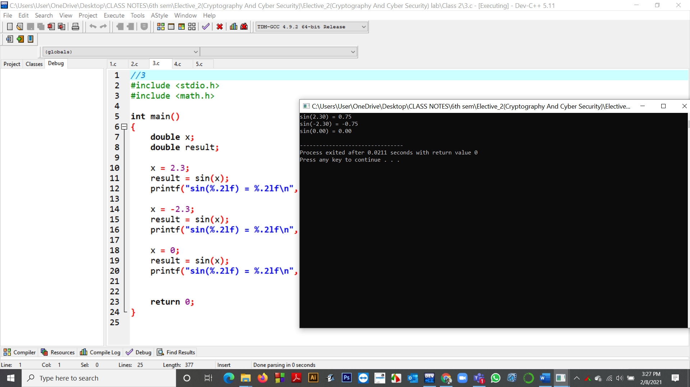
4. C program to demonstrate Basic Euclidean Algorithm
Program Code:
//4 .C program to demonstrate Basic Euclidean Algorithm
#include <stdio.h>

// Function to return gcd of a and b
int gcd(int a, int b)
{
if (a == 0)
return b;
return gcd(b % a, a);
}

// Driver program to test above function
int main()
{
int a = 10, b = 15;
printf("GCD(%d, %d) = %d\n", a, b, gcd(a, b));
a = 35, b = 10;
printf("GCD(%d, %d) = %d\n", a, b, gcd(a, b));
a = 31, b = 2;
printf("GCD(%d, %d) = %d\n", a, b, gcd(a, b));
return 0;
}

Output:
GCD(10, 15) = 5
GCD(35, 10) = 5
GCD(31, 2) = 1

Screenshot of Output:
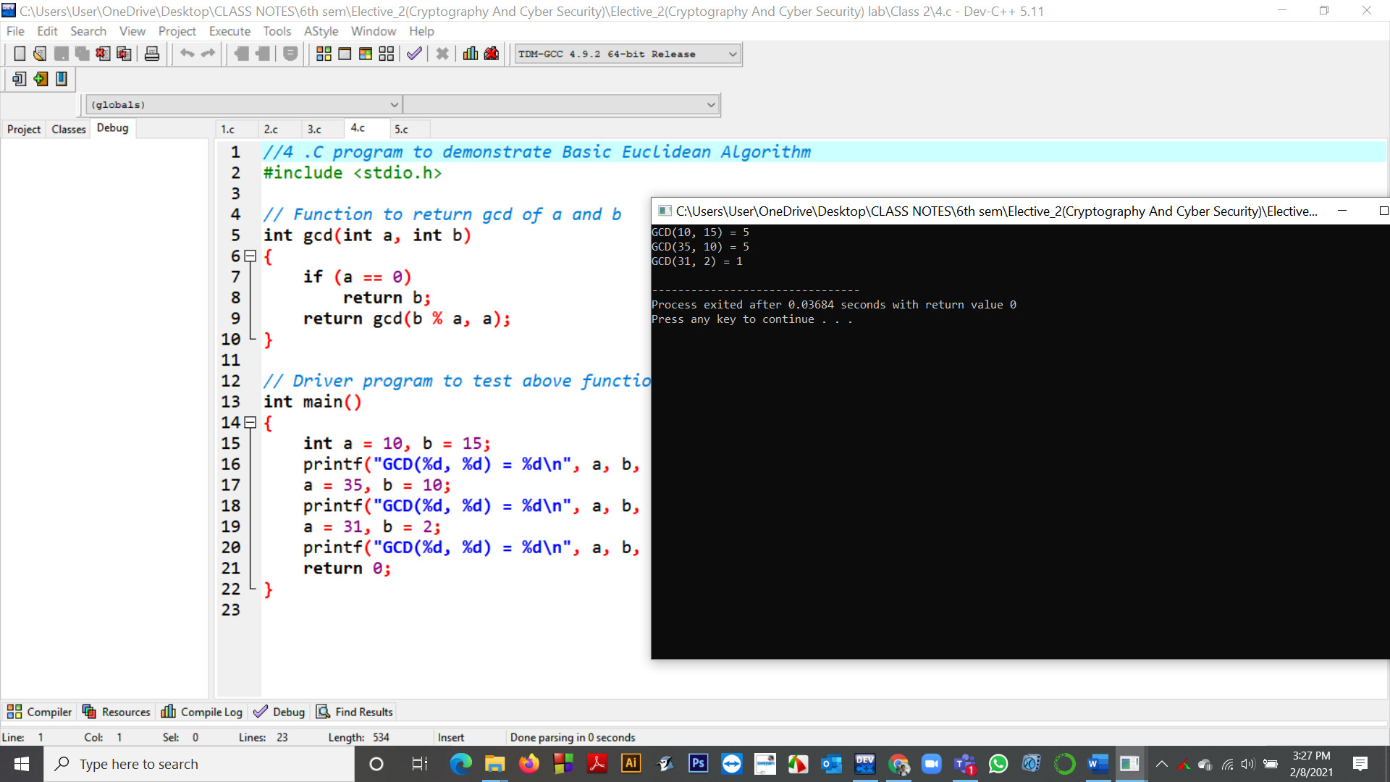

5. C function for extended Euclidean Algorithm
Program Code:
//5
#include <stdio.h>

// C function for extended Euclidean Algorithm
int gcdExtended(int a, int b, int* x, int* y)
{
// Base Case
if (a == 0) {
*x = 0;
*y = 1;
return b;
}

int x1, y1; // To store results of recursive call
int gcd = gcdExtended(b % a, a, &x1, &y1);

// Update x and y using results of recursive
// call
*x = y1 - (b / a) * x1;
*y = x1;

return gcd;
}

// Driver Program
int main()
{
int x, y;
int a = 35, b = 15;
int g = gcdExtended(a, b, &x, &y);
printf("gcd(%d, %d) = %d", a, b, g);
return 0;
}
Output:
gcd(35, 15) = 5
Screenshot of Output:

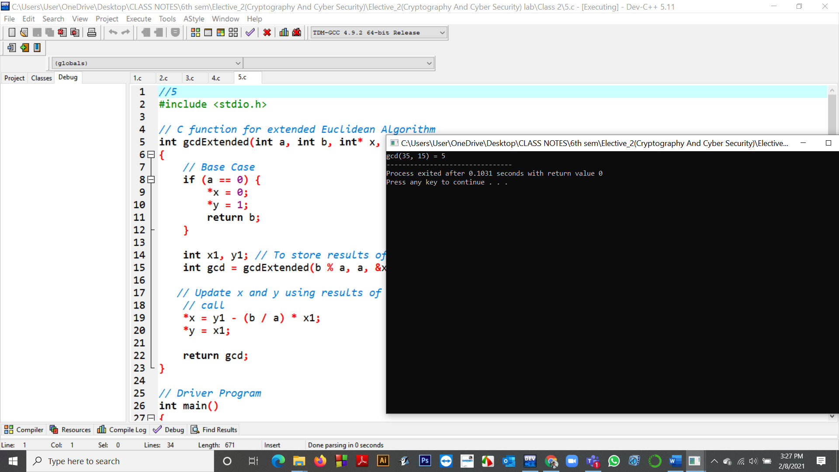

ASSIGMNENT : 3

- Find multiplication inverse of 17 in z-25 domain
Program Code:
def modInverse (a, m):

for x in range(1, m):

if (((a%m) * (x%m)) % m == 1):
return x
return 1

# Driver Code

a = 17

m = 25

# Function call

print (modInverse(a, m))

Output: 3
Screenshot of Output:

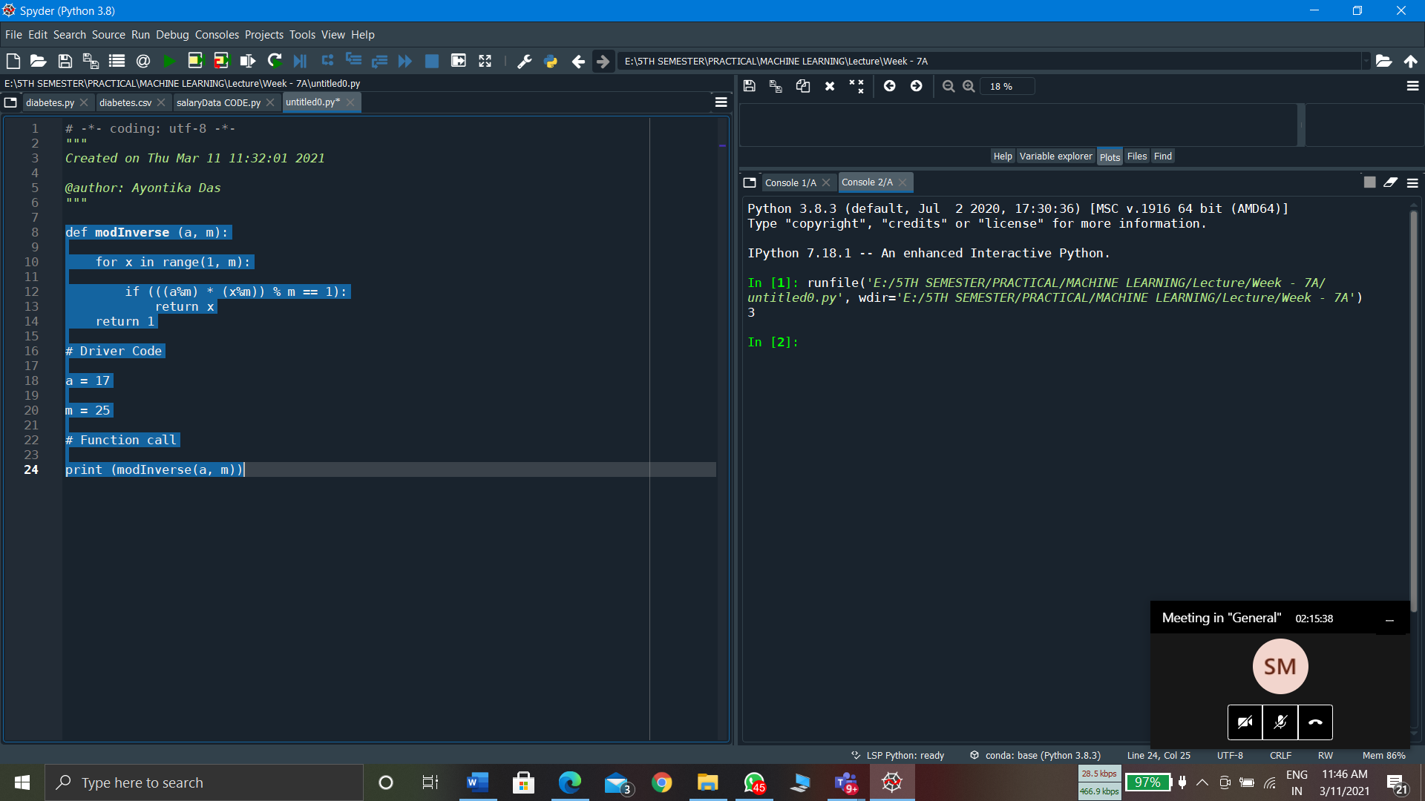

- Find multiplication inverse of 16 in z-21 domain

Program Code:
def modInverse (a, m):

for x in range(1, m):

if (((a%m) * (x%m)) % m == 1):
return x
return 1

# Driver Code
a = 16
m = 21
# Function call

print (modInverse(a, m))
Output: 4

Screenshot of Output:

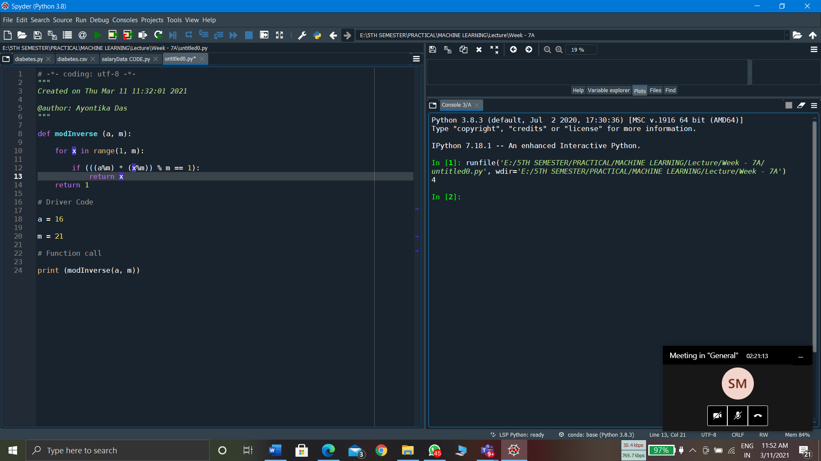

Rail Fence Cipher Encryption and Decryption
INPUT:
def encryptRailFence(text, key):
rail = [['\n' for i in range(len(text))]
for j in range(key)]
dir_down = False
row, col = 0, 0
for i in range(len(text)):
if (row == 0) or (row == key - 1):
dir_down = not dir_down
rail[row][col] = text[i]
col += 1
if dir_down:
row += 1
else:
row -= 1
result = []
for i in range(key):
for j in range(len(text)):
if rail[i][j] != '\n':
result.append(rail[i][j])
return("" . join(result))
def decryptRailFence(cipher, key):
rail = [['\n' for i in range(len(cipher))]
for j in range(key)]
dir_down = None
row, col = 0, 0
for i in range(len(cipher)):
if row == 0:
dir_down = True
if row == key - 1:
dir_down = False
rail[row][col] = '*'
col += 1
if dir_down:
row += 1
else:
row -= 1
index = 0
for i in range(key):
for j in range(len(cipher)):
if ((rail[i][j] == '*') and
(index < len(cipher))):
rail[i][j] = cipher[index]
index += 1
result = []
row, col = 0, 0
for i in range(len(cipher)):
if row == 0:
dir_down = True
if row == key-1:
dir_down = False
if (rail[row][col] != '*'):
result.append(rail[row][col])
col += 1
if dir_down:
row += 1
else:
row -= 1
return("".join(result))
if __name__ == "__main__":
print(encryptRailFence("attack at once", 2))
print(encryptRailFence("GeeksforGeeks ", 3))
print(encryptRailFence("defend the east wall", 3))
print(decryptRailFence("GsGsekfrek eoe", 3))
print(decryptRailFence("atc toctaka ne", 2))
print(decryptRailFence("dnhaweedtees alf tl", 3))

OUTPUT:
atc toctaka ne
GsGsekfrek eoe
dnhaweedtees alf tl
GeeksforGeeks
attack at once
delendfthe east wal

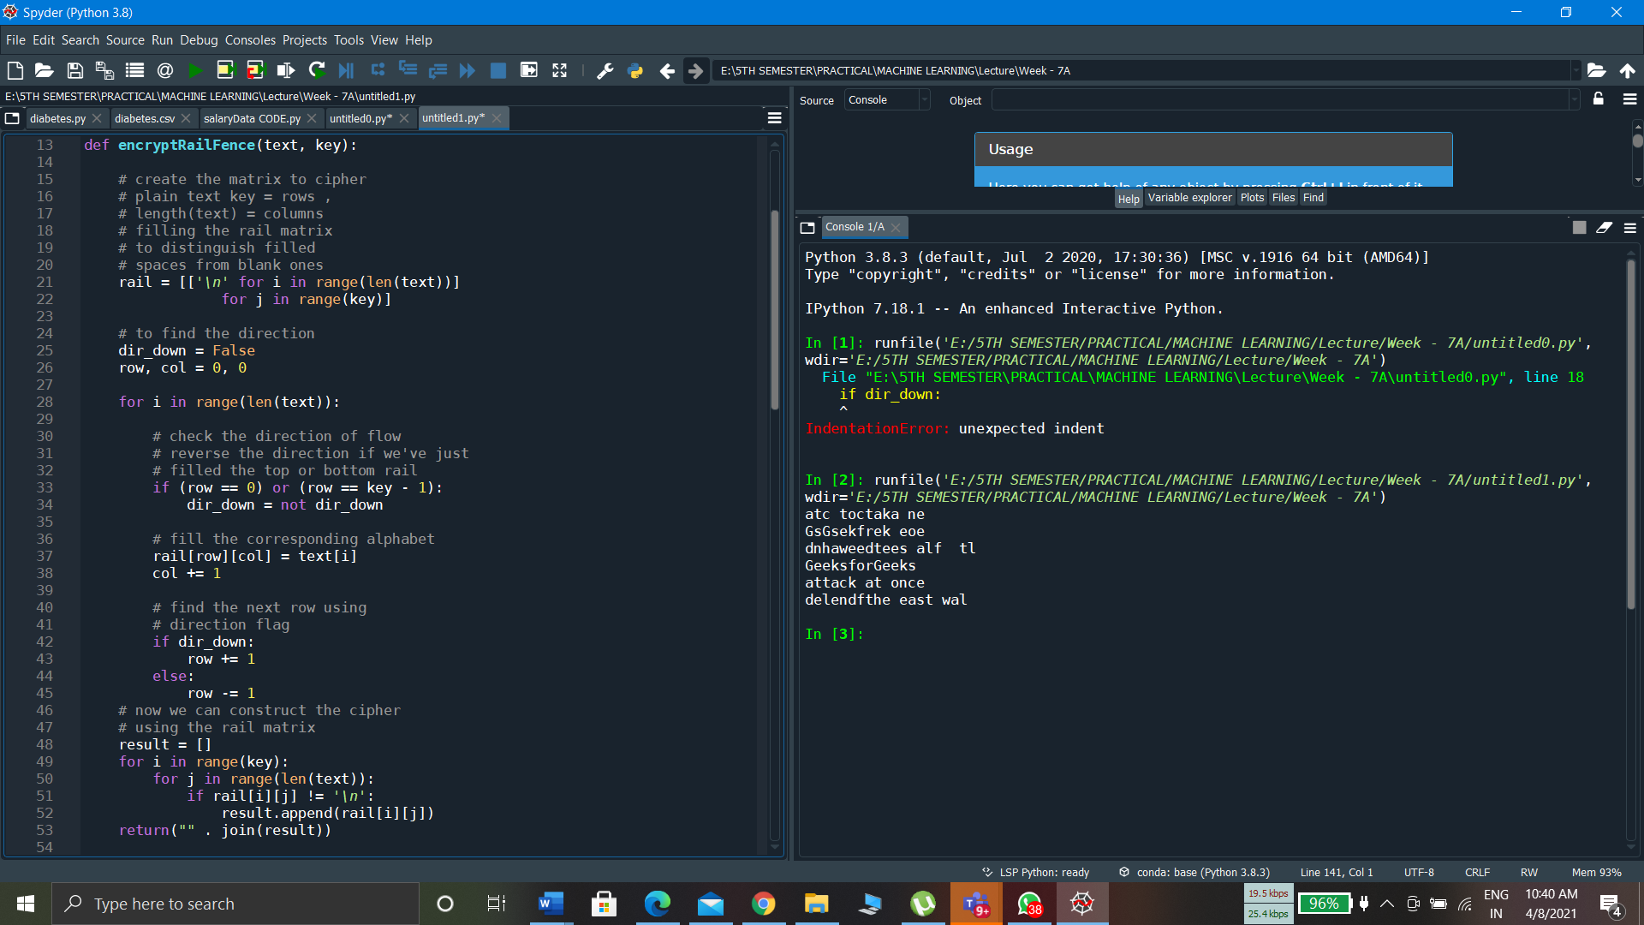

ASSIGMNENT : 6 (25.03.2021)
Program Name:
1.Columnar Transposition Chiper in Python..
Program Code:
# Python3 implementation of
# Columnar Transposition
import math

key = "HACK"

# Encryption
def encryptMessage(msg):
cipher = ""

# track key indices
k_indx = 0

msg_len = float(len(msg))
msg_lst = list(msg)
key_lst = sorted(list(key))

# calculate column of the matrix
col = len(key)

# calculate maximum row of the matrix
row = int(math.ceil(msg_len / col))

# add the padding character '_' in empty
# the empty cell of the matix
fill_null = int((row * col) - msg_len)
msg_lst.extend('_' * fill_null)

# create Matrix and insert message and
# padding characters row-wise
matrix = [msg_lst[i: i + col]
for i in range(0, len(msg_lst), col)]

# read matrix column-wise using key
for _ in range(col):
curr_idx = key.index(key_lst[k_indx])
cipher += ''.join([row[curr_idx]
for row in matrix])
k_indx += 1

return cipher

# Decryption
def decryptMessage(cipher):
msg = ""

# track key indices
k_indx = 0

# track msg indices
msg_indx = 0
msg_len = float(len(cipher))
msg_lst = list(cipher)

# calculate column of the matrix
col = len(key)

# calculate maximum row of the matrix
row = int(math.ceil(msg_len / col))

# convert key into list and sort
# alphabetically so we can access
# each character by its alphabetical position.
key_lst = sorted(list(key))

# create an empty matrix to
# store deciphered message
dec_cipher = []
for _ in range(row):
dec_cipher += [[None] * col]

# Arrange the matrix column wise according
# to permutation order by adding into new matrix
for _ in range(col):
curr_idx = key.index(key_lst[k_indx])

for j in range(row):
dec_cipher[j][curr_idx] = msg_lst[msg_indx]
msg_indx += 1
k_indx += 1

# convert decrypted msg matrix into a string
try:
msg = ''.join(sum(dec_cipher, []))
except TypeError:
raise TypeError("This program cannot",
"handle repeating words.")

null_count = msg.count('_')

if null_count > 0:
return msg[: -null_count]

return msg

# Driver Code
msg = "Enemy attacks to night"

cipher = encryptMessage(msg)
print("Encrypted Message: {}".
format(cipher))

print("Decryped Message: {}".
format(decryptMessage(cipher)))

Output:
Encrypted Message: n a nteacti_Eyts hmtkog_
Decryped Message: Enemy attacks to night
Screenshot of Output:
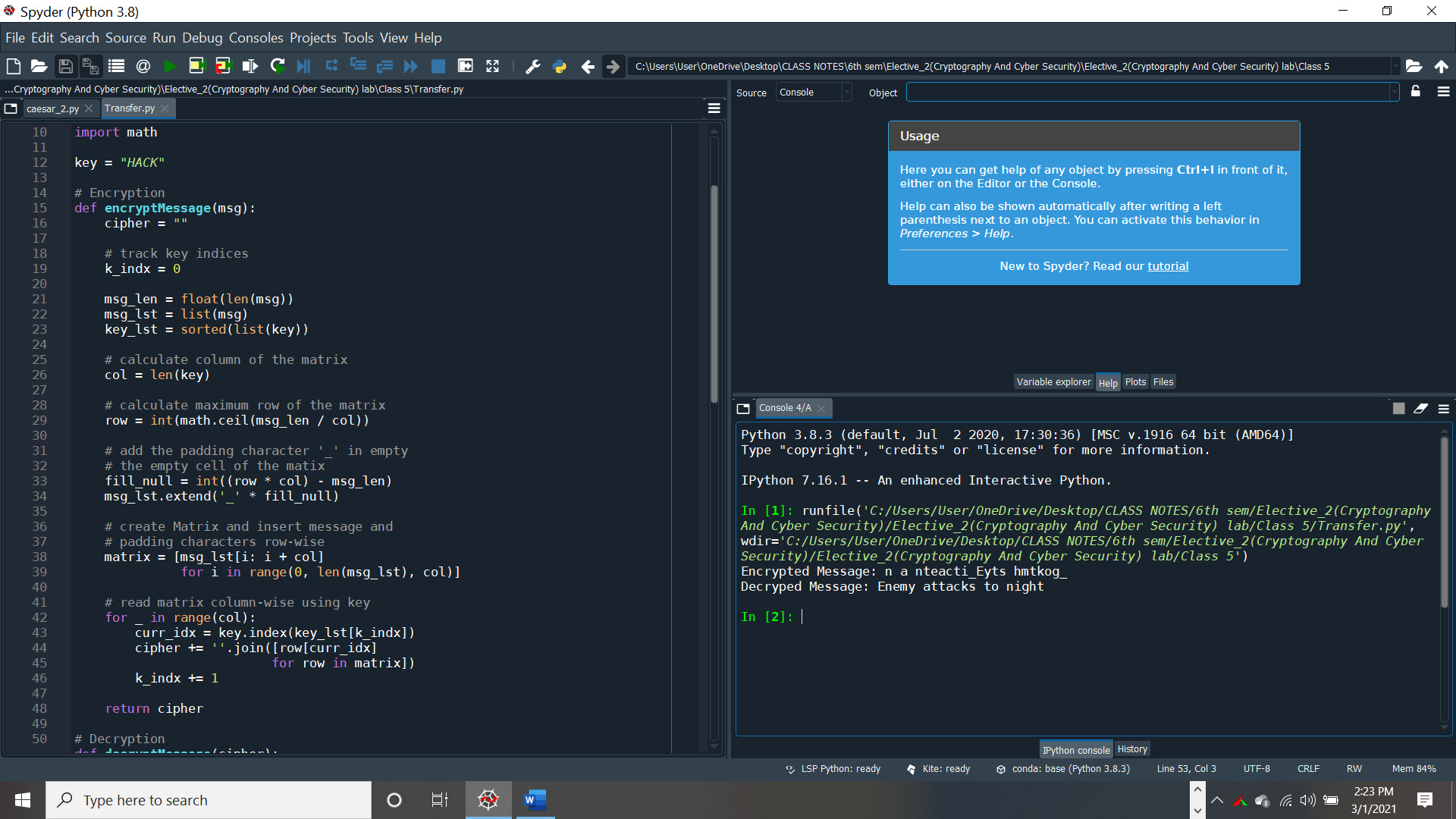

ASSIGMNENT : 2

Program Name: Autokey Cipher

Program Code:

def encrypt(message, key):
cipher = ""
for i in message:
if i.isupper():
cipher += chr((ord(i) + key - 65) % 26 + 65)
elif i.islower():
cipher += chr((ord(i) + key - 97) % 26 + 97)
else:
cipher+=" "
return cipher

message = input("Enter the message:")
key = input("Enter the key numeric value or any alphabet:")
if key.isupper():
key = ord(key) - 65
elif key.islower():
key = ord(key) - 97
else:
key = int(key)
print("Cipher:", encrypt(message, key))

# Decryption part

def decrypt(cipher, key):
message = ""
for i in cipher:
if i.isupper():
message += chr((ord(i) - key - 65) % 26 + 65)
elif i.islower():
message += chr((ord(i) - key - 97) % 26 + 97)
else:
message+=" "
return message

cipher = input("Enter the cipher:")
key = input("Enter the key numeric value or any alphabet:")
if key.isupper():
key = ord(key) - 65
elif key.islower():
key = ord(key) - 97
else:
key = int(key)
print("Message", decrypt(cipher, key))

Output:
Enter the message:Anindya

Enter the key numeric value or any alphabet: 56
Cipher: Ermrhce

Enter the cipher:Ermrhce

Enter the key numeric value or any alphabet: 56
Message Anindya

Screenshot of Output:

