1 . A W S D E P L O Y M E N T S T A T U S
The ML system is deployed and running on AWS using two services: Amazon S3 for artifact storage and an EC2 instance (t3.medium, 2 vCPU, 4 GB RAM) hosting the Streamlit prediction interface. The application is live at http://3.85.169.163:8501 and ready for the April 22nd demo. S3 stores the trained model file (lgbmModel.pkl) and preprocessed feature cache (modelDf.csv, 3.2M rows); the EC2 instance loads the model at startup and serves live inference in under one second per request. The architecture diagram is included in Appendix A (Figure A1).
This is a simplification of the SageMaker batch pipeline proposed at midpoint. Live EC2 inference is more appropriate for a POC demo and avoids unnecessary pipeline complexity. The main pre-demo risk is AWS Academy session timeout stopping the EC2 instance; restarting it and relaunching Streamlit takes under one minute.
2 . F I N A L M O D E L S E L E C T I O N
Why Linear Models Cannot Solve This Problem
OLS, Ridge, and Lasso regression were evaluated first. All three failed to improve on the naive historical baseline (mean throughput per airport/checkpoint/hour/day-of-week/month combination) and were ruled out. The reason is structural: throughput is governed by interactions, not additive effects. ATL is busy. Friday mornings are busy. But ATL on a Friday morning in June is disproportionately busy in a way that cannot be captured by summing an ATL coefficient, a Friday coefficient, and a morning coefficient. A linear model has no mechanism to learn joint effects, so when forced to fit 3.1 million records driven by interactions it cannot represent, it produces noisier predictions than simply looking up the historical average. Ridge and Lasso regularization did not help; the problem is underfitting from a mismatched model class, not overfitting.
Why LightGBM
Gradient boosted trees address the interaction problem directly. Each split encodes a conditional rule (e.g., airport=ATL AND hour=8), and a sequence of hundreds of such splits across residual-targeted trees learns the joint effects that linear models cannot represent. LightGBM is the right specific implementation for this dataset for three reasons: it handles label-encoded categoricals correctly without implying false magnitude ordering; it requires no feature standardization across the mixed-scale feature set; and its histogram-based, leaf-wise growth is computationally practical on 3.1 million training records. Early stopping on the validation set automatically selects the optimal number of boosting rounds, preventing overfitting without manual tuning.
Hyperparameter Tuning
A grid search was conducted over 27 combinations of learning rate [0.03, 0.05, 0.1], number of leaves [63, 127, 255], and minimum child samples [30, 50, 100], evaluated by validation RMSE. Feature fraction, bagging fraction, and bagging frequency were fixed at 0.8, 0.8, and 5; these parameters are less sensitive and including them would have substantially increased search runtime. The optimal configuration was learning rate 0.05, 127 leaves, and 50 minimum child samples. The final model was retrained on training data only with the validation set used solely for early stopping (patience of 100 rounds, cap of 10,000), converging at 1,914 rounds.
Test Set Performance
All metrics below are computed on the held-out test set (final 60 days of data, 159,021 records), which was never seen during training or tuning. Daily Pearson r follows Monmousseau et al. (2020): predictions and actuals are summed to the daily level across all airports and checkpoints before computing correlation.
Metric | Naive Baseline | LightGBM | Staffing Relevance
R² | 0.7968 | 0.8509 | Proportion of throughput variance explained
MAE (passengers) | 147.07 | 123.85 | Average error in original units; used to set staffing buffers
RMSE | 213.53 | 182.93 | Penalizes large single-hour misses; severe under-staffing at one checkpoint-hour has major operational consequences
Daily Pearson r | N/A | 0.9398 | Correlation of daily totals; identifies busy vs. quiet days for system-wide planning
vs. Baseline | N/A | -16% MAE / -14% RMSE | Consistent gains on all metrics relative to the current planning standard
Tradeoffs and Feature Importance
LightGBM is less interpretable than a linear model, which is an acceptable tradeoff for a staffing tool where the end user needs an accurate forecast, not model weights. While LightGBM does not produce coefficients like a linear model, gain-based feature importances confirm that checkpoint identity, hour, and airport code drive over 87% of predictions, a result consistent with domain intuition and sufficient to explain model behavior to a staffing planner. The 16% MAE improvement (147 to 124 passengers) compounds across dozens of checkpoints and hundreds of planning slots. Feature importance validates the model's logic: checkpoint name (52.3%), hour of day (19.2%), and airport code (15.5%) account for 87% of predictive gain; these are precisely the interaction terms linear models cannot represent. Flight schedule features contribute an additional 9.4%, confirming scheduled capacity provides real signal beyond calendar and location alone.
3 . U S E R I N T E R F A C E P L A N
The intended user is a TSA workforce planner making staffing decisions approximately 12 months ahead. The interface is a Streamlit application deployed on EC2, organized into a sidebar for inputs and a main panel for outputs.
Inputs (sidebar):
Input | Description
Airport | Dropdown: 20 major U.S. airports (ATL, LAX, DFW, …)
Month | Planning month (January – December)
Day of week | Monday – Sunday
Federal holiday | Checkbox: marks the date as a U.S. federal holiday
Days to holiday | Slider (0–30): proximity to nearest holiday
Flight schedule | Hourly departure count, avg seats/flight, avg load factor
Outputs (main panel):
Output | Description
Hourly forecast chart | Bar chart of predicted total passengers by hour (4am–11pm), overlaid with the historical average for the selected airport/month/day-of-week as a dotted reference line
Checkpoint breakdown | Horizontal bar chart showing predicted volume per checkpoint at the forecast peak hour
Summary metrics | Peak hour, peak predicted volume, total daily forecast, and % deviation from historical average
Demo Flow
Demo sequence: select ATL / Friday / June, click Generate Forecast, walk through the hourly chart (morning peak ~7–8am), show the per-checkpoint breakdown, then switch to a holiday date to show forecast adjustment. Full flow runs under two minutes. Screenshots are included in Appendix B (Figures B1 and B2). Note: flight schedule inputs are entered manually in the POC; a production system would pull published airline schedule data automatically.
4 . A P P E N D I X
Appendix A: AWS Architecture Diagram
Figure A1. AWS deployment architecture for the TSA Throughput Forecasting POC. Raw data and model artifact are stored in Amazon S3. An EC2 instance (t3.medium) hosts the Streamlit application, loads the model from S3 at startup, and serves live predictions.
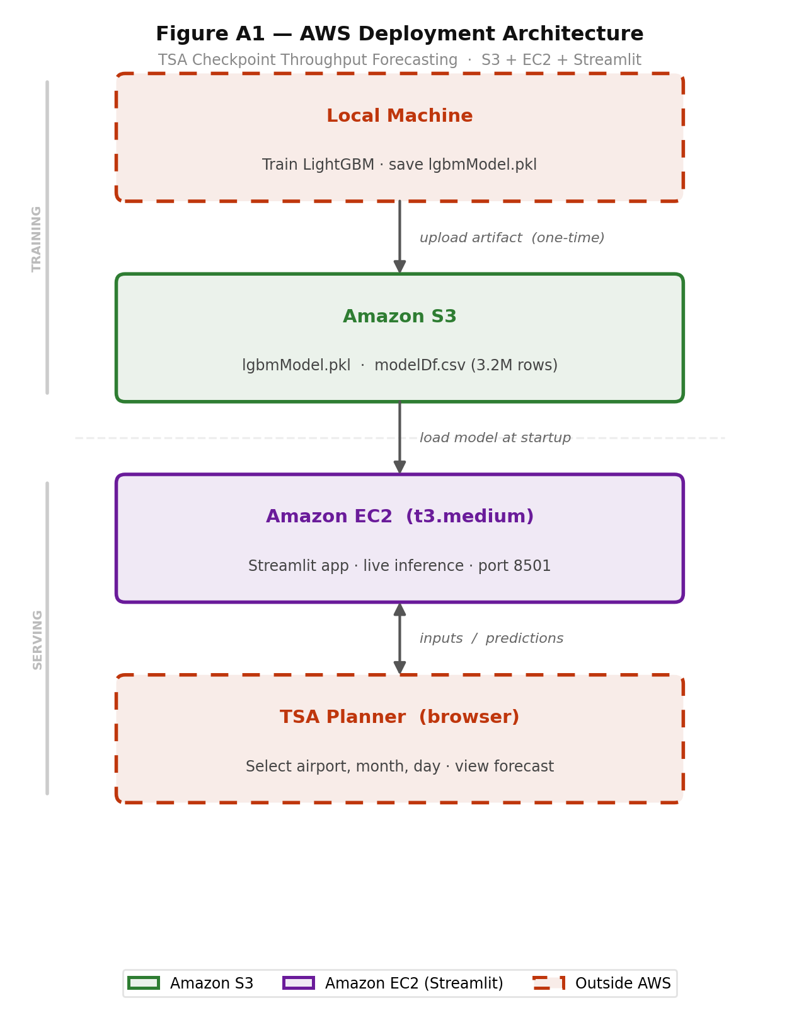
Appendix B: Streamlit Application Screenshots
Figure B1. Main forecast view: hourly throughput forecast (blue bars) vs. historical average (red dotted line) for a selected airport, month, and day of week.
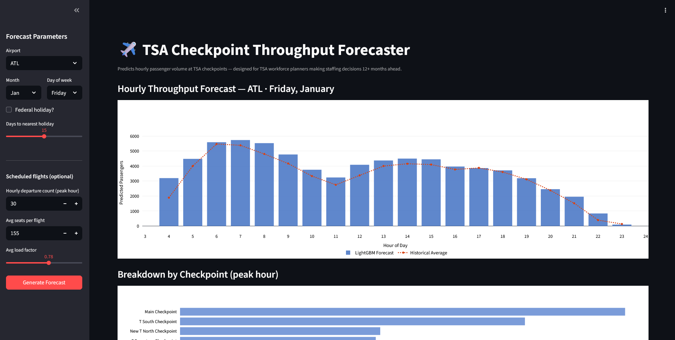

Figure B2. Checkpoint breakdown view — predicted passenger volume by checkpoint at the forecast peak hour.

W O R K S C I T E D
Monmousseau, P., Marzuoli, A., Feron, E., & Delahaye, D. (2020). Predicting and controlling airport passenger flow. Transportation Research Part C: Emerging Technologies, 120, 102796. https://doi.org/10.1016/j.trc.2020.102796

