**SUMMER TRAINING REPORT**

On

“Django”

Under the Portal

(https://www.udemy.com/)

A Project Report submitted in partial fulfilment of

the requirements for the award of

Bachelor of Engineering

IN

COMPUTER SCIENCE AND ENGINEERING

Submitted by:

Vivsvaan Sharma

(Roll no.: CO16362)



**CHANDIGARH COLLEGE OF ENGINEERING AND TECHNOLOGY**

**(DEGREE WING)**

Government Institute under Chandigarh (UT) Administration, Affiliated to Panjab University,

Chandigarh

Sector-26, Chandigarh. PIN-160019

**June, 2019**

**CHANDIGARH COLLEGE OF ENGINEERING AND TECHNOLOGY (DEGREE WING)**

Government Institute under Chandigarh (UT) Administration | Affiliated to Panjab University , Chandigarh

Sector-26, Chandigarh. PIN-160019 | Tel. No. 0172-2750947, 2750943

Website: [www.ccet.ac.in](http://www.ccet.ac.in/) | Email: [principal@ccet.ac.in](mailto:principal@ccet.ac.in) | Fax. No**. :**0172-2750872

**Department of Computer Sc. & Engineering**

**CANDIDATE’S DECLARATION**

I hereby declare that the work presented in this report entitled “Django**”** in fulfilment of the requirement for the award of the degree Bachelor of Engineering in Computer Science & Engineering, submitted in CSE Department, Chandigarh College of Engineering & Technology (Degree wing) affiliated to Punjab University, Chandigarh, is an authentic record of my own work carried out during my degree under the portal *https://www.udemy.com/.* The work reported in this has not been submitted by me for award of any other degree or diploma.

Date: 11 July, 2019 Vivsvaan Sharma

Place: Chandigarh CO16362

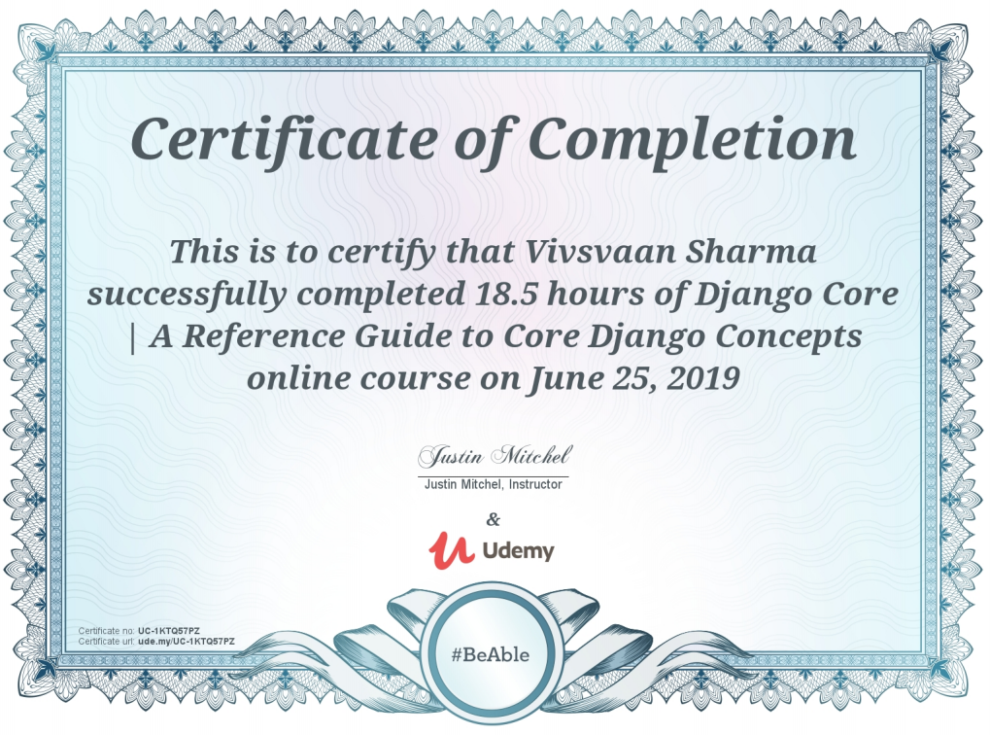

**CHANDIGARH COLLEGE OF ENGINEERING AND TECHNOLOGY (DEGREE WING)**

Government Institute under Chandigarh (UT) Administration | Affiliated to Panjab University , Chandigarh

Sector-26, Chandigarh. PIN-160019 | Tel. No. 0172-2750947, 2750943

Website: [www.ccet.ac.in](http://www.ccet.ac.in/) | Email: [principal@ccet.ac.in](mailto:principal@ccet.ac.in) | Fax. No**. :**0172-2750872

**Department of Computer Sc. & Engineering**

**ACKNOWLEDGEMENT**

It is a great pleasure to present this report of summer training on “Django”. I have taken efforts in this training. However, it would not have been possible without the kind support and help of many individuals and organizations. I would like to extend my sincere thanks to all of them.

I am highly indebted to Udemy Portal for there guidance and constant supervision as well as for providing necessary information regarding the project & also for his support in completing the project.

They taught me all the basic concepts required for the project and guided me through each step of building the project whenever I was stuck.

I would like to express my special gratitude and thanks to institution (Udemy) persons for giving me such attention and time.

My thanks and appreciations also go to my colleague/friend in developing the project and people who have willingly helped me out with their abilities.

I would also like to thank the University for including this summer training as a part of our curriculum.

**CHANDIGARH COLLEGE OF ENGINEERING AND TECHNOLOGY (DEGREE WING)**

Government Institute under Chandigarh (UT) Administration | Affiliated to Panjab University, Chandigarh

Sector-26, Chandigarh. PIN-160019 | Tel. No. 0172-2750947, 2750943

Website: [www.ccet.ac.in](http://www.ccet.ac.in/) | Email: [principal@ccet.ac.in](mailto:principal@ccet.ac.in) | Fax. No**. :**0172-2750872

**Department of Computer Sc. & Engineering**

**ABSTRACT**

The following report is an account of everything I have learned and done and the project made during my Summer Training in “Django” on the portal of Udemy.

First chapter is all about installation and basic introduction to python. The second chapter give details about various data type variables like numeric, string, list, tuple and dictionary and basic syntax to use them with example programs.

In the third chapter basics of programming in python is discussed like how to use conditional statements, how to use loops, functions, built-in-modules, etc. There basic syntax with examples are also given in this chapter.

The fourth chapter talks about principles of object-oriented programming, its overview , syntax to declare class and objects. It also discuss and implement some features of OOP also with example programs.

The fifth chapter is all about SQLite Database, its basic introduction, how to work with them like creating a database, deleting a database, creating and deleting a table, inserting data in them. And also explain how to implement all the above operations through Python.

The sixth chapter talks about developing a GUI(Graphical User Interface) in Python With the help of PyQT . It is a program or we can say a software to develop GUI with simple drag and drop methods and with help of widgets in it.

The seventh chapter talks about the project “Fantasy Cricket Game” which have some objective, scope, problem statement, on the basis of which a project is developed using our learnings from previous chapters and talks about the database design and some features of our project.