# Tutorial

## Mesh io

Matlab: test_read_mesh.m

C++

## Mesh show

Matlab:

eg_trisurf.m

test_plot_mesh.m (outdated, use trisurf as much as possible)

test_texturepatch.m

C++

## Feature computation

Matlab

test_compute_curvature.m

test_gaussian_curvature_conformal_factor

C++

# Resources

## Data sets

1. AIM@SHAPE: <http://shapes.aim-at-shape.net/viewmodels.php>
2. Surface Correspondence Benchmark

[**SCAPE**](http://robotics.stanford.edu/~drago/Projects/scape/scape.html)**:** 71 meshes representing a human body in different poses. All the meshes were fit to scanner data with a common template (thus corresponding vertices have same IDs).   
[**TOSCA:**](http://tosca.cs.technion.ac.il/book/resources_data.html) 80 meshes representing people and animals in a variety of poses. The meshes appear in 8 groups with common topology (corresponding within the same class have the same ID).   
[**Watertight:**](http://watertight.ge.imati.cnr.it/) 400 meshes arranged evenly in 20 object categories, many of which are articulated figures (humans, octopus, four-legged animals, ants, etc.). We selected 11 classes for our experiments that have well defined correspondences and genus zero. In addition, we excluded two human models with non-zero genus.   
  
[Download the benchmark (184Mb)](http://shape.cs.princeton.edu/vkcorrs/CorrsBlended/SurfCorr2.0.benchmarks.bins.zip): this package includes meshes from aforementioned datasets (in *.off format, with consistent normal orientation and after [delaunay triangulation](http://graphics.stanford.edu/~mdfisher/Data/IntrinsicDelaunay.pdf) (via edge flips) filter. It also contains manually selected ground truth correspondences and some useful processing scripts.

## Tools

1. **Deep Exploration**
   1. **Viewer**
   2. **3D File Convertor**
   3. **Mesh Simplification** (Reduce)
   4. Measurer
2. MeshLab
3. Graphite

## Coding Platform

1. Plugin
   1. MeshLab
   2. Graphite
2. C++
   1. data structure – CGAL
   2. Viewer – VTK or libQGLViewer
   3. GUI – QT
3. Matlab & C++

## Open source libraries

CG libs: http://vcg.isti.cnr.it/cglibs/

### Math

1. [**Eigen**](http://eigen.tuxfamily.org/index.php?title=Main_Page)
   1. Eigen is a C++ template library for linear algebra: matrices, vectors, numerical solvers, and related algorithms.
2. **SuiteSparse**
3. [ALGLIB](http://www.alglib.net/)
   1. ALGLIB is a cross-platform numerical analysis and data processing library.
4. [C++ LAPACK](http://www.cplusplus.com/forum/articles/14441/)
5. Others
   1. [redsvd](https://code.google.com/p/redsvd/)

### Point cloud

1. PCL: <http://pointclouds.org/>
2. 3DTK — The 3D Toolkit: <http://slam6d.sourceforge.net/>

#### PCL

速度不行，效果一般。

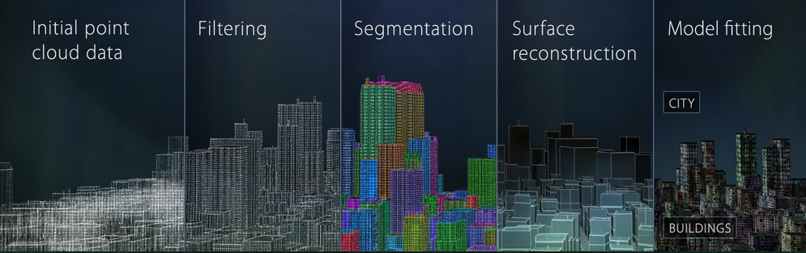

#### 3DTK

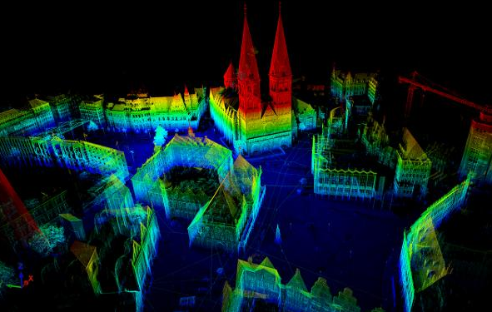

### Mesh

1. CGAL
2. OpenMesh

### Visualization

1. OpenGL
   1. libQGLViewer
2. VTK
3. MeshLab
4. Graphite

## CG Conferences

1. **SIGGRAPH**
2. **Eurographics**
3. **SIGGRAPH Asia**
4. **Eurographics Symposium on Geometry Processing (SGP)**
5. **Pacific Graphics (PG)**
6. **Symposium on Solid and Physical Modeling (SPM)**
7. **Shape Modeling International (SMI): 3.13**
8. **Geometric Modeling and Processing (GMP)**
9. **Computer Graphics International (CGI): 2.1**
10. <http://graphicsconferences.wikidot.com/conference-deadlines>
11. <http://kesen.realtimerendering.com/>
12. <https://sites.google.com/site/wuxiaomao/resource>

## CG Journals

[**ACM Transactions on Graphics (TOG)**](http://www.acm.org/pubs/tog/)

[**IEEE Transactions on Visualization and Computer Graphics**](http://www.computer.org/tvcg/)[**(TVCG)**](http://www.computer.org/tvcg/)

IEEE COMPUTER GRAPHICS AND APPLICATIONS

[**Computer Graphics Forum**](http://www.eg.org/EG/Publications/CGF)

[**Computer & Graphics**](http://www.elsevier.com/wps/find/journaldescription.cws_home/371/description)[**(CG)**](http://www.eg.org/EG/Publications/CGF)

[**Computer-Aided Design**](http://www.sciencedirect.com/science/journal/00104485) **(CAD)**

[**Computer Aided Geometric Design**](http://ees.elsevier.com/cagd/) **(CAGD)**

[**The Visual Computer**](http://link.springer.de/link/service/journals/00371/) **(TVCJ)**

[**Graphics Models**](http://www.elsevier.com/wps/find/journaldescription.cws_home/622839/description)

[**IEEE Computer Graphics and Applications**](http://www.computer.org/cga/)

[**计算机辅助设计与图形学学报**](http://jcad.ict.ac.cn/index.htm) **EI**

[**中国图形图像学报**](http://www.cjig.cn/jig/ch/index.aspx)

Multimedia Tools and Applications, IF: 0.6