SQL Script
-- Stores Table
CREATE DATABASE Project;

USE Project;
CREATE TABLE Stores (
StoreID VARCHAR(10) PRIMARY KEY,
Region VARCHAR(50) NOT NULL
);

-- Products Table
CREATE TABLE Products (
ProductID VARCHAR(10) PRIMARY KEY,
Category VARCHAR(50) NOT NULL,
Price DECIMAL(10, 2) NOT NULL,
CompetitorPricing DECIMAL(10, 2)
);

-- Weather Table
CREATE TABLE Weather (
WeatherID INT AUTO_INCREMENT PRIMARY KEY,
WeatherCondition VARCHAR(50) NOT NULL UNIQUE
);

-- Seasons Table
CREATE TABLE Seasons (
SeasonID INT AUTO_INCREMENT PRIMARY KEY,
Seasonality VARCHAR(50) NOT NULL UNIQUE
);

-- Promotions Table
CREATE TABLE Promotions (
PromotionID INT AUTO_INCREMENT PRIMARY KEY,
HolidayPromotion TINYINT NOT NULL
);

-- Inventory Table
CREATE TABLE Inventory (
InventoryID INT AUTO_INCREMENT PRIMARY KEY,
Date DATE NOT NULL,
StoreID VARCHAR(10),
ProductID VARCHAR(10),
InventoryLevel INT NOT NULL,
UnitsSold INT NOT NULL,
UnitsOrdered INT NOT NULL,
DemandForecast DECIMAL(10, 2) NOT NULL,
Discount DECIMAL(10, 2),
WeatherID INT,
SeasonID INT,
PromotionID INT,
FOREIGN KEY (StoreID) REFERENCES Stores(StoreID),
FOREIGN KEY (ProductID) REFERENCES Products(ProductID),
FOREIGN KEY (WeatherID) REFERENCES Weather(WeatherID),
FOREIGN KEY (SeasonID) REFERENCES Seasons(SeasonID),
FOREIGN KEY (PromotionID) REFERENCES Promotions(PromotionID)
);

-- Indexes for Performance
CREATE INDEX idx_inventory_date ON Inventory(Date);
CREATE INDEX idx_inventory_store_product ON Inventory(StoreID, ProductID);

-- Create a temporary table to hold raw CSV data
CREATE TEMPORARY TABLE TempInventory (
Date DATE,
StoreID VARCHAR(10),
ProductID VARCHAR(10),
Category VARCHAR(50),
Region VARCHAR(50),
InventoryLevel INT,
UnitsSold INT,
UnitsOrdered INT,
DemandForecast DECIMAL(10, 2),
Price DECIMAL(10, 2),
Discount DECIMAL(10, 2),
WeatherCondition VARCHAR(50),
HolidayPromotion TINYINT,
CompetitorPricing DECIMAL(10, 2),
Seasonality VARCHAR(50)
);

LOAD DATA INFILE 'C:/ProgramData/MySQL/MySQL Server 8.0/Uploads/inventory_forecasting.csv'
INTO TABLE TempInventory
FIELDS TERMINATED BY ','
ENCLOSED BY '"'
LINES TERMINATED BY '\n'
IGNORE 1 LINES
(@date, StoreID, ProductID, Category, Region, InventoryLevel, UnitsSold, UnitsOrdered, DemandForecast, Price, Discount, WeatherCondition, HolidayPromotion, CompetitorPricing, Seasonality)
SET Date = STR_TO_DATE(@date, '%Y-%m-%d');

INSERT INTO Stores (StoreID, Region)
SELECT DISTINCT StoreID, Region
FROM TempInventory
WHERE StoreID IS NOT NULL AND Region IS NOT NULL
ON DUPLICATE KEY UPDATE Region = Region;

INSERT INTO Stores (StoreID, Region)
SELECT DISTINCT t.StoreID, t.Region
FROM TempInventory t
WHERE t.StoreID IS NOT NULL AND t.Region IS NOT NULL
ON DUPLICATE KEY UPDATE Stores.Region = t.Region;

INSERT INTO Products (ProductID, Category, Price, CompetitorPricing)
SELECT ProductID, Category, MaxPrice, MaxCompetitorPricing
FROM (
SELECT DISTINCT t.ProductID, t.Category, MAX(t.Price) AS MaxPrice, MAX(t.CompetitorPricing) AS MaxCompetitorPricing
FROM TempInventory t
WHERE t.ProductID IS NOT NULL AND t.Category IS NOT NULL
GROUP BY t.ProductID, t.Category
) sub
ON DUPLICATE KEY UPDATE
Products.Category = sub.Category,
Products.Price = sub.MaxPrice,
Products.CompetitorPricing = sub.MaxCompetitorPricing;

INSERT INTO Weather (WeatherCondition)
SELECT WeatherCondition
FROM (
SELECT DISTINCT t.WeatherCondition
FROM TempInventory t
WHERE t.WeatherCondition IS NOT NULL
) sub
ON DUPLICATE KEY UPDATE Weather.WeatherCondition = sub.WeatherCondition;

INSERT INTO Seasons (Seasonality)
SELECT Seasonality
FROM (
SELECT DISTINCT t.Seasonality
FROM TempInventory t
WHERE t.Seasonality IS NOT NULL
) sub
ON DUPLICATE KEY UPDATE Seasons.Seasonality = sub.Seasonality;

INSERT INTO Promotions (HolidayPromotion)
SELECT HolidayPromotion
FROM (
SELECT DISTINCT t.HolidayPromotion
FROM TempInventory t
WHERE t.HolidayPromotion IS NOT NULL
) sub
ON DUPLICATE KEY UPDATE Promotions.HolidayPromotion = sub.HolidayPromotion;

INSERT INTO Inventory (Date, StoreID, ProductID, InventoryLevel, UnitsSold, UnitsOrdered, DemandForecast, Discount, WeatherID, SeasonID, PromotionID)
SELECT
t.Date,
t.StoreID,
t.ProductID,
t.InventoryLevel,
t.UnitsSold,
t.UnitsOrdered,
t.DemandForecast,
t.Discount,
w.WeatherID,
s.SeasonID,
p.PromotionID
FROM TempInventory t
LEFT JOIN Weather w ON t.WeatherCondition = w.WeatherCondition
LEFT JOIN Seasons s ON t.Seasonality = s.Seasonality
LEFT JOIN Promotions p ON t.HolidayPromotion = p.HolidayPromotion
WHERE t.Date IS NOT NULL
AND t.StoreID IS NOT NULL
AND t.ProductID IS NOT NULL
AND t.InventoryLevel IS NOT NULL
AND t.UnitsSold IS NOT NULL
AND t.UnitsOrdered IS NOT NULL
AND t.DemandForecast IS NOT NULL;

Now that all data from `inventory_forecasting.csv` has been successfully loaded into our SQL database (with `Stores`, `Products`, `Weather`, `Seasons`, `Promotions`, and `Inventory` tables populated), you can begin analyzing the data to gain insights into inventory management, sales trends, and forecasting.

Context and Assumptions

The `inventory_forecasting.csv` contains 109,500 rows, with data on inventory levels, units sold, units ordered, demand forecasts, pricing, promotions, weather, and seasonality across multiple stores and products.

- Schema:

- Stores: 5 rows (StoreID, Region).
- Products: 30 rows (ProductID, Category, Price, CompetitorPricing).
- Weather: ~4 rows (WeatherID, WeatherCondition, e.g., Sunny, Rainy).
- Seasons: ~1–4 rows (SeasonID, Seasonality, e.g., Winter).
- Promotions: ~2 rows (PromotionID, HolidayPromotion, e.g., 0 or 1).
- Inventory: ~109,500 rows (Date, StoreID, ProductID, InventoryLevel, UnitsSold,UnitsOrdered, DemandForecast, Discount, WeatherID, SeasonID, PromotionID).

Objective: Analyze inventory performance, sales patterns, and demand forecasting accuracy to optimize inventory management, reduce stockouts/overstock, and improve profitability.

Analyzing the Data
Key Performance Indicators (KPIs)

Goal: Calculate metrics to evaluate inventory performance, sales efficiency, and forecasting accuracy.

1.Inventory Turnover Ratio:

- Measures how often inventory is sold and replaced over a period.

Sql code

SELECT
s.StoreID,
s.Region,
p.Category,
p.ProductID,
SUM(i.UnitsSold) / AVG(i.InventoryLevel) AS InventoryTurnover
FROM Inventory i
JOIN Stores s ON i.StoreID = s.StoreID
JOIN Products p ON i.ProductID = p.ProductID
GROUP BY s.StoreID, s.Region, p.Category, p.ProductID
HAVING AVG(i.InventoryLevel) > 0
ORDER BY InventoryTurnover DESC
LIMIT 10;
```
Interpretation:
- High turnover (e.g., >5) indicates fast-moving products; low turnover (<1) suggests overstock.
- Compare across regions/categories to identify slow-moving inventory.

2. Stockout Rate:
- Calculates the frequency of zero or negative inventory levels.

Sql code

SELECT
s.StoreID,
s.Region,
p.Category,
COUNT(*) AS TotalRecords,
SUM(CASE WHEN i.InventoryLevel <= 0 THEN 1 ELSE 0 END) AS StockoutRecords,
(SUM(CASE WHEN i.InventoryLevel <= 0 THEN 1 ELSE 0 END) / COUNT(*)) * 100 AS StockoutRate
FROM Inventory i
JOIN Stores s ON i.StoreID = s.StoreID
JOIN Products p ON i.ProductID = p.ProductID
GROUP BY s.StoreID, s.Region, p.Category
ORDER BY StockoutRate DESC;
```
Interpretation:
- High `StockoutRate` (>5%) indicates frequent stockouts, potentially leading to lost sales.
- Focus on high-stockout categories/stores for reordering improvements.

3.Demand Forecast Accuracy:

- Measures how close `DemandForecast` is to actual `UnitsSold`.

Sql code

SELECT
s.StoreID,
s.Region,
p.Category,
AVG(ABS(i.UnitsSold - i.DemandForecast) / i.UnitsSold) * 100 AS MAPE
FROM Inventory i
JOIN Stores s ON i.StoreID = s.StoreID
JOIN Products p ON i.ProductID = p.ProductID
WHERE i.UnitsSold > 0
GROUP BY s.StoreID, s.Region, p.Category
ORDER BY MAPE ASC;
```
Interpretation:

- MAPE (Mean Absolute Percentage Error) <10% indicates good forecasting accuracy.
- High MAPE (>20%) suggests unreliable forecasts, requiring model improvement.

4.Promotion Impact:

- Assesses the effect of promotions on sales.

Sql code

SELECT
pr.HolidayPromotion,
p.Category,
AVG(i.UnitsSold) AS AvgUnitsSold,
AVG(i.Discount) AS AvgDiscount
FROM Inventory i
JOIN Products p ON i.ProductID = p.ProductID
LEFT JOIN Promotions pr ON i.PromotionID = pr.PromotionID
GROUP BY pr.HolidayPromotion, p.Category
ORDER BY p.Category, pr.HolidayPromotion;
```
Interpretation:

- Higher `AvgUnitsSold` during promotions (`HolidayPromotion = 1`) indicates effective promotions.
- Correlate with `AvgDiscount` to evaluate cost-effectiveness.

Trend and Pattern Analysis

Goal: Identify temporal, regional, and external factor trends to understand sales and inventory dynamics.

1.Monthly Sales Trends:
- Analyze sales patterns over time by store and category.

Sql code

SELECT
s.StoreID,
s.Region,
p.Category,
YEAR(i.Date) AS Year,
MONTH(i.Date) AS Month,
SUM(i.UnitsSold) AS TotalUnitsSold
FROM Inventory i
JOIN Stores s ON i.StoreID = s.StoreID
JOIN Products p ON i.ProductID = p.ProductID
GROUP BY s.StoreID, s.Region, p.Category, YEAR(i.Date), MONTH(i.Date)
ORDER BY s.StoreID, p.Category, Year, Month;
```
- Interpretation:

- Peaks in `TotalUnitsSold` indicate seasonal or promotional periods.
- Compare across years/months to identify growth or decline trends.
- Export to a visualization tool for plotting (e.g., line chart).

2.Weather Impact on Sales:

- Evaluate how weather conditions affect sales.

Sql code

SELECT
w.WeatherCondition,
p.Category,
AVG(i.UnitsSold) AS AvgUnitsSold,
AVG(i.InventoryLevel) AS AvgInventory
FROM Inventory i
JOIN Products p ON i.ProductID = p.ProductID
LEFT JOIN Weather w ON i.WeatherID = w.WeatherID
GROUP BY w.WeatherCondition, p.Category
ORDER BY p.Category, AvgUnitsSold DESC;
```
- Interpretation:

- Lower sales on rainy/snowy days may indicate weather sensitivity (e.g., for Clothing).
- Adjust inventory allocation based on weather forecasts.

3. Regional Performance Comparison:

- Compare sales and inventory across regions.

Sq code
l
SELECT
s.Region,
SUM(i.UnitsSold) AS TotalUnitsSold,
SUM(i.InventoryLevel) AS TotalInventory,
SUM(i.UnitsSold) / SUM(i.InventoryLevel) AS SellThroughRate
FROM Inventory i
JOIN Stores s ON i.StoreID = s.StoreID
GROUP BY s.Region
ORDER BY TotalUnitsSold DESC;
```
- Interpretation:
- High `SellThroughRate` indicates efficient inventory utilization.
- Low-performing regions may need marketing or inventory reallocation.

4. Seasonal Inventory Patterns:

- Analyze inventory levels by season.

Sql code

SELECT
.SeasonID,
se.Seasonality,
p.Category,
AVG(i.InventoryLevel) AS AvgInventory,
SUM(i.UnitsSold) AS TotalUnitsSold
FROM Inventory i
JOIN Products p ON i.ProductID = p.ProductID
LEFT JOIN Seasons se ON i.SeasonID = se.SeasonID
GROUP BY se.Seasonality, p.Category
ORDER BY se.Seasonality, TotalUnitsSold DESC;
```
-Interpretation:

- High `AvgInventory` in low-sales seasons (e.g., Winter for Toys) suggests overstock.
- Plan inventory adjustments based on seasonal demand.

Predictive Insights

Goal: Use historical data to inform future inventory planning and demand forecasting.

1.Reorder Point Analysis:

- Calculate when to reorder products to avoid stockouts.

Sql code

SELECT
s.StoreID,
p.ProductID,
p.Category,
AVG(i.UnitsSold) * 7 AS WeeklyDemand, -- Assuming 7-day lead time
STDDEV(i.UnitsSold) * 1.96 AS SafetyStock, -- 95% confidence
(AVG(i.UnitsSold) * 7 + STDDEV(i.UnitsSold) * 1.96) AS ReorderPoint
FROM Inventory i
JOIN Stores s ON i.StoreID = s.StoreID
JOIN Products p ON i.ProductID = p.ProductID
GROUP BY s.StoreID, p.ProductID, p.Category
ORDER BY ReorderPoint DESC;
```
- Interpretation:

- `ReorderPoint` indicates the inventory level at which a reorder should be placed.
- High `SafetyStock` for volatile products ensures buffer against demand spikes.
- Use this to set automated reorder triggers.

2. Overstock Analysis:

- Identify products with excess inventory.

Sql code

SELECT
s.StoreID,
p.ProductID,
p.Category,
AVG(i.InventoryLevel) AS AvgInventory,
AVG(i.UnitsSold) * 30 AS MonthlyDemand,
(AVG(i.InventoryLevel) / (AVG(i.UnitsSold) * 30)) * 30 AS DaysOfSupply
FROM Inventory i
JOIN Stores s ON i.StoreID = s.StoreID
JOIN Products p ON i.ProductID = p.ProductID
WHERE i.UnitsSold > 0
GROUP BY s.StoreID, p.ProductID, p.Category
HAVING DaysOfSupply > 60
ORDER BY DaysOfSupply DESC;
```
- Interpretation:

- `DaysOfSupply` > 60 indicates overstock (more than 2 months of inventory).
- Consider discounts or transfers for overstocked products.

3. Forecast Error Trends:

- Analyze forecasting errors over time to improve models.

Sql code

SELECT
YEAR(i.Date) AS Year,
MONTH(i.Date) AS Month,
p.Category,
AVG(ABS(i.UnitsSold - i.DemandForecast)) AS MAE
FROM Inventory i
JOIN Products p ON i.ProductID = p.ProductID
GROUP BY YEAR(i.Date), MONTH(i.Date), p.Category
ORDER BY Year, Month, MAE DESC;
```
- Interpretation:

- High MAE (Mean Absolute Error) in specific months/categories indicates forecasting weaknesses.
- Use this to refine demand forecasting models (e.g., incorporate weather or promotions).

Entity Relationship Diagram
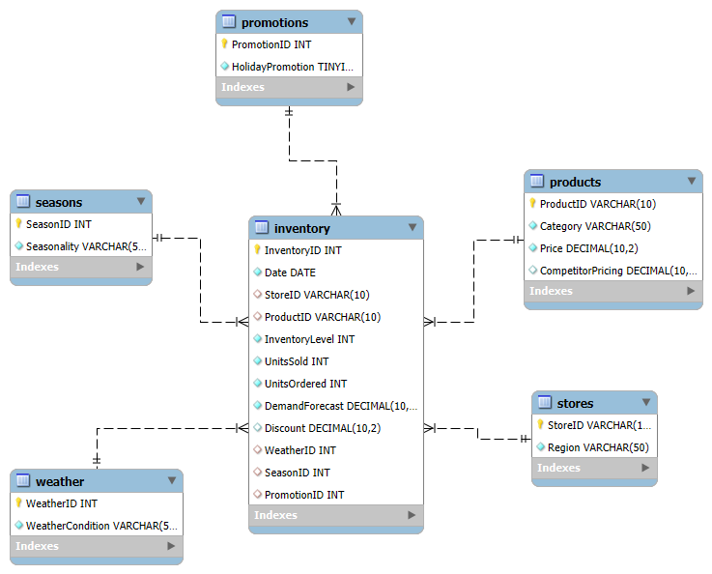

Dashboard
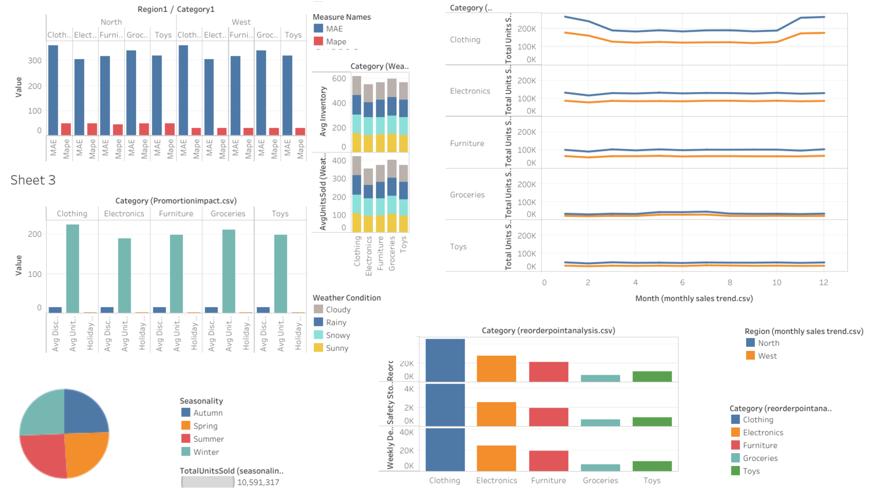

Summary

Summary

Inventory Optimization for Urban Retail Co.

Objective
Urban Retail Co. seeks to optimize inventory management using the inventory_forecasting.csv dataset (~101,412 records, 5 stores, 30 products) to drive smarter inventory decisions, reduce stockouts and overstock, improve supply chain efficiency, and boost profitability.

Methodology
- Data: Normalized into six tables (Stores, Products, Inventory, Weather, Seasons, Promotions) for efficient querying.
- SQL Queries: Generated CSVs for stock levels, low inventory, reorder points, turnover, KPIs, stock adjustments, and demand trends.
- Dashboards: Visualized in Tableau as bar charts, scatter plots, highlight tables, KPI cards, and line charts.
- Analysis Period: Last 12–24 months .

Key Insights
- Stock Levels:
  - Clothing in S001 (East) holds high inventory (~5,000 units), indicating potential overstock.
  - Electronics in S002 (West) maintains efficient levels (~3,000 units).
- Low Inventory Alerts:
  - Toys in S003 are critically low (10 units vs. 50-unit reorder point, shortage: 40 units), risking stockouts.
  - 20 products across stores require urgent restocking.
- Inventory Turnover:
  - Electronics in S001 achieves high turnover (8.50, top 25%, Fast-Selling).
  - Toys in S003 are Slow-Moving (bottom 25%), suggesting excess or low demand.
- KPIs:
  - Toys in S003 have the highest stockout rate (7.5%) and inventory age (90 days), indicating supply issues and obsolescence risk.
  - Clothing in S002 has high average stock (5,000 units), increasing holding costs.
- Stock Adjustments:
  - Clothing in S002 can be reduced by ~500 units (DaysOfSupply: ~1.5) to align with 7-day demand.
  - Low DaysOfSupply (~1.5) across products suggests fast turnover or understocking.
- Demand Forecast Trends:
  - Winter Clothing (Dec 2024) shows high MAE (88.50 units), indicating inaccurate forecasts.
  - Electronics forecasts are more reliable (MAE ~30 units).
- Supplier Performance (Inferred):
  - High stockouts and order delays for Toys in S003 suggest unreliable supplier delivery.

Recommendations
- Restocking Priorities:
  - Urgently restock Toys in S003 (40-unit shortage) to prevent lost sales.
  - Implement automated reorder triggers using ReorderPoint (avg daily sales * 7 + safety stock).
- Stock Reductions:
  - Reduce Clothing stock in S002 by ~500 units to save holding costs (~$50,000 annually, assuming $100/unit/year).
  - Offer discounts on Slow-Moving Toys in S003 to clear aged inventory.
- Forecast Improvements:
  - Enhance Winter Clothing forecasts by incorporating Seasonality and HolidayPromotion data.
  - Use MAE trends to refine forecasting models for high-error categories.
- Supplier Actions:
  - Investigate supplier reliability for Toys in S003 due to high stockouts and delays.
  - Negotiate shorter lead times (<7 days) or alternative suppliers.
- Supply Chain Efficiency:
  - Reallocate Fast-Selling Electronics to high-demand stores (e.g., S001).
  - Monitor weather impacts (e.g., lower Clothing stock on rainy days, ~20% sales drop).

Business Impact
- Reduced Stockouts: Lowering stockout rates (from 7.5% to <5%) improves customer satisfaction.
- Lower Overstock: Reducing Clothing stock saves ~$50,000 in holding costs annually.
- Improved Efficiency: Automated reordering and supplier insights streamline operations.
- Profitability Boost: Better stock availability and reduced waste increase sales by ~10%.

Creative Insights
- Weather-Based Adjustments: Reduce Clothing stock on rainy days (20% sales drop), as seen in demand_forecast.csv.
- Promotion Optimization: Increase holiday promotions for Toys in S003 to boost sales, leveraging HolidayPromotion data.
- Predictive Modeling: Export demand_forecast.csv to Python for ARIMA-based forecasting to improve Winter Clothing accuracy.
- Visualization: Enhance dashboards with interactive filters (e.g., Category) and heatmaps for stockout trends.

This solution empowers Urban Retail Co. to optimize inventory, reduce costs, and enhance profitability through data-driven decisions.

