#### 

Staff Contact Management

Prototype Report

Red Opal Innovations

Version 1

**Created by:** Viyada Tarapornsin

Table of Contents

Design the application prototype 3

Interface design 3

4

Flowchart 8

Online user manual design 12

Screen orientations 17

Menu structure 18

18

Sign-off 19

# Design the application prototype

## Interface design



**+**

**...**



Staff contact management

1 Jasmin Brown

2 Koda Summit

3 Jia Kim

4 Anthony Mitchel

5 Luca Smith

Main screen



**+**

**...**



Staff contact management

1 Jasmin Brown

2 Koda Summit

3 Jia Kim

4 Anthony Mitchel

5 Luca Smith

Secondary menu

Theme 1

Theme 2

Help

**Measurements and proportions**

***Section 1:*** Toolbar 1/12 of screen size of a small mobile device

***Section 2:*** ROI logo 1.5/12 of screen size

***Section 3:*** Title 0.5/12 of screen size (font size 20 points)

***Section 4:*** List of staff 8/12 of screen size (font size 18 points)

Mobile version is to launch when a user clicks on the application icon. The above images show the Main screen and the menu bar. The users are able to move up and down the contents by scrolling up and down on the screen.

The following images show an input form, which allows users to enter a staff’s contact details. All entries in the form are mandatory, therefore, they must be provided when a button is clicked. With the [New] status, the form will appear empty and is ready for user’s input. With the [Update] and [Delete] statuses, the form will be pre-filled with the selected staff’s contact details and the user is able to make change accordingly.

There are three buttons on the form, including [SAVE], [DELETE], and [CANCEL]. The [SAVE] button will validate all the input fields. They must be provided, otherwise a message box will pop up to remind the user to fill in all the fields. After the validation and all inputs are valid, the input will be saved into the People.xml file using serialisation and deserialization to persist the data, then a popup message box will be shown for inform the user that the contact has been successfully saved into the file.

When the [DELETE] button is clicked, the program will validate the contact Id. It must be provided in a number format, otherwise, a warning message will appear to remind the user to provide a valid format of the contact details. After the validation and valid Id is provided, the record will be removed from the xml file.

When the [CANCEL] button is clicked, the user will be brought back to the Main screen.



**🡨**

Id

Name

Phone

Department

Street

City

Add new staff screen



City

State

Zip

Country

**🡨**

SAVE

DELETE

CANCEL

Add new staff screen (continue)



**🡨**

Id

Name

Phone

Department

Street

City

Update and delete screen

5

Luca Smith

97554784

1

Williams

Granville



**🡨**

City

State

Zip

Country

NSW

2147

Australia

Update and delete screen (continue)

Granville

SAVE

DELETE

CANCEL

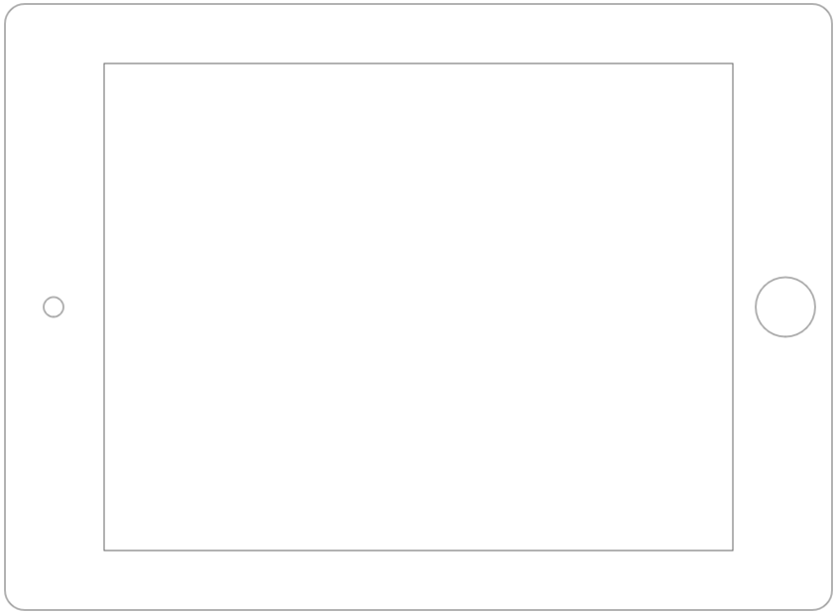

**+**

**...**



Staff contact management

Main screen (Landscape orientation)

1 Jasmin Brown

2 Koda Summit

3 Jia Kim

4 Anthony Mitchel

5 Luca Smith

The application is able to display on a bigger screen, like in a tablet, with the same features and look-and-feel.

**Info**

You have successfully deleted Jia Kim

OK

Delete information dialogue

**Info**

You have successfully added Jia Kim

OK

Add information dialogue

**Info**

You have successfully updated Jia Kim

OK

Update information dialogue

**Alert**

All fields are required

OK

Alert message dialogue

**Alert**

Id must be a number

OK

Alert message dialogue

The above images show the message boxes with information or feedback of what goes wrong.

There are 2 themes provided with this application. The first theme is in colour. It is in normal mode. The font size is in the standard size which is suitable and comfortable for everybody to use. The second theme is in black and white and the font size is enlarged. It is designed for people with vision impairment, like colour blind and vision disorder.



**+**

**...**



Staff contact management

1 Jasmin Brown

2 Koda Summit

3 Jia Kim

4 Anthony Mitchel

5 Luca Smith

Select Theme 1 option

Theme 1

Theme 2

Help



**+**

**...**



**Staff contact management**

1 Jasmin Brown

2 Koda Summit

3 Jia Kim

4 Anthony Mitchel

5 Luca Smith

Theme 1

An online help is provided by clicking on the [Help] dropdown menu. It provides step by step instructions of how to operate each functionality, including adding a new staff, updating an existing staff’s contact, and deleting an existing staff’s contact.



**+**

**...**



Staff contact management

1 Jasmin Brown

2 Koda Summit

3 Jia Kim

4 Anthony Mitchel

5 Luca Smith

Select Theme 2 option

Theme 1

Theme 2

Help



Theme 2

**+**

**...**



**Staff contact management**

1 Jasmin Brown

2 Koda Summit

3 Jia Kim

4 Anthony Mitchel

5 Luca Smith



**+**

**...**



Staff contact management

1 Jasmin Brown

2 Koda Summit

3 Jia Kim

4 Anthony Mitchel

5 Luca Smith

Select Help option

Theme 1

Theme 2

Help



**🡨**

Help

**How to add a new staff contact**

1. Click on the + sign on the top right corner of the toolbar.

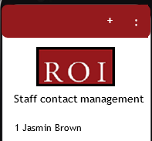

2. Enter Id, Name, Phone, Department, Street, City, State, Zip, and Country in the provided entries.

## Flowchart

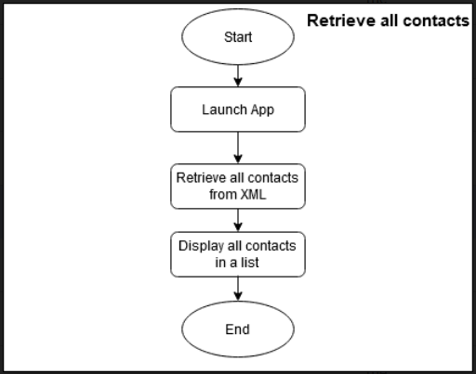

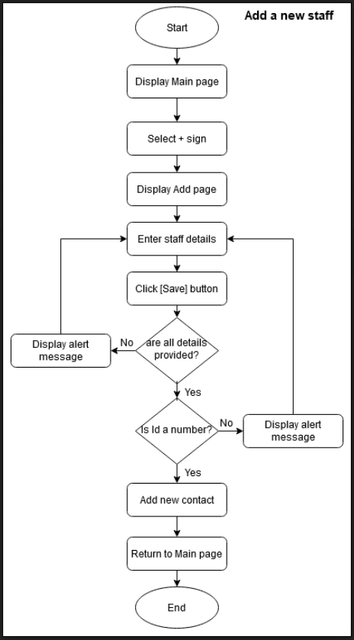

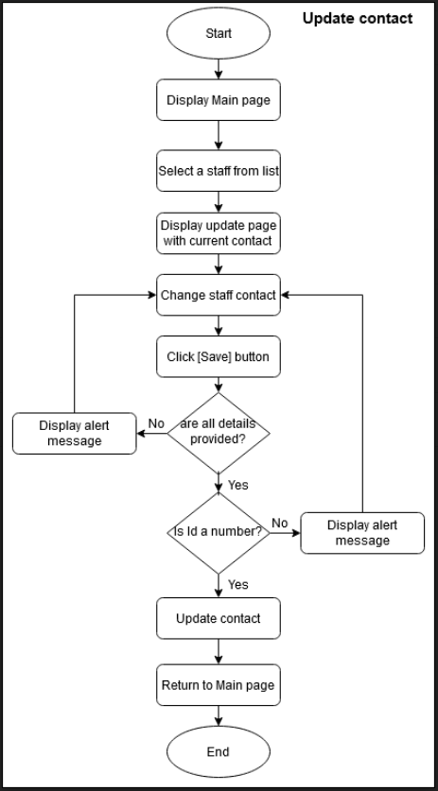

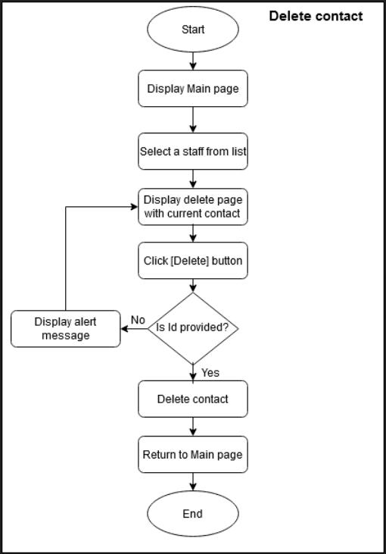

## Online user manual design

### Add a new contact

**How to add a new staff contact**

1. Click on the + sign on the top right corner of the toolbar.



**+**

**...**



Staff contact management

1 Jasmin Brown

2 Koda Summit

3 Jia Kim

4 Anthony Mitchel

5 Luca Smith

1. Enter Id, Name, Phone, Department, Street, City, State, Zip, and Country in the provided entries.



**🡨**

Id

Name

Phone

Department

Street

City

1. Click on [Save] button to add the new staff.



City

State

Zip

Country

**🡨**

SAVE

DELETE

CANCEL

1. You will see a confirmation message that you have successfully added the staff contact.

**Info**

You have successfully added Jia Kim

OK

### Update contact

**How to update a staff contact**

1. Click on the staff name.



**+**

**...**



Staff contact management

1 Jasmin Brown

2 Koda Summit

3 Jia Kim

4 Anthony Mitchel

5 Luca Smith

1. Update the details of the staff.



**🡨**

Id

Name

Phone

Department

Street

City

5

Luca Smith

97554784

1

Williams

Granville

1. Click on [Save] button to update the staff contact.



**🡨**

City

State

Zip

Country

NSW

2147

Australia

Granville

SAVE

DELETE

CANCEL

1. You will see a confirmation message that you have successfully updated the staff contact.

**Info**

You have successfully updated Jia Kim

OK

### Delete a contact

**How to delete a staff contact**

1. Click on the staff name.



**+**

**...**



Staff contact management

1 Jasmin Brown

2 Koda Summit

3 Jia Kim

4 Anthony Mitchel

5 Luca Smith

1. Click on [Delete] button to delete the staff contact.



**🡨**

City

State

Zip

Country

NSW

2147

Australia

Granville

SAVE

DELETE

CANCEL

1. You will see a confirmation message that you have successfully deleted the staff contact.

**Info**

You have successfully deleted Jia Kim

OK

## Screen orientations

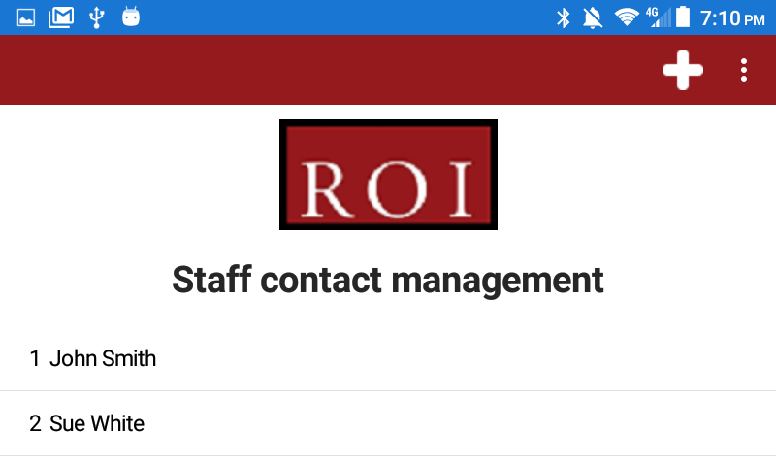

Theme 1 Landscape

Theme 1 Portrait

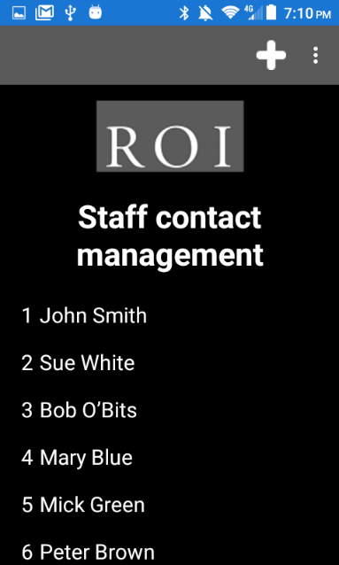

Theme 2 Portrait

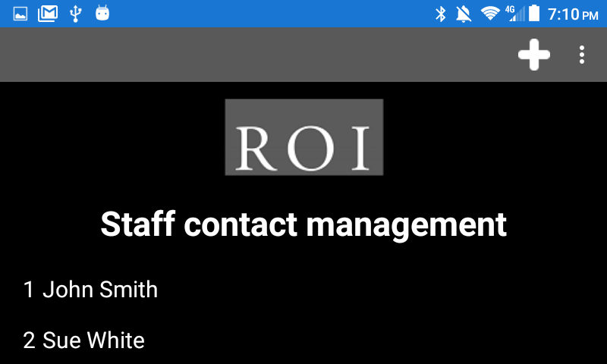

Theme 2 Landscape

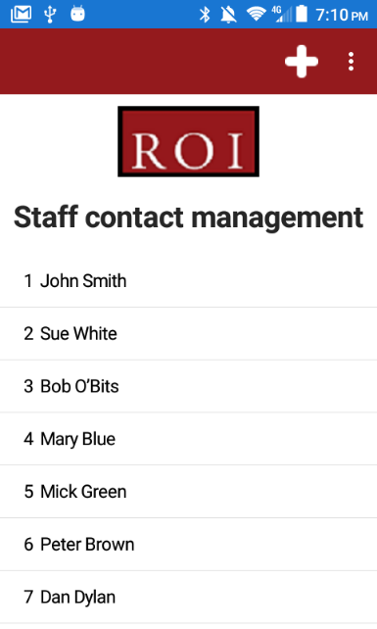

## Menu structure

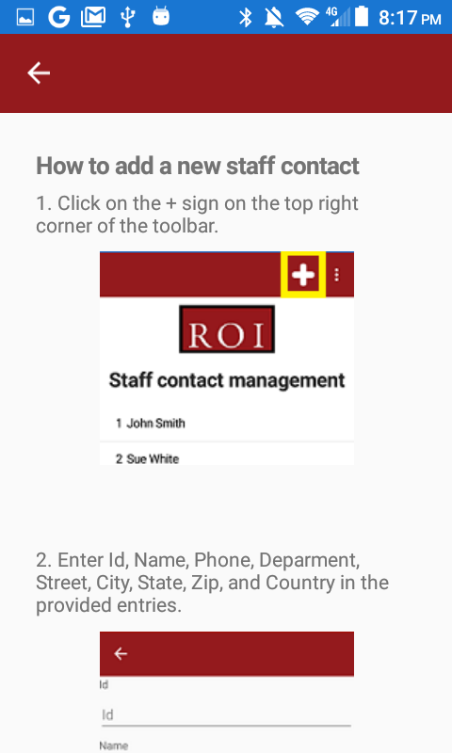

Navigation

Theme 1

Theme 2

Help

## Sign-off

|  |  |  |  |
| --- | --- | --- | --- |
| Name | Position/role | Date | Signature |
|  |  |  |  |