**Object-oriented design**

for the

**Western Sydney Medical Practices (WSMP) System**

Version 1.0

November 2020

## Revision History

| Contributors | Date | Instructions |
| --- | --- | --- |
| **Viyada Tarapornsin** | 14 Nov 2020 | Initial draft based on the WMedical practice system software requirements version 1 (SWRqmntsWSMP.docx) |

Table of Contents

Revision History 2

Sequence diagram for Manage patient appointment 4

Manage patient appointment (View appointments) 4

Manage patient appointment (Add appointment) 5

Manage patient appointment (Amend appointment) 5

Manage patient appointment (Cancel appointment) 6

Activity diagram for Manage patient appointment 7

Activity diagram for View appointment 7

Activity diagram for Add appointment 8

Activity diagram for Amend appointment 9

Activity diagram for Cancel appointment 10

Class definition 11

Static class diagram 23

Detailed class diagram 24

## Sequence diagram for Manage patient appointment

### Manage patient appointment (View appointments)

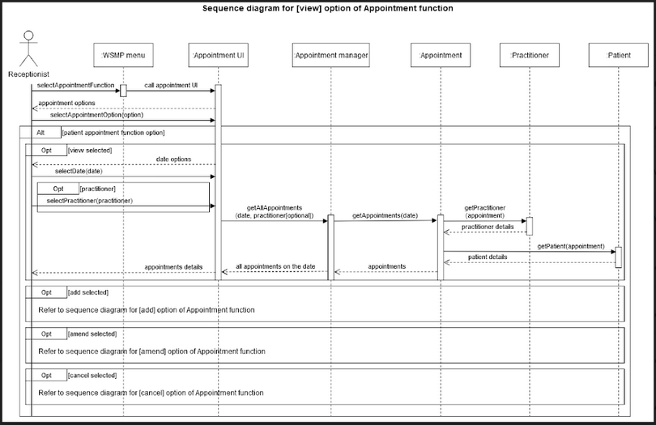

### Manage patient appointment (Add appointment)

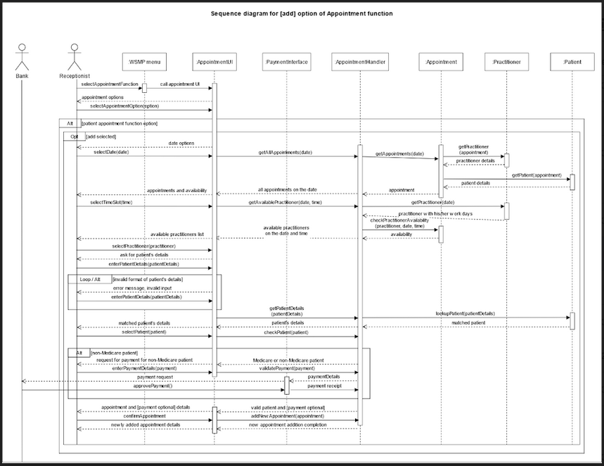

### Manage patient appointment (Amend appointment)

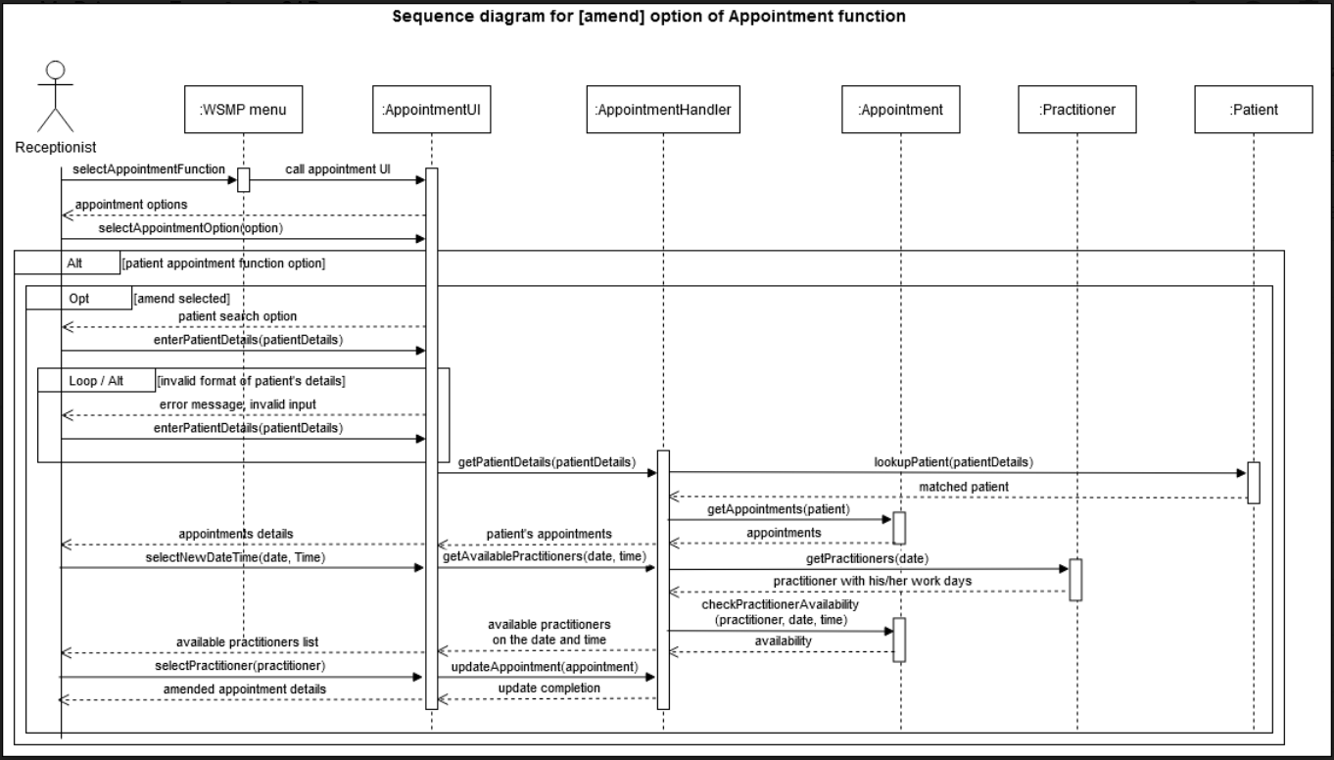

### Manage patient appointment (Cancel appointment)

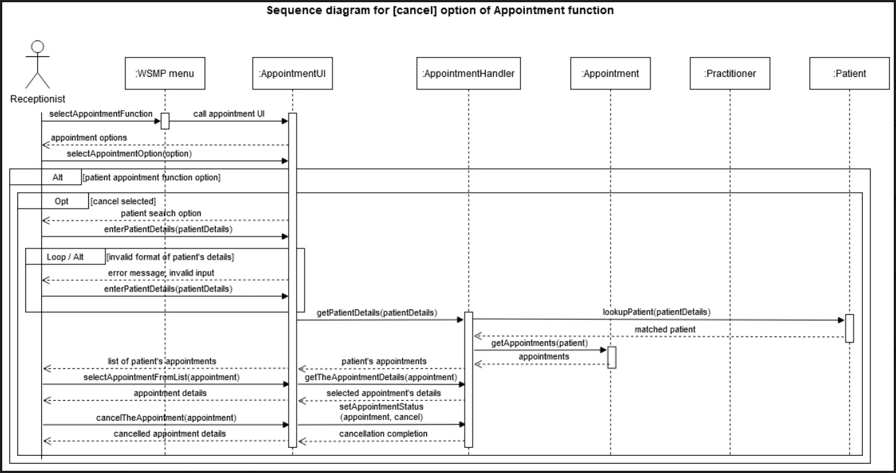

## Activity diagram for Manage patient appointment

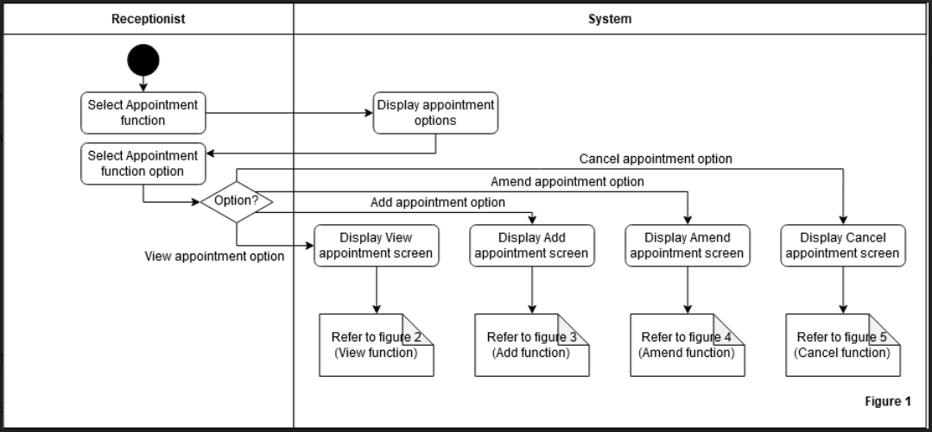

### Activity diagram for View appointment

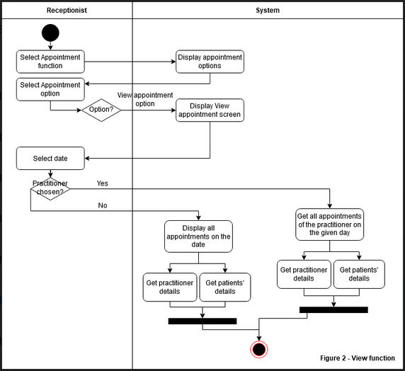

### Activity diagram for Add appointment

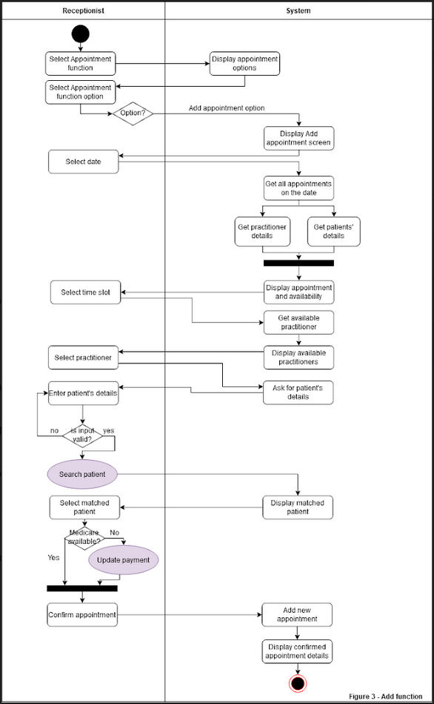

### Activity diagram for Amend appointment

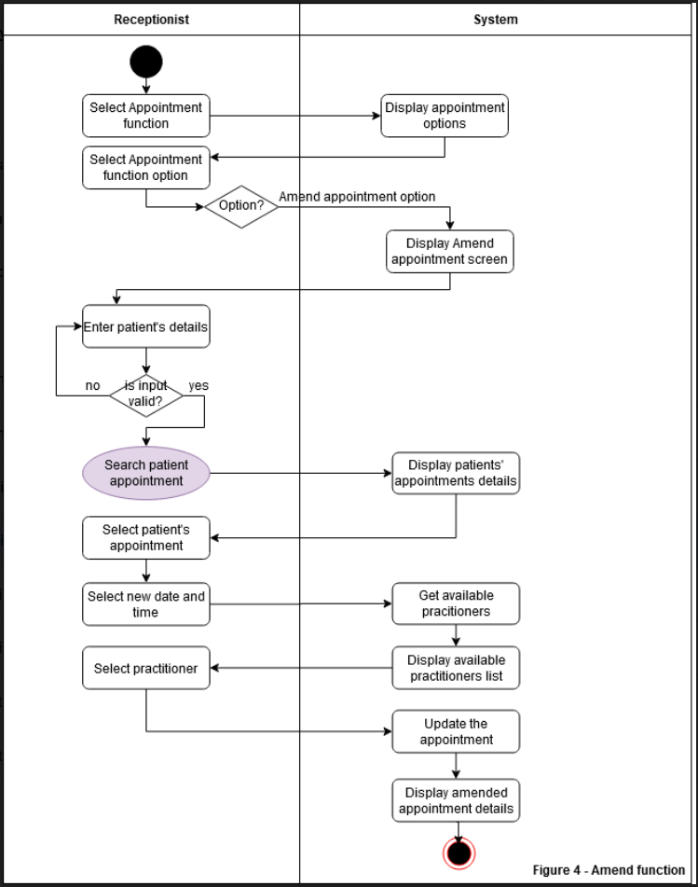

### Activity diagram for Cancel appointment

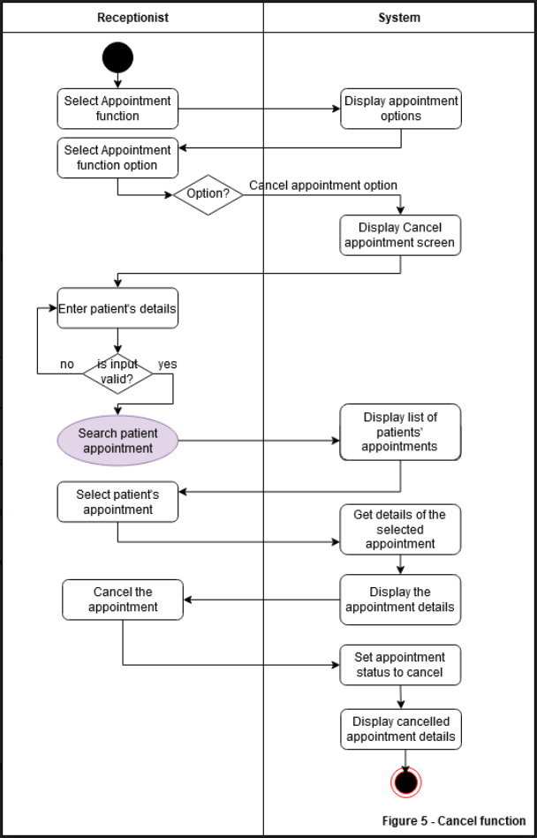

## Class definition

|  |  |  |  |  |
| --- | --- | --- | --- | --- |
| **Class name** | Address | | | |
| **Version** | 1 | | | |
| **Date** | 23-Nov-2020 | | | |
| **Modification date:** | Nil | | | |
| **Modification purpose:** | Nil | | | |
| **Base/Super class** | None | | | |
| **Category** | Entity | | | |
| **Description** | Address details | | | |
| **Attributes** | | | | |
| **Name** | **Visibility** | **Data Type** | **Description** | |
| ownerID | private | string | The id of the owner of the address. It can be patient ID or practitioner ID who lives in the address. | |
| streetNo | private | string | Address number | |
| street | private | string | Street name of the address | |
| city | private | string | City name of the address | |
| state | private | string | State of the address | |
| postcode | private | string | Postcode of the address | |
| country | private | string | Country of the address | |
| **Operations** | | | | |
| **Name** | **Visibility** | **Description** | | **Return Type** |
| getAddress() | public | Get address details | | Address |
| setAddress(streetNo, street, city, state, postcode, country) | public | Assign values of each attribute of the address | | void |

|  |  |  |  |  |
| --- | --- | --- | --- | --- |
| **Class name** | Appointment | | | |
| **Version** | 1 | | | |
| **Date** | 23-Nov-2020 | | | |
| **Modification date:** | Nil | | | |
| **Modification purpose:** | Nil | | | |
| **Base/Super class** | None | | | |
| **Category** | Entity | | | |
| **Description** | Appointment details | | | |
| **Attributes** | | | | |
| **Name** | **Visibility** | **Data Type** | **Description** | |
| practitioner | private | Practitioner | The practitioner object who attends this appointment. | |
| patient | private | Patient | The patient object who attends this appointment. | |
| date | private | date | Date of the appointment. | |
| time | private | time | Time of the appointment. | |
| status | private | AppointmentStatus | Enum: status of the appointment, whether it is new, completed, or cancel. | |
| paid | private | bool | True or false value to indicate that the patient has paid for the appointment (if he/she is not a Medicare card holder). | |
| consultation | private | Consultation | Consultation object that holds the details of consultation, like description. | |
| **Operations** | | | | |
| **Name** | **Visibility** | **Description** | | **Return Type** |
| getAppointment(practitioner, patient, date, time) | public | Get the appointment details by practitioner, patient, date of appointment, and time of appointment). | | Appointment |
| getPractitioner() | public | Get the practitioner, who attends the appointment. | | Practitioner |
| getPatient() | public | Get the patient, who attends the appointment. | | Patient |
| getDate() | public | Get the date of the appointment. | | date |
| getTime() | public | Get the time of the appointment. | | time |
| getStatus() | public | Get the status to the appointment. | | AppointmentStatus |
| setAppointment(practitioner, patient, date, time, status) | public | Assign values of the appointment’s attributes. | | void |
| setPatient(patient) | public | Assign a patient to the appointment. | | void |
| setPractitioner(practitioner) | public | Assign a practitioner to the appointment. | | void |
| setDate(date) | public | Set date of the appointment. | | void |
| setTime(time) | public | Set time of the appointment. | | void |
| setStatus(appointmentStatus) | public | Assign a status to the appointment. | | void |
| setPaymentStatus(status) | public | Assign a status of payment to the appointment. | | void |
| setConsultation(description) | public | Add description to the consultation. | | void |

|  |  |  |  |  |  |  |
| --- | --- | --- | --- | --- | --- | --- |
| **Class name** | Consultation | | | | | |
| **Version** | 1 | | | | | |
| **Date** | 23-Nov-2020 | | | | | |
| **Modification date:** | Nil | | | | | |
| **Modification purpose:** | Nil | | | | | |
| **Base/Super class** | None | | | | | |
| **Category** | Entity | | | | | |
| **Description** | Consultation details | | | | | |
| **Attributes** | | | | | | |
| **Name** | **Visibility** | | **Data Type** | | **Description** | |
| consultationID | private | | int | | The internal id of the consultation record (this id is auto generated in the database). | |
| description | private | | string | | The consultation details, this information is entered by a practitioner. | |
| **Operations** | | | | | | |
| **Name** | | **Visibility** | | **Description** | | **Return Type** |
| getConsultation(constructionID) | | public | | Get address details | | Address |

|  |  |  |  |  |  |  |
| --- | --- | --- | --- | --- | --- | --- |
| **Class name** | Pathology | | | | | |
| **Version** | 1 | | | | | |
| **Date** | 23-Nov-2020 | | | | | |
| **Modification date:** | Nil | | | | | |
| **Modification purpose:** | Nil | | | | | |
| **Base/Super class** | None | | | | | |
| **Category** | Entity | | | | | |
| **Description** | Pathology details | | | | | |
| **Attributes** | | | | | | |
| **Name** | **Visibility** | | **Data Type** | | **Description** | |
| practitioner | private | | Practitioner | | Practitioner who orders the pathology test. | |
| patient | private | | Patient | | Patient whom the pathology test is for. | |
| dateTimeOrdered | private | | datetime | | Date and time that the pathology test is requested. | |
| status | private | | PathologyStatus | | Enum: status of the pathology, whether it is new, collected, sent, or completed. | |
| **Operations** | | | | | | |
| **Name** | | **Visibility** | | **Description** | | **Return Type** |
| getPathology(practitioner, patient, dateTimeOrdered) | | public | | Get the details of a pathology test request. | | Pathology |
| setPathology(practitioner, patient, dateTimeOrdered, status) | | public | | Assign values to pathology’s attributes. | | void |

|  |  |  |  |  |  |  |
| --- | --- | --- | --- | --- | --- | --- |
| **Class name** | Patient | | | | | |
| **Version** | 1 | | | | | |
| **Date** | 23-Nov-2020 | | | | | |
| **Modification date:** | Nil | | | | | |
| **Modification purpose:** | Nil | | | | | |
| **Base/Super class** | None | | | | | |
| **Category** | Entity | | | | | |
| **Description** | Patient details | | | | | |
| **Attributes** | | | | | | |
| **Name** | **Visibility** | | **Data Type** | | **Description** | |
| patientID | private | | string | | A unique ID of a patient. | |
| name | private | | string | | Patient’s name. | |
| phone | private | | string | | Patient’s contact number. | |
| email | private | | string | | Patient’s email address. | |
| address | private | | Address | | Address object, containing address of a patient. | |
| dateOfBirth | private | | date | | Patient’s date of birth. | |
| medicareNo | private | | string | | Patient’s unique Medicare number. | |
| **Operations** | | | | | | |
| **Name** | | **Visibility** | | **Description** | | **Return Type** |
| getPatient(patientID) | | public | | Get the details of a patient using patient ID. | | Patient |
| getName() | | public | | Get name of the patient. | | string |
| getPhone() | | public | | Get phone number of the patient. | | string |
| getEmail() | | public | | Get email address of the patient. | | string |
| getAddress() | | public | | Get address of the patient. | | Address |
| getMedicareNo() | | public | | Get Medicare number of the patient. | | string |
| setPatient(name, phone, email, address, medicareNo) | | public | | Assign values to the Patient’s attributes. | | Void |

|  |  |  |  |  |  |  |  |
| --- | --- | --- | --- | --- | --- | --- | --- |
| **Class name** | Practitioner | | | | | | |
| **Version** | 1 | | | | | | |
| **Date** | 23-Nov-2020 | | | | | | |
| **Modification date:** | Nil | | | | | | |
| **Modification purpose:** | Nil | | | | | | |
| **Base/Super class** | Staff | | | | | | |
| **Category** | Entity | | | | | | |
| **Description** | Practitioner details | | | | | | |
| **Attributes** | | | | | | | |
| **Name** | | **Visibility** | | **Data Type** | | **Description** | |
| practitionerRegistrationNo | | private | | int | | A unique registration number of a practitioner. | |
| Availability | | private | | List<WorkDays> | | A list of the practitioner’s work days in a week. | |
| practitionerType | | private | | PractitionerType | | Enum: Patient’s type whether it is a doctor, psychologist, or nurse. | |
| **Operations** | | | | | | | |
| **Name** | | | **Visibility** | | **Description** | | **Return Type** |
| getPractitionerRegNo() | | | public | | Get registration number of the practitioner. | | Int |
| getAvailability() | | | public | | Get a list of work days of the practitioner. | | List<WorkDays> |
| getPractitionerType() | | | public | | Get type of practioner. | | PractitionerType |
| setPractitionerRegNo(regNo) | | | public | | Assign practitioner registration number to the practitioner object. | | Void |
| setAvailability(WorkDay) | | | public | | Set workdays of the practitioner. | | Void |
| setPractitionerType(practitionerTYpe) | | | public | | Set type of practitioner. | | Void |

|  |  |  |  |  |  |  |
| --- | --- | --- | --- | --- | --- | --- |
| **Class name** | Staff | | | | | |
| **Version** | 1 | | | | | |
| **Date** | 23-Nov-2020 | | | | | |
| **Modification date:** | Nil | | | | | |
| **Modification purpose:** | Nil | | | | | |
| **Base/Super class** | None | | | | | |
| **Category** | Entity | | | | | |
| **Description** | Staff details | | | | | |
| **Attributes** | | | | | | |
| **Name** | **Visibility** | | **Data Type** | | **Description** | |
| staffID | protected | | string | | A unique ID of a staff. | |
| Name | protected | | string | | Staff’s name. | |
| phone | protected | | string | | Staff’s contact number. | |
| Email | protected | | string | | Staff’s email address. | |
| Address | protected | | Address | | Address object, containing address of a staff. | |
| dateOfBirth | protected | | date | | Staff’s date of birth. | |
| username | protected | | string | | Username to login to the system. | |
| password | protected | | string | | Password to login to the system. | |
| **Operations** | | | | | | |
| **Name** | | **Visibility** | | **Description** | | **Return Type** |
| getStaff(staffID) | | public | | Get the details of a staff using staff ID. | | staff |
| getStaff(username, password) | | public | | Get a staff’s details by username and password. | | staff |
| getRole() | | public | | Get the staff’s role. | | StaffRole |
| setStaff(name, phone, email, address, password, username, role, status) | | public | | Assign values to a staff’s attributes. | | void |
| setStaffStatus(status) | | public | | Assign status to the staff object. | | void |
| setPassword(password) | | public | | Set password of the staff. | | void |

|  |  |  |  |  |  |  |
| --- | --- | --- | --- | --- | --- | --- |
| **Class name** | Stock | | | | | |
| **Version** | 1 | | | | | |
| **Date** | 23-Nov-2020 | | | | | |
| **Modification date:** | Nil | | | | | |
| **Modification purpose:** | Nil | | | | | |
| **Base/Super class** | None | | | | | |
| **Category** | Entity | | | | | |
| **Description** | Stock details | | | | | |
| **Attributes** | | | | | | |
| **Name** | **Visibility** | | **Data Type** | | **Description** | |
| stockID | private | | int | | A unique ID of a product in stock. | |
| productName | private | | string | | Name of the product. | |
| productDescription | private | | string | | Description of the product. | |
| price | private | | double | | Cost per unit of the product. | |
| stockOnHand | private | | int | | Number of available item. | |
| **Operations** | | | | | | |
| **Name** | | **Visibility** | | **Description** | | **Return Type** |
| getStock(stockID) | | public | | Get the details of a product by ID. | | Stock |
| getProductName() | | public | | Get the name of the product. | | string |
| getProductDesc() | | public | | Get the description of the product. | | string |
| getPrice() | | public | | Get the price of the product. | | double |
| getStockOnHand() | | public | | Get the number of item available in the stock. | | int |
| setStock(productName, productDesc, price, stockOnHand) | | public | | Set the values of Stock’s attributes. | | void |

|  |  |  |  |  |
| --- | --- | --- | --- | --- |
| **Class name** | AppointmentHandler | | | |
| **Version** | 1 | | | |
| **Date** | 23-Nov-2020 | | | |
| **Modification date:** | Nil | | | |
| **Modification purpose:** | Nil | | | |
| **Base/Super class** | None | | | |
| **Category** | Control | | | |
| **Description** | Handle all appointment actitivites | | | |
| **Operations** | | | | |
| **Name** | | **Visibility** | **Description** | **Return Type** |
| getAppointments(date) | | public | Get appointments on a specific date from Appointment class. | List<Appointment> |
| lookupPatient(patient) | | public | Get a patient detail. | Patient |
| getAppointment(patient) | | public | Get all appointments of a particular patients. | List<Appointment> |
| setAppointmentStatus(appointment, status) | | public | Set status of an appointment. | void |
| getPractitioners(date) | | public | Get all practitioners who work on the given date. | List<Practitioner> |
| checkPractitionerAvailability(practitioner, date, time) | | public | Check the availability of a particular practitioner on a given date and time. | Bool |
| getPractitioner(appointment) | | public | Get practitioner who attends the appointment. | Practitioner |
| getPatient(appointment) | | public | Get patient who attends the appointment. | Patient |

|  |  |  |  |  |
| --- | --- | --- | --- | --- |
| **Class name** | | AppointmentStatus | | |
| **Version** | | 1 | | |
| **Date** | | 23-Nov-2020 | | |
| **Modification date:** | | Nil | | |
| **Modification purpose:** | | Nil | | |
| **Base/Super class** | | None | | |
| **Category** | | State (Enum) | | |
| **Description** | | The statuses of appointments | | |
| **Operations** | | | | |
| **Name** | **Visibility** | | **Description** | **State value** |
| New | public | | New appointment. | 1 |
| Completed | public | | Patient already attends the appointment. | 2 |
| Cancel | public | | The appointment has been cancelled. | 3 |

## Static class diagram

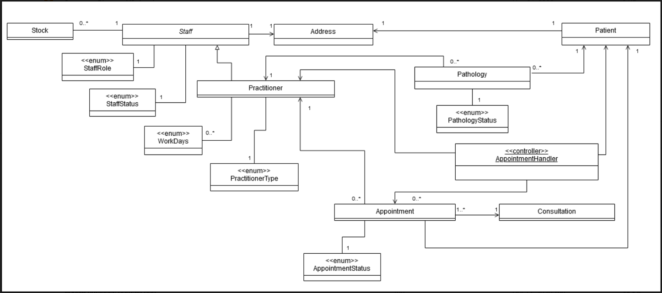

## Detailed class diagram

