**Software Requirements**

for the

**Western Sydney Medical Practices (WSMP) System**

Version 1.0

November 2020

## Revision History

| Contributors | Date | Instructions |
| --- | --- | --- |
| **Viyada Tarapornsin** | 12 Nov 2020 | Initial draft based on the WMedical practice system client requirements (WSMP_client_requirements.docx) |
| **Ned Gee, Viyada Tarapornsin** | 16 Nov 2020 | Second version, includes comments and revisions from the advisor |

Table of Contents

Revision History 3

Project Overview 5

Scope 5

Problems 5

Client requirements 6

Future requirements 7

Business domain 7

Functional and Non-functional Requirements 8

Functional business process 8

Non-functional business process 11

Opportunities for business process efficiencies improvement 12

Use case diagram 13

Project Feasibility 14

Technical 14

Operational 15

Budgetary 15

Scheduling 16

Proposed Solutions 16

Three feasible solutions 16

Solutions comparison 19

Assumptions and Risks 21

Assumptions 21

Risks analysis 21

Recommendations 22

Bibliography 23

Appendix A: Technical Specifications 24

Use case specification 24

Classes 35

## Project Overview

Western Sydney Medical Practices (WSMP) system is a computer-based system customised for the Western Sydney Medical Practices centre, which will replace the existing paper-based record-keeping procedures currently used at the Western Sydney Medical Practices centre.

### Scope

As described in the WSMP client requirements document (WSMP_client_requirements.docx) the WSMP system is a software application to facilitate management of patient and staff data, patient appointment, doctors’ Medicare scheduled fee, pathology test request service, centre management, reporting service, and GP clinical functions including prescription, referral, and pathology testing management.

The primary users of the WSMP system are doctors, psychologists, nurses, pathologists, receptionists, and management team members. Each user is required to logon to the system using their own username and password, which will identify their role on the system whether they are a receptionist, a practitioner (doctor and psychologist), or a member of the management team. Each role can access different functionalities of the system.

The WSMP system will be computerised and improve the current business process by reducing workloads of receptionists, decreasing waiting time and maintaining accurate appointment time which will improve patient satisfaction, and accommodating the future expansion of the medical practice by well handling a large volume of patients’, practitioners’, consultations’, prescriptions’ data, patients’ pathology records, and stock’s details.

The WSMP system will automate Medicare reports and is scheduled to send to Medicare system every Monday morning. The system will also interface with pathology centres, where the collected pathology samples are sent to and the results are returned from.

The WSMP system does not include:

* staff payroll
* accounting
* online booking of appointments

### Problems

The current working procedures are based on paper file-based recording, which causes problems in many areas, such as the insufficient storage and the flow of data. The data is quite out of date. The paper-based procedures rely heavily on receptionists to retrieve, reconcile, and store the paperwork and does not support the growth of patient numbers, who live in the Western Sydney region, in the past couple of years. All this paperwork is manually created by either receptionists or practitioners. This manual work creates excessive workloads to the receptionists and is prone to error and delay, which results in several problems, such as inaccurate patient data, lengthy waiting time for each patient. These problems create frustration and dissatisfactory experiences to patients.

In conclusion, there are three main areas of problems including the management of patients’ data, the management of patients’ appointment, and the offline work of prescription processing system and pathology data management. These problems make the future expansion very difficult.

### Client requirements

Outline the client requirements (as confirmed with the client).

The WSMP system should enable

Receptionist to:

* check, make, change, and cancel an appointment for all patients (pre-registered and walk-in(emergency) patients)
* each appointment is allocated 15 minutes time block, an appointment can take more than one session block
* add the data of a patient’s first visit, including the patient’s details and answers to the first visit questionnaire
* check and update stock’s details
* update payment either Medicare bulk-billed or cash

Practitioner to:

* view and update patient’s records, including the patient’s details, medical history, consultation record (with an option to tick ‘pathology test is advised’)
* issue a prescription
* set weekly availability (one week in advance)
* check their appointments through their personal device (mobile device)

Pathologist to:

* add data of the collected sample
* submit the data to a pathology centre
* update the results received from the pathology centre

Management team to:

* prepare the practitioners’ roster based on practitioners’ weekly availability
* view stock

Automation:

* produce Medicare reports consisting of the details of all consultations between Sunday and Saturday (every Monday morning)
* send the Medicare reports to Medicare system on Monday morning

### Future requirements

The expansion of the facilities, including the number of consultation rooms, can handle more patients per day. For this reason, the increment of the number of practitioners is required to handle the larger volume of patients per day. Therefore, the WSMP system is required to handle the expansion.

### Business domain

The main business domain of Western Sydney Medical Practices (WSMP) is to provide general health services to people who live in the Western Sydney region.

The main services include:

* General health checks
* Issue prescriptions
* Pathology test

The business domain of WSMP system that will contribute to the main services provided by Western Sydney Medical Practices is as follow:

* Patient management

This functionality will help to speed up the process of managing patient information, appointments,

* Practitioner management
* Consultation management
* Pathology management
* Medicare report

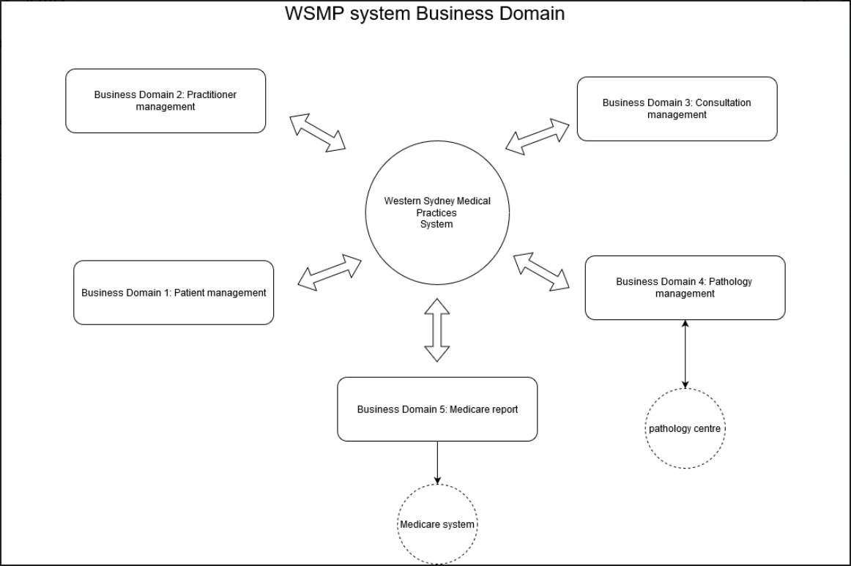

## Functional and Non-functional Requirements

### Functional business process

|  |
| --- |
| Priority |
| Must have this feature |
| Should have this feature if possible |
| May have this feature in the future |

A – All users function

R – Receptionist function

RP – Receptionist and practitioner function

RM – Receptionist and Management function

M – Management function

B – Background job (Automation)

| Use case ID | Name | Priority |
| --- | --- | --- |
| **A01** | The system shall allow all users to log on to the system |  |
| **R01** | The system shall allow a receptionist to add a new appointment for a patient (both pre-registered and walk-in(emergency) patients) in 15 minutes block sessions |  |
| **R02** | The system shall allow a receptionist to amend an appointment for a patient (both pre-registered and walk-in(emergency) patients) in 15 minutes block sessions |  |
| **R03** | The system shall allow a receptionist to cancel an appointment for a patient (both pre-registered and walk-in(emergency) patients) in 15 minutes block sessions |  |
| **R04** | The system shall allow a receptionist to view all appointments |  |
| **RP01** | The system shall allow a receptionist and a practitioner to search for a patient’s record |  |
| **RP02** | The system shall allow a receptionist and a practitioner to view a patient’s information |  |
| **R05** | The system shall allow a receptionist to add a new patient (enter patients’ first visit data and response to questionnaire) |  |
| **R06** | The system shall allow a receptionist to update a patient’s details |  |
| **R07** | The system shall allow a receptionist to update a payment record for a patient who must pay fee in cash, such as a non-Medicare card holder, or Medicare bulk-billed |  |
| **RM08** | The system shall allow a receptionist to view stock’s details |  |
| **R09** | The system shall allow a receptionist to update stock’s details |  |
| **R10** | The system shall allow a receptionist to add new products |  |
| **P01** | The system shall allow a practitioner to add a patient’s consultation details into the system |  |
| **P02** | The system shall allow a practitioner to view a patient’s history |  |
| **P03** | The system shall allow a practitioner to issue a prescription to a patient, if needed |  |
| **P04** | The system shall allow a practitioner to mark a patient’s consultation as ‘pathology test is advised’ |  |
| **P05** | The system shall allow a practitioner to set their availability (at least one week in advance) |  |
| **P06** | The system shall allow a practitioner to update their availability (at least one week in advance) |  |
| **P07** | The system shall allow a practitioner to check their appointments through their own personal device (mobile device) |  |
| **P08** | The system shall allow a practitioner to enter new data of the collected sample of a patient into the system |  |
| **P09** | The system shall allow a practitioner to submit a patient’s pathology data to a pathology centre |  |
| **P10** | The system shall allow a practitioner to update the results received from the pathology centre |  |
| **P11** | The system shall allow a practitioner to access the system remotely |  |
| **M01** | The system shall allow a management team member to prepare the practitioners’ roster based on practitioners’ weekly availability |  |
| **M02** | The system shall allow a management team member to update the practitioners’ roster based on practitioners’ weekly availability |  |
| **B01** | The system shall produce Medicare reports consisting of the details of all consultations between previous Sunday and Saturday on Monday morning and send the Medicare reports to Medicare system |  |

### Non-functional business process

**Security requirements**

1. All users are required to enter their username and password to be authenticated and authorised to access the system.
2. The system shall allow all users change their password.
3. The access to the system shall be controlled by different access levels for different user types.
4. The system shall be secure and protect privacy of patients’ personal data.
5. The system shall be protected from any kind of computer security threat.
6. The system shall restrict access to all functionalities, including Receptionist functions, Practitioner functions, Pathologist functions, Management team member functions, and Automation job, to the management team members.
7. The system shall allow Management team members to add a new user with a relevant role into the system.
8. The system shall allow Management team members to manage user roles.
9. The system shall restrict access to Receptionist functions to receptionists.
10. The system shall restrict access to Practitioner functions to practitioners, including doctors and psychologist.
11. The system shall restrict access to Pathologist functions to pathologists.

**Scalability requirements**

1. The system shall handle the future-expansion and it shall work efficiently in the future after the expansion.
2. The system shall be able to cope with the access of at least 14 computers (10 in chambers for doctors, 1 in a pathology room, and 3 at the receptionist counter) and 12 printers (10 in chambers for doctors, 1 in a pathology room, and 1 at the receptionist counter) concurrently.
3. The system shall be able to cope with 400 patient records per day.
4. The system shall be able to store 500 current patient’s data, with 100 patient files expansion in the next 3 years.
5. The system shall be running on Monday morning while the system auto-generate a Medicare report and send it to Medicare system.

**Robustness requirements**

1. An error tracking system shall be in place.
2. Database transactions shall be recorded in log files for future reference.
3. Backups of all system data shall be generated on a weekly basis.

**Interoperability requirements**

1. The system shall allow sending Medicare report to the Medicare system on Monday morning.
2. The system shall allow submitting a patient’s pathology data to a pathology centre.
3. The system shall allow receiving pathology results from the pathology centre.

**Operating requirements**

1. The system shall allow operate on a server running Windows server as the users (receptionists) are familiar with the Windows environment.

**Usability requirements**

1. The interface for all users should be easy to use, without requiring extensive technical assistance, support, or offline user guides.
2. The system shall display friendly error message to the users.
3. The system shall capture the consultation times of each practitioner.
4. The system shall provide user-friendly interface.
5. The system shall be reliable and respond fast to each request.

**User Documentation requirements**

1. One user manual with step-by-step instructions of how to use each functionality shall be provided.

**Design and Implementation Constraints**

1. The system shall be written in C#.
2. The system shall run on Windows10 or above operating system.
3. The system shall connect to MSSQL server to save all data.
4. The system shall use Model, View, and Controller (MVC) modular to make the system easy to maintain in the future.

### Opportunities for business process efficiencies improvement

The WSMP system will help to improve business process efficiencies. It will enable the medical practice to handle the increasing number of patients by:

* Reducing waiting time of patients as both receptionists and practitioners are able to access patients’ data and update their information electronically.
* Reducing administrative processing time as all patient’s records, appointments, test request, medical history, are searchable.
* Eliminating the excessive workload and overtime work caused by the archaic paper-based system. For example, claims are automated by the system.
* Keeping patient’s data, including patient’s personal details, medical history, and appointments, up to date as all records are updated instantly by receptionists and practitioners.
* Reducing human errors such as appointment allocated times, double booking appointments as the appointment details are validated by the system.

### Use case diagram

Map the business processes using a suitable digital modelling tool:

1. Draw a high-level use case diagram of the new system. One of the use cases should be ‘Manage Patient Appointment’.

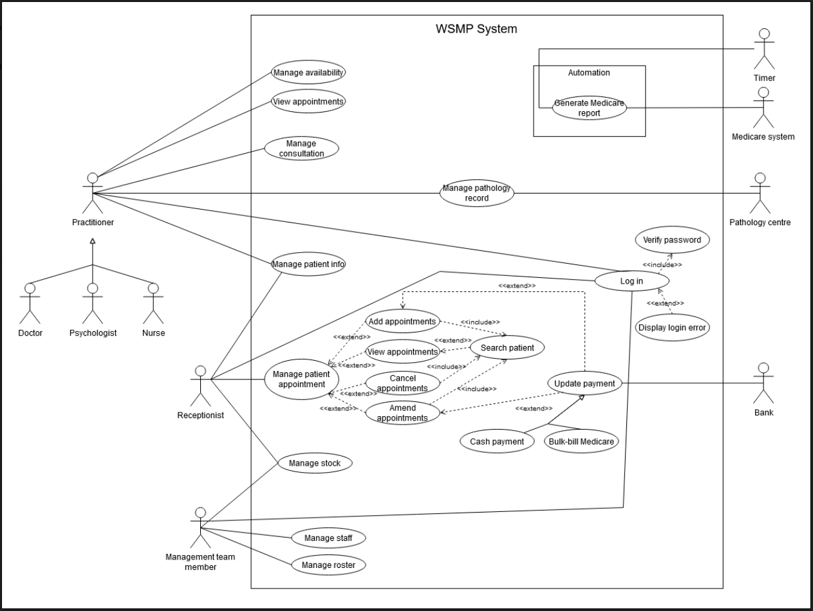

1. Draw an expanded use case diagram of the new WSMP system.

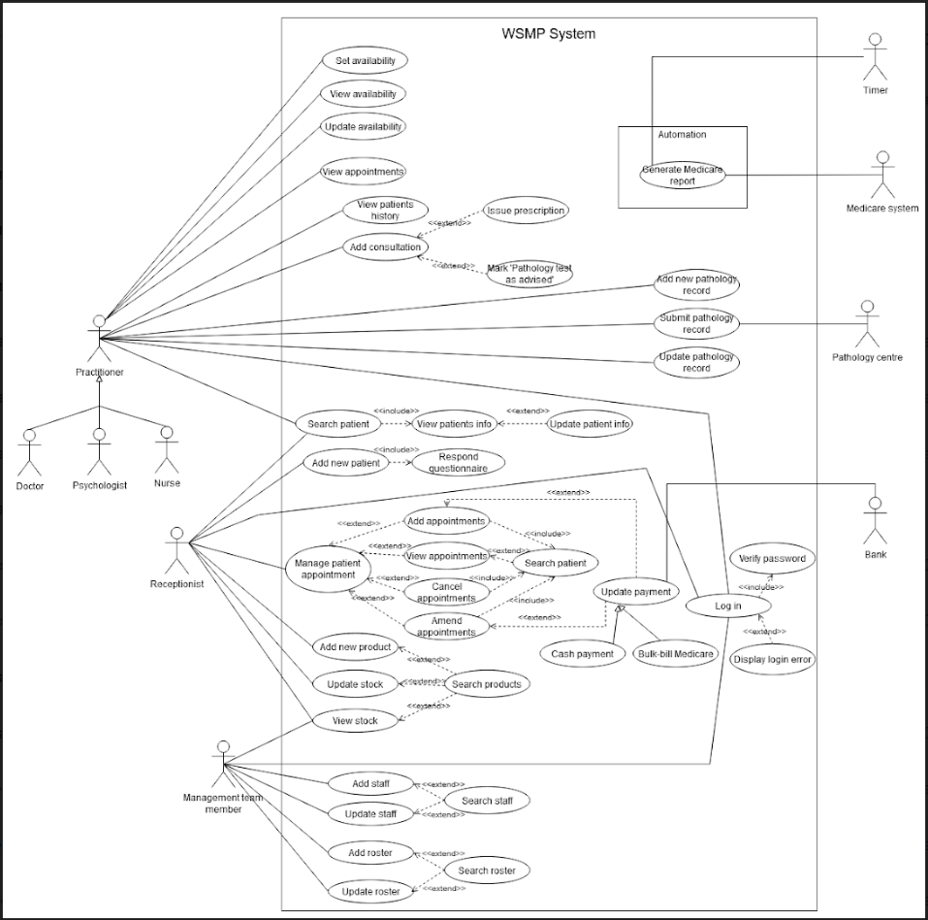

## Project Feasibility

### Technical

#### Software

The WSMP system is a computer-based software, which will be developed using Microsoft developing tools and technologies, such as Visual Studio and C#, Microsoft Windows Server 2019, and Microsoft SQL server. These technologies are reliable, manageable, and scalable. The software development team has relevant technical skills and capabilities on these tools and technologies as they have developed several other similar projects in the past, so the technical requirement, in terms of human resource and technologies, is feasible.

#### Hardware and Network Infrastructure

A server, fourteen computers, and twelve laser printers are required for this project, which relatively small, so a switch can facilitate the sharing of resources by connecting the server, computers and laser printers together, while a router with a built-in modem can connect the computers to the Internet with NBN high speed connection and allow it to communicate to the Medical System and Pathology Centre. Although the network connects to the Internet, the server is protected and controlled any access by a firewall and ensuring only authorized users can gain access to the patients’ data. The server provides a high capacity of storage that can save a big volume of all existing data (more than 500 patient data) as well as newly created data in the future. The high performance of CPU and RAM of the server ensure the reliability and fast responsive rate of the system, which guarantees over 100 patient records transaction per day.

With these software, hardware and network infrastructure, the WSMP system is technically feasible and supported for future expansion.

### Operational

The WSMP system will be running on Windows 10 or later versions. As the users are currently using Microsoft products, like Windows 8, MS Office 2007 - Excel, and Words, they will be familiar with the system. The users can retrieve, update, delete, and view all available data within a click, so it will save the users time, process of work, and workload. It will be beneficial to all users by automating workflow and reducing their manual work and paperwork. The new system shall reduce operational time of manual work for each patient from 15 minutes to 3 minutes or by 80%. The system evidently reduces operational time and effort, so it is operational feasible.

### Budgetary

The budget of $20,000 will be spent on the following expected monetary cost:

* Software development team for 4 weeks, which includes
  + One system designer (7 days * $45 * 8 hours = $2,520)
  + One user interface designer and developer (5 days * $35 * 8 hours = $1,400)
  + One backend developer (8 days * $40 * 8 hours = $2,560)
  + One database developer (5 days * $40 * 8 hours = $1,600)
  + One software tester (8 days * $30 * 8 hours = $1,920)
  + One networking developer (2 days * $35 * 8 hours = $560)
* Server and network components

Server: Dell PowerEdge T440 Tower ($3,100)

Other network components: Cables and Switch ($1,000), considering that a router with a built-in modem is provided by the Medical Practice

* The cost of the maintenance and upgrade of the software is $1,000 per year for 5 years.
* The total cost of the WSMP system is $19,660, which is feasible and within the budget of $20,000.

### Scheduling

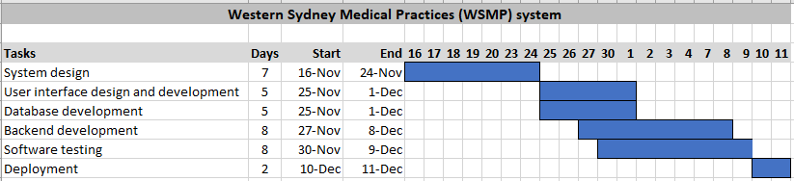

* The system design phase takes 7 days.
* The development phase takes 20 days’ worth of work, 5 days for user interface design and development, 5 days for database development, and 10 days for backend development.
* The testing phase takes 8 days.
* The deployment phase takes 2 days.
* Total days of work is 35-man days; however, all the work will be completed within the timeframe of 1 month or 4 weeks as some tasks can start at the same time and some tasks can be done simultaneously.

## Proposed Solutions

### Three feasible solutions

1. **ePractice** is a Windows based Practice management software, which allows users to manage their patients’ details, appointments, treatment or consultation details, practitioners and rosters details. It lacks functionalities that handle inventory management and additional note or request, like pathology request.

* Cost of licenses for ePractice are $1,199 per full-time doctor per year, $599 per part-time doctor per year, and $419 per other types of health professional.
* For 12 practitioners, which include 4 full-time doctors, 4 casual doctors, 4 other types of health professional, it will cost $8,868 (4 * $1,199 + 4 * $599 + 4 * $419) per year.
* Server and network components, including Dell PowerEdge T440 Tower ($3,100), cables and switch ($1,000).
* The cost of the maintenance and upgrade of the software is $1,000 per year for 5 years.

1. **Power Diary** is an online web-based Practice management software, which uses Amazon Web Services as the infrastructure to host the software application, database and data storage to save its clients’ data. It provides most features required for this project, including appointment management, consultation details management, patient record management, practitioner details and roster management, Pathology request management, and inventory management.

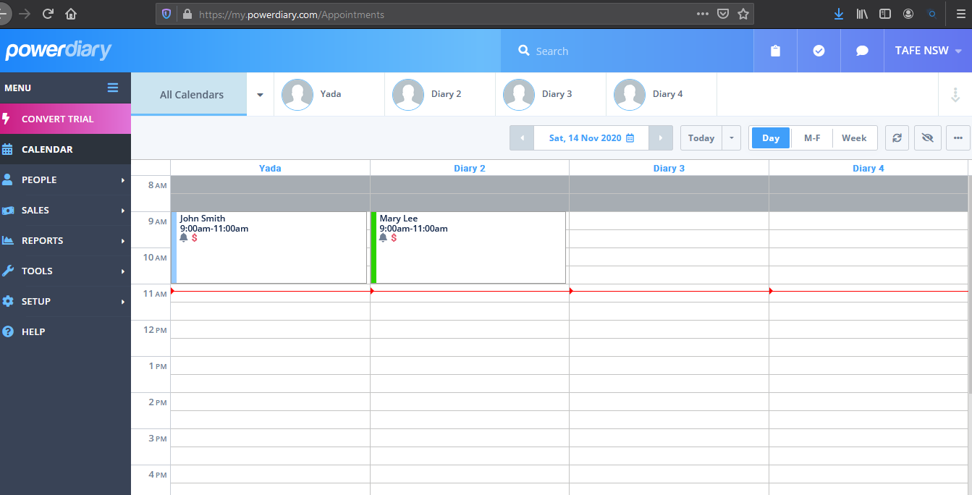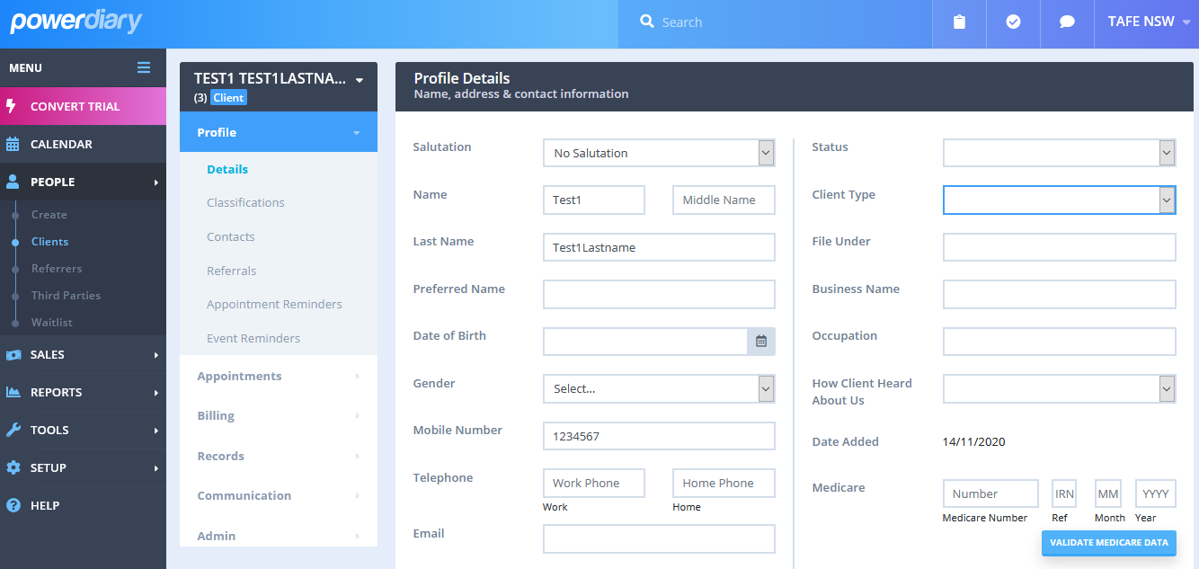

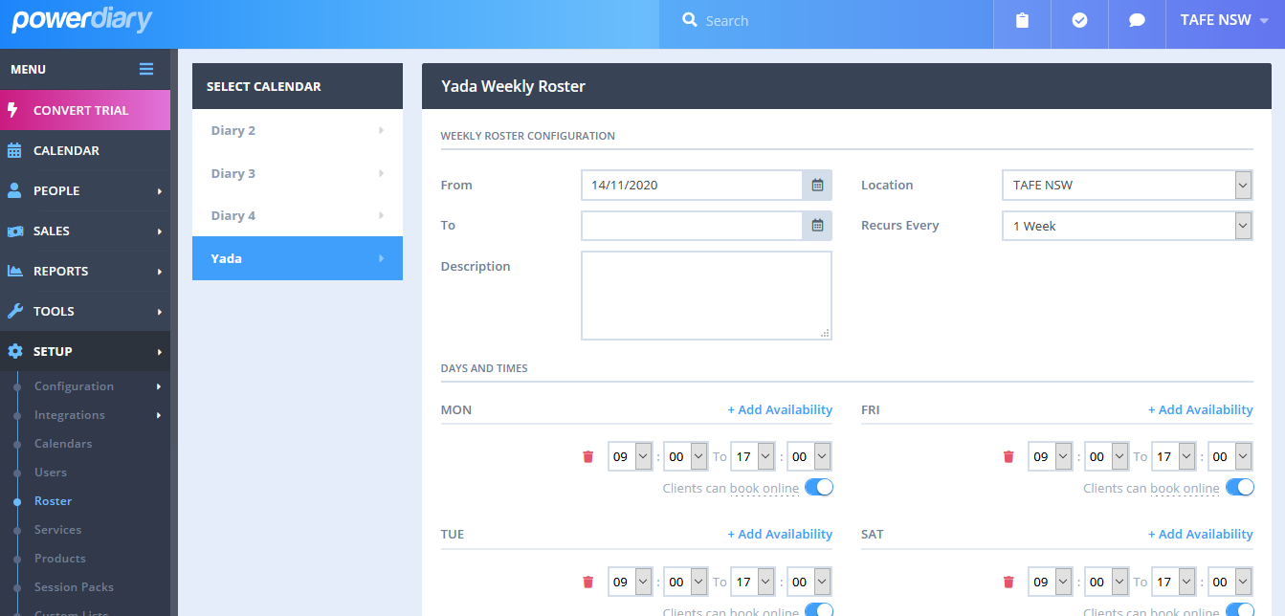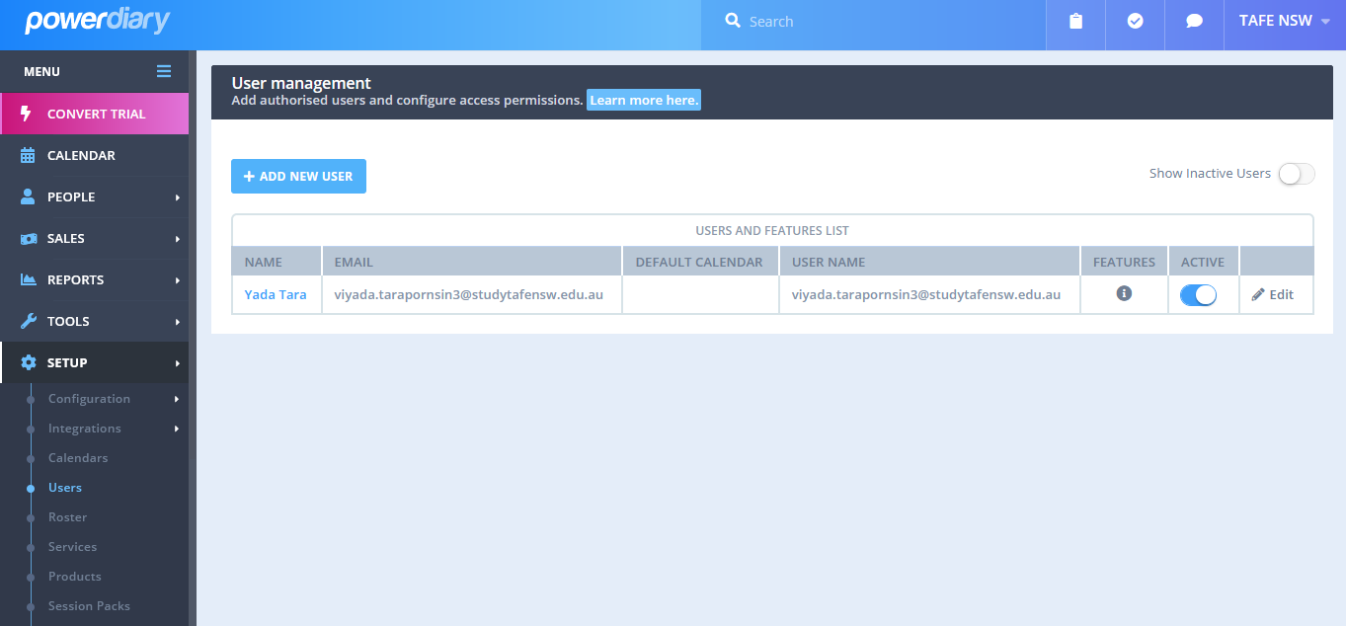Appointment management Patient records management

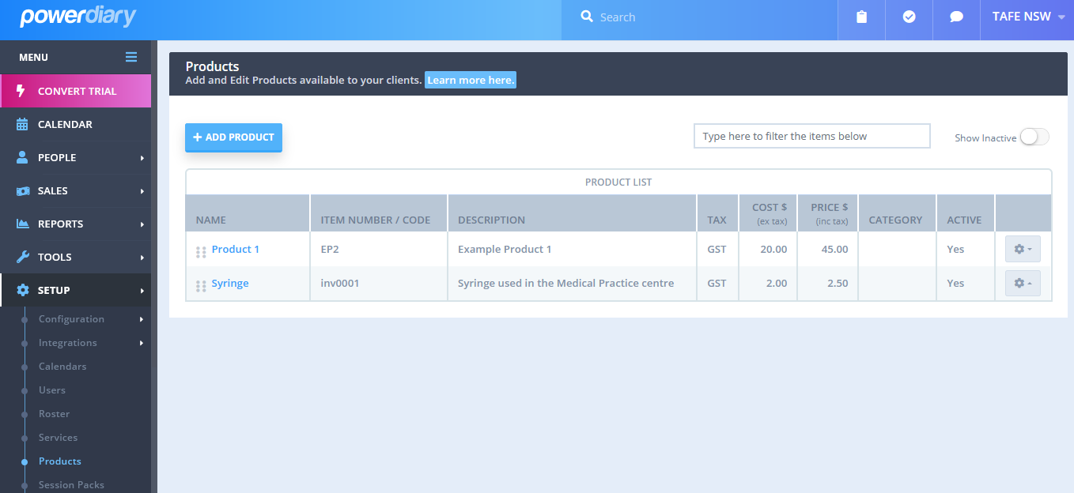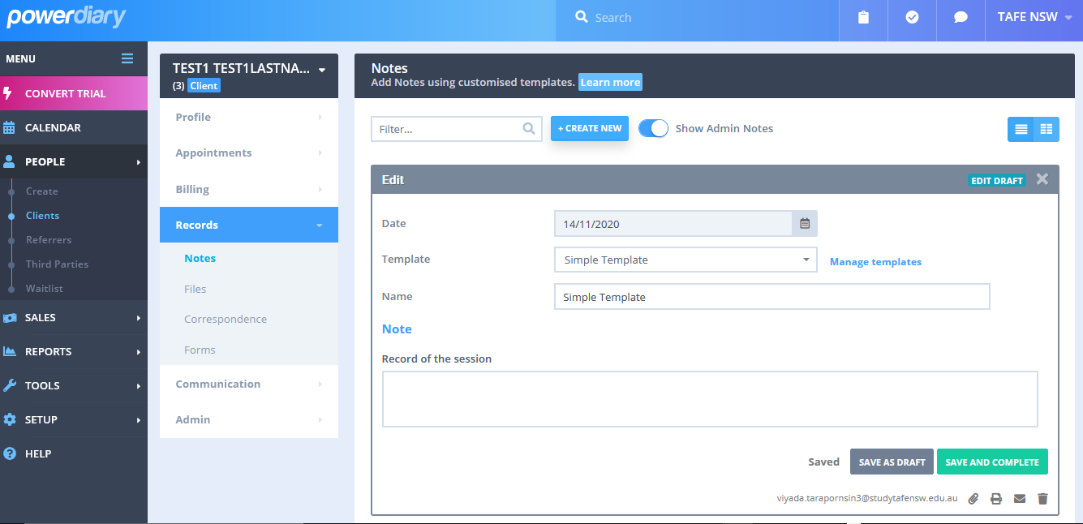Practitioner management Roster management

Inventory management Pathology request management

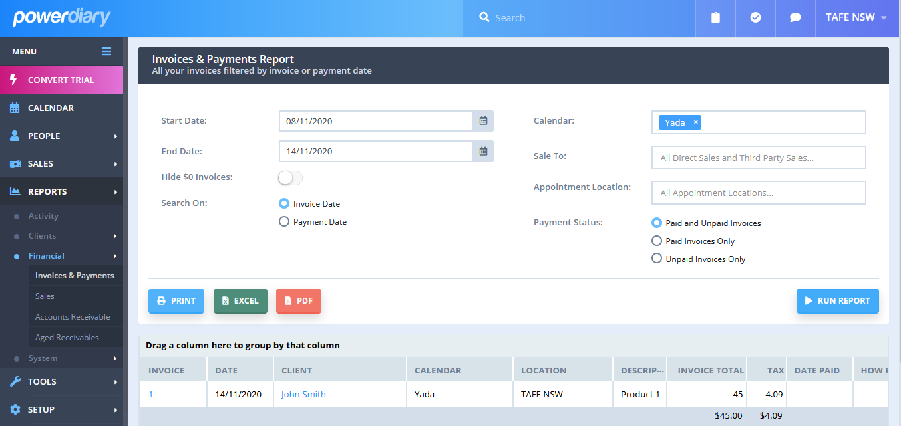

Medicare report management

* Cost of Power Diary for 12 practitioners is $50 per week, which is equivalent to $13,000 for 5 years term.
* Cost of IT professional to configure and setup the software to better suit client’s requirement is $560 (2 days * $35 * 8 hours).
* Cost of other network components: Cables and Switch ($1,000), to connect to the router provided by client.
* It supports future expansion, in terms of storage and application updated.
* Profile details of patients and practitioners are preset.
* The cost will be increased by $2.40 per week per practitioner, if there are more than 20 active practitioners in the system.
* The cost of the maintenance and upgrade of the software is $1,000 per year for 5 years.
* Inventory management does not provide the ability to maintain level of inventory.
* Pathology request management can be done by adding a note to a patient’s record, so the pathology requests cannot be automated and submitted to the pathology centre.
* Medicare report can be done by a receptionist. The receptionist is required to run a report and manually submit it to the Medicare centre. The report cannot be scheduled to autogenerate and send to the Medicare centre.

1. The **WSMP as a web application**, it is to be developed using Visual Studio and C#, Microsoft Windows Server 2019, and Microsoft SQL server and deploy it to a web hosting provider to run and store data. This option will involve:

* Software development cost of $10,560.
* Ongoing hosting cost of $130 per month. This price includes 150 GB storage, 8GB RAM, 4 CPU, Database, and Secure Sockets Layer (SSL).
* The cost of the maintenance and upgrade of the software is $1,000 per year for 5 years.

### Solutions comparison

1. Client’s requirements

WSMP, Power Diary, and WSMP as a web application provide all functionalities required by client.

Power Diary, however, cannot schedule and automate the Medicare Report and sent it to Medicare centre. It needs to be done manually by a receptionist. Even though, a note can be added to a patient record, which can be used as a pathology request note, it cannot be automated and submitted to the Pathology centre without a receptionist to retrieve these notes and manually send them off to the Pathology centre.

ePractice fails to provide functionalities to record any pathology data. The data can possibly be captured in forms of a note for the patient, which ties to the consultation record. A Medicare report can be generated with a click by a receptionist, but it can be scheduled to generate and automatically sent to the Medicare Centre. Practitioner roster and inventory are not captured by the application.

| Functionality | WSMP | ePractice | Power Diary | WSMP as a web application |
| --- | --- | --- | --- | --- |
| Patient management | Checkmark PNG, Checkmark Transparent Background - FreeIconsPNG | Checkmark PNG, Checkmark Transparent Background - FreeIconsPNG | Checkmark PNG, Checkmark Transparent Background - FreeIconsPNG | Checkmark PNG, Checkmark Transparent Background - FreeIconsPNG |
| Practitioner management | Checkmark PNG, Checkmark Transparent Background - FreeIconsPNG | Checkmark PNG, Checkmark Transparent Background - FreeIconsPNG | Checkmark PNG, Checkmark Transparent Background - FreeIconsPNG | Checkmark PNG, Checkmark Transparent Background - FreeIconsPNG |
| Appointment management | Checkmark PNG, Checkmark Transparent Background - FreeIconsPNG | Checkmark PNG, Checkmark Transparent Background - FreeIconsPNG | Checkmark PNG, Checkmark Transparent Background - FreeIconsPNG | Checkmark PNG, Checkmark Transparent Background - FreeIconsPNG |
| Consultation details management | Checkmark PNG, Checkmark Transparent Background - FreeIconsPNG | Checkmark PNG, Checkmark Transparent Background - FreeIconsPNG | Checkmark PNG, Checkmark Transparent Background - FreeIconsPNG | Checkmark PNG, Checkmark Transparent Background - FreeIconsPNG |
| Pathology management | Checkmark PNG, Checkmark Transparent Background - FreeIconsPNG | Delete Cross Black - Free vector graphic on Pixabay | Checkmark PNG, Checkmark Transparent Background - FreeIconsPNG Delete Cross Black - Free vector graphic on Pixabay | Checkmark PNG, Checkmark Transparent Background - FreeIconsPNG |
| Medicare report | Checkmark PNG, Checkmark Transparent Background - FreeIconsPNG | Delete Cross Black - Free vector graphic on Pixabay | Delete Cross Black - Free vector graphic on Pixabay | Checkmark PNG, Checkmark Transparent Background - FreeIconsPNG |
| Roster management | Checkmark PNG, Checkmark Transparent Background - FreeIconsPNG | Delete Cross Black - Free vector graphic on Pixabay | Checkmark PNG, Checkmark Transparent Background - FreeIconsPNG | Checkmark PNG, Checkmark Transparent Background - FreeIconsPNG |
| Inventory management | Checkmark PNG, Checkmark Transparent Background - FreeIconsPNG | Delete Cross Black - Free vector graphic on Pixabay | Checkmark PNG, Checkmark Transparent Background - FreeIconsPNG | Checkmark PNG, Checkmark Transparent Background - FreeIconsPNG |

1. Feasibility

WSMP, ePractice, Power Diary, and WSMP as a web application meet the technical feasible criteria. They are all scalable, developed and working on new technologies that support future expansion.

WSMP, Power Diary, and WSMP as a web application meet all operational feasible criteria, while ePractice misses out some major functionalities required by client.

|  |  |  |  |  |
| --- | --- | --- | --- | --- |
| Feasibility | WSMP | ePractice | Power Diary | WSMP as a web application |
| Technical | Checkmark PNG, Checkmark Transparent Background - FreeIconsPNG | Checkmark PNG, Checkmark Transparent Background - FreeIconsPNG | Checkmark PNG, Checkmark Transparent Background - FreeIconsPNG | Checkmark PNG, Checkmark Transparent Background - FreeIconsPNG |
| Operational | Checkmark PNG, Checkmark Transparent Background - FreeIconsPNG | Delete Cross Black - Free vector graphic on Pixabay | Checkmark PNG, Checkmark Transparent Background - FreeIconsPNG | Checkmark PNG, Checkmark Transparent Background - FreeIconsPNG |
| Budgetary | $19,660 | $13,968 (1st year)  $9,868 (following years) | Checkmark PNG, Checkmark Transparent Background - FreeIconsPNG  $19,560 (in 5 years)  Additional $2.4 per week per practitioner over 20) | Delete Cross Black - Free vector graphic on Pixabay  $23,360 (in 5 years) |
| Scheduling | Checkmark PNG, Checkmark Transparent Background - FreeIconsPNG | Checkmark PNG, Checkmark Transparent Background - FreeIconsPNG | Checkmark PNG, Checkmark Transparent Background - FreeIconsPNG | Checkmark PNG, Checkmark Transparent Background - FreeIconsPNG |

1. meeting the project constraints.

|  |  |  |  |  |
| --- | --- | --- | --- | --- |
| Constraints/Solutions | WSMP | ePractice | Power Diary | WSMP as a web applicatoin |
| Functionalities | Checkmark PNG, Checkmark Transparent Background - FreeIconsPNG | Delete Cross Black - Free vector graphic on Pixabay | Delete Cross Black - Free vector graphic on Pixabay | Checkmark PNG, Checkmark Transparent Background - FreeIconsPNG |
| Feasibilities | Checkmark PNG, Checkmark Transparent Background - FreeIconsPNG | Delete Cross Black - Free vector graphic on Pixabay | Checkmark PNG, Checkmark Transparent Background - FreeIconsPNG | Delete Cross Black - Free vector graphic on Pixabay |

WSMP meets all the project constraints, in terms of, requirements, cost, and time.

WSMP as a web application does not meet the budgetary constraints. ePractice does not meet client’s requirements and budgetary, while Power Diary meet the cost and time constraints, but does not provide the best fitted functionalities.

## Assumptions and Risks

### Assumptions

The customised WSMP System is best suited for the Medical Practice Management as it meets all client’s requirements, supports future expansion, is under the budget, makes reasonable profit, and can be completed within the expected timeframe.

The quality of the WSMP system will depend on the quality of the server, like CPU, RAM, hard drive, networking, etc, and the quality of code, database structure, and the user-friendly interface.

Visual Studio, .NET framework, C# programming, Microsoft Windows Server 2019, and Microsoft SQL server are tools required for the development of this project. Computers and laser printers are connected to the server where a SQL server installed. A router with a built-in modem and a firewall setup connects to the Internet with NBN high speed and allows the application send Medical reports and pathology request to the Medical System and Pathology Centre, respectively. A switch may be required for additional network ports.

### Risks analysis

Database size may exceed the storage volume supported by the proposed server storage. To overcome this problem, we provide the server that is scalable and is able to have 8 more hard drives to support data grows over time.

Server outage and data loss are a risk to the projects that run on a server. To minimize this risk, data backup must be conducted weekly. The company may provide a generator or battery backup system to supply uninterrupted power, however, this is out of the scope of this project.

LAN Speed may slow down when more devices are connected to the server using Wi-Fi. To solve this issue, ethernet cables may be used to connect the devices to the network.

Server Security is another common issue that can be a risk to client’s data. To protect the server and client’s data, the server must be secured by installing firewalls and antivirus software, and connecting via a private network to ensure secure data communications.

## Recommendations

The customised WSMP system is recommended as the solution for this project because it meets all client’s requirements. It provides all functionalities requested by client. It is technically and operationally feasible and it can be achieved within the budget and project timeframe.

## Bibliography

AusPCMarket (2020). *Dell PowerEdge T440 Tower Server Xeon Bronze 3204 16GB 1TB(1/8) NO OS*. <https://www.auspcmarket.com.au/systems/servers/dell-poweredge-t440-tower-server-xeon-bronze-3204-16gb-1tb-1-8-no-os/>

Best practice an evolution in medical software (2020). *Powerful software, simple pricing.* [https://bpsoftware.net/bp-premier/premier-pricing-4/#](https://bpsoftware.net/bp-premier/premier-pricing-4/)

e-Practice (2016). *Practice management*. <https://www.e-practice.com.au/features.html>

GoDaddy (2020). *Business web hosting*. <https://au.godaddy.com/hosting/business-hosting-plans>

Petty, Black, and Victor Raymond. Interview by Viyada Tarapornsin. Client interview. Granville, November 12, 2020.

Power diary (2020). *Trusted practice management software*. <https://www.powerdiary.com/au/>

Smith, John, and Jane Doe. Interview with Viyada Tarapornsin. Management team interview. Granville, November 11, 2020.

Western Sydney Medical Practice (2020). *Existing paperwork, policy, and procedures*.

WMedical practice system client requirement (2020). *WSMP_client_requirements.docx*.

## Appendix A: Technical Specifications

### Use case specification

Write a use case specification document for the ‘Manage Patient Appointment’ use case.

| Use case name | Manage patient appointment | |
| --- | --- | --- |
| Scenario | A patient calls or walks in to the WSMP centre. A receptionist asks whether (s)he has any appointment. | |
| Triggering event | A receptionist selects an option to access the patient appointment management function. | |
| Brief description | This use case allows a receptionist to access the patient appointment management function, where the receptionist can choose to view appointments, to add an appointment for a patient, to update (amend) an appointment, or to cancel an appointment. | |
| Actors | Receptionist | |
| Related use cases | Manage patient appointment (View appointments)  Manage patient appointment (Add appointment)  Manage patient appointment (Amend appointment)  Manage patient appointment (Cancel appointment) | |
| Stakeholders | Receptionist  Patient  Practitioner | |
| Preconditions | The receptionist logs in to the system and has the right role in the system. | |
| Post conditions | Related function is displayed on the screen. | |
| Flow of activities | **Actor** | **System** |
| 1. A receptionist selects patient appointment function.   3. The receptionist selects an option: View, Add, Amend, and Cancel. | 1. System redirects the receptionist to the patient appointment management with four options: View, Add, Amend, and Cancel.   4. System shows View appointment screen if the receptionist clicks on View appointment screen. [refer to Manage patient appointment (View appointments use case)].  System shows Add appointment screen if the receptionist clicks on Add appointment screen. [refer to Manage patient appointment (Add appointments use case)].  System shows Amend appointment screen if the receptionist clicks on Amend appointment screen. [refer to Manage patient appointment (Amend appointments use case)].  System shows Cancel appointment screen if the receptionist clicks on Cancel appointment screen. [refer to Manage patient appointment (Cancel appointments use case)]. |
| Exception conditions | * 1. , 4.1 GUI is not responding, display error message. | |

| Use case name | Manage patient appointment (View appointments) | |
| --- | --- | --- |
| Scenario | A patient calls or walks in to the WSMP centre and asks a receptionist of an availability of a practitioner. The receptionist asks for a preferred date and view all the appointments for that date or for a preferred practitioner and view all the available time slots of the practitioner within a given timeframe. | |
| Triggering event | A receptionist selects an option to view all the appointments on a particular date or all the available time slots of a practitioner within a given timeframe. | |
| Brief description | This use case allows a receptionist to look up for any availabilities or any appointments on a specific date, or of a practitioner for a given timeframe. | |
| Actors | Receptionist | |
| Related use cases | n/a | |
| Stakeholders | Receptionist  Patient  Practitioner | |
| Preconditions | The receptionist logs in to the system and has the right role in the system. | |
| Post conditions | All appointments and available time slots for the given timeframe (and of a specific practitioner, if identified) are displayed on screen. | |
| Flow of activities | **Actor** | **System** |
| 1. A receptionist selects a date and time. 2. The receptionist selects a particular practitioner (Optional). 3. The receptionist clicks on the [View appointments] button. | 1. System searches for all appointments and availabilities that match the criteria. 2. System displays appointments’ details and availabilities on the screen. |
| Exception conditions | 3.1 GUI is not responding, display error message.  4.1 Database cannot be reached, display network failure message. | |

| Use case name | Manage patient appointment (Add appointment) | |
| --- | --- | --- |
| Scenario | A patient calls or walks in to the WSMP centre and would like to make an appointment for a consultation. A receptionist asks the patient whether it is for the first-time visit.  **For the first-time visit:**  Call-in: The receptionist asks for the patient’s Medicare card or personal details in case of non-Medicare card holders. Then enter the information into the system (refer to Add new patient use case).  Walk-in: The receptionist prints a form and questionnaire for the first-time patient to fill in. After the patient fills in the form and questionnaire, the receptionist enters the patient’s information into the system (refer to Add new patient use case).  **After the patient’s information is in the system:**  The receptionist asks the patient when (s)he would like the appointment for. Then view the availability. The patient agrees on the appointment time slot. The receptionist asks for the patient’s Medicare card or Identification card in case of non-Medicare card holders. Then the receptionist searches for the patient in the system (refer to Search patient use case). The receptionist adds the patient to the appointment time slot.  For walk-in non-Medicare card holders: The receptionist asks for cash payment and update payment to the system (refer to Update payment use case). | |
| Triggering event | A receptionist selects an option to add an appointment on a particular date to a specific practitioner (if specified) into the system. | |
| Brief description | This use case allows a receptionist to add appointment(s) for a patient. | |
| Actors | Receptionist | |
| Related use cases | Update payment (for non-Medicare card holders)  Search patient | |
| Stakeholders | Receptionist  Patient  Practitioner | |
| Preconditions | Patient’s information must exist in the system.  The time slot of a practitioner must be available.  All appointments and availabilities are displayed on the View appointments screen. | |
| Post conditions | New appointment(s) is added to the system. | |
| Flow of activities | **Actor** | **System** |
| 1. A receptionist selects a date.   3. The receptionist selects time slot.  5. The receptionist selects a practitioner based on the patient’s choice.  7. The receptionist enters the patient’s details and clicks [Search patient] button.  9. The receptionist selects the matched patient.  10. The receptionist has an option to update payment (for non-Medicare holders) (refer to the Update payment use case).  11. The receptionist confirms the appointment. | 2. System displays appointments of patients and practitioners as well as the availability on the date.  4. System shows available practitioners.  6. System asks for the details of the patient.  8. System displays matched patient.  12. System saves the new appointment into the system.  13. System display confirmed appointment details on screen. |
| Exception conditions | 2.1 GUI is not responding, display an error message.  7.1 Patient’s details are not in the right format, display error message and ask to enter details in a valid format.  12.1 Another receptionist chooses the same time slot and the same practitioner at the same time, display unavailable time slot message.  12.2 Database cannot be reached, display network failure message. | |

| Use case name | Manage patient appointment (Amend appointment) | |
| --- | --- | --- |
| Scenario | A patient requests to change his/her appointment (practitioner, date, and/or time). A receptionist accesses the ‘Manage patient appointment’ function and ‘Update the appointment’ option. | |
| Triggering event | A receptionist selects an option to amend an appointment from the Manage patient appointment screen. | |
| Brief description | This use case allows a receptionist to update a patient’s appointment. | |
| Actors | Receptionist | |
| Related use cases | Search patient appointments | |
| Stakeholders | Receptionist  Patient  Practitioner | |
| Preconditions | Patient’s appointment must exist in the system. | |
| Post conditions | The appointment is amended to the new date, time, and/or practitioner. | |
| Flow of activities | **Actor** | **System** |
| 1. The receptionist searches for the appointment by entering the patient’s details and clicking on [Search appointments].   3. The receptionist selects a particular appointment to be amended.  4. The receptionist changes to new date or time.  6. The receptionist selects a practitioner.  7. The receptionist clicks on [Save] button. | 1. System shows a list of appointments of the patient, including practitioner, date and time.   5. System shows available practitioners at the given.  8. System saves the change to the database. |
| Exception conditions | * 1. GUI is not responding, display error message.   2. Patient is not found in the system, display error message.   1.3 Patient’s details are not in the right format, display error message and ask to enter details in a valid format.  4.1 There is no other practitioner available during that time slot, the receptionist needs to cancel the appointment and add a new appointment, if the patient would like to change the appointment any further.  8.1 GUI is not responding, display error message.  8.2 Another receptionist chooses the same time slot and the same practitioner at the same time, display unavailable time slot message. | |

| Use case name | Manage patient appointment (Cancel appointment) | |
| --- | --- | --- |
| Scenario | A patient requests to cancel his/her appointment or change date or time of the appointment. A receptionist accesses the ‘Manage patient appointment’ function and views the patient’s appointment details. The receptionist cancels a currently booked appointment. | |
| Triggering event | A receptionist selects an option to cancel an appointment from the Manage patient appointments screen. | |
| Brief description | This use case allows a receptionist to cancel an appointment. | |
| Actors | Receptionist | |
| Related use cases | Search patient appointments | |
| Stakeholders | Receptionist  Patient  Practitioner | |
| Preconditions | Patient’s appointment must exist in the system and be in the future. | |
| Post conditions | The appointment is removed from the system, the date and time slot and the selected practitioner are available for a new appointment. | |
| Flow of activities | **Actor** | **System** |
| 1. The receptionist searches for the appointment by entering the patient’s details and clicking on [Search appointments].   3. The receptionist selects a particular appointment to be cancelled.  5. The receptionist clicks [Cancel] button. | 1. System shows a list of appointments of the patient, including practitioner, date and time.   4. The system displays the selected appointment in detail.   1. The system sets the appointment status to cancel. 2. The system displays the summary of the cancellation. |
| Exception conditions | 1.1 GUI is not responding, display error message.  1.2 Patient is not found in the system, display error message.  1.3 Patient’s details are not in the right format, display error message and ask to enter details in a valid format.  3.1 GUI is not responding, display error message.  6.1 Database cannot be reached, display network failure message. | |

### Classes

Candidate classes within class categories.

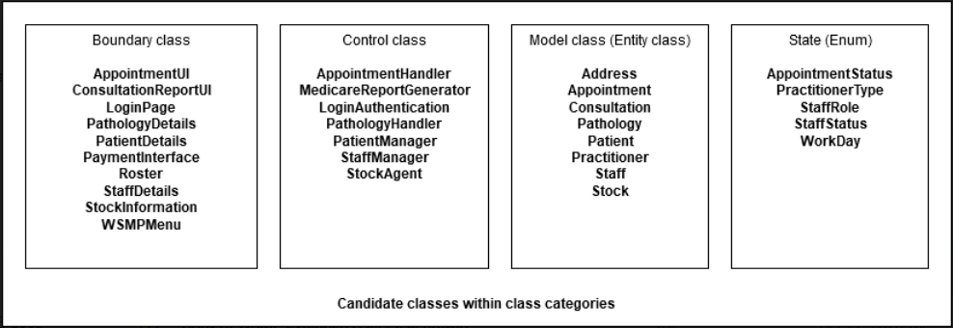

There are 4 class categories and , including boundary classes, control classes, model classes, and enumeration classes. The boundary classes are classes that interact with users and other systems, like user interfaces (UI), forms, system interfaces. For example, AppointmentUI is the user interface that captures inputs from users. PaymentInterface is the system interface that interacts with the banking system of banks. The control classes are classes that communicate with the boundary classes and model classes to control the logic of the system, for example, AppointmentHandler to control the flow and logic of the system by getting data from Model classes and manipulating the data before sending to the Boundary classes. The model classes are classes that hold data to and from Data Access Layer to get and retrieve data from database. The enumeration classes are classes that wrap around an integral type, using them for object states.