Vicky Ye

Programming Usable Interfaces: Section A

October 26, 2018

Assignment 6

**Low-Fidelity Mockup**

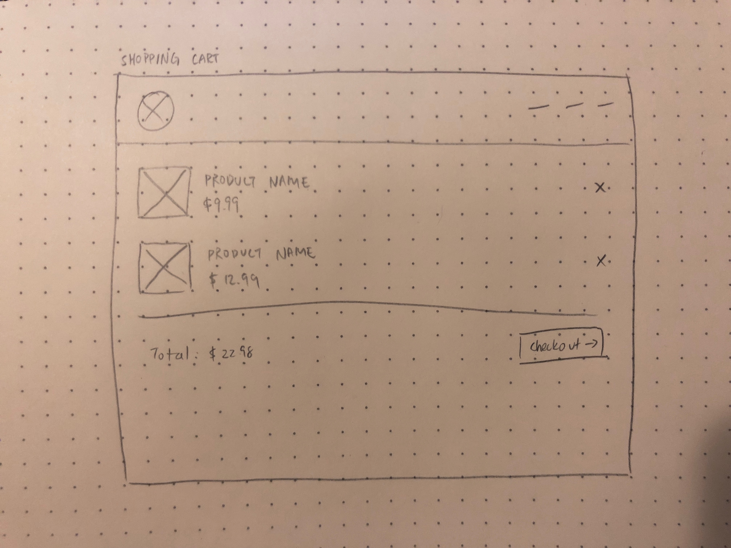

In the low-fidelity mockup of the shopping cart, I focused on what information was required for the page. I included images, so users would immediately know what the listed item is. There is also the name of the product, the price, and the order total (all information customers typically confirm before checking out).

**High-Fidelity Mockup**

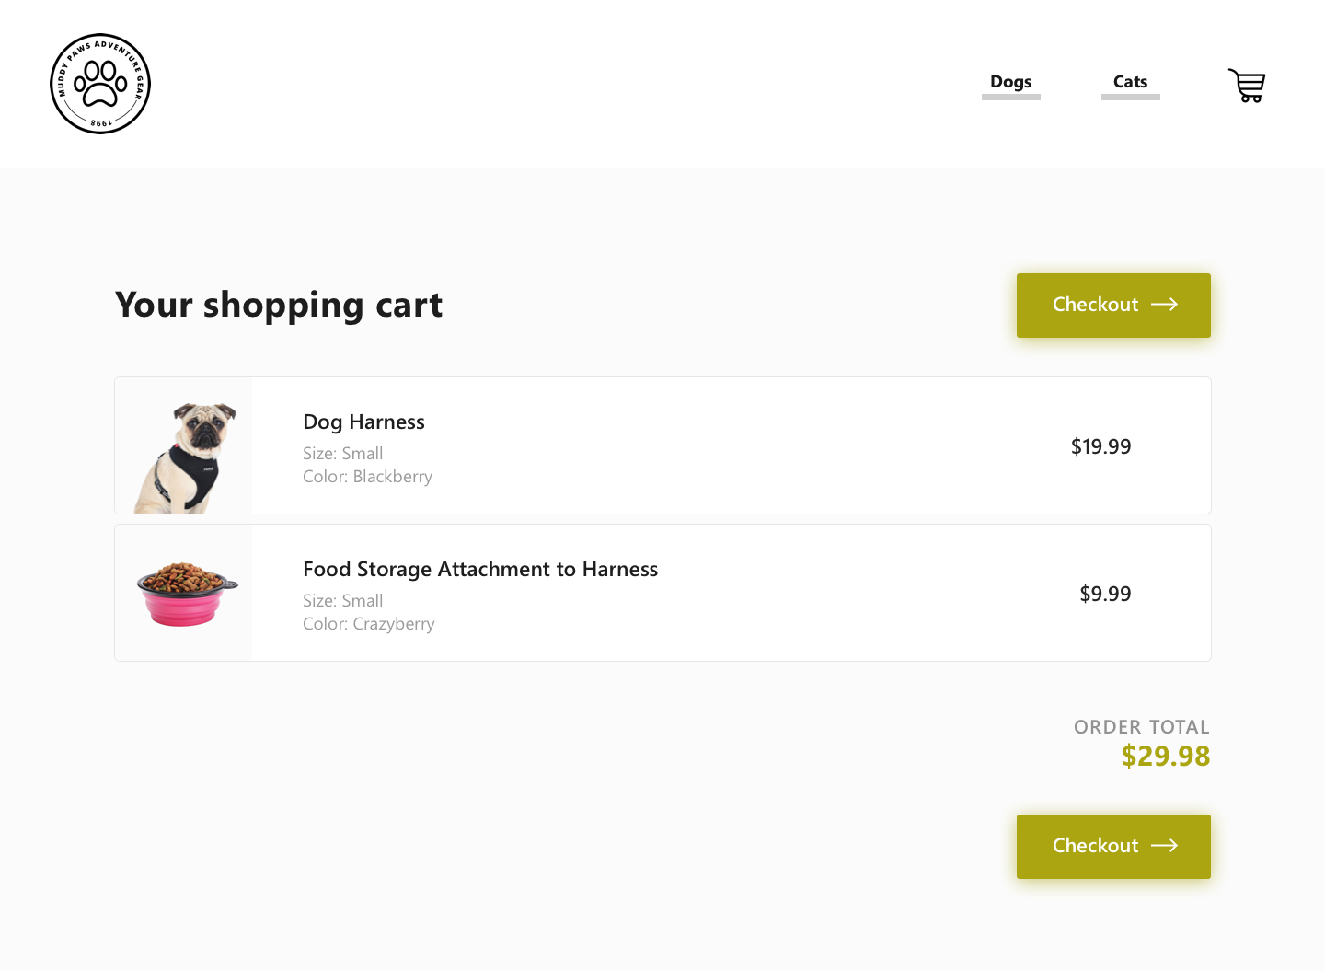

In the following iterations, I made prominent checkout buttons to indicate a clear next-step action. I also added size and color details, after realizing that users would want to confirm this information as well before checkout.

**Reflection**

One of the greatest challenges/bugs occurred in the shopping cart, when trying to remove items. In the Javascript code, I had identified which item to remove based on unique IDs I appended to each div, then removing the corresponding index in local storage based on that ID. After debugging and printing many variables to the console, I realized that while the index of items in the local storage will change and update, the IDs I was assigning to each div did not update and did not correspond to the appropriate index in local storage. In the end, I realized I could identify each div and item in storage based on the index alone.