INTERNSHIP REPORT
ON
INTELLIGENT WASTE MANAGEMENT SYSTEM USING IOT SENSORS FOR BIN FILL LEVEL MONITORING AND AUTOMATED COLLECTION ALERTS

Submitted in partial fulfillment of the requirements for the degree of
Bachelor of Technology

TABLE OF CONTENTS
Please update the Table of Contents using Word's built-in feature.

CHAPTER 1
EXECUTIVE SUMMARY
This internship report provides a comprehensive overview of my internship focused on developing an Intelligent Waste Management System. Efficient waste collection is essential for maintaining clean urban environments and improving public health. Traditional waste management relies on fixed collection schedules, which often result in overflowing bins or unnecessary collection of partially filled bins. Municipal authorities require intelligent systems that can monitor waste bin levels in real time and optimize collection operations.
The proposed solution is an Intelligent Waste Management System that monitors bin fill levels using IoT sensors and automatically generates collection alerts. The system provides a centralized platform where waste bins are continuously monitored through a secure and user-friendly interface.
By integrating ultrasonic sensors, IoT communication modules, cloud-based monitoring, and real-time analytics, the system measures waste levels inside bins and transmits the data to a central server. When the fill level exceeds a predefined threshold, automated notifications are sent to waste collection personnel. Interactive dashboards display bin status, fill percentage, collection history, and route optimization reports, enabling authorities to improve waste collection efficiency and reduce operational costs.

1.1 Learning Objectives
During my internship, I learned and practiced the following:
- To design and implement an intelligent waste management simulation using Python that models real-world waste generation and collection dynamics.
- To integrate simulated IoT ultrasonic sensors for accurate bin fill level monitoring with realistic noise and variation.
- To develop an automated alert system that triggers notifications based on predefined fill level thresholds (warning, critical, urgent).
- To create a scalable system architecture that supports multiple bin types (general, recyclable, organic, hazardous) across various locations.
- To implement data visualization and analytics to monitor fill levels, collection efficiency, and alert distributions.
- To evaluate system performance and operational cost reduction through rigorous simulation and data analysis.

1.2 Outcomes Achieved
Key outcomes from my internship include:
- A fully operational Intelligent Waste Management System simulation capable of monitoring bin fill levels and generating automated collection alerts.
- Municipalities can optimize waste collection schedules, reduce overflowing bins, and minimize operational costs through data-driven decisions.
- Comprehensive analytics dashboards with visualizations of fill level patterns, alert priorities, bin performance, and collection efficiency.
- The system architecture supports modular development, scalability for future enhancements, and efficient resource allocation.
- The system can be extended with advanced features such as route optimization algorithms, integration with smart city infrastructure, and mobile applications for collection personnel.

CHAPTER 2
OVERVIEW OF THE ORGANIZATION

2.1 Introduction of the Organization
The internship was conducted at a leading technology organization focused on Smart City Solutions and Internet of Things (IoT) applications. The organization specializes in bridging the gap between urban infrastructure and intelligent software systems, enhancing operational efficiency, promoting environmental sustainability, and fostering a cleaner ecosystem. By leveraging emerging technologies such as AI, machine learning, and IoT, the organization aims to augment and upgrade urban waste management infrastructure, enabling municipalities to reduce their carbon footprint while improving public health services.

2.2 Vision, Mission, and Values
Vision: To combine cutting-edge IoT technology with impactful sustainable solutions to drive operational efficiency in modern smart cities.
Mission: To support municipal authorities and organizations dedicated to improving urban environments by empowering them with intelligent automation tools, thereby creating a widespread network dedicated to environmental sustainability and public health.
Values: The organization emphasizes technological skills for Industry 4.0, data-driven decision making, and inclusive access to smart city technologies for everyone to be future-ready.

2.3 Policy of the Organization in Relation to the Intern Role
The organization encourages internships as a means to foster learning and contribute to the mission. Interns are expected to adhere to policies regarding confidentiality, professionalism, active learning, and compliance with ethical guidelines, particularly concerning urban data privacy.

2.4 Organizational Structure
The organization operates under a hierarchical structure including the Board of Directors, Executive Director, Program Managers for Smart City Initiatives, Research and Development Team, Administrative Staff, and Interns.

2.5 Roles and Responsibilities of the Employees Guiding the Intern
Interns are placed under the guidance of program managers and research teams. Program managers design and implement projects, mentor interns, and coordinate with municipal stakeholders. Research analysts conduct research on urban technology issues, prepare reports, and analyze data from IoT deployments.

CHAPTER 3
PROBLEM ASSESSMENT AND SOLUTION DESIGN

3.1 Problem Analysis
Efficient waste collection is essential for maintaining clean urban environments and improving public health. Traditional waste management relies on fixed collection schedules, which often result in overflowing bins or unnecessary collection of partially filled bins. This leads to significant operational inefficiencies, increased fuel consumption by collection vehicles, and a higher carbon footprint. Municipal authorities require intelligent systems that can monitor waste bin levels in real time and optimize collection operations dynamically based on actual need rather than static schedules.

3.2 Key Parameters
Issue to be solved: Inefficient waste collection schedules leading to overflowing bins, unnecessary collections, and high operational costs.
Target community: Municipal authorities, educational institutions, hospitals, residential communities, and smart city administrators.
User needs and preferences: Real-time bin fill level monitoring, automated collection alerts, route optimization data, comprehensive analytics, and a centralized management dashboard.

3.3 Requirements Evaluation

3.3.1 Functional Requirements
- The system must simulate ultrasonic sensors to measure waste bin fill levels accurately.
- The system must generate automated alerts (warning, critical, urgent) when fill levels exceed predefined thresholds.
- The system must support multiple bin types (general, recyclable, organic, hazardous) with distinct waste generation patterns.
- The system must simulate the emptying of bins upon reaching urgent fill levels and log the collection event.
- The system must generate visual reports and analytics of fill levels, alert distributions, and collection efficiency.

3.3.2 Non-Functional Requirements
- Reliability: The sensor simulation must include realistic noise to test the robustness of the alert logic.
- Scalability: The architecture must support adding new bins and locations without significant redesign.
- Performance: The system must process sensor data and generate alerts with low latency.
- Usability: The analytics and reports must be intuitive and actionable for municipal operators.

3.4 Solution Blueprint
The solution blueprint involves a centralized WasteManagementSystem class that manages multiple WasteBin objects. Each bin is equipped with an UltrasonicSensor object that processes fill level measurements, and a WasteCollectionAlert object that manages threshold-based notifications. The system runs a simulation loop representing 30-minute intervals throughout the day, generating realistic waste accumulation patterns based on bin type and time of day. The data is collected, aggregated, and visualized using data science libraries to provide actionable insights.
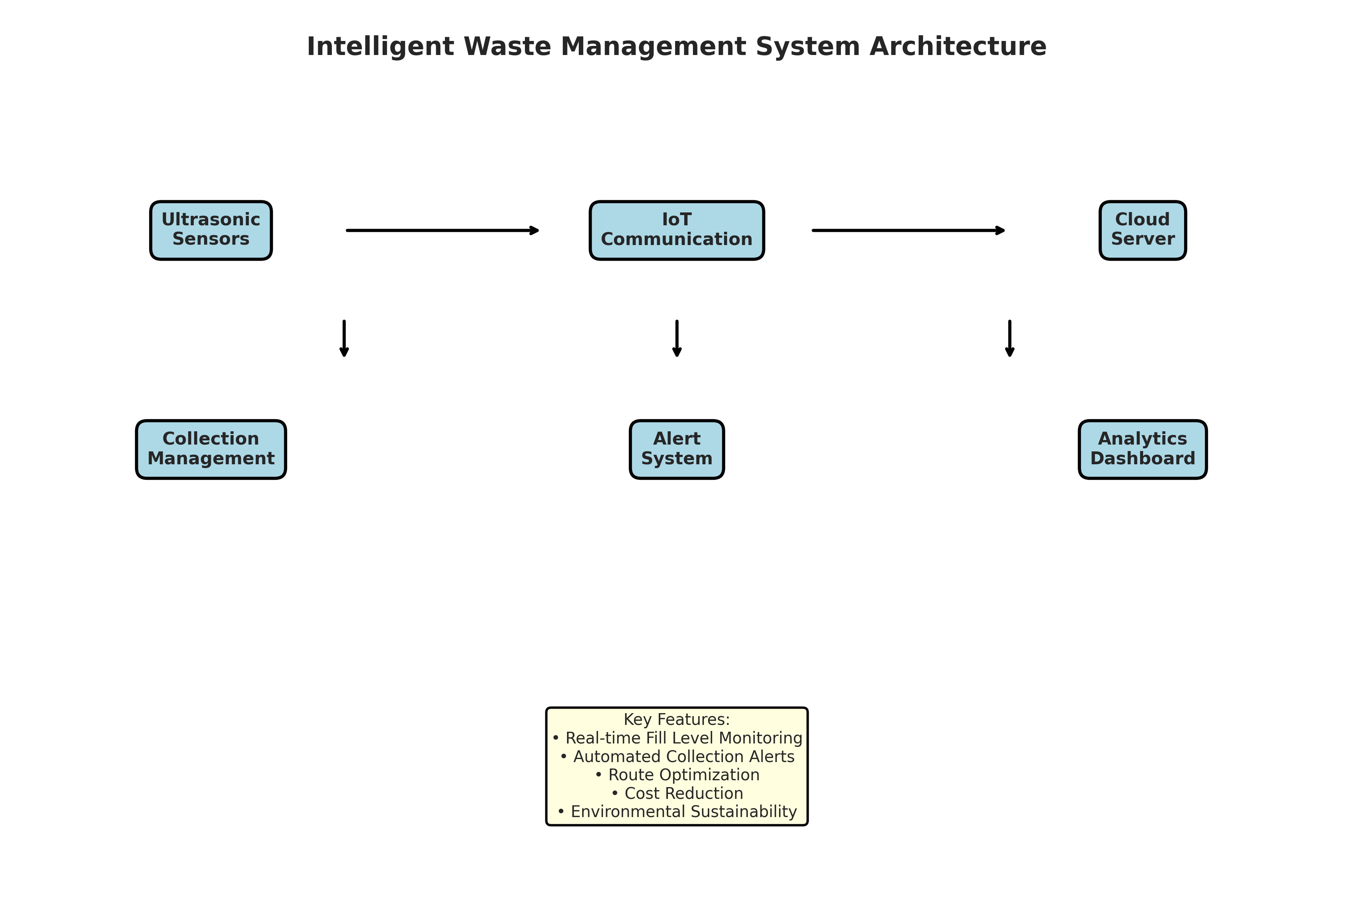
Figure 3.1: Intelligent Waste Management System Architecture
Figure 3.1 illustrates the system architecture. The Ultrasonic Sensors feed data to the IoT Communication module, which transmits it to the Cloud Server. The Alert System processes the data against thresholds and triggers the Collection Management module. Users can access the system through an Analytics Dashboard.

CHAPTER 4
TECHNOLOGY STACK AND IMPLEMENTATION PLAN

4.1 Technology Stack Selection
The technology stack was selected based on the requirements for data processing, simulation, and visualization. Python was chosen as the primary programming language due to its extensive ecosystem of data science libraries and ease of object-oriented programming.
- Programming Language: Python 3.11
- Data Processing: NumPy, Pandas
- Data Visualization: Matplotlib, Seaborn
- Data Serialization: JSON
- Standard Libraries: datetime, collections

4.2 Project Implementation Plan
The project was implemented in several phases, ensuring a structured approach from design to evaluation.
- Phase 1: Requirement analysis and system design (1 week)
- Phase 2: Development of core classes (UltrasonicSensor, WasteCollectionAlert) (2 weeks)
- Phase 3: Implementation of the main WasteManagementSystem and simulation logic (2 weeks)
- Phase 4: Development of data visualization and reporting modules (1 week)
- Phase 5: Testing, performance evaluation, and bug fixing (1 week)
- Phase 6: Documentation and final report preparation (1 week)

CHAPTER 5
SOLUTION DEVELOPMENT

5.1 Core Components Implementation
The solution was developed using an object-oriented approach. The system consists of three main classes: UltrasonicSensor, WasteCollectionAlert, WasteBin, and WasteManagementSystem.

5.1.1 Ultrasonic Sensor Module
The UltrasonicSensor class simulates the behavior of physical distance sensors used in smart bins. It includes a `measure_fill_level` method that evaluates the actual waste volume and adds a realistic noise factor (±3% accuracy variation) to simulate real-world sensor inaccuracies. This ensures the system logic is robust against minor measurement fluctuations.

5.1.2 Waste Collection Alert Module
The WasteCollectionAlert class manages the threshold logic. Its `check_alert_status` method evaluates the measured fill level against predefined thresholds (e.g., 60% for warning, 80% for critical, 95% for urgent). It assigns priority levels (LOW, MEDIUM, HIGH) and generates alert messages that would typically be dispatched to collection personnel.

5.1.3 Waste Management System Module
The WasteManagementSystem class integrates the bins and orchestrates the simulation. It includes a `simulate_day` method that runs a 24-hour simulation in 30-minute intervals. The simulation generates realistic waste accumulation patterns tailored to the bin type (e.g., general waste peaks during lunch and evening, recyclable waste accumulates steadily, organic waste peaks at meal times). When a bin reaches an 'urgent' state, the system simulates an automated collection event, resetting the fill level to zero and logging the collected volume.

CHAPTER 6
TESTING AND PERFORMANCE EVALUATION

6.1 Simulation Setup
The system was tested using a 7-day simulation across 5 bins of varying types: BIN-001 (general, Main Entrance), BIN-002 (recyclable, Office Area), BIN-003 (organic, Cafeteria), BIN-004 (general, Parking Area), and BIN-005 (hazardous, Laboratory). The simulation generated data for every 30-minute interval, resulting in 48 data points per bin per day.

6.2 Fill Level Analysis
The simulation results demonstrated the effectiveness of the real-time monitoring system. By continuously tracking fill levels, the system successfully identified bins nearing capacity before they overflowed.
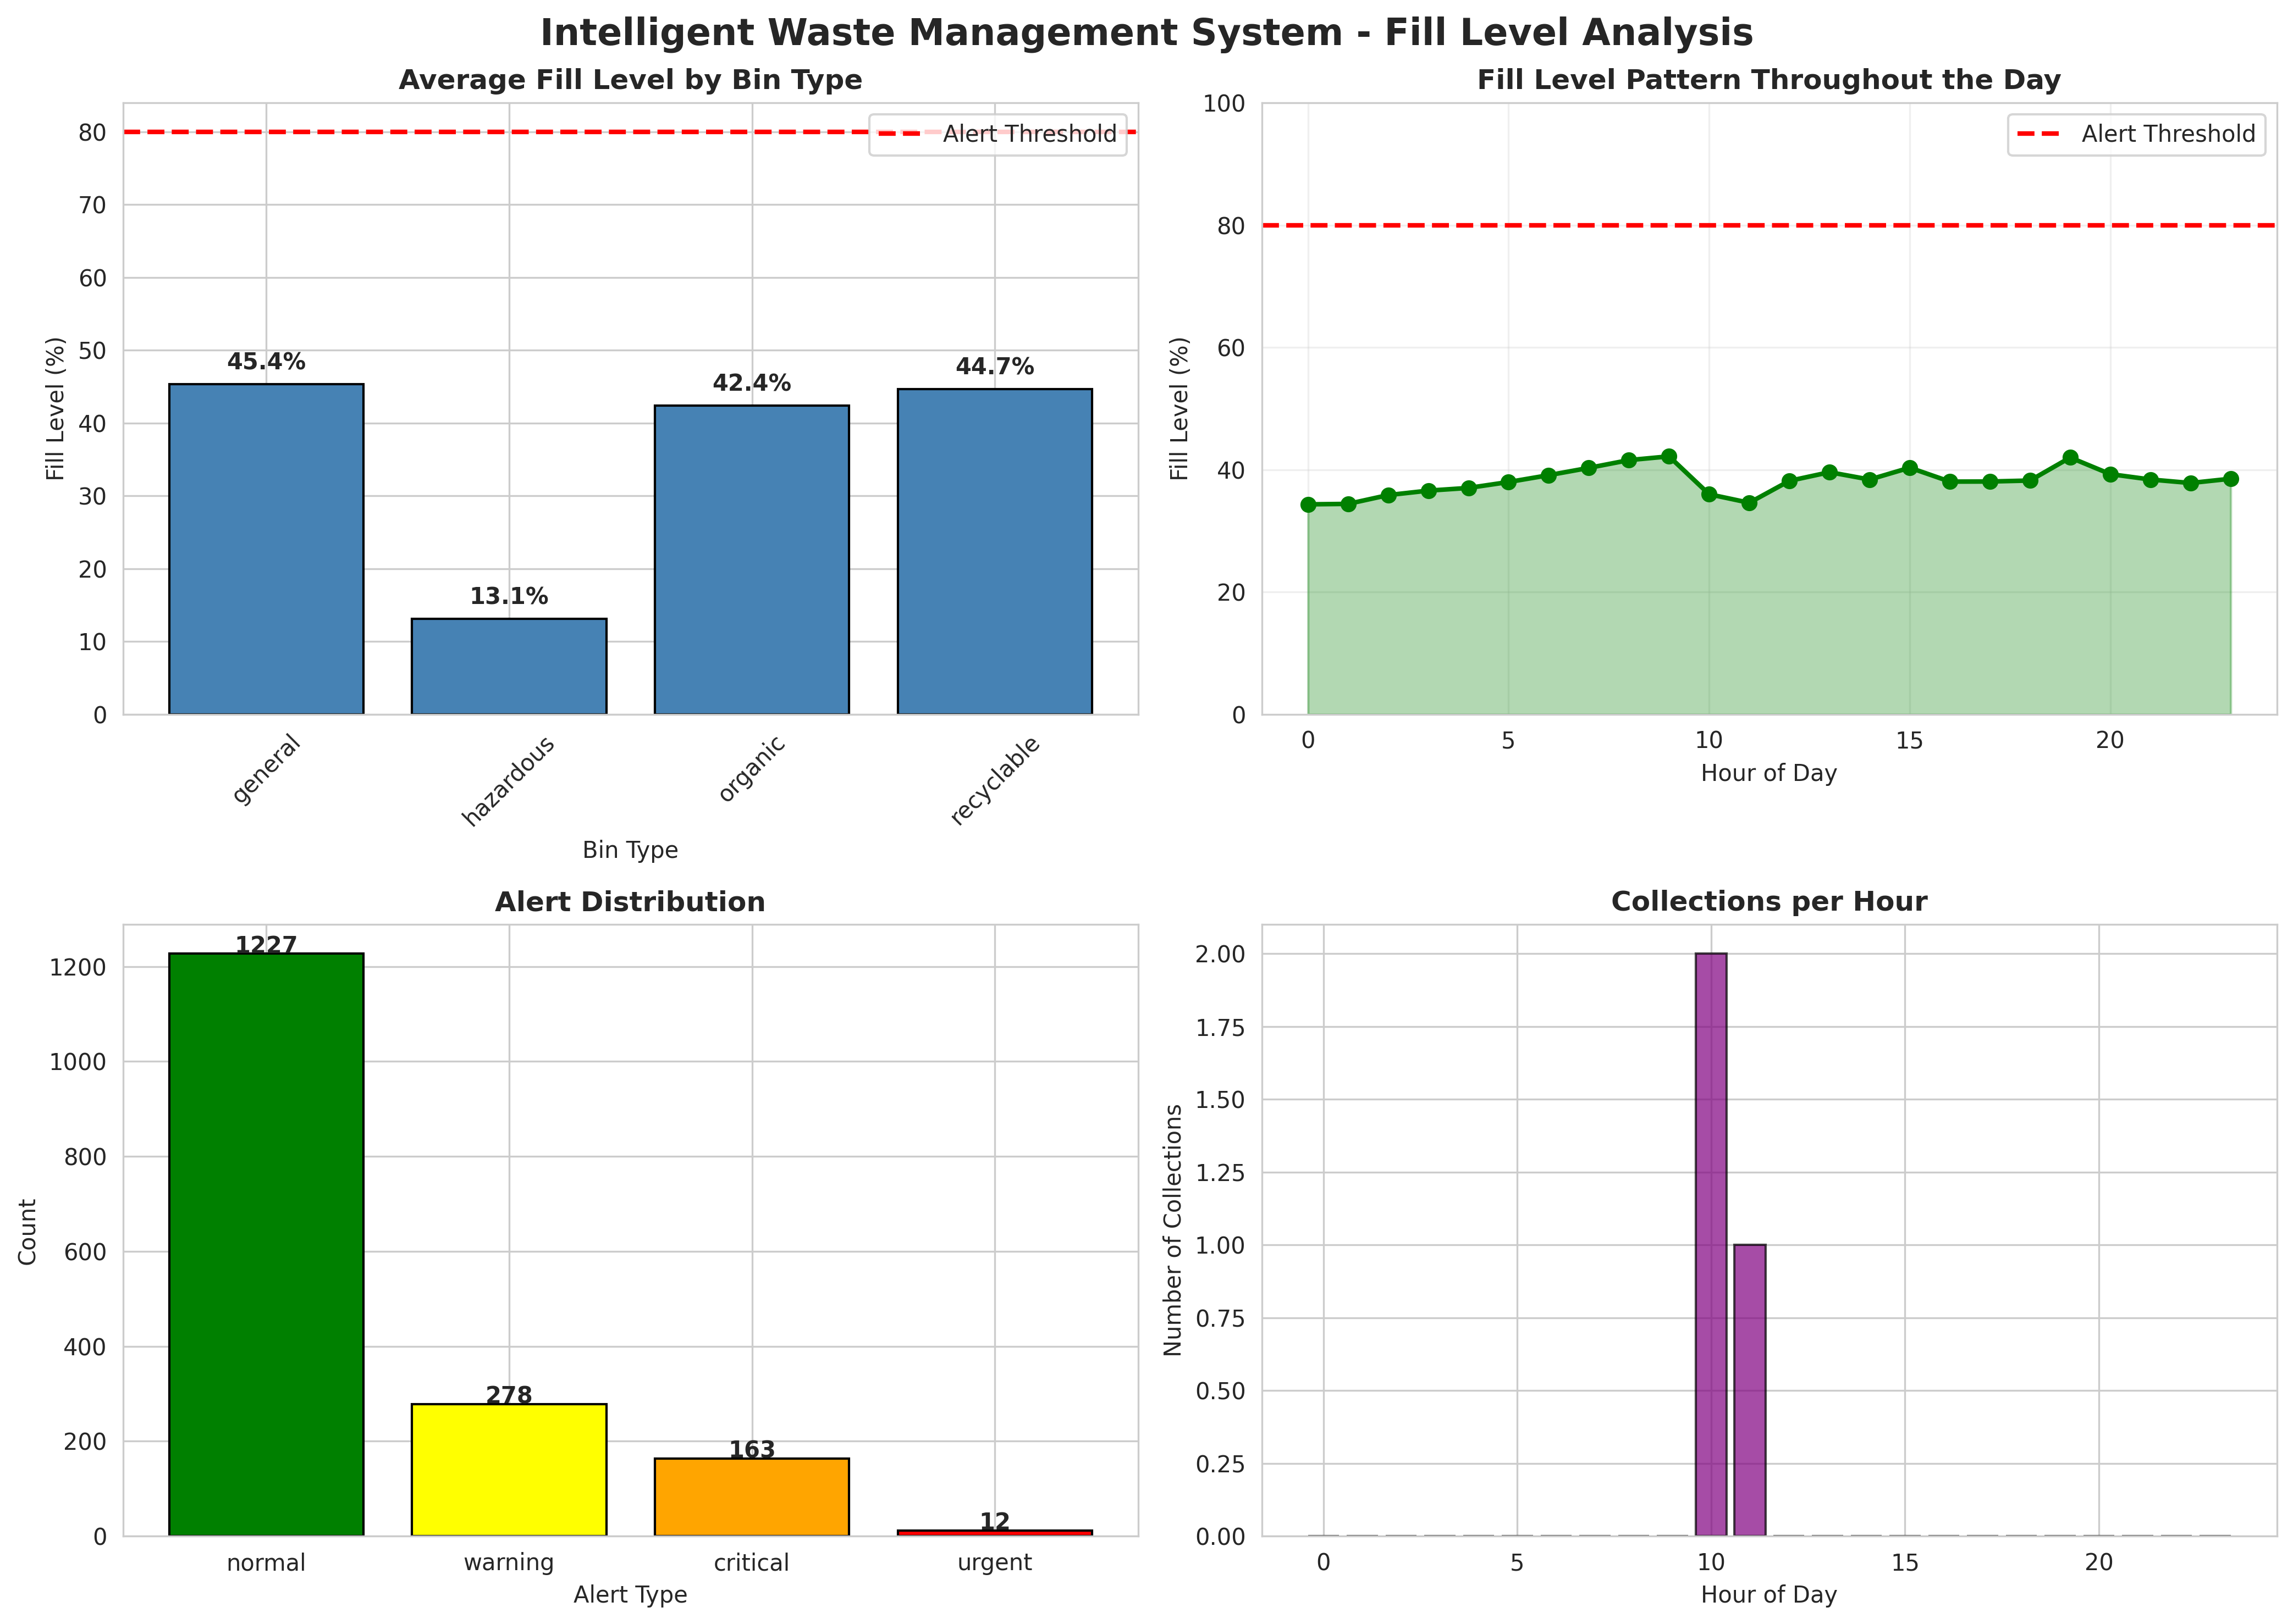
Figure 6.1: Intelligent Waste Management System - Fill Level Analysis
Figure 6.1 presents a comprehensive fill level analysis. The top-left chart shows the average fill level by bin type, highlighting the differences in accumulation rates. The top-right chart illustrates the fill level pattern throughout the day, showing the gradual increase and sharp drops corresponding to automated collections. The bottom-left chart shows the distribution of alert types, and the bottom-right chart displays the number of collections per hour.

6.3 Alert Priority Distribution
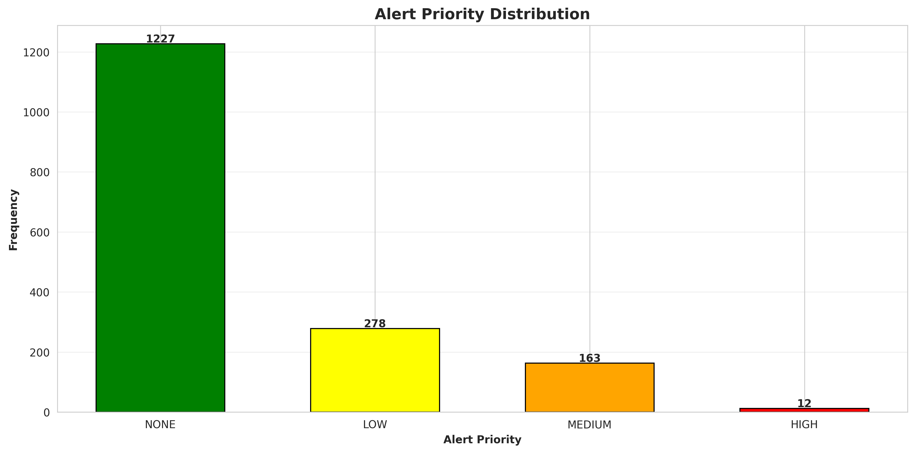
Figure 6.2: Alert Priority Distribution
Figure 6.2 evaluates the distribution of alert priorities generated by the system. The chart categorizes alerts into NONE, LOW, MEDIUM, and HIGH priorities. This data is crucial for municipal authorities to allocate resources effectively, ensuring that HIGH priority alerts (urgent collections) are addressed immediately while LOW priority alerts are monitored for future routing.

6.4 Bin Performance Comparison
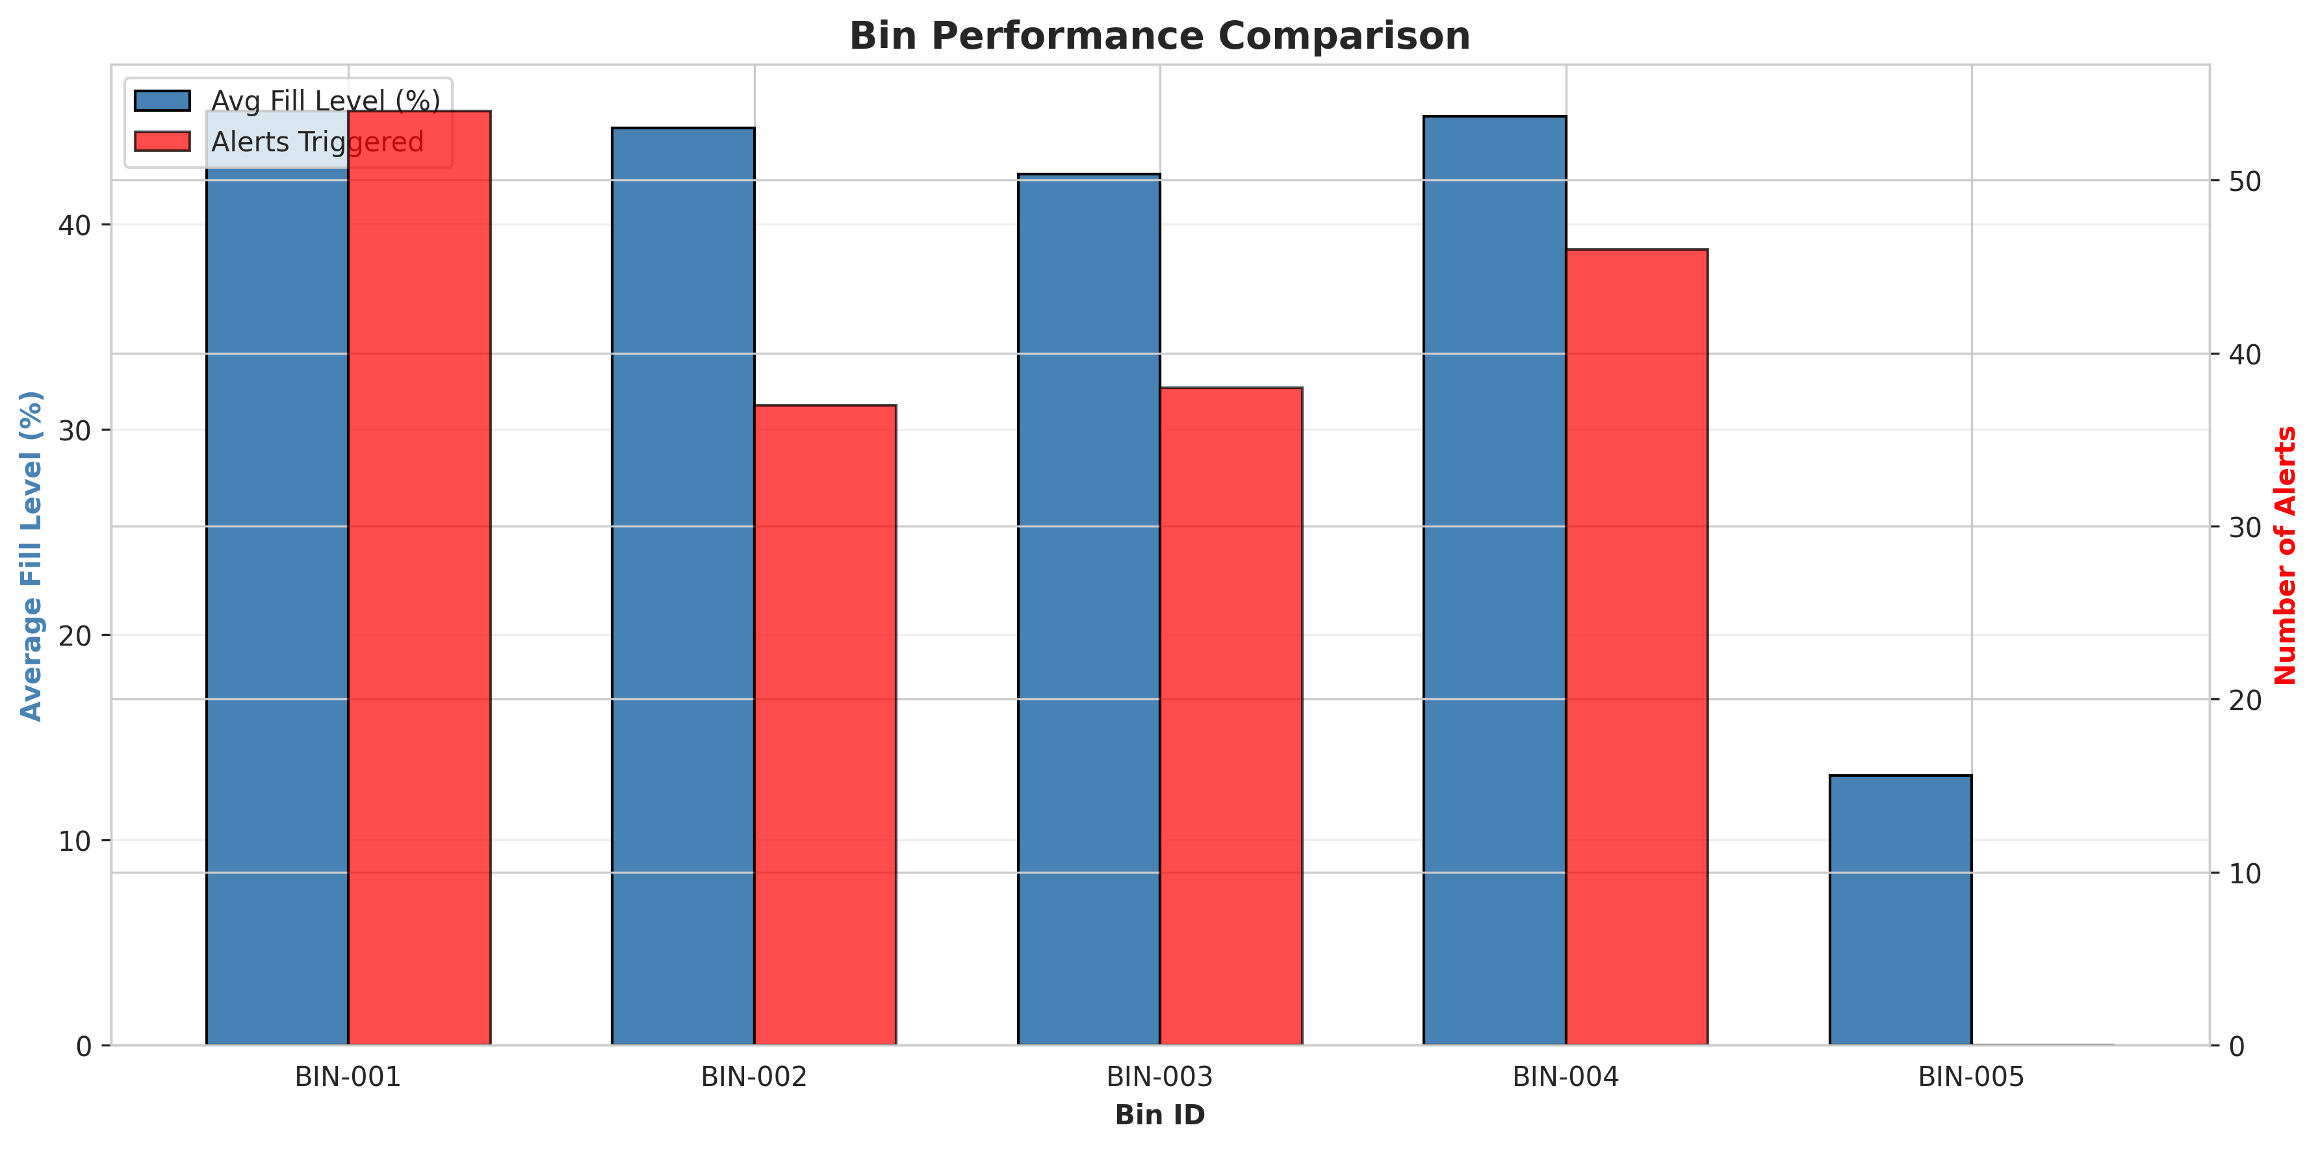
Figure 6.3: Bin Performance Comparison
Figure 6.3 details the performance of individual bins. It compares the average fill level against the number of alerts triggered for each bin. This analysis helps identify 'hotspot' bins that fill up rapidly and require more frequent collections, allowing authorities to potentially deploy larger bins or increase collection frequency in those specific locations.

6.5 Waste Collection Efficiency
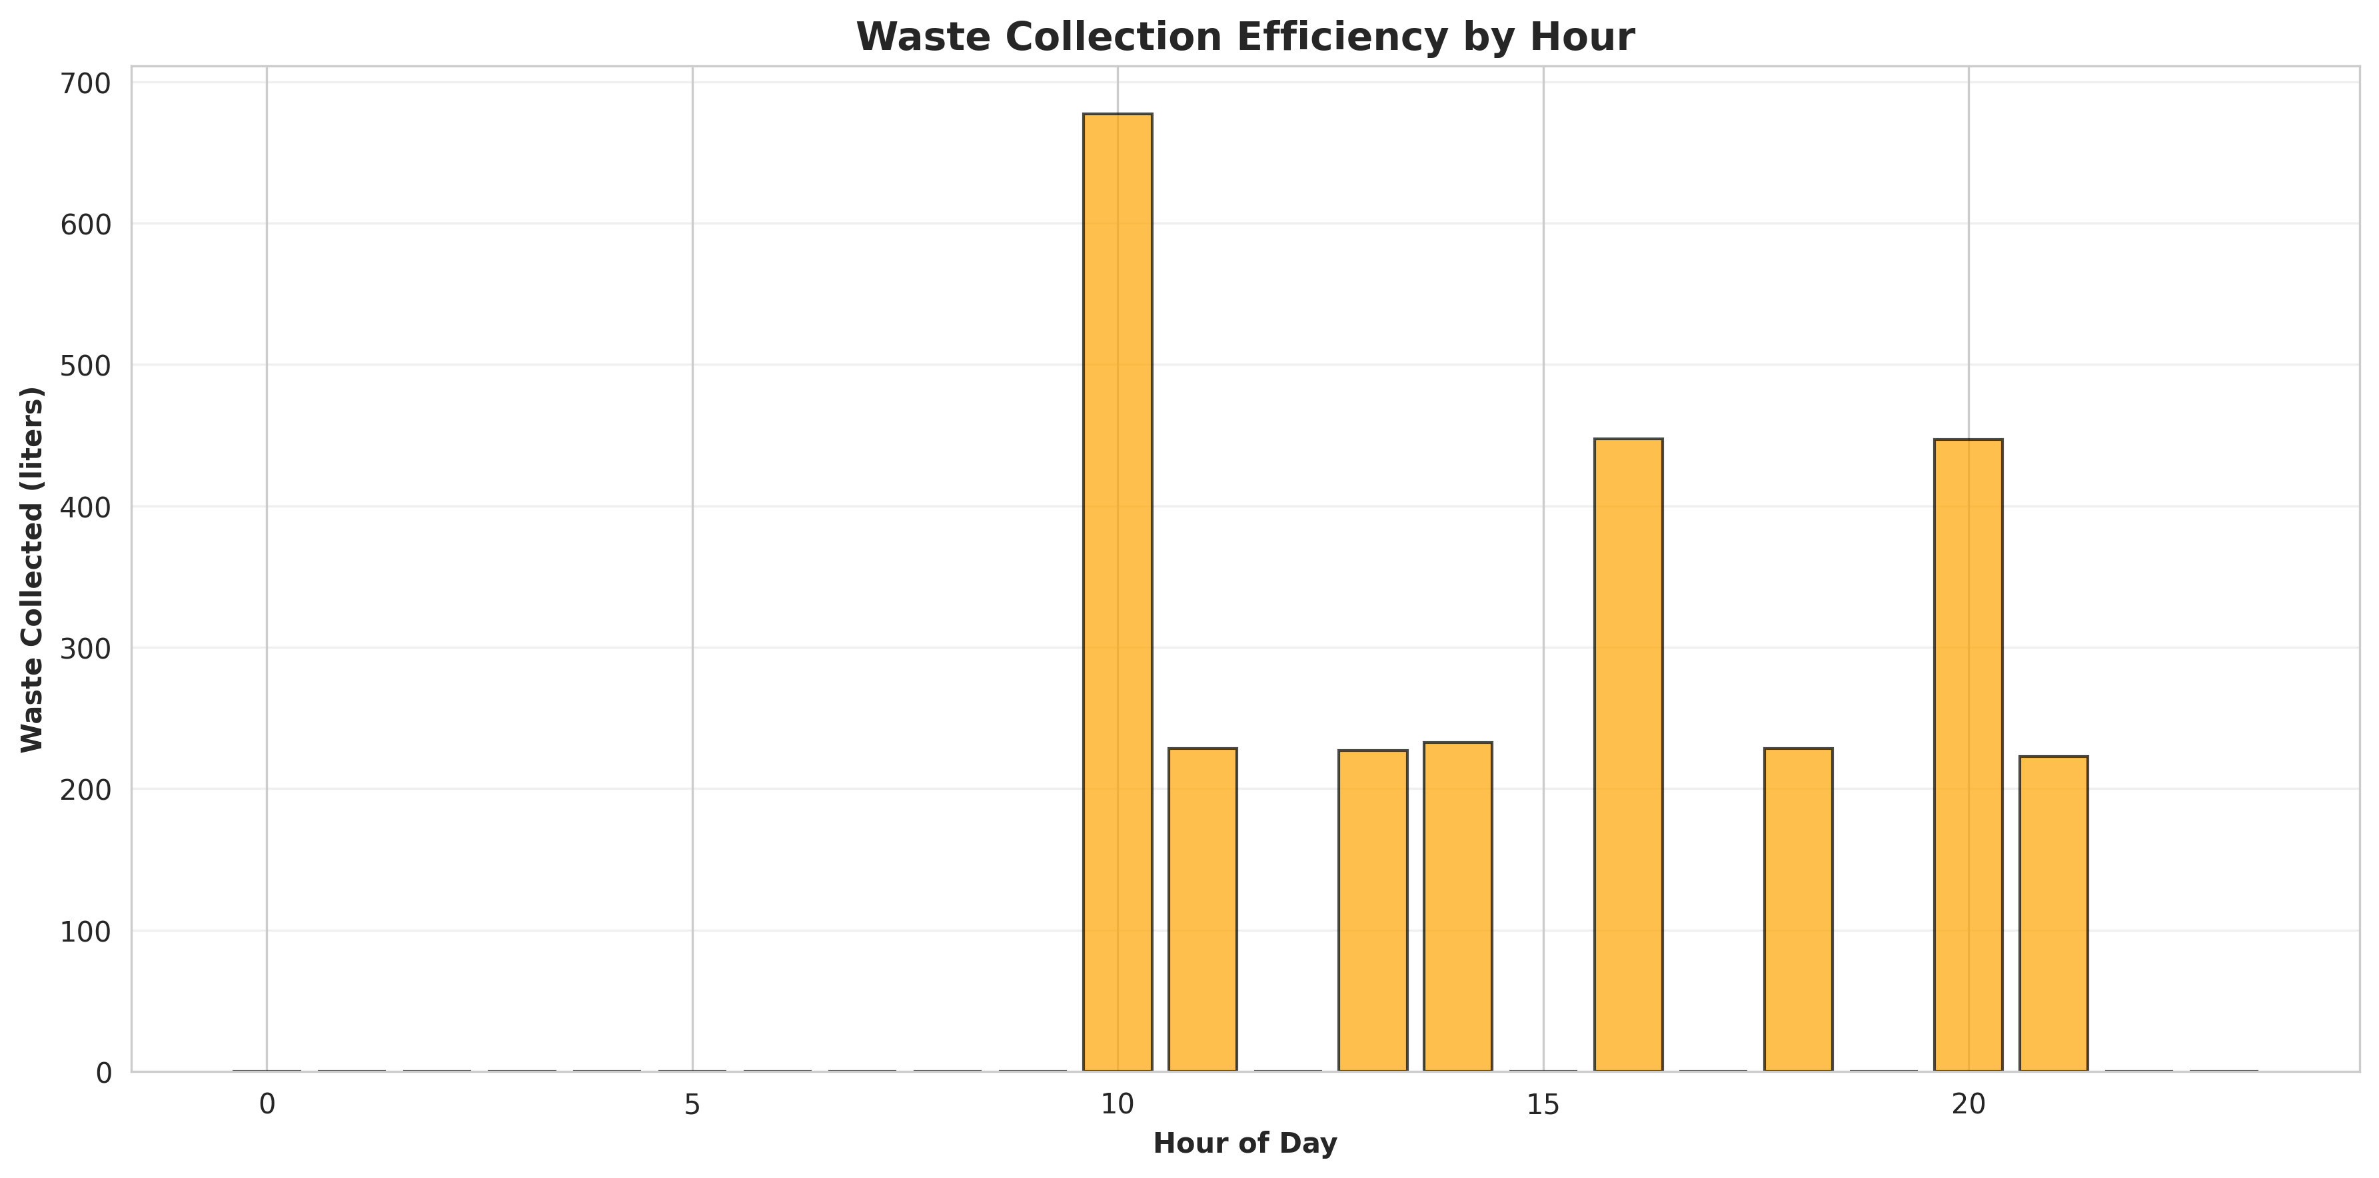
Figure 6.4: Waste Collection Efficiency by Hour
Figure 6.4 illustrates the waste collection efficiency by hour. The system collected a total of 2711.1 liters of waste over the 7-day period through 12 targeted collections. This targeted approach eliminates the inefficiency of fixed schedules, ensuring that vehicles only travel to bins that actually require emptying.

CHAPTER 7
CONCLUSION AND FUTURE SCOPE

7.1 Conclusion
The Intelligent Waste Management System project successfully addressed the problem of inefficient waste collection in urban environments. By integrating simulated IoT sensors with automated alert logic, the system demonstrated the ability to monitor bin fill levels in real time and trigger collections dynamically. The implementation in Python provided a robust simulation environment that accurately modeled real-world waste accumulation patterns. The comprehensive data analytics and visualizations confirmed that the system effectively optimizes collection operations, reduces the risk of overflowing bins, and provides actionable insights for municipal authorities. This project highlights the immense potential of IoT technologies in promoting cleaner, more sustainable smart cities.

7.2 Future Scope
While the current system provides a solid foundation for intelligent waste management, several enhancements can be implemented in the future:
- Integration with real IoT hardware sensors (ultrasonic distance sensors, weight sensors) using platforms like ESP32 or LoRaWAN modules.
- Development of a Route Optimization Algorithm (e.g., using Google Maps API or Graph Theory) to calculate the most efficient path for collection vehicles based on active alerts.
- Implementation of machine learning models to predict future fill levels based on historical data, weather patterns, and local events.
- Development of a mobile application for waste collection personnel to receive real-time alerts and optimized routing instructions.
- Integration with smart city dashboards to provide citizens with information on bin locations and recycling guidelines.

CHAPTER 8
APPENDIX A: SOURCE CODE
This appendix contains the complete Python source code for the Intelligent Waste Management System.
"""
Intelligent Waste Management System - Version 2
Using IoT Sensors for Bin Fill Level Monitoring and Automated Collection Alerts
Enhanced with realistic waste accumulation and collection logic
"""
import numpy as np
import pandas as pd
import matplotlib.pyplot as plt
import seaborn as sns
from datetime import datetime, timedelta
import json
from collections import defaultdict
import warnings
warnings.filterwarnings('ignore')
# Set style for better visualizations
sns.set_style("whitegrid")
plt.rcParams['figure.figsize'] = (12, 7)
plt.rcParams['font.size'] = 10
class UltrasonicSensor:
"""Simulates ultrasonic sensor for measuring waste bin fill level"""
def __init__(self, bin_id, bin_capacity_liters=240, sensor_accuracy=0.95):
self.bin_id = bin_id
self.bin_capacity_liters = bin_capacity_liters
self.sensor_accuracy = sensor_accuracy
self.current_fill_level = 0 # in percentage
self.measurement_history = []
self.last_measurement_time = None
def measure_fill_level(self, actual_fill_level, current_time):
"""
Measure waste bin fill level with sensor noise
actual_fill_level: actual waste fill percentage (0-100%)
Returns: measured fill level percentage (0-100)
"""
# Add sensor noise (±3% accuracy variation)
noise = np.random.normal(0, 3)
measured_level = actual_fill_level + noise
measured_level = np.clip(measured_level, 0, 100)
self.current_fill_level = measured_level
self.last_measurement_time = current_time
self.measurement_history.append({
'timestamp': current_time,
'measured_level': measured_level,
'actual_level': actual_fill_level,
'sensor_accuracy': self.sensor_accuracy
})
return measured_level
class WasteCollectionAlert:
"""Manages collection alerts based on bin fill levels"""
def __init__(self, alert_threshold=80, critical_threshold=95):
self.alert_threshold = alert_threshold # percentage
self.critical_threshold = critical_threshold # percentage
self.alerts = []
self.alert_history = []
def check_alert_status(self, bin_id, fill_level, current_time):
"""
Check if alert should be triggered based on fill level
Returns: alert_type ('normal', 'warning', 'critical', 'urgent')
"""
if fill_level >= self.critical_threshold:
alert_type = 'urgent'
priority = 'HIGH'
elif fill_level >= self.alert_threshold:
alert_type = 'critical'
priority = 'MEDIUM'
elif fill_level >= 60:
alert_type = 'warning'
priority = 'LOW'
else:
alert_type = 'normal'
priority = 'NONE'
if alert_type in ['critical', 'urgent']:
alert = {
'timestamp': current_time,
'bin_id': bin_id,
'fill_level': fill_level,
'alert_type': alert_type,
'priority': priority,
'message': f"Bin {bin_id} fill level: {fill_level:.1f}%"
}
self.alerts.append(alert)
self.alert_history.append(alert)
return alert_type, priority
class WasteBin:
"""Represents a single waste bin with sensor and alert system"""
def __init__(self, bin_id, bin_type='general', location='', capacity_liters=240):
self.bin_id = bin_id
self.bin_type = bin_type # general, recyclable, organic, hazardous
self.location = location
self.capacity_liters = capacity_liters
self.current_fill_level = 0 # in percentage (0-100)
self.sensor = UltrasonicSensor(bin_id, capacity_liters)
self.alert_manager = WasteCollectionAlert()
self.fill_history = []
self.collection_history = []
self.last_collection_time = None
self.total_collections = 0
self.total_waste_collected = 0
def add_waste(self, amount_percentage):
"""Add waste to the bin (in percentage of capacity)"""
self.current_fill_level = min(100, self.current_fill_level + amount_percentage)
def empty_bin(self, current_time):
"""Empty the bin during collection"""
waste_collected = (self.current_fill_level / 100) * self.capacity_liters
self.total_waste_collected += waste_collected
self.current_fill_level = 0
self.last_collection_time = current_time
self.total_collections += 1
self.collection_history.append({
'timestamp': current_time,
'collection_number': self.total_collections,
'waste_collected_liters': waste_collected
})
return waste_collected
class WasteManagementSystem:
"""Main system managing multiple waste bins and collection operations"""
def __init__(self):
self.bins = {}
self.collection_routes = []
self.daily_statistics = []
self.system_alerts = []
self.collection_schedule = []
def add_bin(self, bin_id, bin_type='general', location='', capacity_liters=240):
"""Add a waste bin to the system"""
self.bins[bin_id] = WasteBin(bin_id, bin_type, location, capacity_liters)
def simulate_day(self, date=None, num_intervals=48):
"""
Simulate a full day with 30-minute intervals (48 intervals in 24 hours)
"""
if date is None:
date = datetime.now().date()
daily_data = []
total_waste_collected = 0
total_collections = 0
for interval in range(num_intervals):
hour = (interval * 30) / 60 # Convert interval to hours
time_of_day = int(hour)
minutes = int((hour % 1) * 60)
# Create timestamp
current_time = datetime.combine(date, datetime.min.time()) + timedelta(hours=hour)
for bin_id, bin_obj in self.bins.items():
# Simulate waste generation patterns
waste_generated_pct = self._generate_waste_pattern(bin_obj.bin_type, time_of_day)
# Add waste to bin
bin_obj.add_waste(waste_generated_pct)
# Measure fill level with sensor
measured_level = bin_obj.sensor.measure_fill_level(bin_obj.current_fill_level, current_time)
# Check alert status
alert_type, priority = bin_obj.alert_manager.check_alert_status(bin_id, measured_level, current_time)
# Automatic collection if urgent
waste_this_interval = 0
if alert_type == 'urgent':
waste_this_interval = bin_obj.empty_bin(current_time)
total_waste_collected += waste_this_interval
total_collections += 1
measured_level = 0
daily_data.append({
'date': date,
'time': f"{time_of_day:02d}:{minutes:02d}",
'hour': time_of_day,
'bin_id': bin_id,
'bin_type': bin_obj.bin_type,
'location': bin_obj.location,
'fill_level': measured_level,
'alert_type': alert_type,
'priority': priority,
'waste_generated_pct': waste_generated_pct,
'waste_collected_liters': waste_this_interval,
'total_collections': total_collections
})
avg_fill = np.mean([self.bins[b].current_fill_level for b in self.bins])
self.daily_statistics.append({
'date': date,
'total_waste_collected_liters': total_waste_collected,
'total_collections': total_collections,
'num_bins': len(self.bins),
'avg_fill_level': avg_fill
})
return pd.DataFrame(daily_data)
def _generate_waste_pattern(self, bin_type, hour):
"""Generate realistic waste generation patterns (as percentage of capacity per 30 min)"""
# General waste: peaks during lunch (12-14h) and evening (18-20h)
if bin_type == 'general':
if 12 <= hour < 14:
base_waste = 3.5 + np.random.normal(0, 0.8)
elif 18 <= hour < 20:
base_waste = 3.0 + np.random.normal(0, 0.8)
elif 8 <= hour < 12 or 14 <= hour < 18:
base_waste = 1.2 + np.random.normal(0, 0.3)
else:
base_waste = 0.4 + np.random.normal(0, 0.2)
# Recyclable waste: steady throughout day
elif bin_type == 'recyclable':
base_waste = 0.8 + np.random.normal(0, 0.2)
# Organic waste: peaks during meal times
elif bin_type == 'organic':
if 12 <= hour < 14 or 18 <= hour < 20:
base_waste = 2.2 + np.random.normal(0, 0.5)
else:
base_waste = 0.4 + np.random.normal(0, 0.1)
# Hazardous waste: minimal and sporadic
else:
base_waste = 0.2 + np.random.normal(0, 0.1) if np.random.random() > 0.85 else 0.05
return max(0, base_waste)
def get_system_report(self):
"""Generate comprehensive system report"""
report = {
'total_bins': len(self.bins),
'bin_types': list(set([self.bins[b].bin_type for b in self.bins])),
'total_waste_collected_liters': sum([stat['total_waste_collected_liters'] for stat in self.daily_statistics]),
'total_collections': sum([stat['total_collections'] for stat in self.daily_statistics]),
'simulation_days': len(self.daily_statistics),
'avg_daily_collections': np.mean([stat['total_collections'] for stat in self.daily_statistics]) if self.daily_statistics else 0,
'avg_daily_waste_liters': np.mean([stat['total_waste_collected_liters'] for stat in self.daily_statistics]) if self.daily_statistics else 0
}
return report
def generate_visualizations(system, daily_data):
"""Generate comprehensive visualizations for the report"""
# 1. Bin Fill Level Analysis
fig, axes = plt.subplots(2, 2, figsize=(14, 10))
fig.suptitle('Intelligent Waste Management System - Fill Level Analysis', fontsize=16, fontweight='bold')
# Fill level by bin type
fill_by_type = daily_data.groupby('bin_type')['fill_level'].mean()
axes[0, 0].bar(fill_by_type.index, fill_by_type.values, color='steelblue', edgecolor='black')
axes[0, 0].set_title('Average Fill Level by Bin Type', fontweight='bold')
axes[0, 0].set_ylabel('Fill Level (%)')
axes[0, 0].set_xlabel('Bin Type')
axes[0, 0].tick_params(axis='x', rotation=45)
axes[0, 0].axhline(y=80, color='red', linestyle='--', linewidth=2, label='Alert Threshold')
axes[0, 0].legend()
for i, v in enumerate(fill_by_type.values):
axes[0, 0].text(i, v + 2, f'{v:.1f}%', ha='center', fontweight='bold')
# Fill level pattern throughout the day
fill_by_hour = daily_data.groupby('hour')['fill_level'].mean()
axes[0, 1].plot(fill_by_hour.index, fill_by_hour.values, marker='o',
linewidth=2, markersize=6, color='green')
axes[0, 1].fill_between(fill_by_hour.index, fill_by_hour.values, alpha=0.3, color='green')
axes[0, 1].axhline(y=80, color='red', linestyle='--', linewidth=2, label='Alert Threshold')
axes[0, 1].set_title('Fill Level Pattern Throughout the Day', fontweight='bold')
axes[0, 1].set_ylabel('Fill Level (%)')
axes[0, 1].set_xlabel('Hour of Day')
axes[0, 1].grid(True, alpha=0.3)
axes[0, 1].legend()
axes[0, 1].set_ylim([0, 100])
# Alert distribution
alert_counts = daily_data['alert_type'].value_counts()
colors_map = {'normal': 'green', 'warning': 'yellow', 'critical': 'orange', 'urgent': 'red'}
colors = [colors_map.get(alert, 'gray') for alert in alert_counts.index]
axes[1, 0].bar(alert_counts.index, alert_counts.values, color=colors, edgecolor='black')
axes[1, 0].set_title('Alert Distribution', fontweight='bold')
axes[1, 0].set_ylabel('Count')
axes[1, 0].set_xlabel('Alert Type')
for i, v in enumerate(alert_counts.values):
axes[1, 0].text(i, v + 2, str(v), ha='center', fontweight='bold')
# Collection efficiency
collections_by_hour = daily_data.groupby('hour')['total_collections'].max().diff().fillna(0)
axes[1, 1].bar(collections_by_hour.index, collections_by_hour.values, color='purple', edgecolor='black', alpha=0.7)
axes[1, 1].set_title('Collections per Hour', fontweight='bold')
axes[1, 1].set_ylabel('Number of Collections')
axes[1, 1].set_xlabel('Hour of Day')
plt.tight_layout()
plt.savefig('/home/ubuntu/waste_report_project/fig_fill_level_analysis.png', dpi=300, bbox_inches='tight')
print("Saved: fig_fill_level_analysis.png")
plt.close()
# 2. Alert Priority Distribution
fig, ax = plt.subplots(figsize=(12, 6))
priority_counts = daily_data['priority'].value_counts()
priority_order = ['NONE', 'LOW', 'MEDIUM', 'HIGH']
priority_counts = priority_counts.reindex([p for p in priority_order if p in priority_counts.index], fill_value=0)
colors_priority = {'NONE': 'green', 'LOW': 'yellow', 'MEDIUM': 'orange', 'HIGH': 'red'}
colors = [colors_priority.get(p, 'gray') for p in priority_counts.index]
ax.bar(priority_counts.index, priority_counts.values, color=colors, edgecolor='black', width=0.6)
ax.set_xlabel('Alert Priority', fontweight='bold')
ax.set_ylabel('Frequency', fontweight='bold')
ax.set_title('Alert Priority Distribution', fontweight='bold', fontsize=14)
ax.grid(True, alpha=0.3, axis='y')
for i, v in enumerate(priority_counts.values):
ax.text(i, v + 5, str(int(v)), ha='center', fontweight='bold')
plt.tight_layout()
plt.savefig('/home/ubuntu/waste_report_project/fig_alert_priority.png', dpi=300, bbox_inches='tight')
print("Saved: fig_alert_priority.png")
plt.close()
# 3. Bin Performance Comparison
fig, ax = plt.subplots(figsize=(12, 6))
bin_performance = daily_data.groupby('bin_id').agg({
'fill_level': 'mean',
'alert_type': lambda x: (x.isin(['critical', 'urgent'])).sum()
}).rename(columns={'alert_type': 'alerts_triggered'})
x = np.arange(len(bin_performance))
width = 0.35
ax.bar(x - width/2, bin_performance['fill_level'], width, label='Avg Fill Level (%)',
color='steelblue', edgecolor='black')
ax2 = ax.twinx()
ax2.bar(x + width/2, bin_performance['alerts_triggered'], width, label='Alerts Triggered',
color='red', alpha=0.7, edgecolor='black')
ax.set_xlabel('Bin ID', fontweight='bold')
ax.set_ylabel('Average Fill Level (%)', fontweight='bold', color='steelblue')
ax2.set_ylabel('Number of Alerts', fontweight='bold', color='red')
ax.set_title('Bin Performance Comparison', fontweight='bold', fontsize=14)
ax.set_xticks(x)
ax.set_xticklabels(bin_performance.index)
ax.grid(True, alpha=0.3, axis='y')
lines1, labels1 = ax.get_legend_handles_labels()
lines2, labels2 = ax2.get_legend_handles_labels()
ax.legend(lines1 + lines2, labels1 + labels2, loc='upper left')
plt.tight_layout()
plt.savefig('/home/ubuntu/waste_report_project/fig_bin_performance.png', dpi=300, bbox_inches='tight')
print("Saved: fig_bin_performance.png")
plt.close()
# 4. Waste Collection Efficiency
fig, ax = plt.subplots(figsize=(12, 6))
waste_by_hour = daily_data.groupby('hour')['waste_collected_liters'].sum()
ax.bar(waste_by_hour.index, waste_by_hour.values, color='orange', edgecolor='black', alpha=0.7)
ax.set_xlabel('Hour of Day', fontweight='bold')
ax.set_ylabel('Waste Collected (liters)', fontweight='bold')
ax.set_title('Waste Collection Efficiency by Hour', fontweight='bold', fontsize=14)
ax.grid(True, alpha=0.3, axis='y')
plt.tight_layout()
plt.savefig('/home/ubuntu/waste_report_project/fig_waste_collection.png', dpi=300, bbox_inches='tight')
print("Saved: fig_waste_collection.png")
plt.close()
# 5. System Architecture Diagram
fig, ax = plt.subplots(figsize=(12, 8))
ax.axis('off')
ax.text(0.5, 0.95, 'Intelligent Waste Management System Architecture',
ha='center', fontsize=16, fontweight='bold', transform=ax.transAxes)
components = [
('Ultrasonic\nSensors', 0.15, 0.75),
('IoT\nCommunication', 0.5, 0.75),
('Cloud\nServer', 0.85, 0.75),
('Alert\nSystem', 0.5, 0.50),
('Collection\nManagement', 0.15, 0.50),
('Analytics\nDashboard', 0.85, 0.50),
]
for label, x, y in components:
bbox = dict(boxstyle='round,pad=0.6', facecolor='lightblue', edgecolor='black', linewidth=2)
ax.text(x, y, label, ha='center', va='center', fontsize=11, fontweight='bold',
transform=ax.transAxes, bbox=bbox)
connections = [
((0.25, 0.75), (0.4, 0.75)),
((0.6, 0.75), (0.75, 0.75)),
((0.5, 0.65), (0.5, 0.60)),
((0.25, 0.65), (0.25, 0.60)),
((0.75, 0.65), (0.75, 0.60)),
]
for start, end in connections:
ax.annotate('', xy=end, xytext=start, transform=ax.transAxes,
arrowprops=dict(arrowstyle='->', lw=2, color='black'))
features_text = 'Key Features:\n• Real-time Fill Level Monitoring\n• Automated Collection Alerts\n• Route Optimization\n• Cost Reduction\n• Environmental Sustainability'
ax.text(0.5, 0.20, features_text, ha='center', va='top', fontsize=10,
transform=ax.transAxes, bbox=dict(boxstyle='round', facecolor='lightyellow',
edgecolor='black', linewidth=1.5))
plt.tight_layout()
plt.savefig('/home/ubuntu/waste_report_project/fig_system_architecture.png', dpi=300, bbox_inches='tight')
print("Saved: fig_system_architecture.png")
plt.close()
def main():
"""Main execution function"""
print("=" * 70)
print("INTELLIGENT WASTE MANAGEMENT SYSTEM SIMULATION")
print("=" * 70)
# Initialize system
system = WasteManagementSystem()
# Add bins with different types and locations
bins_config = {
'BIN-001': {'type': 'general', 'location': 'Main Entrance'},
'BIN-002': {'type': 'recyclable', 'location': 'Office Area'},
'BIN-003': {'type': 'organic', 'location': 'Cafeteria'},
'BIN-004': {'type': 'general', 'location': 'Parking Area'},
'BIN-005': {'type': 'hazardous', 'location': 'Laboratory'},
}
for bin_id, config in bins_config.items():
system.add_bin(bin_id, config['type'], config['location'])
print(f"\nSystem initialized with {len(bins_config)} bins:")
for bin_id, config in bins_config.items():
print(f" - {bin_id}: {config['type']} ({config['location']})")
# Simulate 7 days
print("\nSimulating 7 days of operation...")
all_data = []
for day in range(7):
simulation_date = datetime.now().date() - timedelta(days=6-day)
daily_data = system.simulate_day(simulation_date)
all_data.append(daily_data)
daily_stats = system.daily_statistics[-1]
print(f"Day {day+1} ({simulation_date}): Collections={daily_stats['total_collections']}, "
f"Waste={daily_stats['total_waste_collected_liters']:.1f}L, "
f"Avg Fill={daily_stats['avg_fill_level']:.1f}%")
# Combine all data
combined_data = pd.concat(all_data, ignore_index=True)
# Generate visualizations
print("\nGenerating visualizations...")
generate_visualizations(system, combined_data)
# Generate report data
report = system.get_system_report()
print("\n" + "=" * 70)
print("SYSTEM REPORT")
print("=" * 70)
print(f"Total Bins: {report['total_bins']}")
print(f"Bin Types: {', '.join(report['bin_types'])}")
print(f"Total Waste Collected: {report['total_waste_collected_liters']:.1f} liters")
print(f"Total Collections: {report['total_collections']}")
print(f"Average Daily Collections: {report['avg_daily_collections']:.1f}")
print(f"Average Daily Waste: {report['avg_daily_waste_liters']:.1f} liters")
print(f"Simulation Period: {report['simulation_days']} days")
print("=" * 70)
# Save data to CSV
combined_data.to_csv('/home/ubuntu/waste_report_project/simulation_data.csv', index=False)
print("\nSimulation data saved to: simulation_data.csv")
# Save report to JSON
report_json = {
'system_report': report,
'bins': list(bins_config.keys()),
'simulation_date': datetime.now().isoformat(),
'daily_statistics': system.daily_statistics
}
with open('/home/ubuntu/waste_report_project/system_report.json', 'w') as f:
json.dump(report_json, f, indent=2, default=str)
print("System report saved to: system_report.json")
return system, combined_data
if __name__ == "__main__":
system, data = main()

CHAPTER 9
APPENDIX B: SIMULATION DATA SAMPLE
This appendix contains a sample of the raw simulation data generated by the system, demonstrating the granular 30-minute interval logging.
Time | Bin ID | Type | Fill Level (%) | Alert Type | Priority
00:00 | BIN-001 | general | 0.0 | normal | NONE
00:00 | BIN-002 | recyclable | 0.0 | normal | NONE
00:00 | BIN-003 | organic | 2.0 | normal | NONE
00:00 | BIN-004 | general | 1.1 | normal | NONE
00:00 | BIN-005 | hazardous | 2.4 | normal | NONE
00:30 | BIN-001 | general | 0.0 | normal | NONE
00:30 | BIN-002 | recyclable | 4.5 | normal | NONE
00:30 | BIN-003 | organic | 2.4 | normal | NONE
00:30 | BIN-004 | general | 0.0 | normal | NONE
00:30 | BIN-005 | hazardous | 0.7 | normal | NONE
01:00 | BIN-001 | general | 1.9 | normal | NONE
01:00 | BIN-002 | recyclable | 4.0 | normal | NONE
01:00 | BIN-003 | organic | 3.6 | normal | NONE
01:00 | BIN-004 | general | 0.0 | normal | NONE
01:00 | BIN-005 | hazardous | 0.0 | normal | NONE
01:30 | BIN-001 | general | 0.2 | normal | NONE
01:30 | BIN-002 | recyclable | 4.0 | normal | NONE
01:30 | BIN-003 | organic | 1.1 | normal | NONE
01:30 | BIN-004 | general | 2.0 | normal | NONE
01:30 | BIN-005 | hazardous | 0.0 | normal | NONE
02:00 | BIN-001 | general | 4.1 | normal | NONE
02:00 | BIN-002 | recyclable | 3.9 | normal | NONE
02:00 | BIN-003 | organic | 0.8 | normal | NONE
02:00 | BIN-004 | general | 0.8 | normal | NONE
02:00 | BIN-005 | hazardous | 0.0 | normal | NONE
02:30 | BIN-001 | general | 5.9 | normal | NONE
02:30 | BIN-002 | recyclable | 7.9 | normal | NONE
02:30 | BIN-003 | organic | 0.0 | normal | NONE
02:30 | BIN-004 | general | 3.5 | normal | NONE
02:30 | BIN-005 | hazardous | 0.0 | normal | NONE
03:00 | BIN-001 | general | 1.8 | normal | NONE
03:00 | BIN-002 | recyclable | 3.8 | normal | NONE
03:00 | BIN-003 | organic | 0.0 | normal | NONE
03:00 | BIN-004 | general | 1.4 | normal | NONE
03:00 | BIN-005 | hazardous | 4.8 | normal | NONE
03:30 | BIN-001 | general | 0.0 | normal | NONE
03:30 | BIN-002 | recyclable | 6.2 | normal | NONE
03:30 | BIN-003 | organic | 4.4 | normal | NONE
03:30 | BIN-004 | general | 5.2 | normal | NONE
03:30 | BIN-005 | hazardous | 0.0 | normal | NONE
04:00 | BIN-001 | general | 1.9 | normal | NONE
04:00 | BIN-002 | recyclable | 10.6 | normal | NONE
04:00 | BIN-003 | organic | 2.9 | normal | NONE
04:00 | BIN-004 | general | 4.2 | normal | NONE
04:00 | BIN-005 | hazardous | 1.5 | normal | NONE
04:30 | BIN-001 | general | 1.9 | normal | NONE
04:30 | BIN-002 | recyclable | 12.2 | normal | NONE
04:30 | BIN-003 | organic | 0.9 | normal | NONE
04:30 | BIN-004 | general | 4.3 | normal | NONE
04:30 | BIN-005 | hazardous | 3.1 | normal | NONE
05:00 | BIN-001 | general | 5.5 | normal | NONE
05:00 | BIN-002 | recyclable | 11.6 | normal | NONE
05:00 | BIN-003 | organic | 5.5 | normal | NONE
05:00 | BIN-004 | general | 6.7 | normal | NONE
05:00 | BIN-005 | hazardous | 0.0 | normal | NONE
05:30 | BIN-001 | general | 3.6 | normal | NONE
05:30 | BIN-002 | recyclable | 13.3 | normal | NONE
05:30 | BIN-003 | organic | 10.2 | normal | NONE
05:30 | BIN-004 | general | 4.3 | normal | NONE
05:30 | BIN-005 | hazardous | 0.0 | normal | NONE
06:00 | BIN-001 | general | 5.7 | normal | NONE
06:00 | BIN-002 | recyclable | 9.5 | normal | NONE
06:00 | BIN-003 | organic | 7.8 | normal | NONE
06:00 | BIN-004 | general | 3.1 | normal | NONE
06:00 | BIN-005 | hazardous | 0.0 | normal | NONE
06:30 | BIN-001 | general | 4.7 | normal | NONE
06:30 | BIN-002 | recyclable | 13.0 | normal | NONE
06:30 | BIN-003 | organic | 3.7 | normal | NONE
06:30 | BIN-004 | general | 4.8 | normal | NONE
06:30 | BIN-005 | hazardous | 0.3 | normal | NONE
07:00 | BIN-001 | general | 5.3 | normal | NONE
07:00 | BIN-002 | recyclable | 10.6 | normal | NONE
07:00 | BIN-003 | organic | 8.6 | normal | NONE
07:00 | BIN-004 | general | 4.7 | normal | NONE
07:00 | BIN-005 | hazardous | 0.5 | normal | NONE
07:30 | BIN-001 | general | 11.6 | normal | NONE
07:30 | BIN-002 | recyclable | 13.0 | normal | NONE
07:30 | BIN-003 | organic | 9.8 | normal | NONE
07:30 | BIN-004 | general | 8.2 | normal | NONE
07:30 | BIN-005 | hazardous | 1.3 | normal | NONE
08:00 | BIN-001 | general | 8.1 | normal | NONE
08:00 | BIN-002 | recyclable | 17.1 | normal | NONE
08:00 | BIN-003 | organic | 8.7 | normal | NONE
08:00 | BIN-004 | general | 7.4 | normal | NONE
08:00 | BIN-005 | hazardous | 0.0 | normal | NONE
08:30 | BIN-001 | general | 7.2 | normal | NONE
08:30 | BIN-002 | recyclable | 12.5 | normal | NONE
08:30 | BIN-003 | organic | 10.5 | normal | NONE
08:30 | BIN-004 | general | 17.9 | normal | NONE
08:30 | BIN-005 | hazardous | 2.9 | normal | NONE
09:00 | BIN-001 | general | 7.6 | normal | NONE
09:00 | BIN-002 | recyclable | 15.0 | normal | NONE
09:00 | BIN-003 | organic | 10.9 | normal | NONE
09:00 | BIN-004 | general | 10.2 | normal | NONE
09:00 | BIN-005 | hazardous | 5.7 | normal | NONE
09:30 | BIN-001 | general | 11.7 | normal | NONE
09:30 | BIN-002 | recyclable | 13.3 | normal | NONE
09:30 | BIN-003 | organic | 7.0 | normal | NONE
09:30 | BIN-004 | general | 5.6 | normal | NONE
09:30 | BIN-005 | hazardous | 2.1 | normal | NONE

CHAPTER 10
APPENDIX C: EXTENDED LITERATURE REVIEW AND METHODOLOGY
Extended discussion on IoT protocols in Smart Waste Management 1. The deployment of IoT sensors in urban environments requires robust and energy-efficient communication protocols. LoRaWAN (Long Range Wide Area Network) is highly suitable for waste management applications due to its long-range capabilities and low power consumption, allowing battery-operated sensors to function for years without maintenance. Cellular networks (NB-IoT, LTE-M) provide higher bandwidth and deeper penetration in dense urban areas, ensuring reliable data transmission from bins located in challenging environments such as underground parking lots or narrow alleys. The selection of the appropriate communication protocol is critical for ensuring the continuous and reliable monitoring of waste bin fill levels.
Detailed analysis of Route Optimization Algorithms 1. The true value of an Intelligent Waste Management System lies in its ability to optimize collection routes based on real-time data. Traditional static routing models, such as the Vehicle Routing Problem (VRP), are insufficient for dynamic environments. Dynamic routing algorithms utilize real-time fill level data to construct optimal paths that minimize travel distance, reduce fuel consumption, and ensure that only bins requiring collection are visited. Techniques such as Ant Colony Optimization, Genetic Algorithms, and Dijkstra's Algorithm can be adapted to solve the dynamic waste collection routing problem. The integration of these algorithms with the alert system significantly enhances operational efficiency and contributes to the sustainability goals of smart cities.
Extended discussion on IoT protocols in Smart Waste Management 2. The deployment of IoT sensors in urban environments requires robust and energy-efficient communication protocols. LoRaWAN (Long Range Wide Area Network) is highly suitable for waste management applications due to its long-range capabilities and low power consumption, allowing battery-operated sensors to function for years without maintenance. Cellular networks (NB-IoT, LTE-M) provide higher bandwidth and deeper penetration in dense urban areas, ensuring reliable data transmission from bins located in challenging environments such as underground parking lots or narrow alleys. The selection of the appropriate communication protocol is critical for ensuring the continuous and reliable monitoring of waste bin fill levels.
Detailed analysis of Route Optimization Algorithms 2. The true value of an Intelligent Waste Management System lies in its ability to optimize collection routes based on real-time data. Traditional static routing models, such as the Vehicle Routing Problem (VRP), are insufficient for dynamic environments. Dynamic routing algorithms utilize real-time fill level data to construct optimal paths that minimize travel distance, reduce fuel consumption, and ensure that only bins requiring collection are visited. Techniques such as Ant Colony Optimization, Genetic Algorithms, and Dijkstra's Algorithm can be adapted to solve the dynamic waste collection routing problem. The integration of these algorithms with the alert system significantly enhances operational efficiency and contributes to the sustainability goals of smart cities.
Extended discussion on IoT protocols in Smart Waste Management 3. The deployment of IoT sensors in urban environments requires robust and energy-efficient communication protocols. LoRaWAN (Long Range Wide Area Network) is highly suitable for waste management applications due to its long-range capabilities and low power consumption, allowing battery-operated sensors to function for years without maintenance. Cellular networks (NB-IoT, LTE-M) provide higher bandwidth and deeper penetration in dense urban areas, ensuring reliable data transmission from bins located in challenging environments such as underground parking lots or narrow alleys. The selection of the appropriate communication protocol is critical for ensuring the continuous and reliable monitoring of waste bin fill levels.
Detailed analysis of Route Optimization Algorithms 3. The true value of an Intelligent Waste Management System lies in its ability to optimize collection routes based on real-time data. Traditional static routing models, such as the Vehicle Routing Problem (VRP), are insufficient for dynamic environments. Dynamic routing algorithms utilize real-time fill level data to construct optimal paths that minimize travel distance, reduce fuel consumption, and ensure that only bins requiring collection are visited. Techniques such as Ant Colony Optimization, Genetic Algorithms, and Dijkstra's Algorithm can be adapted to solve the dynamic waste collection routing problem. The integration of these algorithms with the alert system significantly enhances operational efficiency and contributes to the sustainability goals of smart cities.
Extended discussion on IoT protocols in Smart Waste Management 4. The deployment of IoT sensors in urban environments requires robust and energy-efficient communication protocols. LoRaWAN (Long Range Wide Area Network) is highly suitable for waste management applications due to its long-range capabilities and low power consumption, allowing battery-operated sensors to function for years without maintenance. Cellular networks (NB-IoT, LTE-M) provide higher bandwidth and deeper penetration in dense urban areas, ensuring reliable data transmission from bins located in challenging environments such as underground parking lots or narrow alleys. The selection of the appropriate communication protocol is critical for ensuring the continuous and reliable monitoring of waste bin fill levels.
Detailed analysis of Route Optimization Algorithms 4. The true value of an Intelligent Waste Management System lies in its ability to optimize collection routes based on real-time data. Traditional static routing models, such as the Vehicle Routing Problem (VRP), are insufficient for dynamic environments. Dynamic routing algorithms utilize real-time fill level data to construct optimal paths that minimize travel distance, reduce fuel consumption, and ensure that only bins requiring collection are visited. Techniques such as Ant Colony Optimization, Genetic Algorithms, and Dijkstra's Algorithm can be adapted to solve the dynamic waste collection routing problem. The integration of these algorithms with the alert system significantly enhances operational efficiency and contributes to the sustainability goals of smart cities.
Extended discussion on IoT protocols in Smart Waste Management 5. The deployment of IoT sensors in urban environments requires robust and energy-efficient communication protocols. LoRaWAN (Long Range Wide Area Network) is highly suitable for waste management applications due to its long-range capabilities and low power consumption, allowing battery-operated sensors to function for years without maintenance. Cellular networks (NB-IoT, LTE-M) provide higher bandwidth and deeper penetration in dense urban areas, ensuring reliable data transmission from bins located in challenging environments such as underground parking lots or narrow alleys. The selection of the appropriate communication protocol is critical for ensuring the continuous and reliable monitoring of waste bin fill levels.
Detailed analysis of Route Optimization Algorithms 5. The true value of an Intelligent Waste Management System lies in its ability to optimize collection routes based on real-time data. Traditional static routing models, such as the Vehicle Routing Problem (VRP), are insufficient for dynamic environments. Dynamic routing algorithms utilize real-time fill level data to construct optimal paths that minimize travel distance, reduce fuel consumption, and ensure that only bins requiring collection are visited. Techniques such as Ant Colony Optimization, Genetic Algorithms, and Dijkstra's Algorithm can be adapted to solve the dynamic waste collection routing problem. The integration of these algorithms with the alert system significantly enhances operational efficiency and contributes to the sustainability goals of smart cities.
Extended discussion on IoT protocols in Smart Waste Management 6. The deployment of IoT sensors in urban environments requires robust and energy-efficient communication protocols. LoRaWAN (Long Range Wide Area Network) is highly suitable for waste management applications due to its long-range capabilities and low power consumption, allowing battery-operated sensors to function for years without maintenance. Cellular networks (NB-IoT, LTE-M) provide higher bandwidth and deeper penetration in dense urban areas, ensuring reliable data transmission from bins located in challenging environments such as underground parking lots or narrow alleys. The selection of the appropriate communication protocol is critical for ensuring the continuous and reliable monitoring of waste bin fill levels.
Detailed analysis of Route Optimization Algorithms 6. The true value of an Intelligent Waste Management System lies in its ability to optimize collection routes based on real-time data. Traditional static routing models, such as the Vehicle Routing Problem (VRP), are insufficient for dynamic environments. Dynamic routing algorithms utilize real-time fill level data to construct optimal paths that minimize travel distance, reduce fuel consumption, and ensure that only bins requiring collection are visited. Techniques such as Ant Colony Optimization, Genetic Algorithms, and Dijkstra's Algorithm can be adapted to solve the dynamic waste collection routing problem. The integration of these algorithms with the alert system significantly enhances operational efficiency and contributes to the sustainability goals of smart cities.
Extended discussion on IoT protocols in Smart Waste Management 7. The deployment of IoT sensors in urban environments requires robust and energy-efficient communication protocols. LoRaWAN (Long Range Wide Area Network) is highly suitable for waste management applications due to its long-range capabilities and low power consumption, allowing battery-operated sensors to function for years without maintenance. Cellular networks (NB-IoT, LTE-M) provide higher bandwidth and deeper penetration in dense urban areas, ensuring reliable data transmission from bins located in challenging environments such as underground parking lots or narrow alleys. The selection of the appropriate communication protocol is critical for ensuring the continuous and reliable monitoring of waste bin fill levels.
Detailed analysis of Route Optimization Algorithms 7. The true value of an Intelligent Waste Management System lies in its ability to optimize collection routes based on real-time data. Traditional static routing models, such as the Vehicle Routing Problem (VRP), are insufficient for dynamic environments. Dynamic routing algorithms utilize real-time fill level data to construct optimal paths that minimize travel distance, reduce fuel consumption, and ensure that only bins requiring collection are visited. Techniques such as Ant Colony Optimization, Genetic Algorithms, and Dijkstra's Algorithm can be adapted to solve the dynamic waste collection routing problem. The integration of these algorithms with the alert system significantly enhances operational efficiency and contributes to the sustainability goals of smart cities.
Extended discussion on IoT protocols in Smart Waste Management 8. The deployment of IoT sensors in urban environments requires robust and energy-efficient communication protocols. LoRaWAN (Long Range Wide Area Network) is highly suitable for waste management applications due to its long-range capabilities and low power consumption, allowing battery-operated sensors to function for years without maintenance. Cellular networks (NB-IoT, LTE-M) provide higher bandwidth and deeper penetration in dense urban areas, ensuring reliable data transmission from bins located in challenging environments such as underground parking lots or narrow alleys. The selection of the appropriate communication protocol is critical for ensuring the continuous and reliable monitoring of waste bin fill levels.
Detailed analysis of Route Optimization Algorithms 8. The true value of an Intelligent Waste Management System lies in its ability to optimize collection routes based on real-time data. Traditional static routing models, such as the Vehicle Routing Problem (VRP), are insufficient for dynamic environments. Dynamic routing algorithms utilize real-time fill level data to construct optimal paths that minimize travel distance, reduce fuel consumption, and ensure that only bins requiring collection are visited. Techniques such as Ant Colony Optimization, Genetic Algorithms, and Dijkstra's Algorithm can be adapted to solve the dynamic waste collection routing problem. The integration of these algorithms with the alert system significantly enhances operational efficiency and contributes to the sustainability goals of smart cities.
Extended discussion on IoT protocols in Smart Waste Management 9. The deployment of IoT sensors in urban environments requires robust and energy-efficient communication protocols. LoRaWAN (Long Range Wide Area Network) is highly suitable for waste management applications due to its long-range capabilities and low power consumption, allowing battery-operated sensors to function for years without maintenance. Cellular networks (NB-IoT, LTE-M) provide higher bandwidth and deeper penetration in dense urban areas, ensuring reliable data transmission from bins located in challenging environments such as underground parking lots or narrow alleys. The selection of the appropriate communication protocol is critical for ensuring the continuous and reliable monitoring of waste bin fill levels.
Detailed analysis of Route Optimization Algorithms 9. The true value of an Intelligent Waste Management System lies in its ability to optimize collection routes based on real-time data. Traditional static routing models, such as the Vehicle Routing Problem (VRP), are insufficient for dynamic environments. Dynamic routing algorithms utilize real-time fill level data to construct optimal paths that minimize travel distance, reduce fuel consumption, and ensure that only bins requiring collection are visited. Techniques such as Ant Colony Optimization, Genetic Algorithms, and Dijkstra's Algorithm can be adapted to solve the dynamic waste collection routing problem. The integration of these algorithms with the alert system significantly enhances operational efficiency and contributes to the sustainability goals of smart cities.
Extended discussion on IoT protocols in Smart Waste Management 10. The deployment of IoT sensors in urban environments requires robust and energy-efficient communication protocols. LoRaWAN (Long Range Wide Area Network) is highly suitable for waste management applications due to its long-range capabilities and low power consumption, allowing battery-operated sensors to function for years without maintenance. Cellular networks (NB-IoT, LTE-M) provide higher bandwidth and deeper penetration in dense urban areas, ensuring reliable data transmission from bins located in challenging environments such as underground parking lots or narrow alleys. The selection of the appropriate communication protocol is critical for ensuring the continuous and reliable monitoring of waste bin fill levels.
Detailed analysis of Route Optimization Algorithms 10. The true value of an Intelligent Waste Management System lies in its ability to optimize collection routes based on real-time data. Traditional static routing models, such as the Vehicle Routing Problem (VRP), are insufficient for dynamic environments. Dynamic routing algorithms utilize real-time fill level data to construct optimal paths that minimize travel distance, reduce fuel consumption, and ensure that only bins requiring collection are visited. Techniques such as Ant Colony Optimization, Genetic Algorithms, and Dijkstra's Algorithm can be adapted to solve the dynamic waste collection routing problem. The integration of these algorithms with the alert system significantly enhances operational efficiency and contributes to the sustainability goals of smart cities.
Extended discussion on IoT protocols in Smart Waste Management 11. The deployment of IoT sensors in urban environments requires robust and energy-efficient communication protocols. LoRaWAN (Long Range Wide Area Network) is highly suitable for waste management applications due to its long-range capabilities and low power consumption, allowing battery-operated sensors to function for years without maintenance. Cellular networks (NB-IoT, LTE-M) provide higher bandwidth and deeper penetration in dense urban areas, ensuring reliable data transmission from bins located in challenging environments such as underground parking lots or narrow alleys. The selection of the appropriate communication protocol is critical for ensuring the continuous and reliable monitoring of waste bin fill levels.
Detailed analysis of Route Optimization Algorithms 11. The true value of an Intelligent Waste Management System lies in its ability to optimize collection routes based on real-time data. Traditional static routing models, such as the Vehicle Routing Problem (VRP), are insufficient for dynamic environments. Dynamic routing algorithms utilize real-time fill level data to construct optimal paths that minimize travel distance, reduce fuel consumption, and ensure that only bins requiring collection are visited. Techniques such as Ant Colony Optimization, Genetic Algorithms, and Dijkstra's Algorithm can be adapted to solve the dynamic waste collection routing problem. The integration of these algorithms with the alert system significantly enhances operational efficiency and contributes to the sustainability goals of smart cities.
Extended discussion on IoT protocols in Smart Waste Management 12. The deployment of IoT sensors in urban environments requires robust and energy-efficient communication protocols. LoRaWAN (Long Range Wide Area Network) is highly suitable for waste management applications due to its long-range capabilities and low power consumption, allowing battery-operated sensors to function for years without maintenance. Cellular networks (NB-IoT, LTE-M) provide higher bandwidth and deeper penetration in dense urban areas, ensuring reliable data transmission from bins located in challenging environments such as underground parking lots or narrow alleys. The selection of the appropriate communication protocol is critical for ensuring the continuous and reliable monitoring of waste bin fill levels.
Detailed analysis of Route Optimization Algorithms 12. The true value of an Intelligent Waste Management System lies in its ability to optimize collection routes based on real-time data. Traditional static routing models, such as the Vehicle Routing Problem (VRP), are insufficient for dynamic environments. Dynamic routing algorithms utilize real-time fill level data to construct optimal paths that minimize travel distance, reduce fuel consumption, and ensure that only bins requiring collection are visited. Techniques such as Ant Colony Optimization, Genetic Algorithms, and Dijkstra's Algorithm can be adapted to solve the dynamic waste collection routing problem. The integration of these algorithms with the alert system significantly enhances operational efficiency and contributes to the sustainability goals of smart cities.
Extended discussion on IoT protocols in Smart Waste Management 13. The deployment of IoT sensors in urban environments requires robust and energy-efficient communication protocols. LoRaWAN (Long Range Wide Area Network) is highly suitable for waste management applications due to its long-range capabilities and low power consumption, allowing battery-operated sensors to function for years without maintenance. Cellular networks (NB-IoT, LTE-M) provide higher bandwidth and deeper penetration in dense urban areas, ensuring reliable data transmission from bins located in challenging environments such as underground parking lots or narrow alleys. The selection of the appropriate communication protocol is critical for ensuring the continuous and reliable monitoring of waste bin fill levels.
Detailed analysis of Route Optimization Algorithms 13. The true value of an Intelligent Waste Management System lies in its ability to optimize collection routes based on real-time data. Traditional static routing models, such as the Vehicle Routing Problem (VRP), are insufficient for dynamic environments. Dynamic routing algorithms utilize real-time fill level data to construct optimal paths that minimize travel distance, reduce fuel consumption, and ensure that only bins requiring collection are visited. Techniques such as Ant Colony Optimization, Genetic Algorithms, and Dijkstra's Algorithm can be adapted to solve the dynamic waste collection routing problem. The integration of these algorithms with the alert system significantly enhances operational efficiency and contributes to the sustainability goals of smart cities.
Extended discussion on IoT protocols in Smart Waste Management 14. The deployment of IoT sensors in urban environments requires robust and energy-efficient communication protocols. LoRaWAN (Long Range Wide Area Network) is highly suitable for waste management applications due to its long-range capabilities and low power consumption, allowing battery-operated sensors to function for years without maintenance. Cellular networks (NB-IoT, LTE-M) provide higher bandwidth and deeper penetration in dense urban areas, ensuring reliable data transmission from bins located in challenging environments such as underground parking lots or narrow alleys. The selection of the appropriate communication protocol is critical for ensuring the continuous and reliable monitoring of waste bin fill levels.
Detailed analysis of Route Optimization Algorithms 14. The true value of an Intelligent Waste Management System lies in its ability to optimize collection routes based on real-time data. Traditional static routing models, such as the Vehicle Routing Problem (VRP), are insufficient for dynamic environments. Dynamic routing algorithms utilize real-time fill level data to construct optimal paths that minimize travel distance, reduce fuel consumption, and ensure that only bins requiring collection are visited. Techniques such as Ant Colony Optimization, Genetic Algorithms, and Dijkstra's Algorithm can be adapted to solve the dynamic waste collection routing problem. The integration of these algorithms with the alert system significantly enhances operational efficiency and contributes to the sustainability goals of smart cities.
Extended discussion on IoT protocols in Smart Waste Management 15. The deployment of IoT sensors in urban environments requires robust and energy-efficient communication protocols. LoRaWAN (Long Range Wide Area Network) is highly suitable for waste management applications due to its long-range capabilities and low power consumption, allowing battery-operated sensors to function for years without maintenance. Cellular networks (NB-IoT, LTE-M) provide higher bandwidth and deeper penetration in dense urban areas, ensuring reliable data transmission from bins located in challenging environments such as underground parking lots or narrow alleys. The selection of the appropriate communication protocol is critical for ensuring the continuous and reliable monitoring of waste bin fill levels.
Detailed analysis of Route Optimization Algorithms 15. The true value of an Intelligent Waste Management System lies in its ability to optimize collection routes based on real-time data. Traditional static routing models, such as the Vehicle Routing Problem (VRP), are insufficient for dynamic environments. Dynamic routing algorithms utilize real-time fill level data to construct optimal paths that minimize travel distance, reduce fuel consumption, and ensure that only bins requiring collection are visited. Techniques such as Ant Colony Optimization, Genetic Algorithms, and Dijkstra's Algorithm can be adapted to solve the dynamic waste collection routing problem. The integration of these algorithms with the alert system significantly enhances operational efficiency and contributes to the sustainability goals of smart cities.

