GUI

The application will have 3 main GUIs due to the fact that there are different functionalities. They will be accessed with an automatically generated username and password for the owner/admins/employees. The log in form (*figure 1*) will have a field to enter your ID and your password. Depending on the account the exact form type will open (e.g. if the account is registered as an admin, an Admin form type will open).

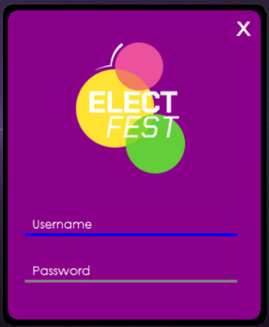

Figure 1

The GUI for all the people will look similarly but the content inside will be different (*figure 2*). The username or/and personal ID will be shown on the top, next to the logo of the event. The Admin one will have the task to give information about the event from the inside to the admins and the owner. It will display data about the employees, working on the event and the number of participants registered and who of them are inside the event. Also, it may display charts showing the income of the event. Every piece of information will be accessed by clicking on a different button.

The form for the selling department will look the same but the buttons will show different kind of information. For example, a person from this department will be able to track the inventory in the store, sell available items and generate coupons for the participants.

The form for the employees who will check the tickets when entering the event or the campsite will be the same. When a user scans the provided QR code he/she will be able to see whether the person has a ticket and if yes what kind of ticket it is

The picture below shows how the GUI will look like in general (All colors are just example ones):

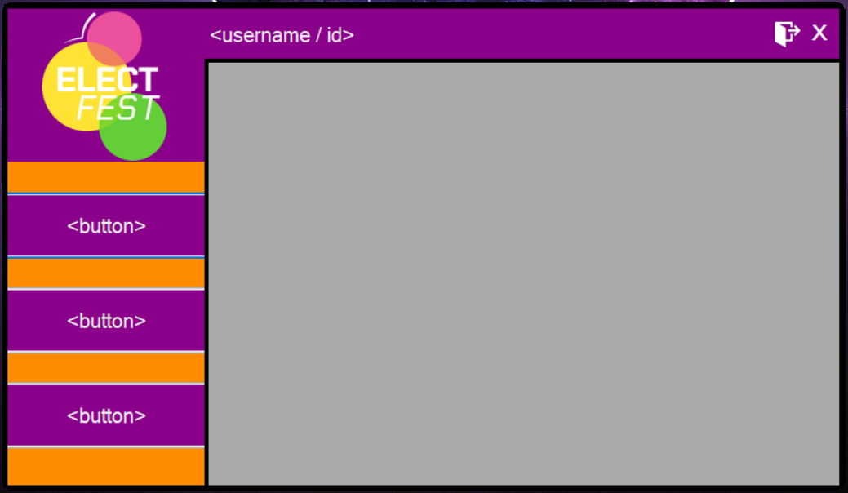

Figure 2