DS1307 manual

Following next steps you will be able to connect without any problem(I hope so) real time clock module ds1307 to your Orange Pi one board.
This manual was tested ONLY for Orange Pi one board and Armbian OS ver 5.75.
So I’m not responsible for any troubles with another boards and Oss.
On another boards driver may be necessary to enable in kernel device tree config file:
/kernel/device/tree/directory/.config

CONFIG_RTC_LIB=y
CONFIG_RTC_CLASS=y
CONFIG_RTC_HCTOSYS=y
CONFIG_RTC_HCTOSYS_DEVICE="rtc0"
CONFIG_RTC_SYSTOHC=y
CONFIG_RTC_SYSTOHC_DEVICE="rtc0"
# CONFIG_RTC_DEBUG is not set

#
# RTC interfaces
#
CONFIG_RTC_INTF_SYSFS=y
CONFIG_RTC_INTF_PROC=y
CONFIG_RTC_INTF_DEV=y
# CONFIG_RTC_INTF_DEV_UIE_EMUL is not set
# CONFIG_RTC_DRV_TEST is not set

#
# I2C RTC drivers
#
# CONFIG_RTC_DRV_ABB5ZES3 is not set
# CONFIG_RTC_DRV_ABX80X is not set
CONFIG_RTC_DRV_DS1307=y
# CONFIG_RTC_DRV_DS1374 is not set

1. Connect ds1307 module to board:

Pin 3(PA12) → SDA
Pin 4(+5V Power) → VCC
Pin 5(PA11) → SCL
Pin 6(Ground) → GND

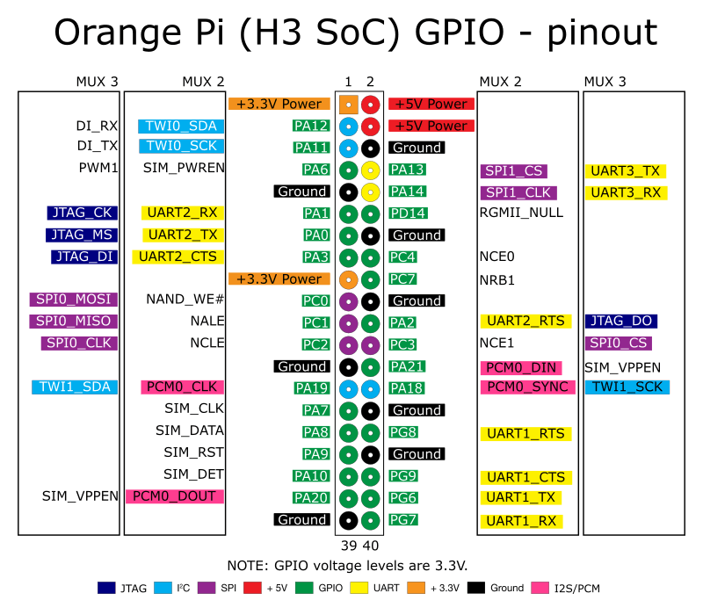

2. Edit your sun8i-h3-one.dtb file in boot/dtb-4.19.20-sunxi directory.

2.1 Decompile your .dtb into .dts using next command:
dtc -I dtb -O dts -o sun8i-h3-one.dts sun8i-h3-one.dtb

2.2 Edit the next block in resulting .dts:

i2c@1c2ac00 {
compatible = "allwinner,sun6i-a31-i2c";
reg = <0x1c2ac00 0x400>;
interrupts = <0x0 0x6 0x4>;
clocks = <0x3 0x3b>;
resets = <0x3 0x2e>;
pinctrl-names = "default";
pinctrl-0 = <0x1d>;
status = "okay";
#address-cells = <0x1>;
#size-cells = <0x0>;
phandle = <0x5d>;
rtc1@68 {
compatible = "dallas,ds1307";
reg = <0x68>;
status = "okay";
};
};

2.2.1 In section __symbols__ { }
add after
i2c0 = "/soc/i2c@1c2ac00";
next string:
ds1307 = "/soc/i2c@1c2ac00/rtc1@68";

It would be like this:

__symbols__ {
………
uart2 = "/soc/serial@1c28800";
uart3 = "/soc/serial@1c28c00";
i2c0 = "/soc/i2c@1c2ac00";
ds1307 = "/soc/i2c@1c2ac00/rtc1@68";
i2c1 = "/soc/i2c@1c2b000";
lcd_ssd1306 = "/soc/i2c@1c2b000/lcd_ssd1306@3c";
i2c2 = "/soc/i2c@1c2b400";
…………
};

2.3 Compile .dts to .dtb using next command:
dtc -O dtb -I dts -o sun8i-h3-one.dtb sun8i-h3-one.dts

2.4 replace old sun8i-h3-one.dtb on new .dtb

3. Edit file etc/default/rtc or if it’s absent – create it:

I2CNAME="ds1307"
I2CADDR="0x68"
BUSNUM="1"

3.1 You can plug in ds1307 on another i2c-N bus, so obviously you will need to choose another BUSNUM=”N” and edit .dts file according to your bus.

4. Edit file /lib/systemd/system/rtc.service or if it’s absent – create it:

[Unit]
Description=Initialize RTC device driver
DefaultDependencies=no
Requires=systemd-modules-load.service
After=systemd-modules-load.service
Before=sysvinit.target
ConditionPathExists=/sys/class/i2c-adapter
Conflicts=shutdown.target

[Service]
Type=oneshot
RemainAfterExit=yes
EnvironmentFile=/etc/default/rtc
ExecStart=/bin/sh -c "echo ${I2CNAME} ${I2CADDR} > /sys/class/i2c-adapter/i2c-${BUSNUM}/new_device"

[Install]
WantedBy=sysinit.target

5. Check the presence of file /lib/systemd/system/hwclock-save.service or if it’s absent – create it:

[Unit]
Description=Synchronise Hardware Clock to System Clock
DefaultDependencies=no
Before=shutdown.target
ConditionFileIsExecutable=!/usr/sbin/ntpd
ConditionFileIsExecutable=!/usr/sbin/openntpd
ConditionFileIsExecutable=!/usr/sbin/chrony
ConditionVirtualization=!container

[Service]
Type=oneshot
ExecStart=/sbin/hwclock -D --systohc

[Install]
WantedBy=reboot.target halt.target poweroff.target

6. Check the service hwclock-save.service in systemd using next command:

systemctl status hwclock-save.service

Result:

hwclock-save.service - Synchronise Hardware Clock to System Clock
Loaded: loaded (/lib/systemd/system/hwclock-save.service; enabled)
Active: inactive (dead)

6.1 If it’s absent – tune it using next command:

systemctl daemon-reload && systemctl reenable hwclock-save.service

7. Tune your systemd using next command:

systemctl daemon-reload && systemctl reenable rtc.service

Result:
Removed symlink /etc/systemd/system/sysinit.target.wants/rtc.service.
Created symlink from /etc/systemd/system/sysinit.target.wants/rtc.service to /lib/systemd/system/rtc.service.

8. Reboot board using next command:

reboot

9. Check rtc1 using next command:
dmesg | grep rtc

Result:
[0.928262] sunxi-rtc sunxi-rtc: rtc core: registered sunxi-rtc as rtc0
[5.256555] rtc-ds1307 0-0068: rtc core: registered ds1307 as rtc1

10.Delete fake-hwclock:

apt-get --purge autoremove fake-hwclock

11. Tune system time when you starting system.
Edit file /lib/udev/rules.d/50-udev-default.rules.
Change section in file:

from

# select "system RTC" or just use the first one
SUBSYSTEM=="rtc", ATTR{hctosys}=="1", SYMLINK+="rtc"
SUBSYSTEM=="rtc", KERNEL=="rtc0", SYMLINK+="rtc", OPTIONS+="link_priority=-100"

into

# select "system RTC" or just use the first one
SUBSYSTEM=="rtc", ATTR{hctosys}=="1", SYMLINK+="rtc"
SUBSYSTEM=="rtc", KERNEL=="rtc1", SYMLINK+="rtc", OPTIONS+="link_priority=-100"
ACTION=="add", SUBSYSTEM=="rtc", RUN+="/sbin/hwclock -s --localtime"

12. Set system time in ds1307 using next command(Please, do it like superuser. I had a terrible headache with access rights to system clocks):

hwclock --set --date='2525-08-14 07:11:05'

13. reboot again

14. Check system time using next command:
hwclock -r -f /dev/rtc1

