Paper Title (Font: Century 22pt, align center)

Name (Font: Century 12pt, align center)

Department(学部) University(Kyoto University) (Font: Century 12pt, align center)

Abstract: Write a short (max 150 word) synopsis of your paper in order to provide a quick outline, giving the reader an overview of the research. In this section, backgrounds, methods, results and conclusion should be written concisely. Importance, aim and motivation are included in backgrounds. About methods, you should clarify all concrete factors, such as objects, period, viewpoint etc. Results and conclusion should be brief. (Font: Century 9pt, bold)

Key Words: Put 2~4 key words of your paper. (Font: Century 9pt, bold, align center)

1. Introduction
(Section Title. Font: Century 9pt, bold, align center)
The following are the guidelines for preparing your paper for the 3rd International Symposium on Liberal Arts and General Education Proceedings. Please note that this document can also serve as a template. (Contents. Font: Century 9pt)
In the introduction section, you should prepare for the explanation. Backgrounds such as aims or motivation of the research should be definite. It is important to define key terms and tell the importance of your own work, with referring former studies. You could suggest the result in this section, if it is convenient.
You must specify certain reference in the case of summary or quotation, with following way. (A, 2011 [0]) [last name, year [reference number]
□□□□□□□, □□□□□□□□□□□□□□□, □□□□□□□, □□□□□□□□□□□□□□. □□□□□□□, □□□□□□□□□□□□□□□, □□□□□□□, □□□□□□□□□□□□□□. □□□□□□□, □□□□□□□□□□□□□□□, □□□□□□□, □□□□□□□□□□□□□□.
□□□□□□□, □□□□□□□□□□□□□□□, □□□□□□□, □□□□□□□□□□□□□□. □□□□□□□, □□□□□□□□□□□□□□□, □□□□□□□, □□□□□□□□□□□□□□. □□□□□□□, □□□□□□□□□□□□□□□, □□□□□□□□□□□□□□.
(There must be one blank line between sections.)

2. Methods
2.1. Subsection 1
(Subsection Title. Font: Century 9pt)
(1) Unit 1 (Unit Title. Font: Century 9pt)
In the methods section, you must definitely show what you did. Objects, processes and materials of the study should be clarified. In addition, remember to write the way of your analysis.
Subsections and units are just examples. You may use them, but not nessensuary.
(2) Unit2
□□□□□□□, □□□□□□□□□□□□□□□, □□□□□□□, □□□□□□□□□□□□□□. □□□□□□□, □□□□□□□□□□□□□□□, □□□□□□□, □□□□□□□□□□□□□□. □□□□□□□, □□□□□□□□□□□□□□□, □□□□□□□□□□□□□□.

3. Results
3.1. Subsection 1
In the results section, outcome of the study must be written objectively. At first, analysis viewpoint should be shown. Then you must concretely produce discoveries with examples.
Remember that this section is only used to tell the fact. Your own opinions and induction must be placed in the discussion section.
Figures and tables should be fully utilized to make readers understand your work easily. Figure captions should be below the figures, and table captions should be above the tables. Avoid placing figures and tables before their first mention in the text.
(There must be one blank line between sentences and tables or figures.)

Table 1.The sample table
(Table Title. Font: Century 8pt, align center)
(Table title should be written on the top of the table)
Trial number | Applied force [N] | acceleration [m/s^2]
1 | 30 | 6.01
2 | 31 | 6.12
3 | 33 | 6.13
4 | 29 | 6.02
5 | 29 | 5.93
6 | 30 | 5.98

(Table contents. Font: Century 8pt)

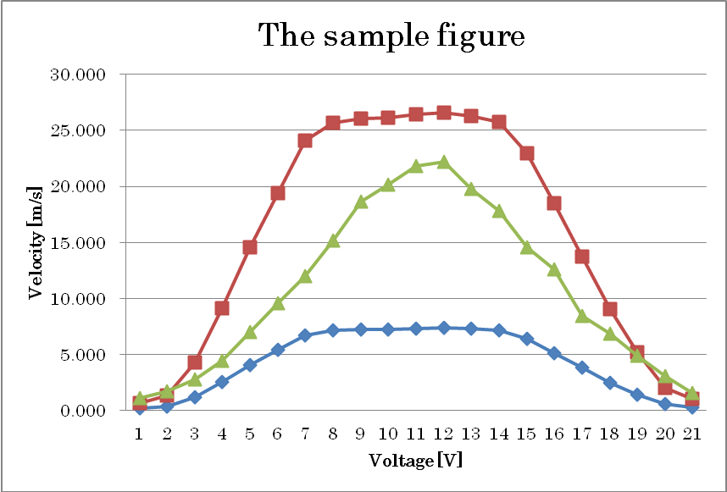

Figure 1.The sample figure
(Figure Title. Font: Century 8pt, align center)
(Figure title is written below the figure. It is possible to use color tables and figures.)

3.2. Subsection 2
□□□□, □□□□□□□□□□□□□□□, □□□□□□□, □□□□□□□□□□□□□□. □□□□, □□□□□□□□□□□□□□□, □□□□□□□, □□□□□□□□□□□□□□.

4. Discussion
In the discussion section, it is most important to rationally argue your points on the basis of the results. Vital results should be shown again, especially when the result is the object of interpretation. You may add weak points or limitations of your study.□□□ □□□□, □□□□□□□□□□□□□□□, □□□□□□□, □□□□□□□□□□□□□□. □□□□□□□, □□□□□□□□□□□□□□□, □□□□□□□, □□□□□□□□□□□□□□□, □□□□□□□, □□□□□□□□□□□□□□. □□□□□□□, □□□□□□□□□□□□□□□, □□□□□□□, □□□□□□□□□□□□□□□, □□□□□□□, □□□□□□□□□□□□□□. □□□□□□□, □□□□□□□□□□□□□□□, □□□□□□□, □□□□□□□□□□□□□□. □□□□□□□, □□□□□□□□□□□□□□□, □□□□□□□, □□□□□□□□□□□□□□. □□□□□□□, □□□□□□□□□□□□□□□, □□□□□□□, □□□□□□□□□□□□□□. □□□□□□□, □□□□□□□□□□□□□□□, □□□□□□□, □□□□□□□□□□□□□□. □□□□□□□, □□□□□□□□□□□□□□□, □□□□□□□, □□□□□□□□□□□□□□. □□□□□□□, □□□□□□□□□□□□□□□, □□□□□□□, □□□□□□□□□□□□□□. □□□□□□□, □□□□□□□□□□□□□□□, □□□□□□□, □□□□□□□□□□□□□□. □□□□□□□.

5. Conclusions
In the conclusion section, the most vital factor is what you want to tell from the study. Using outcomes of results and discussion, you have to conclude this paper logically. After that, you can add suggestions from your study or expectation of further studies. □□□□□□□, □□□□□□□□□□□□□□□, □□□□□□□, □□□□□□□□□□□□□□. □□□□□□□, □□□□□□□□□□□□□□□, □□□□□□□, □□□□□□□□□□□□□□. □□□□□□□, □□□□□□□□□□□□□□□, □□□□□□□, □□□□□□□□□□□□□□. □□□□□□□, □□□□□□□□□□□□□□□, □□□□□□□, □□□□□□□□□□□□□□. □□□□□□□, □□□□□□□□□□□□□□□, □□□□□□□, □□□□□□□□□□□□□□. □□□□□□□, □□□□□□□□□□□□□□□, □□□□□□□, □□□□□□□□□□□□□□. □□□□□□□, □□□□□□□□□□□□□□□, □□□□□□□, □□□□□□□□□□□□□□.□□□□□□□, □□□□□□□□□□□□□□□, □□□□□□□, □□□□□□□□□□□□□□.

6.References
List all references in this section in alphabetical order. References should be written as in the example below. This example, follows the APA format 6th edition. Refer to this if you cannot find what you want to see in this example.

([0] Author, A. B. (year). Title of the book. Location/City, State: Publisher. )
[1] Benson, P. (2006). Autonomy in language teaching and learning. State-of-the-art article. Language Teaching, 40, 20-40. doi:10.1017/S026144806003958
[2] Brown, F. (Ed.). (2006). Maximize business profits through e-partnerships. Hershey, PA: IR Press.
[3] Deci, E. L., & Ryan, R. M. (1991). A motivational approach to self: Integration in personality. In Dienstbier, R. A. (Ed.), Perspectives on motivation (pp. 237-288). Lincoln: University of Nebraska Press.
[4] Takeuchi, O. (2003). Yoriyoi gaikokugo gakushuho wo motomete [In pursuit of better language learning]. Tokyo: Shohakusha.

Format: A4-size paper, set top margin to 30mm, bottom margin to 30mm, left and right margins to 15mm, and left- and right-justify your columns. Do not put page numbers in your paper.

