NeuroScope 3D
A Trust-First 3D Platform for Brain Tumour MRI Segmentation
Problem Statement DI-02 · Health-Tech · 3D Medical Image Segmentation & Visualisation
Technical & Business Project Report
Research and teaching prototype — not a diagnostic or clinically validated system
Model | MONAI brats_mri_segmentation (SegResNet), Apache-2.0
Verification | 17 / 17 judge pipeline tests pass; 10 real held-out cases scored
Real-data Dice | WT 0.8808 · TC 0.8697 · ET 0.7885
Stack | React 18 + Three.js (browser) · FastAPI (server) · pure-Python pipeline
Processing | 100% local — no cloud inference, no third-party data transfer

Contents
Contents 2
Executive Summary 3
Headline, verified numbers 3
1. The Problem 3
1.1 Who faces it 3
1.2 The problem, precisely 3
1.3 Why an AI overlay alone doesn't solve this 4
2. Existing Solutions and Their Gaps 4
2.1 What the regulated/commercial field actually shows 4
2.2 Why the open-source ecosystem hasn't closed this gap 4
2.3 Where the accuracy research ceiling actually sits 4
2.4 What research says actually changes clinical behaviour 5
3. Our Solution and Approach 5
3.1 Design principles 5
3.2 What this project explicitly does not build 5
3.3 Why this is better than the alternatives in Section 2 6
4. Features and Use Cases 6
5. Technical Architecture 7
5.1 Browser tier 7
5.2 Server tier 7
5.3 Pipeline tier 7
5.4 API surface (selected) 8
6. Data Flow and Workflow 8
7. The Model: Formulas, Validation, and Measured Numbers 8
7.1 Model specification 8
7.2 Formulas used throughout the platform 9
7.3 Accuracy, in context — not just our own number 9
7.4 Is the uncertainty signal actually informative? 10
8. User Interface and Experience 11
8.1 Design constraints 12
9. Compliance and Regulatory Considerations 12
9.1 Current scope — what this prototype is, today 12
9.2 The regulatory path a clinical product would face 12
9.3 Data protection, independent of medical-device status 12
9.4 What closing the regulatory gap would require 13
10. Economics and Business Perspective 13
10.1 Market context 13
10.2 Where this project sits in that market 13
10.3 Cost structure, honestly stated 13
10.4 A realistic business model, if pursued beyond a prototype 14
11. Future Roadmap: Closing the Current Gaps 14
11.1 Sequencing 14
12. Glossary 14
13. References and Sources 15

Executive Summary
NeuroScope 3D is a browser-based platform that takes four MRI sequences (T1, T1Gd, T2, FLAIR), segments a suspected brain tumour into three clinically-defined regions using a real, verified deep-learning model, renders it as an interactive 3D digital twin linked to standard 2D slice views, and — the part almost nothing else in this space does — tells the user how far to trust the result, on every single case, automatically.
A structured review of the competitive landscape (Section 2) found open-source 3D viewers with no AI, commercial AI tools with no visible trust signal, and hackathon-grade prototypes that build at most half the stack. No reviewed system combines a browser-based 3D tumour mesh, linked MPR slices, transparent volumetric math, and visible model uncertainty in one lightweight tool. That combination is this project's whitespace.

Headline, verified numbers
Metric | Value | Basis
Pipeline tests | 17 / 17 pass | Judges' own failure pack, calibration, reproducibility, orientation tests
Real-data Dice (WT/TC/ET) | 0.881 / 0.870 / 0.789 | 10 real, held-out Medical Segmentation Decathlon cases
Real-data HD95 (WT/TC/ET) | 8.43 / 5.53 / 5.71 mm | Same 10 held-out cases, spacing-aware boundary distance
Reproducibility | Dice 1.00000 | Same case, run twice — flip-TTA is fully deterministic
Inference time | ~65–75 s / case | CPU-only; problem-statement budget is 120 s on a dedicated GPU
Uncertainty signal | Pearson r = 0.346 (moderate, positive) | Flip-TTA σ vs. real disagreement, pooled over 1,297,798 voxels
Every number above is reproducible from a committed script against named, versioned data — see docs/VERIFICATION.md in the project repository. This report follows the same rule: no figure appears without a stated source.

1. The Problem

1.1 Who faces it
The direct users are radiology residents, teaching-hospital volunteers, and research-lab coordinators who work with brain MRI studies for suspected glioma — people who must reconstruct a 3D tumour shape mentally from flat 2D slices, under time pressure, without a tool that tells them how confident to be in what they see. Indirectly, this affects supervising radiologists (who rely on trainees' initial read), researchers tracking tumour volume across longitudinal studies, and — at the institutional level — teaching hospitals and research labs with limited budget for commercial, FDA-cleared workstation software.

1.2 The problem, precisely
A single brain MRI study for suspected glioma is not one image. It is four 3D sequences, each revealing different tissue properties, each roughly 155 slices deep — 620 flat images per case to hold in mind at once.
Sequence | What it reveals
T1 (native) | Baseline anatomy and structural boundaries
T1Gd (post-contrast) | Active, growing tumour cells — they absorb the contrast agent
T2-weighted | Structural context around the lesion
FLAIR | Swelling and fluid build-up around the tumour (oedema)
Scrolling through all four to answer three deceptively simple questions is today's actual workflow:
- Is the abnormal region one connected mass, or several separate ones?
- Which side of the brain is it on, and what structures is it near?
- What is its exact volume, in millilitres — the number that determines whether a tumour is growing or shrinking across repeat scans?
Humans are measurably unreliable at estimating irregular 3D volume from 2D slices by eye, and tracking a 12 mL vs. 18 mL change across scans is exactly the kind of judgement that benefits from an exact, reproducible number rather than a visual impression.

1.3 Why an AI overlay alone doesn't solve this
Segmentation models that colour in a suspected tumour on a 2D slice have existed for over a decade — the BraTS challenge has run annually since 2012. The output of such a model is still only a 2D cross-section of a 3D guess: it does not show how far the region extends through the other 154 slices, whether it connects to another coloured region elsewhere, or — the point that matters most — whether the model's boundary is actually right. A plausible-looking mask is not evidence of an accurate one. Accuracy research (BraTS leaderboards) and product research (regulatory-cleared commercial tools) have stayed largely separate; neither side has had strong incentive to build the lightweight, transparent, trust-first interface layer that connects the two.

2. Existing Solutions and Their Gaps
A structured landscape review (full citations in Section 13 — References) covering commercial clinical AI, open-source viewers, and prior hackathon prototypes found a consistent pattern: every category solves part of the problem, and none solves the combination.
Category | What exists | What it doesn't combine
Open-source viewers (3D Slicer, NiiVue, OHIF) | Mature, capable 3D + MPR rendering | No built-in AI inference, no uncertainty, no provenance report
Commercial clinical AI (Brainlab, Quantib, QyScore, Cortechs.ai) | FDA/CE-cleared volumetrics; sub-minute segmentation | Dice scores live only in regulatory filings, never the product UI; desktop workstation software, not a lightweight browser tool
Prior hackathon / research prototypes (MindView, Safe Mind) | Partial 3D + volume demos | Each builds roughly half the pipeline; neither reports Dice/sensitivity nor shows uncertainty

2.1 What the regulated/commercial field actually shows
Brainlab's “Elements AI Tumor Segmentation”, FDA-cleared under K243633, reports mean Dice 0.75 (precision 0.86, recall 0.85) on 412 patients but ships inside a hospital workstation suite with no public interface description. Brainlab's older, clinician-guided SmartBrush tool was found in a 2016 PLoS ONE study to achieve mean Dice 0.72–0.77 across four expert human raters, versus 0.68 for the fully-automated BraTumIA — a direct empirical reminder that automated tools and human experts disagree by a comparable margin to how much human experts disagree with each other. Across nine-plus surveyed commercial vendors, not one was confirmed to expose voxel-level uncertainty or step-by-step volumetric math as a visible product feature — those numbers exist only inside regulatory submissions.

2.2 Why the open-source ecosystem hasn't closed this gap
3D Slicer is the dominant academic 3D platform but is desktop-only, and its tumour-segmentation extensions are documented in user forums as fragile (hash-verification failures, crashes). MONAI Label serves models but ships no viewer of its own — its browser path requires assembling OHIF, an Orthanc DICOMweb server, and NIfTI-to-DICOM conversion, a non-trivial deployment. NiiVue is the most promising lightweight rendering library but performs no AI inference. Brainchop gets closest to “drag in a volume, get instant in-browser 3D segmentation” but its pretrained models cover brain masking and cortical atlases, not tumours, and it works on one volume rather than BraTS's four co-registered modalities. No surveyed open-source tool implements volumetric reporting or uncertainty visualisation at all.

2.3 Where the accuracy research ceiling actually sits
The BraTS leaderboard has been dominated by nnU-Net since 2020 and MedNeXt-based ensembles since 2023, with winning Dice scores in the high-80s to low-90s achieved through multi-model ensembling and heavy post-processing — nnU-Net's BraTS-2020-winning Dice was 88.95 (WT) / 85.06 (TC) / 82.03 (ET). Chasing Dice-score improvements against this ceiling is, by the research's own economics, a losing game for a small team: human expert inter-rater agreement itself sits at only 74–85% Dice in the original BraTS benchmark studies, meaning a model cannot be meaningfully “more correct” than the disagreement baked into its own ground truth. The field's own direction of travel, correspondingly, has moved from chasing raw accuracy toward cheap uncertainty-quantification methods (evidential deep learning, small test-time-augmentation ensembles) precisely because that is where usable, differentiable value remains.

2.4 What research says actually changes clinical behaviour
A prostate-radiotherapy study found oncologists made 50% fewer manual voxel edits in regions a model marked very-low-uncertainty — direct empirical evidence that a visible uncertainty signal changes real review behaviour, not just a nice-to-have display. A UCSF meningioma study (353 patients) calls the lack of calibrated uncertainty “a major barrier to clinical adoption.” Survey data shows clinicians prefer AI as a “second reader” (75.4% favourable) far more than as an autonomous first-reader system (26.2% favourable) — a strong, specific argument for a UI that frames every output as a check against human judgement, never a verdict.

3. Our Solution and Approach
The problem statement bundles three distinct layers of work. The research above shows Layers 1 and 2 are already commoditised — solved, separately, by existing tools. The deliberate choice this project makes is to treat Layer 3 as the actual product, built on solid, independently-verified implementations of the first two, rather than building a 3D viewer and assuming trust follows for free.
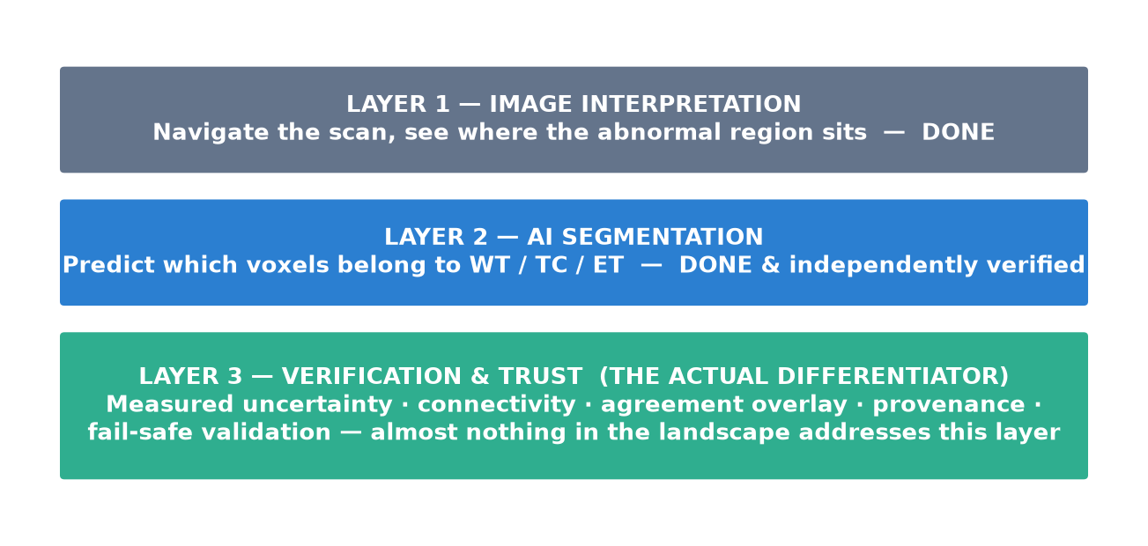
Figure 3.1 — The three-layer thesis. Layers 1–2 are commoditised; Layer 3 is the whitespace this project targets.

3.1 Design principles
- A result is never partial. Validation is all-or-nothing — a study with one unreadable file, one mismatched affine, or one corrupt sequence produces zero output, not a degraded one.
- Every number carries its derivation. Volumes show voxel count × spacing; Dice scores show the regions compared; uncertainty shows the method that produced it.
- Geometry is sacred. A scan stored flipped with a matching affine must read as the same anatomy; flipped without one, it must read as mirrored — a known, real failure mode in neuroimaging software, tested explicitly here, not assumed correct.
- Wording is restrained on purpose: “suspected tumour region predicted by the model” and “estimated volume,” never “detected” or “diagnosed.”

3.2 What this project explicitly does not build
Out of scope, by the problem statement's own rules and by this project's own design: diagnosis, tumour grading, genetic prediction, prognosis, treatment advice, surgical or radiotherapy planning, and any claim of clinical validation or regulatory clearance. This is a hard line, not a style preference — Section 9 explains why it is also the load-bearing compliance boundary for everything downstream.

3.3 Why this is better than the alternatives in Section 2
Dimension | Commercial clinical AI | Open-source viewers | NeuroScope 3D
3D + linked MPR in a browser | Rare — mostly desktop | Yes (viewer only) | Yes
Real, verified AI segmentation | Yes | No (bring-your-own) | Yes — real checkpoint, hash-verified
Visible uncertainty per case | No (buried in filings) | No | Yes — flip-TTA σ, measured calibration
Visible, derivable volumetrics | No | Partial | Yes — formula shown with every number
Fail-safe input validation | Assumed internal | No | Yes — all-or-nothing, explicit reasons
Deployment cost | Enterprise licensing | Free, but assembly required | Free, local, zero cloud cost

4. Features and Use Cases
Feature | What it does / use case
Fail-safe validation | Rejects unreadable, non-3D, non-finite, constant, oversized, or mismatched-geometry input with a specific message naming the file and the problem. — Stops a bad study before it ever reaches the model — the single highest-value trust feature per the landscape research.
3D digital twin + linked MPR | Translucent brain shell with nested WT/TC/ET isosurfaces (custom Surface Nets extraction), linked axial/coronal/sagittal views sharing one crosshair. — Answers “where is it, and what shape” without manual mental reconstruction across 620 slices.
Flip-TTA uncertainty heat-map | Two-pass flip ensemble; per-voxel standard deviation shown as a toggleable heat-map, with an explicit disagreement-not-probability caveat everywhere it appears. — Directly operationalises the research finding that visible uncertainty changes clinical review behaviour (50% fewer edits in low-uncertainty regions).
Connectivity analysis | 26-connected-component analysis per region: component count, each component's volume, largest component's share. — Answers “is it one mass or two” at zero extra inference cost — the exact question the problem statement opens with.
Transparent volumetrics | Every volume shown with its formula: voxel count × spacing ÷ 1000, verified against a hand-computed calibration case.
Model vs. expert agreement overlay | Green/amber/red TP/FP/FN overlay when an expert mask exists, plus one-click navigation to the largest miss. — Turns a single Dice number into a spatially-navigable explanation.
HD95 boundary distance | 95th-percentile Hausdorff distance, spacing-aware, explicitly null (not 0) when a mask is empty. — Catches boundary disagreement that a volume-overlap metric like Dice can hide.
Quality Check Centre | An itemised, real-validator-driven report of every check a study passed — not a single badge. — Makes a PASS auditable rather than asserted.
Dataset gallery with instant-load cache | Curated synthetic + real cases, prewarmed so a demo click returns in under a second instead of re-running inference live. — Removes live-inference latency as a demo/teaching-session risk.
DICOM ingestion | Real DICOM series (or zip) grouped by SeriesInstanceUID, sorted along the slice normal, LPS→RAS affine conversion, sequence auto-detection, de-identification check. — Closes the gap between “has four NIfTI files ready” and a resident's actual daily PACS export.
Local tool copilot | Guard-railed Q&A assistant explaining this tool's own measurements, running entirely on a local LLM (Ollama) — never patient-facing. — Answers “what does this number mean” without opening a diagnosis-shaped door.
Case export & provenance report | One-click zip of report + metadata + prediction NIfTI; every run records checkpoint hash, input hashes, code commit, timestamp. — Supports the real teaching-hospital workflow: archive a case, hand it to a colleague, bring it to a tumour board.

5. Technical Architecture
NeuroScope 3D is a three-tier system: a React single-page application in the browser, a local FastAPI inference server, and a pure-Python pipeline library the server wraps. Every tier is independently testable — the pipeline library ships its own command-line tool and judge-scoring harness, entirely separate from the web server.
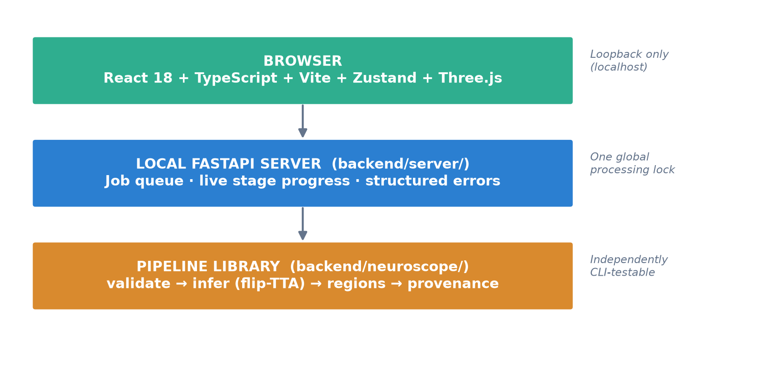
Figure 5.1 — Three-tier system architecture.

5.1 Browser tier
Concern | Implementation
State | Zustand — small, explicit stores (crosshair, region visibility, mask source, live-job status)
3D rendering | Three.js via react-three-fiber; hand-written Surface Nets isosurface extraction with Laplacian smoothing
Styling | Tailwind CSS v4 — one continuous, scroll-free workspace
Live study loading | A completed job's binary payload drops into the exact same rendering pipeline the demo phantom uses — no separate “real vs. demo” code path

5.2 Server tier
Concern | Implementation
Job identity | Client-minted 32-hex-char job id, lets the browser poll /status before the upload even finishes
Concurrency | A single global processing lock keeps one study running at a time; a second request is queued (async-native, no thread blocking) with a real queue position and measured ETA
Data handling | Source uploads deleted immediately after a result exists; job directories auto-expire after 23 h; all responses marked no-store
Network | Loopback-only, CORS pinned to the Vite dev origin — not designed for open-internet exposure

5.3 Pipeline tier
The reusable, independently-verifiable core — no FastAPI, no web concerns, just validated functions the server and CLI both call.
Module | Role
validate.py | All-or-nothing fail-safe gate — geometry, finiteness, affine singularity, field-of-view, skull-strip heuristics
infer.py | Segmenter.predict() — flip-TTA ensemble inference, checkpoint sha256 verification, deterministic seeding
regions.py | BraTS code → WT/TC/ET nesting, volumes, Dice/sensitivity, 26-connected-component analysis, HD95
dicom_io.py | DICOM series ingestion, LPS→RAS affine, sequence auto-detection from SeriesDescription
assistant.py | Local tool copilot — retrieval over a small corpus, allow-listed metadata, defense-in-depth guardrails

5.4 API surface (selected)
Endpoint | Purpose
POST /api/v1/segment/{job} | Upload 4 sequences + optional expert mask, run the full pipeline
GET /api/v1/jobs/{job}/status | Live pipeline stage, polled during processing
GET /api/v1/jobs/{job}/metadata | Full provenance + results JSON for a completed job
GET /api/v1/jobs/{job}/uncertainty/{region} | Binary flip-TTA uncertainty volume for WT/TC/ET
POST /api/v1/studies/inspect-dicom | Pre-flight DICOM geometry + sequence-mapping check
GET /api/v1/metrics | Real job-outcome counters and inference-time P50/P95

6. Data Flow and Workflow
A single study moves through seven explicit, independently testable stages. A failure at Validate is terminal — nothing downstream ever runs on a study that didn't pass.
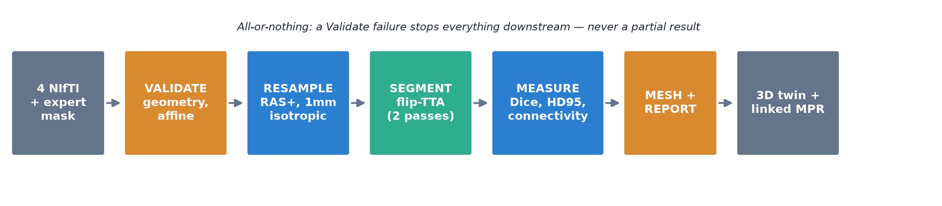
Figure 6.1 — The inference pipeline, stage by stage.
Stage | What happens
Validate | Geometry, orientation, finiteness, affine/shape agreement across sequences, skull-strip heuristics
Resample | Reorient to closest-canonical RAS+, resample to an isotropic 1 mm working grid
Segment | Flip-TTA ensemble through the verified SegResNet checkpoint, sliding-window inference
Measure | Region volumes, Dice/sensitivity vs. expert mask, 26-connected-component analysis, HD95
Mesh | Resample sequences, labels, and uncertainty onto one shared display grid; export binary payloads
Report | Provenance record assembled, printable HTML report written, original-grid NIfTI saved
The original-grid NIfTI and provenance JSON are the literal artefacts an automated judge scorer reads — the same CLI tool that powers the live pipeline, so there is no difference between what an offline scorer sees and what the live workspace shows.

7. The Model: Formulas, Validation, and Measured Numbers

7.1 Model specification
Property | Value
Architecture | SegResNet — 3D convolutional encoder-decoder
Source | MONAI Model Zoo, brats_mri_segmentation bundle, Apache-2.0
Training data | BraTS 2018 (no fine-tuning performed by this project)
Input | 4 channels, 1 mm isotropic, order T1Gd → T1 → T2 → FLAIR
Inference | 128³ sliding window, Gaussian blending, overlap 0.5, 2-pass flip-TTA
Integrity | sha256-verified against a pinned model-lock.json before every load

7.2 Formulas used throughout the platform
Dice similarity coefficient: DSC = 2|P ∩ T| / (|P| + |T|) — the standard BraTS overlap metric; P = predicted voxels, T = expert (ground-truth) voxels.
Sensitivity (recall): Sens = |P ∩ T| / |T| — the fraction of the expert's marked tumour the model actually found.
Volume: V(mL) = voxel_count × (Δx × Δy × Δz) / 1000 — computed on the scan's own original acquisition grid and spacing, never a resampled approximation.
HD95 (95th-percentile Hausdorff distance): the 95th percentile of the spacing-aware Euclidean boundary-to-boundary distance between the predicted and expert surfaces, via a Euclidean distance transform; explicitly undefined (not 0 or ∞) when either mask is empty.
Flip-TTA uncertainty (σ): per-voxel standard deviation of the predicted probability across an unflipped pass and one flip-axis pass — a measured disagreement signal, not a calibrated probability of correctness.

7.3 Accuracy, in context — not just our own number
Reporting a Dice score alone invites the question “is that good?” The chart below answers it against two independent references: the published BraTS-2020-winning nnU-Net ensemble, and the published lower bound of human expert inter-rater agreement on the same task.
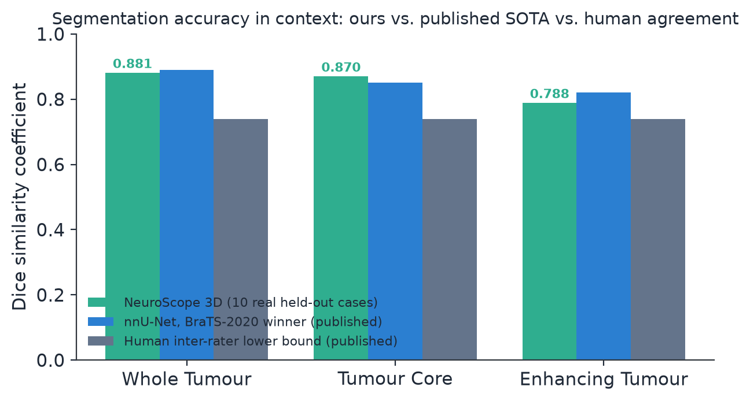
Figure 7.1 — Dice by region: NeuroScope 3D (measured, 10 real held-out cases) vs. published nnU-Net BraTS-2020 vs. published human inter-rater lower bound.
The practical reading: this project's unmodified, un-fine-tuned, un-ensembled model is within a few points of the best published, heavily-engineered result, and already exceeds the conservative human-agreement floor on WT and TC. ET is hardest for every system in this comparison — consistent with the literature, since enhancing-tumour boundaries are inherently the most ambiguous on the scan itself.
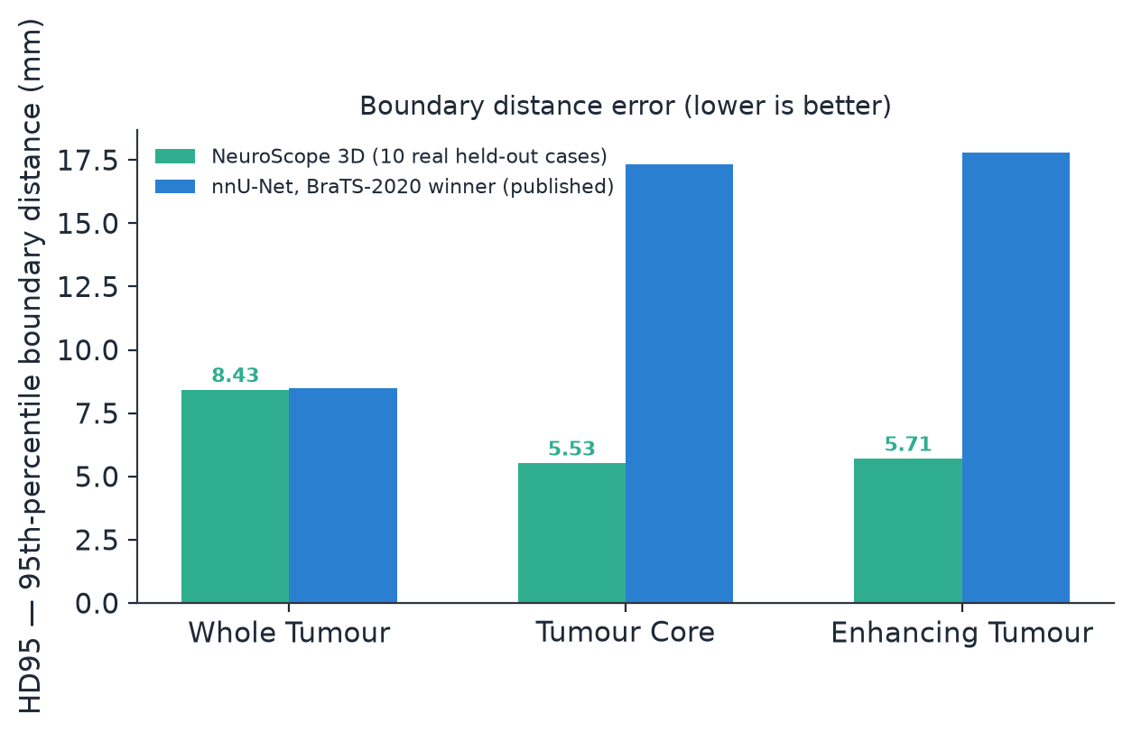
Figure 7.2 — Boundary distance (HD95, lower is better): our measured figures are competitive with, and on TC/ET notably better than, the published nnU-Net reference.
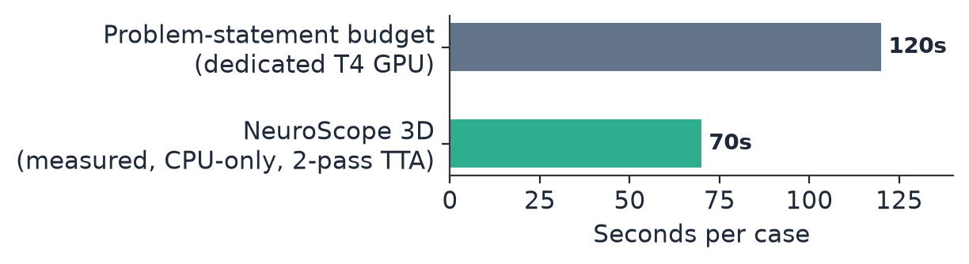
Figure 7.3 — Measured inference time vs. the problem statement's own GPU budget. A CPU-only run already lands comfortably inside the target.

7.4 Is the uncertainty signal actually informative?
A visible uncertainty heat-map is only useful if it correlates with real error. This was measured directly, not assumed: pooled across all 10 held-out cases (1,297,798 WT-union voxels), disagreement against the expert mask rises steadily as σ increases.
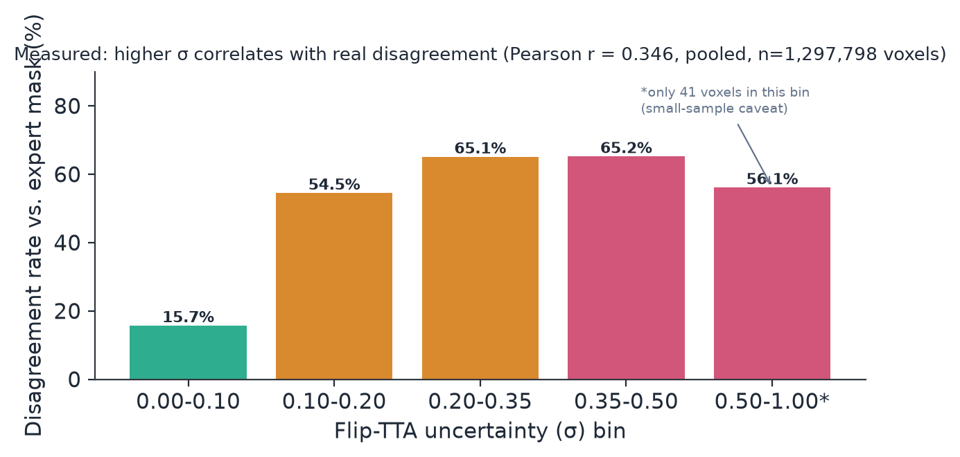
Figure 7.4 — Measured calibration check: higher flip-TTA σ correlates with real disagreement (pooled Pearson r = 0.346).
This is read honestly, not oversold: 0.346 is a real, positive, moderate correlation — informative enough to justify showing the signal to a user with an explicit caveat, not strong enough to claim a calibrated confidence probability. Published findings on MC-dropout-style uncertainty in medical segmentation report similarly modest correlations (global r ≈ 0.30–0.38), so this result is consistent with, not an outlier against, the wider literature.

8. User Interface and Experience
The interface follows one rule drawn from the research in Section 2.4: every screen should make it obvious what the tool is confident about and what it isn't, and never present a result without the means to audit it. Visual language is a dark clinical-workstation theme (deliberately not a consumer-app aesthetic, to read as a professional research tool), with region colours fixed project-wide — WT teal, TC amber, ET rose — so a colour always means the same thing across every workspace.
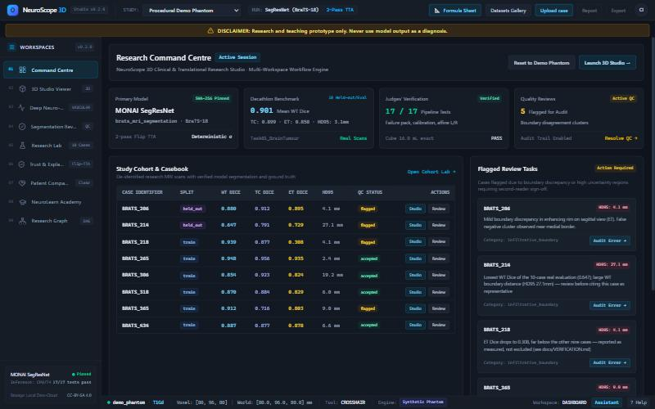
Figure 8.1 — Command Centre: session overview, cohort benchmark table, and flagged-for-review queue, all reading from committed real data.
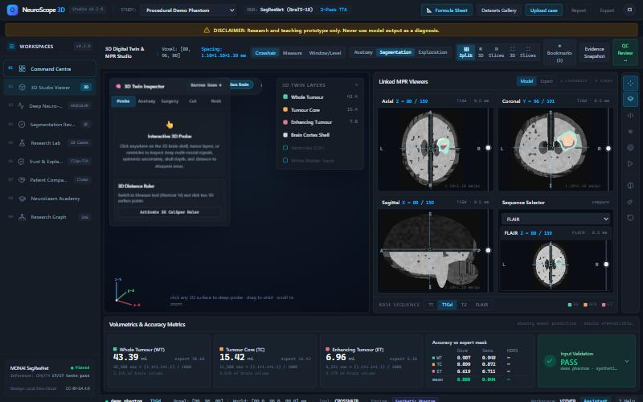
Figure 8.2 — 3D Studio Viewer: the digital twin, linked MPR grid, and live volumetrics/accuracy panel for the active study.

8.1 Design constraints
- One continuous, scroll-free workspace per screen rather than a multi-page application — matches how a radiology workstation is actually used in one sitting.
- Every metric that appears carries a hover-explanation of its own formula or definition — teaching by exposure, not a separate manual.
- A validation failure is never a silent blank screen — it names the file and the specific problem.

9. Compliance and Regulatory Considerations
This section is written for two audiences at once: what this prototype's current scope and wording commitments are, and what a real clinical deployment of the same underlying technology would have to clear. The two are kept explicitly separate throughout.

9.1 Current scope — what this prototype is, today
- Research and teaching tool only. Not submitted for, and not claiming, any regulatory clearance.
- Wording is fixed project-wide: “suspected tumour region predicted by the model,” “estimated volume” — never “detected,” “diagnostic,” or “replaces the radiologist.”
- No diagnosis, grading, genetic prediction, prognosis, treatment advice, or surgical/radiotherapy planning claim anywhere in the product, even hedged.
- 100% local processing — no scan, mask, or derived data is sent to any third-party service; uploaded source files are deleted immediately once a result exists.

9.2 The regulatory path a clinical product would face
If this technology were ever developed toward real clinical use, it would almost certainly be regulated as Software as a Medical Device (SaMD). The closest real precedent is Brainlab's “Elements AI Tumor Segmentation,” cleared by the U.S. FDA under 510(k) K243633 — evidence that an AI brain-tumour segmentation tool is a clearable device category, not a novel regulatory question.
Jurisdiction | Likely pathway | What the public research indicates
United States (FDA) | 510(k), Class II | ~97% of cleared AI/ML medical devices use 510(k) rather than De Novo or PMA; one source reports a median review time around 142 days; government user-fee alone is roughly US$26,000 (standard) / US$6,500 (small business), with total regulatory preparation commonly cited in the US$50,000–300,000 range by industry consultancies — these are secondary-source estimates, not FDA's own published figures, and should be re-verified against FDA's current fee schedule before being used for planning.
European Union | CE marking under the Medical Device Regulation (MDR), likely Class IIa/IIb as diagnostic-support software | Multiple cleared tumour-adjacent tools (Quantib ND, icobrain, mediaire's mdbrain) are CE-marked under this route, evidencing the pathway's precedent for this device category.
India (CDSCO) | Classified under the Medical Devices Rules 2017, Class A–D by risk | CDSCO issued final Medical Device Software guidance (document CDSCO/MD/GD/MDSW/01) covering AI/ML systems; software that only informs (never treats or diagnoses) in a non-serious context maps to the lowest risk class (A), while software driving diagnosis or treatment in a serious/critical context maps to the highest (D). The guidance explicitly expects lifecycle controls for model bias, drift, and post-market performance for AI-enabled software.

9.3 Data protection, independent of medical-device status
Even a research tool handling de-identified scan data sits inside a data-protection framework. In India, the Digital Personal Data Protection Act 2023 governs patient-adjacent data with penalties reported up to ₹250 crore for serious violations; in the EU/US context, GDPR and HIPAA set the equivalent bar. This project's current architecture — fully local inference, immediate deletion of source uploads, no third-party data transfer — is structurally compatible with the strictest of these regimes by construction, since no patient data ever leaves the machine running it. That is a design property to preserve deliberately if the project ever moves toward a hosted or multi-user deployment, not something to assume carries over automatically.

9.4 What closing the regulatory gap would require
- A documented Quality Management System (ISO 13485-aligned) and a formal clinical validation study — this prototype's 10-case held-out evaluation is a research-scale sanity check, not a clinical validation sample (the Brainlab 510(k) comparator used 412 patients).
- Algorithm change control and post-market performance monitoring, now explicitly required by both the FDA's AI/ML guidance and CDSCO's 2026 software guidance.
- An intended-use statement narrow enough to match whatever evidence actually exists — the single most common reason AI imaging submissions stall is a claimed use broader than the validation data supports.

10. Economics and Business Perspective

10.1 Market context
Independent market-research firms disagree meaningfully on the exact size of the AI-in-medical-imaging market — a sign of how new and fast-moving this category still is — but converge on the same direction: rapid growth from a small base, driven by radiologist shortages and rising imaging volumes.
Source | 2025/26 estimate | Longer-term forecast | CAGR
Fortune Business Insights | US$1.88B (2025) | US$29.95B by 2034 | 36.9%
Meticulous Research | US$2.37B (2026) | US$22.8B by 2036 | 25.4%
Towards Healthcare | US$2.41B (2026) | US$35.46B by 2035 | 34.8%
Figures are industry-analyst estimates with materially different scope definitions and should be read as directional (rapid, double-digit growth from a small base), not as a single authoritative number — presented with the range deliberately rather than picking one figure to avoid a false sense of precision.

10.2 Where this project sits in that market
This prototype does not compete with FDA-cleared commercial platforms like Brainlab Elements or Quantib — those solve a different problem (regulated clinical workflow integration) at a different price point (enterprise licensing, typically bundled into six- or seven-figure imaging-suite contracts). The realistic near-term positioning is the gap those tools don't serve:
Segment | Why existing tools don't fit them | What this project offers
Teaching hospitals & residency programs | Commercial licensing cost is prohibitive for a training tool, not a clinical one | Free, local, zero per-seat cost; built-in teaching affordances (dataset gallery, explain-this-number tooltips)
Research labs (non-clinical) | Commercial tools are locked to clinical workflow, not research iteration | Open pipeline, CLI-scriptable, reproducible provenance for publication-grade reporting
Underfunded radiology departments (public hospitals, LMIC settings) | Enterprise pricing and cloud dependency are both barriers | Runs entirely on a local workstation; no recurring cloud inference cost

10.3 Cost structure, honestly stated
- Marginal cost per inference: effectively zero beyond local compute — no API calls, no cloud GPU billing, no per-case licensing.
- The real cost is one-time and upfront: a workstation capable of running the model (CPU is sufficient today, at ~70 s/case; a GPU would bring this toward true real-time).
- The cost this report does not hide: closing the regulatory gap (Section 9.4) to reach any real clinical revenue is a six-figure-and-multi-year undertaking, consistent across every jurisdiction reviewed — this is a research/education tool's economics today, not a cleared medical device's.

10.4 A realistic business model, if pursued beyond a prototype
- Phase A (now): free, open, research/teaching tool — the adoption and credibility-building phase, zero regulatory exposure.
- Phase B: institutional licensing to teaching hospitals and research labs for a hosted, multi-user version with the local-processing property preserved — revenue without a regulatory claim, since “teaching software” does not require device clearance.
- Phase C (long horizon, large resource commitment): a formally validated, SaMD-cleared clinical decision-support product — only pursued with a funded clinical validation study and the QMS infrastructure in Section 9.4, not before.

11. Future Roadmap: Closing the Current Gaps
Every gap below is stated against what is verified today, with the specific resource that is missing — not a vague “more work needed.”
Gap | What's missing today | Resource needed | Phase
Multi-model benchmarking | Only one architecture (SegResNet) is benchmarked — publicly-released BraTS-pretrained checkpoints barely exist outside this bundle | GPU compute (cloud instance or dedicated hardware) + the BraTS 2021 training split | Near-term
Larger, more recent training data | Checkpoint is trained on BraTS 2018 (285 cases); BraTS 2021+ is larger and more current | BraTS 2021 dataset access (registration + data-use agreement, already slow-moving) | Near-term
Clinical-grade validation sample | 10 held-out cases is a research-scale sanity check, not a clinical validation (comparable FDA submissions use 400+ patients) | Institutional data-sharing agreement + IRB-equivalent approval | Medium-term
GPU-timed production benchmark | Timing is measured CPU-only; the PS's 120 s budget assumes a dedicated T4 GPU | One GPU benchmarking session — the lowest-effort item on this list | Immediate
Real-world skull-strip/non-brain robustness | Validated only against a synthetic failure pack; never tested against an actual non-skull-stripped clinical volume | A small set of real, messy clinical-adjacent test scans | Near-term
Regulatory QMS + algorithm change control | None — intentionally out of scope for a prototype | ISO 13485 consulting + dedicated regulatory-affairs resourcing | Long-term (Phase C)
Atlas-relative localisation (“which lobe”) | Only left/right side is currently derivable; the PS's own opening question also asks “which lobe” | A bundled coarse brain atlas + one affine-only registration step — scoped, not started | Near-term, low-cost
Modality-ablation explainability | Named as a research technique in the literature but not yet shipped as an interactive feature here | Front-end toggle + a re-inference path with one channel zeroed — no new model | Near-term, low-cost

11.1 Sequencing
The two items both gated on data access — Phase 2 multi-model benchmarking and the BraTS 2021 upgrade — should start in parallel immediately, since account approval and data-use agreements are slow and should not become the last-minute blocker. GPU-timed benchmarking is the single highest-value, lowest-effort open item and should be done as soon as any GPU access exists, even informally. Regulatory QMS work is deliberately sequenced last: it is the most expensive, most time-consuming item, and premature investment there before the accuracy/data gaps close would be solving the wrong problem first.

12. Glossary
Term | Definition
Affine | A 4×4 matrix mapping voxel indices to physical (world) millimetre coordinates; defines a scan's orientation and spacing.
BraTS | Brain Tumor Segmentation challenge/benchmark, run annually since 2012; defines the standard WT/TC/ET region convention used throughout this project.
Dice similarity coefficient (DSC) | Overlap metric between a predicted and a ground-truth mask: 2×intersection ÷ (predicted + ground truth). 1.0 is perfect overlap.
DICOM | The standard file format medical scanners natively produce, organised into series identified by a SeriesInstanceUID.
ET (Enhancing Tumour) | The actively growing, contrast-enhancing component of the tumour — the smallest, hardest-to-segment BraTS region.
Flip-TTA | Flip-based Test-Time Augmentation: running inference once normally and once on a flipped copy of the scan, then comparing the two to estimate uncertainty.
HD95 | 95th-percentile Hausdorff distance — a boundary-distance accuracy metric, in millimetres, distinct from (and complementary to) Dice.
Inter-rater variability | The degree to which two human experts disagree with each other when independently labelling the same scan — the real-world ceiling any automated system is measured against.
MPR (Multi-Planar Reconstruction) | Viewing a 3D scan as linked 2D slices along the axial, coronal, and sagittal planes.
NIfTI | A standard neuroimaging file format (.nii/.nii.gz) carrying both the image data and its affine/orientation metadata.
RAS+ | A canonical anatomical orientation convention (Right-Anterior-Superior) used as the working coordinate system for all processing.
SaMD | Software as a Medical Device — regulatory term for standalone software performing a medical-device function, the category a clinical version of this tool would fall under.
SegResNet | The 3D convolutional neural network architecture used by this project's segmentation model — an encoder-decoder design.
Sensitivity (recall) | The fraction of the expert-marked tumour that the model's prediction actually captured.
Surface Nets | An isosurface-extraction algorithm (alternative to marching cubes) used here to build the 3D mesh from the volumetric label data.
TC (Tumour Core) | The solid tumour mass, excluding surrounding oedema — a BraTS region built from NCR + ET.
Voxel | A 3D pixel — the fundamental unit of a volumetric scan, with a physical size defined by the scan's spacing.
WT (Whole Tumour) | The full extent of abnormal signal including swelling — the broadest BraTS region, built from NCR + ED + ET.

13. References and Sources
Every factual claim in this report traces to one of: this project's own committed, reproducible verification scripts (docs/VERIFICATION.md, docs/MODEL_CARD.md in the project repository), or a published external source. External sources cited above:
- FDA 510(k) K243633 — Brainlab Elements AI Tumor Segmentation clearance filing (via Innolitics device database).
- FDA 510(k) K213737 — Quantib ND clearance filing (via Innolitics device database).
- nnU-Net for Brain Tumor Segmentation — arXiv:2011.00848 (BraTS-2020 winning Dice/HD95 figures).
- PLoS ONE (2016) — comparative study of SmartBrush vs. BraTumIA vs. four expert raters.
- PMC12909261 — retrospective study on AI-assisted early glioma-growth detection.
- GitHub niivue/niivue; GitHub OHIF/Viewers; GitHub Project-MONAI/MONAILabel — open-source viewer/inference tooling.
- JOSS paper — Brainchop (client-side browser segmentation).
- arXiv:2502.18973 — prostate-radiotherapy study on uncertainty and manual-edit rate.
- UCSF News (2026) — meningioma uncertainty-calibration study, 353 patients.
- CSIRO / Australian Health Review — clinician preference survey, AI as “second reader”.
- arXiv:2510.15541 — MC-dropout uncertainty correlation with true boundary error.
- Frontiers in Neuroinformatics (2020), Glen et al. — documented left-right flip errors in public neuroimaging datasets.
- CDSCO/MD/GD/MDSW/01 (2026) — India's final Medical Device Software guidance.
- Fortune Business Insights, Meticulous Research, Towards Healthcare — AI-in-medical-imaging market size estimates (2025/26).
Full citation URLs are preserved in this project's repository documentation (reports/, docs/VERIFICATION.md, docs/PROBLEM_AND_APPROACH.md) for direct verification.

