CASCADE ’26 · THEME 3 · PROBLEM 3: THE ATTENTION DIGITAL TWIN
Parallel
Your attention digital twin
Every ping forks your day. Parallel shows you both futures before you tap.
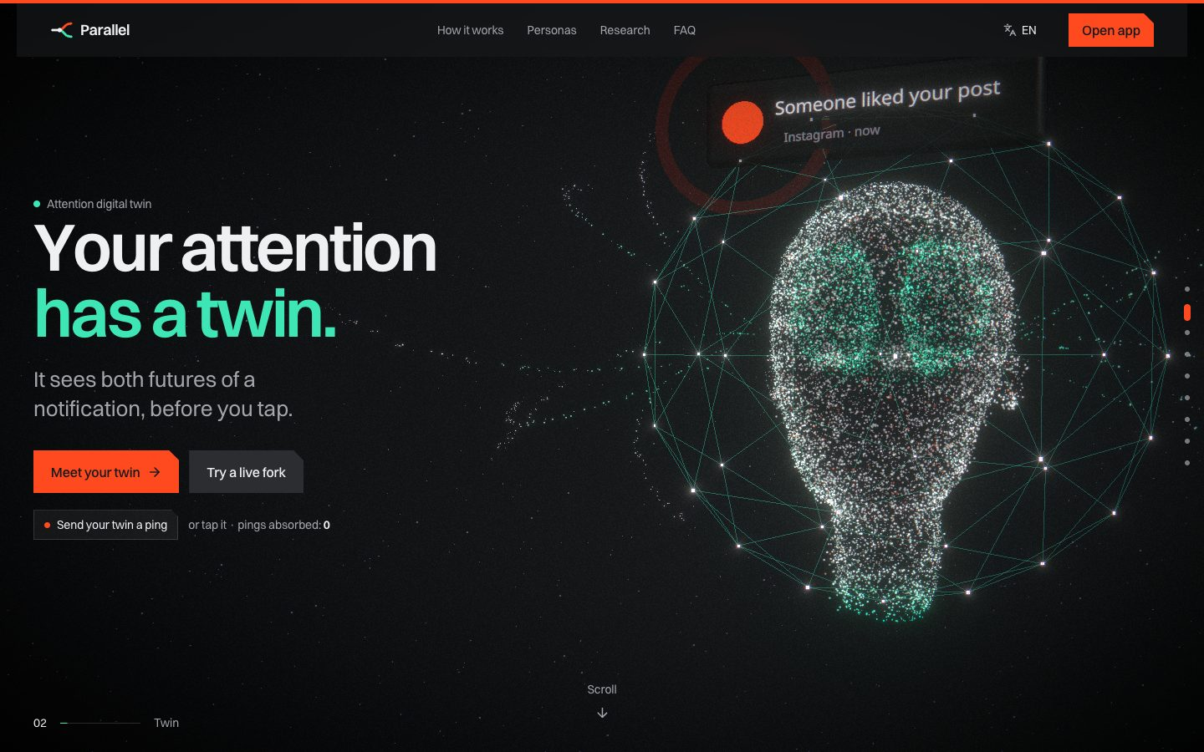

~27 min  focus lost to one “harmless” like, in the worked example | 0.845  AUC predicting opens on unseen users (prior: 0.728) | 2,000  simulated futures behind every decision | v0.4  working prototype: web, PWA, Android/iOS shells

1–4  Problem, users, gaps, approach | 5–7  Features, USP and moat, data | 8–15  Stack, architecture, flows, prototype | 16–18  Impact, business, research

Project document · Problem, solution, technology, impact and business · October 2026 · github.com/vizsh/Parallel

Contents
Parallel at a glance 2
1 The problem 3
2 Who faces it, and how 4
3 Existing solutions and their gaps 5
4 Our approach 6
5 Solutions and features 7
6 Our unique approach, moat and USP 9
7 Data: what we need and what we capture 10
8 Technology stack 11
9 Technical architecture 12
10 System flow: the life of one ping 13
11 Models and accuracy 14
12 User flow 15
13 Feature flows 16
14 Prototype gallery 17
15 Simulations: how it is used in real life 18
16 Impact, feasibility and viability 19
17 Business model (short) 20
18 Research and case studies 21

Parallel at a glance
The problem | Every notification has a hidden price in focus. People accept or ignore pings without knowing what they will cost, and apps are engineered to make tapping feel free.
Who has it | Students before exams, developers in flow, creators whose work tool is also their biggest distraction, professionals in meeting-heavy days.
What exists | Trackers look backward (RescueTime, Rize). Blockers apply the same rule to everyone (Freedom, Opal). Focus modes are manual. None predicts the cost of this ping for this person.
Our approach | A digital twin of your attention: it predicts the chain of events each ping will set off, simulates 2,000 futures, compares with holding it, decides (or asks), and learns from what really happened.
What it feels like | The cost shows on top of the notification. Swipe to triage, peek through two doors at comic futures, drop holds in a jar, get texts from future you. Comedy on top, honest numbers underneath.
Moat | Personal models that improve with every decision, a causal method (randomized holdouts), a manipulation X-ray users trust, and a playful design people share.
Status | v0.4 prototype: 13 app screens, 5 phone simulations, coach, shields, trained models. Next: Android notification listener and a closed beta.

One-line pitch. Parallel is the first app that tells you what a notification will cost you before you open it, and quietly holds the ones that are not worth it.

1 The problem
The problem is not screen time. It is that we accept or ignore interruptions without knowing what they will cost us. A glance becomes an app, the app becomes a feed, and the return to the task is slow and foggy. The cost is invisible at the moment of the tap, different for every person, and repeated dozens of times a day.
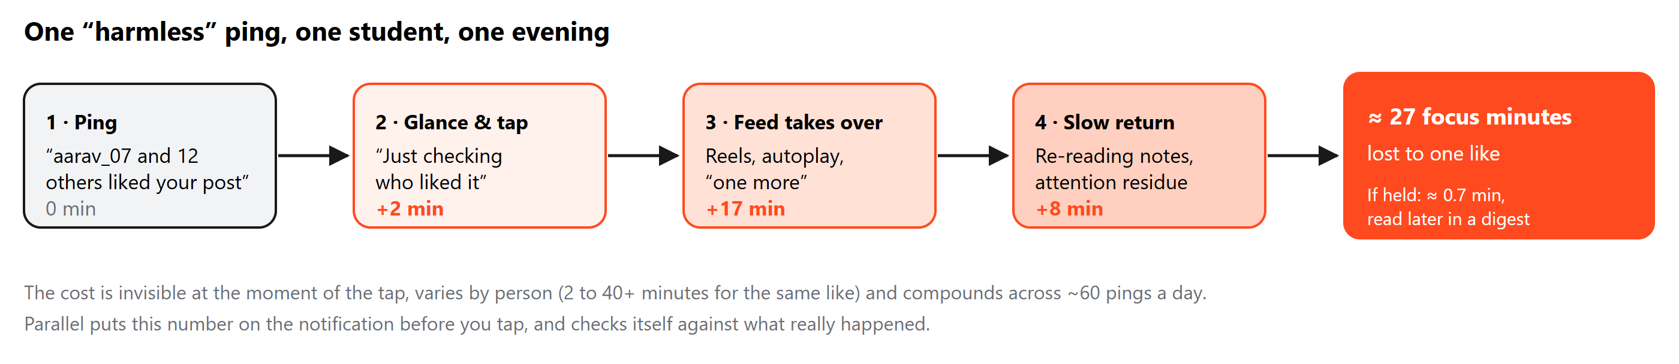

What the research says
63.5  notifications a day on average (Pielot et al., 2014) | ≈ 47 s  average time on one screen before switching (Gloria Mark) | Same as a call  a notification alone disrupts focus, even unanswered (Stothart et al., 2015) | ~25 min  before an interrupted task is resumed, with other tasks in between (Mark et al., 2005)

Why it is hard to solve
Challenge | Why it matters
Small cause, large effect | A two-second glance can trigger a 30-minute rabbit hole. Duration alone hides the damage.
Every ping looks the same | A teammate, a bank alert and a like land in the same tray with the same sound.
Everyone is different | The same like costs one person 2 minutes and another 40, depending on task, time, fatigue and habits.
Apps are designed to pull | Social proof, vague teasers, streaks and “we miss you” pings are tuned to maximise opens, not wellbeing.
Recovery is invisible | Time spent getting back into the task never shows up in screen-time reports, yet it is often the biggest part of the cost.
Turning everything off backfires | A randomized study found disabling notifications raised anxiety and FoMO; batching helped (Fitz et al., 2019).

How notifications are engineered to pull
Social proof  “aarav_07 and 12 others liked your post” turns a tap into a reward waiting for you. | Vague teasers  “You have new activity 👀” hides the content so you must open the app to find out. | Streaks & urgency  “Don’t lose your streak”, “ends tonight”: loss aversion and countdowns push a decision now. | Re-engagement  “We miss you” pings are sent because you were away, not because anything happened.

2 Who faces it, and how
Who | A real moment | What it costs | What they need
Students preparing for exams | 11:45 PM, DBMS notes open. “aarav_07 and 12 others liked your post.” One check becomes 40 reels. | ~27 min of revision; sleep pushed past 1 AM | Hold low-value pings during study blocks; protect exam week
Developers in flow | 41 minutes into a payments bug. YouTube: “I coded for 24 hours straight.” Slack: “review my PR?” | Lost mental stack; 15–25 min to rebuild context | Let urgent work through, batch the rest after the block
Creators | Editing a thumbnail. Instagram: “You have 9 new notifications 👀” – the feed is also the job. | An evening of half-finished edits | Tell real engagement from re-engagement bait
Professionals | Analysis due at 3 PM. Email newsletter, Teams chat, LinkedIn like, calendar reminder in 10 minutes. | Fragmented day, decisions made tired | Know what matters now; guard golden hours

Two short stories
Asha, 20, engineering student  Two days before her DBMS exam, the class group chat sends 14 messages in three minutes. She opens “just one” and loses the next hour to Goa plans and memes.  With Parallel the burst becomes one held thread, a draft reply says “studying till 7”, and she catches up in one go at 7 PM. | Rohan, 26, backend developer  Mid-debug, three pings land: a YouTube suggestion, his mother on WhatsApp, a PR review on Slack. Normally all three break his flow.  Parallel holds the video (algorithm bait), lets his mother through instantly (VIP), and moves the PR to his 12:30 digest. 99 minutes unbroken.

The common thread
- Nobody knows the price before paying it. The decision to tap happens in under a second, the cost arrives over the next half hour.
- Generic advice fails. “Turn off notifications” ignores that some pings matter, and that the right answer changes with task, hour and fatigue.
- Guilt does not work. Shame-based screen-time reports are ignored within a week; people need something they want to open.
- Late nights are the worst. Fatigue raises the chance of opening and the length of the rabbit hole, exactly when sleep is at stake.

Each kind of busy has its own pattern
Student  Peaks 10 AM and 9:30 PM · social likes and DMs dominate · tired from 4 PM | Developer  Peaks 11 AM and 11 PM · work chat, email, news · tired from 4:30 PM | Creator  Peaks 2 PM and 8 PM · social likes are also work · tired from 6 PM | Professional  Peaks 9:30 AM and 3 PM · work chat, email, meetings · tired from 3 PM

3 Existing solutions and their gaps
Tool | Does well | What it lacks
RescueTime, Rize | Track time, count context switches | Looks backward only; no prediction per notification
Freedom, Opal, ScreenZen | Block apps and sites by rule | Static rules, no learning, no “what if”; blocking raises FoMO
one sec | Adds friction before opening an app | Acts at app open, not at notification time; not personal
Forest | Motivation through gamification | No data model at all
Apple Focus, Android Digital Wellbeing | Focus modes, summaries, bedtime | Manual setup; no cost estimate; same rules for every ping
Clockwise, Reclaim | Protect calendar focus time | No device or notification signal

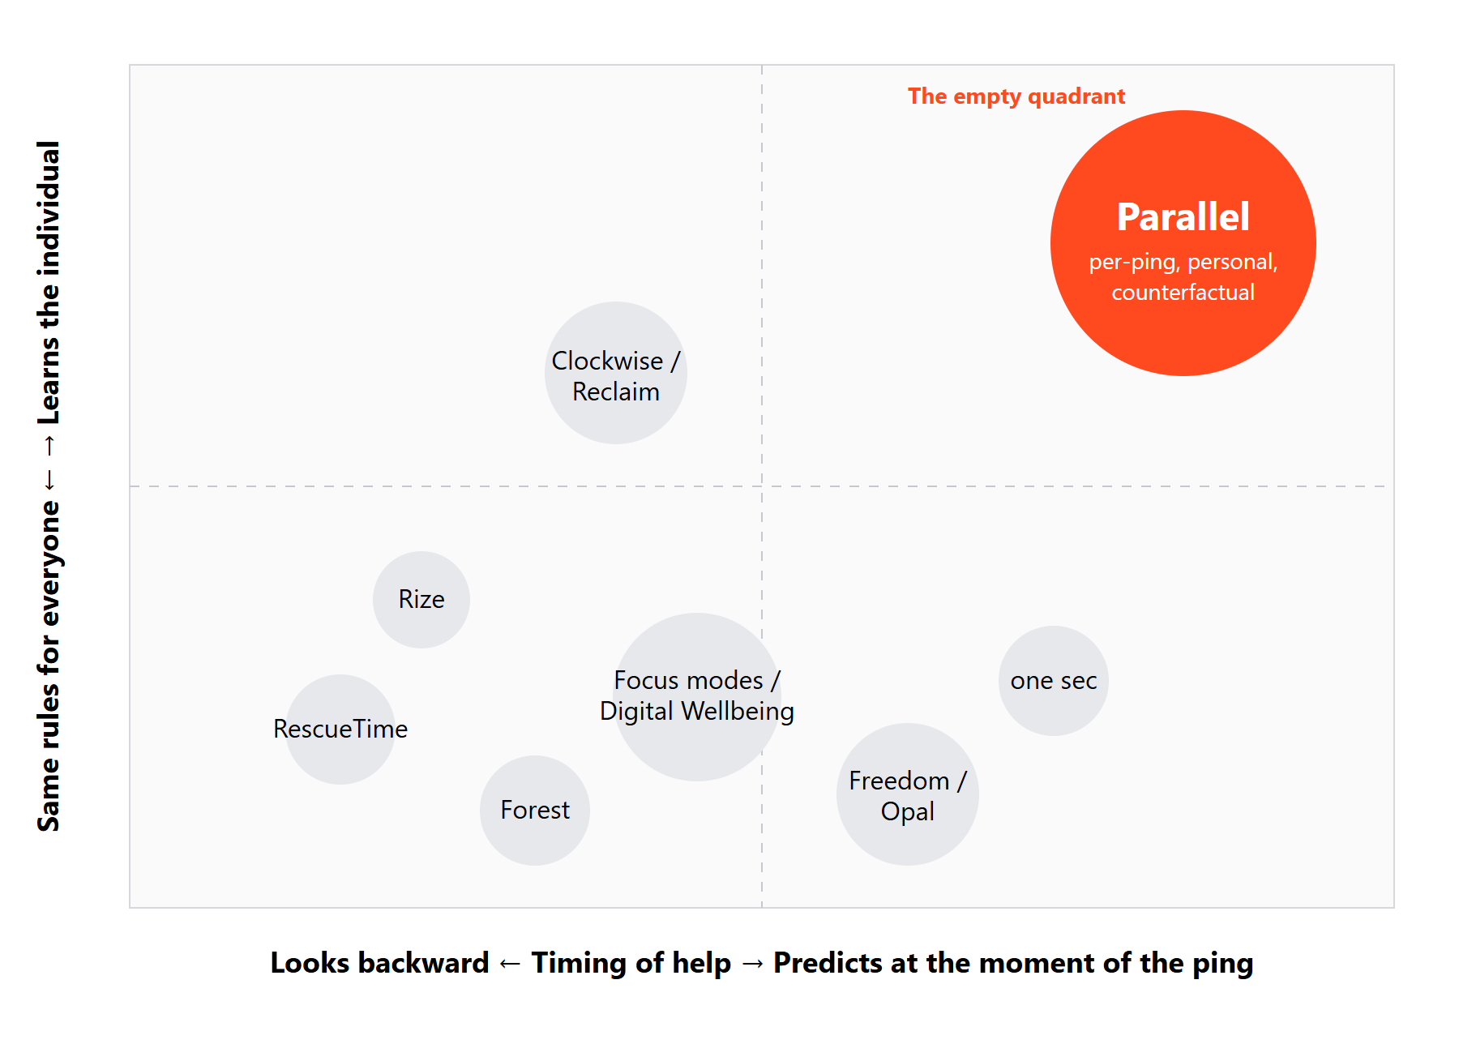  Positioning: nobody predicts per ping, per person. | The gap in one sentence  Nobody predicts the downstream chain one notification will cause for this person, shows the counterfactual, and then checks whether the prediction was right.  What is missing in all of them  - A cost per ping with a range and confidence  - A causal estimate of holding vs allowing  - Learning from the individual over time  - Defence against engagement tricks  - A delightful reason to come back

Side-by-side
Capability | Parallel | Trackers | Blockers | one sec | Focus modes
Cost per notification | ✓ | – | – | – | –
Learns the individual | ✓ | ~ | – | – | –
Counterfactual / self-check | ✓ | – | – | – | –
Names manipulation tactics | ✓ | – | – | – | –
Batching without FoMO | ✓ | – | ~ | – | ~
Fun, shareable experience | ✓ | – | ~ | ~ | –
Works on top of notifications | ✓ | – | ~ | – | ~

4 Our approach
Parallel is a digital twin of your attention. For every notification it predicts what tapping will set off for you, simulates 2,000 possible futures, compares them with holding it, recommends allow, hold or digest (or asks when unsure), and then checks itself against what really happened.

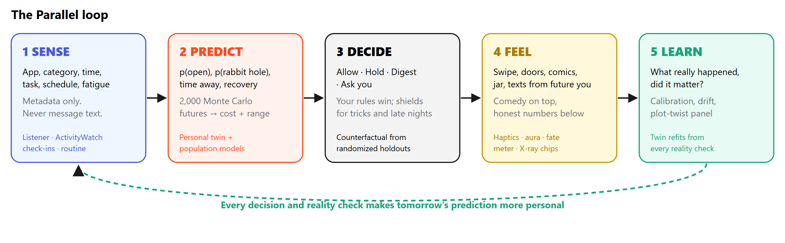

Design principles
Numbers are real, stories are comedy. Every comic and text is built from the model and says “an estimate, not a prophecy”. | Triage, not blocking. Hold and batch; never silently drop. Batching beats switching off. | Your rules win. VIPs always pass. Opening on purpose is a valid choice and earns points too.
Honest about uncertainty. Ranges everywhere, abstention when evidence is thin, accuracy shown. | Metadata only. Message text is never stored; the X-ray reads wording in memory only. | No shame mechanics. Streaks forgive, XP can’t be farmed, the joke is on the app, not you.

Three layers, one product
Layer | What it does | Where
The model | Learns when you focus best, what pulls you away, which apps fragment you, when you are tired and which pings matter. | backend/app/twin.py, ml/
The decision | Allow, hold until a checkpoint, digest, or ask. Shields catch manipulative pings and late-night pulls. | /api/simulations, Smart inbox
The feeling | Makes the number felt: swipe, doors, comics, jar, aura, texts from future you, haptics. | frontend/src/components

What we deliberately do not do
No blanket blocking. Hard blocks create FoMO and get uninstalled. | No reading your messages. Decisions use metadata; text is never stored. | No shame. No red “screen time up 40%” reports; the joke is on the app.

One decision, end to end
In: Instagram like · 11:45 PM · 23 min into deep study · fatigue 35% · exam in 2 days | Model: 74% chance of a rabbit hole · ~18 min expected (4–31) · holding costs 0.7 min | Out: “−18 min if you tap · hold until 1:00 PM” with Peek / Hold / Open on the notification

5 Solutions and features
Area | Feature | How it works
Predict | Cost per ping | Chance you open it × chance it becomes a rabbit hole × time away + recovery, simulated 2,000 times → expected minutes with a p10–p90 range.
 | Counterfactual | Cost if held, learned from randomized holdouts so the comparison is fair.
 | Confidence + ask | Grows with similar past moments (35% → 95%); below 50% the twin asks you instead of deciding.
Decide | Smart inbox | Allow / hold / digest per ping with the reason (“You’re in Lectures until 1 PM”). Accept all twin calls in one tap.
 | Shields | Manipulation X-ray names 7 tactics; re-engagement shield digests “we miss you”; late-night guard holds non-VIPs after bedtime.
 | Routine-aware | Classes, work blocks and deadlines make the twin stricter; check moments are when blocks end.
Feel | Swipe triage | Right allow, left hold, up digest, down “noise”. A different haptic for each.
 | Door to the Future | Two doors per ping open onto 4-panel comics drawn from your numbers: The Scrollfather or Main Character. Peephole, share poster.
 | Jar, receipt, cards | Held pings drop into a jar you pour later; clearing the inbox prints a receipt; each choice earns a holo card.
 | Aura & fate | Holding the line earns aura, a confirmed doomscroll costs it; a needle shows today’s arc.
 | Texts from future you | “bro. it’s 1 AM 💀” arrives when the twin predicted the ping would have ended.
Learn | Reality check | Tell the twin what really happened; it grades itself, shows a plot-twist panel if wrong, and refits.
 | Coach | 25 question types, memory, follow-up chips; grounded in your numbers; optional Claude; voice in 4 languages.
 | Insights | Fingerprint heatmap, replay, twin brain, accuracy, time machine, doppelgänger, simulations.

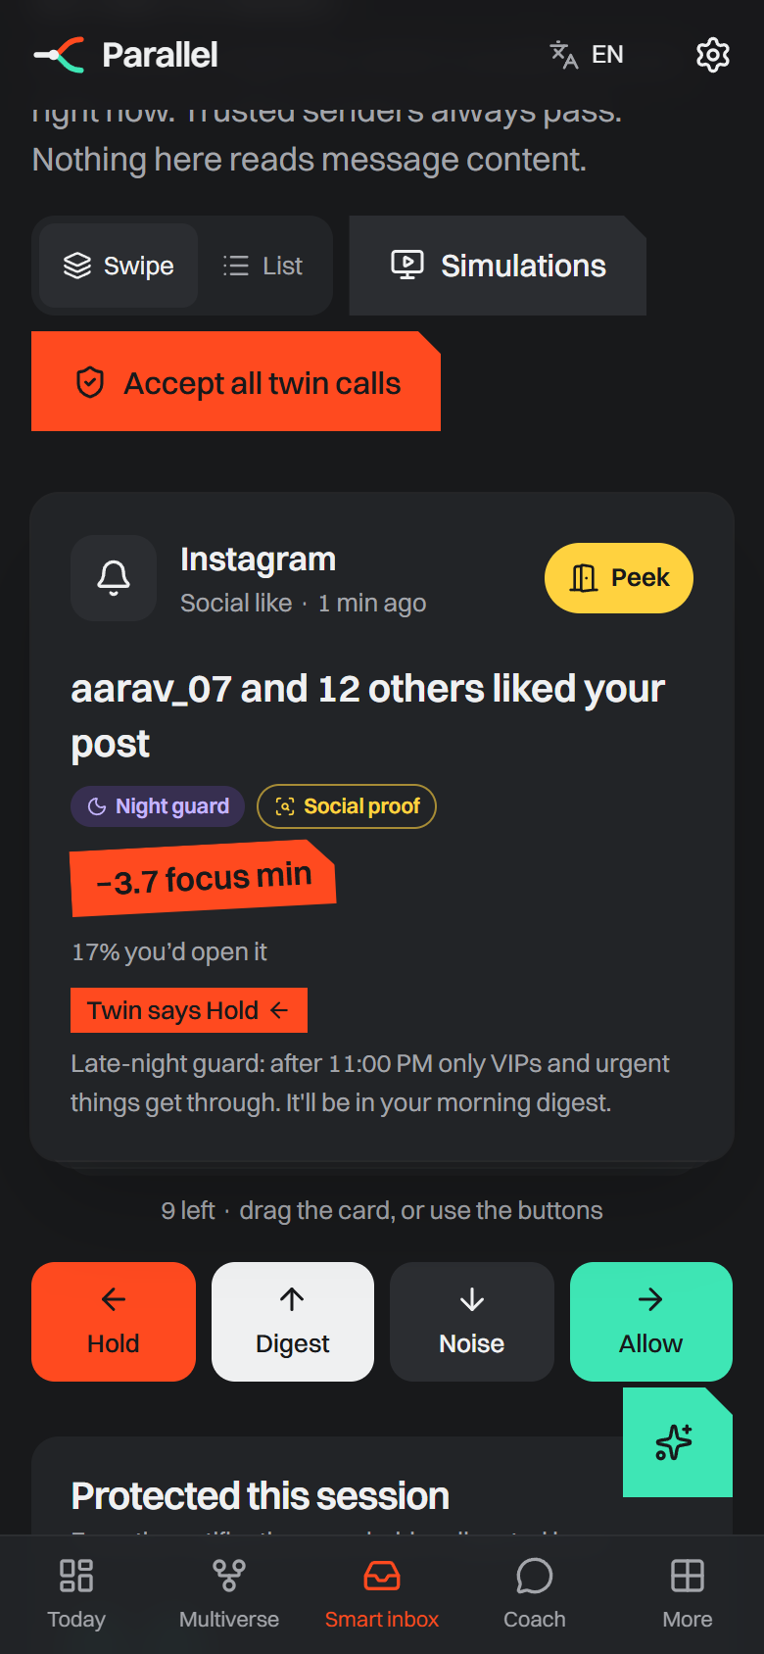  Swipe triage with X-ray chips | 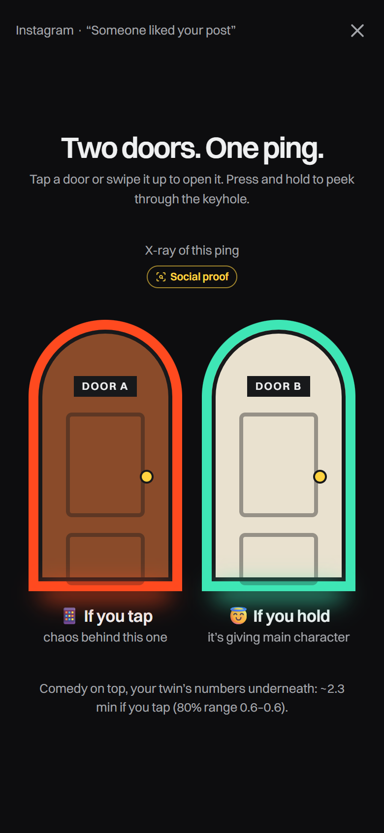  Two doors, one ping | 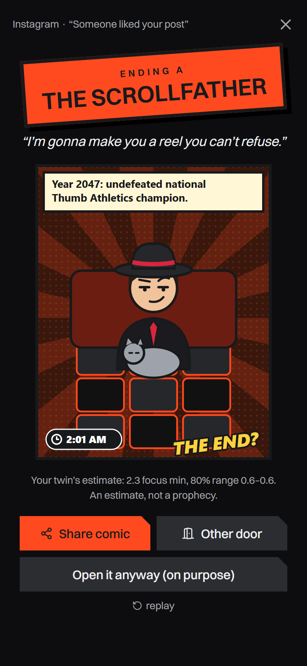  Ending A: The Scrollfather | 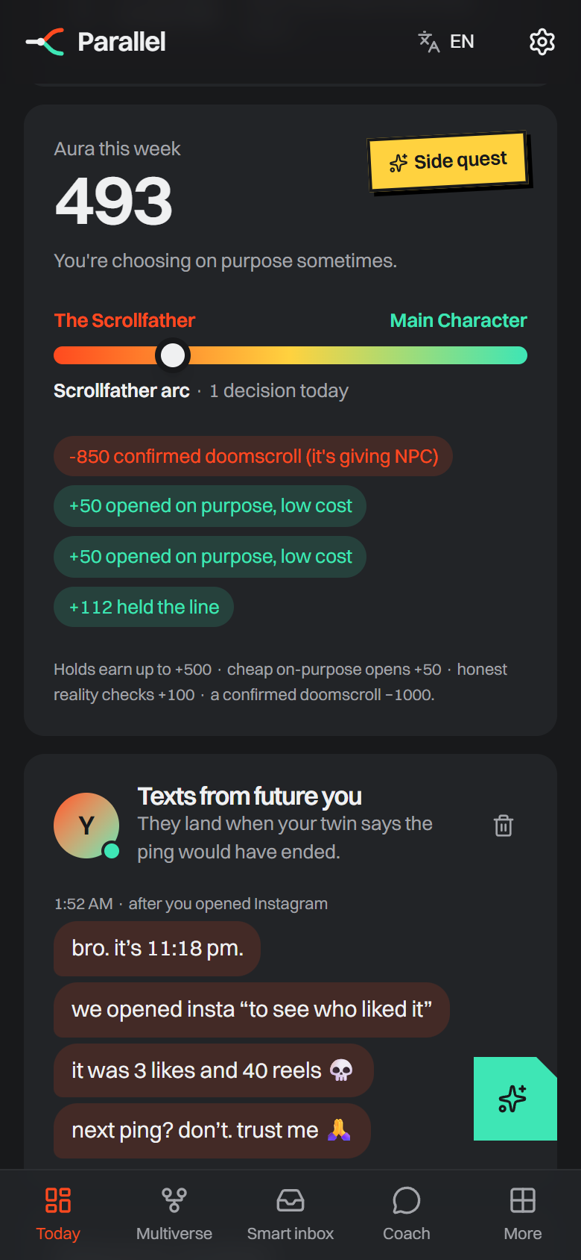  Aura, fate meter, future texts

Feature highlights in the prototype
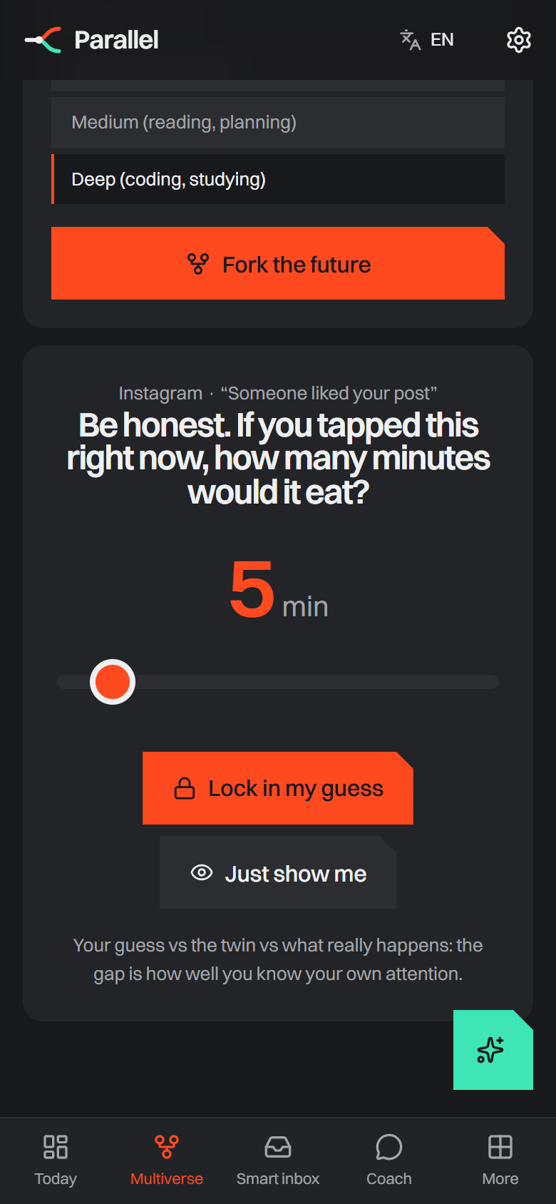  Guess before the reveal | 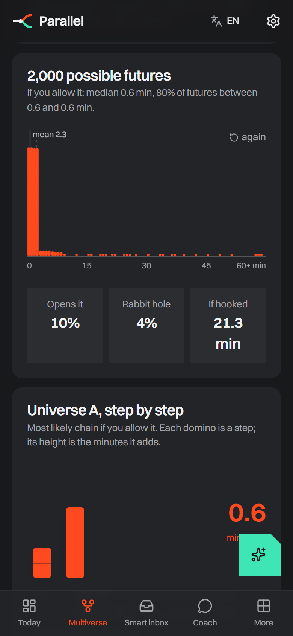  2,000 futures fall into a histogram | 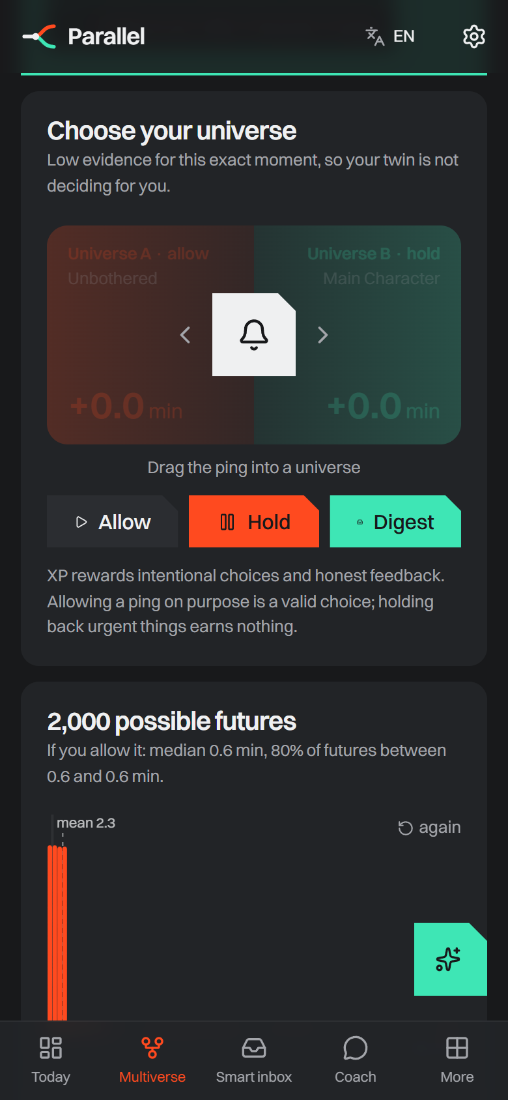  Drag to fork the future | 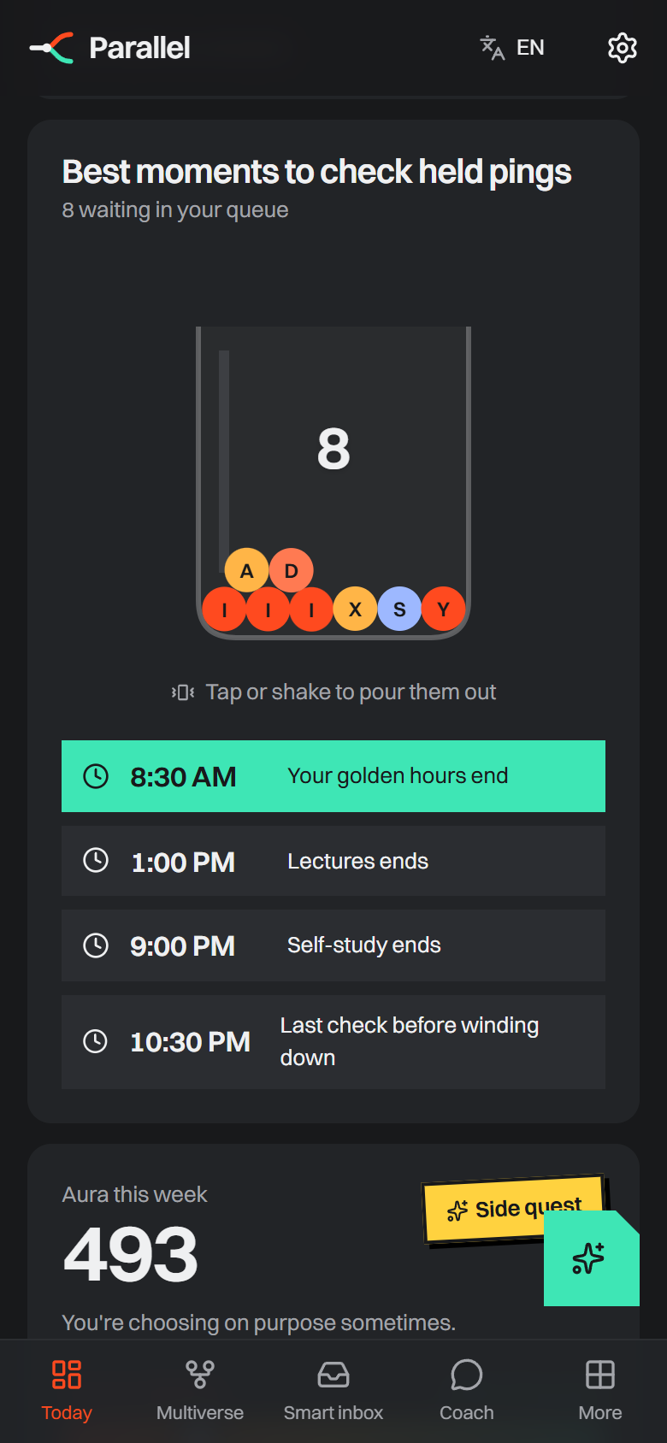  The held-pings jar

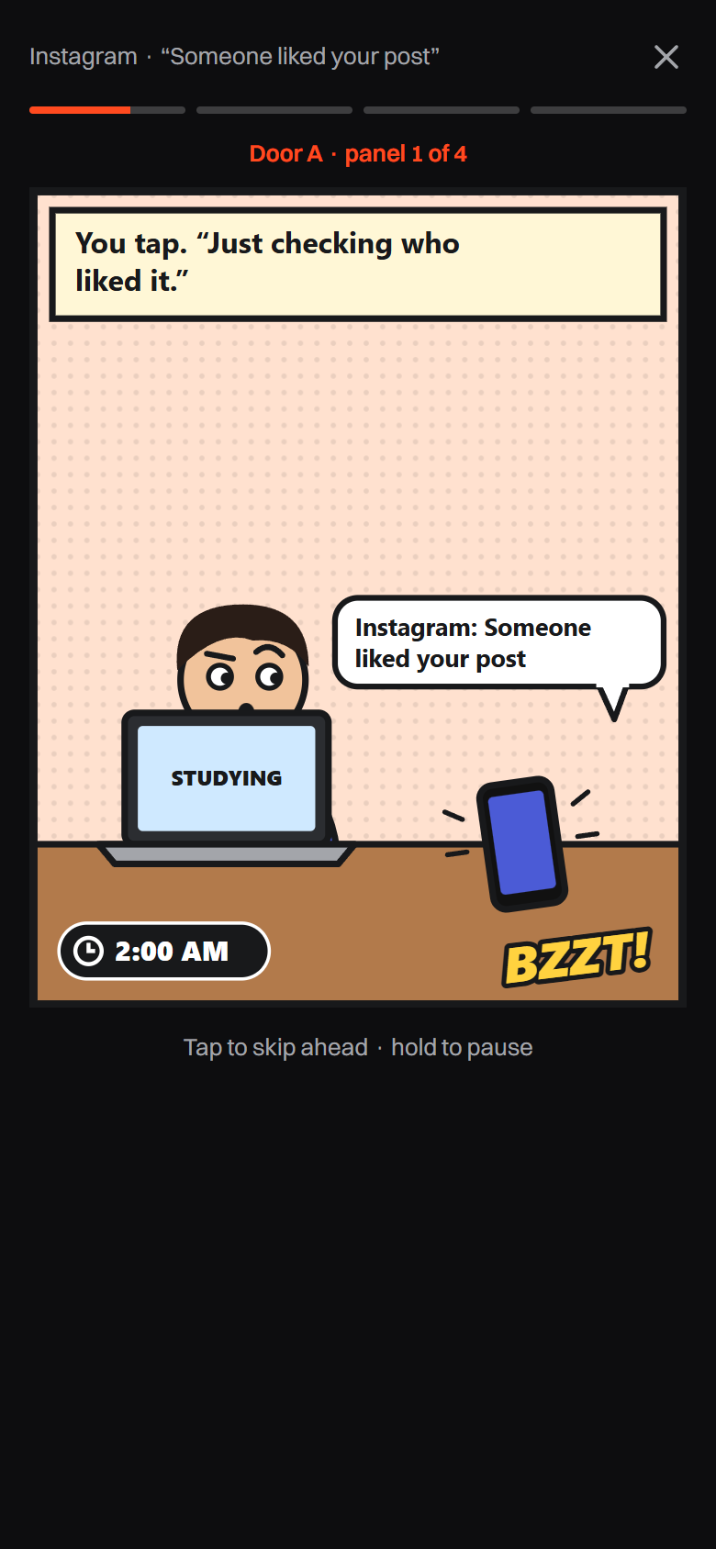  Comic panel 1: BZZT! | 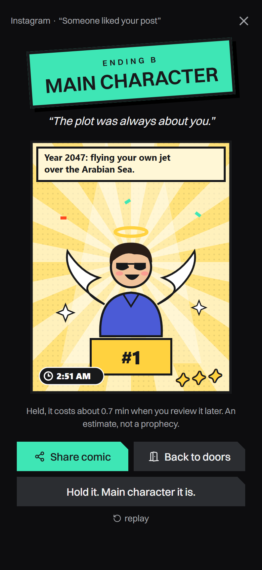  Ending B: Main Character | 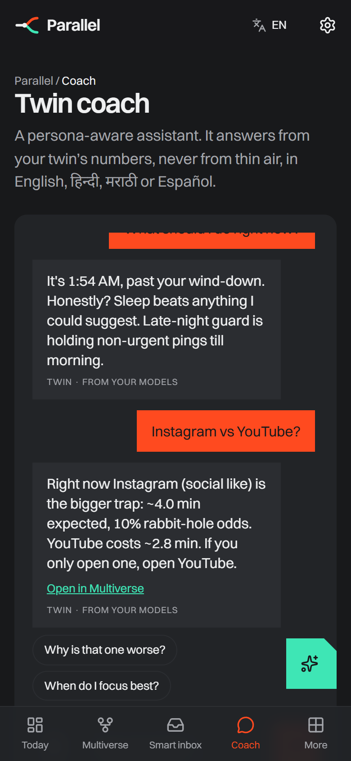  Coach with follow-up chips | 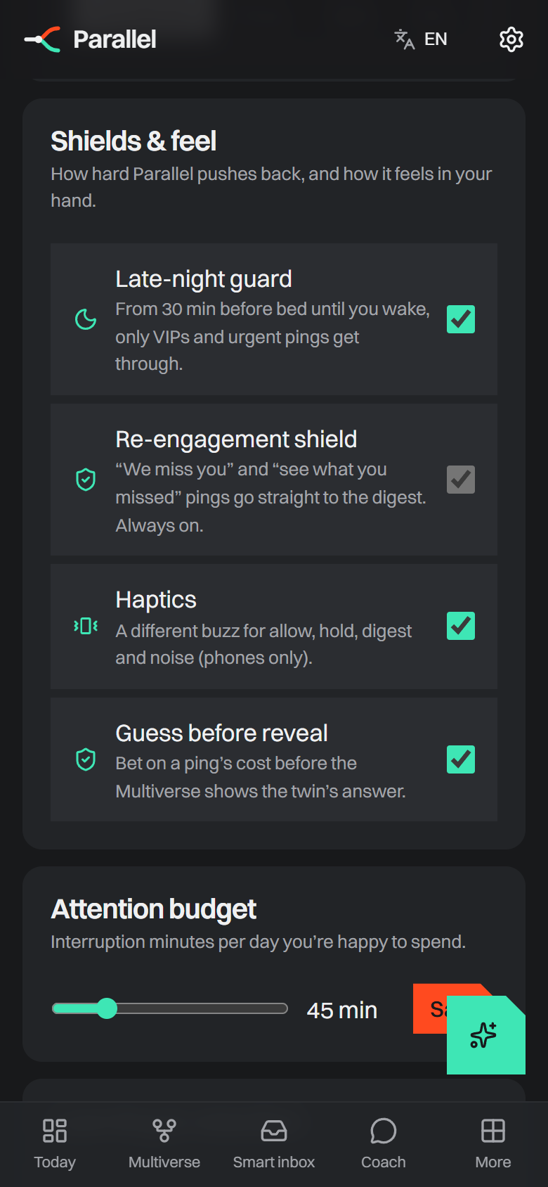  Shields & feel

What makes each interaction work
Interaction | Psychology behind it
Cost on the notification | Makes an invisible, delayed cost visible at the moment of choice (boosting, not nudging).
Door to the Future + texts from future you | Episodic future thinking reduces present bias; seeing your future self increases long-term choices.
Jar + checkpoints | Turns unpredictable rewards into predictable batches; batching improves attention without FoMO.
Swipe, haptics, aura | Fast, satisfying, reversible choices; rewards intention instead of abstinence.

6 Our unique approach, moat and USP

USP: what only Parallel does
Price before the tap  A focus-minute cost with a range on every notification, personal to you, at the moment you decide. | Counterfactual, not correlation  Randomized holdouts and a T-learner estimate what holding really saves, and the twin grades itself. | Manipulation X-ray  Names the engagement trick inside a ping (social proof, teaser, re-engagement) and shields you from it.
Comedy on top of honesty  Doors, comics, aura and texts from future you make the numbers felt and shareable, never shaming. | Triage, not blocking  Nothing is dropped. VIPs pass, the rest returns in calm batches at moments that fit your schedule. | Ask, don’t guess  When evidence is thin the twin abstains and asks, then learns from your answer.

USP in one line: Parallel prices every notification in focus minutes before you tap, personal to you, and proves it was right.

Moat: why it gets harder to copy over time
Moat | Why it compounds
Personal data flywheel | Every decision, “did this matter?” tap and reality check makes the twin more accurate for that person; a new app starts from zero.
Causal method | Exploration holdouts create unbiased training data that pure trackers and blockers never collect.
Trust by design | Metadata only, on-device decisions, export/delete, audit log: a privacy posture that is hard to retrofit.
Brand and shareability | Comic posters, receipts and archetype cards turn private habits into shareable culture (the Duolingo/Wrapped effect).
Characters and stories | The Scrollfather, Main Character and the comic universe give the product a recognisable voice competitors cannot simply copy.
Platform | The Attention API lets other apps ask “should I interrupt now?”, turning Parallel into infrastructure.

Why now
Regulators are moving. FTC dark-patterns report, EU DSA Article 25, New York SAFE for Kids and California SB 976 all target manipulative design and late-night pings. | Platforms opened the door. Android lets users grant notification access; iOS offers Focus filters and Screen Time APIs; on-device ML is cheap. | A generation that knows. Gen Z talks openly about doomscrolling and wants tools that are fun, not preachy.

7 Data: what we need and what we capture
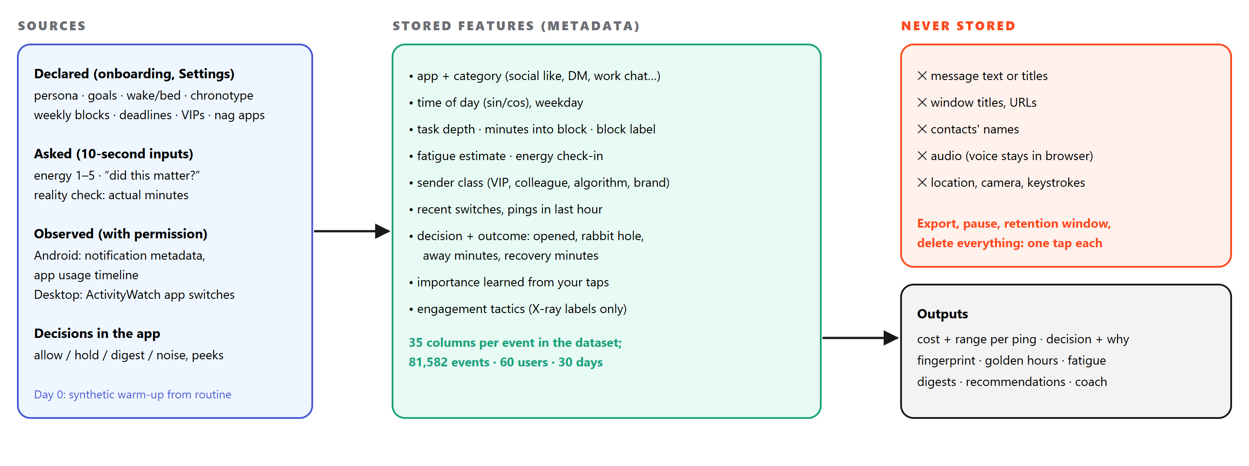
Input | How it is captured | Used for
Persona, goals, routine, schedule, deadlines | 7-step onboarding; editable in Settings | Cold-start prior, focus curve, block-aware holds, strict mode
Notification metadata (app, category, time, sender class) | Android NotificationListener (planned); sample queue today | Every prediction and decision
App switches and dwell time | Android UsageStats; ActivityWatch on desktop | Rabbit-hole and recovery models, fingerprint
Energy 1–5 | 10-second battery check-in | Overrides the fatigue estimate for 3 hours (60% weight)
“Did this matter?” | One tap per ping | Learned importance (Bayesian update, prior = 6 taps)
Actual minutes | Reality check after a decision | Grades the twin; new training row; plot-twist panel
Decisions | Swipe / buttons / doors | XP, aura, fate meter, future texts

Privacy rule: the app never stores message text, titles, URLs or contacts. The Manipulation X-ray reads wording in memory at decision time and keeps only the tactic labels. Export, pause learning, retention window and delete are one tap each.

What one stored event looks like
Field | Example | Field | Example
category · app | social_like · Instagram | decision | hold (until 1:00 PM)
hour · weekday | 23.75 · Thursday | opened · rabbit hole | false · false
task depth · minutes in | 1.0 (deep) · 23 | away · recovery (min) | 0 · 0.7
fatigue · energy | 0.35 · 3/5 | mattered? | no (taught by a tap)
block · deadline | Self-study · DBMS in 2 days | tactics (X-ray) | social proof

8 Technology stack
Layer | Technology | Where it is used | Why this choice
UI framework | React 19 + TypeScript, Vite 6 | All 13 screens, landing, simulations | Fast iteration, one codebase for web, PWA and native
Styling & motion | Tailwind v4, motion (Framer Motion) | Swipe deck, doors, jar, dominoes, cards | Gesture physics and springs with reduced-motion fallbacks
3D & graphics | three.js, React Three Fiber, GLSL, Canvas, SVG | Hologram landing, raining futures, jar physics, comics | Memorable visuals; SVG comics export to PNG posters
Mobile | Capacitor 8 (Android, iOS), PWA | Haptics, local notifications, share, status bar | Native features without rewriting the app
i18n & voice | react-i18next, Web Speech API | English, हिन्दी, मराठी, Español; voice coach | Reach Indian students; voice stays in the browser
API | FastAPI (Python), Pydantic, JWT | Twin, shields, routine, coach, platform routes | Same language as the ML; typed, fast, auto-docs
ML | scikit-learn, NumPy, pandas, joblib | Personal twin, population models, Monte Carlo | Small, explainable, calibratable models that train in seconds
Storage | SQLite (→ PostgreSQL) | Users, history, predictions, audit chain, dataset | Zero-ops for the prototype; same schema scales to Postgres
LLM (optional) | Claude via Anthropic SDK | Coach replies from a grounded facts sheet | Natural replies in 4 languages without inventing numbers
Desktop data | ActivityWatch | Laptop app switches → live segments | Open source, local-first, privacy friendly
Quality | pytest, tsc, ESLint, headless Chrome | API tests, type checks, recorded simulations | Repeatable checks and demo videos

13  app screens + landing + public simulations | 90+  REST endpoints with Swagger docs | 5  recorded phone simulations | 4  languages in UI, voice and coach

Alternatives we considered
Choice | Instead of | Because
React + Capacitor | Flutter, native Kotlin/Swift | One codebase for web, PWA and both phones; the 3D landing and SVG comics reuse web tech
FastAPI (Python) | Node/Express | The models, simulation and API live in one language; typed request models and free Swagger docs
Gradient boosting + logistic models | Deep learning | Small tabular data, needs calibration and explanations, trains in seconds, runs on device
SQLite → PostgreSQL | A NoSQL store | Relational history, simple joins for evaluation; zero setup for the prototype
Rule engine + optional LLM | LLM-only chatbot | Never invents numbers; works offline and free; Claude only rephrases grounded facts

9 Technical architecture
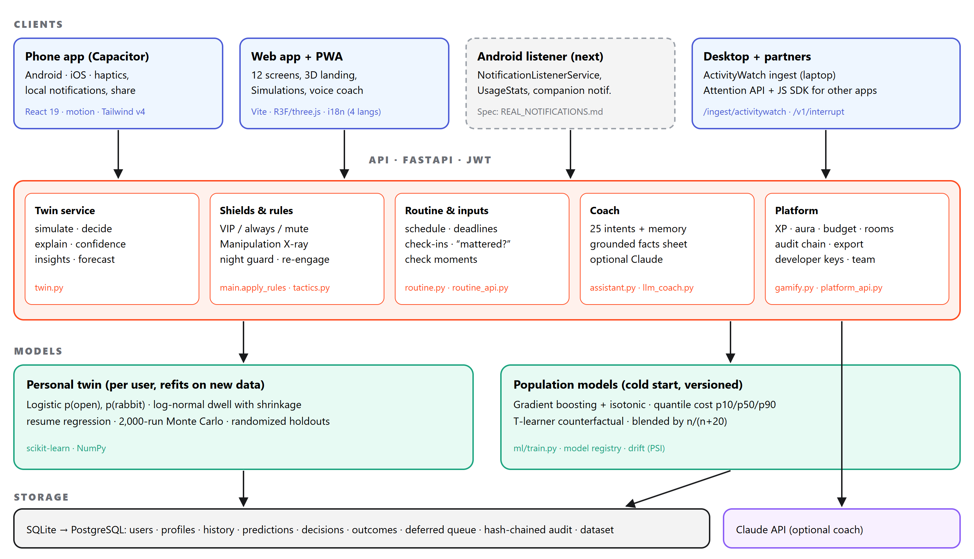
Layer | Responsibility
Clients | React app shipped as web, PWA and Capacitor Android/iOS. The planned Android listener reads notification metadata, decides on device from a cached policy and shows a Peek / Hold / Open companion notification. Desktop data comes from ActivityWatch; other apps can ask the Attention API.
API | FastAPI routers: twin (simulate, decide, explain), shields and rules, routine and ongoing inputs, coach, platform (XP, budget, rooms, audit, developer keys). JWT auth; every prediction is logged and hash-chained.
Models | A personal twin per user that refits when new rows arrive, blended with versioned population models trained offline (ml/train.py) and monitored for drift (PSI).
Storage | SQLite for the prototype with per-user history tables; the same schema moves to PostgreSQL with Alembic migrations for production.

Deployment
Web / PWA on Vercel or Netlify (static build, `VITE_API_URL`). | API on Render, Railway or Fly.io (`uvicorn app.main:app`). | APK via Android Studio or a CI job; iOS via Xcode.

Security and privacy in the design
- PBKDF2 password hashing, JWT sessions, per-user data isolation, CORS limited to the app origin.
- Metadata-only schema; the X-ray reads wording in memory; export, pause learning, retention window and delete endpoints.
- Hash-chained audit log of every prediction; team views only show aggregates of five or more people.

10 System flow: the life of one ping
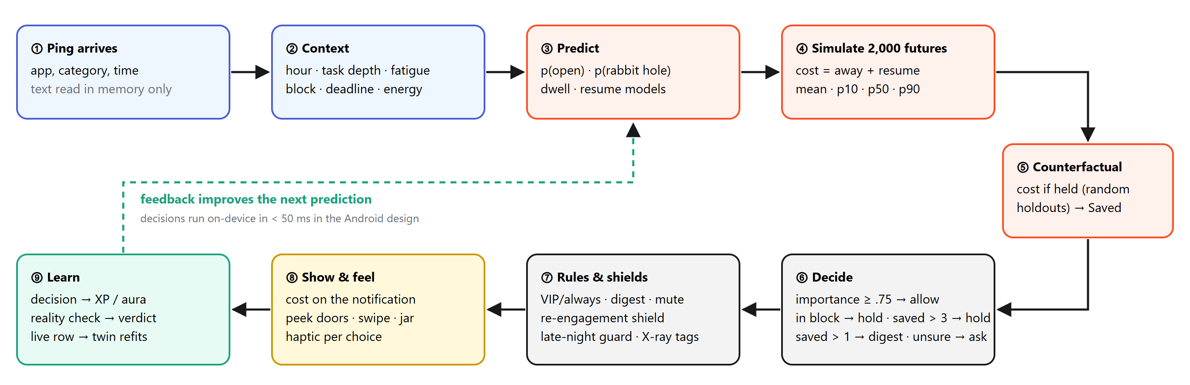

The core formulas (short)
Step | Formula
Open | p_open = σ(w · [sin/cos hour, depth, minutes-in, fatigue, importance, category])
Rabbit hole | p_rabbit = σ(v · x), trained only on opened pings
Time away | rabbit: e^N(μ_c, s_c) with μ_c = (8·ln prior + Σ ln a) / (8 + n); quick check: e^N(μ_q, s_q)
Recovery | resume = β0 + β1·away + β2·depth + β3·away·depth + ε
Futures | C_k = away_k + resume_k for k = 1…2000 → mean, p10, p50, p90
Saved | Saved = E[C_allow] − (mean randomized-holdout cost + 4·importance if importance > 0.5)
Confidence | min(0.95, 0.35 + 0.6·(1 − e^(−n_similar/25)))
Blend | w = n/(n+20); p = w·p_personal + (1 − w)·p_population
Importance | I = (6·prior + yes taps) / (6 + taps); × 0.6 for apps marked as nags
Aura | hold: clip(25 × minutes saved, 50, 500) · cheap open +50 · reality check +100 · doomscroll −1000

Rule order for every ping: VIP / always → allow · digest rule · mute rule · re-engagement shield → digest · late-night guard → hold · otherwise the twin’s decision (importance ≥ 0.75 → allow; in a block → hold; saved > 3 min, or > 1.5 in exam week → hold; saved > 1 → digest; else allow; unsure → ask).

Speed and scale
< 50 ms  per decision on device (cached policy, Android design) | ~1 min  to retrain the population models on 81,582 events | 600–2,000  Monte Carlo rollouts per question, seeded and repeatable | Per user  twin refits automatically when new live rows arrive

11 Models and accuracy
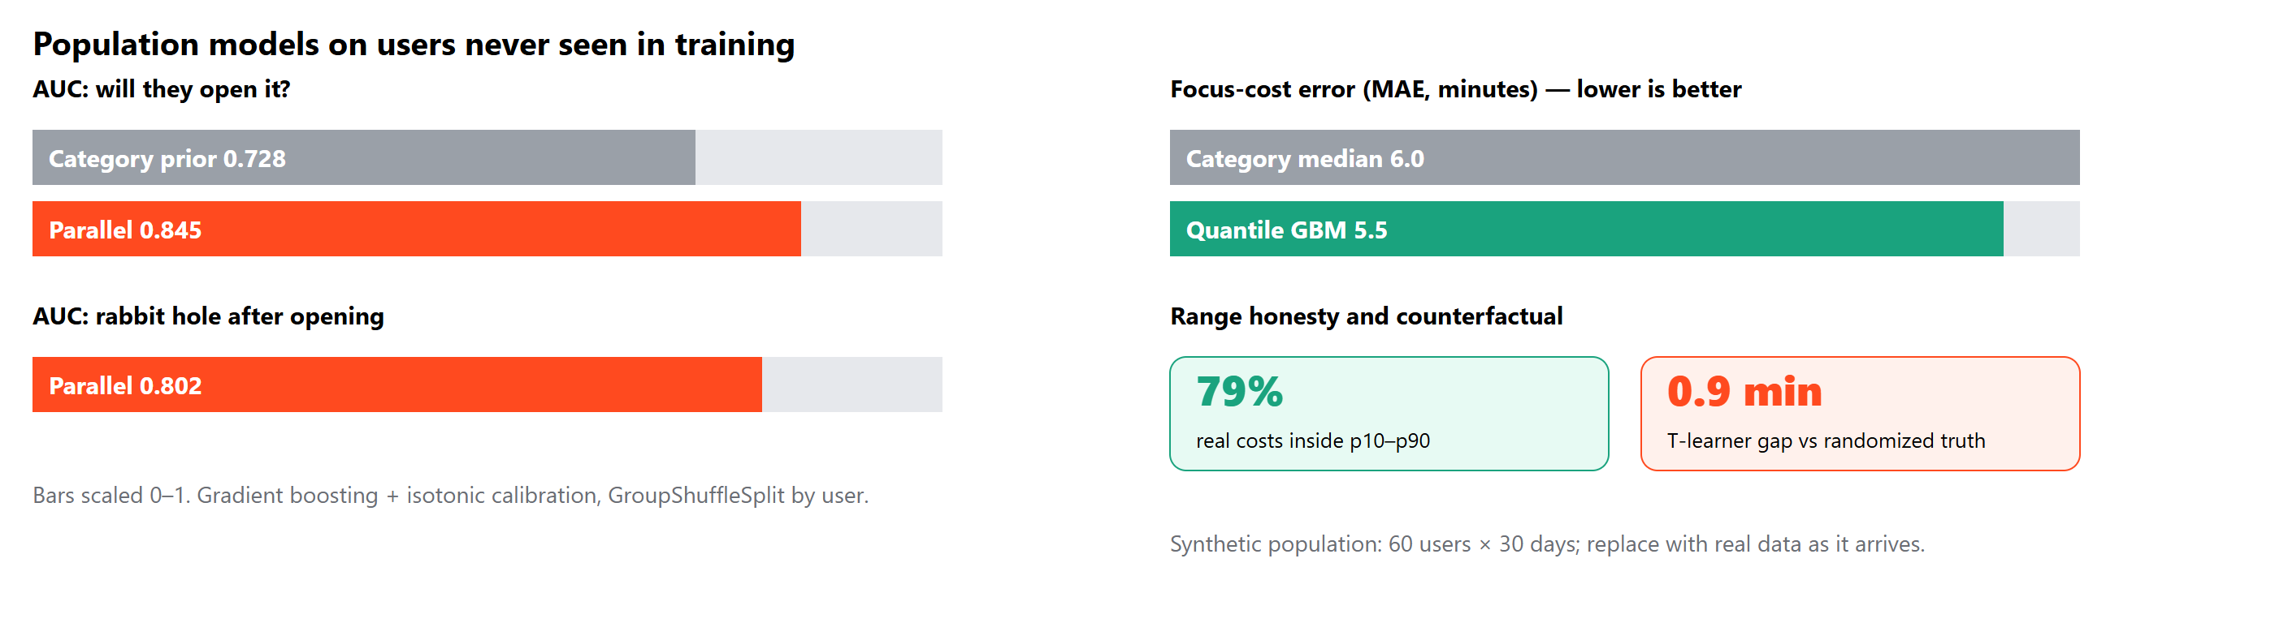
Target | Model | Unseen-user result | Baseline
Will they open it? | Gradient boosting + isotonic calibration | AUC 0.845 | 0.728 (category rate)
Rabbit hole after opening | Gradient boosting + isotonic calibration | AUC 0.802 | 0.747
Focus cost p10–p90 | Quantile gradient boosting | 79% coverage, MAE 5.5 min | MAE 6.0 min
Effect of holding | T-learner | 0.9 min gap vs randomized truth | —

Data and evaluation
Dataset. 60 synthetic users × 30 days, 81,582 notification events × 35 columns, 149,649 app sessions. Behaviour follows published effects (fatigue raises opens, deep work protects, late nights deepen rabbit holes). | Honest testing. Split by user (48 train, 12 test) so the models are judged on people they have never seen. Calibration bins, drift (PSI) and a hash-chained audit trail are visible in the app. | What drives opening. Permutation importance: recent app switches, sender importance, fatigue, pings in the last hour, task depth, minutes into the block.

Limits we state openly: accuracy numbers are on synthetic data; day-0 history is generated from the declared routine until real data arrives; fatigue is a behavioural estimate, never a medical claim.

How the twin gets better over time
Signal | Effect on the model
Each decision | Adds a row; similar-moment count rises, so confidence grows and the personal weight n/(n+20) increases
“Did this matter?” | Moves that category’s importance (prior worth 6 taps), changing which pings pass
Reality check | Grades the prediction, becomes a live training row, triggers the plot-twist panel when wrong
Real activity (ActivityWatch / listener) | Replaces the generated warm-up history; fingerprint and golden hours follow real behaviour

12 User flow
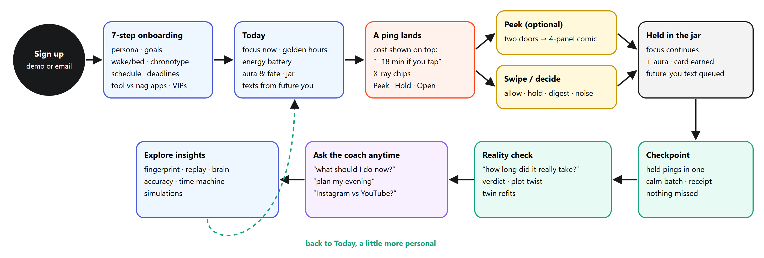
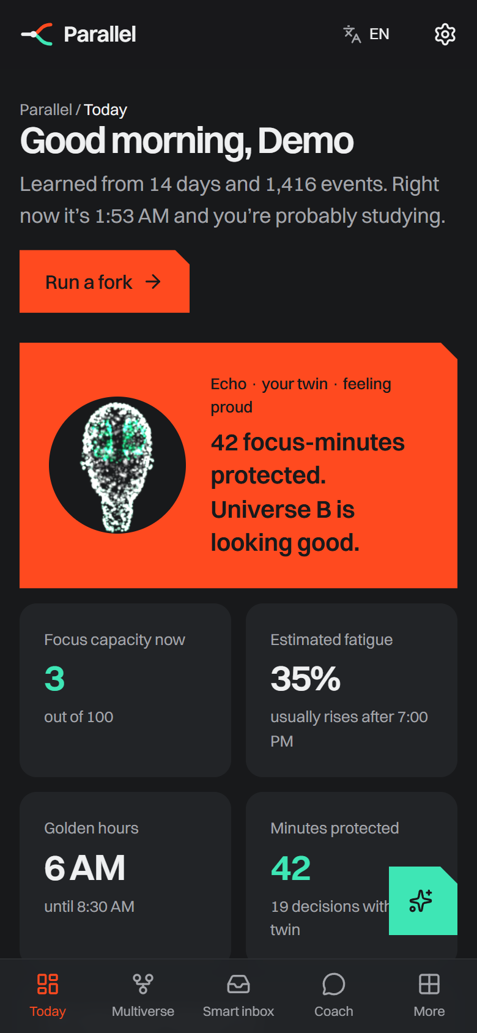  1 · Today: state of your attention | 2 · A ping, priced and tagged | 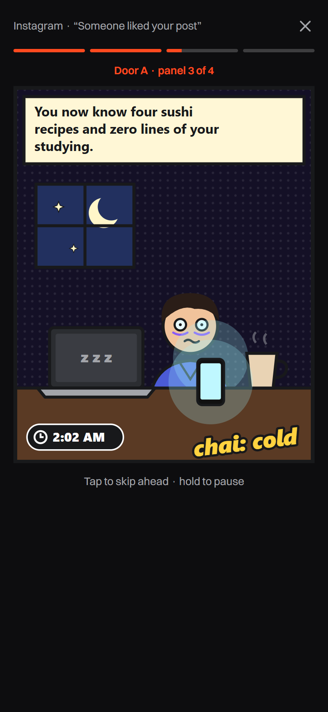  3 · Peek: what happens if you tap | 4 · Held until a check moment

First five minutes
Step | What the user does | What Parallel learns or shows
1 | Picks a persona and goals, sets wake/bed time and classes | A starting twin shaped to their kind of day
2 | Marks tool apps vs nag apps, picks VIPs | Who always gets through; which apps get stricter treatment
3 | Sees Today: focus now, golden hours, check moments | The first “aha”: their own attention pattern
4 | Swipes the first few pings | First decisions, first aura, first card

13 Feature flows
Feature | Trigger | Flow | Outcome
Swipe triage | Pings waiting in the inbox | Card shows cost, chance of opening, twin’s call, X-ray chips → swipe right/left/up/down | Decision logged, haptic, XP and aura, card leaves the deck
Door to the Future | Peek on a card or in the Multiverse | Two doors → hold to peek through the keyhole → open → 4 story panels → ending → share or choose | Decision from the ending; 1080×1920 poster
Shields | A ping with a tactic, or after bedtime | X-ray scans wording in memory → re-engagement → digest; late night → hold | Shielded / Night guard badge; morning digest
Jar & checkpoint | Hold or digest | Ball drops into the jar → check moment (end of block) → tap or shake to pour | One calm batch; receipt when the inbox is clear
Reality check | After deciding in the Multiverse | Enter real minutes → verdict → plot-twist panel if outside the range | New training row; twin refits; +XP / aura
Texts from future you | Any decision | Queued for now + predicted cost → typing indicator → arrives as chat (or local notification) | Future-self reminder that lands at the right moment
Coach | A question by text or voice | Intent + memory → facts sheet from the models → reply (rules or Claude) → follow-up chips | Grounded answer; link to the right screen
Simulations | Simulations tab or /demo | Pick a scenario → 7-step phone animation with captions | Understand real-world use; download MP4

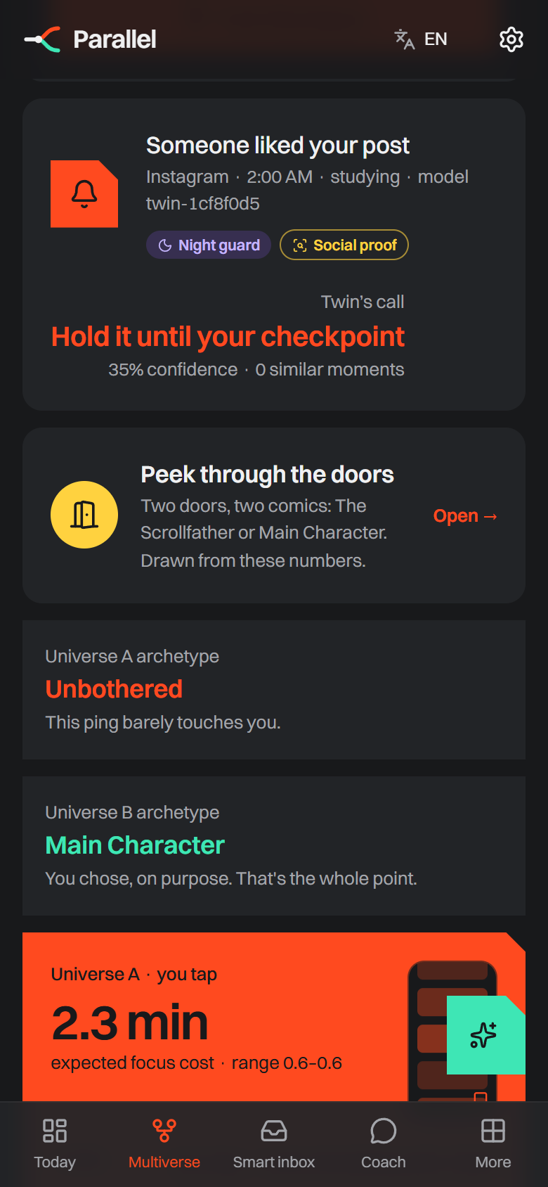  Multiverse: X-ray + twin’s call | 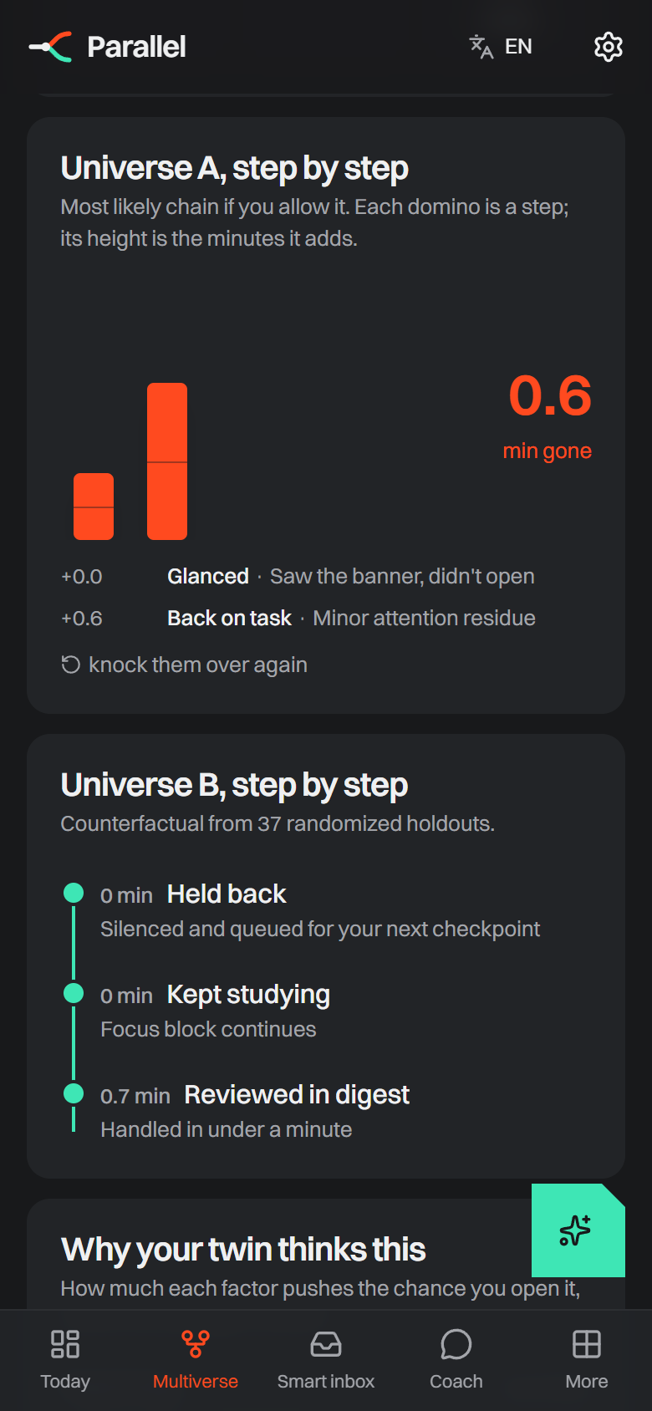  Dominoes: minutes per step | 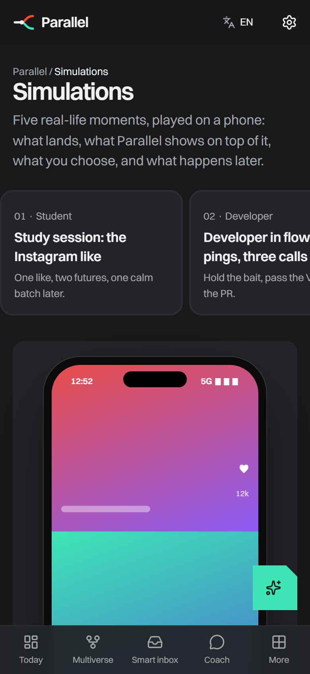  Simulations tab | 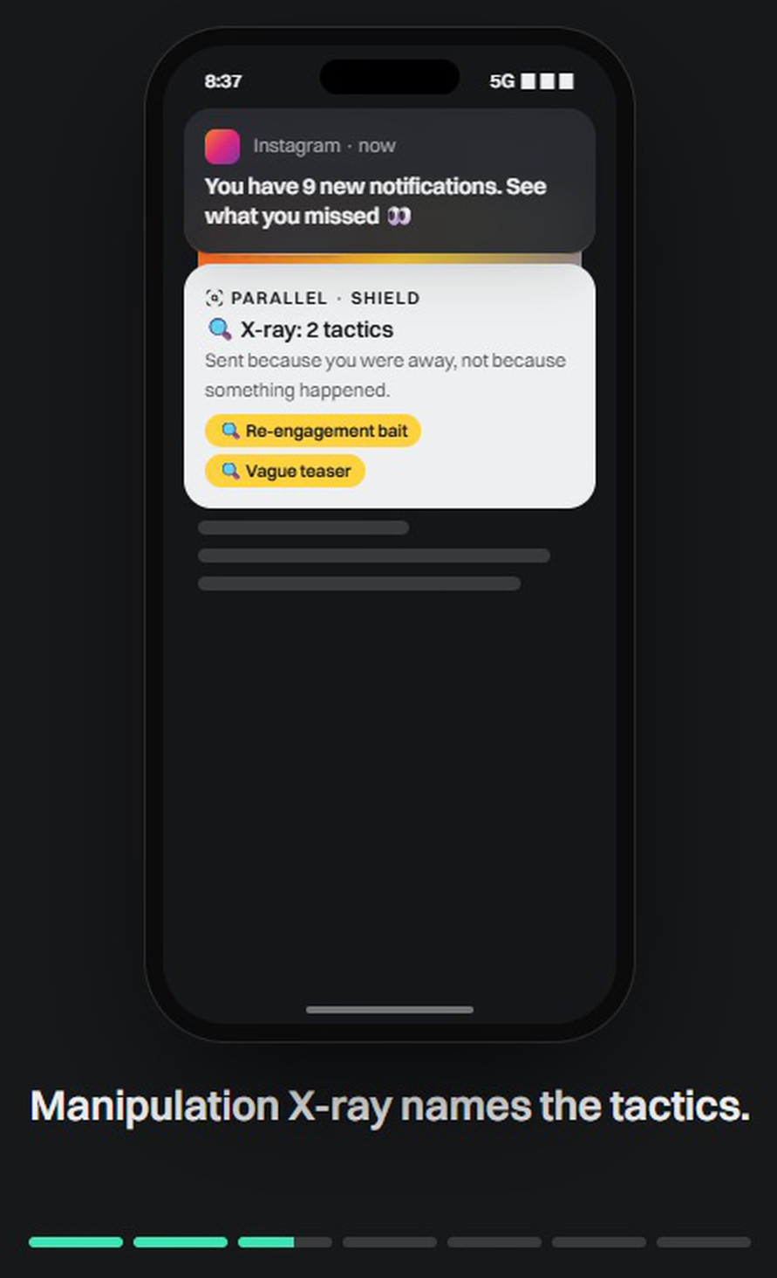  X-ray inside a simulation

14 Prototype gallery
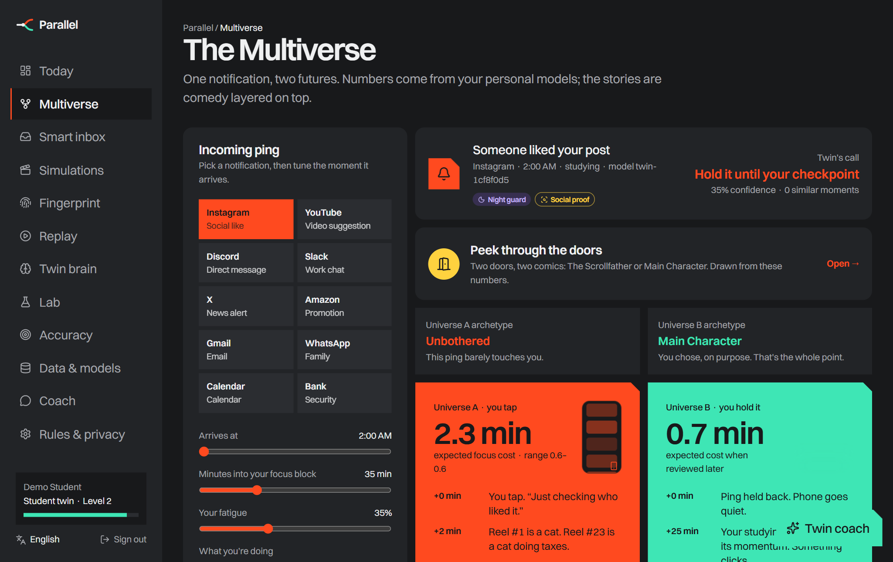
The Multiverse on a laptop: pick a ping and the moment, see both universes, peek through the doors, fork.
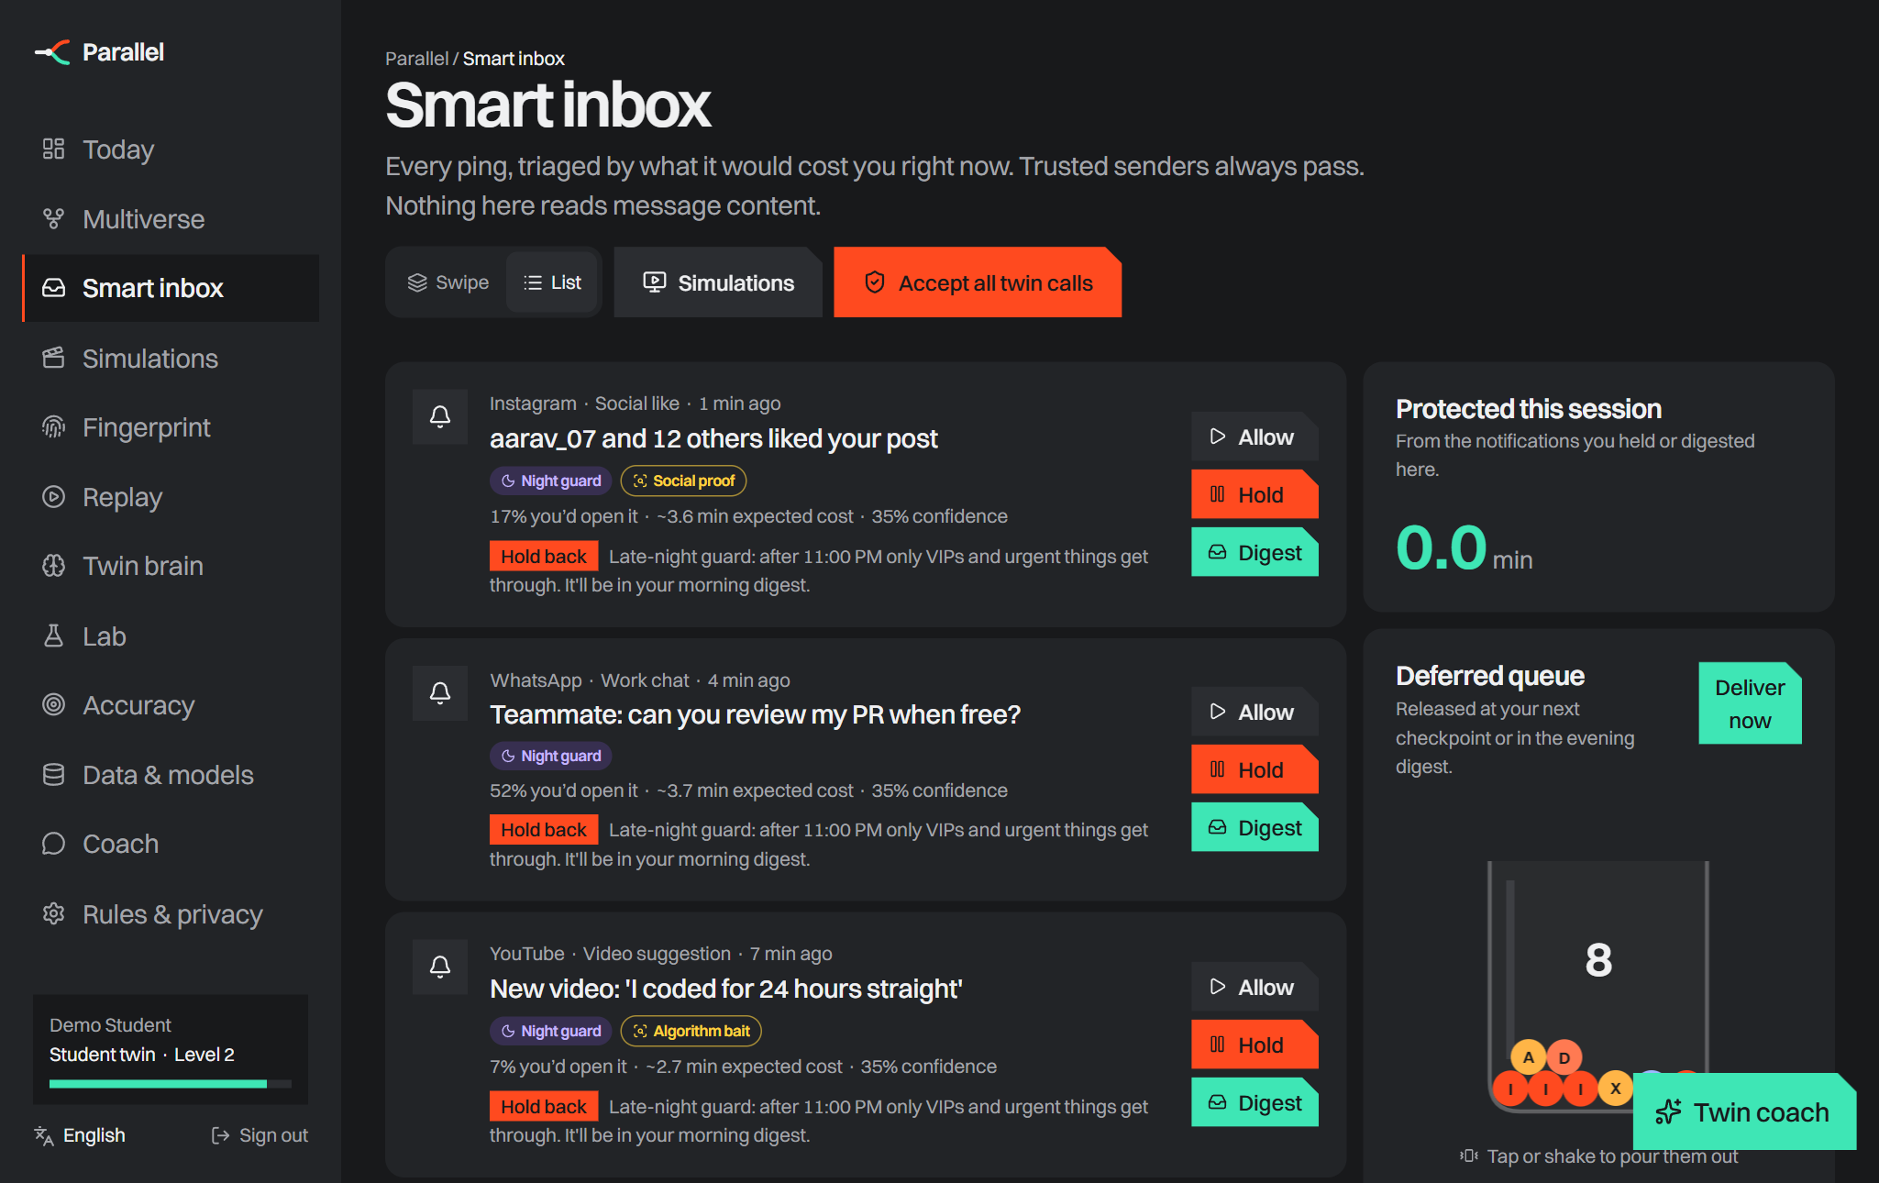  Smart inbox: shields, X-ray chips, deferred queue | 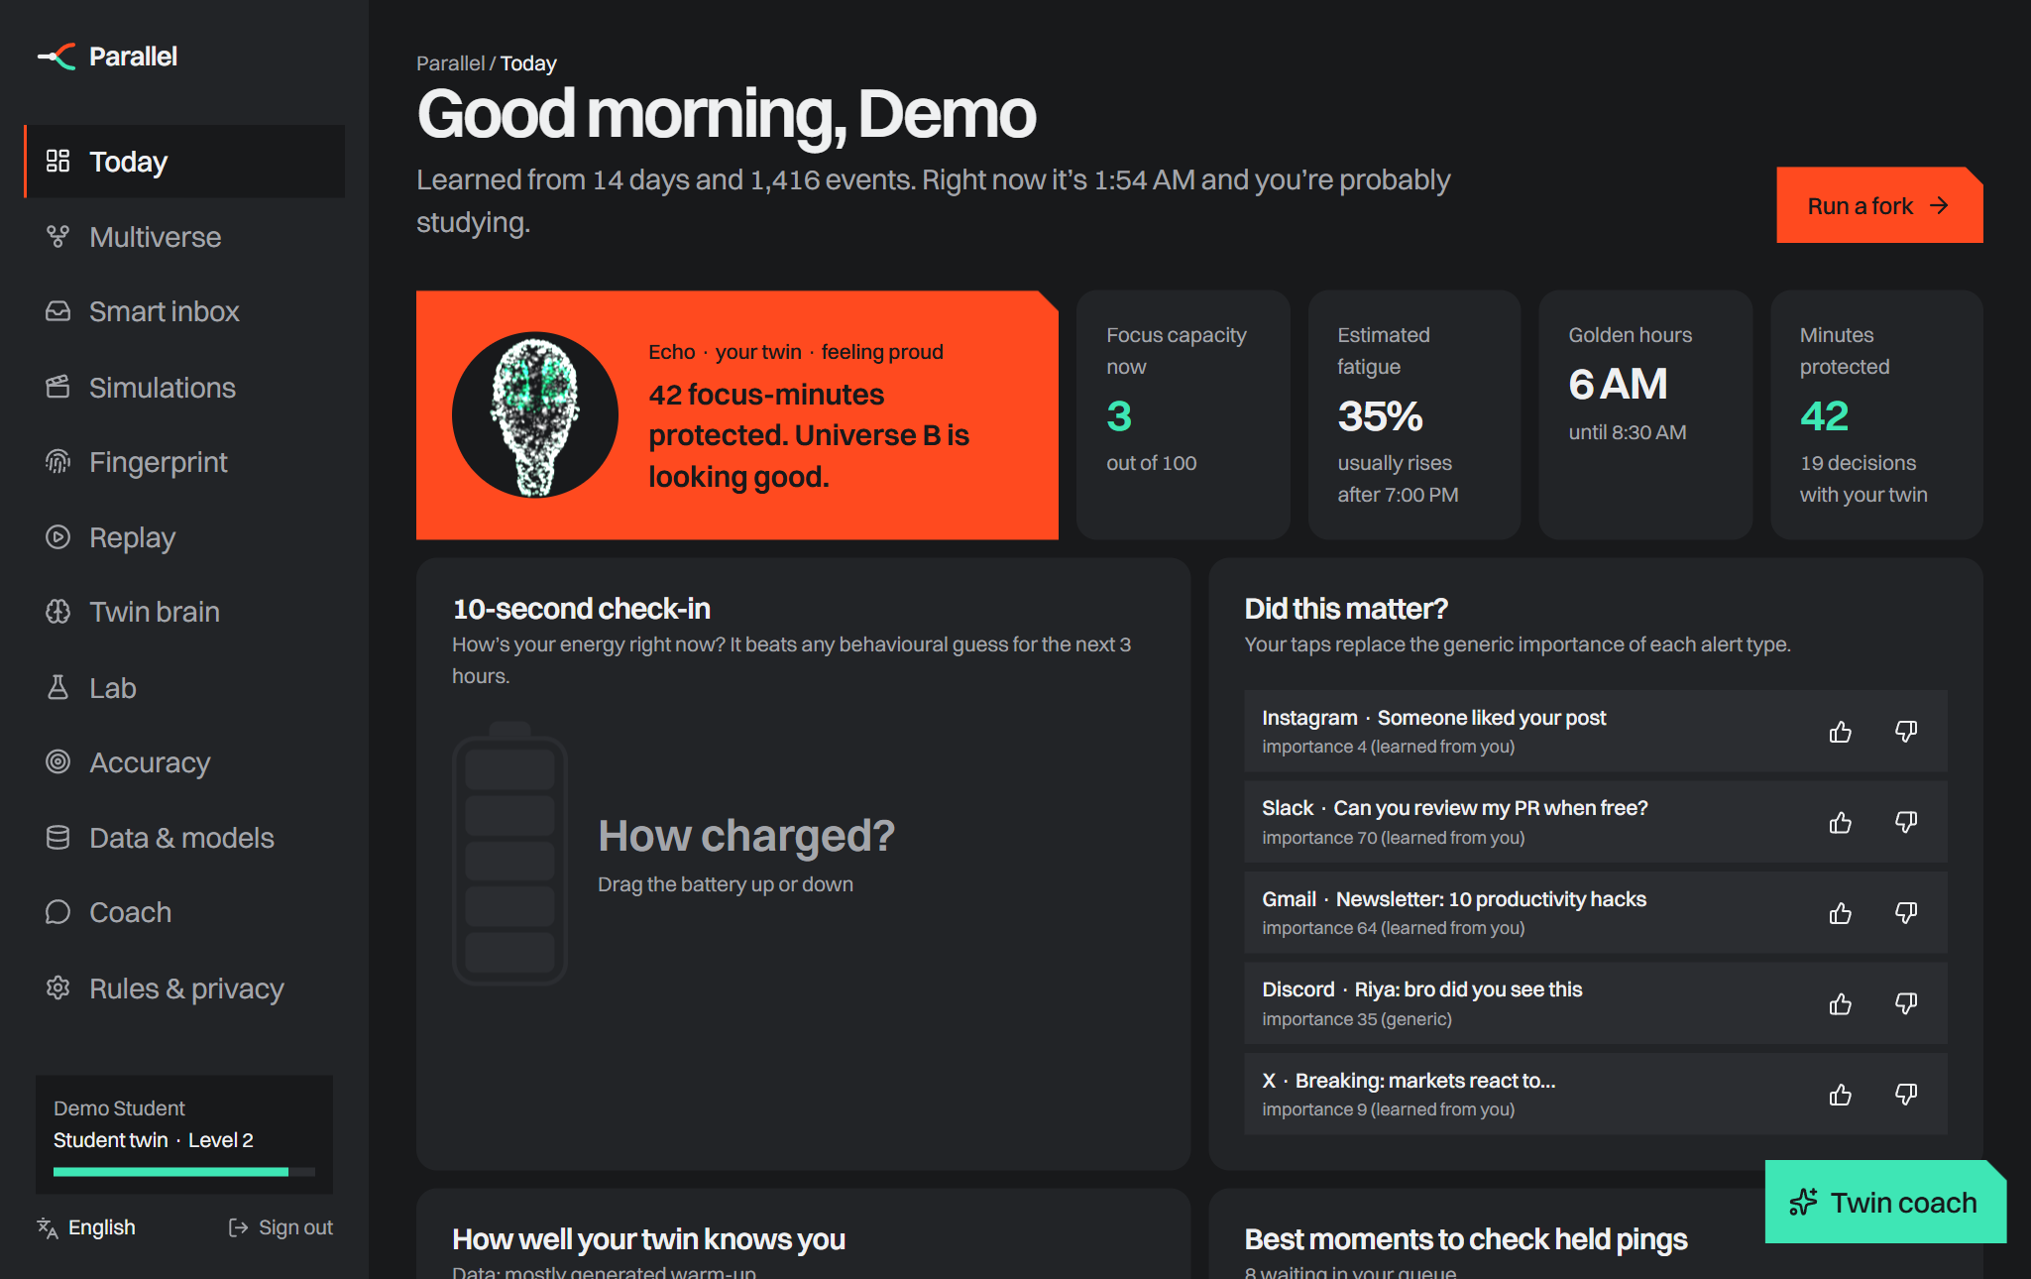  Today: Echo the companion, live state, inputs
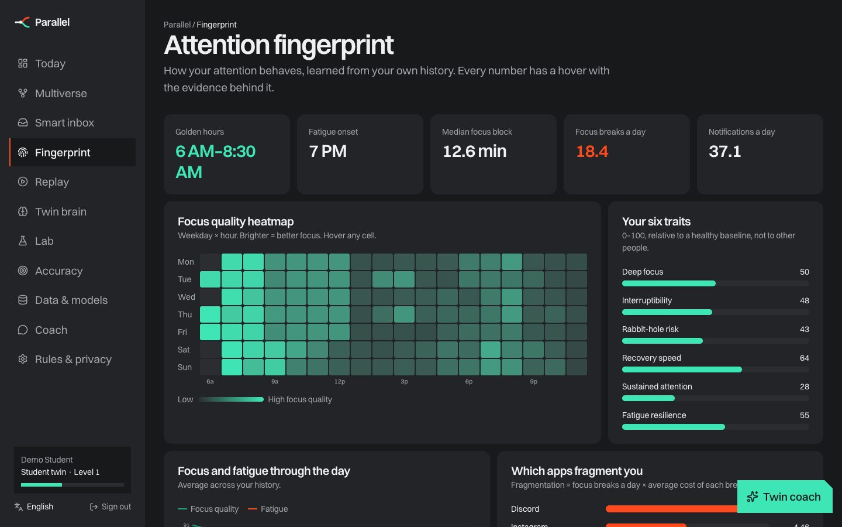  Attention fingerprint: when you focus best | 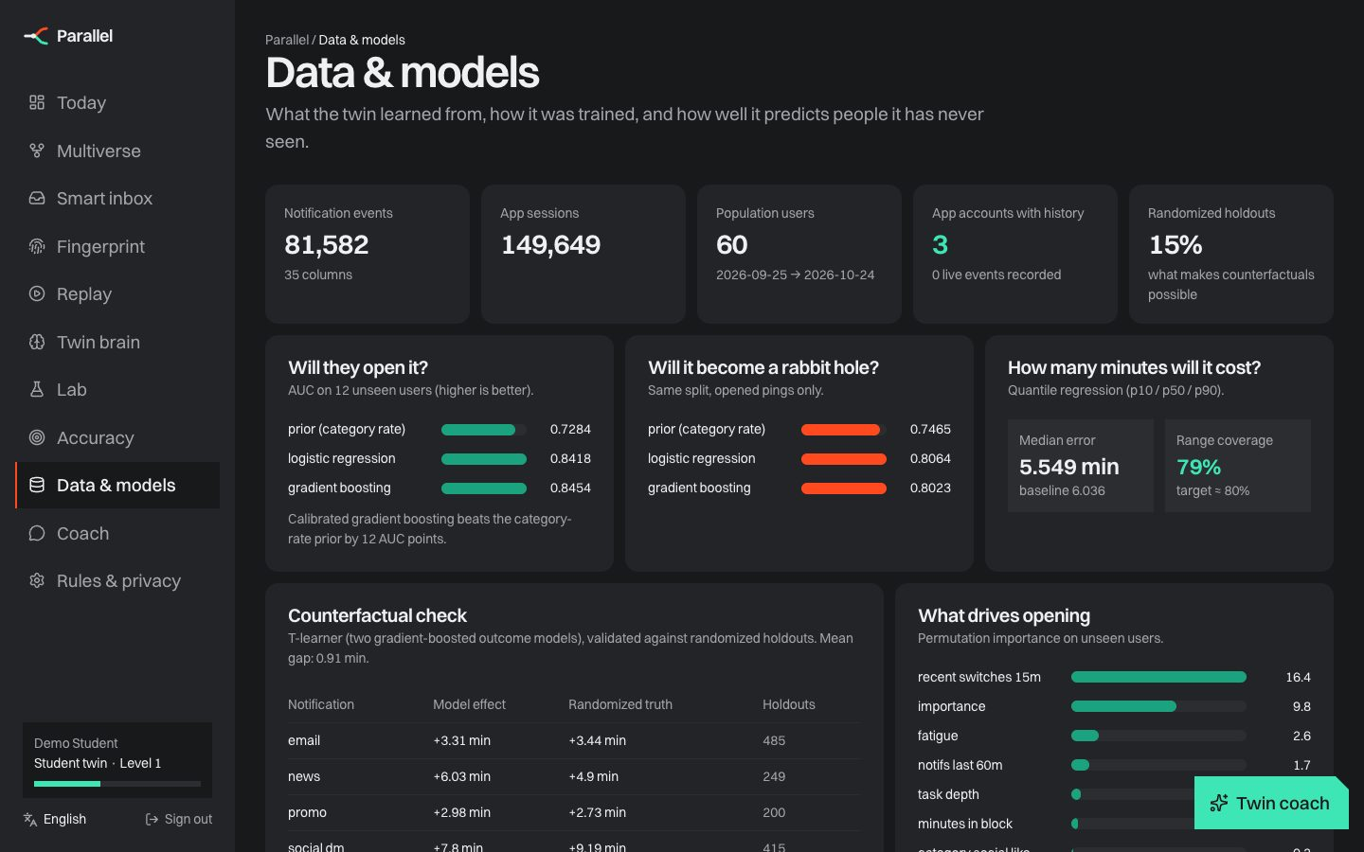  Data & models: dataset, metrics, registry

15 Simulations: how it is used in real life
Five self-playing phone scenarios show Parallel working on top of real notifications. Each is in the app (Simulations tab, /demo) and recorded as an 18-second 1080×1920 video.
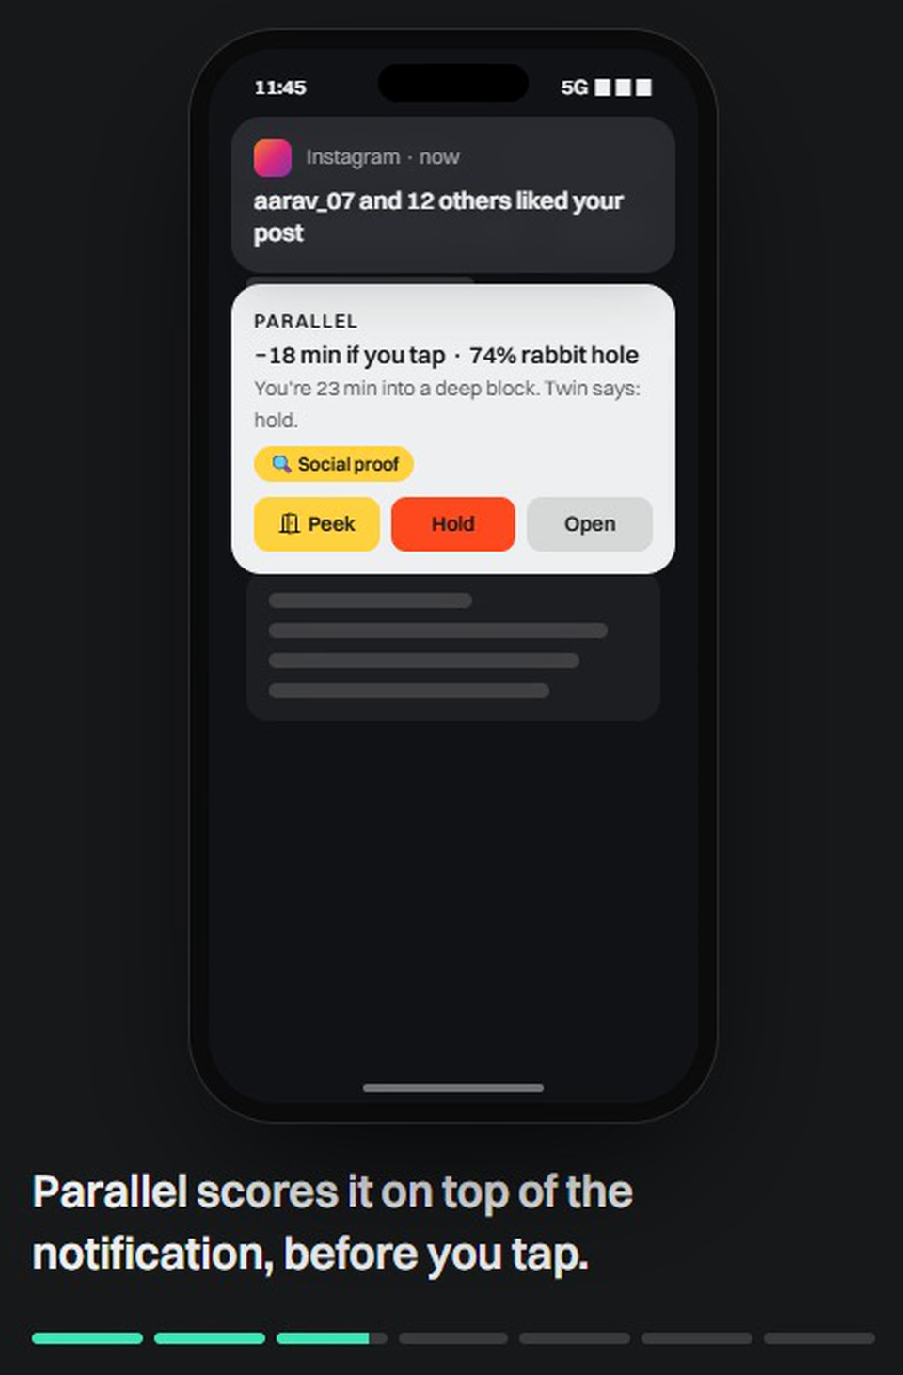  Study session |  |  | 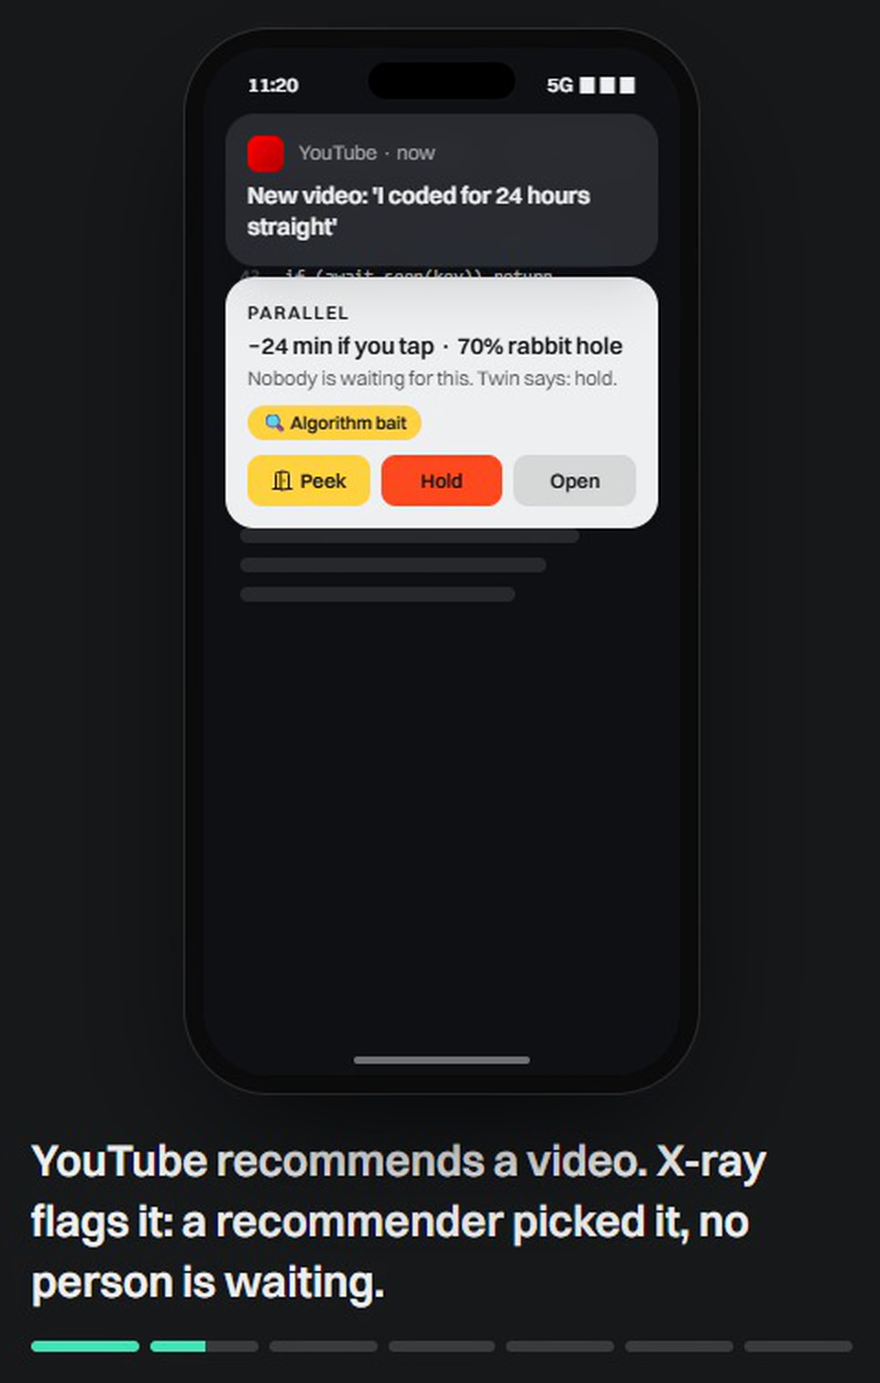  Developer in flow |  | 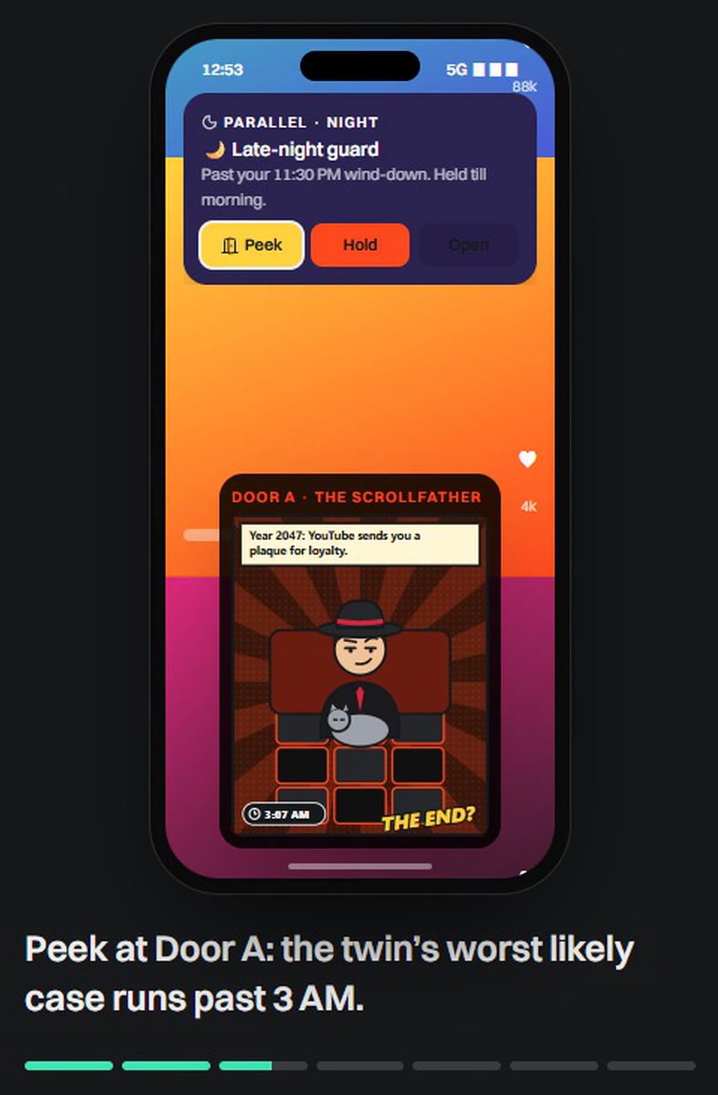  1 AM doomscroll |  | 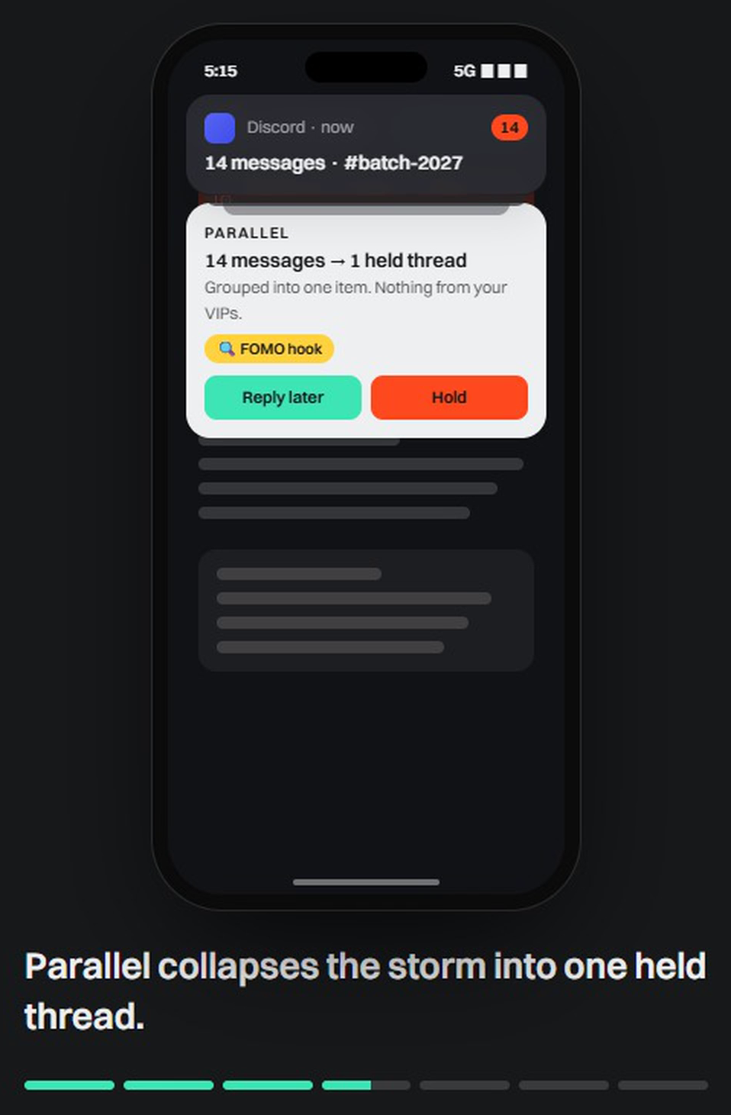  Exam-week storm |  |  | “We miss you” trap
Scenario |  | What happens |  |  |  |  |  | What it proves
Study session |  | Instagram like at 11:45 → “−18 min if you tap” → peek both doors → hold → 1 PM batch + text from future you |  |  |  |  |  | Cost before the tap; holding loses nothing
Developer in flow |  | YouTube suggestion held as algorithm bait; Mom passes instantly; PR review to the 12:30 digest |  |  |  |  |  | Different pings, different calls; VIPs always win
1 AM doomscroll |  | New ping held by the late-night guard; Door A shows 3 AM; future you: “8 am class 💀”; wind down; morning digest |  |  |  |  |  | Protecting sleep without a lecture
Exam-week storm |  | 14 Discord messages collapse into one held thread; auto-reply draft; 7 PM summary |  |  |  |  |  | Strict mode near deadlines; no FoMO
“We miss you” trap |  | X-ray: re-engagement bait + vague teaser; unmasked as “1–3 likes”; shielded; +500 aura |  |  |  |  |  | Naming manipulation changes the choice
 | 5  scenarios across 4 personas |  |  | 7  steps each, with captions |  | ~18 s  per video, looping |  |  | 1080×1920  Reels / Stories format

What to notice when watching
- Parallel sits on top of the notification, so the decision happens without opening the app.
- Nothing is lost. Every held ping returns at a checkpoint, in one calm batch, with a summary.
- Different pings get different calls: VIPs pass instantly, bait is held, work waits for the end of the block.
- The tone is a friend, not a parent: comics, future-you texts and aura instead of warnings.
Videos: frontend/public/simulations/study.mp4, dev.mp4, night.mp4, exam.mp4, reengage.mp4 · live at /app/simulations and /demo · recorded with headless Chrome from /demo?scenario=<id>&clean=1.

16 Impact, feasibility and viability

Impact
30–60 min  focus a day we target protecting per active user (pilot goal) | 3×/day  batched delivery, the pattern shown to improve attention and mood | Sleep  late-night guard targets the costliest rabbit holes | Literacy  users learn to spot manipulation tactics for life
- Students: more revision time in exam weeks, fewer 1 AM spirals. Developers: longer flow, fewer context rebuilds. Teams: fewer interruptions without missing what matters.
- Measured, not claimed: every user sees predicted vs actual minutes, calibration and the twin’s accuracy. Success = minutes protected and calibration, not time in app.
- Society: a tool that teaches people to recognise manipulative design, in line with where regulation is heading.

Feasibility
Area | Status / risk | Mitigation
Technology | Working prototype: models train in ~1 min, predictions in milliseconds; web, PWA, Android/iOS shells | Ship the Android listener next; decide on device from a cached policy
Platform limits | iOS cannot read other apps’ notifications | Android first; iOS via Focus filters, Screen Time and the in-app inbox
Store policy | Notification and usage access are sensitive permissions | Prominent disclosure, metadata only, clear core purpose
OEM battery killers | Some phones stop background services | Device-specific guidance, rebinding, foreground notification
Battery & speed | A listener runs for every notification | Tiny cached policy on device; heavy work (refits) on the server
Data quality | Accuracy so far is on synthetic data | Closed beta with real data; shrinkage priors keep early users safe

Viability
Low running cost. Small scikit-learn models; no GPU; a coach that works without an LLM. Optional Claude adds cents per active user. | Strong pull. Students and knowledge workers already pay for focus tools; shareable comics and receipts drive organic growth. | Tailwinds. Regulators (FTC, EU DSA, NY SAFE for Kids, California SB 976) are moving against manipulative design.
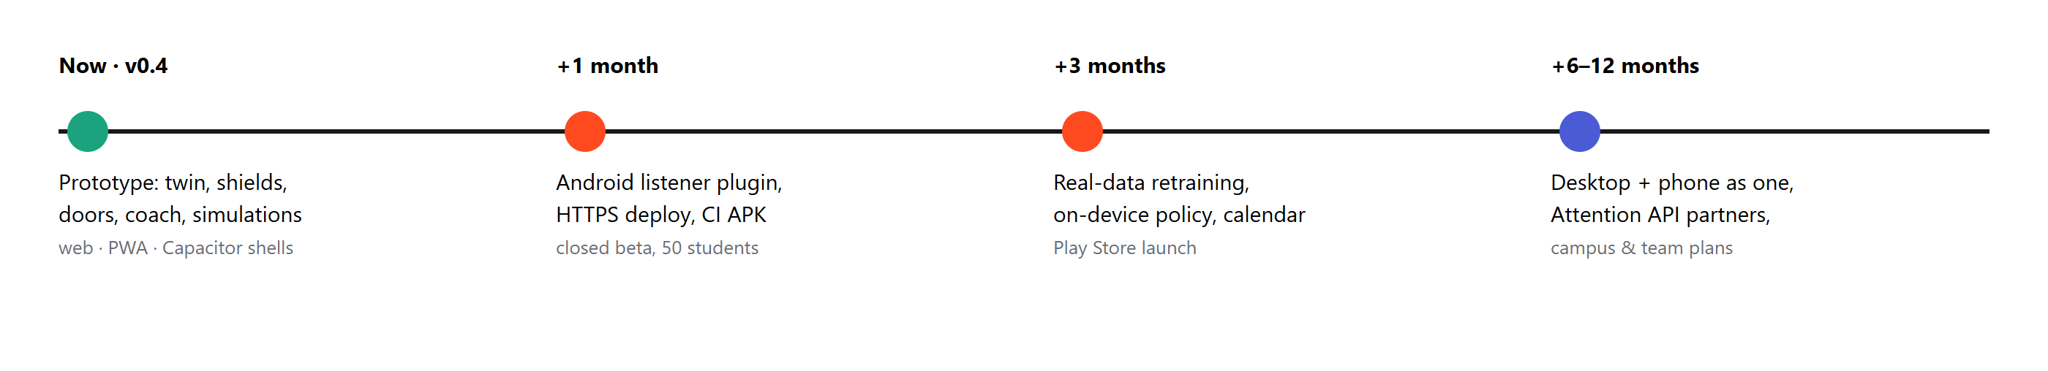

17 Business model (short)
Plan | Price (indicative) | Who | Includes
Free | ₹0 | Everyone | Twin, smart inbox, shields, 3 peeks a day, weekly report
Plus | ₹99 / month · ₹799 / year | Students, creators, developers | Unlimited peeks, comics and posters, coach (Claude), simulations, desktop + phone sync
Campus | ₹30 / student / month | Colleges, coaching institutes | Exam-week strict mode, co-focus rooms, anonymous cohort insights (k ≥ 5)
Teams | ₹199 / seat / month | Startups, remote teams | Focus reservations, meeting-aware holds, team health (aggregates only)
Attention API | Usage-based | App developers | “Should I interrupt now?” endpoint + SDK for respectful notifications

Go-to-market
1. Campus first. Student ambassadors, exam-season launches, hostel co-focus challenges. | 2. Shareable loops. Comic posters, receipts and aura tiers on Instagram Stories. | 3. Developers & creators. Content on flow and focus; desktop + phone bundle. | 4. B2B2C. Colleges and teams buy seats; the API brings partner apps.

Market and economics
Item |  | Note
Audience |  | India has 40M+ higher-education students and a large young knowledge workforce, the heaviest notification users
Revenue mix |  | Consumer subscriptions first; campus and team plans for predictable revenue; API later
Cost per user |  | Hosting and models are cheap (CPU-only); LLM coach is optional and metered
Partnerships |  | Colleges and coaching institutes (exam-season programmes), ed-tech and productivity apps via the Attention API
Key metrics |  | Weekly active deciders, minutes protected per user, calibration, paid conversion, share rate of posters
 | Positioning on price: cheaper than global focus apps priced in dollars, with a free tier that already protects time; campus plans make it near-free for students.

Illustrative unit economics (Plus plan)
₹99  monthly price; ₹799 a year | < ₹8  hosting + optional coach cost per active user / month | ~90%  gross margin target | 5–8%  free-to-paid target, in line with consumer productivity apps

18 Research and case studies
Research | Finding | How we used it
Stothart et al., 2015 | A notification alone, unanswered, disrupts an attention task about as much as a call or text | Price the ping itself, not just screen time
Kushlev, Proulx & Dunn, 2016 (CHI) | Notifications increase inattention and hyperactivity symptoms | Make silence the default for low-value pings
Fitz et al., 2019 (n = 237, RCT) | Batching 3×/day improved attention, mood and control; turning all off raised anxiety | Triage and batch, never block everything
Mark et al., 2005; Leroy, 2009 | Interrupted work resumes ~25 min later; attention residue hurts the next task | Recovery time is part of the cost model
Pielot et al., 2014 | ~63.5 notifications a day; boredom predictable from phone use (AUC 0.83) | Receptive moments are learnable; timing matters
Peters & Büchel, 2010; Hershfield, 2011 | Vivid future thinking and meeting your future self reduce present bias | Door to the Future; texts from future you
Hertwig & Grüne-Yanoff, 2017 | Boosts build competence and counter commercial nudging | Show the mechanism; Manipulation X-ray
Harris, 2016; Parker, 2017; Fogg (B=MAP) | Variable rewards and social validation drive compulsive checking; the notification is the prompt | Predictable checkpoints; name the tactic

Case studies we learned from
Case | Lesson | Applied in Parallel
Duolingo & Spotify Wrapped | One shareable, image-like card with playful captions spreads on its own | Comic posters, receipts, aura tiers
one sec (PNAS 2023) | A short pause at the moment of impulse reduces opening (company-reported results) | Peek and guess: a pause with information
Forest & Finch | A character that grows with good habits keeps people returning | Echo the companion, world levels, cards
Snapchat streaks | Loss-aversion mechanics are linked to problematic use | Streaks that forgive; no guilt mechanics
Apple Focus, Android 15 cooldown | Platforms are adding manual controls and softer repeated alerts | Automate the choice per ping, personally
Meta fewer-notifications test | Fewer alerts → less time in app but users preferred it | Optimise for satisfaction and minutes protected

Three lessons that shaped Parallel
Price the moment, not the day. The decision happens in a second at the notification; that is where help must be. | Batch, don’t block. Predictable checkpoints keep attention and avoid FoMO. | Make the future vivid and funny. Imagined futures change choices; humour gets shared, guilt gets ignored.
Full references and design reasoning: docs/PSYCHOLOGY.md, docs/IDEATION.md, docs/LOGIC_AND_FORMULAS.md · github.com/vizsh/Parallel

