FORWARD DEPLOYED AI ENGINEERING
Capstone Project
Capstone Pack
Contents of this folder
A one page map of everything in the pack and the order to use it in.
Read 00_PROJECT_INSTRUCTIONS first, then 01_Read_First / 00_Start_Here.
INDIVIDUAL PROJECT · DEADLINE 13 SEPTEMBER

The six folders
Work through the folders roughly in numerical order. The table below tells you what each one holds and the point in the project at which you will need it.
Folder | What it holds | When
01_Read_First | Start Here, the Project Brief, the Build Specification and the README. | Before you begin
02_Stage_Workbooks | The five workbooks you fill in, one per stage. | Throughout
03_Reference | Setup Guide, Evaluation Framework, Governance Framework. | As needed
04_Submission | Submission Guide and Effort Log. | Read week one, use week three
05_Datasets | Tickets, documentation, expert answers, hidden evaluation set. | From week one
06_Configuration | Dependency list and environment variable template. | Week one, day one

Every file in the pack
File | Purpose
00_PROJECT_INSTRUCTIONS.docx | Rules, deadline, submission format and marking. Read this first.
01_Read_First / 00_Start_Here.docx | Orientation. Read this first; it takes fifteen minutes.
01_Read_First / 01_Project_Brief.docx | The core document. Client, architecture, targets, constraints.
01_Read_First / 02_Build_Specification.docx | What the software must do. Twelve acceptance criteria and the pass or fail gate.
01_Read_First / README.md | Step by step walkthrough of the whole project.
02_Stage_Workbooks / Stage_1_Discovery_Workbook.docx | Interviews, evidence tables, problem statement.
02_Stage_Workbooks / Stage_2_PRD_Template.docx | The requirements document you write from your findings.
02_Stage_Workbooks / Stage_3_Prompt_Library.docx | Specifications and the versioned prompt register.
02_Stage_Workbooks / Stage_4_Sprint_Plan.docx | Backlog, owners, estimates, definition of done.
02_Stage_Workbooks / Stage_5_PRD_Revision_Log.docx | What your requirements got wrong and why. Compulsory.
03_Reference / Setup_Guide.docx | Environment, keys, vector store, monitoring, CI.
03_Reference / Evaluation_Framework.docx | Every metric, its calculation and its target.
03_Reference / Governance_Framework.docx | Risk, fairness, decision logging, incident response.
04_Submission / Submission_Guide.docx | Exact format for video, report, effort log and code.
04_Submission / Effort_Log.docx | Your hours by stage and task. Fill in as you go.
05_Datasets / development_tickets.json | 500 labelled tickets. Use freely.
05_Datasets / documentation.json | The knowledge base your retrieval layer searches.
05_Datasets / ground_truth_responses.json | 200 expert answers for reference and comparison.
05_Datasets / validation_tickets.json | the full evaluation set. Use once, at the end.
06_Configuration / requirements.txt | Pinned Python dependencies.
06_Configuration / .env.example | Environment variable template. Placeholders only.

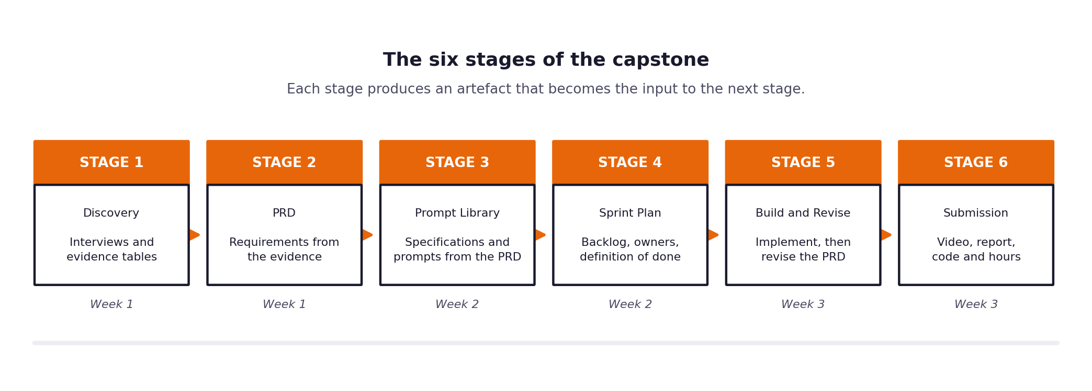
The six stages of the project.
If you only do one thing today
Read 00_PROJECT_INSTRUCTIONS.docx, then 01_Read_First / 00_Start_Here.docx. Together they take about half an hour and everything else in the pack makes more sense afterwards. The submission deadline is 13 September at 23:59.

