COMPARITIVE ANALYSIS OF IMAGE CLASSIFICATION USING MACHINE LEARNING & DEEP LEARNING TECHNIQUES

**A Project Report submitted in partial fulfilment of the requirements for the award of the degree of**

**BACHELOR OF TECHNOLOGY IN**

**COMPUTER SCIENCE AND ENGINEERING**

**Submitted by**

**Vizzapu Prajesh Gupta, 121910303013**

**M.Nithin Venugopal, 121910303017**

**Under the esteemed guidance of**

**Mr. Rajesh Bandaru Assistant Professor**



**DEPARTMENT OF COMPUTER SCIENCE & ENGINEERING GITAM**

**(Deemed to be University) VISAKHAPATNAM**

**October 2022**

**DEPARTMENT OF COMPUTER SCIENCE AND ENGINEERING GITAM SCHOOL OF TECHNOLOGY**

**GITAM**

**(Deemed to be University)**



**DECLARATION**

We, hereby declare that the project report entitled “**COMPARITIVE ANALYSIS OF** **IMAGE CLASSIFICATION USING MACHINE LEAARNING & DEEP LEARNING TECHNIQUES** ” is an original work done in the Department of Computer Science and Engineering, GITAM Institute of Technology, GITAM (Deemed to be University) submitted in partial fulfilment of the requirements for the award of the degree of B.Tech. in Computer Science and Engineering. The work has not been submitted to any other college or University for the award of any degree or diploma.

Date: 19-10-2022

**Registration No(s). Name(s) Signature(s) 121910303013 Vizzapu Prajesh Gupta**

**121910303017 M.Nithin Venugopal**

**DEPARTMENT OF COMPUTER SCIENCE AND ENGINEERING GITAM SCHOOL OF TECHNOLOGY**

**GITAM**

**(Deemed to be University)**



**CERTIFICATE**

This is to certify that the project report entitled “**COMPARITIVE ANALYSIS OF** **IMAGE CLASSIFICATION USING MACHINE LEAARNING & DEEP LEARNING TECHNIQUES**” is a bonafide record of work carried out by **Vizzapu Prajesh Gupta (121910303013), Nithin Venugopal (121910303017)** students submitted in partial fulfillment of requirement for the award of degree of Bachelors of Technology in Computer Science and Engineering.

**Project Guide Head of the Department**

**Mr . Rajesh Bandaru Dr. R Sirieesha**

**Assistant Professor Professor**

**TABLE OF CONTENTS**

|  |  |  |  |
| --- | --- | --- | --- |
| 1. | Abstract | | 5 |
| 2. | Introduction | | 6 |
| 3. | Literature Review | | 7-9 |
| 4. | Problem Identification & Objectives | | 10 |
| 5. | System Methodology | | 11-16 |
| 6. | Overview of Technologies | | 17 |
| 7. | Implementation | |  |
|  | 7.1 | Coding | 18-19 |
|  | 7.2 | Testing | 20-22 |
| 8. | Results & Discussion | | 23-27 |
| 9. | Conclusion & Future Scope | | 28 |
| 10. | References | | 29 |

# ABSTRACT

In machine learning we often encounter two types of problems classification and regression.

The evolution of image classification started with first binary classification then multi-

classification using machine learning algorithms then with introduction of deep learning had

a great impact on image classification.

So in this project we are going to make a comparative study of image classification using

few machine learning and deep learning algorithms and then choose a best classifier which

would give best results on the CIFAR-10 dataset which is a standard dataset from Keras.

Later using the obtained best classifier we will perform image classification on the CIFAR-10

dataset.

# INTRODUCTION

In machine learning we often encounter two types of problems classification and regression.

The evolution of image classification started with first binary classification then multi-

classification using machine learning algorithms then with introduction of deep learning had

a great impact on image classification.

We all know how important he facial recognition system and image classification has become

in our daily life for various purposes. For Example, identifying people on facebook, Security

purposes etc. So, In this project the main aim is to show the working of the image

classification on a dataset called CIFAR-10. The data set contains a few features based on

which the algorithms starts classifying the image.

# LITERATURE REVIEW

* 1. **TITLE: Comparative Analysis of Image Classification Algorithms Based on Traditional Machine Learning and Deep Learning**

**AUTHORS:** [Pin Wang](https://www.researchgate.net/scientific-contributions/Pin-Wang-2169374935?_sg%5B0%5D=QjizTOZr4RFvOOsQjs1zymeR5_hz31lMyIT-4-hRqSq8Q41R0rzg9YMaQ3YLE3GEOvZ0ii8.8ad8brcYuylbP95Z4hkN9Z6L1DUuh3Fd_H7G3oFlqcl46_dVGIfPLTplr52p8nB3BYXIfk4aMIfD3gRnZIDicw&_sg%5B1%5D=Hk71y9ctEttqeyQsfAsf5Qexf5QpaErA98EUdME7bsg3nMMl9fGmzjQCXwrFv1eeEbxjX5w.f_Y5-Fv639cbAKmhhfBH2dmdgAWJU7kGaigrM1uuvI-jkGWw4xnFyBhcgLwegBgfSEvUiKzV10hxpg6HPwZnJg), [Peng Wang](https://www.researchgate.net/scientific-contributions/Peng-Wang-2169375630?_sg%5B0%5D=QjizTOZr4RFvOOsQjs1zymeR5_hz31lMyIT-4-hRqSq8Q41R0rzg9YMaQ3YLE3GEOvZ0ii8.8ad8brcYuylbP95Z4hkN9Z6L1DUuh3Fd_H7G3oFlqcl46_dVGIfPLTplr52p8nB3BYXIfk4aMIfD3gRnZIDicw&_sg%5B1%5D=Hk71y9ctEttqeyQsfAsf5Qexf5QpaErA98EUdME7bsg3nMMl9fGmzjQCXwrFv1eeEbxjX5w.f_Y5-Fv639cbAKmhhfBH2dmdgAWJU7kGaigrM1uuvI-jkGWw4xnFyBhcgLwegBgfSEvUiKzV10hxpg6HPwZnJg) and Fan En

**ABSTRACT:** Image classification is a hot research topic in today's society and an important direction in the field of image processing research. SVM is a very powerful classification model in machine learning. CNN is a type of feedforward neural network that includes convolution calculation and has a deep structure. It is one of the representative algorithms of deep learning. Taking SVM and CNN as examples, this paper compares and analyzes the traditional machine learning and deep learning image classification algorithms. This study found that when using a large sample mnist dataset, the accuracy of SVM is 0.88 and the accuracy of CNN is 0.98; when using a small sample COREL1000 dataset, the accuracy of SVM is 0.86 and the accuracy of CNN is 0.83. The experimental results in this paper show that traditional machine learning has a better solution effect on small sample data sets, and deep learning framework has higher recognition accuracy on large sample data sets.

* 1. **TITLE: A Comparison of Machine Learning and Deep Learning in Hyperspectral Image Classification**

**AUTHORS:** Fady Mohamed Sadek,Mahmud Iwan Solihin,Fahri Heltha,Wei Hong Lim &

M.Rizon

**ABSTRACT:** In recent years, hyperspectral remote sensing has become popular in various applications. This technology can capture hyperspectral images with a large terrestrial data. In this paper, the feasibility of applying various machine learning and deep learning techniques to perform classification on hyperspectral images are investigated and compared. Particularly, a total of three popular machine learning classifiers namely supports vector machine (SVM), K-nearest neighbors (KNN) and artificial neural networks (ANN) are used for hyperspectral imagine classification, followed by another two deep architectures in convolutional neural networks (CNN). Three benchmarking datasets of hyperspectral images are used to evaluate the classification performances of suggested machine learning and deep learning techniques, namely: Indian Pines (IP) dataset, Salinas dataset, and Pavia University (PU) dataset. Extensive simulation studies reveal the excellent performance of 3D CNN deep learning in solving larger datasets with better classification accuracy despite the longer training time is required. However, it is not really the case when the dataset is not large enough. This is because deep learning is data-hungry architecture. Furthermore, the 3D CNN deep learning models employed in this study have shown more advantageous as compared to other machine learning models for having simplified pre-processing stages such as feature extraction in solving the classification problems of hyperspectral images.

* 1. **TITLE: Machine Learning vs. Deep Learning in 5G Networks - A Comparison of Scientific Impact**

**AUTHORS:** IIler Tuker & Serhat Orkun Tan

**ABSTRACT:** Introduction of fifth generation (5G) wireless network technology has matched the crucial need for high capacity and speed needs of the new generation mobile applications. Recent advances in Artificial Intelligence (AI) also empowered 5G cellular networks with two mainstreams as machine learning (ML) and deep learning (DL) techniques. Our study aims to uncover the differences in scientific impact for these two techniques by the means of statistical bibliometrics. The performed analysis includes citation performance with respect to indexing types, funding availability, journal or conference publishing options together with distributions of these metrics along years to evaluate the popularity trends in a detailed manner. Web of Science (WoS) database host 2245 papers for ML and 1407 papers for DL-related studies. DL studies, starting with 9% rate in 2013, has reached to 45% rate in 2022 among all DL and ML-related studies. Results related to scientific impact indicate that DL studies get slightly more average normalized citation (2.256) compared to ML studies (2.118) in 5G, while SCI-Expanded indexed papers in both sides tend to have similar citation performance (3.165 and 3.162 respectively). ML-related studies those are indexed in ESCI show twice citation performance compared to DL. Conference papers in DL domain and journal papers in ML domain are superior in scientific interest to their counterparts with minor differences. Highest citation performance for ML studies is achieved for year 2014, while this peak is observed for 2017 for DL studies. We can conclude that both publication and citation rate for DL-related papers tend to increase and outperform ML-based studies in 5G domain by the means of citation metrics.

* 1. **TITLE: Skin Disease Detection: Machine Learning vs Deep Learning**

**AUTHORS:** Payal Bose ,Prof. Samir K. Bandopadhyay, Prof. Amiya Bhaumik &

Dr. Sandeep Poddar

**ABSTRACT:** Skin disease is a very common disease for humans. In the medical industry detecting skin disease andrecognizing its type is a very challenging task. Due to the complexity of human skin texture and the visual closenesseffect of the diseases, sometimes it is really difficult to detect the exact type. Therefore, it is necessary to detect andrecognize the skin disease at its very first observation.In today's era, artificial intelligence (AI) is rapidly growing in medical fields. Different machine learning (ML) and deeplearning(DL) algorithms are used for diagnostic purposes. These methods drastically improve the diagnosis process andalso speed up the process. In this paper, a brief comparison between the machine learning process and the deep learningprocess was discussed. In both processes, three different and popular algorithms are used. For the machine Learningprocess Bagged Tree Ensemble, K-Nearest Neighbor (KNN), and Support Vector Machine(SVM) algorithms wereused. For the deep learning process three pre-trained deep neural network models ResNet50, VGG16, and GoogleNetwere used. It was observed that the accuracy of both processes is much satisfactory.

# PROBLEM IDENTIFICATION & OBJECTIVES

In machine learning we often encounter two types of problems classification and regression.

The evolution of image classification started with first binary classification then multi-

classification using machine learning algorithms then with introduction of deep learning had

a great impact on image classification.

So in order to confirm which algorithm gives the best result on image classification we have to perform a comparative study of machine learning algorithms and deep learning algorithms

on image classification.

The objectives of this project are:

1. Identification of suitable dataset for image classification
2. Make a comparative study of the identified dataset using machine learning and deep learning.
3. Identify the best algorithm for image classification from the above study.
4. Develop a suitable front end for image classification.

# SYSTEM METHODOLOGY

* 1. **BLOCK DIAGRAM**

A block diagram is a system's representation of its main components or functions through the use of blocks connected by lines that reveal the connections between the blocks.

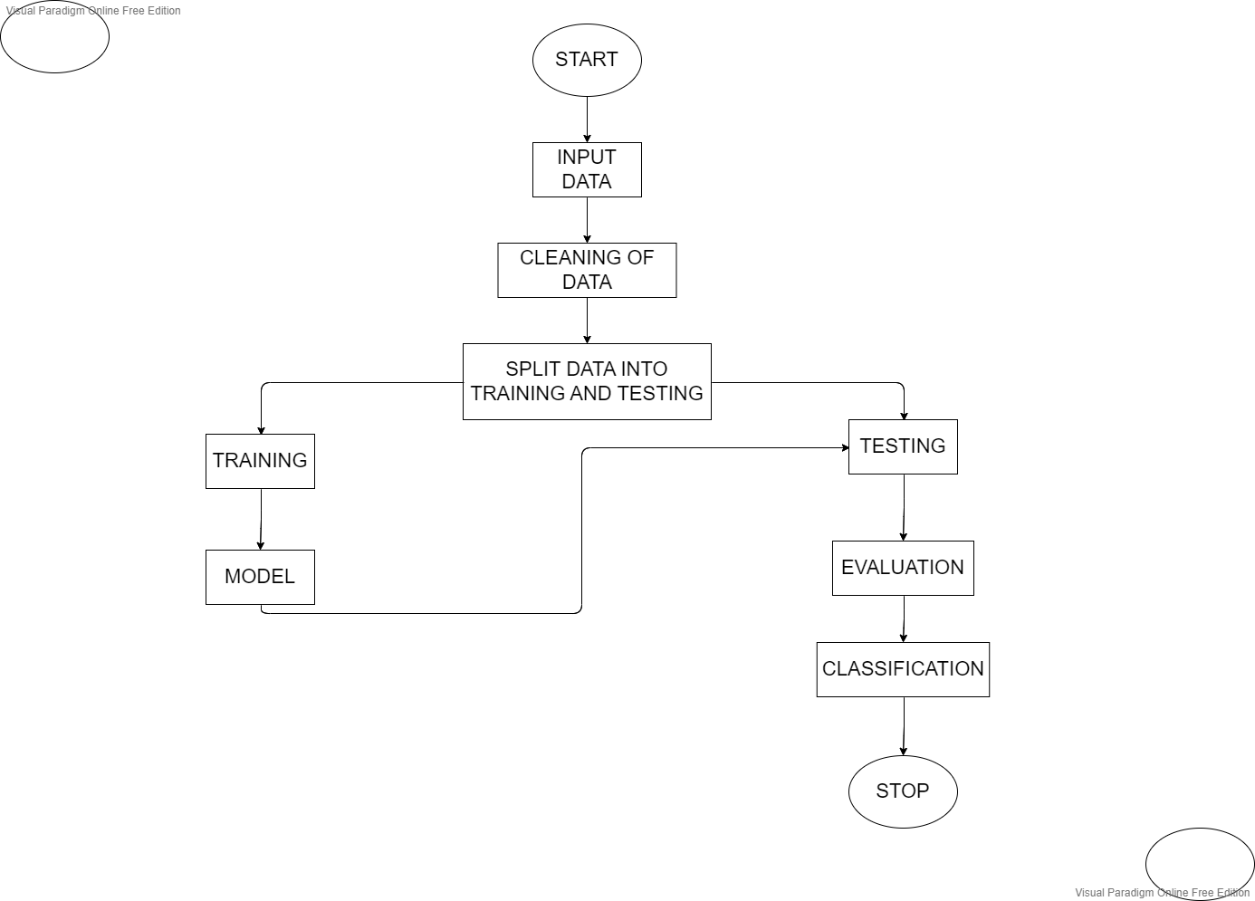

* 1. **UML DIAGRAMS**

The Unified Modeling Language (UML) is a common language for business modelling, non- software systems, and software system artefact specification, visualisation, construction, and documentation. Project teams can communicate, explore new designs, and evaluate the software's architectural design by using the UML.

**CLASS DIAGRAM:**

The class diagram is employed to polish the use case diagram and specify a thorough system design. The use case diagram's actors are categorised into a number of interconnected classes using the class diagram. Various functionalities might be available from each class in the class diagram. These features offered by the class are known as its "methods." In addition, each class could have particular "attributes" that specifically identify the class.. Here we used aggregation relation. We use aggregation arrows when we want to convey that two classes are associated, but not as close as in direct association. The child class can exist independent of the parent element.

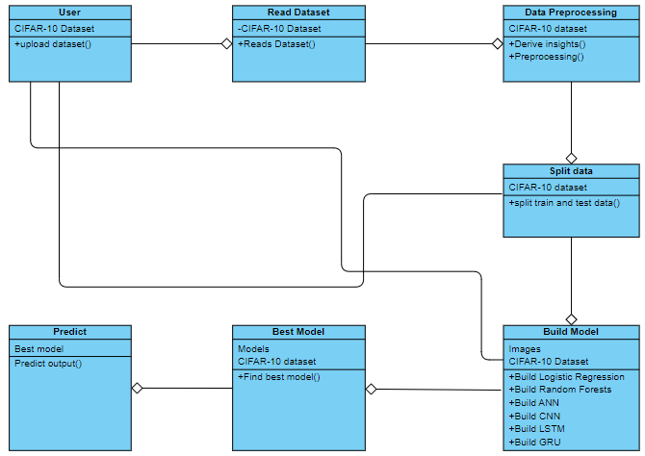

**OBJECT DIAGRAM:**

A unique variety of class diagram is the object diagram. A class's instances are objects. In essence, this means that while the system is functioning, an object represents the state of a class at a specific time. The object diagram represents the current state of the many classes in the system, as well as any interactions or associations between them. We used aggregation relations even in the object diagram.

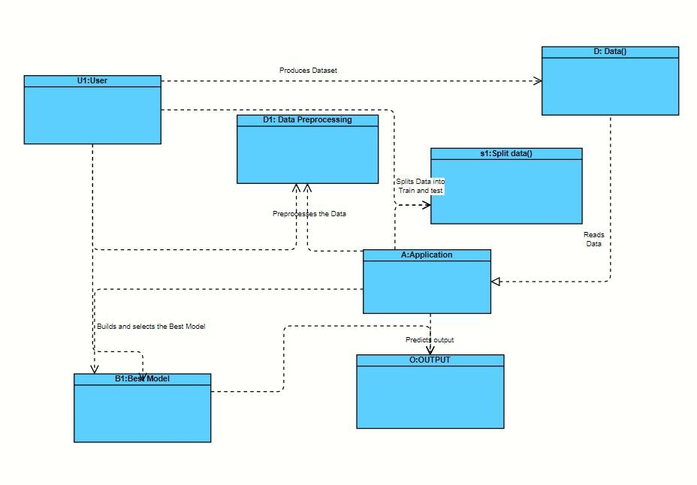

**USE CASE DIAGRAM:**

The use case diagram is used to specify the fundamental components and operational procedures of the system. The procedures are referred to as "use cases," and the key components are referred to as "actors." The actors who interact with each use case are depicted in the use case diagram.

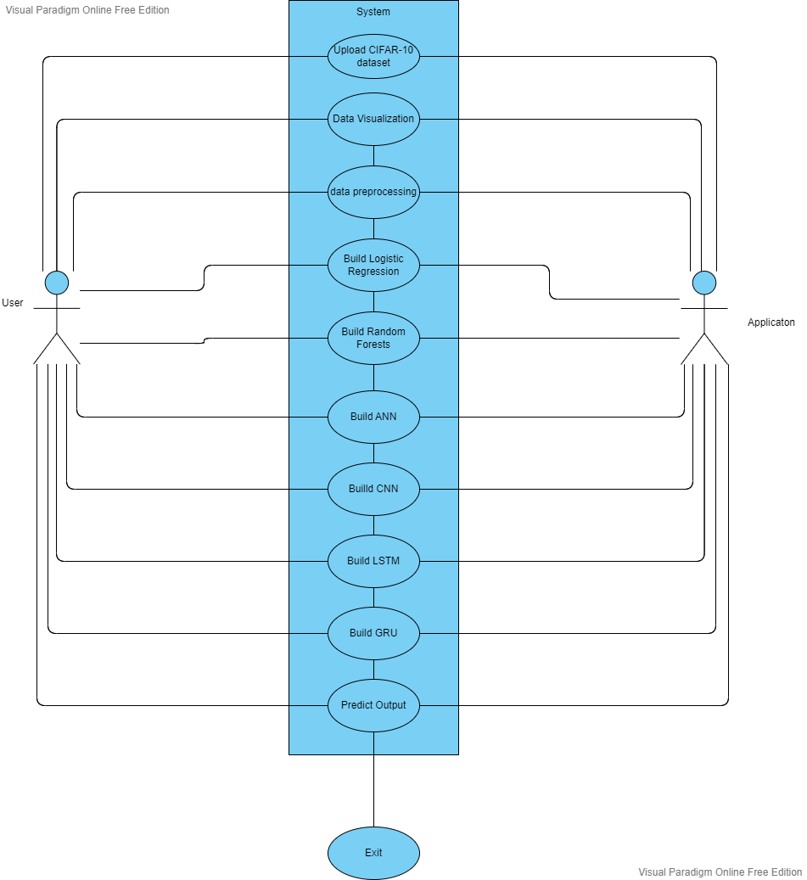

**STATE DIAGRAM:**

A state diagram, as the name suggests, represents the different states that objects in the system undergo during their life cycle. Objects in the system change states in response to events. In addition to this, a state diagram also captures the transition of the object's state from an initial state to a final state in response to events affecting the system.

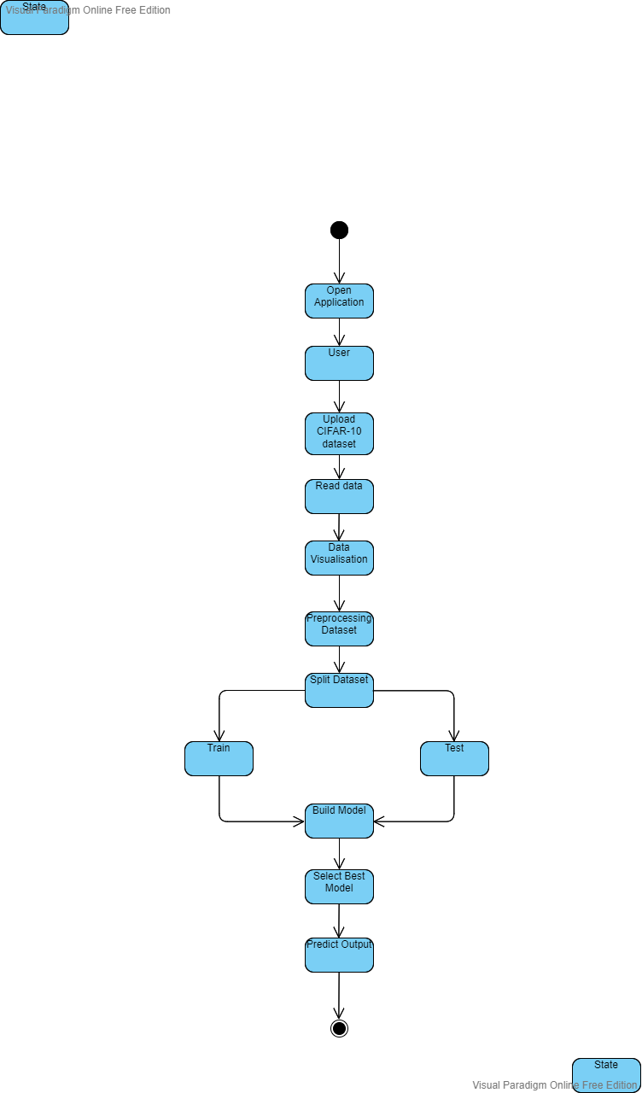

**SEQUENCE DIAGRAM:**

A sequence diagram represents the interaction between different objects in the system. The important aspect of a sequence diagram is that it is time-ordered. This means that the exact sequence of the interactions between the objects is represented step by step. Different objects in the sequence diagram interact with each other by passing "messages".

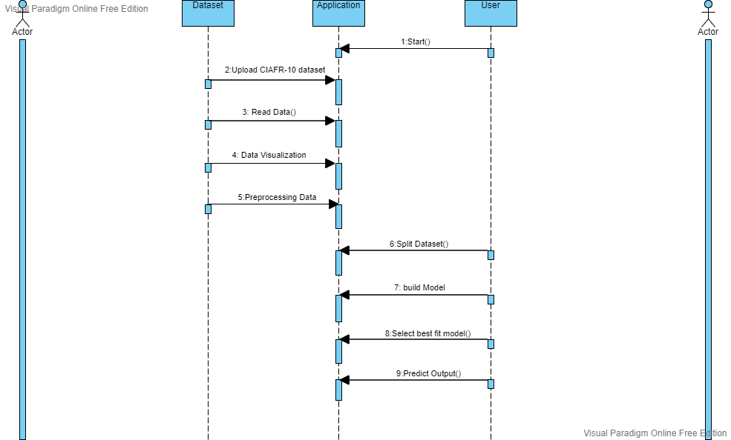

1. **OVERVIEW OF TECHNOLOGIES**

Python programming language and frameworks such as NumPy, Pandas, Scikit-learn, Tensor Flow, Keras are used to build the whole model.

  

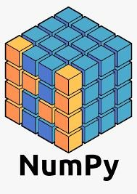

Google Colab is used as IDE.

For visualization of the plots, Matplotlib, Seaborn and Plotly are used. Heroku is used for deployment of the model.

MySQL/MongoDB is used to retrieve, insert, delete, and update the database. Front end development is done using HTML/CSS

GitHub is used as version control system.

1. **Implementation**

**7.1 Coding**

Totally six different algorithms have been implemented for the comparative analysis which

were already discussed above:

**Logistic Regression:**

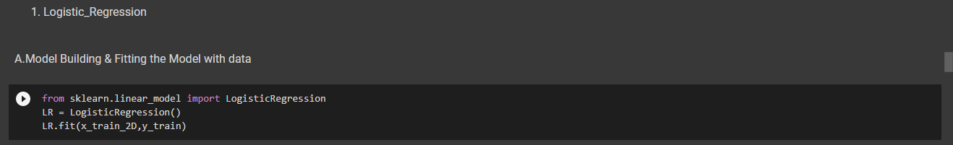

**Random Forests:**

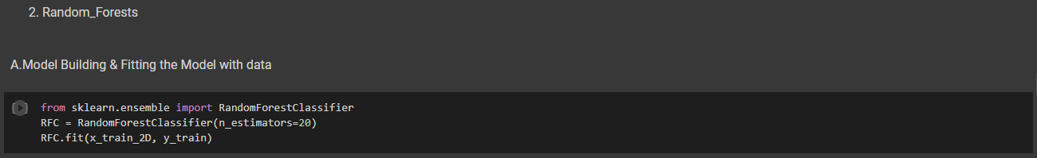

**Artificial Neural Network:**

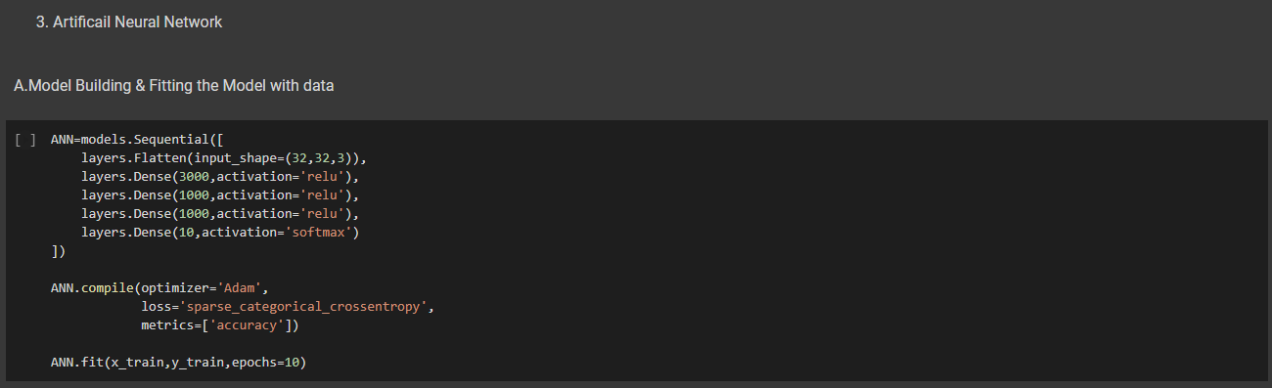

**Convolutional Neural Network:**

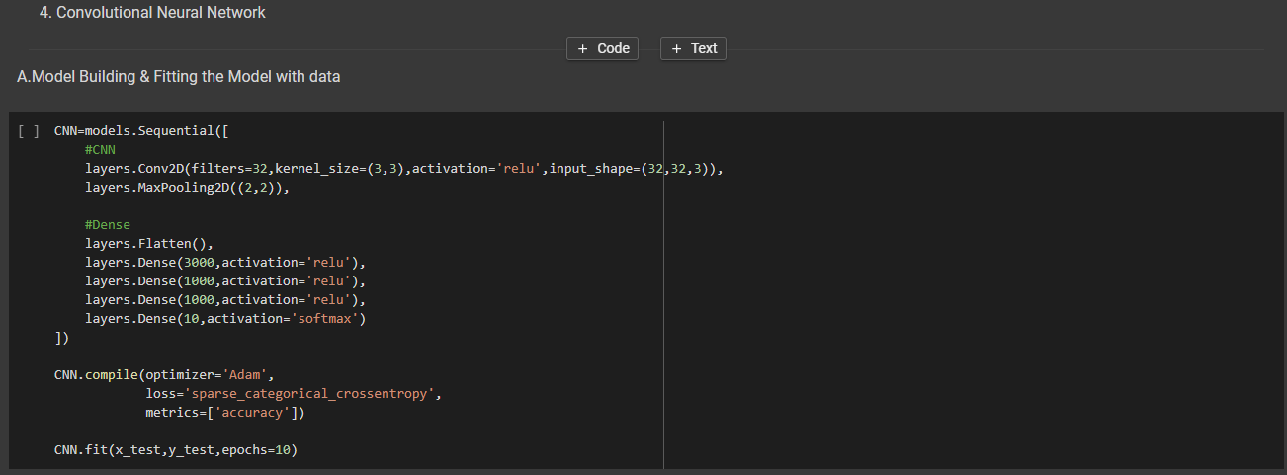

**Long Short Term Memory:**

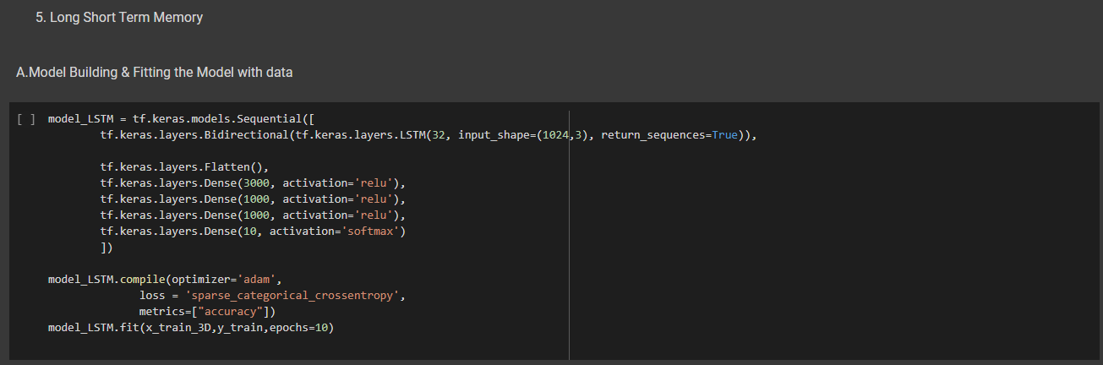

**Gated Recurrent Units:**

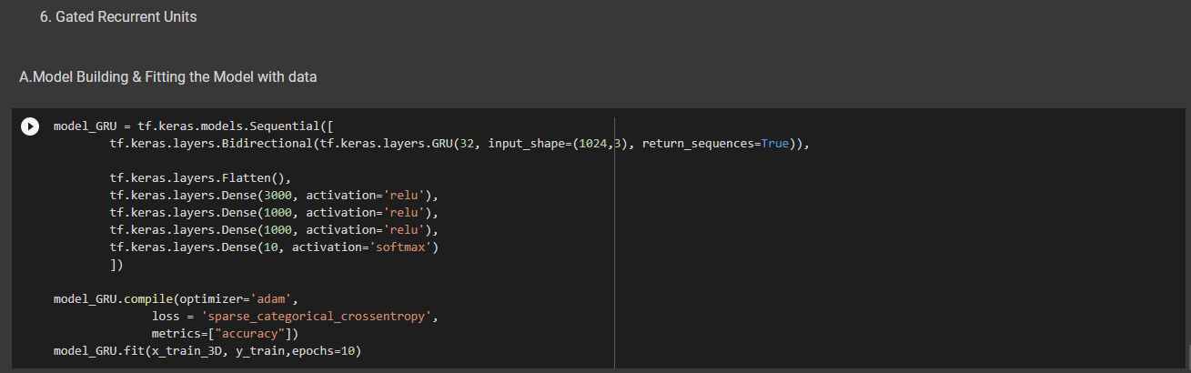

**7.2 Testing**

Valuation result of all the models used in this project:

**Logistic Regression:**



**Random Forests:**



**Artificial Neural Network:**

**Training Accuracy:**

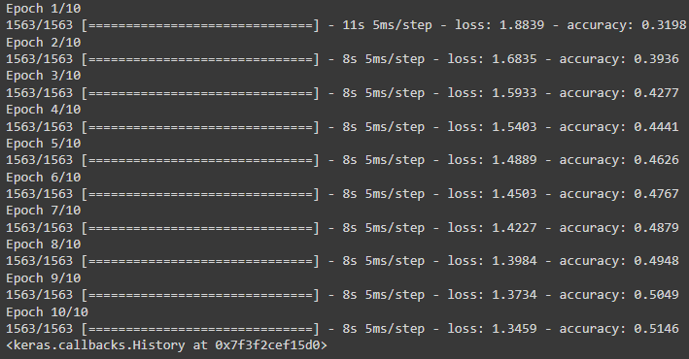

**Evaluation:**



**Convolutional Neural Network:**

**Training Accuracy:**

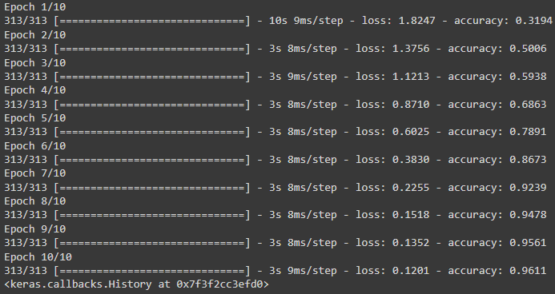

**Evaluation:**



**Long short Term Memory:**

**Training Accuracy:**

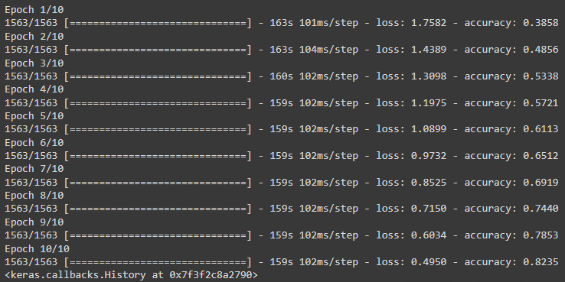

**Evaluation:**



**Gated Recurrent Units:**

**Training Accuracy:**

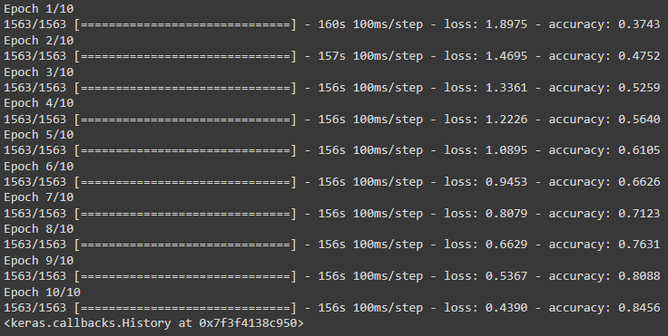

**Evaluation:**



1. **Results & Discussions**

**Classification Report table for all the models used**

**S.NO Model Name Classification Report**

1. Logistic Regression

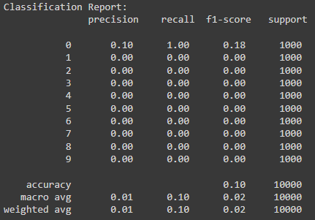

2.Random Forest Classifier

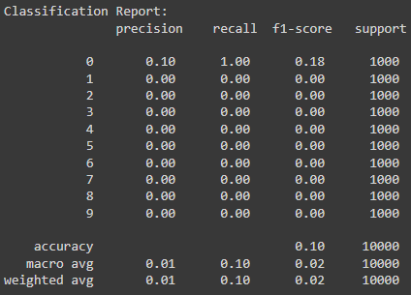

3. ANN

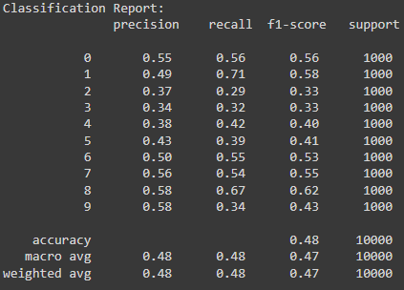

4. CNN

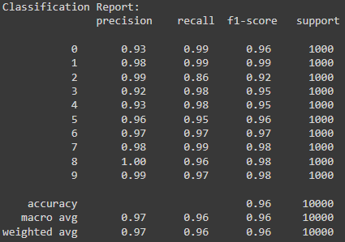

5. LSTM

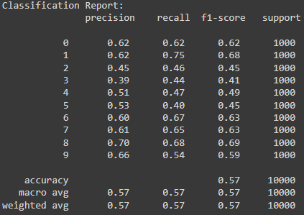

6. GRU

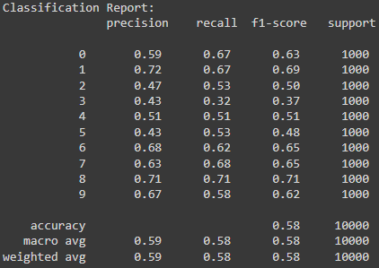

**Confusion Matrix table for all the models used**

**S .No Model Name Confusion Matrix**

1. Logistic Regression

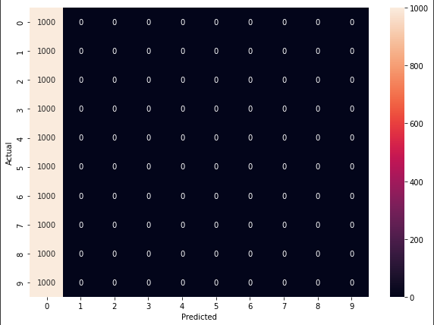

1. Random Forest Classifier

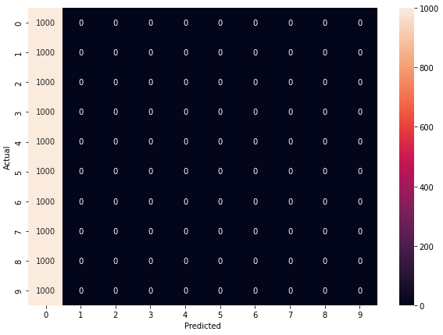

1. ANN

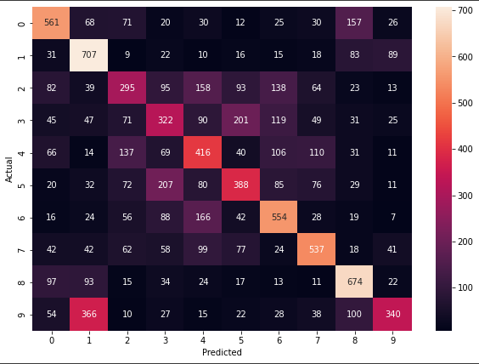

1. CNN

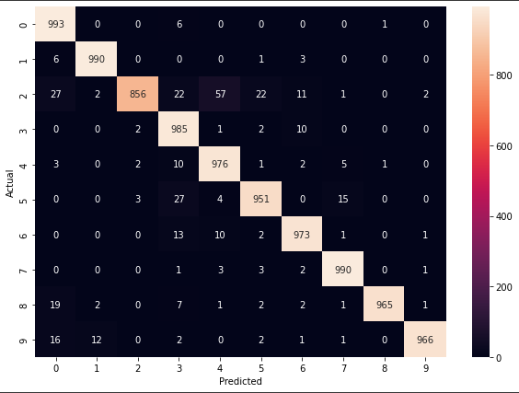

1. LSTM

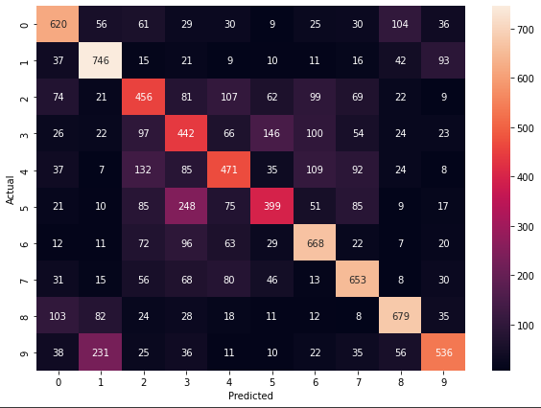

1. GRU

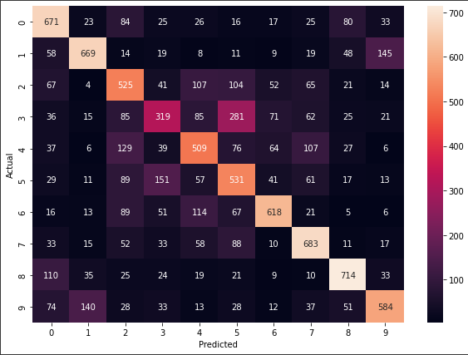

**CNN model testing:**

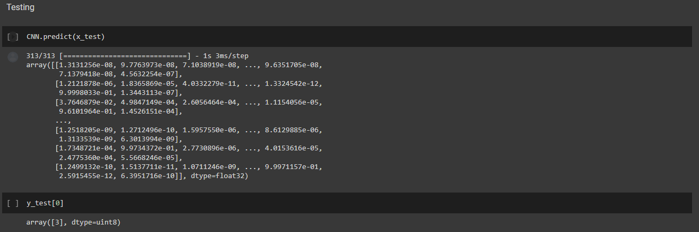

**Sneak-peek of the developed Front-End:**

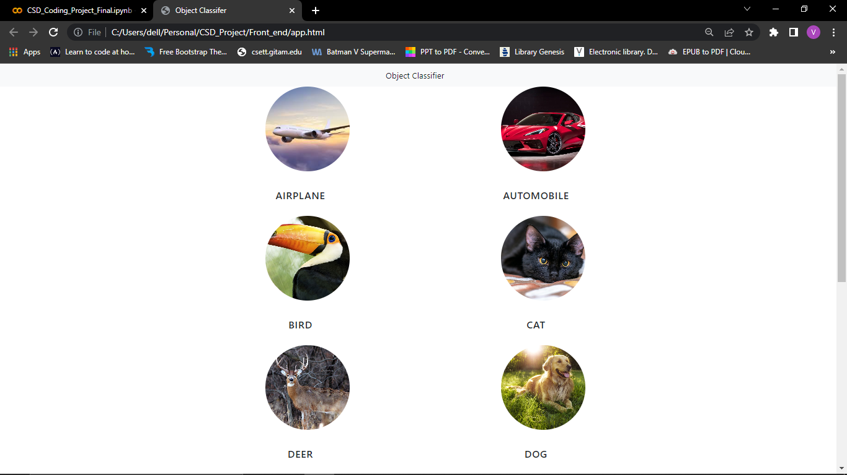

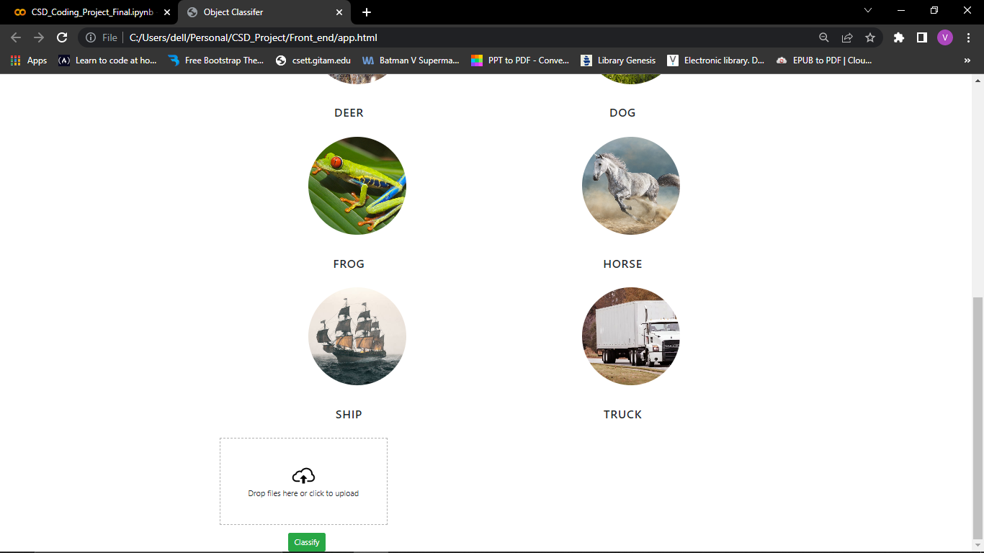

1. **Conclusion and Future Scope**

From the above classification report table and confusion matrix tables we can conclude

that CNN model gives best result on CIFAR-10 dataset .Also, CNN model gives an

accuracy of 96.11% which is very high when compared to the other models used in this

project. Thus CNN model is used as a classifier for classification images for the CIFAR-10

dataset.

In future the classifier and the developed front end can be linked with a python flask server

and can be deployed using AWS technology for the availability of the users.

1. **REFERENCES**
2. https://www.researchgate.net/
3. https://towardsdatascience.com/
4. https://www.deeplearningbook.org/
5. https://www.coursera.org/programs/gitam-open-catalogue-program-2utls?authProvider=gitam&collectionId=&currentTab=MY_COURSES&productId=W_mOXCrdEeeNPQ68_4aPpA&productType=course&showMiniModal=true
6. https://www.coursera.org/programs/gitam-open-catalogue-program-2utls?authProvider=gitam&collectionId=&currentTab=MY_COURSES&productId=8Ceijel7EeqVIgpj8IJl1w&productType=course&showMiniModal=true
7. https://youtube.com/playlist?list=PLeo1K3hjS3uvCeTYTeyfe0-rN5r8zn9rw
8. https://Wikipedia.com
9. https://youtube.com/playlist?list=PLeo1K3hjS3uu7CxAacxVndI4bE_o3BDtO