CERVICAL PROCEDURES & SURGICAL TECHNIQUES
1. Anterior Cervical Discectomy and Fusion (ACDF)
ACDF is an anterior surgical procedure utilized to resolve nerve root compression or spinal cord compression caused by disk herniations or arthritic bone spurs.
- Anatomical Corridor: The incision is located along a natural skin crease on the front of the neck. The dissection pathway splits the space between the midline structures (trachea and esophagus) and the lateral neurovascular structures (carotid sheath).

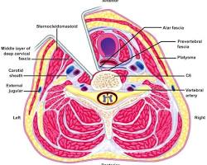
anterior cervical spine surgery approach anatomical dissection pathway

- Surgical Decompression: The target intervertebral disc is completely excised down to the posterior longitudinal ligament. Specialized instruments slice away osteophytes (bone spurs) compressing the spinal cord or exiting cervical nerve roots.

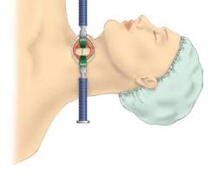

cervical spinal decompression surgery illustration osteophyte removal
- Anatomical Stabilization: An interbody fusion cage or bone graft is placed inside the vacant disc space to restore normal formatting height and lordotic alignment. A titanium anterior plate is screwed across the adjacent vertebral bodies to ensure structural fixation while bone fusion matures.
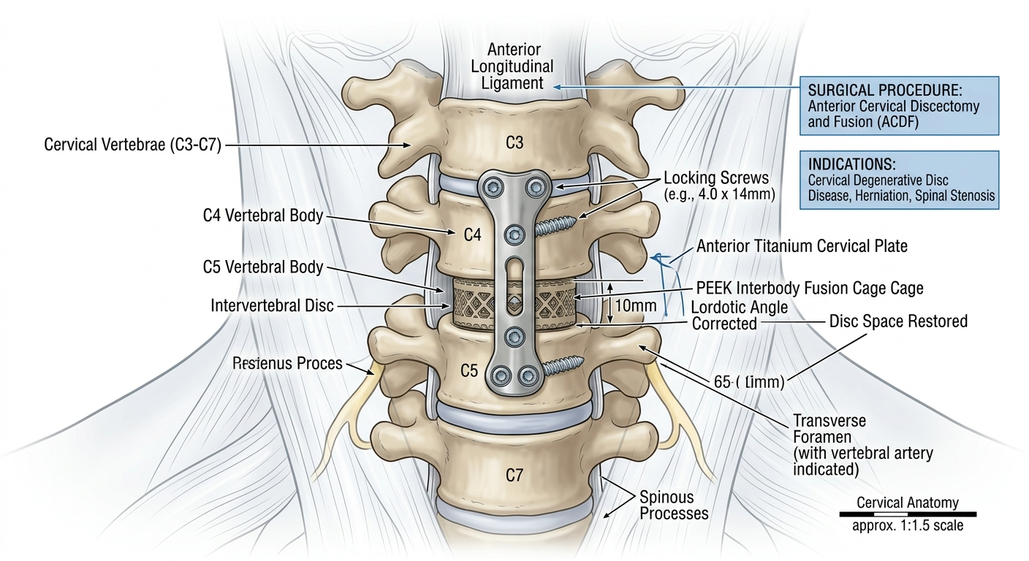

anterior cervical plate and cage fusion illustration

2. Cervical Artificial Disc Replacement (ADR)
Cervical Artificial Disc Replacement (or total disc arthroplasty) serves as a motion-preserving alternative to structural fusion for single or two-level disease in patients free from advanced facet joint arthrosis.
- Anatomical Corridor: Employs the identical anterolateral retro-visceral corridor as the ACDF procedure, ensuring minimal disruption to posterior musculature.



cervical artificial disc replacement anatomical approach
- Motion Preservation: Rather than bridging the functional spinal unit with a rigid cage/graft, an articulating prosthetic implant made of medical metals and high-density polymers is anchored into the structural disc space.
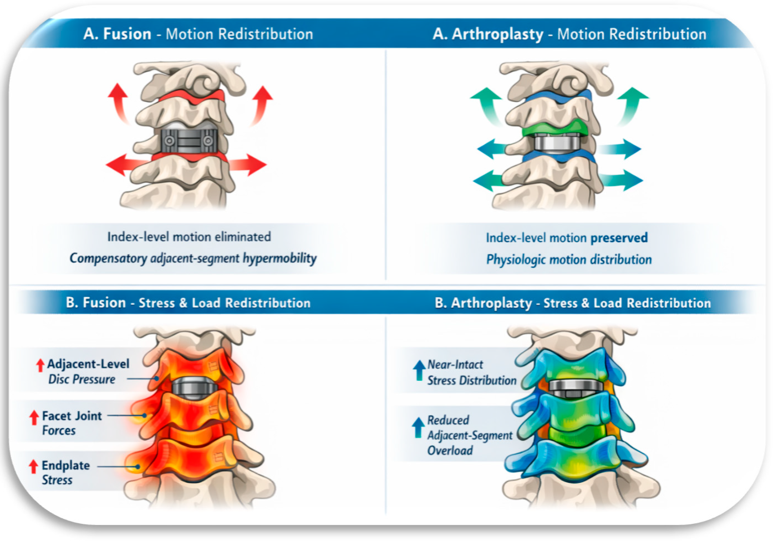
A review of motion preserving cervical implant and fusion constructs

- Biomechanical Integrity: The implant mimics natural segmental kinematics (flexion, extension, lateral bending), maintaining normal physiological load sharing and buffering adjacent levels from accelerated stress.
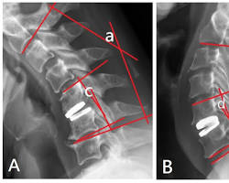
biomechanical illustration of cervical artificial disc replacement range of motion.
3. Posterior Cervical Foraminotomy
This posterior decompression method is indicated when neural impingement is strictly localized to the exit channel (neural foramen) by a lateral disc fragment or foraminal bone spur.
- Anatomical Corridor: The patient is oriented in a prone position. A midline or paramedian posterior longitudinal neck incision is carried out to reflect paraspinal muscles away from the lamina and facet complexes.
- Keyhole Decompression: Operating under high microscopic view, a partial laminectomy and a partial medial facetectomy are carefully performed. This small 'keyhole' unroofs the osseous boundaries of the neural foramen to free the entrapped nerve root
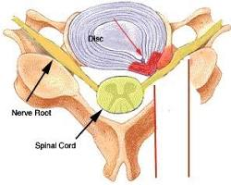.
posterior cervical foraminotomy keyhole decompression anatomy diagram

- Anatomical Benefit: The structural mechanics of both the anterior columns and core posterior elements stay completely intact, bypassing any requirement for hardware stabilization or fusion cages.

4. Cervical Laminoplasty
Laminoplasty is an extensive reconstruction technique designed for multi-level central spinal stenosis and cervical myelopathy, providing canal expansion while preserving segmental range of motion.
- Anatomical Corridor: A posterior midline incision permits wide bilateral exposure of the dorsal laminae spanning the affected levels, typically from C3 through C7.


- Reconstruction Sequence: Instead of performing a full laminectomy, a complete osteotomy is cut through the lamina on one side ('open side'). On the contralateral side, a shallow, partial groove is carved through the outer cortex to create a flexible greenstick bone hinge.
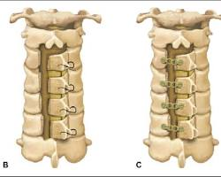

cervical laminoplasty open door technique bone hinge diagram

- Canal Expansion: The rigid lamina arch is gently swung outward like a door. This opens the central canal cross-section, allowing the compromised spinal cord to shift posteriorly away from anterior compressive segments. Specialized titanium mini-plates are screwed into place to maintain the open position permanently.

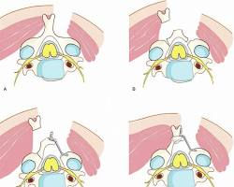
open door laminoplasty procedure spinal surgery diagram

