Motion Preservation in Spine Surgery
The Science Behind Restoring Natural Biomechanics
In the field of modern spine surgery, Motion Preservation represents a major shift away from traditional, rigid fusion techniques toward treatments that maintain the spine’s natural flexibility and movement. When a spinal segment is fused, it becomes a single, immobile unit. While fusion can successfully relieve pain, it alters the natural mechanics of the neck. Motion preservation techniques—such as Total Disc Arthroplasty (TDA)—aim to treat the underlying pathology while keeping the joint moving naturally.
The Biomechanical Strategy: Fusion vs. Motion Preservation
Understanding how motion preservation changes the long-term health of the spine, requires looking closely at how kinematic stress moves through the cervical vertebrae columns:
[ Traditional Fusion (ACDF) ]  1. Eliminates movement at the treated index level.  2. Forces adjacent levels to bend and twist further to compensate mechanically.  RESULT: High localized pressure on neighbouring discs (Adjacent Segment Disease). | [ Motion Preservation (ADR/TDA) ]  1. Replicates natural flexion, extension, and multi-axial axial rotation.  2. Keeps physiological stress distribution normal across the spine.  RESULT: Neighbouring cervical discs are protected from extra wear and tear.

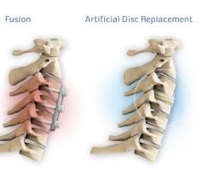
Cervical artificial disc replacement vs fusion motion preservation
Core Clinical Benefits of Motion Preservation
1. Protection Against Adjacent Segment Disease (ASD)
The most significant benefit of motion preservation is protecting the structural integrity of the rest of the spine. When a cervical segment is locked via fusion, the discs immediately above and below it experience a sharp, unnatural increase in intradiscal pressure and shear stress. Over time, this accelerated wear and tear often leads to symptomatic degeneration, requiring secondary surgical revisions. Maintaining kinematic mobility keeps load distribution balanced.
2. Maintaining Natural Neck Flexibility
Patients who undergo motion preservation surgeries retain their natural physiological range of motion. Preserving synchronized flexion, extension, lateral bending, and axial rotation allows patients to maintain a fluid, normal quality of life. This is uniquely crucial for young, active individuals and professionals who rely on physical mobility.
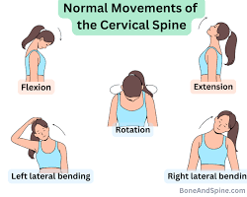
cervical spine range of motion flexion extension lateral bending rotation
3. Avoiding Fusion-Related Complications
- Pseudarthrosis Elimination: Because motion preservation relies entirely on instant mechanical anchoring rather than biological osseous integration, there is absolute zero risk of the bones failing to fuse (non-union).
- No Structural Bone Harvesting: Eliminates autograft structural harvesting procedures (e.g., iliac crest site pain) or reliance on high-cost synthetic bone substitutes, reducing operative times.
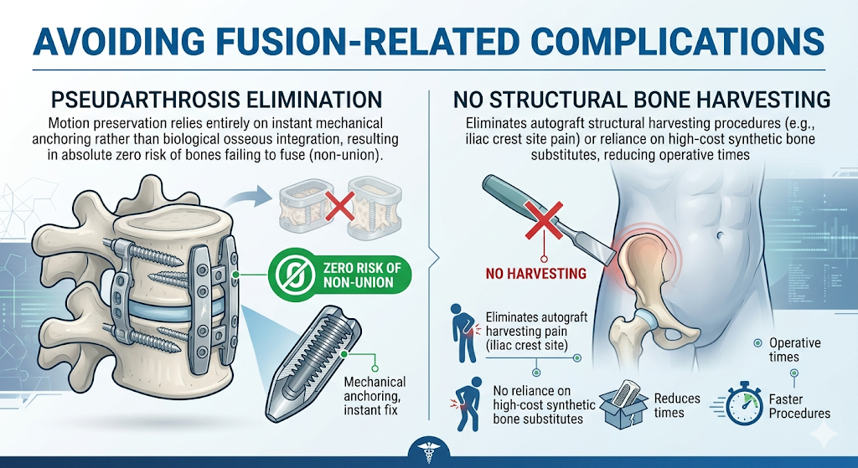

4. Faster Recovery and Mobilization
Because the artificial disc provides instant mechanical stability immediately post-implantation, patients avoid uncomfortable, prolonged rigid post-op neck braces. Early, controlled movement exercises are safe immediately following the operation, effectively preventing muscle atrophy and accelerating the safe rweturn to daily workflows.
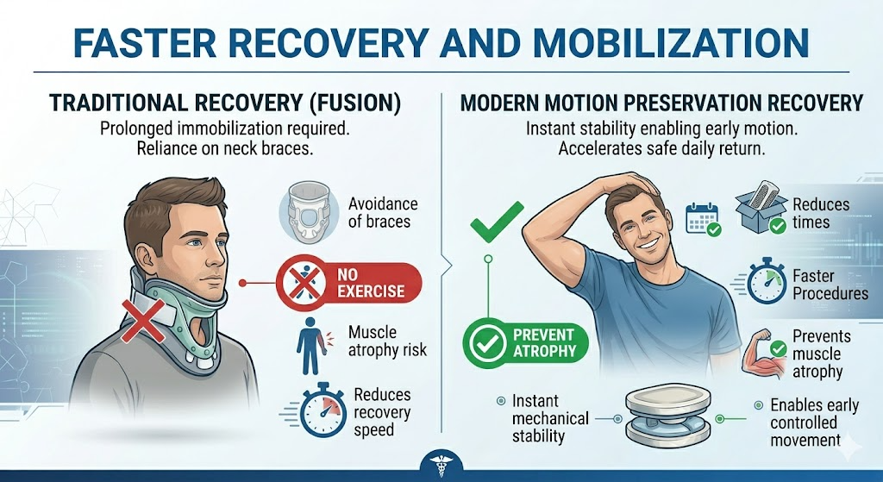
The ILT Spine Approach to Motion Preservation
The ILT Spine Artificial Disc is engineered specifically around these physiological principles. By mimicking the exact structural center of rotation of a healthy human disc, it integrates seamlessly within the mobile cervical spine. This design provides long-term kinematic performance while simultaneously protecting the surrounding prevertebral soft tissues and delicate posterior facet joints from accelerated mechanical wear.
Advancing Patient Outcomes
Motion preservation is more than just an alternative to fusion—it is a proactive, advanced surgical methodology focused on shielding and preserving long-term global spinal health.

