6. SCREENSHOTS
6.1 Admin Page
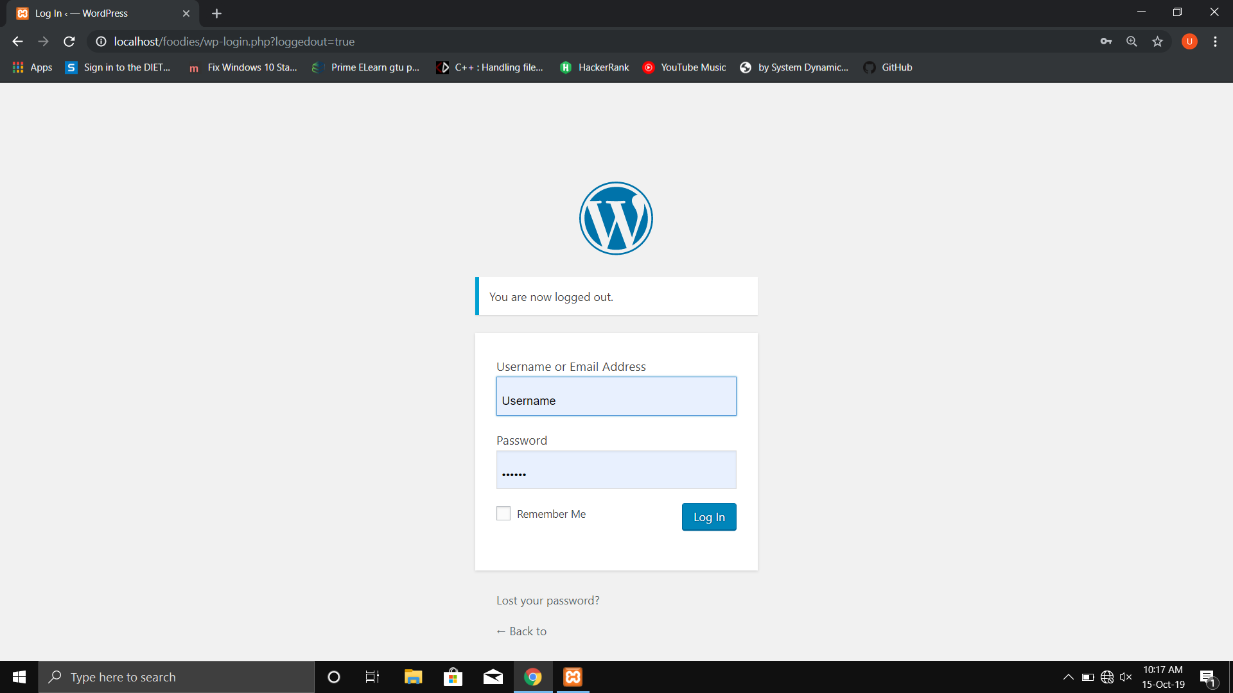
Fig. 6.1

- Admin of the system can log in through this page.
- Admin panel is displayed once logged in.
- Admin can manage pages, products, etc from here.

6.2 Store Page
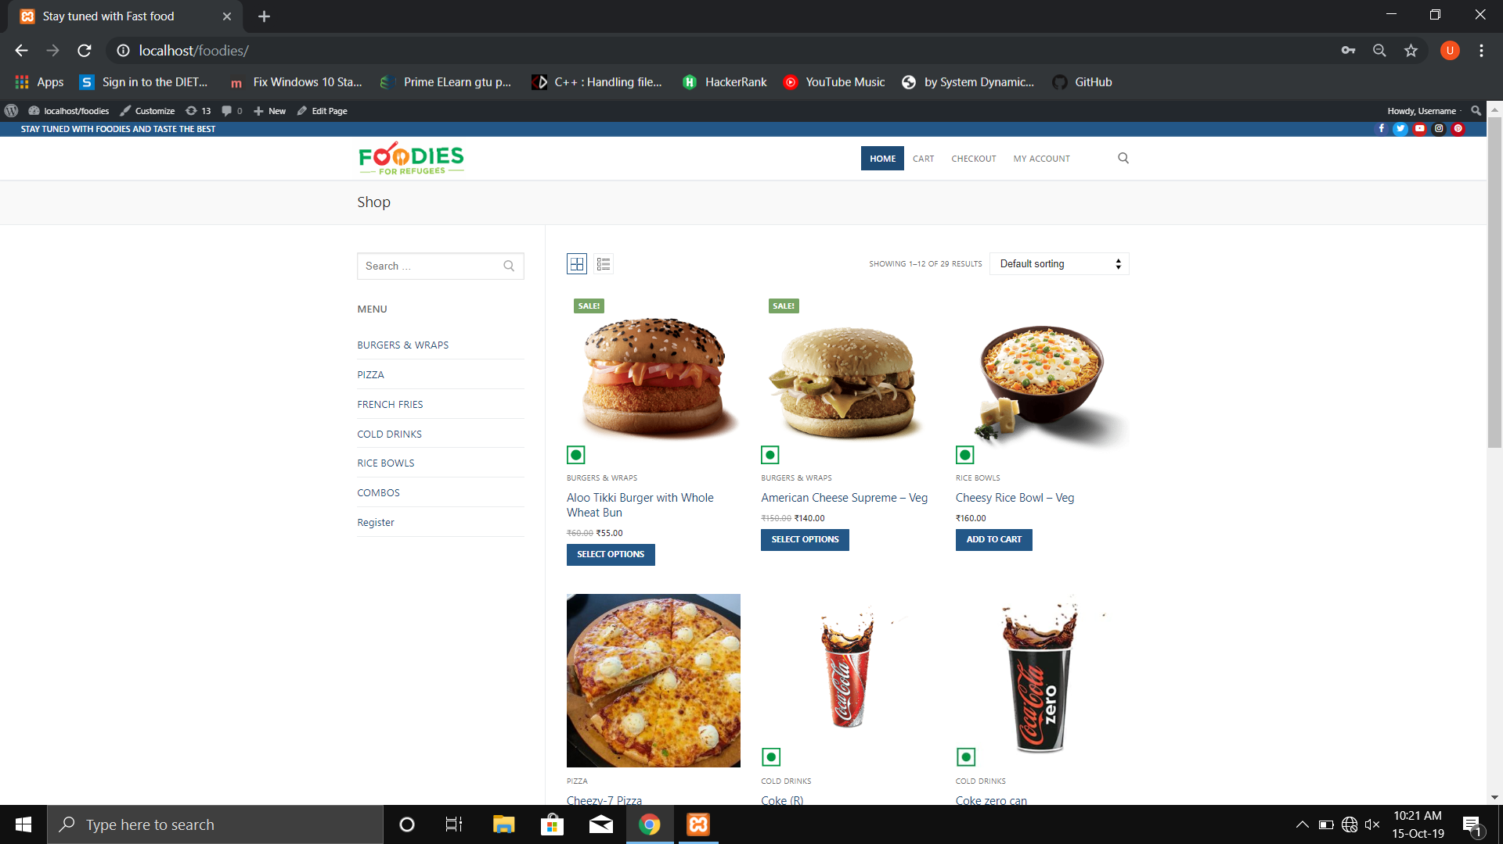
Fig. 6.2

- Main store page is displayed as above.
- Products are listed with price and with different available options.
- User can search products or filter by category.

6.3 Store Page
Fig. 6.3

- Main store page is displayed as above.
- Products are listed with price and with different available options.
- User can search products or filter by category.

6.4 Product Detail Page
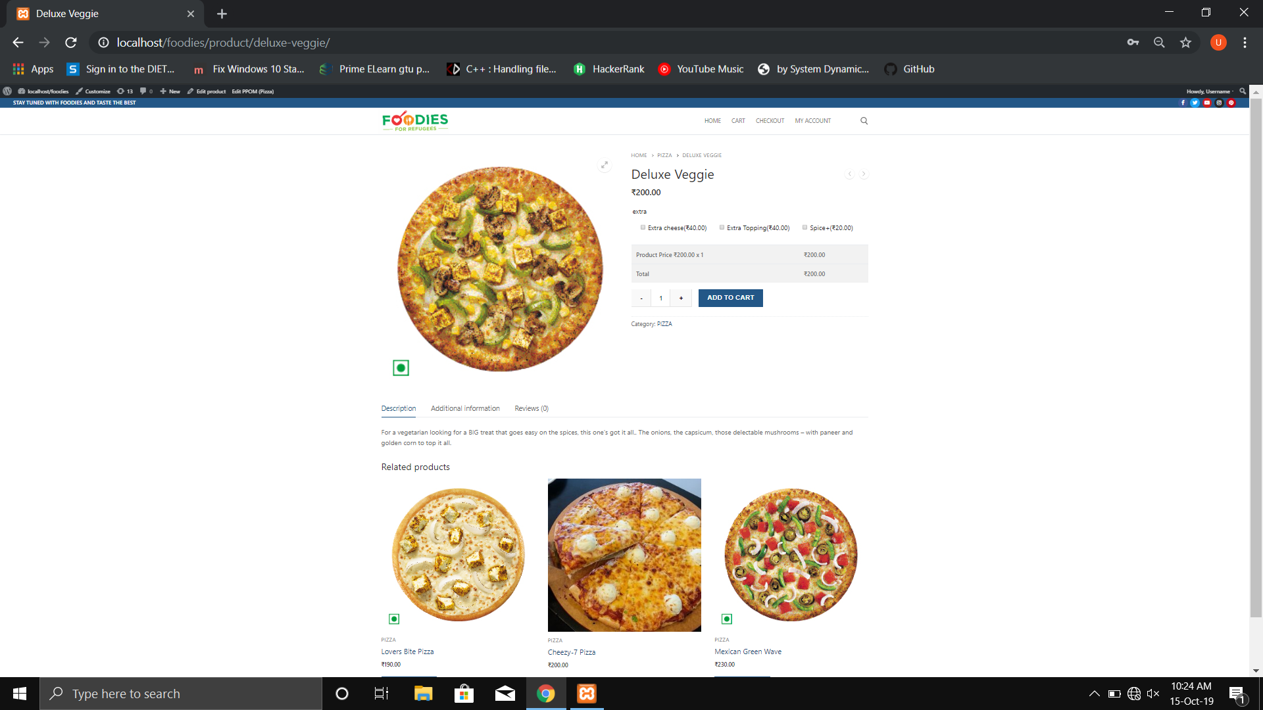
Fig. 6.4

- Product details are displayed with all details on this page.
- User can select topping and cheese options.
- User can add item to cart or purchase directly.

6.5 Products Page
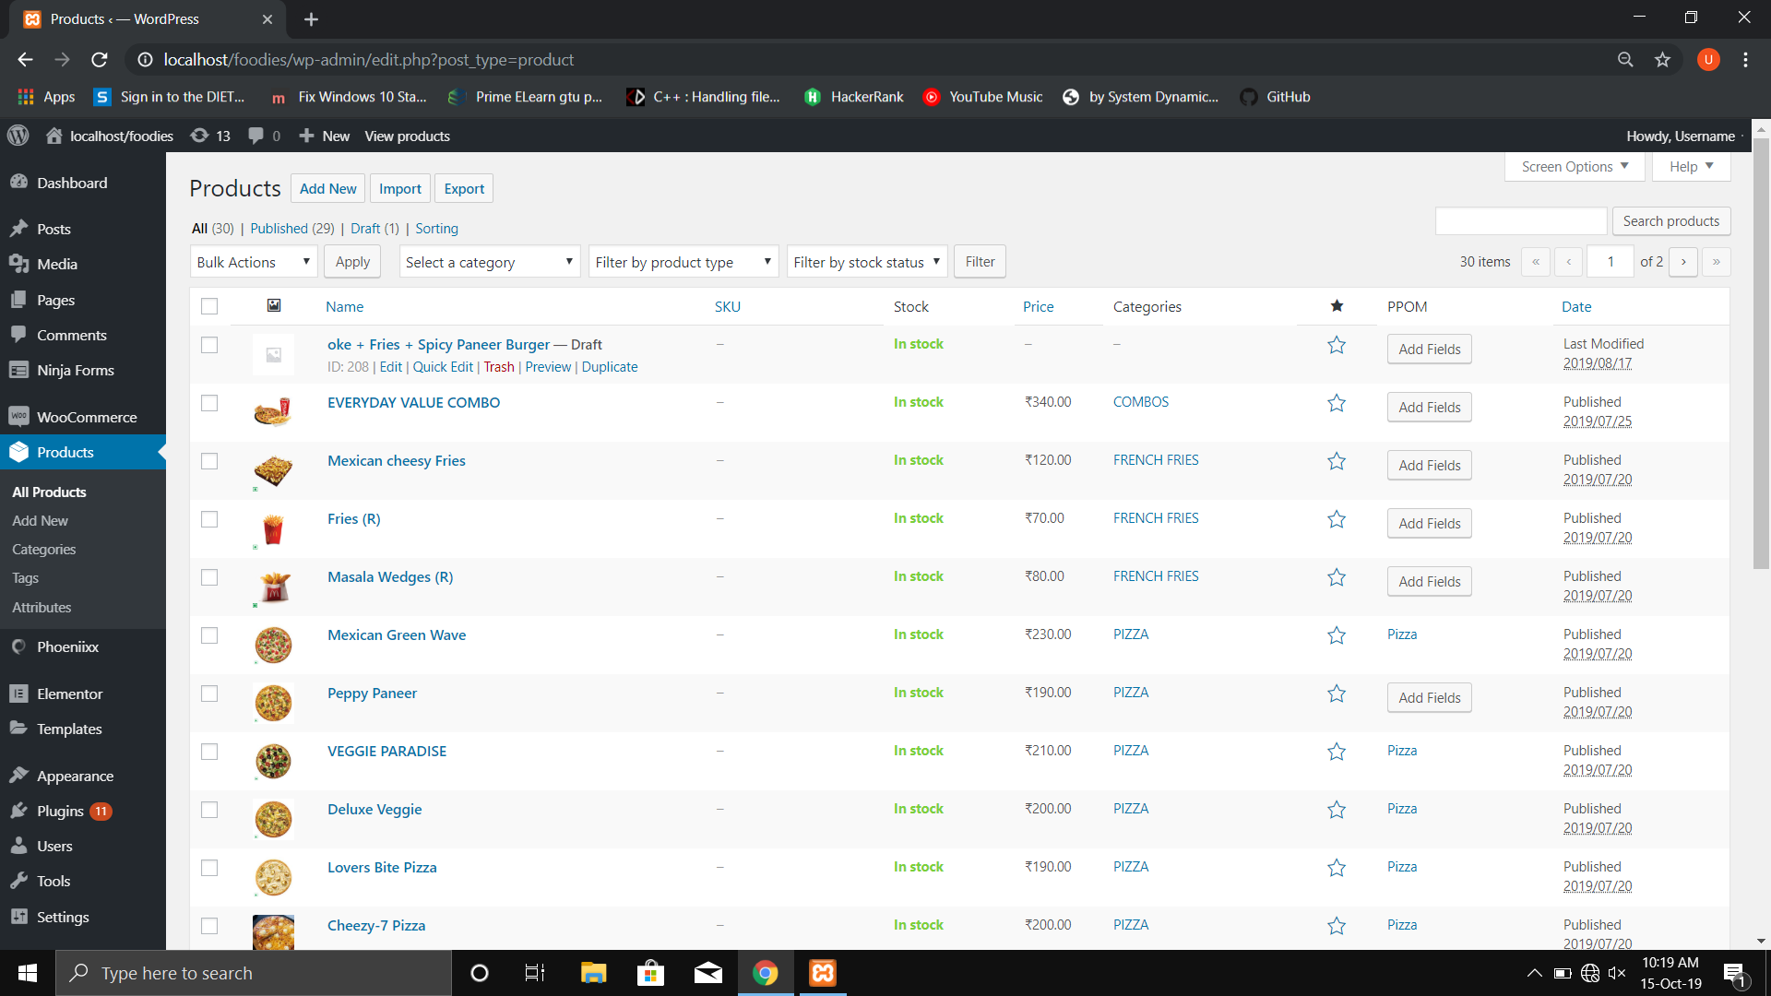
Fig. 6.5

- This is admin product management page.
- Admin can add, edit and delete products from here.

6.6 Media Library
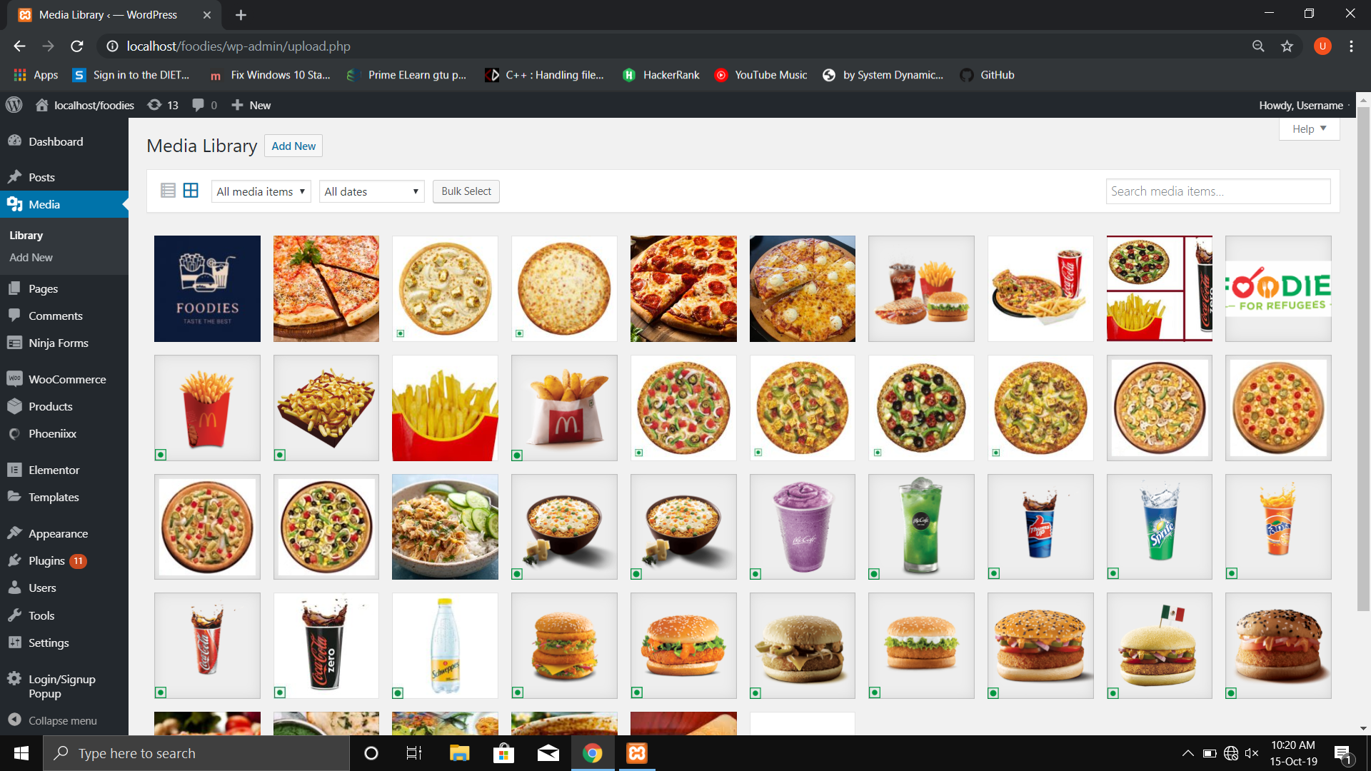
Fig. 6.6

- Media Library can be accessed by admin.
- It contains all the media of the website.

6.7 Cart Page
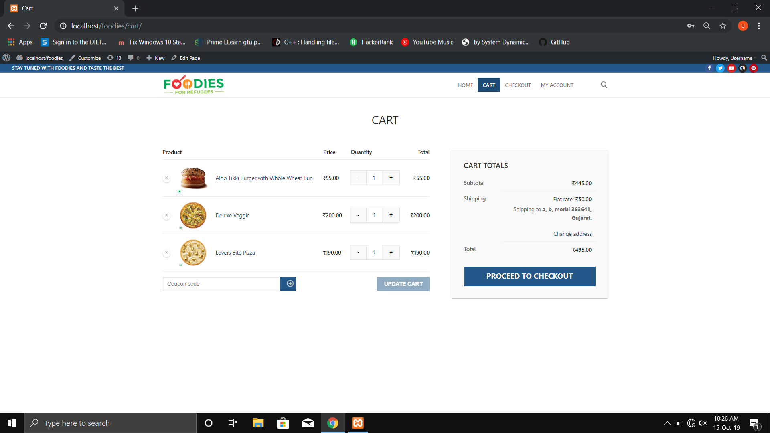
Fig. 6.7

- User can view their cart items as shown above.
- It displays all added items with selected items, quantity and price.
- Checkout is also available.

6.8 Checkout Page
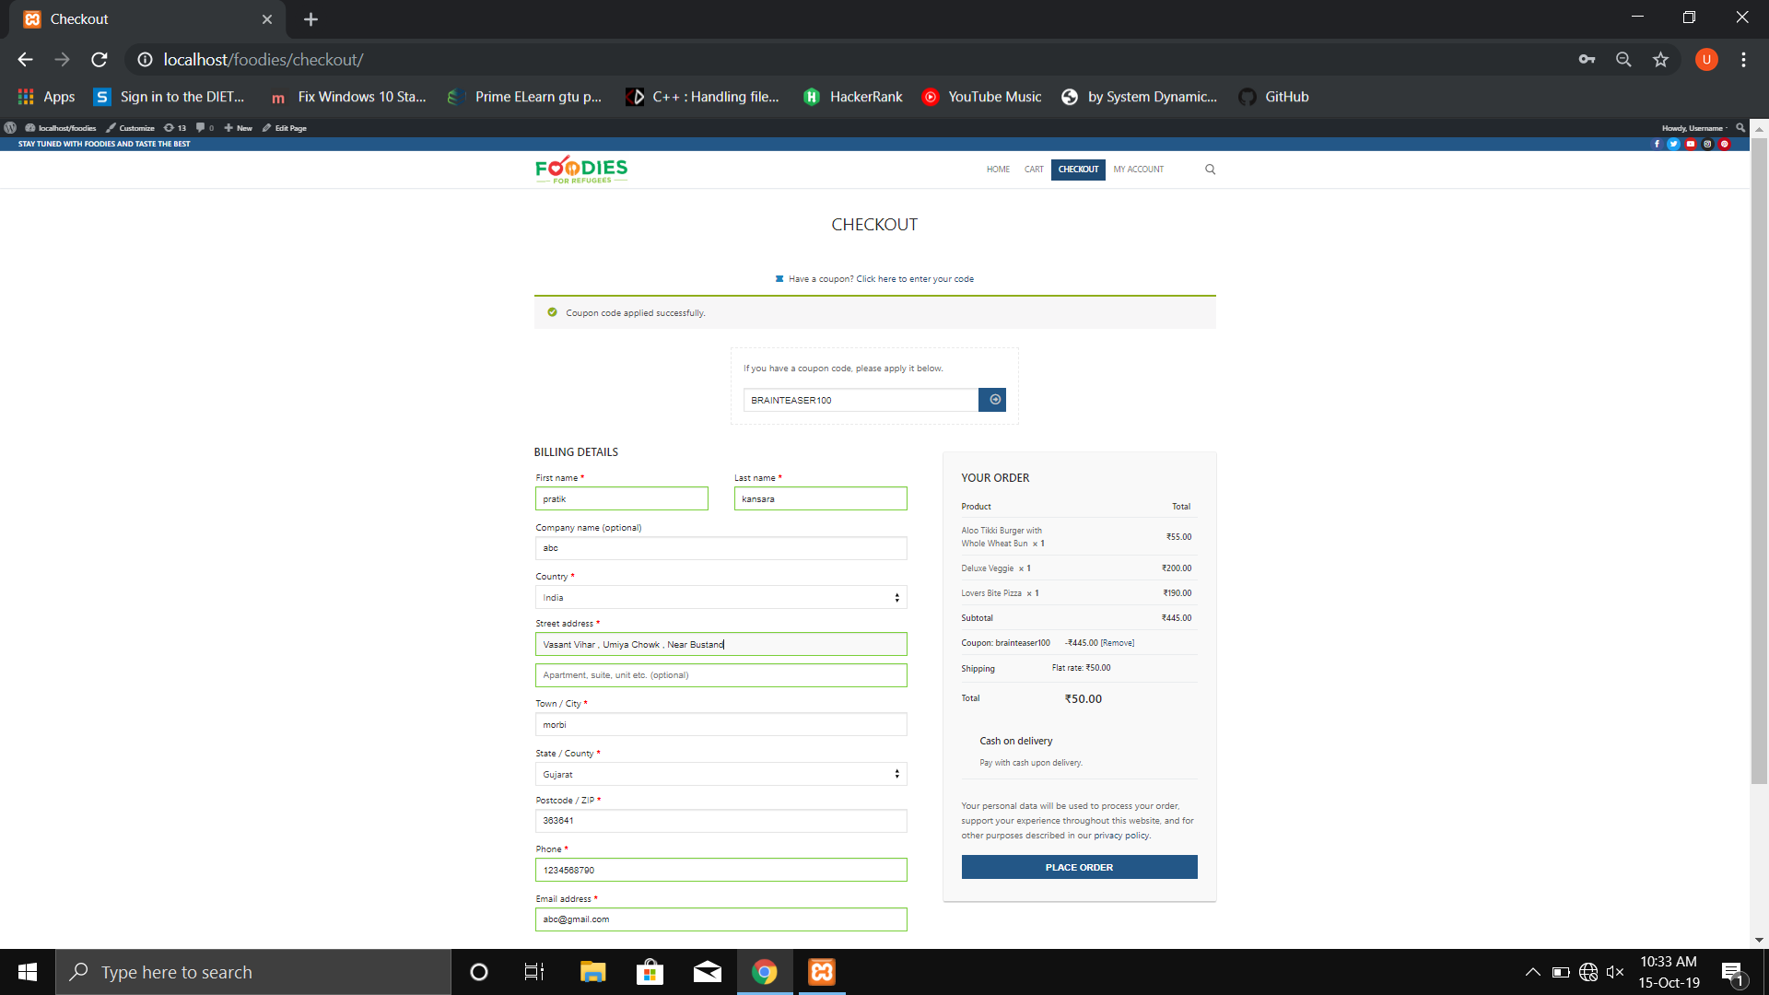
Fig. 6.8

- Checkout page contains form where user has to fill out their details.
- It also shows a summary of order.
- Coupon can be applied if the user has one.

6.9 User Login Page
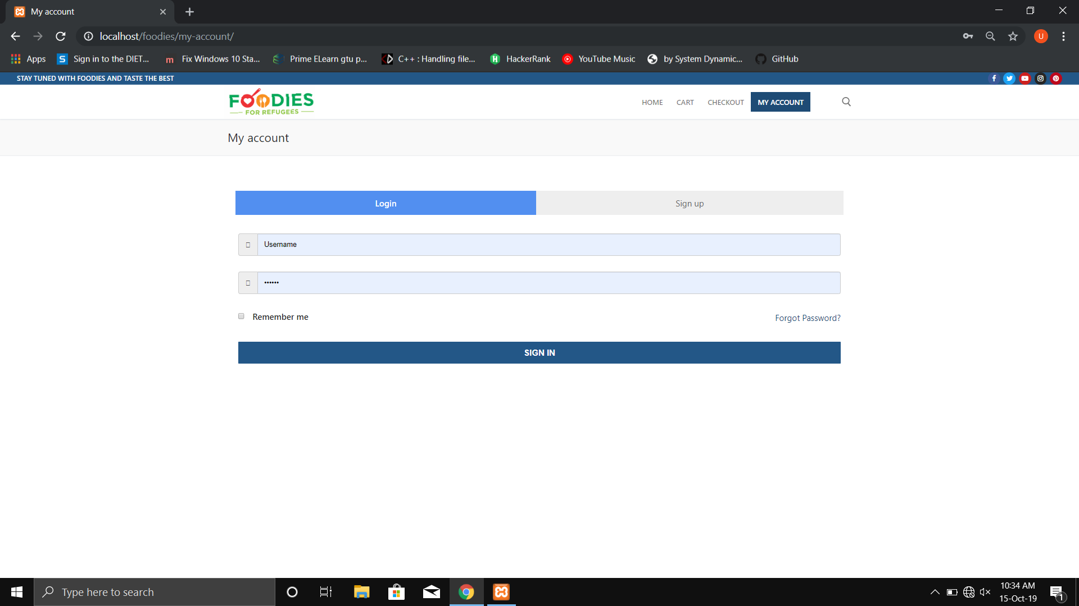
Fig. 6.9

- Users can login from here.
- Forgot password option is also available which sends a reset link to user through email.

6.10 Register Page
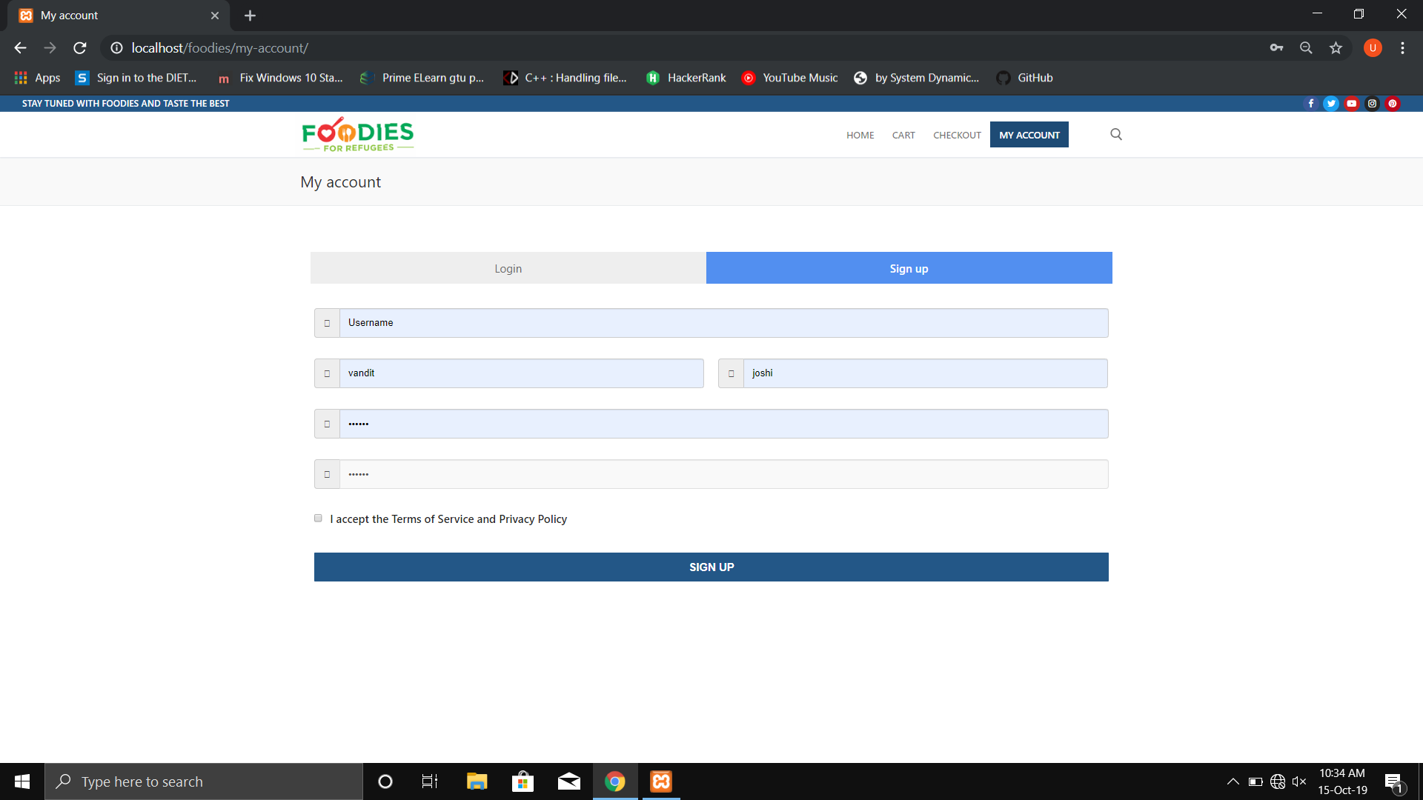
Fig. 6.10

- User can register by filling up the details above.
- User must accept the terms & conditions.

