Market Signal Project Architecture
  - Technical design and code review
Reviewed 6 September 2026
Market Signal is a Streamlit application that discovers up to three competitors, collects live search evidence, and produces validated research cards and a downloadable JSON snapshot. LangGraph controls a bounded, sequential competitor queue; web and news requests for each competitor run concurrently.

Design scope
Original concept | Implemented design
Groq LLM in researcher | OpenRouter in discovery and analyst; researcher makes direct search calls
ReAct agent calling tools | Fixed LangGraph workflow; no autonomous tool-selection loop
youcom_tools.py wrapper | youcom_client.py is called directly
Web, news, academic search | Web and news sections of You.com's unified Search API; academic search is not implemented
Analyst after research | Analyst runs for each competitor, then routing checks the remaining queue
JSON report output | Pydantic report objects displayed as cards and serialized for download

These are deliberate descriptions of the current code. Adding Groq, academic search, or an agentic tool loop would be a separate feature change.

Implemented architecture
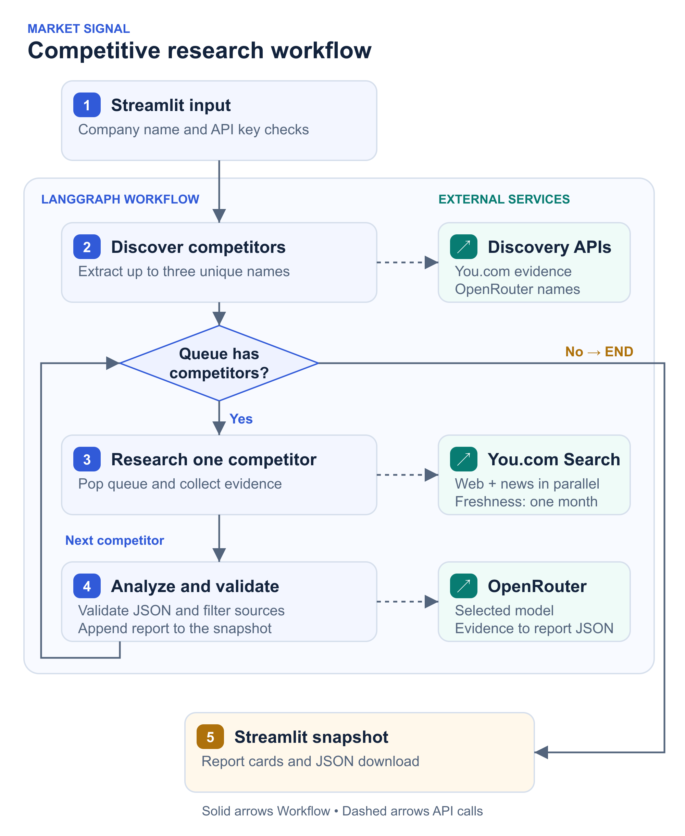
Figure 1 Workflow and external service calls

Components and contracts
File | Responsibility
app.py | Load local configuration, validate input/keys, run workflow, store snapshot identity, escape card HTML, render and export reports
pipeline.py | Compile discover → researcher → analyst graph, normalize the queue, stop at zero competitors
youcom_client.py | POST Search API requests, select web/news sections, retain snippets and dates, filter URLs, execute two searches concurrently
analyst.py | Extract names, request report JSON, normalize with Pydantic, restrict source URLs to supplied evidence
models.py | SearchResult, CompetitorReport, and ResearchState contracts
test_pipeline.py | Offline graph, parser, analyst, HTTP contract, and Streamlit regression tests
scripts/check_secrets.py | Pattern-based credential scan of tracked and unignored files
.github/workflows/ | Credential scan and Python regression checks

State and output
ResearchState contains company, competitor_queue, current_competitor, search_results, reports, and status. Search results hold only the current competitor's evidence and are overwritten on the next pass. Reports accumulate within the run.
CompetitorReport contains name, website, summary, positioning, pricing, features, recent_news, strengths, watchouts, and sources. List/text normalization accepts common model shape variations. Pydantic checks structure, not factual truth. Evidence URL filtering prevents invented citations from being displayed but does not prove that each claim is supported by its cited source.

Runtime sequence
- Streamlit clears the previous snapshot on a new run, validates a nonblank company and API keys, and constructs the search client and analyst.
- Discovery queries You.com for competitor evidence. If evidence is empty, it returns no competitors without calling the model.
- OpenRouter extracts up to three company names. Names are trimmed, deduplicated case-insensitively, and filtered to exclude the target. The pipeline also enforces these queue invariants.
- Research pops one name and runs two requests in a two-worker thread pool: product/pricing research selects results.web; recent-news research selects results.news with freshness=month. Each category retains up to eight unique HTTP(S) results and up to 6,000 snippet characters per result.
- Analysis sends category-labelled evidence, URLs, and available dates to OpenRouter. Empty evidence produces an “Evidence unavailable” report without model invocation. Model JSON is normalized and validated.
- Report identity is set from the queue. Website and source URLs not found exactly in the evidence are removed; source duplicates are removed.
- The graph appends the report and loops while the queue is nonempty. Terminal status reports completion or zero discovered competitors.
- Streamlit stores the company alongside the reports so editing the input cannot relabel an existing snapshot. A new run clears the old snapshot. JSON download includes company and an array of serialized reports.
There are at most seven search calls and four initial model invocations for three competitors. Each model stage can regenerate once for invalid output, for up to eight model invocations before SDK retries. Empty evidence can reduce model calls. Competitors run sequentially; only the two searches within a competitor run concurrently. A legacy title-based search_competitors fallback remains for clients without evidence discovery; the application uses the evidence/LLM path.

Configuration and external boundaries
Use Python 3.12 for the tested environment. See README for setup.
Variable | Behavior
OPENROUTER_API_KEY | Required model credential
YDC_API_KEY | Required You.com Search API credential
OPENROUTER_MODEL | Defaults to openrouter/free in code and example configuration
APP_URL | Optional OpenRouter attribution; defaults to localhost
YDC_SEARCH_ENDPOINT | Optional trusted endpoint override; receives the search API key

The adapter uses POST https://ydc-index.io/v1/search with an X-API-Key header. Parsing follows the documented separate web/news result sections, snippets, and page_age field. You.com Search API reference.
OpenRouter is called at https://openrouter.ai/api/v1 via ChatOpenAI. The default model identifier is configuration, not a guarantee of provider availability. Search service charges and model limits depend on the account and selected model. The LLM client has an explicit 45-second request timeout and two SDK retries; these do not impose a total workflow deadline.
Company queries are sent to You.com; company names and retrieved evidence are sent to OpenRouter. Credentials stay in local environment configuration. There is no database, durable checkpoint, email delivery, or background job.

Review findings and changes
Gap found | Resolution
News section discarded and descriptions used without snippets | Select the requested category; preserve snippets and publication dates
News limited to one day | Use a month filter to cover less frequent company announcements
Default paid model conflicted with free-router documentation | Align code default with .env.example
Discovery forced exactly three names and could retain whitespace-padded target | Allow fewer names, skip empty evidence, normalize queue
Model could change report name or invent citations | Enforce queue identity and exact evidence-URL membership
Untrusted report text interpolated into HTML | Escape names, summaries, positioning, and source text
Input edits relabelled old reports; failed reruns left old output | Store snapshot company and clear snapshot when starting a run
JSON output not exportable | Add JSON download
Final status remained “Researched …” | Set completion status after final analysis
Smoke script omitted an existing test; CI ran only secret scan | Discover every test and add Python test CI
Diagram had overlapping components and unsupported retry claims | Replace diagram and document actual failure behavior

Failure behavior and remaining gaps
- Blank input fails before API work. Empty discovery completes with zero cards.
- Search uses a 12-second request timeout and no application retry. A 401 or 403 has a targeted message. Other HTTP/network failures stop the run.
- LLM SDK retries selected transient failures. Discovery and analysis each regenerate once from the original evidence if output is empty, malformed, or fails validation. Text-block responses and fenced JSON are supported. A second invalid response stops the run with an actionable model-configuration message instead of a raw parsing traceback. No provider fallback is implemented.
- A failure in either search or any competitor aborts the run. Earlier reports from that run are not recovered or shown. Partial-result recovery and category-level failure handling remain future work.
- The UI shows run-level progress, not streamed node events.
- Search snippets are untrusted. Prompts instruct the model to treat them as data; stronger claim-level verification and prompt-injection evaluation remain open.
- Dependencies have minimum versions rather than a reproducible lockfile. CI tests Python 3.12; other Python/dependency combinations are not certified.
- No durable evidence archive, observation timestamp, request-ID logging, or full workflow deadline exists. These matter for production auditability.
- The credential scanner checks known patterns in current files; it does not audit Git history or detect every possible secret format.

Validation
Run python -m unittest discover -v (or python test_pipeline.py) and python scripts/check_secrets.py. Regression tests use mocked external clients and Streamlit AppTest; they require no API credentials or live provider calls. The review validated the offline workflow, not live account access, model quality, provider availability, or a deployed application.

