Double-click

PetAtl
Online Retail Store

User Requirements Analysis

Document History
Prepared by: | Vijay Zarapala
Version: | DBMS.1.01
Date: | 09/30/2017
Project Board:
Sponsor: | Dr Yu Kai Lin
Reviewed By
Organization | Person
MSIS DBMS | Vinamrata K
MSIS DBMS | Apurva R
MSIS DBMS | Archana D
Revision Record
Number | Date and Sections | Notes

Acronyms
Acronym | Description
ATL | Atlanta

References
Document Title
- Team Project Fall 2017 supplied by Professor on iCollege

Table of Contents
Update
1. Introduction 1
1.1 Purpose 1
1.2 Scope of the project 1
1.3 Assumptions 1
2. Requirements List 2
2.1 High Level Requirements 2
2.2 Detailed Requirements 2
3. High Level Decomposition 3
3.1 Product list page: 3
3.2 Product details page: 4
3.3 Order check-out page. 5
3.4 Order history page: 6
3.5 Customer information page: 6
4. Glossary 7

Introduction
The following subsections of the User Requirements Analysis (URA) document provide an overview of the requirements for creating an online retail store to sell packaged dry dog food.

Purpose
The document captures the details of URA and presents the development team with info for building a frontend web application and a backend database.

Scope of the project
In scope: The scope of the project is limited and the following are in it
- Provide User with access to the web application to browse all products
- Allow user to place order with the details like product, no of units, price, customer info
- Prompt user to login if the user holds an account or ask user to create an account
- Provide user to store details like billing and shipping address, credit card
- Allow user to make payments using a credit card payment mode
- Allow user to modify or cancel a placed order
- Store the order details in database
- Store the details about shipping mode and provide those details upon request
Out of scope: The following are out of scope for this project
- Product supply
- Inventory management
- Reason for cancelation
- Requesting refund
- Processing refund

Assumptions
- Credit Card: shipping & billing address are the same

Requirements List

High Level Requirements
ID Number | Priority | Requirement Description
Pet_Atl_001 | 1 | Creation of web application
Pet_Atl_002 | 1 | Creation of database

Detailed Requirements
ID # PetAtl_001: Creation of web applications
ID Number | Priority | Description | Remarks
Pet_Atl_001_01 | 1 | Browse all products
Pet_Atl_001_02 | 1 | Place Orders
Pet_Atl_001_03 | 1 | Check details (product, #units, price, customer)
Pet_Atl_001_04 | 1 | Prompt user to login/create an account
Pet_Atl_001_05 | 1 | Credit Card Payment
Pet_Atl_001_06 | 2 | Modify/Cancel an order
Pet_Atl_001_07 | 1 | Store Order details in database
Pet_Atl_001_08 | 3 | Ship the products to customer

ID # PetAtl_002: Creation of database
ID Number | Priority | Description | Remarks
Pet_Atl_001_01 | 1 | Display Products
Pet_Atl_001_02 | 1 | Display product details
Pet_Atl_001_03 | 1 | Create Cart
Pet_Atl_001_04 | 1 | Create login or give access to an account
Pet_Atl_001_05 | 1 | Create Order
Pet_Atl_001_06 | 1 | Make Payment and store details in database
Pet_Atl_001_07 | 2 | Modify/Cancel an order
Pet_Atl_001_08 | 2 | View Order History

High Level Decomposition

Product list page:
The first screen shows a list of available products, along with a brief information like Product details, Product Price, Product Features, Product Reviews, Product Manufacturer/Distributor name and Product Best Seller tag (if applicable)
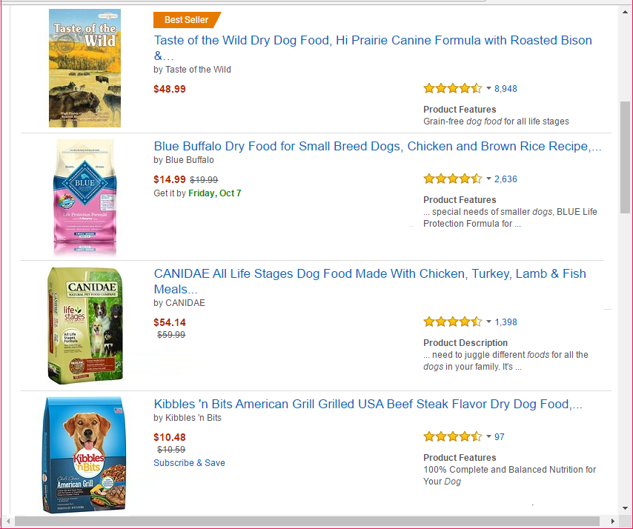
Figure 1. Item List Mock-Up Screen 1

Product details page:
Once the user selects a product in the product list page, this page displays the detailed information of the product selected and the page allows the user to place the item into an order (shopping cart)

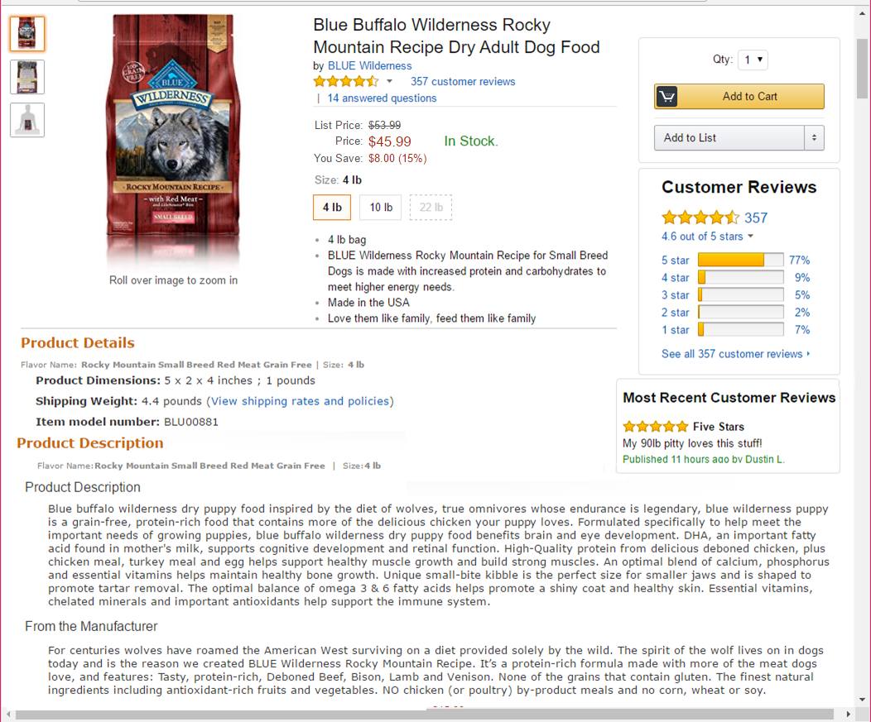
Figure 2. Product Details Mock-Up Screen

Order check-out page.
  - It displays the product placed in the shopping cart, the charge of each product and the total cost of the order including applicable tax and shipping cost. It also allows the user to select which credit card is charged for the order. The page should also allow the user to modify the order either by changing the quantity of each product or delete a product from the order.
  - Once the user accepts the order, the order is saved and the credit card is charged.
  - The payment details have billing contact, billing address, payment method and provide with option to create an account if the user is new

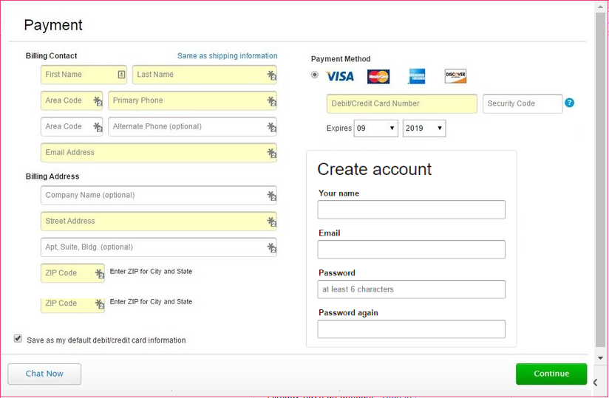
Figure 3. User Credit Card & Account Information Mock-Up Screen

Order history page:
It allows the user to list all placed orders and the delivery status of each order (in-process, in-transition, or shipped) and allows to modify or cancel a selected order.
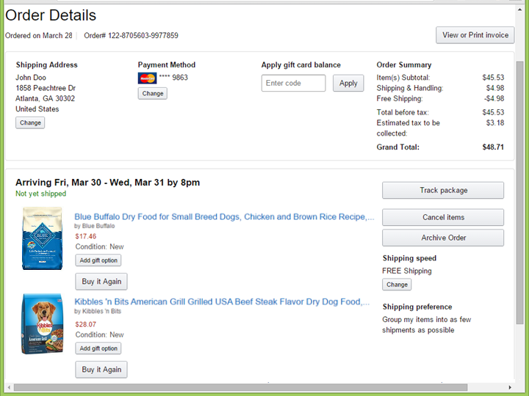
Figure 4. Order Detail Mock-Up Screen

Customer information page:
- Customer name and addresses
- Credit card information (including the card number, expiration date, card holder name and address, etc.).
- All orders placed by the customer which could be links opening the order details page.

Glossary

If there are no additional terms to define, delete the term and definition line below as well as the sentence beginning with “This section defines...” in the unhidden paragraph above.
Term | Definition
HTML | Hyper Text Markup Language
CFML | Coldfusion Markup Language
DBMS | Database Management System

Remove

