**ASSIGNMENT-2**

|  |  |
| --- | --- |
| **1** | Explain use of Divide and conquer technique for Binary search method. State its best, average and worst case complexity. Apply binary search algorithm and find the element 𝑥=31 in the following array.  10, 15, 18, 26, 27, 31, 38, 45, 59 |
| **2** | Explain Asymptotic notation. |
| **3** | Solve following knapsack problem using dynamic programming algorithm with given capacity W=5, (Weight, Value) are as follows:  (2,12),(1,10),(3,20),(2,15) |
| **4** | Apply Kruskal's algorithm to the following graph:  Edges:  A-B: 1  A-C: 4  B-C: 2  B-D: 5  C-D: 3 |
| **5** | Apply Prim's algorithm to the following graph starting from vertex A:  Edges:  A-B: 1  A-C: 4  B-C: 2  B-D: 5  C-D: 3 |
| **6** | Design and analyze algorithm for knapsack problem using greedy approach. |
| **7** | The graph shown below 8 edges with distinct integer edge weights. The minimum spanning tree (MST) is of weight 36 and contains the edges: {(A, C), (B, C), (B, E), (E, F), (D, F)}. The edge weights of only those edges which are in the MST are given in the figure shown below. What is minimum possible sum of weights of all 8 edges of this graph? |
| **8** | Explain Best case, average case, and worst case analysis of merge sort using Recursion Tree. |
| **9** | Perform a Quick Sort on the array [9, 7, 5, 11, 12, 2, 14, 3, 10, 6]. Show the steps. |
| **10** | Explain the partitioning step in Quick Sort with an algorithm and an example. |
| **11** | Suppose the letters a, b, c, d, e, f have occurrence probabilities 1/2, 1/4, 1/8, 1/16, 1/32, 1/32 respectively. Then find out Huffman code for the letter a, b, c, d, e, f? |
| **12** | Solve the Max-Min problem for the array [7, 2, 5, 3, 8, 6, 4, 1] using the divide-and-conquer approach. |
| **13** | Compare the efficiency of the naive and divide-and-conquer approaches for the Max-Min problem. |
| **14** | Describe the steps of Dijkstra's algorithm and apply Dijkstra's algorithm to find the shortest path from vertex A to all other vertices in the following graph:  Edges:  A-B: 1  A-C: 4  B-C: 2  B-D: 5  C-D: 1 |
| **15** | You have a knapsack with a capacity of 50 units. You are given the following items, each with a weight and a value. The goal is to maximize the total value of items in the knapsack using a greedy algorithm.   | **Item** | **Weight** | **Value** | | --- | --- | --- |  |  |  |  | | --- | --- | --- | | A | 10 | 60 |  |  |  |  | | --- | --- | --- | | B | 20 | 100 |  |  |  |  | | --- | --- | --- | | C | 30 | 120 | |
|  |  |

16. A fruit vendor has a basket that can hold upto 10kg. they have various fruits with different weights and values:

|  |  |  |  |  |
| --- | --- | --- | --- | --- |
|  | Apple | Bananas | Oranges | Grapes |
| Weight | 4kg | 6kg | 2kg | 1kg |
| Value | Rs. 40 | Rs. 30 | Rs. 20 | Rs. 10 |

How should they fill the basket to maximize the total value, considering that they can sell fraction of fruits.

17. A Cargo ship has a capacity of 5000kg. there are various items to be shipped with different weight and values:

|  |  |  |  |  |
| --- | --- | --- | --- | --- |
|  | Machineries | Electronics | Furniture’s | Textiles |
| Weight | 2000kg | 1000kg | 1500kg | 1500kg |
| Value | 3000$ | 2000$ | 2500$ | 1000$ |

How should they fill the cargo to maximize the total value, considering that they can sell fraction of fruits.

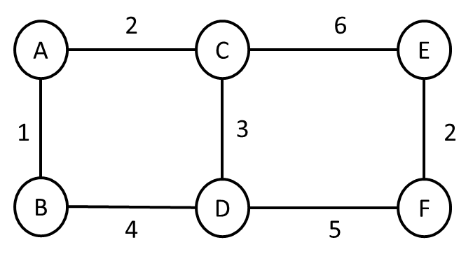18. Use Kruskal’s and Prims algorithm to find the MST from vertex A for the below graphs

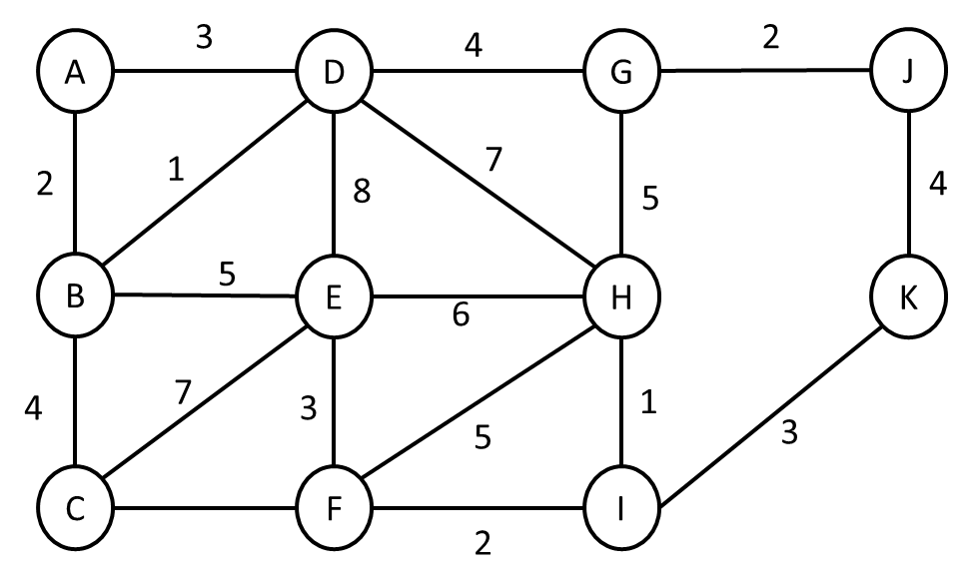

19. Find the Huffman code and draw the Huffman tree for the given message with characters and their frequency of occurrence is given as below,

|  |  |  |  |  |  |  |
| --- | --- | --- | --- | --- | --- | --- |
| Character | A | B | C | D | E | F |
| Freq/Count | 5 | 9 | 12 | 13 | 16 | 45 |

20. given the item listed below, each with an associate’s weight and values. Find the best combination of items that can fit in 0/1 knapsack with weight capacity of 6 units to maximize the total value.

|  |  |  |  |  |
| --- | --- | --- | --- | --- |
| Weight | 1 | 3 | 4 | 2 |
| Value | $10 | $25 | $35 | $20 |