“Are You an Editor?”

A Narrative Exploration of a Semester in Technical Editing

V. Jasey Herrington

ENGL 7000 | Fall 2024

**Introduction**

This course, and in turn the group publication project, has been one of the most challenging of my academic career. I believe this is due to several factors, namely balancing a full-time job with my schoolwork, my relative inexperience with Adobe software, and coordinating my team as a first-time managing editor. In this report, I will delve into the experiences I have had throughout the semester and how they have altered my view of technical editing. I will also discuss the specific articles and textbook chapters that have had the most impact on my own developing editing philosophy and how I applied these insights to our group publication project and other professional projects. Finally, and perhaps most importantly, I will reflect on the mistakes I have made along the way and the lessons I have learned from them.

**Getting Started**

During our first class of the semester Dr. Ross gave each of us a red pen, the quintessential symbol of an editor, and asked us to edit his syllabus. I hesitated, as did many of my classmates. Who am I to edit the document of our instructor, a professional editor in his own right? There were a few intentional typos and grammatical errors that were meant to give us something to discuss. However, once those spelling and dating mistakes were addressed, the biggest takeaway from that experience was the vulnerability of collaborative, in person editing.

Previously, when editing on Word or Google Docs, it was all too easy to leave a comment on an author’s writing without truly considering how that comment would be received, or if I had missed the author’s intention seeking out minute errors. Editing the syllabus with its author in the room helped me begin to grasp the importance of editing with an emphasis on both accuracy and respect for the author, whether they are “imaginary” or right in front of you. This assignment, the first of the semester, had an immense impact on my outlook of how this course would influence my editing philosophy. Some of our first readings explored topics that I would not have previously considered relevant to the art of technical editing. In retrospect, I understand why these articles and chapters were assigned at the start of the semester. These chapters and articles, particularly Clem and Cheek’s “Unjust Revisions” and Tham and Grace’s “Design Thinking in Localized Service-Learning”emphasized the editor’s impactful and often “overlooked” role in influencing the equity and inclusion of a published work.

One of the topics I first learned of in Tham and Grace’s chapter of *Amplifying Voices* is the idea of “wicked” problems, which are problems that don’t have a straightforward answer due to their complexity and cyclical nature where each possible solution only spurs further complications (Tham and Grace, 2024, p.21-48.). Throughout this semester, I have begun to further understand the issue of wicked problems, not only in editing but in my life, community, and country. While pondering these issues can be depressing, I feel that recognizing their nature as “wicked” is the first step to creating a world in which they may one day be solvable.

In reading “Unjust Revisions”*,* we explored how to examine our own perspectives and biases to understand how they influence our editing choices and some best practices for creating a collaborative publication. In the paper, the authors explain the roadblocks that keep the editing industry from expanding its inclusive practices. This was an extremely important consideration to make as we, novice editors, created a publication. By understanding our own positionality, privilege, and power (Walton, et al. 2019), we become more capable of “car(ing) for a text, rather than polic(ing) it” (Clem and Cheek, 2022). These considerations were especially impactful as our team began to develop the style guide and mission statement for our group publication, the largest and most collaborative assignment of our course.

**Starting a Publication**

While I have previously taken classes where we divided into teams and created something that was eventually “published” or presented to the class, I have never taken a course that requires you to start from scratch and create a publication on this scale. Typically, I do best when the description for an assignment is presented with all the parameters for success (as in “what you can and cannot do to make an A”). In this case, we were given a lot of creative freedom. While the scope of the project felt manageable, I was more concerned with the open-ended nature of the assignment.

In one of our first readings of *Technical Editing* we began to understand what it takes to create, edit and publish a document. As we read in “Preparing for an Editing Project”, to start the process, we had to “understand the rhetorical situation through and analysis of the communicators and audiences of the document and the contexts of the communication” (Cunningham, et al., 2021, p.21).

The rhetorical situation refers to the idea that “no document exists in a vacuum” and is instead shaped by its situation. The rhetorical situation is made up of four main parts (Cunningham, et al., 2021, p.21):

1. Communicators and their purposes, responsibilities, and authority
2. One or more audiences and their needs, abilities, and preferences
3. The various contexts of communication
4. The document (its content, organization, style, medium or media, and genre)

Before starting the editing process, it was important for our group to have a strong grasp on the rhetorical situation of our planned publication and our role in relation to the audience, purpose, and context of our publication. As discussed in Chapter 2 of Technical Editing, our main responsibility as editors has been “to advocate for readers and users” (Cunningham, et al., 2020, p. 20). As we discussed the budding idea in class, we followed the example presented later in the chapter and the rhetorical situation began to take shape:

1. **“Who are the originator and owner of the document, and what are their purposes?”**

The editorial team comprised of five members; to complete an assignment in ENGL 7000 and learn more about the process of editing a publication.

1. **“As editor, what are your goals, responsibility, and authority?”**

To create a collaborative cookbook designed to allow individuals to contribute recipes that represent something about their personal identity.

1. **“Who are the others in the communication chain?”**

Each member of the editorial team and Dr. Ross.

Separating into groups was easy to do once we established who was interested in participating in which project. However, establishing our roles within the group proved to be more challenging. I was the one who initially presented the topic and therefore, became the defacto managing editor. I was hopeful, based on our initial conversation in class, that our team would be able to equally share the tasks involved in bringing the idea to fruition.

This was the first learning opportunity for me in this assignment. Initially, we struggled with role clarity, but this experience taught me the importance of establishing clear responsibilities early on. This also meant that our progress on developing the publication was effectively stalled because each group member was not clear about their individual roles.

To help with this, we held a Zoom meeting in early October to establish those roles and divide the remaining tasks. In Box, I created an agenda for the meeting that we used to stay on topic and color-coded action items coordinating with each assigned role. For example, red represented submission editors, blue represented our copyediting team, purple was for our layout editors, and green defined tasks for the managing editor.

Figure 1: List of Action Items for Culinary Chronicles

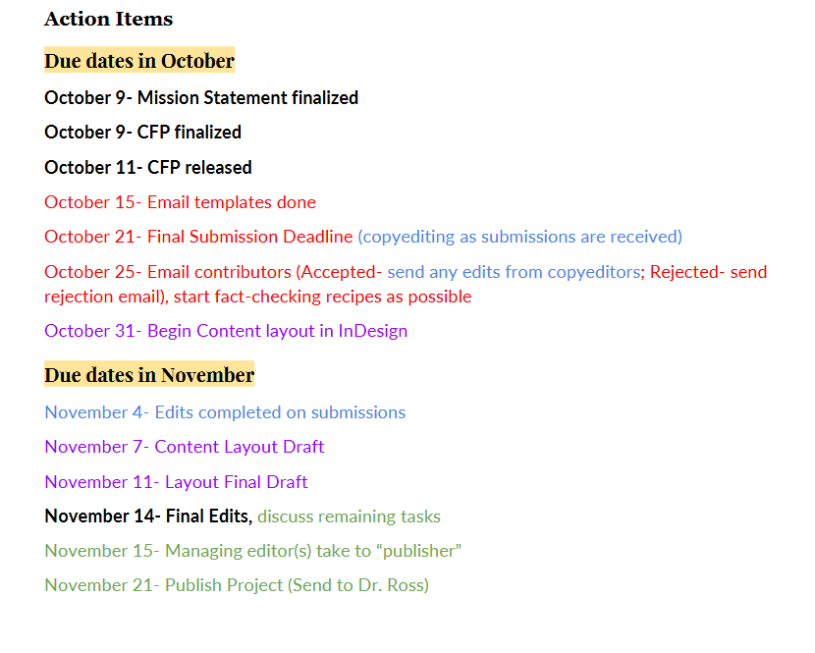

In this meeting, I was excited to discuss the project “face to face” and outside of class. This allowed us to see how much of the project requirements had already been completed (i.e. drafted mission statement and CFP, style guide, etc.) and what work remained to be done. It was encouraging to be able to work through tasks quickly because we weren’t waiting for others to respond over Box, GroupMe, or email. However, it was also slightly discouraging because even when those communication obstacles were removed, some members had to be pushed into contributing or volunteering for tasks.

Once we had our roles written down and confirmed that everyone had access to the Box folder, we were ready to move on to the tasks of crafting a mission statement, creating a style guide, writing a Call for Papers (CFP) and gathering submissions, and laying out the cookbook in InDesign.

**Crafting a Mission Statement**

As the originators of Culinary Chronicles, it was our responsibility to create a mission statement that could encompass our goals and promises relating to how our editorial team would work to create as inclusive a publication as possible. Due to our disorganization at the beginning, developing the mission statement was limited to the Box folder and external examples. Technology issues also meant that some group members were still struggling to access the Box folder so input on the statement was limited. The included image shows how collaboration on our initial draft evolved into our final statement once we received feedback from our classmates to change the original wording from “recipes we choose” to “recipes we include” to benefit the overall approachability of our publication.

Figure 2: Screenshot from Box of our Mission Statement Collaboration

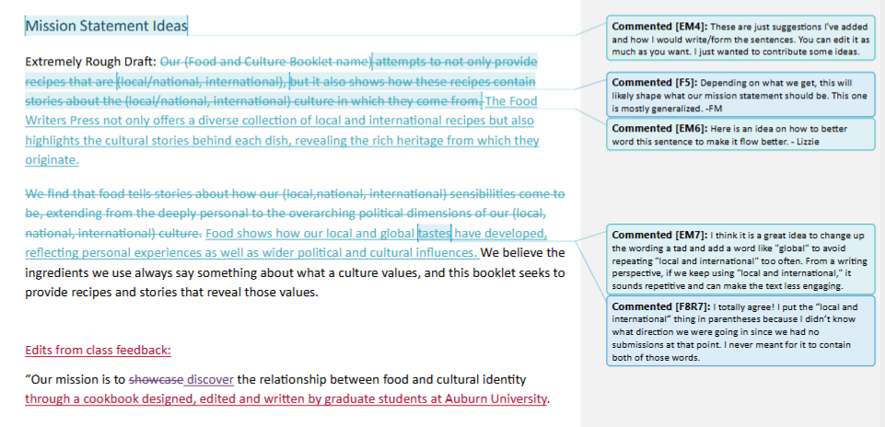

I still feel that our statement, however concise, provided exactly what we needed to begin developing a comprehensive style guide and editorial process. A mission statement gives clarity of purpose for the editors, authors, and readers of a publication, helping them understand the organization’s goals. Having a strong mission statement “can remind you where your priorities lie and guide you to make decisions for the greater good” (Chandler, 2023).

An important discussion we had surrounding the mission statement is its ability to increase audience buy in for an organization. The style of a well-crafted mission statement conveys an organization's purpose, values, and objectives. This offers potential customers, employees, and partners a clear understanding of its identity and guiding principles. This resonates with individuals who share similar values, helping them feel aligned with the organization's goals and making them more likely to consider buying into an organization or contributing to a publication (Yadav & Seghal, 2019).

Because this statement was meant to define our publication in a few sentences, we focused on three main components: cultural identity, food and recipes, and the ability of storytelling to establish connections with those around us. The final verbiage of our statement says, “Our mission is to showcase the relationship between food and cultural identity. The recipes we include help tell a story about a culture’s values and traditions. Through recipes and storytelling, we seek to celebrate the heritage and experiences involved in each meal.”

One of the readings we did during the mission statement and style guide development process was from Amare and Manning on editor-author ethics. Amare and Manning argue that editing decisions range from foundational (based on a specific set of moral principles) to non-foundational (based on contextual negotiations among decision participants) (Amare, Manning, 2009). This article was especially helpful in determining how we would structure our editing process to incorporate and maintain each contributor’s voice.

As editors, we have focused on ensuring that contributor stories are accurately represented while also ensuring that recipes are easy for readers to follow. For example, we used standardized measurements for clarity, while allowing flexibility in anecdotal style. Our goal was not to “globalize a design by eliminating characteristics that relate to users”, but rather to “integrate reactors of character and influence to establish balance...” (Lancaster, Tucker King, 2024, p.6). By making our cookbook approachable to a wide audience, we ensure that the publication can be used by diverse populations and will continue to serve the larger purpose of amplifying our contributors’ experiences.

**Developing a Style Guide**

One of the things I enjoyed most about this course was developing a style guide for our group publication. This aspect of publication development was interesting to me because it allowed us to craft a comprehensive outline of exactly how we wanted our finished product to look, both physically and aesthetically. A style guide is a “rule-driven document that sets the parameters for consistency and acceptability of all written materials produced by an individual or group” (Adhya, 2015). Style guides are crucial for any brand or publication because they enable audience, authors, editors and stakeholders to visualize the full scope of an organization’s purpose and identity. There are a few key elements that I feel should be included in a style guide to maximize its utility.

A table of contents may seem like an obvious place to start, but it is an important inclusion to make for the navigation of a document. In Chapter 5 of Technical Editing, we looked at how adding navigational aids to a document increases the longevity and usability of said document. A table of contents functions so that readers can see the “overall structure of the document, the location of specific sections, and the relationships among various topics” (Cunningham, et al., 2020, p.93). In our table of contents, we organized the information in such a way that readers can skim to find the sections most useful to them.

A second important component to an effective style guide is including an explanation of the editing process. An incomplete style guide can wreak havoc on the editorial process for a group publication because it allows too much ambiguity. Without a systematic set of steps to follow, a team of editors (especially those who are new to collaborative editing) could find themselves doubling back over portions of a document or even neglecting entire sections that need revision.

A 1997 article written by Stephen Gale titled “A Collaborative Approach to Developing Style Guides” pontificated on what makes style guides fail. One of the reasons he cites is that an organization’s style guide can become too long-winded and therefore is nearly impossible to use. There are a couple of areas where our style guide went in far more detail than is necessary, particularly in the Color Scheme and Imagery sections. Based on feedback from our classmates, we adjusted those sections of the style guide and removed any unnecessary or superfluous information, such as detailed context on the psychology of each color choice.

In the conclusion of Esha Adhya’s Key Elements of an Effective Style Guide in the New Age, they argue that a style guide will be most effective when “it is supported by management, incorporates input from all its beneficiaries, is integrated into the day-to-day operations, and is updated regularly” (Adhya, 2015). Although this guide will cease to be useful at the end of the course, the lessons I learned while developing it will stick with me long after grades are posted.

**Copyediting Homework**

It was around this time in the semester that, in addition to working on our publication, we started to dive deeper into specific roles that an editor can take on. Copyediting can be a somewhat tedious role, but it is vital if a document is to maintain its accuracy and credibility. In Chapter 12 of *Technical Editing,* they tout the most common definition of copyediting which is “editing to ensure correctness and consistency; conformity to guidelines or specifications; and accuracy and completeness” (Cunningham, et al., 2021, p.281). Before this course, I would have lumped copyediting and proofreading together, arguing that they both require close reading to check for grammar errors and lacks in consistency. However, after learning more about the steps to copyediting, I have a better grasp on how these tasks differ.

The copyediting homework we did was also helpful to my personal development as an editor because I realized how much I enjoy taking a focused approach to examining a document. Whether this says something about my perfectionism, I’m not sure, but I have had to learn how to accept that there will always be something I miss, no matter how many times I read over a document. In class, when we peer edited drafts of our final report, having a timer set for each level of copyediting meant that I felt locked in and focused on the task at hand. Unbelievably, I have never tried to time myself to do an assignment or edit a document and have discovered that this tactic is a gamechanger to help me move forward on an assignment.

Figure 3: Screenshot of our Copyediting Homework from September

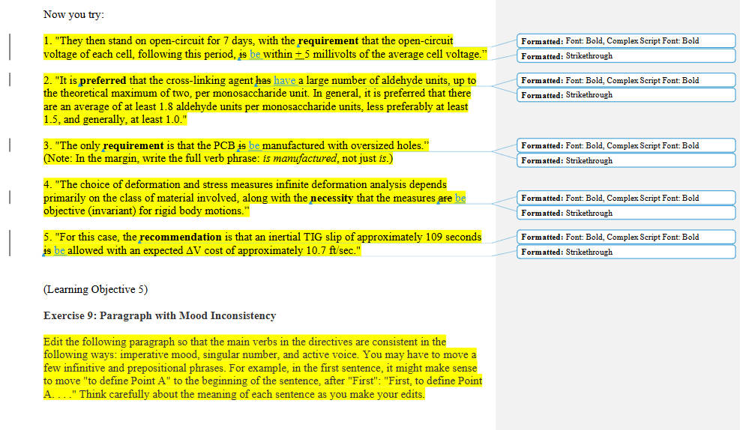

**Writing our Call for Papers**

One of the concerns our group had when planning the cookbook was what would happen if we did not receive enough responses. Initially, the idea was to only have graduate students contribute to maintain a focused perspective and influence on the project. However, after discussion among the team, we decided that opening submissions to a wider audience, such as our friends, family, and colleagues, would provide an opportunity to create a more diverse collection of recipes, expanding the overall quality and appeal of the cookbook.

A Call for Papers, or CFP, is a way for academics, editors, conference chairs and others to request submissions on a particular theme or subject matter (Mauer, Venecek. 2021. pp.42). Along with listing the topic of the publication, it is important to include information previously listed in the organization’s style guide to give authors a sense of the organization itself and help them determine if they fit the characteristics of intended authors.

Because a Call for Papers can draw heavily on the style guide of an organization, it is vital that the CFP and Style Guide are complementary of one another. In creating complementary documents, editors are better able to establish standards for reviewing submissions. Editing documents from so many authors requires patience and a strong sense of what the purpose of the publication is, which is where a solid style guide and CFP come in handy. In Chapter 4 of Technical Editing, it discusses the various ways an editor can be expected to interact with submissions and proposals. One of the ideas that stood out to me was the perception that ensuring compliance with submission guidelines falls heavily on an editor.

In small classes like ours we must take on multiple responsibilities within our group due to the scope of our project. However, it had not dawned on me before reading that chapter that even in industry settings, editors can be expected to complete tedious work because another individual does not place value on accuracy, accessibility, or some other important aspect of consistency. This further elevates my view on the importance of utilizing the skillsets of competent editors in all aspects of published documents. Utilizing our Call for Papers and reaching out to friends and family, we were able to gather twenty-four total recipes. These recipes ranged from appetizers to drinks to desserts and spanned multiple countries in their influences. Of course, this meant that we had much more to edit than we had originally expected. This division of labor was helped by the “plant group” assisting in our copyediting.

**Accessibility Tools**

One of the most interesting subjects we went over in ENGL 7000 was the importance of checking and ensuring the accessibility of documents, publications, websites, and more. Accessibility tools are useful in editorial processes because they can help a technical editor find gaps in accessibility as well as create a more inclusive environment for both the intended audience and any others who may use the publication.

Thankfully, there are many sites, articles, and government checklists for confirming the accessibility of digital and printed documents. These sites also include tools within programs such as Adobe Acrobat and Microsoft Word to ensure compliance with federal regulations.

One of these checklists can be found at section508.gov/create. I liked using this website because it walked me through the process of confirming accessibility compliance while educating me on accessibility concerns I never considered, such as the best placement of captions on images so screen readers capture identifying information first.

It was enlightening to try and step into the shoes of those with disabilities to better understand their needs and how we as editors can best serve diverse populations with simple adjustments to our documents. One of the ways I have taken these lessons into my own editing practice is through my involvement with the Access Champions Task Force here on campus. I volunteered to write our accessibility audit report, which included accessibility information on over 200 buildings on campus. However, after going over this topic in class and completing the assigned practice activities, I realized that my report on accessibility at Auburn University was not even close to accessible itself! Therefore, I used the tools provided by Drs. Ross and Whittemore to rework the document and provide alt text and captions for images and followed the guidelines set forth by the ADA to make the extensive report usable by those with disabilities.

**Creating the Cookbook**

Figure 4: Hand drawn draft layout of cookbook

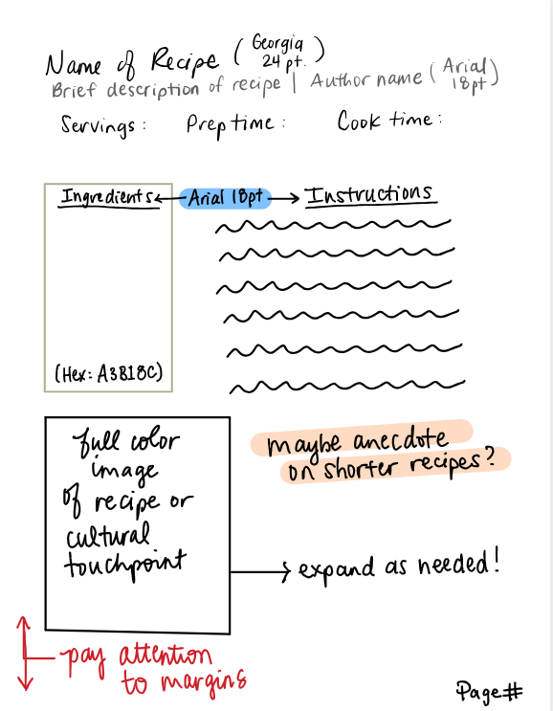

Based on our discussions, I used my iPad to draft an initial layout of what each page of our cookbook “should” look like before we started work in Adobe. This was uploaded into Box and discussed among the group about what changes should be made. This draft was especially helpful when beginning to work with InDesign. The draft was developed using our style guide, and included placement of specific hex codes, typography requirements and the arrangement of information.

After taking the InDesign tutorial, I felt confident in adding the shapes needed to create each page, but there are still plenty of tools I needed to discover to create the final product. I utilized spreads, shapes, frames, and images to craft the structure of our cookbook, which provided a guideline as I began to copy and paste the information from each submitted recipe into the program. I also tried out some skills not mentioned in the original tutorial, such as creating color schemes in Adobe Color which helped keep our color consistent with our style guide.

I thought there would be a way for all of us to collaborate on InDesign simultaneously (as we did in Box), but unfortunately that was not possible, so I worked with my group members to make it possible for them to comment on what needed to be edited. These comments helped find errors in continuity and content that were missed during the original design work. Our workshop session in class was especially helpful in getting everyone in our team on the same page.

Figure 5: Screenshot of Comments on Adobe

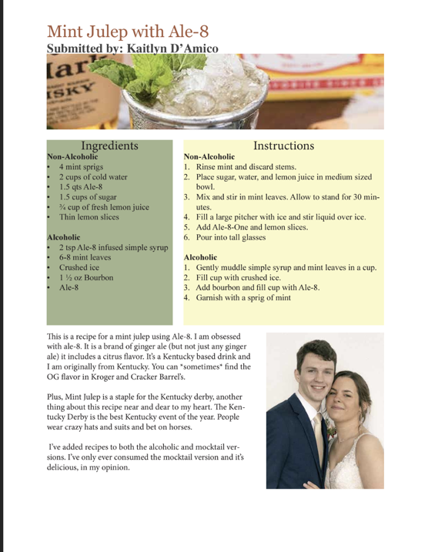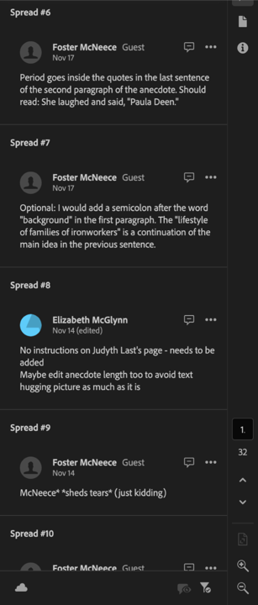

Another helpful resource for me in this course has been working with Sylvan, the other group’s managing editor. I messaged her early in the semester after struggling with my first reflection assignment and we met to discuss how best to succeed in a graduate level course as rigorous as this one. That initial discussion led to multiple meetups at Coffee Mafia to troubleshoot issues with InDesign layouts, assist each other with establishing timelines, and even venting about group dynamics. I am grateful to have collaborated with her during my time in the class and I feel she was indispensable in helping me stay on track.

Once the cookbook was created and printed, it was clear there were edits that needed to be made, such as the placement of the page numbers, incorrect hex codes in certain places, and image quality. This realization was hard for me to accept after spending what felt like weeks staring at our cookbook in InDesign. After encouragement from Dr. Ross, two of my group members were willing to try and make those edits. Handing over the only copy of our cookbook and leaving final edits to someone other than myself was difficult, and some of the edits were never completed, but I am slowly learning the art of making “things look as consistent as possible, then walk(ing) away”. My skills in InDesign have increased dramatically and my editing philosophy has grown to include ideas of accessibility, inclusion, and always incorporating the “imaginary author” in your editing process. Despite initial disorganization, I feel that our team produced a cookbook that is useable and attractive.

**Conclusion**

Technical editing is a vital process with wide definition and applications, a fact that has become clearer to me the further we have gotten into this course. With each assignment, my understanding of the fluidity of the editing process has grown. There have been many opportunities to examine whether I have the skills, desire, and even the patience to become a professional editor. One of the questions I have pondered the most is, “Am I an editor”? Each time I try to respond to this question, my answer changes.

Initially, I doubted my ability to be an editor, feeling that I lacked the knowledge this class was meant to teach me. In more chaotic moments, I wondered if it mattered if I identified as an editor, or if I should just focus on turning in the assignment and “getting the grade”. In the end, I have come to realize that regardless of my current or future job title, I engage in editing every day through my words and actions. When I edit my emails to my students to improve clarity, I am editing for organization. When I take an extra moment to check the accessibility of a document I share with others, I am editing for inclusivity. When I pause before marking up another person’s draft, I am editing with the “imaginary author” in mind and considering how my perspective may differ from theirs. Therefore, I feel that I can confidently identify myself as a “lowercase ‘e’ editor” with the humility, inexperience, and learning curves that title imbues.

**Works Cited**

Adhya, E. (2015). Key elements of an effective style guide in the new age. Technical Communication, 62(3), 183-192.

Amare, N., & Manning, A. (2009). Examining editor-author ethics: Real-world scenarios from interviews with three journal editors. Journal of Technical Writing and Communication, 39(3), 285–303.

Chandler, A. (2023, August 18). Why mission and value statements matter. Forbes. <https://www.forbes.com/councils/forbesbusinesscouncil/2023/08/18/why-mission-and-value-statements-matter/>

Chartier, M. (2022, April 27). Your call for papers template (with tips). Fourwaves. <https://www.fourwaves.com/blog/call-for-papers-template/>

Clem, S., & Cheek, R. (2022). Unjust revisions: A social justice framework for technical editing. IEEE Transactions on Professional Communication, 65(1), 135–150.

Cunningham, C., Malone, M., & Rothschild, J. (2020). Technical editing: A guide to editing in the workplace. Oxford Press.

Gale, S. (1996, April). A collaborative approach to developing style guides. In Proceedings of the SIGCHI Conference on Human Factors in Computing Systems (pp. 362-367).

Lancaster, A., & Tucker King, C. S. (2024). Amplifying voices in UX. State University of New York Press.

Mauer, B., & Venecek, J. (2022). Strategies for conducting literary research.

Omnipress. (2022, October 6). 10 tips for writing instructions for your call for papers [Infographic]. Omnipress. <https://www.omnipress.com/blog/10-tips-for-writing-instructions-for-your-call-for-papers/>

Tham, J., & Grace, L. (2024). Design Thinking in Localized Service-Learning. In A. Lancaster & C. S. Tucker King (Eds.), Amplifying voices in UX (pp. 21-48). State University of New York Press.

U.S. General Services Administration. (n.d.). Authoring guides. Section508.gov. Retrieved December 7, 2024, from <https://www.section508.gov/create/documents/authoring-guides/>

Walton, R., Moore, K. R., & Jones, N. N. (2019). Technical communication after the social justice turn: Building coalitions for action. Routledge.

Yadav, N., & Sehgal, V. (2019). Effectiveness of mission statements in organizations: A review. Journal of Management & Organization. Cambridge University Press. <https://doi.org/10.1017/jmo.2019.18>