**COEN-6312 -MODEL DRIVEN SOFTWARE ENGINEERING**

**DELIVARABLE -1**

**AIRLINE RESERVATION SYSTEM**

**PRESENTED TO**

Abdelwahab Hamou Lhadj

Professor at Concordia University

Montreal, Quebec, Canada

Winter 2022

**PRESENTED BY**

Jagadeesh Chandra Bose Viswanadhuni (40164625)

Vinishaa Kuntalo (40181334)

Bhogeswar Reddy Kalathuru (40115168)

Kamal Rohith Unnam (40166731)

Kalyan Srinivas Pandur (40169859)

Divya Pankajakshan Nair (40195179)

Table of Contents

Introduction: 3

Class diagram: 3

Application Features: 4

Functional Requirements: 4

Non-Functional Requirements: 5

User Stories: 5

Making Reservation(Epic-01) 5

Edit a Reservation(Epic-02) 6

Cancel a Reservation(Epic-03) 6

Expected user interface: 6

Opening page: 6

Login page: 7

Home page: 7

Team members: 8

# 

# 

# **Introduction:**

Airline reservation system is an online e-ticketing platform used for instant flight bookings of any airline. The system collects data from every airline available using global distribution system. This ensures that the customer is up to date regarding the cost of flight, seat availability and other aspects as to which airline is best for them. Customers are inclined towards e-ticketing platform for their bookings especially during covid-19 as to reach their home as soon as possible as how government imposes lockdown without prior notice. Now a days, to compete, we need to have access to up to date data to sustain and create impact in the industry. The design of the web interface is the key in order to be user-friendly.

In order to be a successful airline reservation system, it should meet certain standards with respect to pre booking, while booking and post booking operations. Customer should be able to do lot of stuff while browsing as to check the prices and timings and which airline is best for them and the number of layovers if any and the city they takeoff. During booking they need to fill the appropriate details in order to make the reservation and number of people that are going to board the flight. Plans can change anytime due to urgent work or other commitments and due to this they will not be able to board the flight. In this case they can cancel or even modify their booking to a much more suitable and preferred date.

# **Class diagram:**

Figure 1: Class Diagram

The above Airlines Reservation System Class Diagram represents the structure, attributes, methods, and their relationship between objects for reserving a ticket to the passenger. The main classes in this application are Person, Passenger, Employee, Airline, Reservation, Schedule, Flight.

Here Person class is the main class where it has 4 attributes – Name, Email, Mobile, Dob. The person class is inherited by the Passenger Class and Employee Class, as these two classes are inherited by the Person class, they have the same attributes and Employee class has an extra attribute for determination of their role. Employee class further associated with the Airline class where it has an attributes – Name and an operation – addEmployee(). In this association the airline has many employees and employee works for one airline company. Airline class is further associated with Flight class which has 5 attributes – From, To, Departtime, Arrivetime, Numofseats and two operations – getAirline(), getCrew(). Here flight class belongs to one Airline and Airline class is built in a way that it has many flights. The next one is Schedule Class where it has 5 attributes – departDate, arriveDate, expectedDepartTime, fullBooked, delay and has an operation – getFlight(). Here flight and schedule were built in a way in this application that one flight has many schedules and each schedule is designed for one flight. Coming to the last class in the application, Reservation has two attributes –Seat number, Invoice Num and has three operations – getPassenger(), addReservation(), modifyReservation() here all the attributes are related to the booking, This class has two associations one with Schedule class and Passenger class where once schedule can has zero or one reservation and one reservation has one schedule and coming to the reservation and passenger association, a passenger can make zero or many reservation and one reservation can have many passengers.

# **Application Features:**

• User can create a new account by giving their personal details like Name, Address and mobile number.

• To make a flight reservation, registered user can sign in with the email address and password.

• Users must select their destinations, date and time of travel and one-way or round trip.

• Users can change the password and can reset password if they forget the password.

• Passengers can choose the seat numbers and can add meal plan to their ticket.

• Users can cancel reservation.

• Users can log off from the application.

# 

# **Functional Requirements:**

* A non-registered user can check flight availability but cannot make any reservations.
* The unregistered user can sign-up as a new user to use the application
* To make a reservation, registered users need to log in.
* A consumer may book a flight ticket online by selecting the origin and destination airports, the class of travel, such as economy or business class, the one-way or round-trip mode of travel, and finally the number of passengers.
* The user should be asked the return date for reservation purposes if he/she chooses the option of round trip.
* Checking the reservation status should be possible under the Manage Booking tab. The user should be able to select seats / add extra baggage / upgrade the class of travel.
* You should be able to cancel your reservations only if you are a registered user with a valid reservation.
* User information such as mobile number, payment card information, etc. can be updated.

# **Non-Functional Requirements:**

* The Airline Reservation System (ARS) should have high availability.
* ARS should have high performance while accessing, querying and retrieving information from the database.
* The system should be scalable as per the number of users.
* Highly fault tolerant. For instance, user cannot book flight if flight is full.
* A user-friendly system is essential. (Easy to use)

# **User Stories:**

|  |  |
| --- | --- |
| **S.no** | **User stories** |
|  | **Making Reservation (Epic-01)** |
| 1. | As a user, I want to select the type of travel like round-trip or single trip to book a flight reservation. |
| 2. | As a user, I want to select the source and destination country. |
| 3. | As a user, I need to select the specific date for departure, if it is roundtrip for returning. |
| 4. | As a user, I want to select the class of travel such as economy or business class or first class. |
| 5. | As a user, I want to select the payment through credit or debit card. |
| 6. | As a user, I want to select the seat from list of available seats. |
| 7. | As a user, I want to order food for my travel. |
| 8. | As a user, I want to select an airline from list of airlines specified for provided destination. |
| 9. | As a user, I want to select the layouts from source to destination country |
|  | **Edit a Reservation (Epic-02)** |
| 10. | As a user, I want to edit passenger details. |
| 11. | As a user, I want to change the class type of travel for specific reservation. |
| 12. | As a user, I want to change the seating of my passenger for a particular reservation. |
| 13. | As a user, I want to change the travel date. |
|  | **Cancel a Reservation (Epic-03)** |
| 14. | As a user, I want to cancel my Reservation |

# **Expected user interface:**

## **Opening page:**

Figure 2: opening page

## 

## **Login page:**

Figure 3: login page

## **Home page:**

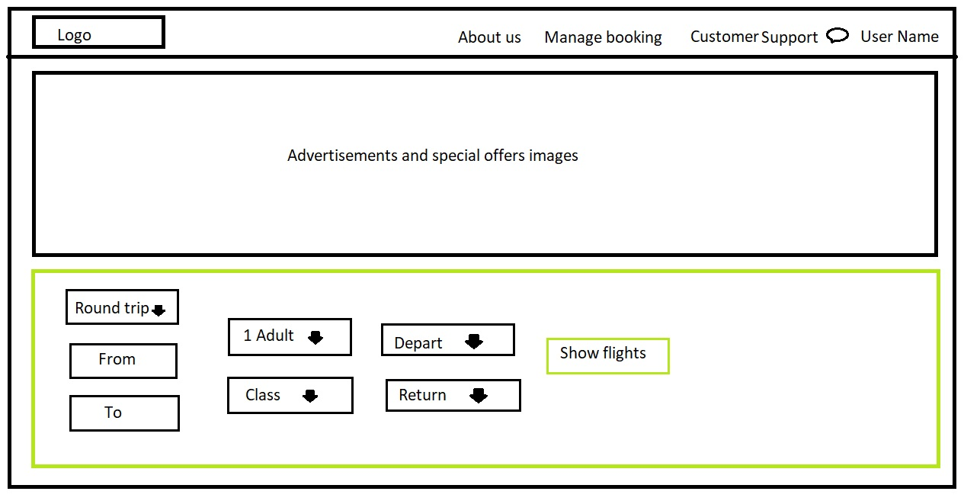

Figure 4: home page

# **List of figures:**

Figure 1: Class Diagram 4

Figure 2: opening page 8

Figure 3: login page 8

Figure 4: home page 9

# 

# **Team members:**

|  |  |  |
| --- | --- | --- |
| TEAM MEMBERS | EXPERTISE | PREFFERED LANGUAGES |
| Jagadeesh Chandra Bose Viswanadhuni (40164625) | C++, Java and JavaScript | Java, CSS, JavaScript |
| Bhogeswar Reddy Kalathuru (40115168) | Java, Python, JavaScript | Java, HTML |
| Vinishaa Kuntalo (40181334) | Java, HTML, CSS3, JavaScript, SQL | Java, CSS |
| Kamal Rohith Unnam (40166731) | C++, Python, HTML, CSS, JavaScript | JavaScript, HTML |
| Kalyan Srinivas Pandur (40169859) | HTML, CSS, Java, Python, JavaScript | Java, JavaScript |
| Divya Pankajakshan Nair (40195179) | C, C++,  Python and JavaScript | JavaScript |