DOC-3

ACADEMICS-MAIN TAB

ABOUT PROGRAMME -SUBTAB

* **MBA PROGRAMME**
* **PROGRAMME OUTCOMES**
* **PROGRAMME EDUCATIONAL OBJECTIVES(PEOS)**

COURSE STRUCTURE -SUBTAB

* **REGULATIONS**
* **CURRICULUM**
* **SYLLABUS**

COUNCILS AND COMMITTES-SUB TAB

* MBA ACADEMIC ADVISORY COUNCIL
* PROGRAMME ASSESSMENT COMMITTEE(PAC)
* GOVERNING BODY
* EXECUTIVE COMMITEE

## ABOUT PROGRAMME

## MBA PROGRAMME

VISWAJYOTHI offers Management Programme (MBA, affiliated to APJ Abdul Kalam Technological University and approved by AICTE) through its management school, VISWAJYOTHI School of Management Studies (VSMS). VSMS is dedicated to the development of promising leaders who can create wisdom, innovation from action, networks from contacts and sustained adaptability from changes.

VSMS opens up new frontiers in the global management scene, and equips the students with the skill-set to cope with today’s business environment which is filled with complexity and uncertainty. At VSMS, students are exposed to emerging state of the art technologies and leading edge business management practices which will enable them to lead multinational work forces, communicate with stakeholders, and develop creative solutions to emerging business issues and drive innovation through entrepreneurial practices. VSMS provides a unique programme with quality, reliability, standards and recognition. Primary Objective of VSMS is to promote personal integrity and social responsibility among the students. VSMS provides the students with an ideal platform for the display of their creative and innovative abilities and offer unique opportunities to further enhance personal capabilities.

**PROGRAMME OUTCOMES**

Apply knowledge of management theories and practices to solve business problems.

Foster analytical and critical thinking abilities for databased decision-making.

Ability to develop value based leadership ability.

Ability to understand, analyze and communicate global, economic, legal, and ethical aspects of business.

Ability to lead themselves and others in the achievement of organizational goals, contributing effectively to a team environment.

## PROGRAMME EDUCATIONAL OBJECTIVES (PEOS)

Core knowledge in management theories and practices with established expertise to serve the society.

Sense of professionalism, ethical attitude, communication skills, team spirit, multidisciplinary approach and leadership skills to function productively and professionally.

Attained a general level of competence in management and to enable them to act with creative, innovative and entrepreneurial potential employability skills and tools with attitude of lifelong learning.

COURSE STRUCTURE (pdf ATTACHED)

* **REGULATIONS**
* **CURRICULUM**
* **SYLLABUS**

**COUNCILS AND COMMITTEES**

## MBA ACADEMIC ADVISORY COUNCIL

An Academic Advisory Council for the MBA course of the Viswajyothi College of Engineering and Technology was constituted on 14th October 2016. Advisory board has 14 members headed by Msgr.Dr.Pius Malenkandathil (Manager) and Rev. Fr. Paul Nedumburath as the secretary. The members are nominated by the Board of Trustees.

Manager

Msgr.Dr.Pius Malenkandathil

(President)

(Manager VJCET,President of Diocesan Technical Education Trust)

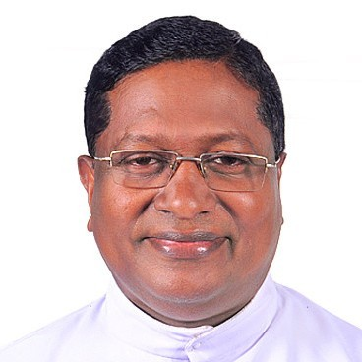

Rev.Fr.Paul Nedumpurath

(Director)

Designation:Secretary of the Trust

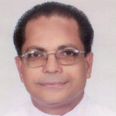

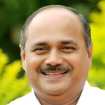

Adv.Francis George

(Member)

Designation:Former Manager

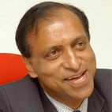

Dr.V.A.Joseph

(Former Chairman,SIB)

Designation:Former Manager

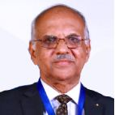

Dr.Venugopal C Govind

(Managing Partner,Varma and Varma Associate)

Designation:Member



Ms.Preethi Gopala Krishnan

(Assistant Director,Strategic Talent Consulting,E&Y)

Designation:Member

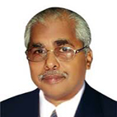

Dr.G.C.Gopalapillai

(Former CMD,FACT.KELTORN,INKEL)

Designation:Member

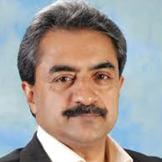

Mr.Dinesh Thampi

(VP&DCH,TCS Kerala)

Designation:Member

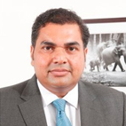

Mr.Rajesh Nair

(Director,E&Y)

Designation:Member

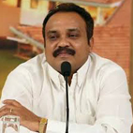

Dr.Anandakuttan B Unnithan

(Dean-IIM,Kozhikode)

Desination:Member

## PROGRAMme ASSESSMENT COMMITTEE (PAC)

The Program Assessment Committee (PAC) has been formed for monitoring of different activities related to the MBA Program The PAC consists of faculty members of the department who periodically monitor the activities and evaluate different parameters.

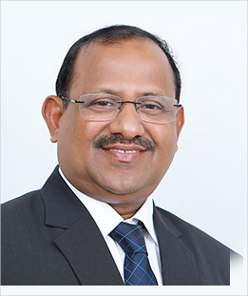

Dr.Cyriac Joseph

Dean&HOD-Management Studies

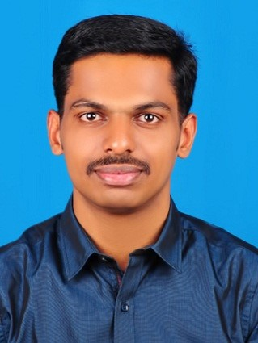

Mr.Sebin Joseph

Designation:Assistant Professor

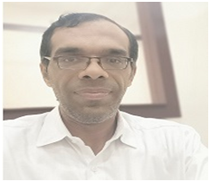

Mr.Pratheep Kumar

Designation:Assistant Professor

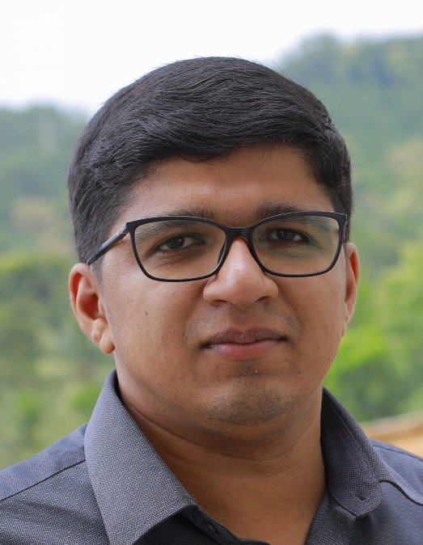

Mr.Anish John A

Designation:Assistant Professor

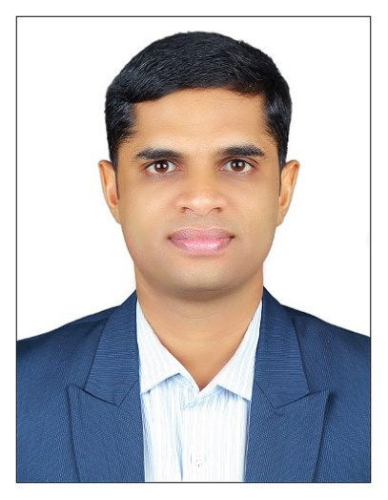

Dr.Jose Mamman

Designation:Assistant Professor

Mrs.Merrin Geordie Pottas

Designation:Assistant Professor

## GOVERNING BODY

Governing body formulates policy and directs the affairs of the institution. Governing body of VJCET consists of 14 members headed by Msgr. Dr. Pius (Manager) and

Dr. K K Rajan (Principal) as the secretary. It includes eight members nominated by the Board of Trustees and nominated members from AICTE, DTET, KTU and MGU. The governing body is elected for a period of three years. It meets twice or thrice in a year to assess the performance of the institution and to discuss the future developmental activities.

Dr.K.K. Rajan

Principal

Responsibilty:Chairman

Mob:9072964417

Mr.Somy P. Mathew

Vice Principal

Responsibilty:Convenor& Secretary

Mob:9048104565

Dr.Cyriac Joseph

HOD-MBA

Responsibilty-Member

Mob:9447571222

Mr.Amel Austine

HOD-CSE

Responsibilty-Member

Mob:9847671025

Dr.B.Aruna

HOD-EEE

Responsibilty-Member

Mob:9072964416

Mrs.Smitha Cyriac

HOD-ECE

Responsibilty-Member

Mob:9447523022

Mrs.Anju Susan George

HOD-IT

Responsibilty-Member

Mob:9846132699

Mr.Shunmughesh K

HOD-ME

Responsibilty-Member

Mob:9947929956

Mrs.Shine George

HOD-Civil

Responsibilty-Member

Mob:7907664856

Mrs.Viji George

HOD-S&H

Responsibilty-Member

Mob:7907664856

## EXECUTIVE COMMITTEE

The Executive committee is constituted from the members of Board of Trustees. It includes 9 members and is elected for a term of three years. They meet frequently for evaluating the day to day activities, proper minutes are prepared in each meeting and minutes are passed in the consecutive meeting.

Msgr.Dr.Pius Malekandathil

(Manager VJCET,President of Diocesan Technical Education Trust)

Responsibility:President

Mob:

Adv.K.T.Thomas Kakkuzhiyil

(Senior Advocate)

Responsibility:Vice President

Mob:9446932112

Rev.Fr.Paul Nedumpurath

(HolyMagi Church,Muvattupuzha)

Responsibility:Director

Mob:9495023390

Adv.K.Francis George

(Ex-Chairman,Kerala Feeds,Govt.of Kerala

Responsibility-Secretary

Mob:9446411100

Mr.K.T Mathew Kochummutom

(Contractor,PWD,Govt.of Kerala)

Responsibility:Joint Secretary

Mob:9495992375

Mr.Lukachan Olickal

(Retd.Bank Manager)

Responsibility:Treasurer

Rev.Fr.John Mundackal

Arakuzha

Responsibilty-Member

Mob:9447390315

Mr.V.V.Kurian

Vallamattom

Responsibilty-Member

Mob:9447255038

Adv.Johny Nelloor

(Ex.Member of Legislative Assembly)

Responsibilty-Member

Mob:9846032723