CHAPTER 1 INTRODUCTION

1.1 OVERVIEW OF THE PROJECT

“Financial Automation Tool” is the web based application that provides an efficient way to maintain various information of resources in a project like billing, resource maintenance and generate project reports in a quick way. The resource information is immediately stored in the database to view later and it can be exported as excel format and can be sent to client for billing approval.

In this project, the requirement is to build a web application to manage the billing and accounting related to each project resources. This also helps in forecasting the bill in advance with respect to the leaves of each resources allocated to the project.

This tool enables the user to view resource details easily in web page and it helps the project head to have the better monitoring of total revenue of the account. The generated reports can be saved and downloaded for later use.

In existing system, all billing related activities are doing manually and that process is a time consuming and ineffectual. This tool provides complete automation of billing activity of resources in most efficient manner.

CHAPTER 2

SYSTEM ANALYSIS

EXISTING SYSTEM

In existing system one or two resources has been allocated in the project to do this work manually entering and maintaining the details of the other resources in a Microsoft excel workbook. A leave tracker workbook which consists of leave details of the resources and forecast workbook contains the resource details and the client billing details for the upcoming week which is prepared by the resource persons for each week and another workbook called actual which contains the final and actual revenue details of each month.

Drawbacks of the existing system

    - Consumes more time in preparing these workbook.

    - Productivity hours get reduced.

    - High probability of making mistakes since it is prepared manually.

    - Loss of revenue for the project.

To avoid all these limitations and make the work more accurate, the system needs to be enhanced.

PROPOSED SYSTEM

The aim of the proposed system is to develop a system with improved facilities. The proposed system can overcome all the limitations of the existing system and allows the resource to prepare the excel workbook automatically in the minimal time.

This provides resource details management which maintains the details of working days, leaves and billing details. The actual workbook which will be generated each month will have their total costs which the client need to pay for each resource in a project.

The system provides graphical table representation of the workbook in a webpage and also the resource can add new resource to any project and also can remove any resource from a project if they released from the project or moved to different project with simple button click.

Advantages of proposed system

The system is very simple in design and to implement and it requires less number of persons to evaluate and maintain it. The system will work in almost all configurations. It has got following features

    - Resource financial details management is done effectively.

    - Consumes very less time than the manual method.

    - Data is accurate and it takes less time to prepare billing document.

    - Productivity time increases.

    - Saves productivity cost.

    - No chance of making mistake since it is automatically calculated data.

FEASIBILITY STUDY

During system analysis, the feasibility study of the proposed system is to be carried out. This is to ensure that the proposed system is not a burden to the user. For feasibility analysis, some understanding of the major requirements of the system is essential. Three key considerations involved in the feasibility analysis are

    - Technical Feasibility
    - Operational Feasibility
    - Economic Feasibility

Technical Feasibility

The technical feasibility basically centers on alternatives for hardware, software and design approach to determine the functional aspects of system. This web application will be useful web users because it is being enhanced with Bootstrap.
.

Operational Feasibility

Operational feasibility is the measure of how well a proposed system solves the problems in the existing system. Embedding the report generation features, export of data with this web application makes it easier to generate report from any device and supervisor of system need not to use a separate tool for report generation and integrating the generated reports with the web application has been reduced.

Economic Feasibility

Embedding the report generating features with this web application makes it easier to generate report from any device and editor need not to use a separate tool for report generation and integrating the generated reports with the web application has been reduced. Hence no

Need to buy the additional software tool to install on supervisor device for the report generation and maintenance cost of additional software tool also reduced.

PROBLEM ANALYSIS

The first step in the software development life cycle is the identification of the problem as the success of the system depends on how accurately a problem is identified. At present, resource details are maintained manually in Excel workbook.

The consolidated revenue reports such as forecast workbook for upcoming month, actual workbook for the current month are generated with this web application. Actual workbook which the final expected output which contains the billing and revenue of each account in a project.

If you have imported excel file or pasted csv data, you will get to screen with options to map the fields. It is advisable that import operation are done on the backend side to prevent mismatch of inputs.

The software used to solve the problem and develop the application with JAVA programming using Eclipse with Angular JS and MySQL.

DATA FLOW DIAGRAM

The data flow diagram shows the overview of the entire system as a series of process and it shows the interaction between the UI and Excel workbook. The process are POST, GET, DELETE, UPDATE.

CONTEXT DIAGRAM

The context diagram shows the overview of the entire system as a single process and it shows the interaction between the UI and Excel Workbook.

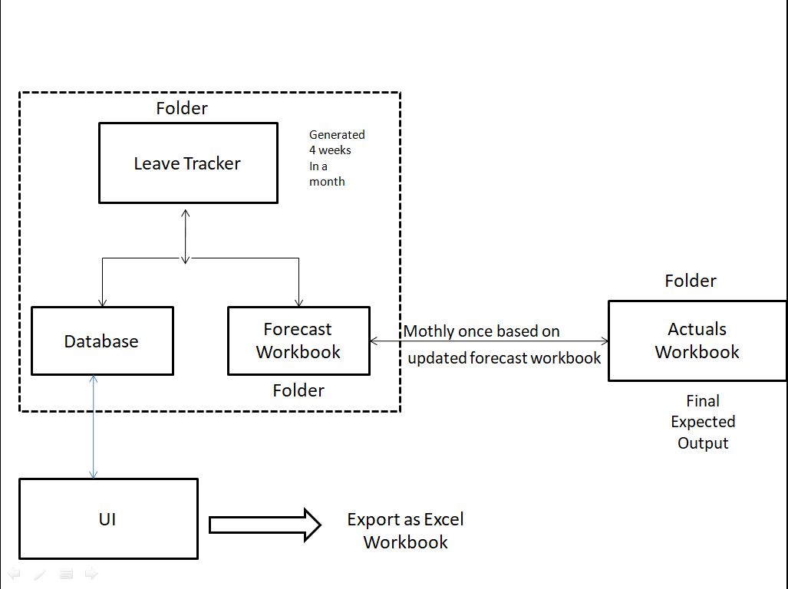

Figure 2.1 Context diagram for Financial Automation Tool

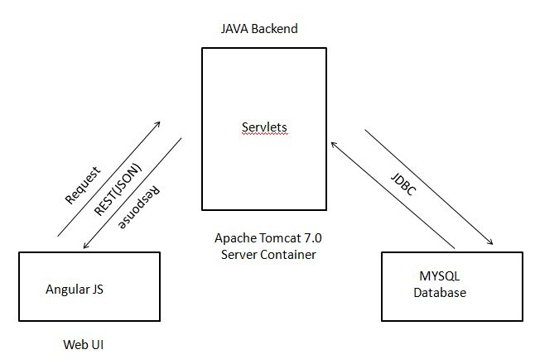

Figure 2.2 Technical Architecture of Financial Automation Tool

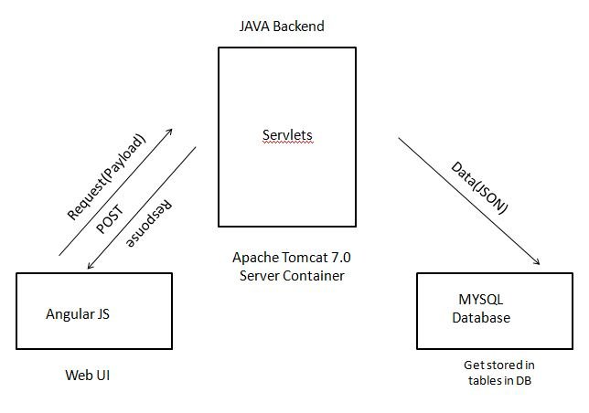

Figure 2.3 POST call for Inserting New Data

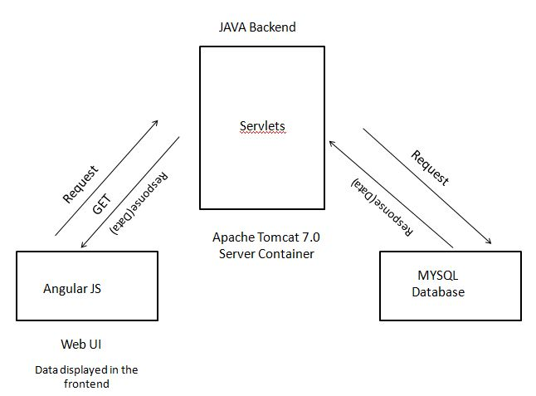

Figure 2.4 GET call for Fetching Data from Database

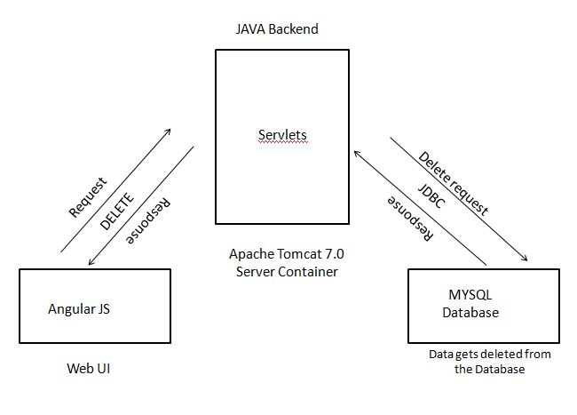

Figure 2.5 DELETE call for Deleting Data from the Database

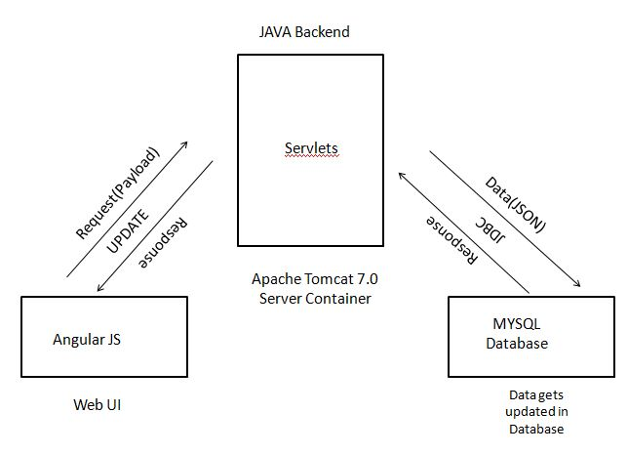

Figure 2.6 UPDATE call for updating the existing data

SYSTEM SPECIFICATION

Hardware Specification

This section gives the details and specification of the hardware on which the system is expected to work.

Processor : Pentium core processor

RAM : 2 GB RAM

Hard Disk : 20 GB storage

Monitor : Any size color monitor
System type : 64-bit operating system

Software Specification

This section gives the details and specification of the software on which the system is expected to work.

Operating System : Windows 7

Environment : Eclipse

Scripting language : HTML5, Angular JS, CSS, Bootstrap
Technology : JAVA, Servlets, REST, Apache POI, JDBC
Web/Application Server : Apache Tomcat 7.0

Backend : MySQL

SOFTWARE DESCRIPTION

Eclipse

Eclipse is an integrated development environment (IDE) for Java and other programming languages like C, C++, PHP, and Ruby etc. Development environment provided by Eclipse includes the Eclipse Java development tools (JDT) for Java, Eclipse CDT for C/C++, and Eclipse PDT for PHP, among others.

Bootstrap

Bootstrap is a free and open source front-end web framework for designing websites and web applications. It contains HTML- and CSS-based design templates for typography, forms, buttons, navigation and other interface components, as well as optional JavaScript extensions. Unlike many web frameworks, it concerns itself with front-end development only.

HTML

Hypertext Markup Language (HTML) is the standard markup language for creating web pages and web applications. With Cascading Style Sheets (CSS) and JavaScript it forms a triad of cornerstone technologies for the World Wide Web. Web browsers receive HTML documents from a web server or from local storage and render them into multimedia web pages. HTML describes the structure of a web page semantically and originally included cues for the appearance of the document.

CSS

Cascading Style Sheets (CSS) is a style sheet language used for describing the presentation of a document written in a markup language. Although most often used to set the visual style of web pages and user interfaces written in HTML and XHTML, the language

can be applied to any XML document, including plain XML, SVG and XUL, and is applicable to rendering in speech, or on other media.

Angular JS

AngularJS is a very powerful JavaScript Framework. It is used in Single Page Application (SPA) projects. It extends HTML DOM with additional attributes and makes it more responsive to user actions. AngularJS is open source, completely free, and used by thousands of developers around the world. It is licensed under the Apache license version 2.0..

JAVA

Java is a high-level programming language developed by Sun Microsystems. It was originally designed for developing programs for set-top boxes and handheld devices, but later became a popular choice for creating web applications.
The Java syntax is similar to C++, but is strictly an object-oriented programming language. For example, most Java programs contain classes, which are used to define objects, and methods, which are assigned to individual classes. Java is also known for being more strict than C++, meaning variables and functions must be explicitly defined. This means Java source code may produce errors or "exceptions" more easily than other languages, but it also limits other types of errors that may be caused by undefined variables or unassigned types.

JSON

JavaScript Object Notation is an open-standard file format that uses human-readable text to transmit data objects consisting of attribute–value pairs and array data types (or any other serializable value). It is a very common data format used for asynchronous browser–server communication, including as a replacement for XML in some AJAX-style systems.
JSON is a language-independent data format. It was derived from JavaScript, but as of 2017 many programming languages include code to generate and parse JSON-format data. The official Internet media type for JSON is application/json . JSON filenames use the extension .json .

Servlet

Servlets provide a component-based, platform-independent method for building Web based applications, without the performance limitations of CGI programs. Servlets have access to the entire family of Java APIs, including the JDBC API to access enterprise databases. This tutorial will teach you how to use Java Servlets to develop your web based applications in simple and easy steps.
Apache POI

Apache POI is a popular API that allows programmers to create, modify, and display MS Office files using Java programs. It is an open source library developed and distributed by Apache Software Foundation to design or modify Microsoft Office files using Java program. It contains classes and methods to decode the user input data or a file into MS Office documents.

REST

Representational State Transfer (REST) is an architectural style for creating, maintaining, retrieving, and deleting resources. REST's information-driven, resource-oriented approach to building Web services can both satisfy your software's users and make your life as a developer easier. This article, the first in a four-part series by REST expert Brian Sletten, introduces the concepts that underlie REST, explains the mechanisms that RESTful applications use, and explores the benefits of REST.

JDBC

JDBC stands for Java Database Connectivity, which is a standard Java API for database-independent connectivity between the Java programming language and a wide range of databases.
The JDBC library includes APIs for each of the tasks mentioned below that are commonly associated with database usage.
- Making a connection to a database.
- Creating SQL or MySQL statements.
- Executing SQL or MySQL queries in the database.
- Viewing & Modifying the resulting records.

Apache Tomcat Server
It is an open source web server and servlet container developed by the Apache Software Foundation (ASF). It implements the Java Servlet and the Java Server Pages (JSP) specifications and provides a pure Java HTTP web server environment for java code to run.

MySQL

MySql is a freely available open source Relational Database Management System (RDBMS) that uses Structured Query Language (SQL). SQL is the most popular language for adding, accessing and managing content in a database.

CHAPTER 3 SYSTEM DESIGN

INPUT DESIGN

Input design is the process of converting user originated inputs to a computer understandable format. Input design is one of the most expensive part of the operation of computerized system. Input data are collected and organized into groups of similar data. Every moment of input design should be analyzed and designed with most care.

The main objective of input design is
    - To process the clear requirements
    - To get highest level of accuracy
    - To produce desired output
    - Data recording
    - Data verification

The input design involves converting user originated inputs into a sub system based format. The aim of input design is to make the data entry easier, logical error free. The following forms are included in this input form.

Adding New Resource

New resource can be added to any account of the project.

Search Resource Details

The search Resource option helps to search a particular resource’s detail quickly and easily.

Updating a Resource Details

Edit option will allow to edit any changes in any resource details and can be updated in the database as well as excel workbook.

Deleting a Resource

Delete option will delete the particular selected resource from an account of the project and also from the database and excel workbook

DATABASE DESIGN

The most important consideration in designing the database is how the information will be used. The main objective of designing a database is:

Data Integration

In a database, information from several files are coordinated, accessed and operated upon as through it is in a single file. Logically, the information is centralized, physically, the data may be located on different devices, connected through data communication facilities.

Data Integrity

Data integrity means storing all data in one place only and how each application access it. This approach results in more consistent information, one update being sufficient to achieve a new record status for all applications. This leads to less data redundancy: data items need not be duplicated: a reduction in the direct access storage requirement.

Data Independence

Data independence is the insulation of application programs from changing aspects of physical data organization. This objective seeks to allow changes in the content and organization of physical data without reprogramming of application and to allow modifications to application programs without reorganizing the physical data. The tables needed for each module were designed and the specification of each and every column was given based on the records and the details collected during record specifications of the system study.

TABLE DESIGN

Table 3.1 Tables in Database

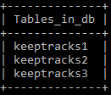
Table 3.2 Keep Track1

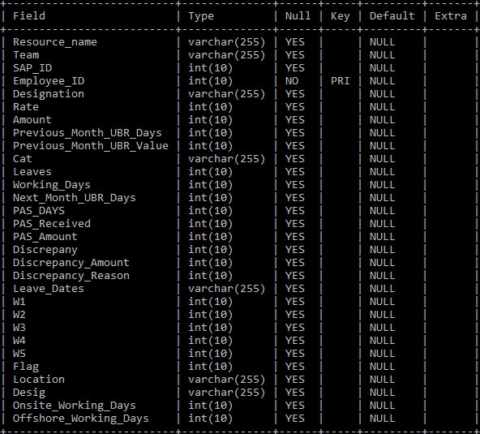

Table 3.3 Keep Track2

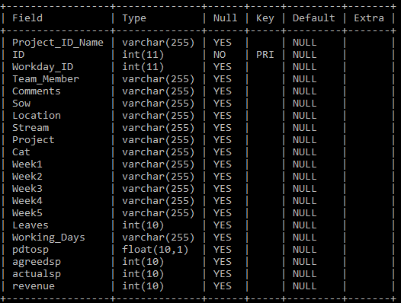

Table 3.4 Keep Track3

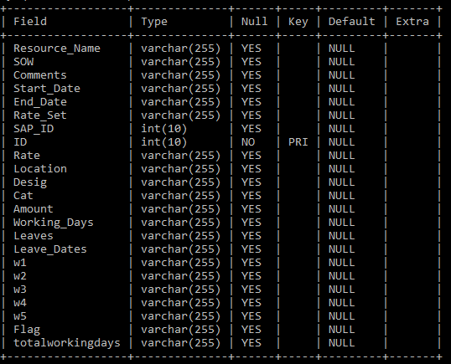
MODULE DESIGN

The main modules exists in this project are listed below

    - Addition of New Resource
    - Updating Resource details
    - Excel Workbook handling
    - Exporting the Final Actual Workbook

Addition of New Resource
In the process of adding new resource the account to which the new resource is going to be added must be selected and then mandatory details such as resource name, ID, location, slab rate, working days, leaves are entered in the add employee table in web application and click save button. Once save button is clicked the data which are entered get posted to the database to respective table.

Updating Resource Details

Update feature enables to update resource details if their story point got varied or whether they are relocated to onsite or offshore. Based on the changes the calculation of their billing amount also varies and get updated in the database. Suppose if any resource got relieved from the project to another project or resigned from the organization delete is option is also available to remove the relieved resource from the database and excel workbook.

Excel Workbook Handling

There are three main excel workbook are to be handled in this web application,
      - Leave tracker workbook – Contains the leave details of the resource like number of days they have taken leaves and number of business days for the particular month.
      - Forecast workbook – Contains the forecast of revenue, leaves and number of working days for a resource of the upcoming coming week and it contains the updated values of every month of a business year. At the beginning of every month an empty template for the forecast workbook will be generated.

      - Actual workbook - Contains the actual and consolidated details of each resource working in the project. This workbook is consolidated at the end of each month and maintained for accounting purpose. In other words actual workbook is also called as updated forecast. Data in actual workbook is handled comparing with the forecast workbook. It contains the revenue details of a project for the particular month alone.

Exporting the Final Actual Workbook

Once the final Actual workbook is being consolidated resource can download the actual workbook any time.

OUTPUT DESIGN

Output design generally refers to the results and information that are generated by the system for users, it should be understandable with the enhanced format.

The computerized output is the most important and the direct source of information to the user. The purpose is to produce the required accounting and billing reports related to the project. The outputs are the most important sources of information to the users. Better design should improve the system's relationship with user.
The report generated in this project are
    - Forecast Template(for next month)
    - Actual workbook

Forecast Template

The forecast template is not downloadable to any resource it remains in the server side for generating actual workbook for the next month.

Actual Workbook

The actual workbook which is the final output of the application which contains the final consolidated details of each resource for sending it to the client for billing purpose.

CHAPTER 4 SYSTEM TESTING

SYSTEM TESTING

Testing is an integral part of any system development life cycle. Insufficient and untested applications may tend to crash and the result is loss of economic and manpower investment besides user's dissatisfaction and downfall of reputation. Software testing can be looked upon as one among many process, an organization performs, and that provides the lost opportunity to correct any flaws in the developed system. Software testing includes selecting test data that have more probability of giving errors.

The first step in system testing is to develop a plan that tests all aspects of the system. Completeness, correctness, reliability and maintainability of the software are to be tested for the best quality assurance that the system meets the specification and requirements for its intended use and performance. System testing is the most useful practical process of executing a program with the implicit intention of finding errors that make the program fails. System testing is done in three phases

    - Unit testing
    - Integration testing
    - Validation testing

Unit Testing

Developers typically do the unit testing in order to trace out the bugs in each module of the code. Unit testing is done in parallel with coding. They were also tested for specification to see if they were working as per what the program should do and how it should perform under various conditions.

All the forms will be run through the menu to see if the proper sequence is maintained. Whenever an error is encountered, an informative error message will be displayed which informs the user what error is. After completion of form testing, the program will be tested.

In this project, user authentication, registration, booking, passenger details, cancellation, report generation are smaller units which are tested.

Integration Testing

Integration testing is a systematic technique for constructing tests to uncover error associated within the interface. In this project, all the modules are combined and then the entire project is tested as a whole. The integration testing was performed by integrating one module with another and checkout their functionality and execution. There are no errors and defects found in the system. The system meets all the specified user requirements and found working properly. The new system developed was tested by the acceptance testing method. The user provided test area. Thus the system was successfully tested and it satisfies the user requirements.

After integration testing all the modules like bus ticket reservation, crew management, fleet management and cost benefit analysis are tested with their integration and that could integrated and manipulated.

Validation Testing

It is said that validation is successful when the software function is systematic manner that can be reasonably accept by the customer. This type of testing is very important because it is the only way to check whether the requirements given by the user have been completely fulfilled. The input given to various form is validated efficiently.

TESTCASE

Test case id | Description | Expected output | Actual result
1 | Keep Track 1: Enter the new resource details. | Accepts the resource details. | PASS
 |  | Else if any mandatory field is empty. | FAIL
2 | Keep Track 1: Click Save Button | Post the new resource details to the database.  Mandatory resource details should not be empty, otherwise it will throw error message. | PASS  FAIL

3 | Keep Track1:  Click the edit button | If there is any changes in resource details, it can be edited. | PASS
4 | Keep Track1: Click Delete Button | Particular resource details will be deleted from the database and the excel workbook and the changes will be effect in web page. | PASS
5 | Keep Track 2: Enter the new resource details. | Accepts the new resource details. | PASS
 |  | Else if any mandatory field is empty. | FAIL
6 | Keep Track 2: Click Save Button | Post the new resource details to the database.  Mandatory resource details should not be empty, otherwise it will throw error message. | PASS  FAIL
7 | Keep Track2:  Click the edit button | If there is any changes in resource details, it can be edited. | PASS
8 | Keep Track2: Click Delete Button | Particular resource details will be deleted from the database and the excel workbook and the changes will be effect in web page. | PASS
9 | Keep Track 2: Enter the new resource details. | Accepts the new resource details. | PASS
 |  | Else if any mandatory field is empty. | FAIL
10 | Keep Track 3: Click Save Button | Post the new resource details to the database.  Mandatory resource details should not be empty, otherwise it will throw error message. | PASS  FAIL
11 | Keep Track3:  Click the edit button | If there is any changes in resource details, it can be edited. | PASS
12 | Keep Track3: Click Delete Button | Particular resource details will be deleted from the database and the excel workbook and the changes will be effect in web page. | PASS

CHAPTER 5

SYSTEM IMPLEMENTATION

When the initial design was done for the system, the system should be made consulted with the client for the acceptance of the design, so that further development can be carried on. After the development of the system, a demonstration was given to them about the working of the system.

During system implementation, it is essential that everyone involved in the system development must be deployed with each other. Often the performance of deployment, efforts impact many of the performing organization’s normal business operations.

The service personnel may be required to assume significant implementation. While responsibilities at the same time having to continue current levels of service on other critical business systems. Technical support personnel may experience unusually high volumes of support requests due to the possible disruption of day-to-day processing.

After the management of the system was approved the system implemented in the concern, initially the system was run parallel with existing manual system. This system was tested with live data and has proved to error free and user friendly. While implementing this project, the system is user friendly with this application. This software is quite simple and easy to install.

CHAPTER 6

CONCLUSION AND FUTURE ENHANCEMENT

CONCLUSION

The web application “FINANCIAL AUTOMATION TOOL” has been developed using JAVA for user interface and prototype of application is built using html, bootstrap, Angular JS and MySQL as database. All modules are tested separately and integrated to form the main system. This web based application provides an efficient way to automate the manual work of generating bill for client and analyze the reports.

The revenue calculation is computerized. Reports can be imported from the excel and can be exported to the excel file.

FUTURE ENHANCEMENT

    - Improvements in UI part.

    - Extending forecast workbook from 6 months to 1 year.

    - Enhancing security features.

APPENDICES

APPENDIX I – SAMPLE SCREENSHOTS

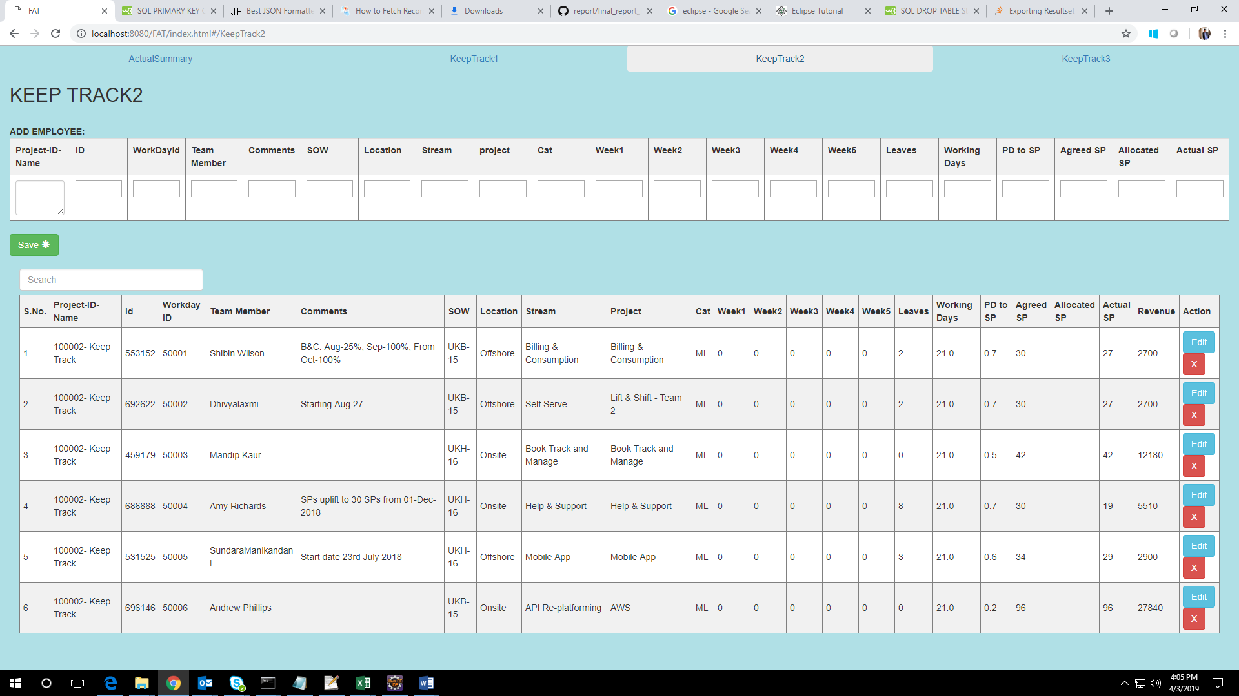

Figure A2.1 Keep Track2 Page

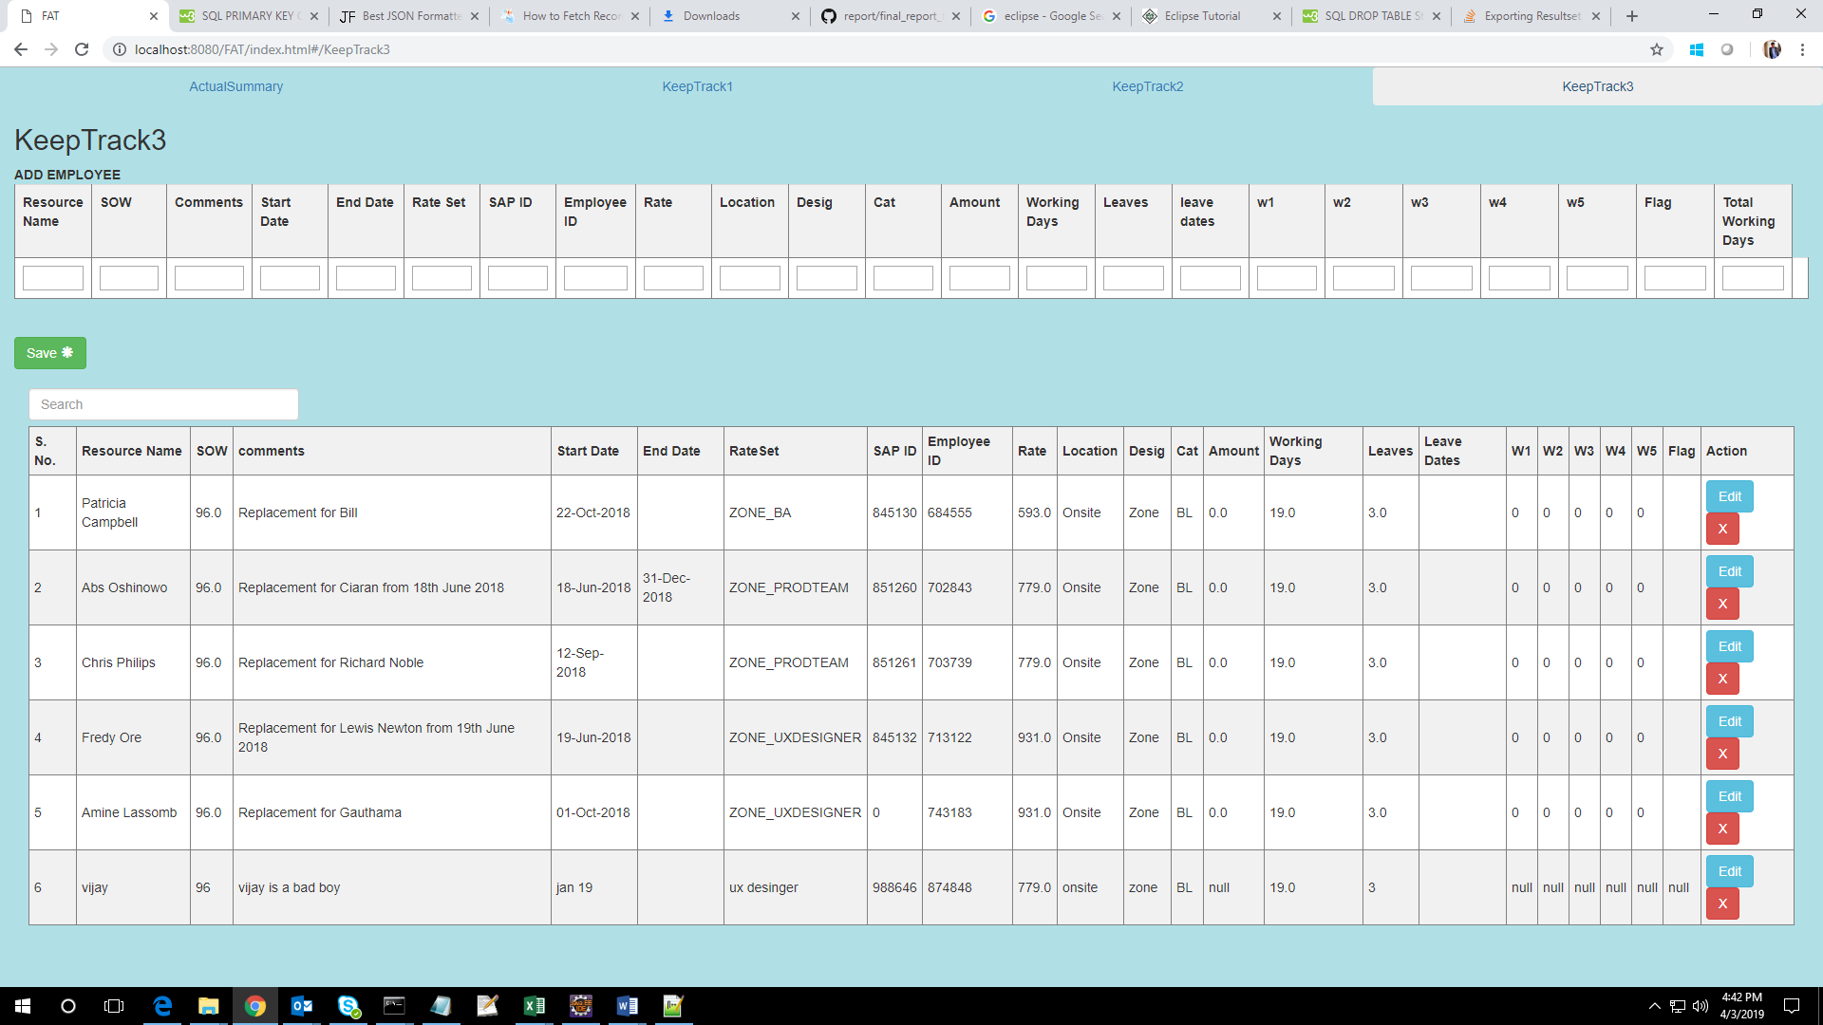

Fig A2.2 Keep Track3 Page

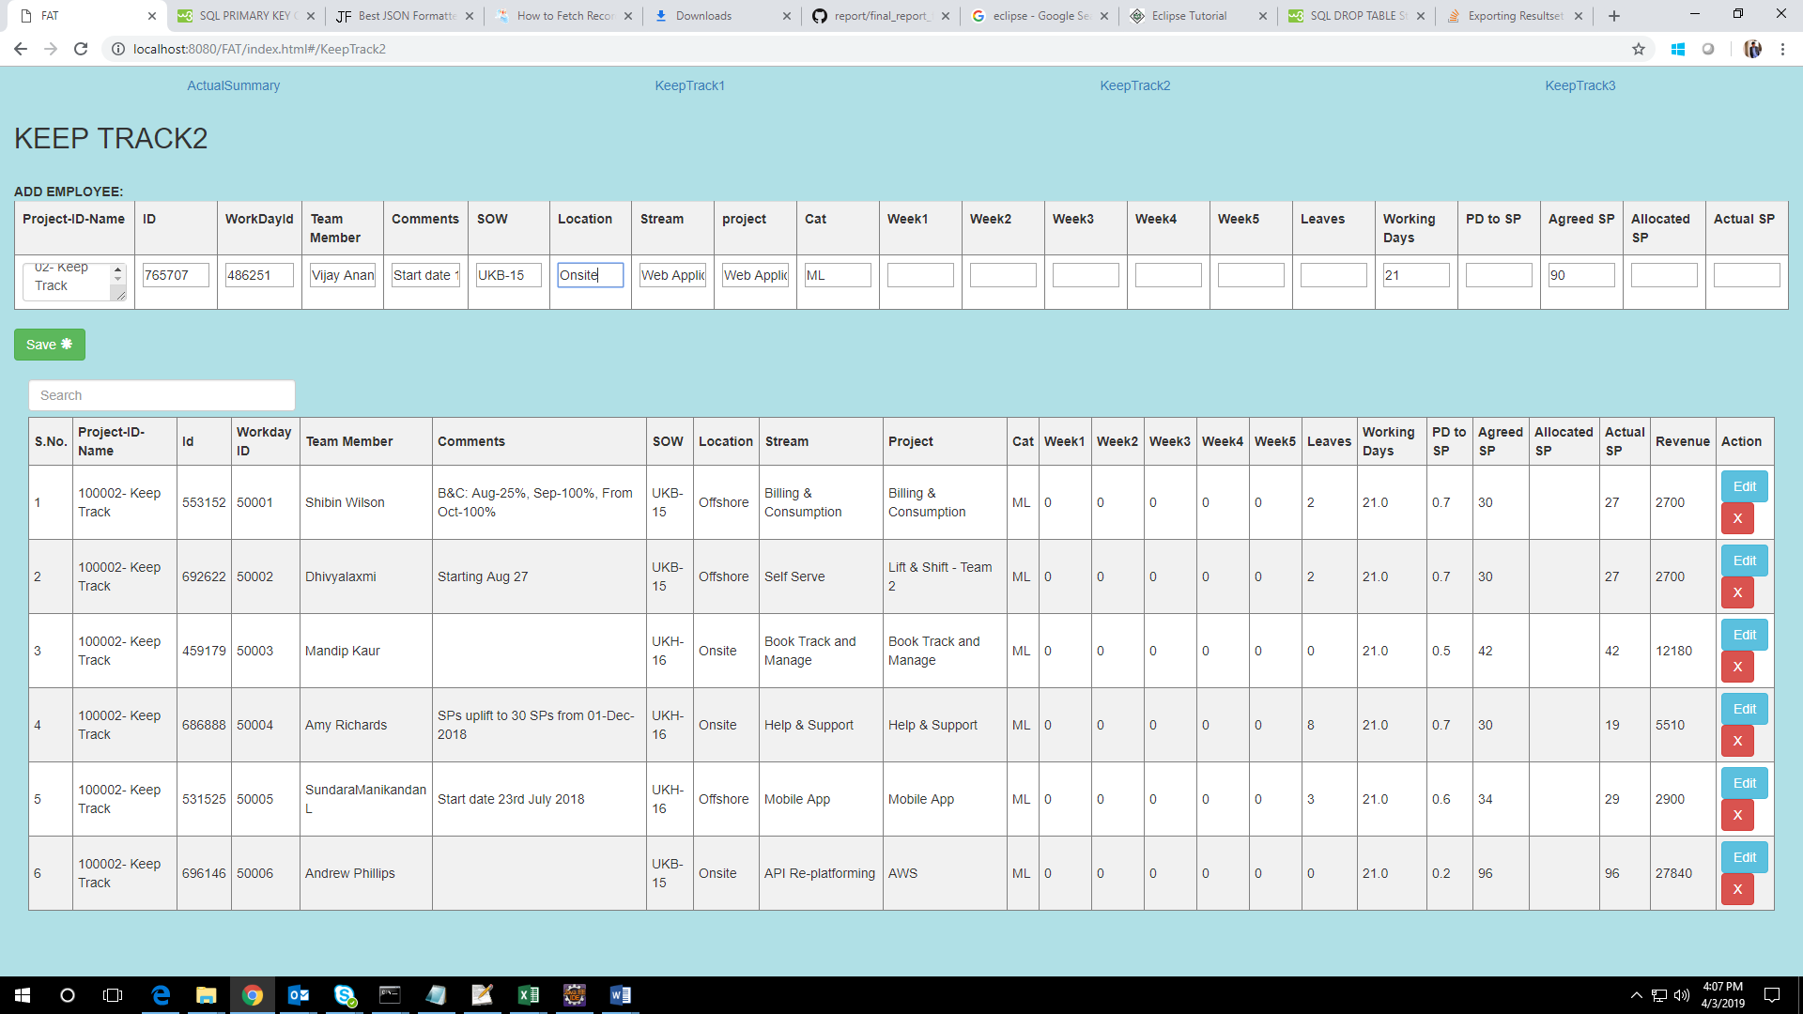

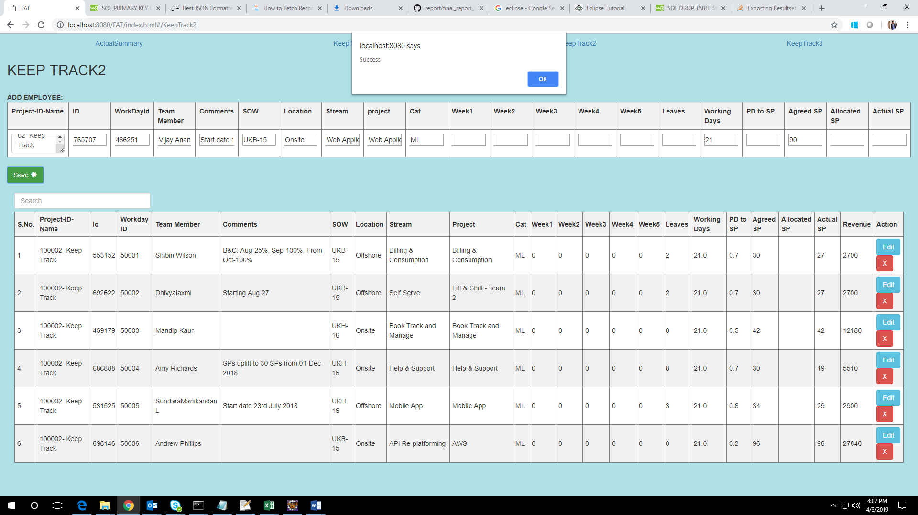

Fig A2.3 Adding New Resource And Success Response

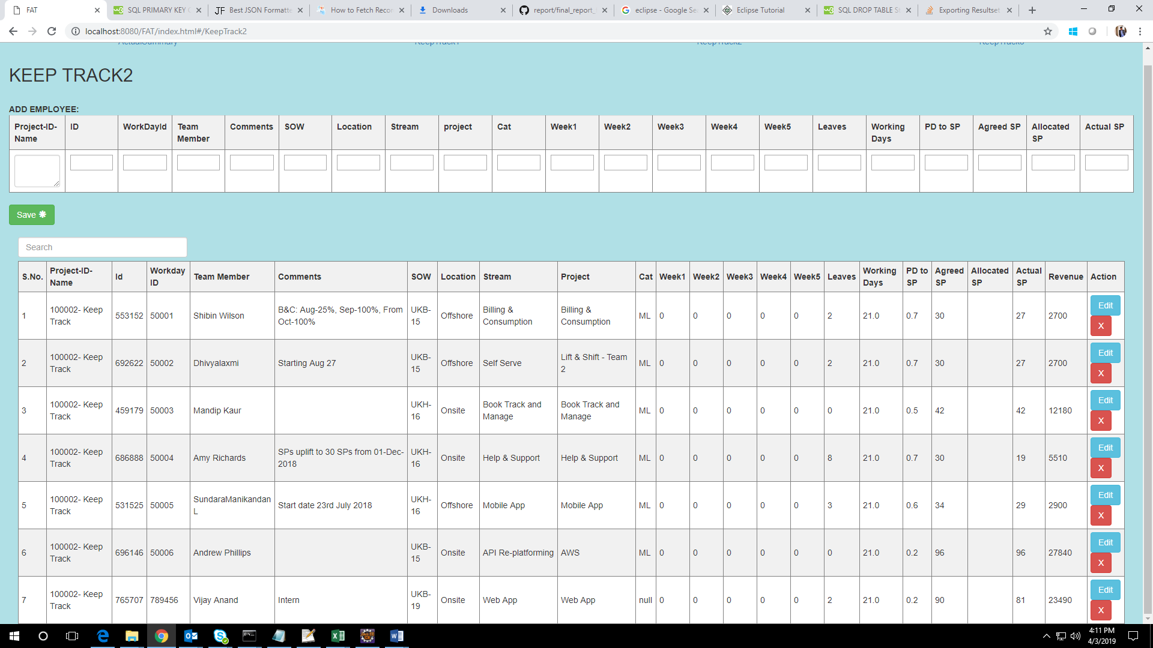

Fig A2.4 New Resource Added

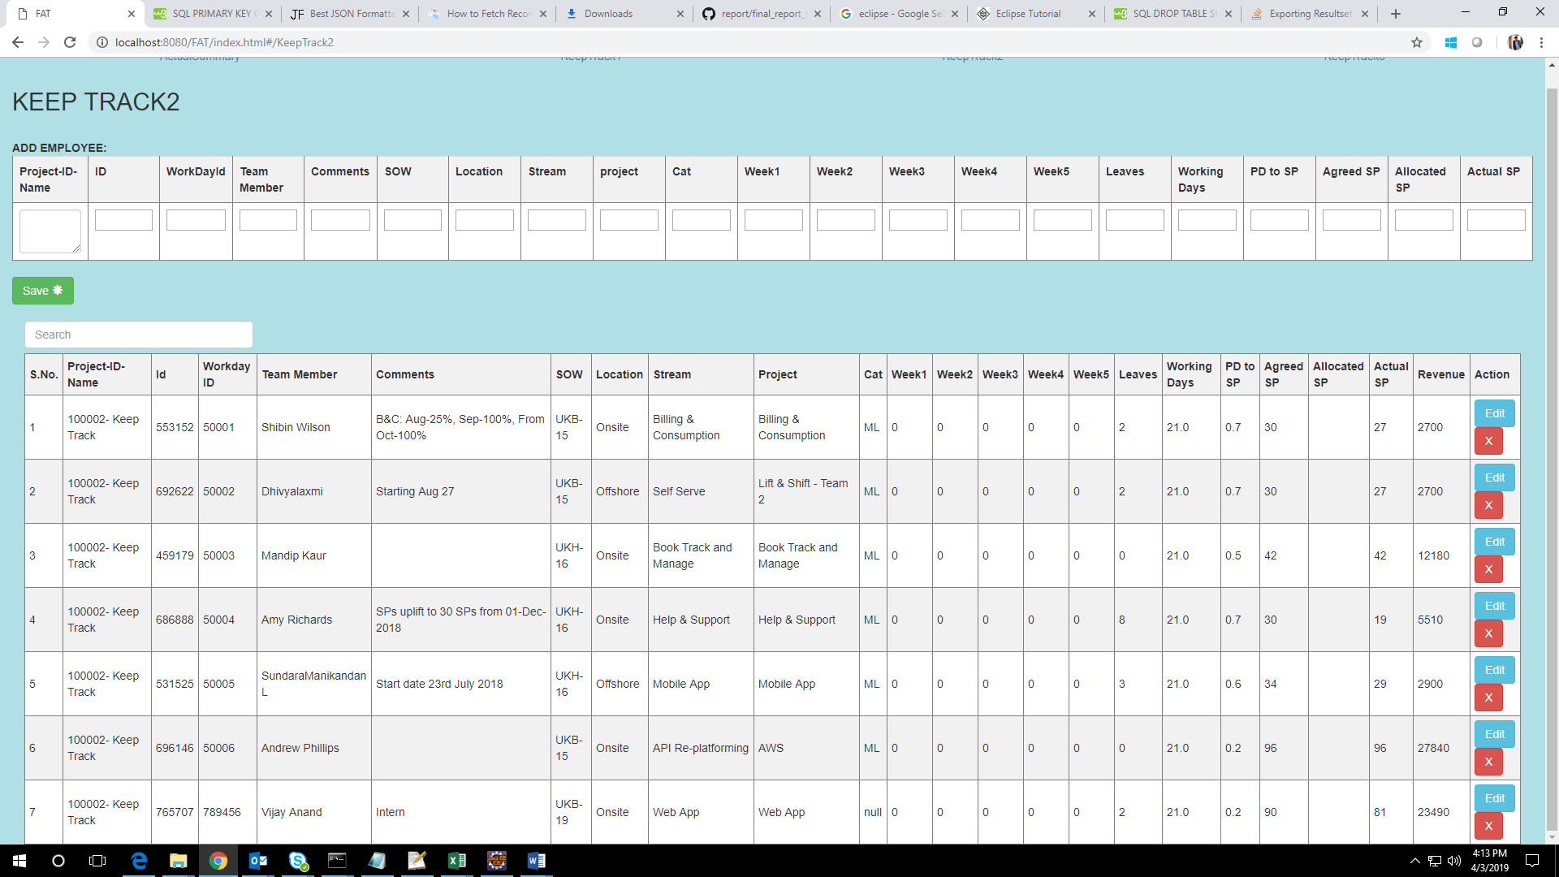

Fig A2.5 Editing Resource Details

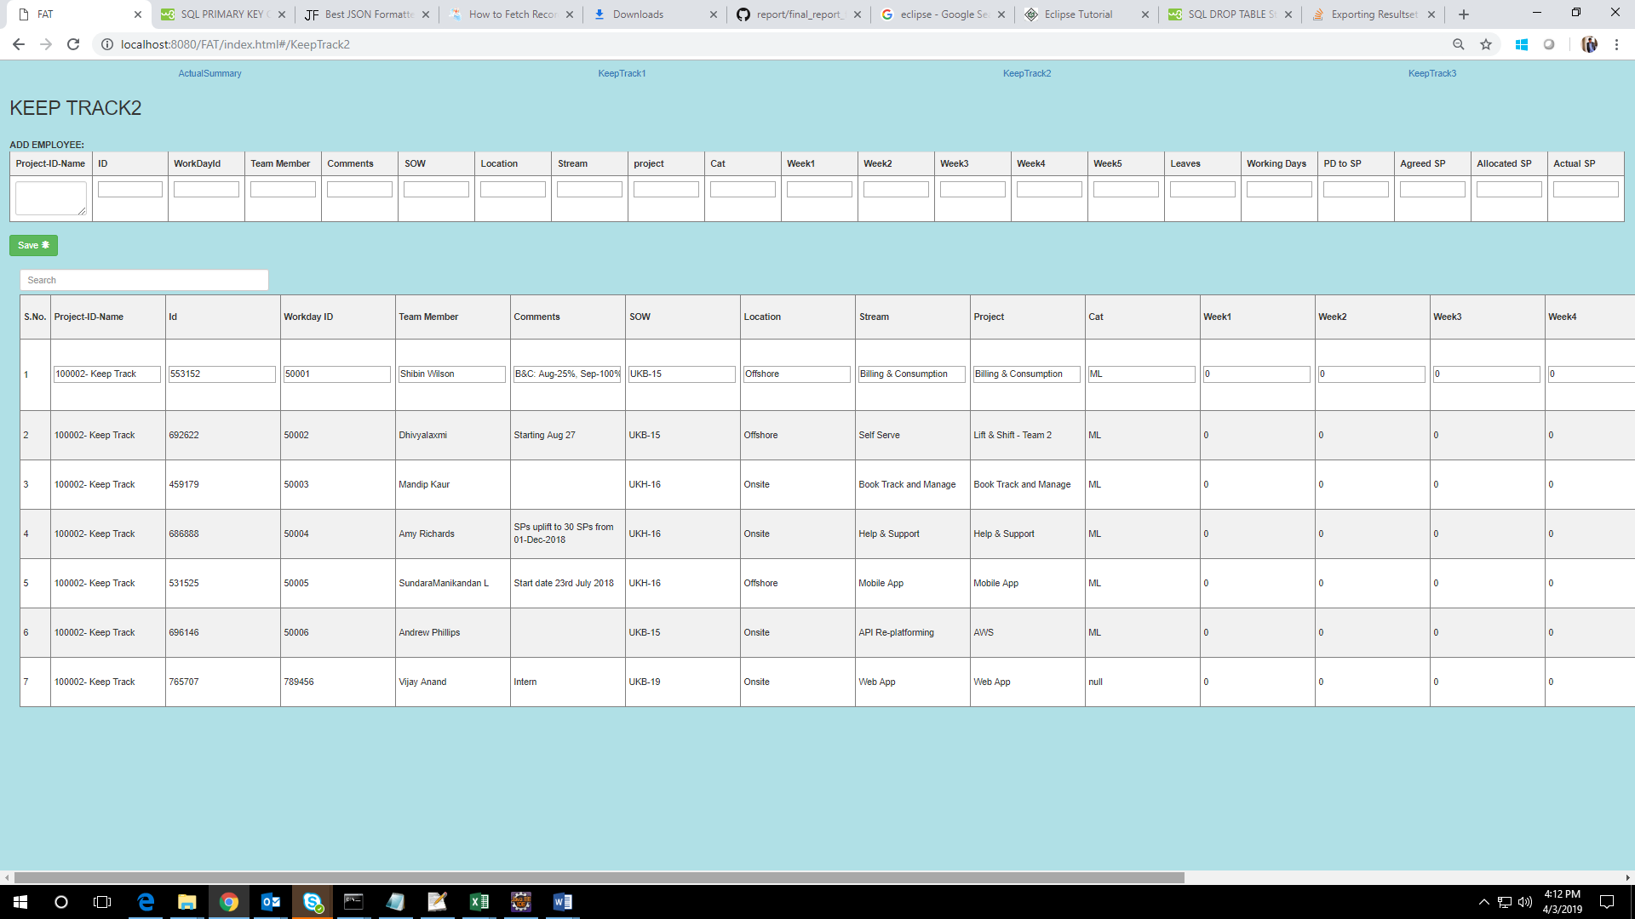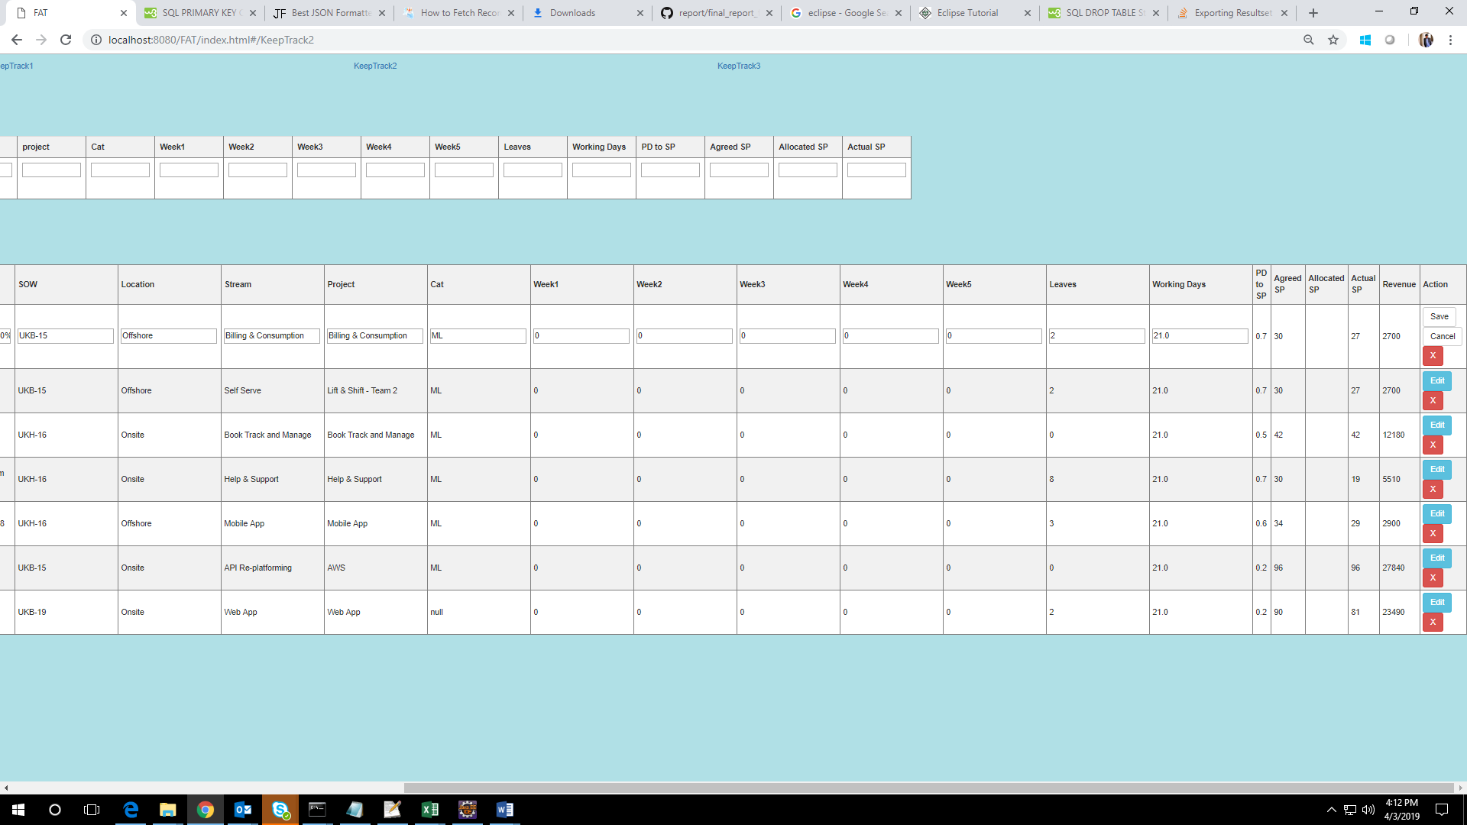

Fig A2.6 Updating Edited Resource Details

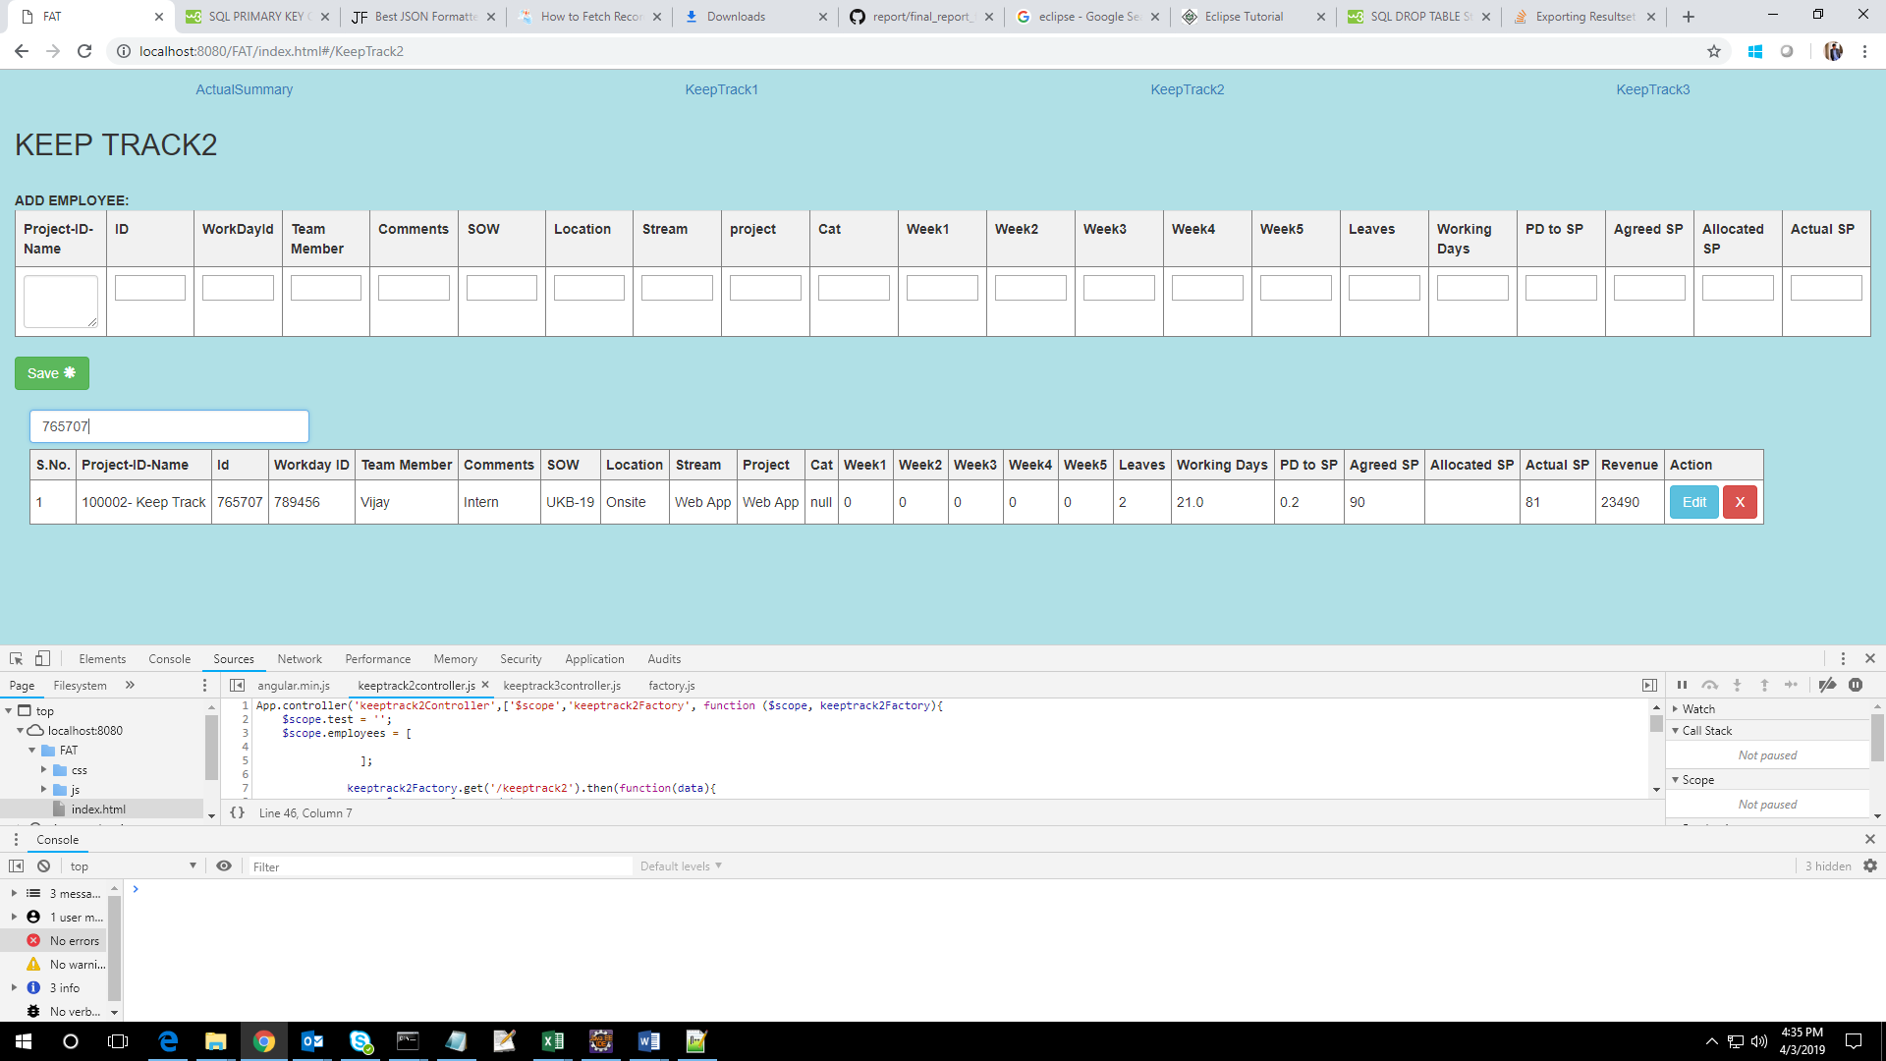

Fig A2.7 Searching Resource Details

REFERENCES

Web References:

- https://www.tutorialspoint.com/angularjs/
- https://www.tutorialspoint.com/java/
- https://www.tutorialspoint.com/servlets/
- https://www.tutorialspoint.com/apache_poi/
- https://www.w3schools.com/sql/default.asp
- https://www.w3schools.com/css/default.asp
- https://www.w3schools.com/bootstrap/default.asp
- https://www.javatpoint.com/java-jdbc

