CHAPTER 1 INTRODUCTION

1.1 OVERVIEW OF THE PROJECT

“Financial Automation Tool” is the web based application that provides an efficient way to maintain various information and generate the reports. The resource information is immediately stored in the database. The resource information and their financial billings can be exported as excel format and can be sent to client for billing.

.

In this project, the requirement is to build a web application to manage fleet details by administrator. In the process of fleet management, the owners have full control of the maintenance of a vehicle fleet. It can be used to record almost every aspect of fleet maintenance activities.

The software is enhanced by using the report generation tool which is embedded in the web application. This feature helps the supervisor of company and admin to have the better bus quality enhancements. The generated reports can be downloaded for later use.

In current growing market, it is mandatory for cost benefit management to give option for administrator to manage profit or loss. This profit or loss is calculated for the given period of time.

CHAPTER 2

SYSTEM ANALYSIS

EXISTING SYSTEM

In existing system one or two resource will be manually entering and maintaining the details of the other resources in a Microsoft excel workbook. A leave tracker workbook which consists of leave details of the resource and forecast workbook contains the resource details and the client billing details for the upcoming week which is prepared by the resource persons for each week and another workbook called actual which contains the final and actual details of each month.

Drawbacks of the existing system

    - Consumes more time in preparing these workbook.

    - Productivity hour get reduced.

    - Ηigh probability of making mistakes since it is prepared manually.

    - Loss of revenue for the project.

To avoid all these limitations and make the working more accurately the system needs to be enhanced.

PROPOSED SYSTEM

The aim of proposed system is to develop a system of improved facilities. The proposed system can overcome all the limitations of the existing system. The system allows the resource to prepare the excel workbook automatically in the minimal time.

This system provides resource details management which maintains the details of working days, leaves and billing details. The actual workbook which are generated each month will have their total costs which the client need to pay for each resource in a project.

The system provides graphical table representation of the workbook in a webpage and also the resource can add new resource to any project and also can remove any resource from a project if they are left from the project or changed to another project with simple click of a button.

Advantages of proposed system

The system is very simple in design and to implement. The system requires very low system resources and the system will work in almost all configurations. It has got following features

    - Resource financial details management is done effectively.

    - Consumes very less time than the manual method.

    - Productivity time increases.

    - Saves productivity cost.

    - No chance of making mistake since it is automatically calculated datas.

FEASIBILITY STUDY

During system analysis, the feasibility study of the proposed system is to be carried out. This is to ensure that the proposed system is not a burden to the user. For feasibility analysis, some understanding of the major requirements of the system is essential. Three key considerations involved in the feasibility analysis are

    - Technical Feasibility
    - Operational Feasibility
    - Economical Feasibility

Technical Feasibility

The technical feasibility basically centers on alternatives for hardware, software and design approach to determine the functional aspects of system. This web application will be useful web users because it is being enhanced with Bootstrap.
.

Operational Feasibility

Operational feasibility is the measure of how well a proposed system solves the problems in the existing system. Embedding the report generation features, export of data with this web application makes it easier to generate report from any device and supervisor of system need not to use a separate tool for report generation and integrating the generated reports with the web application has been reduced.

Economical Feasibility

Embedding the report generating features with this web application makes it easier to generate report from any device and editor need not to use a separate tool for report generation and integrating the generated reports with the web application has been reduced. Hence no

need to buy the additional software tool to install on supervisor device for the report generation and maintenance cost of additional software tool also reduced.

PROBLEM ANALYSIS

The first step in the software development life cycle is the identification of the problem as the success of the system depends on how accurately a problem is identified. At present, resource details are maintained manually in Excel workbook.

The consolidated revenue reports such as fleet report, fuel report, maintenance report, stock movement report, stock balance report, accident report and analysis reports such as cost benefit report, fuel consumption chart and maintenance expenses chart are tedious to generate. To overcome this problem, the software is required and it should be capable of managing the transactions in network environment.

This system provides crew management which maintains the fuel records, accident records, maintenance records. In crew management, graphical chart is generated for fuel consumption which is used to analysis the fuel record for the separate bus and the certain period of days. The maintenance expenses can be easily analyzed by using the graphical charts..

This system provides fleet management which maintains the stock management, rebuild tyres, repairs, insurance management. The fleet maintenance records will have their costs attached to them so that the users can generate various maintenance cost reports.

If you have imported excel file or pasted csv data, you will get to screen with options to map the fields. It is advisable that import rights are given only to admin users since it may cause incorrect/duplicate data if wrong data is imported.

The software used to solve the problem and develop the application with CodeIgniter PHP programming using sublime with Doctrine ORM and Mysql.

DATA FLOW DIAGRAM

The data flow diagram shows the overview of the entire system as a series of process and it shows the interaction between the system and the external agents. The process are bus ticket reservation, crew management, fleet management and cost benefit analysis.

CONTEXT DIAGRAM

The context diagram shows the overview of the entire system as a single process and it shows the interaction between the system and the external agents.

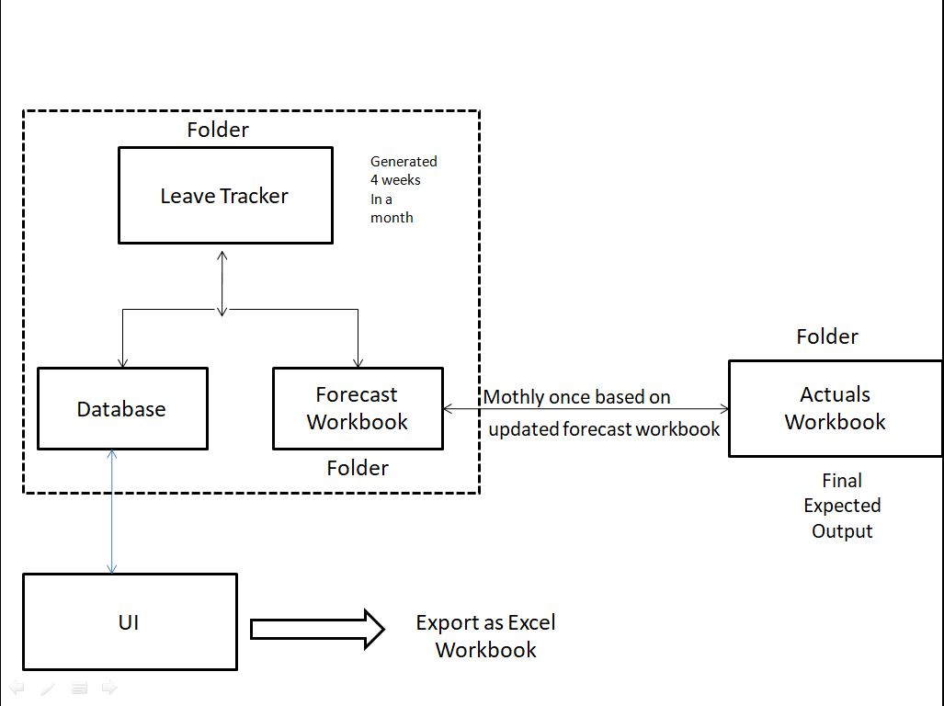
Figure 2.1 Context diagram for Financial Automation Tool

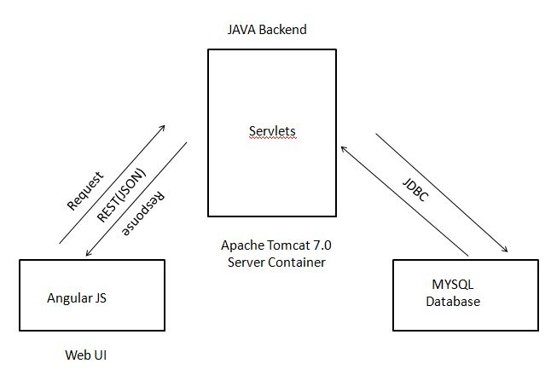

Figure 2.2 Technical Flow Diagram for Online Bus Information System

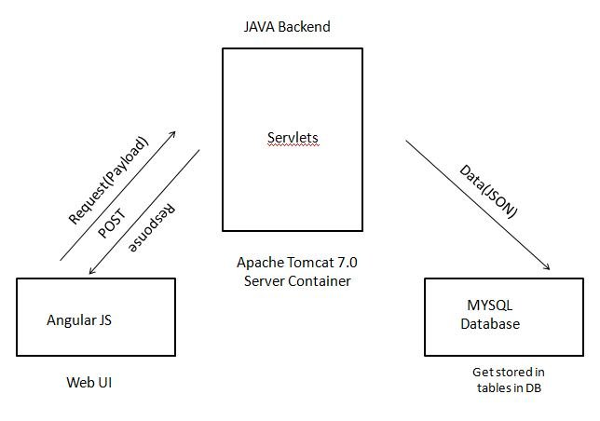

Figure 2.3 POST call for Inserting New Data

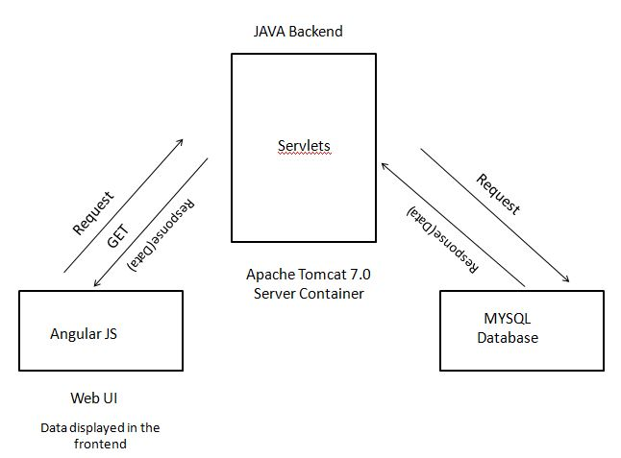

Figure 2.4 GET call for Fetching Data from Database

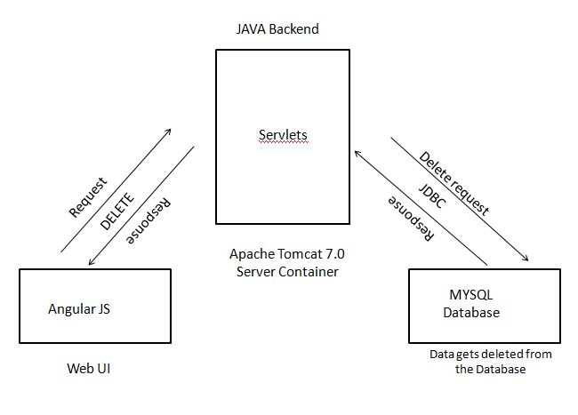

Figure 2.5 DELETE call for Deleting Data from the Database

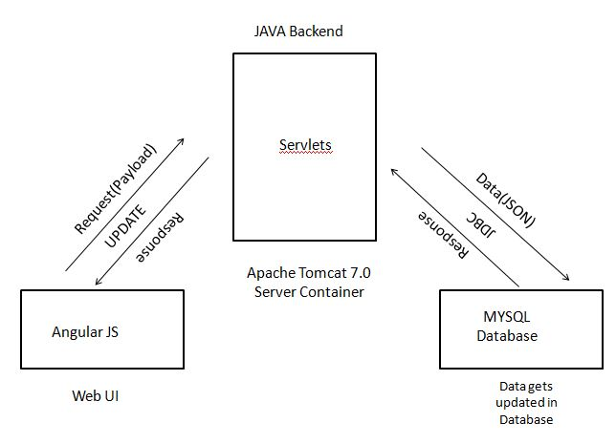

Figure 2.6 UPDATE call for updating the existing data

SYSTEM SPECIFICATION

Hardware Specification

This section gives the details and specification of the hardware on which the system is expected to work.

Processor : Pentium core processor

RAM : 2 GB RAM

Hard Disk : 20 GB storage

Monitor : 17” Color
System type : 64-bit operating system

Software Specification

This section gives the details and specification of the software on which the system is expected to work.

Operating System : Windows 7

Environment : Eclipse

Scripting language : HTML5, Angular JS, CSS, Bootstap
Java : jdk 101

Backend : MYSQL

SOFTWARE DESCRIPTION

Sublime

Sublime Text is a proprietary cross-platform source code editor with a Python application programming interface (API). It natively supports many programming languages and markup languages, and functions can be added by users with plugins, typically community-built and maintained under free-software licenses.

Bootstrap

Bootstrap is a free and open source front-end web framework for designing websites and web applications. It contains HTML- and CSS-based design templates for typography, forms, buttons, navigation and other interface components, as well as optional JavaScript extensions. Unlike many web frameworks, it concerns itself with front-end development only.

HTML

Hypertext Markup Language (HTML) is the standard markup language for creating web pages and web applications. With Cascading Style Sheets (CSS) and JavaScript it forms a triad of cornerstone technologies for the World Wide Web. Web browsers receive HTML documents from a web server or from local storage and render them into multimedia web pages. HTML describes the structure of a web page semantically and originally included cues for the appearance of the document.

CSS

Cascading Style Sheets (CSS) is a style sheet language used for describing the presentation of a document written in a markup language. Although most often used to set the visual style of web pages and user interfaces written in HTML and XHTML, the language

can be applied to any XML document, including plain XML, SVG and XUL, and is applicable to rendering in speech, or on other media.

JavaScript

JavaScript often abbreviated as JS, is a high-level, dynamic, weakly typed, prototype- based, multi-paradigm, and interpreted programming language. Alongside HTML and CSS, JavaScript is one of the three core technologies of World Wide Web content production. It is used to make webpages interactive and provide online programs, including video games. The majority of websites employ it, and all modern web browsers support it without the need for plug-ins by means of a built-in JavaScript engine. Each of the many JavaScript engines represent a different implementation of JavaScript, all based on the ECMAScript specification, with some engines not supporting the spec fully, and with many engines supporting additional features beyond ECMA.

jQuery

jQuery is a cross-platform JavaScript library designed to simplify the client-side scripting of HTML. It is free, open-source software using the permissive MIT License. Web analysis indicates that it is the most widely deployed JavaScript library by a large margin. jQuery's syntax is designed to make it easier to navigate a document, select DOM elements, create animations, handle events, and develop Ajax applications.

JSON

JavaScript Object Notation is an open-standard file format that uses human-readabletext to transmit data objects consisting of attribute–value pairs and array data types (or any other serializable value). It is a very common data format used for asynchronous browser–server communication, including as a replacement for XML in some AJAX-style systems.
JSON is a language-independent data format. It was derived from JavaScript, but as of 2017 many programming languages include code to generate and parse JSON-format data. The official Internet media type for JSON is application/json . JSON filenames use the extension .json .

MVC

The Model-View-Controller (MVC) is an architectural pattern that separates an application into three main logical components such as the model, the view, and the controller.

PHP

The PHP Hypertext Preprocessor (PHP) is a programming language that allows web developers to create dynamic content that interacts with databases. PHP is basically used for developing web based software applications. PHP has received criticism due to lacking native unicode support at the core language level, instead only supporting byte strings.

CodeIgniter Framework

CodeIgniter is an application development framework, which can be used to develop websites, using PHP. It is an Open Source framework. It has a very rich set of functionality, which will increase the speed of website development work. Some of the features are
    - Model-View-Controller Based System
    - Extremely Light Weight
    - Full Featured database classes with support for several platforms.
    - Query Builder Database Support

MySql

MySql is a freely available open source Relational Database Management System (RDBMS) that uses Structured Query Language (SQL). SQL is the most popular language for adding, accessing and managing content in a database.

ORM

Object-relational mapping (ORM, O/RM, and O/R mapping tool) is a programming technique for converting data between incompatible type systems using object-oriented programming languages. In effect, this creates a "virtual object database" that can be used from within the programming language.

CHAPTER 3 SYSTEM DESIGN

INPUT DESIGN

Input design is the process of converting user originated inputs to a computer understandable format. Input design is one of the most expensive part of the operation of computerized system. Input data are collected and organized into groups of similar data. Every moment of input design should be analyzed and designed with most care.

The main objective of input design is
    - To process the clear requirements
    - To get highest level of accuracy
    - To produce desired output
    - Data recording
    - Data verification

The input design involves converting user originated inputs into a sub system based format. The aim of input design is to make the data entry easier, logical error free. The following forms are included in this input form.

Registration form

Any user can register in the web application in order to book the ticket. Supervisor can be added to the system only if the admin approve the request.

Search ticket

The search ticket form get details like source station, destination station, journey date, number of passenger, bus type. Those details are entered in textboxes.

Booking ticket

The booking ticket form get details like name of the passenger, age of the passenger and the sex of the passenger. Those details are entered in textboxes. These details are stored in reservation table.

Cancellation ticket

The cancellation ticket form get ticket number as the only input. This detail is entered in textbox. This detail changes the field status to cancel in reservation table.

Add bus

The add bus form get details like bus number, coach type, source station, destination station, start time, reach time, number of seats and fare. These details are entered using textboxes and combo box. These details are stored in bus table.

Fuel form

The fuel form get details like fleet, vehicle, coupon, fuel date, fuel station, meter reading, litre pumped, litre.price, fill type, last mileage and system date. These details are entered using textboxes and combo box. These details are stored in fuelreport table. In this fields the meter reading should be greater than the last mileage.

Accidents form

The accident form get details like fleet, vehicle, type, date, time, location, driver, deaths, injured, description, vehicle damage, 3rd party damages and system date. These details are entered using textboxes and combo box. These details are stored in accident table. In this

date is entered using datepicker and the time is entered using timepicker. Some of the values of fields assigned in default.

DATABASE DESIGN

The most important consideration in designing the database is how the information will be used. The main objective of designing a database is:

Data Integration

In a database, information from several files are coordinated, accessed and operated upon as through it is in a single file. Logically, the information are centralized, physically, the data may be located on different devices, connected through data communication facilities.

Data Integrity

Data integrity means storing all data in one place only and how each application access it. This approach results in more consistent information, one update being sufficient to achieve a new record status for all applications. This leads to less data redundancy: data items need not be duplicated: a reduction in the direct access storage requirement.

Data Independence

Data independence is the insulation of application programs from changing aspects of physical data organization. This objective seeks to allow changes in the content and organization of physical data without reprogramming of application and to allow modifications to application programs without reorganizing the physical data. The tables needed for each module were designed and the specification of each and every column was given based on the records and the details collected during record specifications of the system study.

TABLE DESIGN

Table 3.1 Registration

FIELD NAME | FIELD TYPE | SIZE | CONSTRAINT
Id | Int | 11 | Not null
Username | Varchar | 30 | Primary key
Password | Varchar | 30 | Not null
Firstname | Varchar | 30 | Not null
Lastname | Varchar | 30 | Not null
Sex | Varchar | 6 | Not null
Phonenumber | Varchar | 10 | Not null
Email_id | Varchar | 30 | Not null

Table 3.2 Bus Details

FIELD NAME | FIELD TYPE | SIZE | CONSTRAINT
Serviceno | Int | 4 | Primary key
Busname | Varchar | 30 | Not null
Bustype | Varchar | 30 | Not null
Source | Varchar | 30 | Not null
Destination | Varchar | 30 | Not null
Start_time | Time | - | Not null
Reach_time | Time | - | Not null
Avail | Int | 3 | Not null
Status | Varchar | 15 | Not null
Fare | Int | 6 | Not null

Table 3.3 Reservation

FIELD NAME | FIELD TYPE | SIZE | CONSTRAINT
Id | Int | 4 | Primary key
Serviceno | Int | 4 | Foreign key
Username | Varchar | 20 | Foreign key
Pass_name | Varchar | 20 | Not null
Age | Int | 2 | Not null
Sex | Varchar | 6 | Not null
Seat | Int | 3 | Not null
Flag | Int | 7 | Not null
Book_date | Date | - | Not null
Dep_date | Date | - | Not null
Cancel_date | Date | - | Null

Table 3.4 Accidents

FIELD NAME | FIELD TYPE | SIZE | CONSTRAINT
Id | Int | 4 | Primary key
Sysdate | Date | - | Not null
Date | Date | - | Not null
Time | Time | - | Not null
Fleet | Varchar | 10 | Not null
Serviceno | Int | 4 | Foreign key
Type | Varchar | 20 | Not null
Details | Varchar | 200 | Not null
Driver | Varchar | 15 | Not null
Injured | Varchar | 40 | Not null
Deaths | Varchar | 40 | Not null
Damage to vehicle | Varchar | 40 | Not null
3rdpartydamages | Varchar | 40 | Not null
Images | Varchar | 200 | Not null
Location | Varchar | 20 | Not null

Table 3.5 Stock Details

FIELD NAME | FIELD TYPE | SIZE | CONSTRAINT
Id | Int | 11 | Primary key
Itemcode | Varchar | 40 | Null
Brand | Varchar | 40 | Null
Description | Varchar | 40 | Null
Supplier | Varchar | 40 | Null
Quantity | Varchar | 40 | Null
Removedfrom | Varchar | 4 | Null
Systemdate | Date | - | Null
Grndate | Date | - | Null
Enteredby | Varchar | 40 | Null
Approvedby | Varchar | 40 | Null
Unitprice | Int | 10 | Null
Status | Varchar | 40 | Null
Refnumber | Varchar | 40 | Null
Currentstock | Varchar | 15 | Null
Fleet | Varchar | 40 | Null
Cost | Int | 40 | Null

Table 3.6 Fleet Type

FIELD NAME | FIELD TYPE | SIZE | CONSTRAINT
Id | Int | 11 | Primary Key
Fleettype | Varchar | 40 | Null
Incharge | Varchar | 40 | Null

Table 3.7 Fuel Master

FIELD NAME | FIELD TYPE | SIZE | CONSTRAINT
Id | Int | 11 | Primary Key
Systemdate | Date | - | Null
Fueldate | Date | - | Null
Serviceno | Int | 4 | Foreign key
Meterreading | Int | 20 | Null
Literspumped | Int | 10 | Null
Priceperliter | Int | 10 | Null
Fuelstation | Varchar | 40 | Foreign Key
Fleet | Varchar | 40 | Null
Lastmileage | Int | 20 | Null
Economy | Int | 15 | Null
Filltype | Varchar | 15 | Null
Driver | Varchar | 40 | Null

Table 3.8 Fuel Station Master

FIELD NAME | FIELD TYPE | SIZE | CONSTRAINT
Id | Int | 11 | Not Null
Fuelstation | Varchar | 40 | Primary Key
Address | Varchar | 60 | Null
Contactnumber | Varchar | 10 | Null
Deposit | Varchar | 40 | Null

Table 3.9 Insurance Claims

FIELD NAME | FIELD TYPE | SIZE | CONSTRAINT
Id | Int | 11 | Primary key
Sysdate | Date | - | Null
Fleet | Varchar | 20 | Null
Type | Varchar | 20 | Null
Serviceno | Int | 4 | Foreign key
Accidentdate | Date | - | Null
Claim | Varchar | 10 | Null
Enteredby | Varchar | 25 | Null
Receiptno | Varchar | 10 | Null
Insurer | Varchar | 40 | Null

Table 3.10 Insurance Company

FIELD NAME | FIELD TYPE | SIZE | CONSTRAINT
Id | Int | 11 | Not null
Name | Varchar | 20 | Primary key
Address | Varchar | 40 | Null
Contactname | Varchar | 20 | Null
Contactnumber | Varchar | 10 | Null

Table 3.11 Inventory Master

FIELD NAME | FIELD TYPE | SIZE | CONSTRAINT
Id | Int | 11 | Primary key
Itemid | Varchar | 10 | Null
Brand | Varchar | 20 | Null
Description | Varchar | 200 | Null
Supplier | Varchar | 40 | Null

Table 3.12 Maintenance

FIELD NAME | FIELD TYPE | SIZE | CONSTRAINT
Id | Int | 11 | Primary key
Fleet | Varchar | 40 | Null
Serviceno | Int | 4 | Null
Type | Varchar | 20 | Null
Supplier | Varchar | 25 | Null
Cost | Int | 10 | Null
Remarks | Varchar | 150 | Null
Refno | Varchar | 10 | Null
Sysdate | Date | - | Null
Date | Date | - | Null
Enteredby | Varchar | 25 | Null
Approval | Varchar | 25 | Null
Meterreading | Int | 20 | Null
Accidentref | Varchar | 10 | Null
Paymentvoucher | Varchar | 20 | Null
Mainttype | Varchar | 10 | Null

Table 3.13 Supplier Master

FIELD NAME | FIELD TYPE | SIZE | CONSTRAINT
Id | Int | 11 | Primary key
Suppliername | Varchar | 40 | Null
Address | Varchar | 40 | Null
Contactperson | Varchar | 25 | Null
Telephone | Varchar | 10 | Null

Table 3.14 Other Renewal

FIELD NAME | FIELD TYPE | SIZE | CONSTRAINT
Id | Int | 11 | Primary key
Fleet | Varchar | 40 | Null
Serviceno | Int | 40 | Null
Vehicletype | Varchar | 40 | Null
Paymenttype | Varchar | 40 | Null
Paymentdate | Date | - | Null
Cost | Int | 40 | Null
Systemdate | Date | - | Null
Enteredby | Varchar | 40 | Null
Periodfrom | Date | - | Null
Periodto | Date | - | Null
Paymentref | Varchar | 40 | Null

Table 3.15 Vehicle Master

FIELD NAME | FIELD TYPE | SIZE | CONSTRAINT
Id | Int | 11 | Primary key
Regno | Varchar | 20 | Null
Fleet | Varchar | 20 | Null
Type | Varchar | 20 | Null
Regdate | Date | - | Null
Cost | Int | 40 | Null
Driverassigned | Varchar | 40 | Null
Make | Varchar | 20 | Null
Model | Varchar | - | Null
Insurancedue | Varchar | 15 | Null

Table 3.16 Admin Master

FIELD NAME | FIELD TYPE | SIZE | CONSTRAINT
Id | Int | 11 | Primary key
Username | Varchar | 40 | Null
Password | Varchar | 40 | Null
Email | Varchar | 40 | Null
Fullname | Varchar | 40 | Null
Groupid | Varchar | 40 | Null

Table 3.17 Analysis Master

FIELD NAME | FIELD TYPE | SIZE | CONSTRAINT
Id | Int | 11 | Primary key
From | Date | - | Null
To | Date | - | Null
Ticketcost | Int | 11 | Null
Fleetcost | Int | 11 | Null
Analysiscost | Int | 11 | Null
Profitlossstatus | Varchar | 10 | Null

MODULE DESIGN

The main modules exists in this project are listed below

    - Bus Ticket Reservation
    - Crew Management
    - Fleet Management
    - Cost Benefit Management

Bus Ticket Reservation

The sub process in bus ticket reservation are

      - Book tickets.
      - View tickets.
      - Cancel tickets.
      - Report generation.

In the process of ticket booking the details of the passenger like one trip or two trip, source place, destination place, date of travelling, bus type are submitted to view the buslist. By selecting the bus the layout of the seats is viewed. The seats are chosen by the passenger and the personal details of the passengers like passenger name, age, sex are entered, then the pnr number is generated for the passenger. The ticket is displayed with the generated pnr number. The amount for the ticket is paid through paytm. The ticket can be downloaded as pdf format.

The next process is the viewing ticket. On providing the details of tickets like journey date, pnr number, service number(bus number), the details of the ticket like passenger_name, age, sex, seatno, journey_date are viewed.

In ticket cancellation process the button named cancel in viewing tickets is pressed, then the details of ticket is updated by changing in the field status from booked to cancelled. The fare of the ticket is refunded to the account based on date of cancellation. The report generation of the particular bus includes the passenger_name, seat_number, journey_date, age and sex of the passenger booked.

Crew Management

The sub process in Crew management are

      - Fuel record
      - Accident record
      - Maintenance record

Fuel record enables users to keep track of all sort of refueling details. It will also show the fuel efficiency of the vehicles. Adding a fuel record is easy. Just select “Fuel Records” and then “Add new” button. Fuel Economy can be calculated from one full tank instance to another full tank instance only. Even if you are making a full tank, if your previous fill was a partial fill then the economy is not calculated. Further, Last mileage & driver name are automatically pulled from the database which can also be manually adjusted if you need in any case.

Accident record facilitates the recording of all accidents. Some of the details can be cross linked to other modules. For instance, accident repairs will have reference to the accident records. Accident records will have detailed information about the accident including casualties, damage to the own vehicle, damages to third parties, accident date, time, location, driver, etc. Further, you can attach a picture of the accident scene if any.

Maintenance record is for recording all the regular/periodic maintenance details of vehicles. All maintenance expenses other than repairs are recorded in the maintenance module. Types of maintenance expenses can be defined in the “Service Types”.

Fleet management

The sub process in fleet management are

      - Stock management.
      - Rebuilt tyre management.
      - Repairs management.
      - Insurance details maintenance.

Stock management can be used to record and track all sorts of stock items used in fleet maintenance such as tyres, oils, bulbs, etc. Stock management has four segments as
      - Stock purchases – this will record all the purchases including quantity and cost.
      - Stock issues – this will record all the stock issued to vehicles. All issues will have a cost attached to it. This will enable users to generate the cost of stocks issued to a particular vehicle in reports.
      - Removals – this means the items removed from vehicles. For instance, if a head light is burnt, it will be removed from the vehicle and the item will get back into the inventory. Such items will bear zero cost.
      - Disposals – this means the disposal of stock items. Such items could be in good condition or ones which have been removed from vehicles.

Rebuild Tyres is used to record tyre rebuilding activities in case tyre rebuilding is done.
Entire process of tyre rebuilding is

      - Tyre Removals – i.e. removal from worn out tyres from vehicles which will be added back to the stock at zero cost.
      - Sending to Rebuild – i.e. sending the tyre rebuilding company from the stock.

      - Rebuilt Receipts – i.e. receiving the tyres after rebuilding into the stocks. Now the cost of the tyre will be the cost of rebuilding.
      - Rebuilt Issues – i.e. issue of tyres in the stock to vehicles. The cost allocated to the vehicle on the issue will be the cost of rebuilding.

All the repairs are recorded in the repair module. Repairs do not include regular maintenance which are carried out periodical or mileage cycle. Repair process has two sections as
      - Accident repair
      - General repair
Repairs arising due to road accidents are recorded in accident repair and all other repair is recorded under general repair.

Insurance details maintenance is used to record all the claims received from the insurance companies due to accidents. This will have accident table reference as well. Accident reference can also be given in claim records.

Cost Benefit Analysis

This module deals with

      - Booking Cost
      - Fleet cost
      - Cost Analysis

In the booking cost, the earnings gained by the tickets booked by the user. The only profit for the system is by the tickets payments. The expenses for the fleet like fuel, service and accident details are maintained by the Fleet cost. The profit or loss of the system is calculated in the profit or loss section by analyzing the earnings and the expenses of the system for the certain period of time.

OUTPUT DESIGN

Output design generally refers to the results and information that are generated by the system for many end-users: it should be understandable with the enhanced format.

The computerized output is the most important and the direct source of information to the user. The purpose is to produce the requirement output for the system to reach its success. The outputs are the most important sources of information to the users. Better design should improve the system's relationship with user and also will help in decision making.
The report generated in this project are
    - View passenger report
    - Accident report
    - Fuel report
    - Stock codes report
    - Maintainence report

View passenger report

The view passenger report is used to view the passenger list of the particular bus. The view passenger report consist of the passenger details like user id, name, seatno, ticket number it can be downloaded in PDF format.

Accident report

The accident report is used to view the accident list of the fleet. The accident report consist of the id, sysdate, date, time, fleet, serviceno, type, details, driver, injured, deaths, Damage to vehicle, Thirdpartydamages, images, location and it can be downloaded in PDF format.

Fuel report

The fuel report is used to view the fuel consumption of the fleet. The fuel report consist of the ID, SystemDate, FuelDate, Vehicle, MeterReading, LitersPumped, PricePerLiter, FuelStation, etc it can be downloaded in PDF format.

Fuel analysis report

The Fuel analysis report is used to view the Fuel consumed by fleet in graphical representation of charts. This chart is mapped using the economy calculated for every fleet. This chart can be calculated for particular bus and also compare the fleet.

Stock codes report

The Stock codes report is used to view the Stock codes of fleet. The Stock codes report consist of the stock codes details like user item id, brand, description, supplier it can be downloaded in PDF format.

Maintenance report

The Maintenance report is used to view the passenger list of the particular bus. The view passenger report consist of the Id, Fleet, Vehicle, Type, Supplier, Cost, Remarks, RefNo, SysDate, MaintType, etc it can be downloaded in PDF format.

Cost analysis report

The Cost analysis report is used to analyze the expenses of the fleet. The cost analysis report consist of the profit or loss details or the certain period of time and it is stored in the analysis table.

CHAPTER 4 SYSTEM TESTING

SYSTEM TESTING

Testing is an integral part of any system development life cycle. Insufficient and untested applications may tend to crash and the result is loss of economic and manpower investment besides user's dissatisfaction and downfall of reputation. Software testing can be looked upon as one among many process, an organization performs, and that provides the lost opportunity to correct any flaws in the developed system. Software testing includes selecting test data that have more probability of giving errors.

The first step in system testing is to develop a plan that tests all aspects of the system. Completeness, correctness, reliability and maintainability of the software are to be tested for the best quality assurance that the system meets the specification and requirements for its intended use and performance. System testing is the most useful practical process of executing a program with the implicit intention of finding errors that make the program fails. System testing is done in three phases

    - Unit testing
    - Integration testing
    - Validation testing

Unit Testing

Developers typically do the unit testing in order to trace out the bugs in each module of the code. Unit testing is done in parallel with coding. They were also tested for specification to see if they were working as per what the program should do and how it should perform under various conditions.

All the forms will be run through the menu to see if the proper sequence is maintained. Whenever an error is encountered, an informative error message will be displayed which informs the user what error is. After completion of form testing, the program will be tested.

In this project, user authentication, registration, booking, passenger details, cancellation, report generation are smaller units which are tested.

Integration Testing

Integration testing is a systematic technique for constructing tests to uncover error associated within the interface. In this project, all the modules are combined and then the entire project is tested as a whole. The integration testing was performed by integrating one module with another and checkout their functionality and execution. There are no errors and defects found in the system. The system meets all the specified user requirements and found working properly. The new system developed was tested by the acceptance testing method. The user provided test area. Thus the system was successfully tested and it satisfies the user requirements.

After integration testing all the modules like bus ticket reservation, crew management, fleet management and cost benefit analysis are tested with their integration and that could integrated and manipulated.

Validation Testing

It is said that validation is successful when the software function is systematic manner that can be reasonably accept by the customer. This type of testing is very important because it is the only way to check whether the requirements given by the user have been completely fulfilled. The input given to various form is validated efficiently.

TESTCASE

Test case id | Description | Expected output | Actual result
1 | Login form: Enter the Username and Password | Accepts the username and password into the textboxes  If user name and password is correct then valid | PASS  PASS
 |  | Else user name is incorrect then invalid | FAIL
 |  | Password is incorrect then invalid
 |  |  | FAIL
2 | Login form: Click Login Button | Navigate into the corresponding user page  Username and password should not be empty, otherwise it will  remains in the same page. | PASS  FAIL

3 | Maintenance form:  Click the Submit button | User wants to enter all the mandatory fields with correct information. if any Error in entering details found, then it  gives appropriate error message | FAIL
4 | Registration form: Click Edit Button | Display the details of corresponding user and user can allowed to change the previous  personal details. | PASS
5 | Maintenance form: Click Edit Button | Display the details of corresponding product and user can allowed to change the  previous details of the product. | PASS
6 | Maintenance  form: Click submit Button | The details of the product will updated in database. | PASS
 |  | If any Error like entering data is found then it gives proper error  message | PASS
7 | Maintenance form: Click  view Button | The particular ticket information will display. | PASS

CHAPTER 5

SYSTEM IMPLEMENTATION

When the initial design was done for the system, the system should be made consulted with the client for the acceptance of the design, so that further system development can be carried on. After the development of the system, a demonstration was given to them about the working of the system.

During system implementation, it is essential that everyone involved in the system development must be deployed with each other. Often the performance of deployment, efforts impact many of the performing organization’s normal business operations.

The service personnel may be required to assume significant implementation. While responsibilities at the same time having to continue current levels of service on other critical business systems. Technical support personnel may experience unusually high volumes of support requests due to the possible disruption of day-to-day processing.

After the management of the system was approved the system implemented in the concern, initially the system was run parallel with existing manual system. This system was tested with live data and has proved to error free and user friendly. While implementing this project, the system is user friendly with this application. This software is quite simple and easy to install into the admin system.

CHAPTER 6

CONCLUSION AND FUTURE ENHANCEMENT

CONCLUSION

The web application “ONLINE BUS INFORMATION SYSTEM” has been developed using CodeIgniter Framework for user interface and prototype of application is built using html, bootstrap, Javascript and MySql as database. All modules are tested separately and integrated to form the main system. This web based application provides an efficient way to book the tickets, cancel the tickets, maintain the fleet information and analyze the reports.

The crew and fleet management is computerized. Reports can be imported from the excel or csv file and can be exported to the excel file, csv file, word file and in the pdf format. The graphical chart is used to analyze the fuel consumption and the maintenance charge for the period of days or for the particular bus.

FUTURE ENHANCEMENT

    - Payroll calculation of the employee can be added as a module.

    - Time sheet based work allocation for supervisor can be done.

    - Comparitive analysis of profit and loss can be done for certain period of time.

APPENDICES APPENDIX I – SAMPLE CODING
<?php
error_reporting(E_ERROR | E_WARNING | E_PARSE); session_start(); if($_SERVER["REQUEST_METHOD"]== "POST")
{
$way = $_POST['way'];
$src= $_POST['from'];
$dest = $_POST['to'];
$adult= $_POST['adult'];
$child= $_POST['child'];
$class = $_POST['bustype'];
$departure = $_POST['departure'];
$return = $_POST['return'];
$total= $adult+$child;
if($src=="0" || $dest=="0"||$total=="0" || $departure=="")
{
$error="";
echo "<script>\n";
echo "alert('Please enter all details')"; echo "</script>";
$error="";
}
else
{

echo "<script>\n";
echo "window.open ('bussearch.php?way=$way &from=$src &to=$dest &adult=$adult &child=$child &bustype=$class &departure=$departure &return=$return ','content')\n";
echo "</script>";
}
}
?>
<html>
<head>
<style type="text/css"> h3
{
color:#FFFFFF; padding-top:20px; text-align: center;
}
</style>
</head>
<body>
<center>
<div style="background-color:green; height:60px;text-align: center;">
<h3> Book Tickets Now!</h3>
</div>
</center>
<div style="height:65%;">
<form action="" method="post" target="_self">
<table height="50%" width="30%" border="0" align="center" style="padding-top:-5pt;">
<br><br><br>
<tr>
<td colspan="4"><input type="radio" name="way" value="2" onclick="document.getElementById('datepick2').disabled=false"> Two Way </input>

<input type="radio" name="way" checked value="1" onclick="document.getElementById('datepick2').disabled=true"> One Way </input> </td>
</tr>
<tr>
<td colspan="2">From: </td>
<td colspan="2">
<select name="from" width="20" value='<?php echo "$src";?>'>
<option value="0">Select</option>
<option value="Bangalore">Bangalore</option>
<option value="Chennai">Chennai</option>
<option value="Coimbatore">Coimbatore</option>
<option value="Trichy">Trichy</option>
<option value="Salem">Salem</option>
</select>
</td>
</tr>
<tr>
<td colspan="2">To: </td>
<td colspan="2">
<select name ="to">
<option value="0">Select</option>
<option value="Bangalore">Bangalore</option>
<option value="Chennai">Chennai</option>
<option value="Coimbatore">Coimbatore</option>
<option value="Trichy">Trichy</option>
<option value="Salem">Salem</option>
</select>
</td>
</tr>
<tr>
<td colspan="2"> No.Of Passangers:</td>

<td>
<select name ="adult">
<option value="0">Adult</option>
<option value="1">1</option>
<option value="2">2</option>
<option value="3">3</option>
<option value="4">4</option>
<option value="5">5</option>
<option value="6">6</option>
</select>
</td>
<td>
<select name ="child">
<option value="0">Child</option>
<option value="1">1</option>
<option value="2">2</option>
<option value="3">3</option>
</select>
</td>
</tr>
<tr>
<td colspan="2"> Departure</td>
<td colspan="2"><input id="datepick1" size="10" name="departure" value='<?php echo "$departure";?>'/>
</tr>
<tr>
<td colspan="2"> Return</td>
<td colspan="2"><input id="datepick2" size="10" name="return" disabled/>
</tr>
<tr>
<td colspan="2">Bus Type: </td>

<td colspan="2">
<select name="bustype">
<option>Super Luxury</option>
<option> A/C</option>
<option>Luxury</option>
<option>Express</option>
</select>
</td>
</tr>
<tr>
<td colspan="2">Concession: </td>
<td colspan="2">
<select name="concession">
<option value="0">General Booking</option>
<option value="1">Cat Card</option>
</select>
</td>
</tr>
<tr>
<td colspan ="4" style="padding-top:10pt;padding-left:70pt"><input type="image" type="submit" src="avail.png"></input></td>
</tr>
</table>
</form>
</div>
</body>
<style type="text/css">
.calendar {
font-family: 'Trebuchet MS', Tahoma, Verdana, Arial, sans-serif; font-size: 0.9em;
background-color: #EEE;

color: #333;
border: 1px solid #DDD;
-moz-border-radius: 4px;
-webkit-border-radius: 4px; border-radius: 4px; padding: 0.2em;
width: 10em;
}
.calendar .months {
background-color: #F6AF3A; border: 1px solid #E78F08;
-moz-border-radius: 4px;
-webkit-border-radius: 4px; border-radius: 4px;
color: #FFF; padding: 0.2em; text-align: center;
}
.calendar .prev-month,
.calendar .next-month {
padding: 0;
}
.calendar .prev-month { float: left;
}
.calendar .next-month {
float: right;
}
.calendar .current-month { margin: 0 auto;
}

.calendar .months .prev-month,
.calendar .months .next-month { color: #FFF;
text-decoration: none; padding: 0 0.4em;
-moz-border-radius: 4px;
-webkit-border-radius: 4px; border-radius: 4px;
cursor: pointer;
}
.calendar .months .prev-month:hover,
.calendar .months .next-month:hover { background-color: #FDF5CE; color: #C77405;
}
.calendar table {
border-collapse: collapse; padding: 0;
font-size: 0.8em; width: 70%;
}
.calendar th {
text-align: center;
}
.calendar td {
text-align: right; padding: 1px; width: 14.3%;
}
.calendar td span {
display: block;

color: #1C94C4; background-color: #F6F6F6; border: 1px solid #CCC; text-decoration: none; padding: 0.2em;
cursor: pointer;
}
.calendar td span:hover { color: #C77405;
background-color: #FDF5CE; border: 1px solid #FBCB09;
}
.calendar td.today span {
background-color: #FFF0A5; border: 1px solid #FED22F; color: #363636;
}
</style>
<script type="text/javascript" src="datepickr.js"></script>
<script type="text/javascript"> new datepickr('datepick1', {
'dateFormat': '20y-m-d'
});
new datepickr('datepick2', { 'dateFormat': '20y-m-d'
});
</script>
</html>

APPENDIX II – SAMPLE SCREEN SHOTS

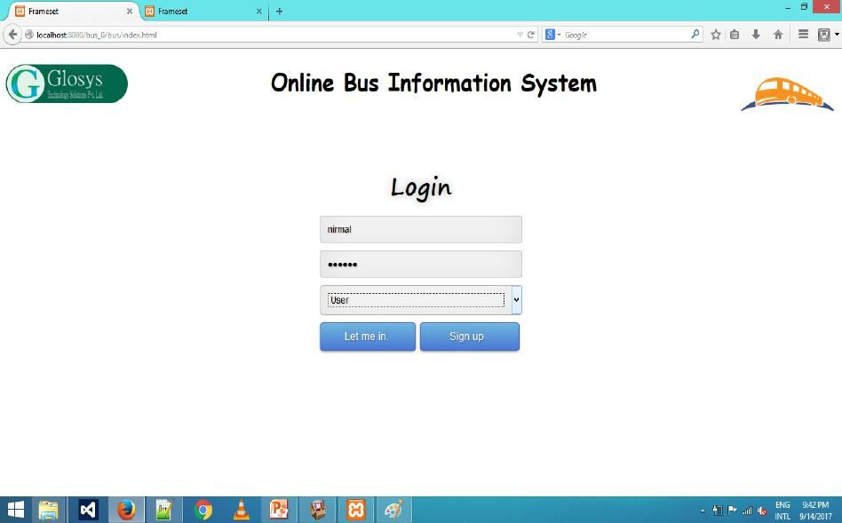

Figure A2.1 Login form

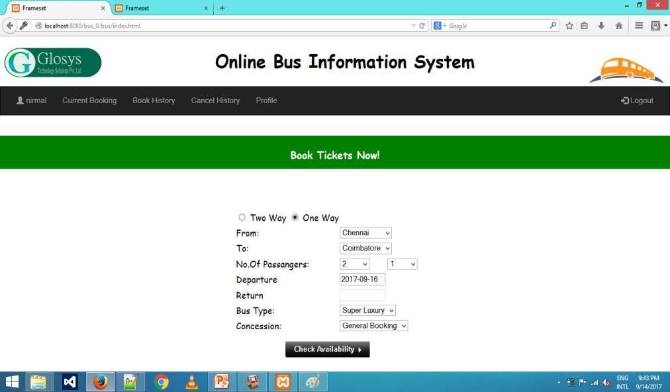

Fig A2.2 Book tickets

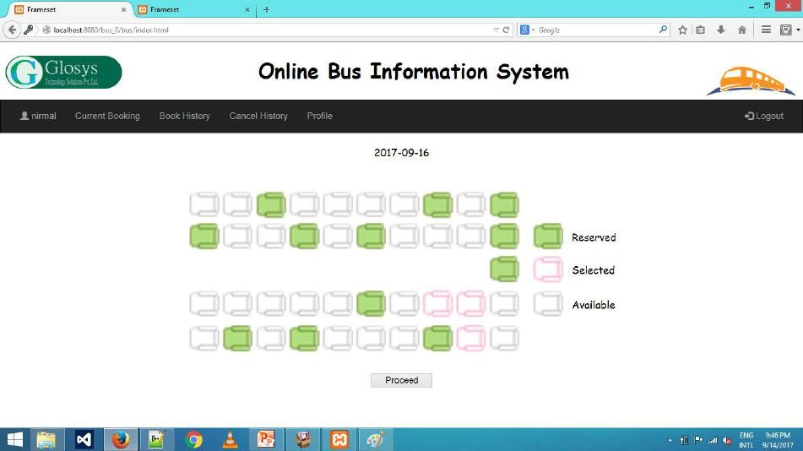

Fig A2.3 Seat layout

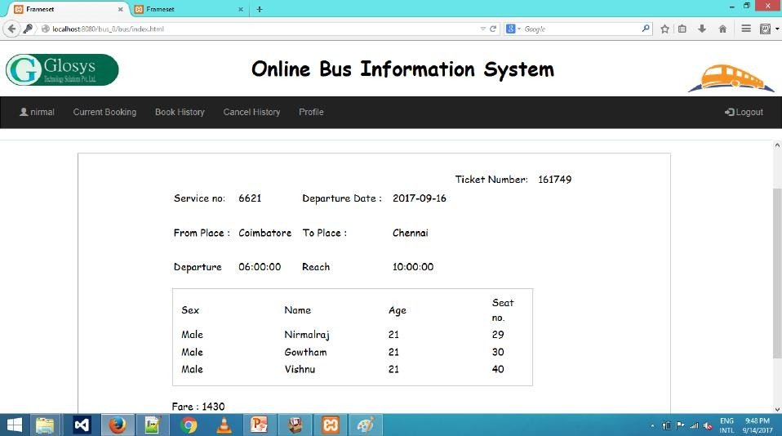

Fig A2.4 Conformation ticket

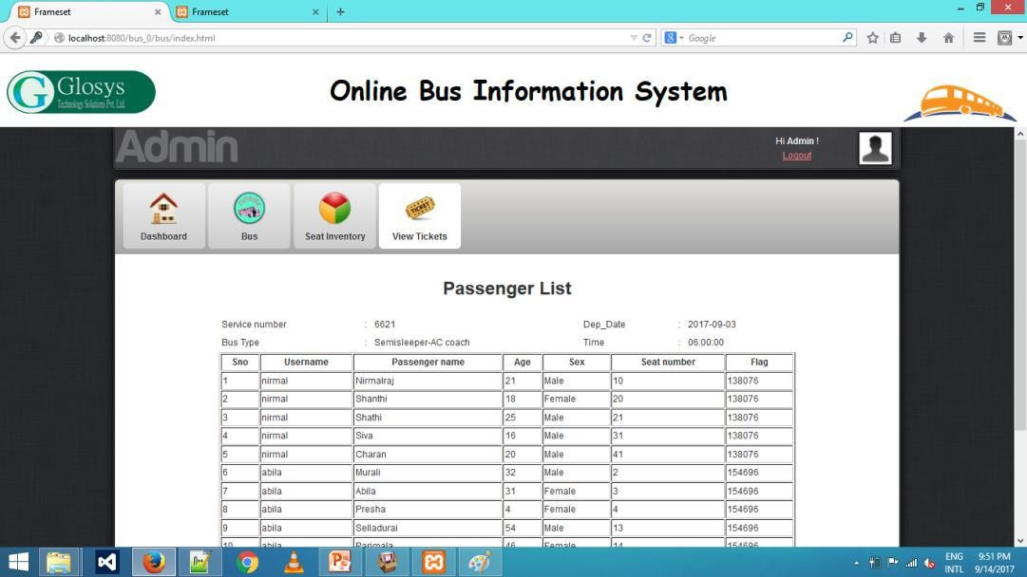

Fig A2.5 Passenger list of particular bus

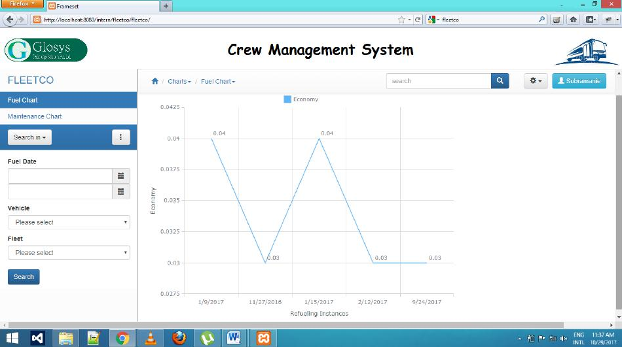

Fig A2.6 Fuel chart record

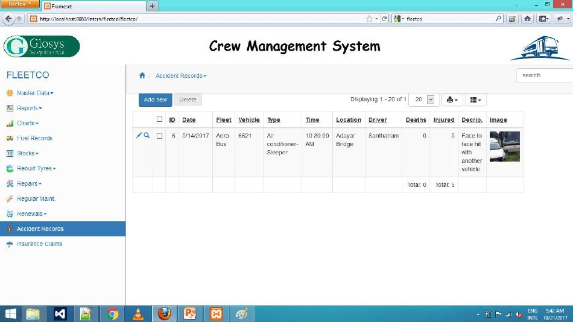

Fig A2.7 Accident record

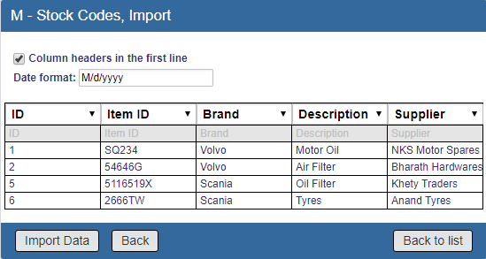

Fig A2.8 Stock Import

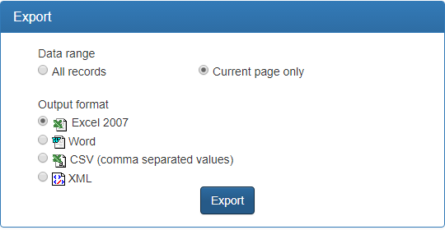

Fig A2.9 Stock Emport

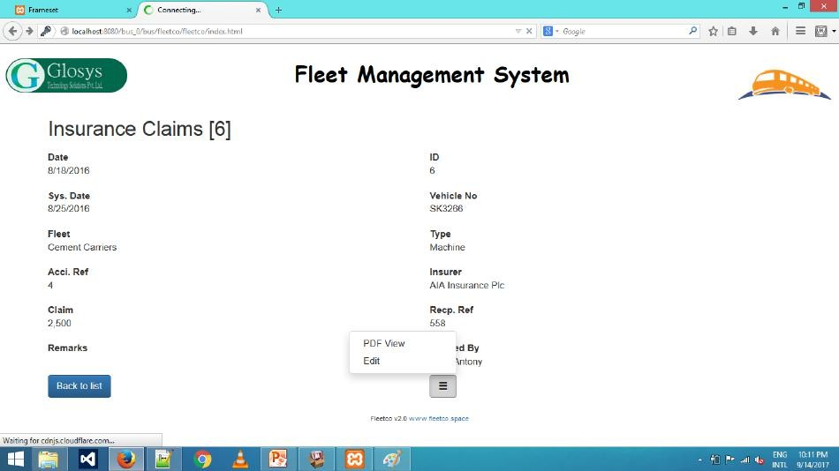

Fig A2.10 Insurance claims view

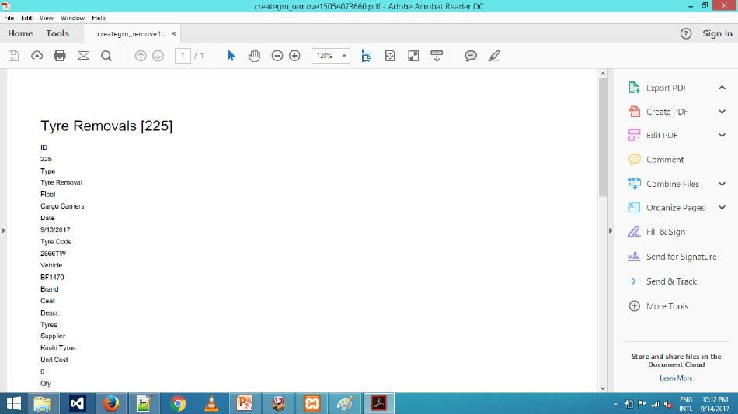

Fig A2.11 Tyre removals pdf

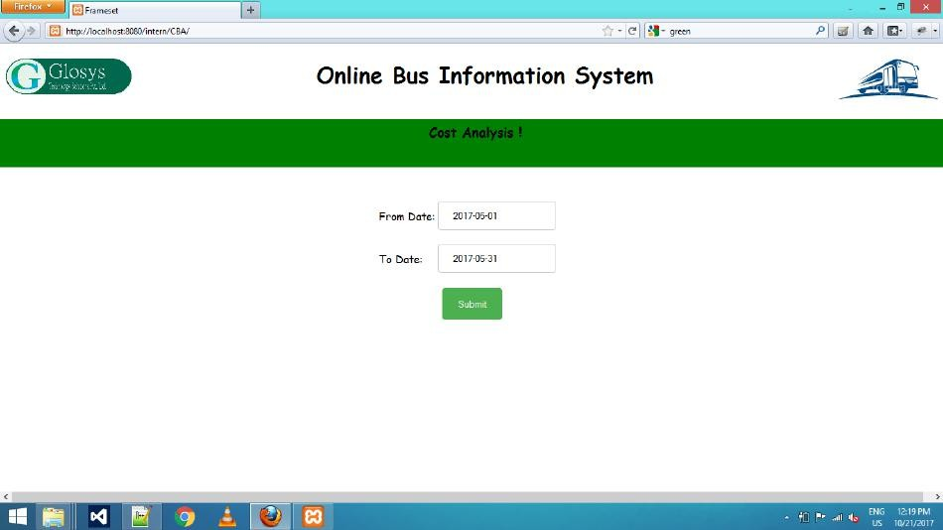

Fig A2.12 Cost analysis record

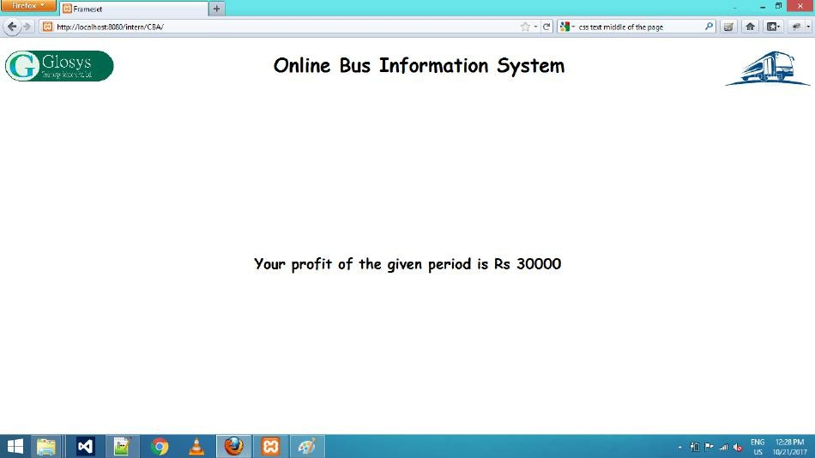

Fig A2.13 cost result record

REFERENCES

BOOK REFERENCES

- Abraham Silberschatz, Henry F Korth and Sudarshan S (2011) ‘Database System Concepts’, Sixth Edition, Mc Graw Hill.
- Adam Griffiths (2010) ‘CodeIgniter 1.7 Professional Development’ Seventh Edition, Packt publishing, Mumbai.

- Roger S. Pressman (2014) ‘Software Engineering – A Practitioners Approach’,
Seventh Edition, Tata McGraw Hill Publishing Company, New Delhi.

WEBSITE REFERENCES

- https://www.tutorialspoint.com/codeigniter/.

- https://www.javatpoint.com/what-is-codeigniter.

- http://talkweb.eu/how-to-run-doctrine-orm-with-codeigniter/

