Case Study 4:

Attack:

* Missing Functional Level Access.

Mission: To login the website and find the details of the client.

Solution :

1). This website uses client side authentication of user.

2). So we can view how the website is authenticating a user.

3). Click on login at top right Corner of webpage.

4) When we want to view the website source code the right click won’t work because it has been disabled.

We can view the source code ether by pressing Ctrl+U or from the menu bar.

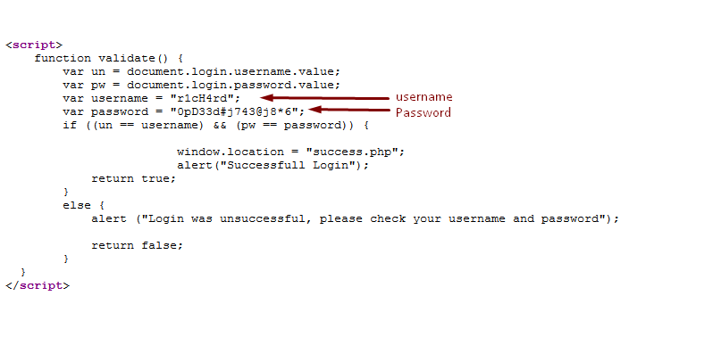

5). The source code will reveal the username and password information.

6). Enter the info and you can get to success.php page and see the details which are required.

