ASSIGNMENT 4

Venkat Jagadeesh Jampani

2022-01-23

# Markdown Basics

## Favorite Foods

1. Burgers
2. Pasta
3. Hot Dogs

## Images

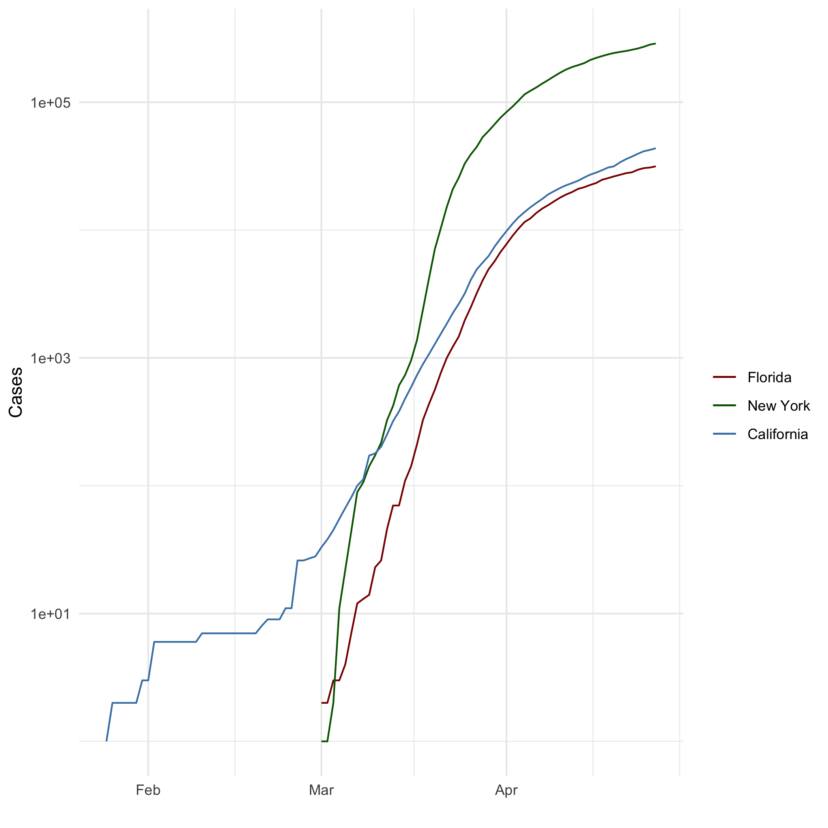

All Cases (Log Plot)

## Add a Quote

“The TASK ahead of you is not greater than the strength within you.” ## Add an Equation $P\left(A|B\right)=\frac{P\left(B|A\right)P\left(A\right)}{P\left(B\right)}$

## Add a Footnote

This is a footnote[1]

## Add Citations

* R for Everyone, (Lander 2014)
* Discovering Statistics Using R, (Field, Miles, and Field 2012)

# Inline Code

## NY Times COVID-19 Data

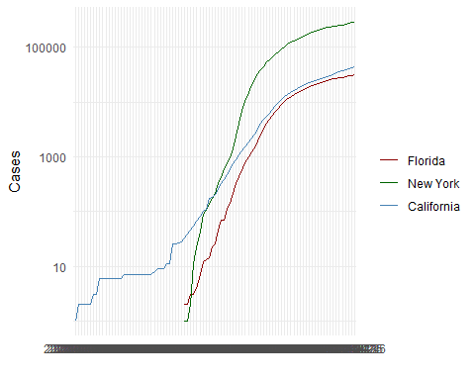

## R4DS Height vs Earnings

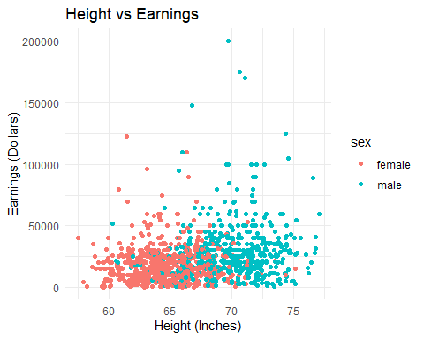

# Tables

## Knitr Table with Kable

One Ring to Rule Them All

| name | race | in_fellowship | is_ring_bearer | age |
| --- | --- | --- | --- | --- |
| Aragon | Men | Yes | No | 88 |
| Bilbo | Hobbit | No | Yes | 129 |
| Frodo | Hobbit | Yes | Yes | 51 |
| Sam | Hobbit | Yes | Yes | 36 |
| Sauron | Maia | No | Yes | 7052 |
| Gandalf | Men | No | Yes | 500 |
| Gollum | Hobbit | No | No | 200 |
| Tom | Men | No | No | 100 |
| Legolas | Men | No | No | 50 |

## Pandoc Table

##   
##   
## +---------+--------+---------------+----------------+------+  
## | name | race | in_fellowship | is_ring_bearer | age |  
## +=========+========+===============+================+======+  
## | Aragon | Men | Yes | No | 88 |  
## +---------+--------+---------------+----------------+------+  
## | Bilbo | Hobbit | No | Yes | 129 |  
## +---------+--------+---------------+----------------+------+  
## | Frodo | Hobbit | Yes | Yes | 51 |  
## +---------+--------+---------------+----------------+------+  
## | Sam | Hobbit | Yes | Yes | 36 |  
## +---------+--------+---------------+----------------+------+  
## | Sauron | Maia | No | Yes | 7052 |  
## +---------+--------+---------------+----------------+------+  
## | Gandalf | Men | No | Yes | 500 |  
## +---------+--------+---------------+----------------+------+  
## | Gollum | Hobbit | No | No | 200 |  
## +---------+--------+---------------+----------------+------+  
## | Tom | Men | No | No | 100 |  
## +---------+--------+---------------+----------------+------+  
## | Legolas | Men | No | No | 50 |  
## +---------+--------+---------------+----------------+------+  
##   
## Table: One Ring to Rule Them All

# References

Field, A., J. Miles, and Z. Field. 2012. Discovering Statistics Using R. SAGE Publications. <https://books.google.com/books?id=wd2K2zC3swIC>.

Lander, J. P. 2014. R for Everyone: Advanced Analytics and Graphics. Addison-Wesley Data and Analytics Series. Addison-Wesley. <https://books.google.com/books?id=3eBVAgAAQBAJ>.

1. This is a footnote in R markdown