**POC or Proof Of Concept on Bank Marketing**



By :- Vijay Singh Kholiya(kholiyavijay123@gmail.com)

B.Tech CSE

LOVELY PROFESSIONAL UNIVERSITY

Phagwara

Reg. No. :- 11603123

POC #: Bank Marketing

The POC is based on Bank data.

Public DATASET available at below :

<https://archive.ics.uci.edu/ml/datasets/Bank+Marketing>

Attributes :-

age an integer number of person’s age

job a string of job type of person

marital_status a string of person’s marital status

education a string of person’s education level

default_credit a Boolean string ‘yes’ or ‘no’ telling if credit in default

housing a Boolean string if taken housing loan

loan a Boolean string if taken personal loan

contact a string of type of communication

month a string of last contact month of year

day_of_week a string of last contact day of the week

duration an integer of last contact duration(in sec)

campaign an integer of no. of contacts performed during this campaign and for this client

pdays an integer of no. of days that passed by after the client was last

contacted from a previous campaign

previous an integer of no. of contacts performed before this campaign

and for this client

poutcome an string of the outcome of the previous marketing campaign

emp_var_rate a float of employment variation rate

cons_pri_ind a float of consumer price index

cons_conf_ind a float of consumer confidence index

euribor3m a float of Euribor 3 month rate

no_employees a float of no. of employees

subs a Boolean string ‘yes’ or ‘no’ if the client has subscribed a term deposit

**Problem Statement :-**

The problem statement is to :

1. Get the list of all the people whose age exceeds 50 to provide pension(only first 5 attributes).
2. Govt. wants to know the count of the unemployed unmarried people.
3. Present the details of those people who have either the housing loan or personal loan.
4. Marketers want to know the number of success time they achieved during marketing campaign.
5. List all the attributes of people whose duration of last call exceeds 3 minutes.

**Data Set file(.txt)**

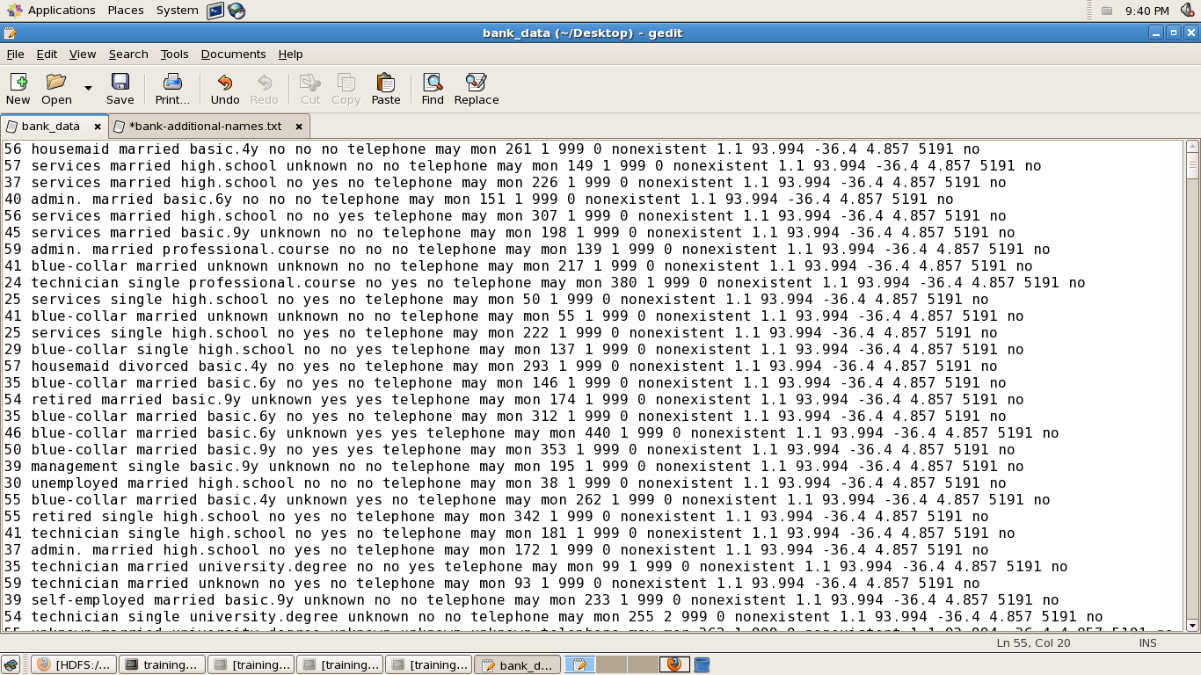

Query to create table bankdata :

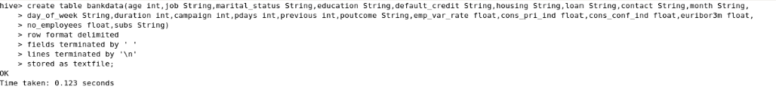

**Loading the data into the table bankdata :**

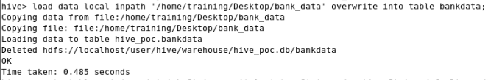

**Creating the table ‘main’ with 15 buckets according to job type :**

 **Inserting data into the table ‘main’ :**

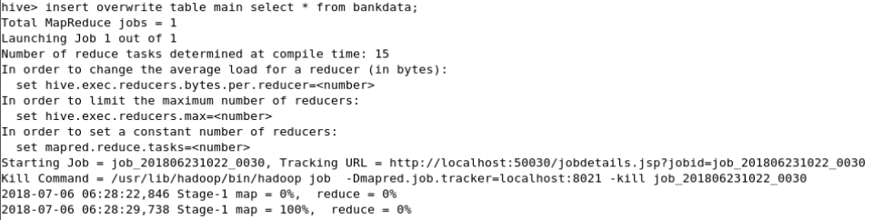

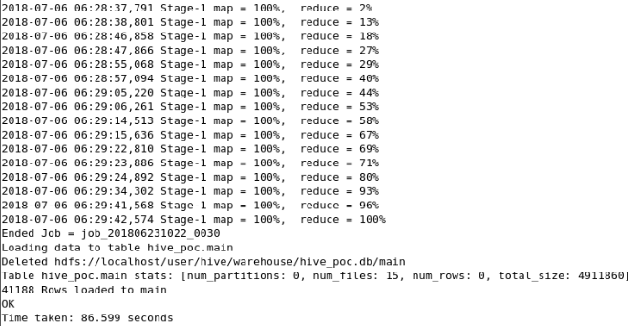

**Question-1 Solution command**

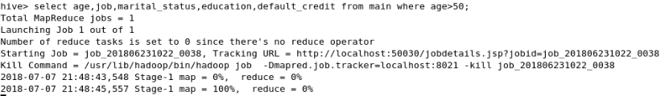

**Output :**

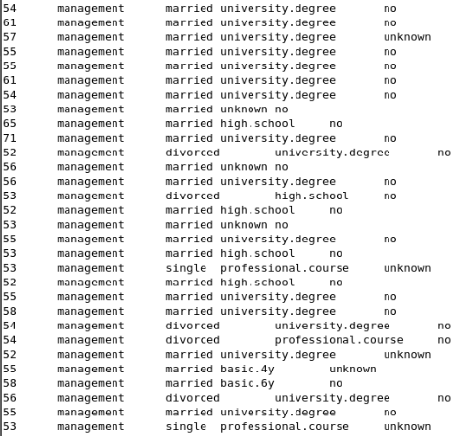

**Question-2 Solution**

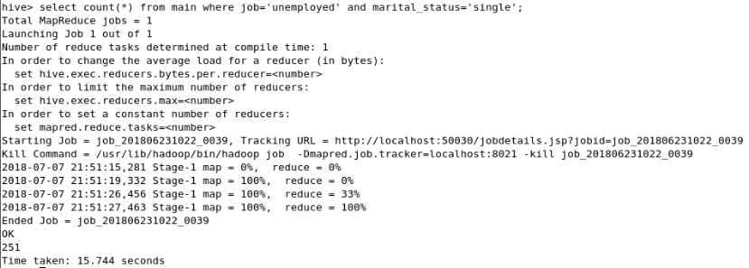

**Question-3 Solution command**

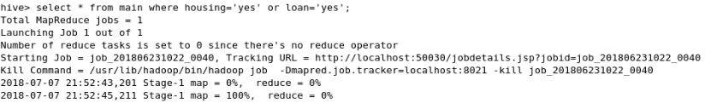

**Output:**

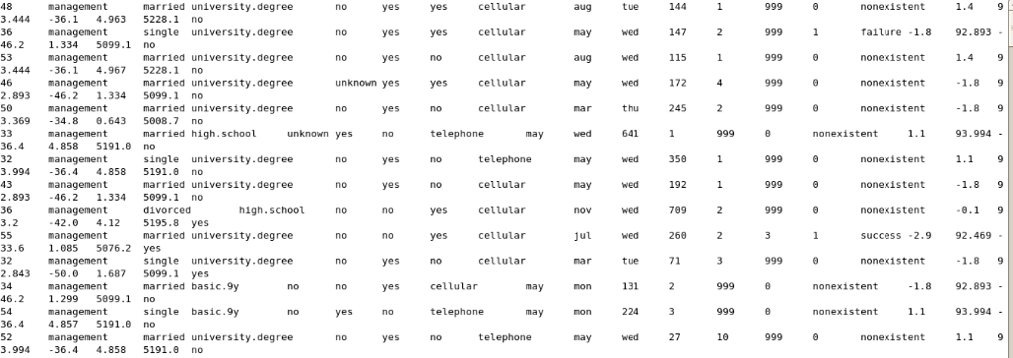

**Question-4 Solution**

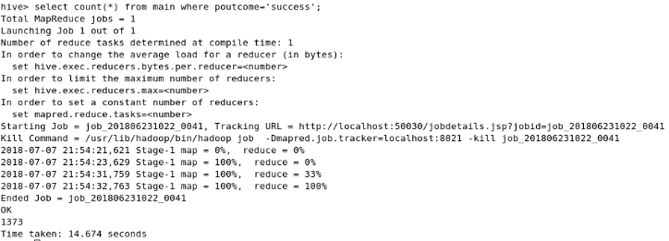

**Question-5 Solution command**

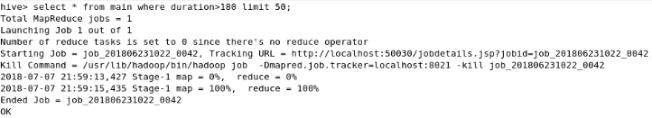

**Output :**

