Steps that need to be followed to configure Email Reset functionality.
In the configurator:
Step1. Under Password Policy Management, set
  - Password Policy as shown below.
    - Policy Name: ResetPolicy.
    - Policy Description: ResetPolicy
    - Policy Status: Enabled
  - Configure Password Poilicy Rules as shown in the Pic 2. The policy configurations are
    - Param Names: MaxFailedAnswers and CheckIntervalMinutes
    - Param Values: Email And 60 respectively.
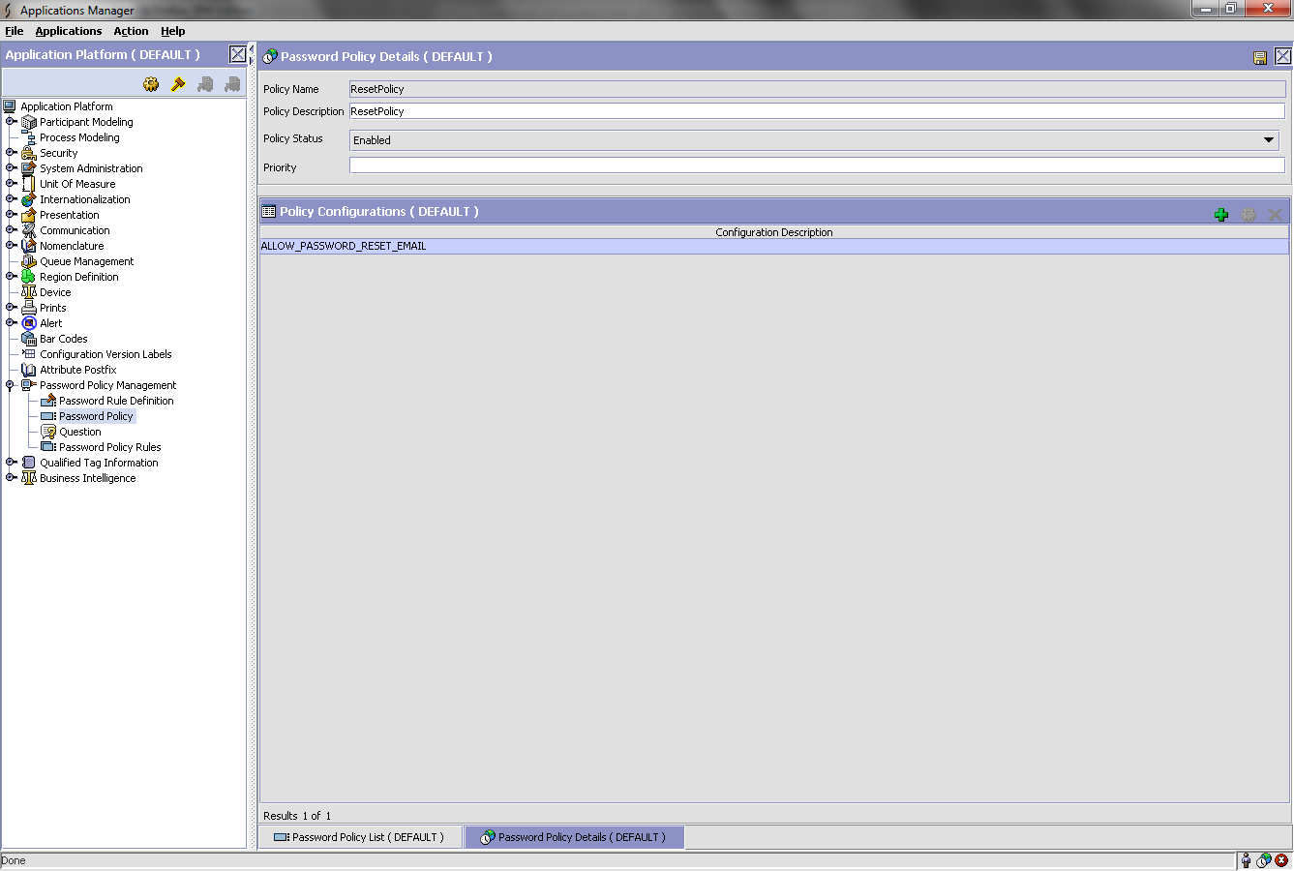
Pic 1
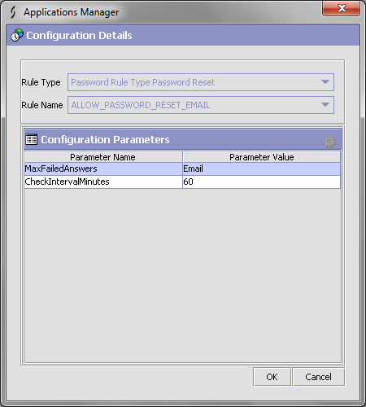
Pic 2

  - Password Rule Definition: Check for the configuration as shown in the snap shot below 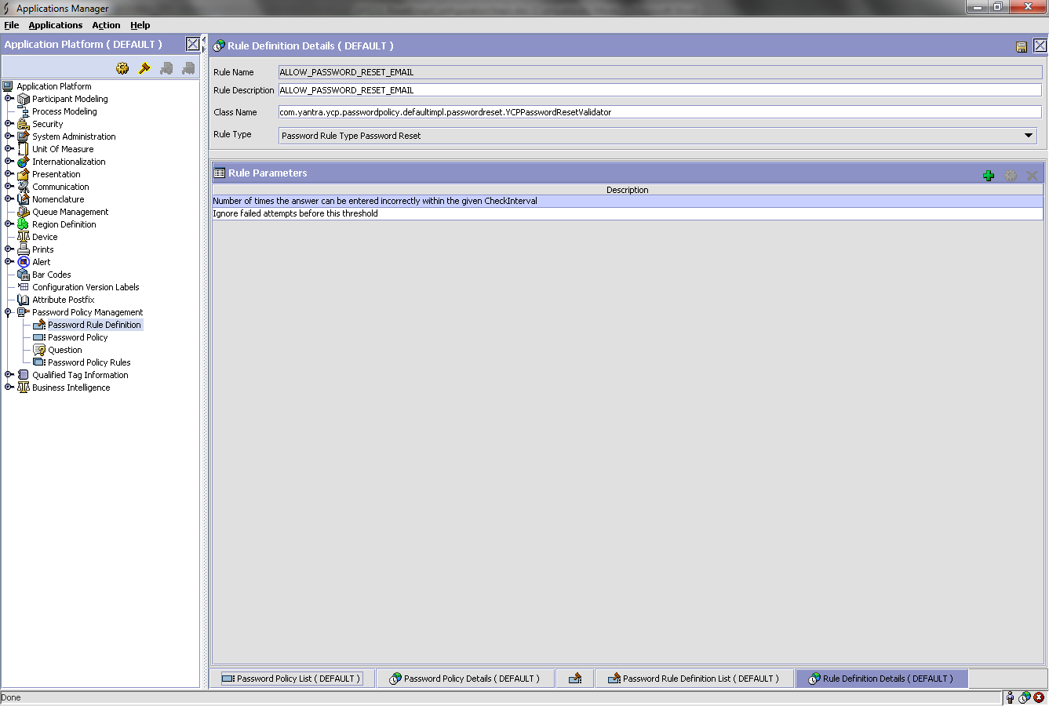
Step 2. Reset Password Transaction:
  - For Reset Password transaction: Activate both, ON_REQUEST and ON_SUCCESS Events.
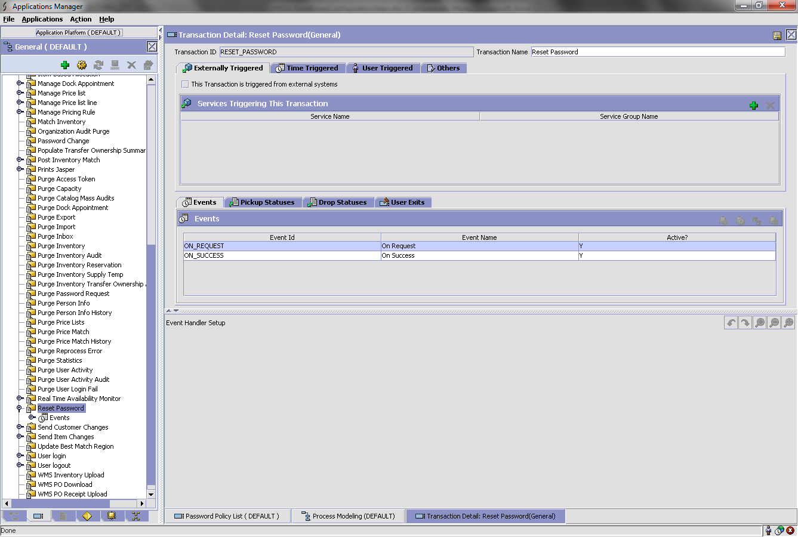
  - For the above Events, Configure the queues in the services. The queue details can be got from CatalogIndexBuild transaction.
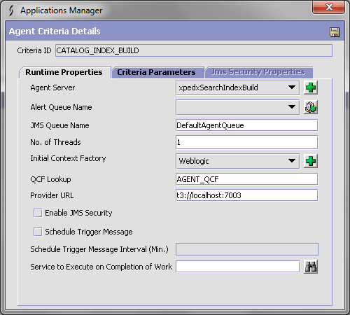

    - 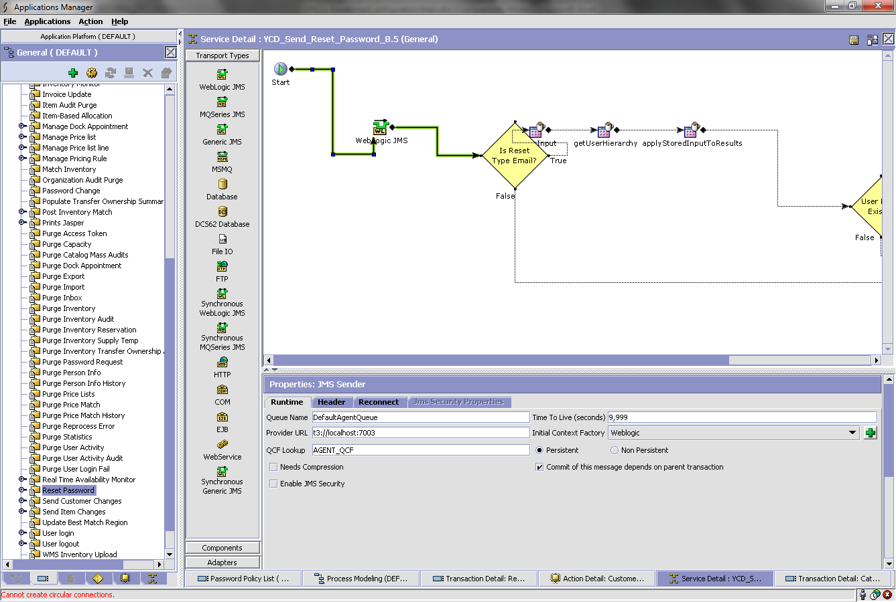
    - The header tab section should have a header value: ResetPassword
    - Email sender property is:
      - As shown below: The exact values have to be configured in the properties file.
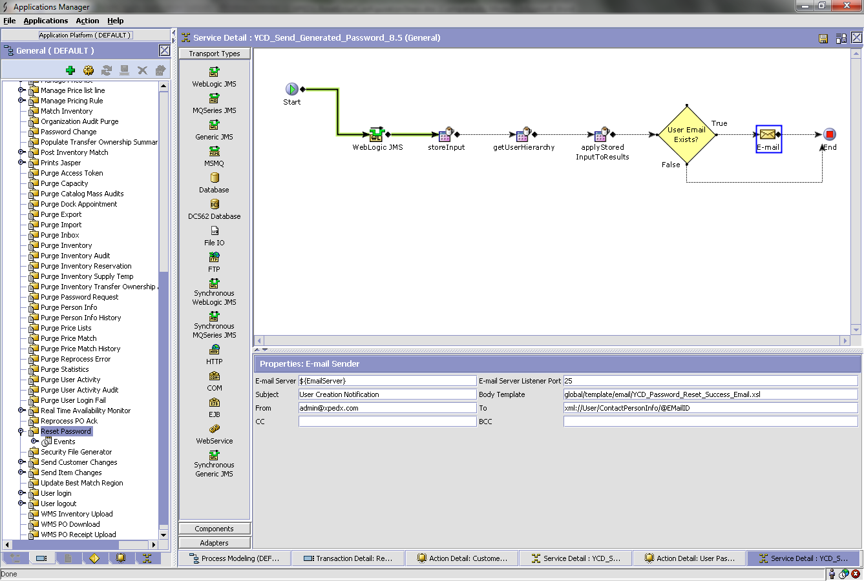

Step 3. PARAMS field in PLT_PWD_RULE_CFG: Also, need to make sure the PARAMS field in PLT_PWD_RULE_CFG table is according to the one configured in Step 1.
The params should be according to what has been configured. This policy key should be set for the organisation curently used.
<?xml version="1.0" encoding="UTF-8"?>
<ParamList>
<Param Name="ResetType" Value="Email"/>
<Param Name="MaxFailedAnswers" Value="Email"/>
<Param Name="CheckIntervalMinutes" Value="60"/>
</ParamList>
Step 4. Once the ResetPassword button is clicked, to receive the email, start the integration server.
\Sterling9.0\Foundation\bin>startIntegrationServer.cmd <Email server configured in service>
- ON_SUCCESS event, the server configured for the email component in the service that is invoked is <EmailServer>
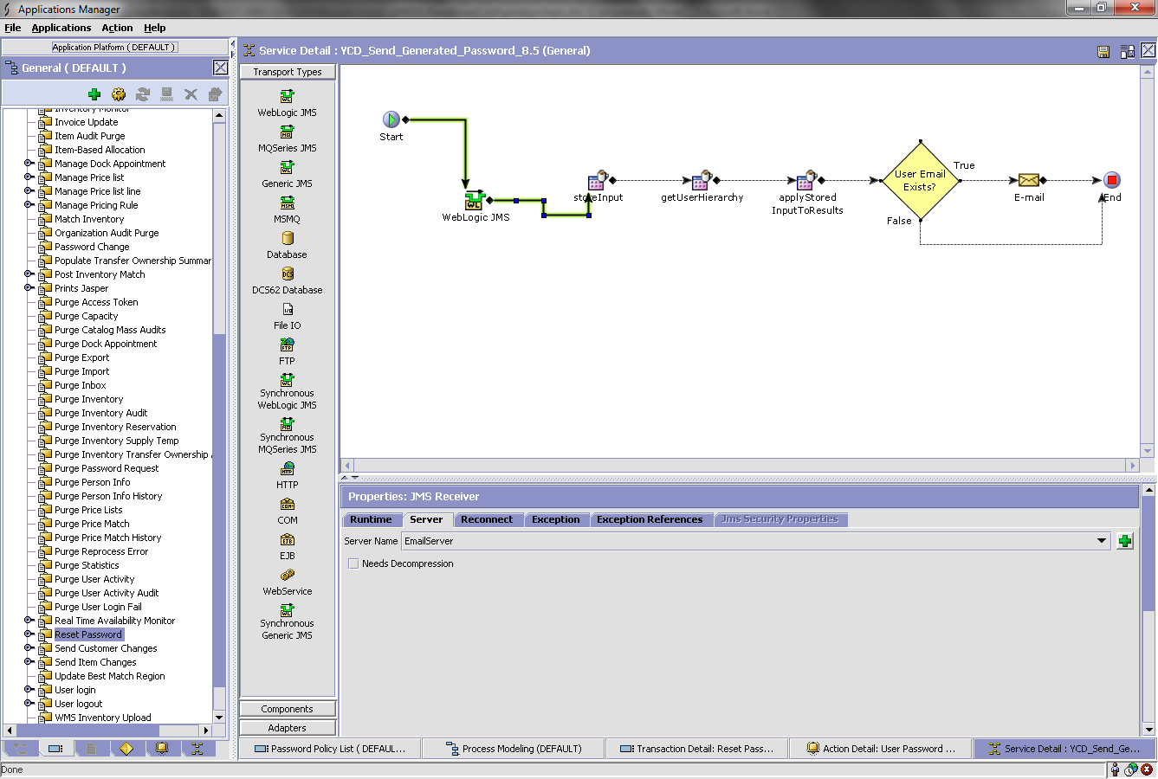
- ON_REQUEST event, the server configured for the email component in the service that is invoked is < EmailServerResetPassword >.
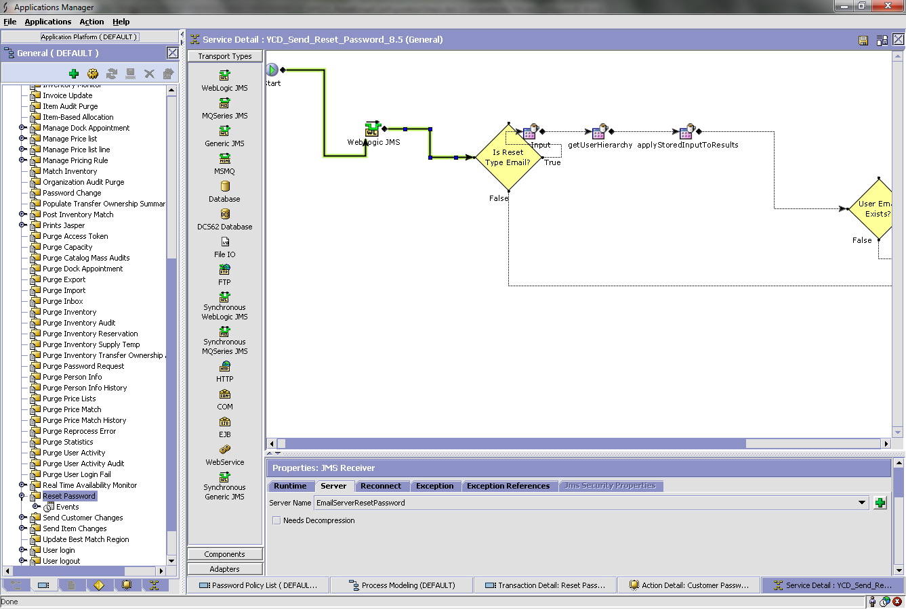

- An email with a link will be received on the configured email address for the user or the one set in the configurator.
- Once the email is received, use the link. The link currently that comes in the email is for eg:
http://www.xpedx.com/xpedx/home/forgotPwd.action?requestId=5tCFbpH9J8
This has to be changed to the following for it work in local. This has to be verified in the xslt too.
http://localhost:7003/swc/home/forgotPwd.action?requestId=5tCFbpH9J8
The link will display the following page:
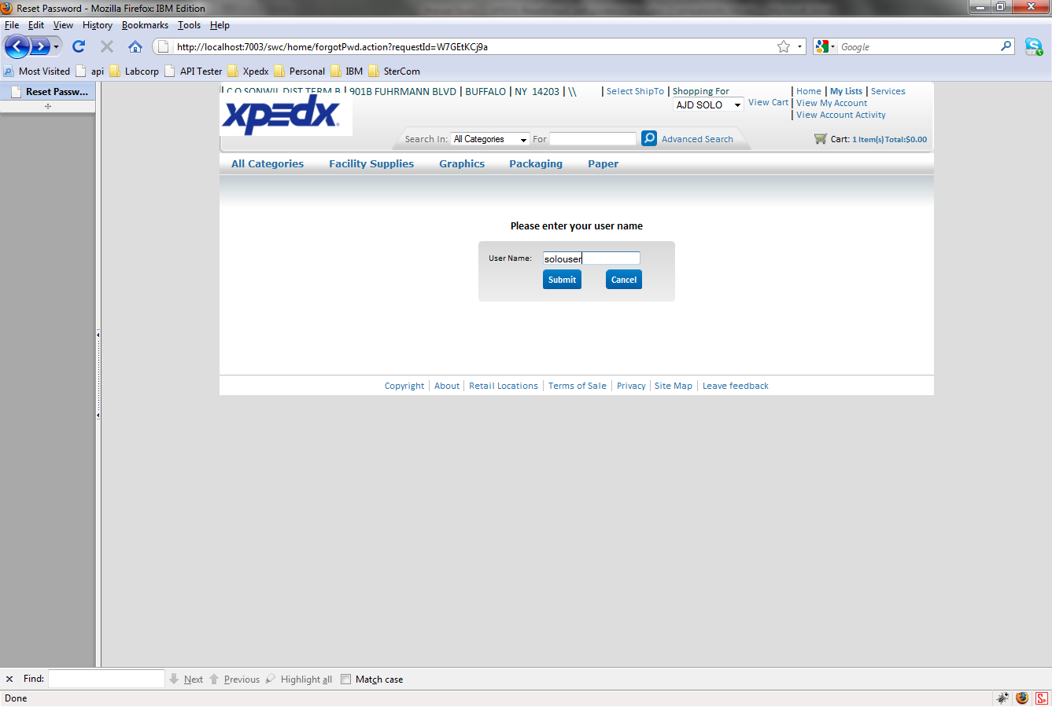
- On submit, The following page is displayed with an option to enter the new password and also confirm.
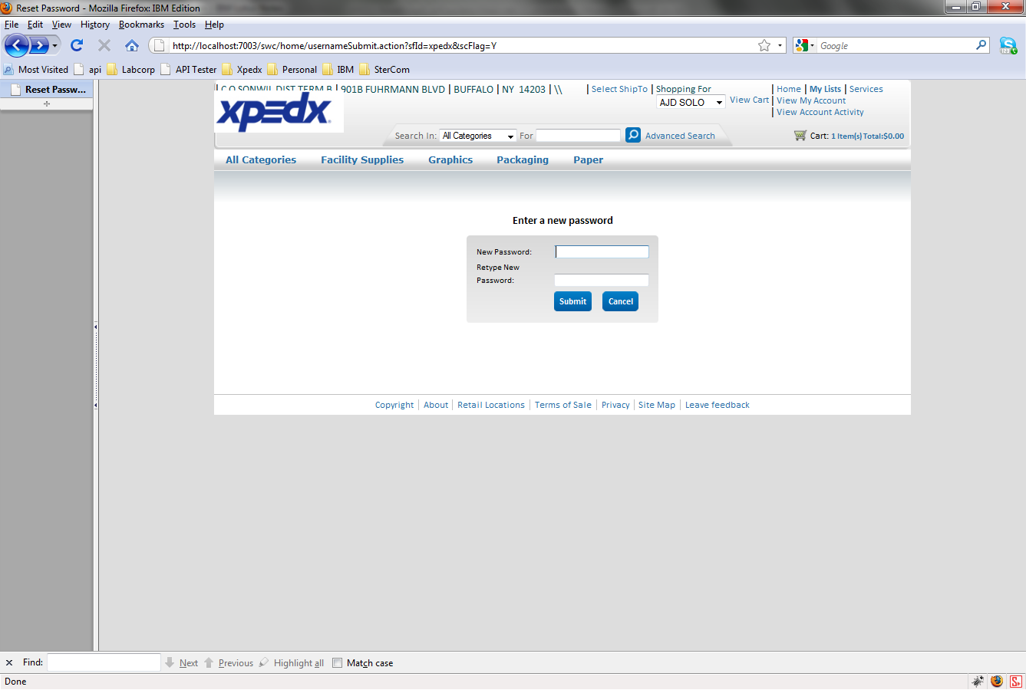
- On entering the required password, on click on submit, the following confirmation page is shown.
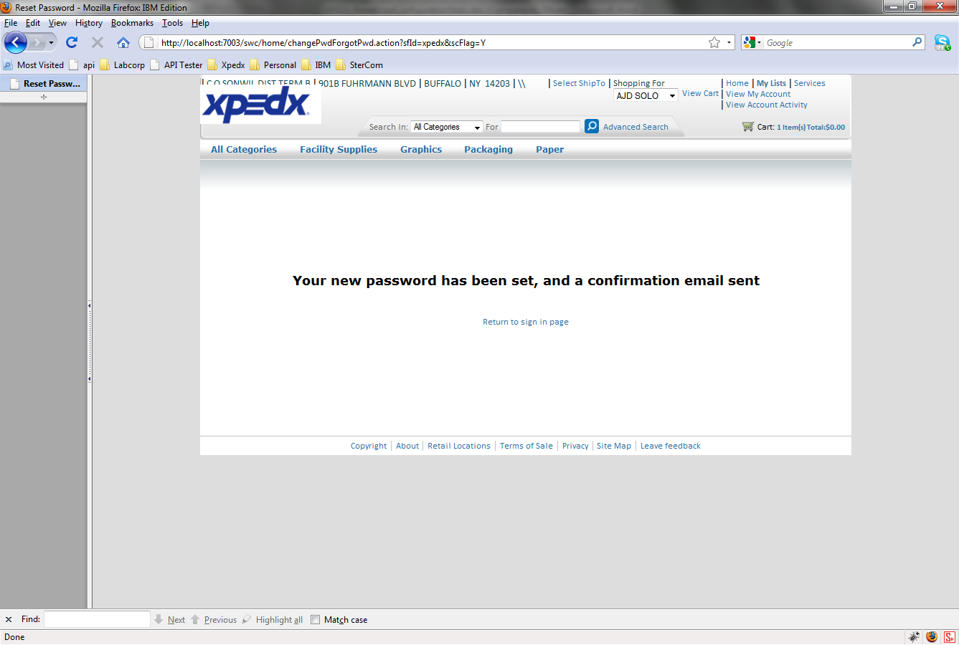
- With the integration server up for EmailServer (OnSuccess Event), another email is triggered to the configured email address in the property file or the one set in the configurator.
- Now, the user can log in with the new password into webchannel. The old password is disabled.

