xpedx.com Next Generation
Technical Design Specification – Account Activity

Authors: | Sterling Commerce
Version: | 0.1
Date Created: | 13/05/2010
Last Updated: | 13/05/2010

Document Revision History
Revision | Date | Description | Author
0.1 | 13/05/2010 | Draft | Sterling Commerce

Document Approval History
Name | Signature | Date | Version Approved/Comments

Reference Documents
Document Name | Description | Owner | Location
SCI_Xpedx Solution Definition Document v1.0 | Solution Definition document | Sterling Commerce
Checkout_Confirmation_Approvals_OrderHistory_Wireframes_3_30_2010_V2_Sent_to_xpedx.pdf | Wireframe | xpedx

Table of Contents
1. Introduction 4
2. Technical Components 4
2.1 Components Overview 4
2.2 Components design 4
2.2.1.1 Design for Order List and Order Widget 4
2.2.1.2 UI Design 5
2.2.1.3 UI Validation 6
2.2.1.4 Input Document 6
2.2.1.5 Output Document 7
2.2.1.6 Configuration 7
2.2.2.1 Design for Approval List and Approval Widget 7
2.2.2.2 UI Design 7
2.2.2.3 UI Validation 8
2.2.2.4 Input Document 8
2.2.2.5 Output Document 9
2.2.2.6 Configuration 9
2.2.3.1 Design for Cart Widget 9
2.2.3.2 UI Design 10
2.2.3.3 UI Validation 10
2.2.3.4 Input Document 10
2.2.3.5 Output Document 11
2.2.3.6 Configuration 11
3. Database Extensions 11
4. Exception and Error Handling 11
5. Security Aspects 11
5.1 Ownership 11
5.2 Encryption 11
5.3 Audit Trail 11
5.4 Other Security Aspects 11
6. Dependencies 11
7. Unit Test Cases 12

1. Introduction
This document covers the design aspect of account activity page, order list page and approval list page. The account activity page covers cart widget, order widget and approval widget.

Purpose
The purpose of the document is to address the design consideration in designing the Account activity page, order list page in order approval list page in Webchannel. This document does not go into the details of OOTB features used in the sterling product. Only the customization feature will be explained.

1.2 Nomenclature

Term | Description

1.3 Performance Considerations
NA

2. Technical Components

2.1 Components Overview
The xpedx account activity page consists of three parts. Order list widget, approval list widget, and cart list widget. Each widget shows the most recent three items in their respective list. The order list, approval list and cart list pages lists fifty items per page each and paginates for the remaining items. These pages also provide search capabilities. Same set of action classes are used for both widget and list pages, the only changes being the number of records being fetched.

2.2 Components design

2.2.1 Order list widget and order list
2.2.1.1 Design for Order List and Order Widget
The request for order list widget and order list page comes from the users home page XPEDXPortalHome.jsp.
Struts File: XPEDXOrderStruts.xml
Action Name for Order list widget: orderListWIdget
Action Name for Order list: orderList
Validation class for order list : OrderListValidation
Action class for order list widget and order list page: com.sterlingcommerce.xpedx.webchannel.order.XPEDXOrderListAction

Action class design:
The action class XPEDXOrderListAction extends the OOTB class OrderListAction which provides most of the capabilities for fetching the order list from the database. The extra functionality needed for xpedx needs to be added in this class.
- Fetch three recent orders from the database for orderlist widget.
- Fetch fifty orders from the database per page for orderlist page.
- Provide extra search functionality for Purchase order number
- Fetch all the chained order list for a order and store it in a HashMap. getXpedxChainedOrderLineList() method takes the arraylist of orders, and gets all the Chained orders for each order, and store it in a HashMap.

2.2.1.2 UI Design
The UI lists all the orders fetched in the action class, along with chained orders if any. For chained orders it uses the HashMap prepared in the action class.

Orderwidget:
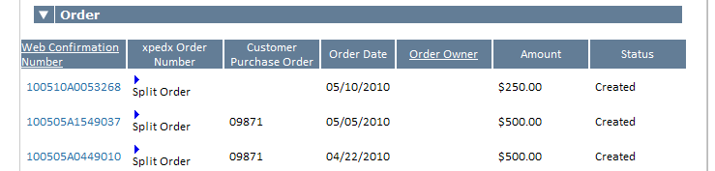

OrderList:
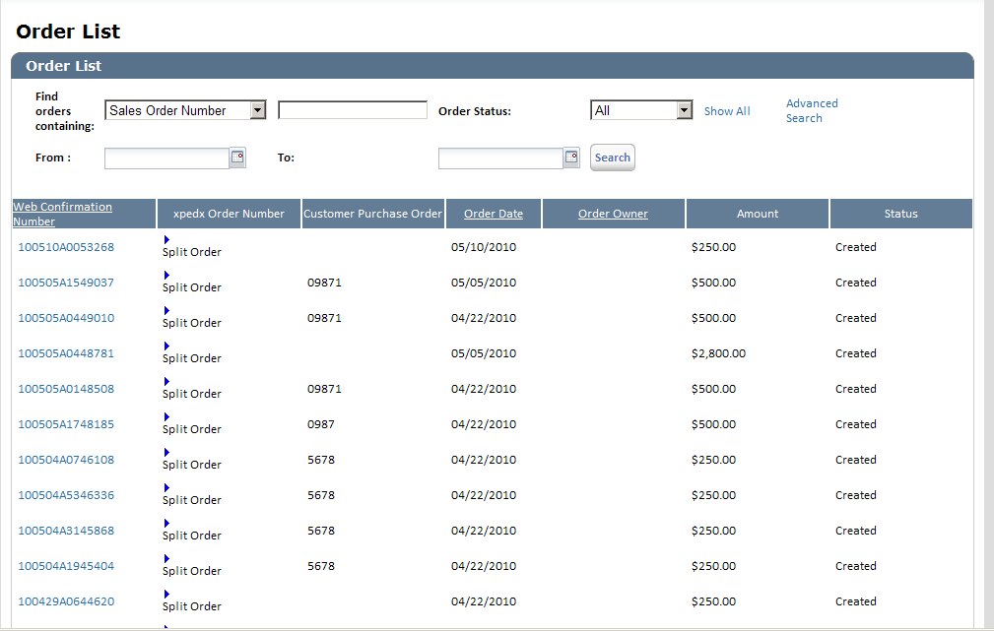

2.2.1.3 UI Validation
NA

2.2.1.4 Input Document
MashupId: XPEDXOrderList
<Page PageNumber="" PageSize="3" PaginationStrategy="GENERIC" Refresh="N">
<PreviousPage PageNumber=""/>
<API Name="getOrderList">
<Input>
<Order ReadFromHistory="N" DraftOrderFlag="N" DocumentType="0001" EnterpriseCode="" OrderComplete="">
<OrderBy>
<Attribute Desc="N" Name="Modifyts"/>
</OrderBy>
</Order>
</Input>
<Template>
<OrderList>
<Order OrderNo="" HoldFlag="" OrderName="" Modifyts="" Createts="" OrderHeaderKey="" CustomerPONo="" OrderDate="" Status="" PaymentStatus="" CustomerFirstName="" CustomerLastName="">
<PriceInfo TotalAmount="" Currency=""/>
<Extn ExtnWebConfNum="" ExtnLegacyOrderNo=""/>
<OrderBy>
<Attribute Desc="" Name=""/>
</OrderBy>
</Order>
</OrderList>
</Template>
</API>
</Page>

2.2.1.5 Output Document
MashupId: XPEDXOrderList
<Page GeneratedOn="" IsFirstPage="Y" IsLastPage="Y" IsValidPage="Y" PageNumber="" PageSetToken="" TotalNumberOfPages="">
<Output/>
</Page>

2.2.1.6 Configuration
NA

2.2.2.1 Design for Approval List and Approval Widget
The request for approval list widget and approval list page comes from the users home page XPEDXPortalHome.jsp.
Struts File: XPEDXOrderStruts.xml
Action Name for Approval list widget: approvalWidget
Action Name for Approval list: approvalList
Action class for approval list widget and approval list page: com.sterlingcommerce.xpedx.webchannel.order.approval.XPEDXOrderApprovalAction

Action class design:
The action class XPEDXOrderApprovalAction extends the OOTB class OrderApprovalAction which provides most of the capabilities for fetching the order list from the database. The extra functionality needed for xpedx needs to be added in this class.
- Fetch three recent orders from the database for approval widget.
- Fetch fifty orders from the database per page for approval list page.
- Provide extra search functionality for Purchase order number

2.2.2.2 UI Design
The UI lists all the approval orders fetched in the action class. The approval list page will now provide a capability to approve and reject the order for every orders listed.

Approvalwidget:
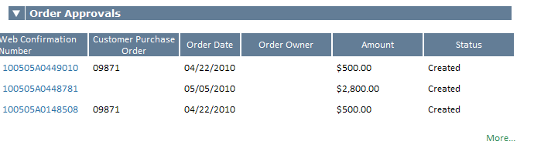

Approval List:
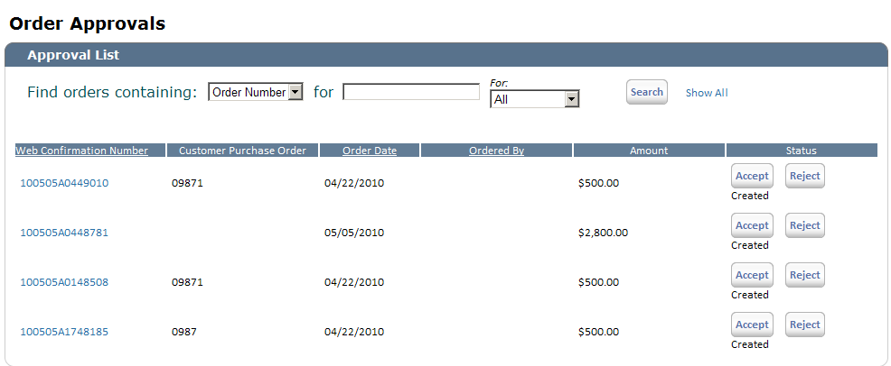

2.2.2.3 UI Validation
NA

2.2.2.4 Input Document
MashupId: orderApprovalList
<Page PageNumber="" PageSize="50" PaginationStrategy="GENERIC" Refresh="Y">
<PreviousPage PageNumber=""/>
<API Name="getOrderList">
<Input>
<Order DraftOrderFlag="N" StatusQryType="NE" Status="9000" CustomerContactID="" CustomerContactIDQryType="" EnterpriseCode="" DocumentType="0001" OrderName="" OrderNameQryType="EQ" OrderNo=""
OrderNoQryType="EQ" >
<OrderHoldType ResolverUserIdQryType="" ResolverUserId="" HoldType="" Status="1100">
<ComplexQuery>
<Or>
<Exp Name="" Value=""/>
</Or>
</ComplexQuery>
</OrderHoldType>
<OrderBy>
<Attribute Desc="Y" Name="Modifyts"/>
</OrderBy>
</Order>
</Input>
<Template>
<OrderList TotalNumberOfRecords="" TotalOrderList="">
<Order BillToID="" CustomerContactID="" BuyerOrganizationCode="" Createts="" DocumentType="" DraftOrderFlag="" EnterpriseCode="" HoldFlag="" Modifyts="" OrderDate="" OrderHeaderKey="" OrderNo="" OrderName="" SellerOrganizationCode="" Status="" isHistory="" CustomerPONo="" PaymentStatus="" CustomerFirstName="" CustomerLastName="">
<Extn ExtnWebConfNum="" ExtnLegacyOrderNo=""/>
<PriceInfo Currency="" EnterpriseCurrency="" TotalAmount="" />
<OrderHoldTypes>
<OrderHoldType HoldType="" ResolverUserId="" Status=""/>
</OrderHoldTypes>
</Order>
</OrderList>
</Template>
</API>
</Page>
2.2.2.5 Output Document
MashupId: orderApprovalList
<Page GeneratedOn="" TotalNumberOfPages="" IsFirstPage="" IsLastPage="" IsValidPage="" PageNumber="" PageSetToken="">
<Output />
</Page>
2.2.2.6 Configuration
NA

2.2.3.1 Design for Cart Widget
The request for cart list widget page comes from the users home page XPEDXPortalHome.jsp.
Struts File: XPEDXOrderStruts.xml
Action Name for Cart list widget: xpedxCartListWidget
Action class for Cart list widget : com.sterlingcommerce.xpedx.webchannel.order.XPEDXDraftOrderListAction

Action class design:
The action class XPEDXDraftOrderListAction extends the OOTB class DraftOrderListAction which provides most of the capabilities for fetching the draft order list from the database. The extra functionality needed for xpedx needs to be added in this class.
- Fetch three recent draft orders from the database for cart widget.

2.2.3.2 UI Design
The UI lists all the approval orders fetched in the action class.

Approvalwidget:
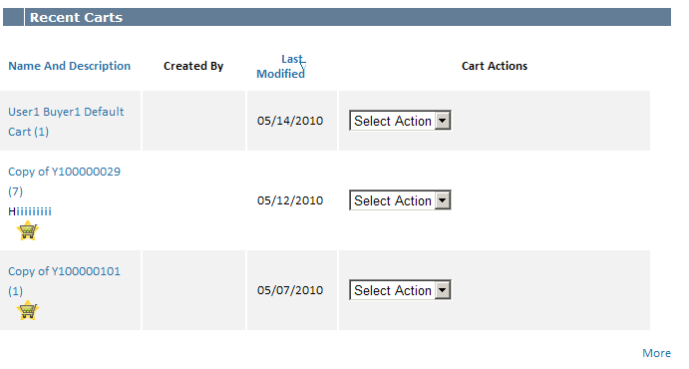

2.2.3.3 UI Validation
NA

2.2.3.4 Input Document
MashupId: xpedxDraftOrderList
<Page PageNumber="" PageSize="" PaginationStrategy="GENERIC"
Refresh="Y">
<PreviousPage PageNumber="" />
<API Name="getOrderList">
<Input>
<Order EnterpriseCode="" DraftOrderFlag="Y" DocumentType="0001"
AuthorizedClient="Web">

<OrderBy>
<Attribute Desc="N" Name="Modifyts" />
</OrderBy>
</Order>
</Input>
<Template>
<OrderList>
<Order OrderNo="" OrderName="" Modifyts="" Createts=""
OrderHeaderKey="" CustomerContactID="" CustomerFirstName=""
CustomerLastName="">
<OrderLines TotalNumberOfRecords="" />
<Extn ExtnOrderDesc="" />
<OrderBy>
<Attribute Desc="" Name="" />
</OrderBy>
</Order>
</OrderList>
</Template>
</API>
</Page>
2.2.3.5 Output Document
MashupId: xpedxDraftOrderList
<Page GeneratedOn="" IsFirstPage="Y" IsLastPage="Y"
IsValidPage="Y" PageNumber="" PageSetToken="" TotalNumberOfPages="">
<Output />
</Page>
2.2.3.6 Configuration
NA

3. Database Extensions
NA
4. Exception and Error Handling

5. Security Aspects
5.1 Ownership
5.2 Encryption
5.3 Audit Trail
5.4 Other Security Aspects

6. Dependencies

JIRA no | desc | To be validated by  (Team/Person) | Status | Implications if incorrect

<For issues those aren’t dependent on customer: Record all dependencies made for this design including business requirement,performance and technical factors, etc. here

Include only those that are not already documented in SDD If there are changes in SDD, reference the specific dependency and state the revised assumption. New assumption should be approved prior to design review> XReference Section 2.8 – Assumptions in Functional Design Document.

No. | Assumption | To be validated by  (Team/Person) | Status | Implications if incorrect

7. Unit Test Cases
Test No. |  | Test Description |  | Execution Instructions |  | Expected Result
1 |  | Account activity page |  | Go to users account activity page |  | The users should see the most recent three carts, orders and approvals(if the user has approval privilege)
2 |  | Order list page |  | Go to order list page |  | User should see fifty orders per page and then pagination. If the orders have chained orders, he should be able to view it.
3 |  | Approval list page |  | Go to approval list page |  | User should see fifty approval orders per page and then pagination. Approver user should be able to approve or reject a order from the list page itself.
4 |  | Order list page |  | Go to order list page |  | The user should see a link for the split orders if any of the order has a split order
4 |  | Order list page |  | Go to order list page |  | Web confirmation number should be part of the order list table with valid values
5 | Order list page |  | Go to order list page |  | Xpedx order number should be part of the order list table with valid values
6 |  | Order list page |  | Go to order list page |  | The page should give the capability to sort against the order date.
7 |  | Order list page |  | Go to order list page |  | The page should give the capability to search the orders by Sales order number, Purchase order number and by Status.
8 |  | Order list page |  | Go to order list page |  | The page should give the capability to search the orders by a date DATERANGE.
9 |  | Cart widget |  | Go to cart widget page |  | The user should see the most recent three carts
10 |  | Cart widget |  | Go to cart widget page |  | The user should be allowed to do cart actions, from the widget itself, provided in a combo box
11 |  | Approval widget |  | Go to approval widget page |  | The user should be search the orders for last 7 days, 14 days and 21 days.

