xpedx.com Next Generation
Technical Design Specification – Cart Functionality

Authors: | Sterling Commerce
Version: | 0.2
Date Created: | 10/05/2010
Last Updated:

Document Revision History
Revision | Date | Description | Author
0.1 | 07/05/2010 | Draft | Sterling Commerce

Document Approval History
Name | Signature | Date | Version Approved/Comments

Reference Documents
Document Name | Description | Owner | Location
SCI_Xpedx Solution Definition Document v1.0 | Solution Definition document | Sterling Commerce

Table of Contents
2.2.1 Design for XPEDXDraftOrderDetailsAction 6
2.3.3 UI Validations 6
2.3.4 Input Document 6
2.3.5 Output Document 7
2.3.6 Configuration 7
2.2.1 Design for XPEDXDraftOrderAddOrderLinesAction 7
2.3.2 UI Design 8
2.3.3 UI Validations 8
2.3.4 Input Document 8
2.3.5 Output Document 8
2.3.6 Configuration 9
2.2.1 Design for XPEDXDraftOrderModifyLineItemsAction 9
2.3.3 UI Validations 9
2.3.4 Input Document 9
2.3.5 Output Document 10
2.3.6 Configuration 10
3. Database Extensions 11
4. Exception and Error Handling 11
5. Security Aspects 11
5.1 Ownership 11
5.2 Encryption 11
5.3 Audit Trail 11
5.4 Other Security Aspects 11
6. Dependencies 11
7. Unit Test Cases 12

1. Introduction
This document describes the detail design for the Cart Functionality customization for xpedx. It covers the customization for Edit Cart Details, Quick Add, Line Special Instructions, and Related Items for the cart, Select All lines and Remove Operation.

Purpose
Provide the struts xml configurations and class level details for cart functionality customization.

1.2 Nomenclature

Term | Description

1.3 Performance Considerations

2. Technical Components
XpedxOrderStruts.xml

<action name="changeOrderHeader" class="com.sterlingcommerce.webchannel.order.CartInContextRefreshingWCMashupAction">
<param name="xmlBindingFile">com/sterlingcommerce/xpedx/webchannel/order/XPEDXChangeOrderHeaderBinding.xml</param>
<param name="mashups">xpedx_me_changeOrderHeader</param>
<param name="resourceId">/swc/order/guestShopping</param>
<result name="success" type="redirectAction">
<param name="actionName">draftOrderDetails</param>
<param name="OrderHeaderKey">${#parameters.OrderHeaderKey}</param>
<param name="draft">${draft}</param>
</result>
</action>

<action name="draftOrderAddOrderLines" class="com.sterlingcommerce.xpedx.webchannel.order.XPEDXDraftOrderAddOrderLinesAction">
<param name="xmlBindingFile">com/sterlingcommerce/xpedx/webchannel/order/XPEDXDraftOrderAddOrderLinesActionBinding.xml</param>
<param name="mashups">xpedx_me_draftOrderAddOrderLines</param>
<param name="resourceId">/swc/order/guestShopping</param>
<result name="success" type="redirectAction">
<param name="actionName">draftOrderDetails</param>
<param name="namespace">/order</param>
<param name="orderHeaderKey">${#parameters.orderHeaderKey}</param>
<param name="zipCode">${#parameters.zipCode}</param>
<param name="quickAddErrorListSessionKey">${quickAddErrorListSessionKey}</param>
<param name="draft">${draft}</param>
</result>
</action>

<action name="draftOrderModifyLineItems" class="com.sterlingcommerce.xpedx.webchannel.order.XPEDXDraftOrderModifyLineItemsAction">
<param name="xmlBindingFile">com/sterlingcommerce/xpedx/webchannel/order/XPEDXDraftOrderModifyLineItemsActionBinding.xml</param>
<param name="mashups">xpedx_me_changeOrderLineDetails</param>
<param name="resourceId">/swc/order/guestShopping</param>
<param name="validationClass">com.sterlingcommerce.webchannel.order.CartDetailValidation</param>
<result name="success" type="redirectAction">
<param name="actionName">draftOrderDetails</param>
<param name="namespace">/order</param>
<param name="orderHeaderKey">${#parameters.orderHeaderKey}</param>
<param name="zipCode">${#parameters.zipCode}</param>
<param name="canCheckout">${#parameters.canCheckout}</param>
<param name="draft">${draft}</param>
</result>
</action>

<action name="xpedxDraftOrderModifyLineNotes" method = "updateNotes" class="com.sterlingcommerce.xpedx.webchannel.order.XPEDXDraftOrderModifyLineItemsAction">
<param name="xmlBindingFile">com/sterlingcommerce/xpedx/webchannel/order/XPEDXDraftOrderModifyLineItemsActionBinding.xml</param>
<param name="mashups">xpedx_me_changeOrderLineNotes</param>
<param name="resourceId">/swc/order/guestShopping</param>
<param name="validationClass">com.sterlingcommerce.webchannel.order.CartDetailValidation</param>
<result name="success" type="redirectAction">
<param name="actionName">draftOrderDetails</param>
<param name="namespace">/order</param>
<param name="orderHeaderKey">${#parameters.orderHeaderKey}</param>
<param name="zipCode">${#parameters.zipCode}</param>
<param name="canCheckout">${#parameters.canCheckout}</param>
<param name="draft">${draft}</param>
</result>
</action>

2.1 Components Overview

2.2 Component Design

- XPEDXDraftOrderDetailsAction

2.2.1 Design for XPEDXDraftOrderDetailsAction
Add a new method getRelatedItemsForDraftOrder() to load the related items for all the items in the cart. This method is called by the existing method getAndProcessItemDetails. The method store all the related items in a hasmap(xpedxItemIDUOMToRelatedItemsListMap) with key as item::uom and value as arraylist of all related items.

2.3.2 UI Design
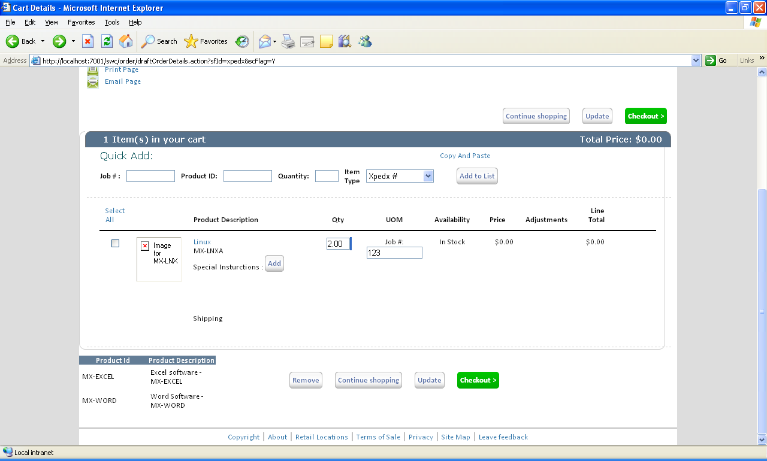

2.3.3 UI Validations
No UI Validations

2.3.4 Input Document
<Item CallingOrganizationCode="xpedx" Currency="USD"
IgnoreInvalidItems="N" IgnoreOrdering="Y" ItemID="MX-LNXA"
ShowFinalSupersededItemOnly="Y" UnitOfMeasure="EACH">
<!-- /Item/ItemAssociationTypeList/ItemAssociationType[]/@Type dynamically added in binding file. -->
<CustomerInformation CustomerID="xpedxCustomer"/>
<ItemAssociationTypeList>
<ItemAssociationType Type="Substitutions"/>
<ItemAssociationType Type="CrossSell"/>
<ItemAssociationType Type="UpSell"/>
</ItemAssociationTypeList>
</Item>

2.3.5 Output Document

<ItemList>
<Item IsItemSuperseded="N" ItemID="MX-LNXA" UnitOfMeasure="EACH">
<PrimaryInformation IsSoldSeparately="Y" IsSubOnOrderAllowed=""
IsValid="Y" MaxOrderQuantity="10.00" MinOrderQuantity="10.00"/>
<AssociationTypeList>
<AssociationType Type="CrossSell">
<AssociationList>
<Association AssociationType="CrossSell">
<Item ItemID="MX-ZIP" UnitOfMeasure="EACH">
<PrimaryInformation ShortDescription="Zip software"/>
<ComputedPrice/>
</Item>
</Association>
</AssociationList>
</AssociationType>
<AssociationType Type="UpSell">
<AssociationList>
<Association AssociationType="UpSell">
<Item ItemID="MX-EXCEL" UnitOfMeasure="EACH">
<PrimaryInformation ShortDescription="Excel"/>
<ComputedPrice/>
</Item>
</Association>
</AssociationList>
</AssociationType>
<AssociationType Type="Substitutions">
<AssociationList/>
</AssociationType>
</AssociationTypeList>
</Item>
</ItemList>

2.3.6 Configuration

2.2.1 Design for XPEDXDraftOrderAddOrderLinesAction
Modify the existing method getProductInformationForEnteredProducts() to read the item type of the product. Based on the item type the sku entered is validated against the xpedx product sku or the manufacturer sku.
Modify the method organizeProductInformationResults() to capture the job id for each item.

2.3.2 UI Design

2.3.3 UI Validations
No UI Validations

2.3.4 Input Document
<Input>
<Order OrderHeaderKey="">
<OrderLines>
<OrderLine Action="CREATE" OrderedQty="" ReservationMandatory="N" ValidateItem="N">
<Item ItemID="" UnitOfMeasure="" ProductClass=""/>
<Extn ExtnJobID=""></Extn>
</OrderLine>
</OrderLines>
</Order>
</Input>
2.3.5 Output Document

<Order OrderHeaderKey="">
<OrderLines>
<OrderLine>
<Extn/>
</OrderLine>
</OrderLines>
</Order>
2.3.6 Configuration
2.2.1 Design for XPEDXDraftOrderModifyLineItemsAction
Add a new method updateNotes(). This method is used to add special instructions at the order line level, edit and save the existing special instructions.
The mashup and binding are also changed to update job id at the line level.

2.3.2 UI Design

2.3.3 UI Validations
No UI Validations

2.3.4 Input Document
<Input>
<Order OrderHeaderKey="">
<OrderLines>
<OrderLine Action="MODIFY" OrderLineKey="" OrderedQty="" DeliveryMethod="" ReservationMandatory="N">
<Extn ExtnJobID=""></Extn>
<Instructions>
<Instruction InstructionText="" InstructionDetailKey = ""/>
</Instructions>
</OrderLine>
</OrderLines>
</Order>
</Input>
2.3.5 Output Document

<Order OrderHeaderKey=""/>

2.3.6 Configuration

3. Database Extensions
Table Name |  | YFS_CUSTOMER
Overview
Extensions/Custom/Hang-off
Primary Keys
Index on
Attribute Name | Column Name | Data Type/Size | OOB Data Type Name | Default Value | Description
ExtnCustLogo | EXTN_CUST_LOGO_PATH |  |  | ‘ ‘ | Customer Logo url path

Table Name |  | YFS_ORDER_LINE
Overview
Extensions/Custom/Hang-off
Primary Keys
Index on
Attribute Name | Column Name | Data Type/Size | OOB Data Type Name | Default Value | Description
ExtnJobID | EXTN_JOB_ID |  |  | ‘ ‘ | Order line Job ID

4. Exception and Error Handling

5. Security Aspects
5.1 Ownership
5.2 Encryption
5.3 Audit Trail
5.4 Other Security Aspects

6. Dependencies

JIRA no | desc | To be validated by  (Team/Person) | Status | Implications if incorrect

No. | Assumption | To be validated by  (Team/Person) | Status | Implications if incorrect

7. Unit Test Cases
Test No. | Test Description | Execution Instructions | Expected Result
1 | Edit Cart Details | Edit cart description and save | Cart description must be saved successfully.
2 | Qucik Add : New Product Attributes | Add job id, item type for a product and add to list. | Product must be verified against the xpedx sku or manufturer sku based on the item type and add the valid items to the cart.
3 | Qucik Add : Copy And Paste | Copy and Paste a list of products(quantity(tab/,) sku) | Items must be added properly to the list.
4 | Select All link | Click Select All link and Remove | All the items in the order must be selected for the operation. Remove should remove all the items in the cart.
5 | Job ID at Ordre Line | Job ID at Ordre Line | Should be able to see job id and edit and update the job id at order line level.
6 | Related Items | See a list of all the related items for the cart | See a list of all the related items for the cart
7 | Line Special Instructions | Special Instructions : Add/Edit | Add a new special instruction at the order line level and edit & save the existing special instructions.

